Last update:31.03.2021

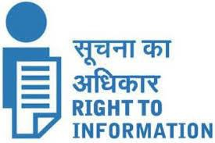

ALL INDIA INSTITUTE OF SPEECH & HEARING,

MANASAGANGOTHRI, MYSORE-570006

**2 Budget and Programme**

2.6 CAG & PAC paras [FNo.1/6/2011-IRdt.15.4.2013]

1. CAG and PAC paras and the action taken reports (ATRs) after these have been laid on the table of both houses of the parliament.

Till date No CAG & PAC paras