ALL INDIA INSTITUTE OF SPEECH AND HEARING, MYSORE
INTERNSHIP AND PLACEMENT CELL
ANNUAL REPORT

- Cumulative Statistics (From 1st April, 2018 to 31st March 2019)

- Internship Cell Activities
As part of internship program the students undergo 10 months of training from the academic year 2009 to the current batch. In the current academic year 2018-19, 61 students are undergoing internship training program in various centres across the country. During the first half of the year (04.06.2018 to 14.11.2018), 30 students of internship were posted at All India Institute of Speech and Hearing (AIISH) and 31 students were posted outside AIISH. In the second half of the year (26.11.2018 to 03.05.2019), 30 students were posted at various centres throughout the country and 31 students at AIISH.

The objectives of Internship are to:
- Facilitate the transition of training from supervised to independent responsibility.
- Provide additional inputs to attain and maintain competence in clinical management of persons with communicative impairments.
- Initiate group and individual action focusing on prevention/early identification and intervention in individuals with speech, hearing, and language impairments at the level of individual/ family and community.
- Facilitate the understanding of professional responsibilities and ethical practices including
- Right and dignity of patients
- Consultation and referral to other professionals
- Conduct and professional obligations to peers/patients/families and the community at large.
To fulfil the above objectives, students are posted at various centres under National Programme for Prevention and Control of Deafness (NPPCD) and Diploma in Hearing Language and Speech (DHLS) centres across the country during their internship program. The intention of posting the students is to provide clinical services at NPPCD and DHLS centres. Following is the details of the centres that were chosen for internship program in 2018-19:
 | 2018-19
States | Centres/ Hospital
- Karnataka | Shimoga  Dharwad  Udupi
- Karnataka | Chikmagalur
- Karnataka | Hubli
- Karnataka | Belagavi
- Karnataka | Mandya
- Karnataka | Tumkur
- Karnataka | Haveri  Sagara, Shimoga
- Pondicherry | Pondicherry
- Uttar Pradesh | Lucknow
- Madhya Pradesh | Jabalpur
- Jharkhand | Ranchi
- Rajasthan  - Assam  - Delhi  - Kerala | Ajmer  Guwahati  Delhi  Calicut

A letter was received from Head, NPPCD to place interns in NPPCD centres across Karnataka. Approval was taken and the remaining centres (Bagalkote, Bidar, Vijayapura, Chamarajanagar, Chitradurga, Gadag, Koppal, Raichur, Yadgiri) will be included in the internship centres for the upcoming academic year (2019-20).

Internship from other institutes posted at various departments in AIISH
Institute | No of students
Guru Gobind Singh Medical College, Faridkot (Punjab) | 8
Ashtavakra Institute of Rehabilitation Sciences & Research, Delhi | 4
DHLS centre, Jabalpur | 2
Jipmer, Pondicherry | 4

Nature of service rendered by the students of Internship program
The internship students are providing clinical services to the clients with various communication disorders under the guidance of staff from the respective centres/ district hospitals. They are also involved in public education on prevention and early identification of communication disorders, including new born screening for early identification of hearing impairment.
Students when posted at DHLS centres of the institute (Ajmer, Ranchi, Jabalpur, Lucknow, Guwahati and Puducherry) are also involved in providing assistance in clinical and academic assistance to enrolled students of DHLS training program. At AIISH, the internship students are posted to the departments of Audiology and Clinical services, where they are rendering diagnostic and rehabilitative services to individuals with communication disorders. They are posted to various special clinics for focused skill developments in the assessment and management of clients with specific communication disorders. They are also involved in extension services, such as, screening of school children for incidence/ prevalence of communication disorders, visits to hospitals for new born infants hearing acuity as part of the activities of the department of Prevention of Communication Disorders. In addition, students are also posted in campus duties for screening general public for incidence/ prevalence of communication disorders at various places organized by the institute.

Work done by the internship cell for the year 2018-19
- The Orientation Program on a topic “Higher Education and Career Guidance” was organized by Internship and Placement Cell on 10th November 2018 for Batch I posted at AIISH, Mysore. 17 participants attended the orientation program.
- Orientation of Batch II was held on 19th January 2019 among which 29 internship students posted at AIISH, Mysore, attended the orientation program. The details of the orientation program are:
Time | Topic | Resource Person
9.25 am to 9.30 am | Welcome the Resource Person  (Dr. Hema N, Ms. Sahana V, Mr. Vikas M D)
Session I: Higher Education
9.30 am to10.15 am | Post Graduation Program- Entrance Preparation | Dr. Prashanth Prabhu  Assistant Professor in Audiology  Department of Audiology
10.15 am to 11.00am | Preparation for higher education in Abroad (GRE & TOEFL) | Mr. Reuben Thomas Varghese  Scientist-B  Department of Speech-Language Sciences
11.00 am to 11.15am | Tea/Coffee Break
Session II: Career Guidance
11.15 am to 12.00 noon | Clinical Practice as Audiologist and Speech-Language Pathologist | Dr. Ganapathy M K  Lecturer in Audiology  Department of Audiology
12.00 noon to 12.45 pm | Clinical practice in Rural set-ups | Mr. Arunraj K  Clinical Assistant  Department of Audiology
12.45 pm to 1.30 pm | Community based Job Opportunities | Dr. Abhishek B. P.  Lecturer in Speech Sciences  Department of Speech-Language Sciences

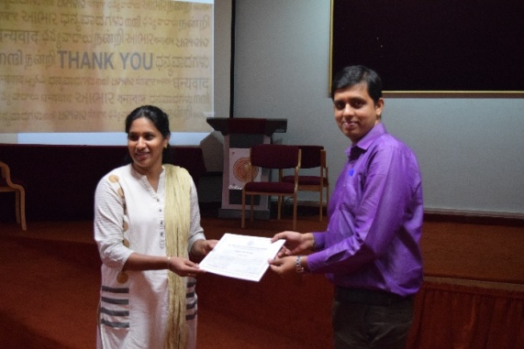 | 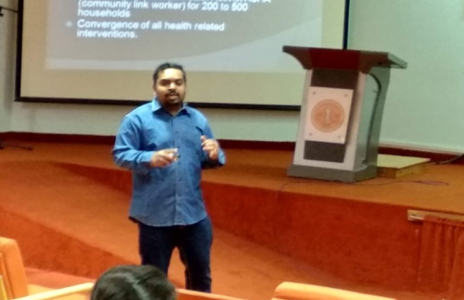
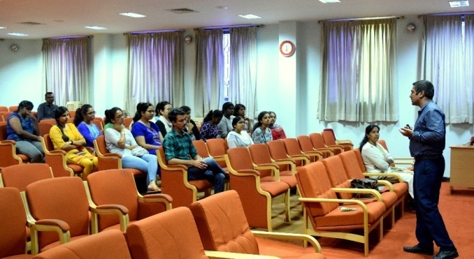 | 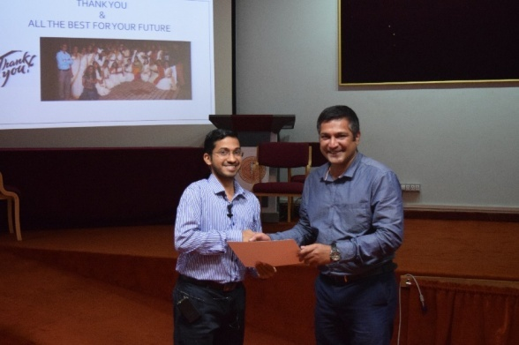

- Orientation program was conducted for III BASLP students on the same topic “Higher Education and Career Guidance” on 25.03.2019 and also regarding the upcoming Internship 2019-20. A total of 62 students attended the same. The details of the orientation program is as follows:
Time | Topic | Resource Person
9.10 am to 9.15 am | Welcome the Resource Person  (Dr. Hema N, Ms. Sahana V, Mr. Vikas M D)
Session I: Higher Education
9.15 am to10.00 am | Post Graduation Program- Entrance Preparation | Dr. Prashanth Prabhu  Assistant Professor in Audiology  Department of Audiology
10.00 am to 10.45am | Preparation for higher education in Abroad (GRE & TOEFL) | Mr. Reuben Thomas Varghese  Scientist-B  Department of Speech-Language Sciences
10.45 am to 11 am | Tea/Coffee Break
Session II: Career Guidance
11.15 am to 11.45 noon | Clinical and Private Practice as Audiologist | Mr. Achaiah  Clinical Audiologist
11.45 pm to 12.15 pm | Clinical Practice as Speech-Language Pathologist | Mr. Prasanna Hegde  Swallowing Therapist and Speech Language Pathologist
12.15 noon to 12.45 pm | Clinical practice in Rural set-ups | Mr. Arunraj K  Clinical Assistant  Department of Audiology
12.45 pm to 1.30 pm | Orientation about Internship rules, regulations and various centres | Dr. Hema N  Ms. Sahana V  Mr. Vikas M D

- Arrangement of resources and infrastructure of the internship and placement cell.
- Rescheduling/revision of posting schedules as per the situational demands.
- Regular follow up and monitoring of students posted outside AIISH regarding the nature of work, records, schedule, travel, facilities provided, other issues etc.
- Communication to parents/guardian regarding issues(s) related to their wards and regarding postings.
- Compilation of monthly attendance & leave statement of students for payment of stipend.
- Maintenance of attendance for annual compilation.
- Maintenance of feedback obtained from students after the completion of first term.
- Compilation of Clinical Performance Record for Internship Students posted outside AIISH.
- Prepared certificates of internship students (2017-18 batch) and passed the same to academics section for further needful.
- Liaison between students and Director/institute.
- Maintenance of files and documents.

Student Related:
- 12 internship students have sought approval to attend conference the WESPAC 2018 conference held at Delhi from 07.11.2018 to 14.11.2018. The list of students permitted were:
- Shoban Banoth
- Madhusudan B M
- Jeevan R S
- Mithun B K
- Jeevan G
- Pruthvik S P
- Lekshmi J L
- Abnamol Sunny
- Rinsha Rakkib
- Annslin Maria Lukose
- Joel Joseph
- Jayasree G K

- Placement Cell Activities
The AIISH placement cell came into existence on 28th March 2012. Located in the first floor of academic section, the placement cell is accessible to the students, Junior Research Fellows and Speech and Hearing professionals are the service seekers of this new section of the institute. The placement cell was initiated with the aim of conveying employment opportunities for students pursuing various courses at the institute (Bachelors, Masters, Diploma and Special education). There are ample opportunities at various institutes, organizations, private clinics, and hospitals inside and outside the country that are in search of quality manpower in the field of speech, language and hearing. The cell acts as a liaison between the final year student trainees and the prospective employers, the students and professionals are encouraged to make the best use of the facilities and services.

Scope
Placement cell advertises job opportunities for diploma holders, graduates, post graduates, Ph. D holders in the area of Speech-Language Pathology, Audiology and Special Education in India and abroad after the approval of Director. The cell also communicates the prospective employers to seek information regarding vacancies and to utilize the services of placement cell to recruit.

Work done by the placement cell for the year 2018-19
- Campus interview was organized at AIISH on 15.11.2018. by Samvaad Institute of Speech and Hearing, Bengaluru. Mrs. Radhika Poovaiah conducted the campus interview and Ms. Sarga Jose and Ms. Archana Rao attended the campus interview. Both of them were placed in the campus selection.
- All communication/ job notifications received by the Director, AIISH were advertised at the placement cell Notice Board.
- Publicity: Word-of-mouth publicity among students/staff of the institute regarding the functioning of the cell.
- Communication was established with organizations/ centres for garner information regarding job vacancies.
- Updating the data base of students: The database was updated periodically regarding the status of employment. In the present academic year, 4 candidates registered under placement cell. 45 applications have been circulated and time was given to enrol to placement cell.
- On receiving a job vacancy notification, the students who suited the criteria were informed about the prospects and details provided.
- The placement cell contacts advertisers of job requirements in the media (web/ newspaper) for a speech-language pathologist/ therapist, audiologist, audiometrician or special educator.
- After ascertaining the details, details of candidates fulfilling the advertised criteria are sent after approval of the Director. Such opportunities are advertised.
- The placement cell is a liaison between Director/ institute and different organizations for selection and placement of AIISH students.
- Organizations/ companies in need of manpower for speech, language and hearing services contact the placement cell through the Director stating their need. Several such companies/organizations contacted the placement cell in this regard, and such information was displayed in the notice board and also a mail was sent to the members enrolled in placement cell.
- The database of the placement cell includes
- Total no of registered job seekers - 152
- Total no of registered M. Sc. (Aud) job seekers - 21
- Total no of registered M.Sc. (SLP) job seekers - 75
- Total no of registered Ph. D job seekers - 8
- Total no of registered DHLS job seekers – 16
- Total no of registered DHA & ET job seekers - 4
- Total no of registered B. S. Ed (HI) job seekers – 6

- The details about the statistics of advertisements received and displayed as follows:

Sl. No | Activity | Numbers
1. | Advertisements displayed | 37
2. | Advertisements posted through email | 78
3. | No.of Posts Displayed for BASLP | 24
4 | No.of Posts Displayed for MASLP | 65
5. | No.of Posts for Displayed DHLS/BSed/MSed | 4
6. | Students placed | 2

Reports prepared by: Mr. Vikas M D
Ms. Sahana.V Checked and verified by

Dr. Hema.N
Coordinator, Internship &
Placement Cell

