Annual Report 2018-19
During the reporting year, the Horticulture section has developed the Mexican Lawn with ornamental plants at an area of 2375 Sq.ft in front of the Dept of SLS and SLP building and developed 500 numbers of indoor ornamental potted plants to place inside the office buildings. Also, the section has prepared around 5 tons of dried leaves compost in the institute nursery yard.
Further, the Horticulture section was represented the institute in the Dasara flower show – 2018, organized by the Dept. of Horticulture, Govt. Of Karnataka and won 1st prize for well garden maintenance and flower pots arrangement.
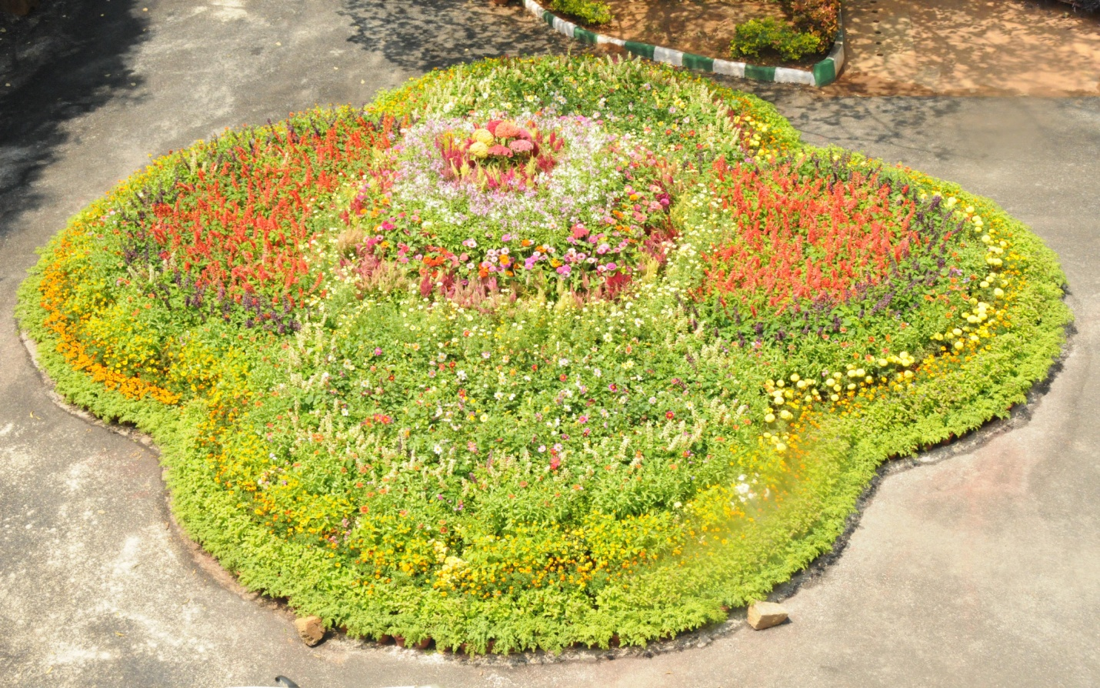Flower pots arrangement during the Dasara flower show – 2018.
The section also participated in the flower show organized by the Mysuru Palace Board, Mysuru, from 26th December to 1st January 2019. The institute received appreciation certificate from Sri. Abhiram G sankar, Deputy Commissioner, Mysuru District and Executive Officer, Mysuru Palace Board, Mysuru.

