अखिल भारतीय वाक् श्रवण संस्थान, मैसूरू - 06
ALL INDIA INSTITUTE OF SPEECH & HEARING: MYSORE-06
संप्रेषण न्यूनता व्यक्तियों के लिए टेली केन्द्र
TELE-CENTER FOR PERSONS WITH COMMUNICATION DISORDERS

SH/TCPD/Annual report/2018-19 दिनांक/ Date: 10.04.2019
NOTE
विषय: 2018-19 के वर्ष के लिए टीसीपीडी वार्षिक रिपोर्ट प्रस्तुत करना I
Sub: Submission of TCPD Annual report for the year of 2018-19 –reg

****
Please find herewith the Annual report of TCPD department for the year of 2018-19 is enclosed for your kind needful.

Head/ केंद्र के अध्यक्ष
TCPD/ टि सी पि डि

को/ To:

पुस्तकालय और सूचना केंद्र / Library and Information Center

अखिल भारतीय वाक् श्रवण संस्थान, मैसूरू - 06
ALL INDIA INSTITUTE OF SPEECH & HEARING: MYSORE-06
संप्रेषण न्यूनता व्यक्तियों के लिए टेली केन्द्र
TELE-CENTER FOR PERSONS WITH COMMUNICATION DISORDERS
SH/TCPD/Annual report/2018-19 दिनांक/ Date: 10.04.2019
I ACADEMIC ACTIVITIES
- Orientation/Short-term Training Programs (For Outsiders) - Nil
- Theme/Topic
- Coordinator
- Objectives
- Target Audience
- Number of Participants
- Date

- Clinical Observation Posting of Students from other Institutes

Number of Students | Course | Institute | Date
40 Students | M.Sc (SLP) | AIISH | 2018 -19
40 Students | M.Sc (Audiology) | AIISH | 2018 -19
15 students | B.Sc. Speech and Hearing | Ashtavakra Institute of Rehabilitation Science and Research, Delhi | 2018-19
30 Students | I B.Sc. (Practical Demonstration of Tele-diagnostics & Tele-Therapy as part of Electronics class) | AIISH | 04.09.2018

- Seminars/Conferences/Workshops/Training Programs - Nil
- Theme/Topic
- Coordinator
- Objectives
- Target Audience
- Number of Participants
- Date

- Staff Enrichment/In-house Training Programmes ( For own staff members)

Sl. No. | Name of the staff | Topic | Date | Department/Place
 | Ms. Yashaswini. R, Clinical supervisor | “National Workshop on Speech-Language Processing" | 27th -28th March 2018. | Organized by SLS, AIISH
Ms. Pavithra K,
SLP Gr I.

- Guest Lectures
Sl. no | Name, Designation  and Institutional  affiliation of Lecturer | Topic of Lecture | Date
 | Dr. Shubha Kashinath,  Alumnae of AIISH,  Associate Professor and Chair Communicative Sciences and Disorders,  California State University,  East Bay, USA | Guest lecture on “Supporting Intentional Communication in children with Autism” | 16.07.2018
 | Dr. Sumanth M M,  Community Medicine,  MMC & RI | Webinar on “Overview of sample size estimation in quantitative studies” | 31.01.2019
 | Ms. Prathiksha Mehtha Guptha  Director, 1 special place | Webinar on Therakonnect software for tele-practice | 28.02.2019

- Additional Academic Services rendered by the Faculty and Staff – Nil

- Invited talks
- Curriculum Development
- Development of Materials to Support learning
- Services in Academic Bodies of other Organizations
- Participation in Committees/ Taskforces and Panels set up by other organizations/ agencies.
- Any other/ (Please Specify)

II Research Activities
A. Extramural Research Projects
i) Completed in 2018-19
Sl. No | Title | Status | Investigators | Grant Amount
 | Life satisfaction and quality of life in persons with Aphasia beyond communication | Completed | PI: Dr.S.P.Goswami | `4, 96,000
 | TOLD-H: An adaptation of TOLD | Completed | Co-PI: Dr.S.P.Goswami | `4, 96,000

ii) New Projects initiated in 2018-19
Sl. No. | Title | Status | Investigators | Source of Fund | Grant Amount
 | SENSE-COG Asia: An open label feasibility study of a supportive hearing intervention in dementia | Initiated | Chief Investigators: Dr. Iracema Lerol, University of Manchester & Dr. Nusrat Husain, University of Manchester PI: Dr. S P Goswami & Dr. Murali Krishna Co. PI: Dr. M Sandeep, | Funded by University of Manchester | £36,674
 | Cognitive Stimulation Therapy (CST) for dementia: International implementation in Brazil, India and Tanzania (CST-International). | Approved | PI: Dr. Mina Chandra – Co-PI: Dr. Smita Deshpande, Dr. Sridhar Vaitheswaran, Dr. Murali Krishna & Dr. S P Goswami, | Global Allowance for Chronic Disease (GACD) & ICMR, New Delhi Research Fund | awaiting for Release of funds
 | Improving diagnosis and access to health care services for persons with dementia using android based applications by community health workers | Approved | Dr. Mina Chandra – PI  Co-Investigators - Dr. Smita N Deshpande, Dr. Murali Krishnan & Dr. S.P.Goswami, Dr. K S Shaji, Dr. Charan Singh, Dr. Bhagyashree Raghavan |  | awaiting for Release of funds

iii) Ongoing

Sl. No | Title | Status | Investigators | Funding Source | Grant Amount
 | Development of an Objective tool for Aphasia Assessment through Artificial Neural Networks. | Ongoing | PI: Dr.S.P.Goswami | - | `4, 83,000
 | Development of Battery for Cognitive Communication– Kannada (BCC-K). | Ongoing | PI: Dr. S. P. Goswami | Funded by ICMR, Ref.No.GIA/87/2014-DHR-365 dated 09.07.2015. | `25, 62,608

B. Postgraduate Research Completed
- Title/Topic
- Candidate
- Guide
C. Postgraduate Research Ongoing

Sl. No | Year | Topic of the Dissertation
 | 2018 | Development of Norms for Confrontation and Generative Naming
 | 2018 | Development of Nouns Gesture Corpus
 | 2018 | Development of Verb Gesture Corpus
 | 2017 | Adaptation and Standardization of Community integration questionnaire (CIQ-R) to kannada Language
 | 2017 | Adaptation and Standardization of revised craig Handicap assessment and reporting technique (CHART) in Kannada
 | 2017 | Conversation strategies used by persons with aphasia in varee communication
 | 2017 | Semantic errors in persons with fluent aphasia
 | 2017 | Syntactic errors in persons with fluent aphasia

D. Research Papers Presented at National/International Conferences/Seminars
(in APA format) -

- Manju, M. P. Goswami, S.P. (2019). Acquisition of Novel Words via Ffast Mapping and explicit encoding in persons with epilepsy in the 51st ISHACON held at Bangalore from 8-10 February, 2019

- Deepak, K.P., Goswami, S.P., Darshan, H. S. & Abhishek, B. P. (2019) Knowledge and Awareness of dementia in General Public: A survey Study in the 51st ISHACON held at Bangalore from 8-10 February, 2019
- Krishnan, G. & Goswami, S.P. (2019). Chin Down Position and Bolus Volume: Complementing or Complicating in the 51st ISHACON held at Bangalore from 8-10 February, 2019

- Krishnan, G. & Goswami, S.P. (2019). Temporal coordination of swallowing events in persistent Dysphagia in Post stroke ” in 51st ISHACON held at Bangalore from 8-10 February, 2019

- Sharon, J. & Goswami, S.P. (2019). Art of Communication in Aphasia in the 51st ISHACON held at Bangalore from 8-10 February, 2019

E. Research Papers Published (in APA format)
    - Papers Published in National/International Journals -

Sl. No | Publications in International journals
 | Pauranik, A., George. A., Sahu, A., Nehra, A., Paplikar, A., Bhat, C , Krishnan. G., Kaur., H ,Saini.J., , Suresh P. A., Ojha, P., Singh, P., Sancheti, P., Karanth, P., Mathuranath, P.S., Goswami, S.P., Chitnis, S., Sundar, N., Alladi, S., Faroqi-Shah, Y. (2019). Expert Group Meeting on Aphasia : A Report. Annals of Indian Academy of Neurology DOI: 10.4103/aian.AIAN_330_18
 | Reuben, T. V., & Goswami, S.P. (2018). Episodic Memory deficits: Comparison between persons with Dementia of Alzheimer’s type, Mild Cognitive Impairment & Healthy Elderly controls. International Journal of Advanced Research 6(9), 300-306. ISSN Print: 2320-5407.
 | Reuben, T. V., & Goswami, S.P. (2018).Semantic Fluency: A Speech Marker for Persons with Dementia of Alzheimer’s Type. International Journal of Psychology and Psychiatry, 6(2). 32-47.
 | Yashaswini, R., & Manjula, R. (2018). Communication Repertoire of Typically Developing Children between 6-12 Months in Free Play Mother-Child Dyadic Interaction. Journal of Humanities and Social Science, 23(11), 43-57. DOI: 10.9790/0837-2311024357
 | Yashaswini, R., & Rao, P. K. S. (2018). Tele Speech-Language Pathology and Audiology in India - A Short Report. Journal of the International Society for Telemedicine and e-health. 6, 1-8.
Sl. No. | Publications in National journals
 | Gayathri, K., & Goswami, S. P. (2018). Dysphagia Research in India: A Status Report. Journal of Indian Speech and Hearing Association (JISHA), 38 (2), 39-46.
 | Goswami, S. P., Priyadarshi, B., Mathews, S., Vasudevamurthy, A. (2018). Gestures and discourse markers: Communicative facilitators in persons with aphasia. Journal of Indian Speech Language Hearing Association; 32, 1, 1-5.
 | Goswami, S.P., Ramkumar, S., & Mathews S., (2018). Income and Work Satisfaction among Speech and Hearing Professionals in India: Two Sides of the Same Coin, Journal of Indian Speech and Hearing Association, 32, 1, 16-22.
 | Rao, P. K. S., & Yashaswini, R. (2018). Telepractice in speech-language pathology and audiology: Prospects and challenges. Journal of Indian Speech Language & Hearing. 32(2). 67-72.

    - Papers Published in Conference/Seminar Proceedings
F. Books Published (In APA format)
G. Books chapter published (in APA format)
H. Books/Manuals/Seminar Proceedings edited
I. Journals Editorship
J. Scholarly Reviewing Activities
- Journal Articles : 1. Journal of Indian Speech and Hearing Association
2. Journal of AIISH, Mysuru
- Conference Papers: 51st ISHACON language papers
- Research projects: Validation of Discourse analysis scale in adults with Dementia” PI: Dr. Hema N for review and comments.
III. CLINICAL SERVICES
A. General Clinical Services - Please refer to Extension services
    - Speech and Language Assessment
    - Speech and Language Rehabilitation
    - Hearing Evaluation
    - Hearing Aid Trail
    - Psychological Evaluation
    - Ear Moulds
    - Hearing Aid Issue and Electro-Acoustic Evaluation (ADIP Scheme, Ministry of Social Justice)
- AIISH Hearing Aid Dispensing Scheme
    - Any other (Please Specify)

B. Specialized Clinical Services - Nil

  - Augmentative and Alternative Communication Unit
- Autism Spectrum Disorder Unit
- Clinic for adult and elderly persons with Language Disorder
- Dysphasia Unit
- Fluency Unit
- Implantable Hearing Devices Unit
- Learning Disability Clinic
- Listening Training Unit
- Neuromotor Speech Disorder Unit
- Neuropsychology Unit
- Pre-School Training and Special Education
- Professional Voice Care Unit
- U-SOFA
- Vertigo Clinic
- Voice Clinic
- Any other (Please specify)
C. Clinical Support Services to Patients and Family - Nil
- Counseling and Guidance
- Certificates Issues
- Financial Aid
- Legal advice
- Any other(Please Specify)

D. Clinical Electronics Service - Nil
- Electro-Acoustic Evaluation
- Hearing Aid Dispensing
- Repair of Hearing Aid
IV. EXTENSION ACTIVITIES

- Rehabilitation and Education through Distance Mode
Tele-Assessment, Tele-intervention and Tele- Education Guidance

Total number of Cases and tele-sessions delivered between April, 2018 and March, 2019

 | Language |  | Phonological |  | Fluency |  | Voice |  | TOTAL
 | No. of Cases | No. of Sessions | No. of Cases | No. of Sessions | No. of Cases | No. of Sessions | No. of Cases | No. of Sessions | No. of Cases | No. of Sessions
Paediatric | 45 | 1,325 | 2 | 25 | 4 | 169 | 1 | 18 | 52 | 1,537
Adult | 10 | 511 | 4 | 33 | 5 | 67 | 0 | 0 | 19 | 611
Geriatric | 1 | 23 | 0 | 0 | 0 | 0 | 0 | 0 | 1 | 23
 | 56 | 1,859 | 6 | 58 | 9 | 236 | 1 | 18 | 72 | 2,171

Graphical representation of Teleservices provided across communication disorders (2018-19)

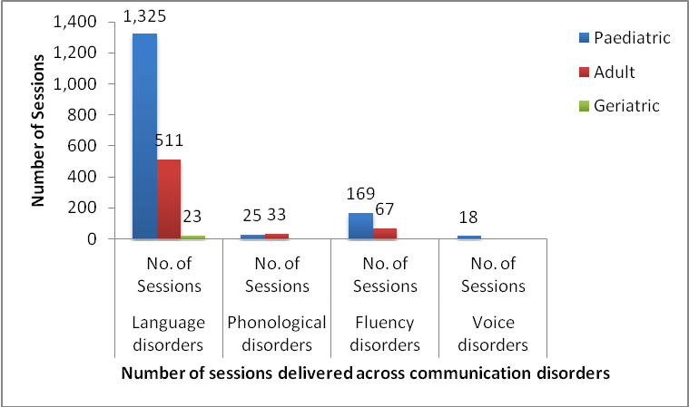
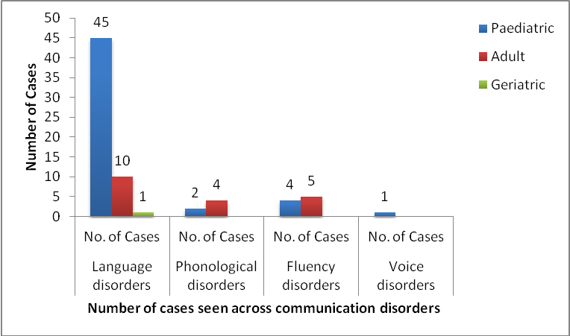

Total number cases and tele-sessions delivered across the Globe (2018-19)

Countries | No. of Cases | No. of Sessions
Abu Dhabi | 1 | 1
Dubai | 2 | 37
India | 60 | 1,737
Japan | 1 | 89
Saudi Arabia | 1 | 2
South Korea | 1 | 45
UK | 3 | 204
US | 3 | 56
Total | 72 | 2,171

Total number cases and tele-sessions delivered across India (2018-19)

States of India | No. of Cases | No. of Sessions
AP | 2 | 26
Assam | 3 | 223
Gujarat | 1 | 70
Haryana | 1 | 17
Jharkhand | 2 | 52
Karnataka | 28 | 819
Kerala | 5 | 177
Maharashtra | 3 | 69
MP | 1 | 12
New Delhi | 1 | 35
Rajasthan | 6 | 64
Tamil Nadu | 2 | 121
Telangana | 2 | 14
Uttar pradesh | 3 | 38
Total | 60 | 1,737

Total number cases and tele-sessions delivered across Karnataka (2018-19)

Districts of Karnataka | No. of Cases | No. of Sessions
Bangalore | 14 | 403
Belagaum | 2 | 65
Bellary | 2 | 35
Davanagere | 2 | 144
HD Kote | 1 | 18
Koppala | 1 | 7
Mysore | 3 | 110
Raichur | 1 | 4
Tumkur | 2 | 33
Total | 28 | 819

- Prevention of Communication Disorders - Nil
- Communication Disorders Screening Camps - Nil
- Orientation Programs – Nil
- Public Lecture Series – Nil

V. TECHNOLOGICAL CONSULTANCY SERVICES
VI. CENTRAL FACILITIES – Not Applicable
- Library and Information Services

- Public Information Activities
- Major Events of the Year with a brief account
- Press Releases and Media Coverage
- Institute Publications

- Materials Development

VII. PLACEMENT CELL ACTIVITIES

VIII. AWARDS AND HONORS RECEIVED BY FACULTY AND STAFF - Nil
IX. EXTRA CURRICULAR ACTIVITIES
- AIISH Gymkhana –

1. Participated in New Year celebration organized by Gymkhana in quadrangle.
2. Participated in Blood Donation Camp conducted by AIISH Gymkhana
3. Participated in Sports, events & other cultural activities conducted by Gymkhana.

- NSS –

  - Co-ordinate for the NSS activities as Assistant NSS officer for Unit-2.
  - Organized and attended the following NSS activities- Orientation program for the students at AIISH on Common laws for Common people and other Shramdhan activities.
  - Organized and attended the following NSS activities- Orientation program for the students at AIISH on 2-8-18, Shramdhan Activities, Collected funds for the Kerala and Kodagu relief from all the departments and also participated in the Rescue for Kodagu at Madikeri.
  - Co-ordinate for the NSS Valedictory ceremony as Assistant NSS officer for Unit-2.

- Others

X. ISO CELL ACTIVITIES
  - ISO External Surveillance on 26.07.2018
  - ISO Internal Audit on 28.01.2019
XI. PEER EVALUATION -
Peer review preparations

- Presentation of activities of TCPD by Head-TCPD for peer review on 14th Nov, 2018

XII. RESEARCH COORDINATION - Nil
XIII. MAJOR EVENTS OF THE YEAR
- Infrastructure: Procurement of equipment and furniture in 2018-19
- Desktop Computers – 08 Nos
- UPS – 05 Nos
- Printer – 01 No
- Chairs and Tables – 02 Sets
- Headset – 07 Nos
- Test Material(CELF, PPVT,GFTA,KLPA)
- Vocal function exercise(Joseph C Stemple – How to series)
- Development of public education materials in 2018-19
    - TCPD Brochures
    - Information Slips on TCPD services for distribution in DCS.
    - Content update on TCPD website and Parkinson’s Helpline.
- Audit in 2018-19
    - Inspection by UGC Committee members for Denovo University Status inspection in May 2018.
    - Stock Verification of TCPD equipment and furniture carried out in April 2018
XIV. EMINENT VISITORS

Sl.  No. | Date | Name & Designation | Purpose | Feedback
1 | 09.04.2018 | Ms. Vandana Jain  Joint Secretary (IFD)  GOI, Ministry of Health & Family welfare, New Delhi | Swatch Bharath | Institute Tour
2 | 19.04.2018 | Shri Gyan Prakash Srivastava  Shri Mukesh Bajpai  Officers at Ministry of Health & Family welfare, New Delhi | - | Institute Tour
3 | 04.05.2018 | Shri J Gaurishankar  Shri S K Chatturvedi UGC  Shri A K Sinha Committee  Shri Gopukumar | Denovo University Status inspection | - PD Helpline  - No. of cases & sessions annually  - No. of Staff  - Student training
4 | 19.06.2018 | Smt. Gayatri Mishra  Joint Secretary  Ministry of Healt & Family Welfare,GOI.  Smt. Niharika Singh  Joint Director  Ministry of Health & Family Welfare, GOI | Subcommittee of the committee of Parliament, an official Language of Central Govt. officers located at Mysore
5 | 11.07.2018 | 9 UG & PG students from Purdue University, west lafayette, Indiana, USA | Educational tour
6 | 23.07.2018 | Representatives from Deccan International School Bangalore & Mysore | Institute Tour | To avail services to their schools
7 | 26.07.2018 | Mr. Vivek Gurjar ( Auditor)  Accompanied by Mr. Bharath S | ISO External Surveillance Audit | 9.30 to 11.30
8 | 09.08.2018 | Shri Basavaraju V S  State Commissioner of PWD,  Bangalore with his Accompaniments. | Annual Day, Institute Tour | Connecting to health Dept. & Education dept. to make the process of rehabilitation more effective
9 | 28.08.2018 | Speech & Hearing Rehabilitations center, Chhattisgarh, Raipur | Institute tour - to get an idea for establishing their Institute | -

XV. ANY OTHER (PLEASE SPECIFY)

Head/ केंद्र के अध्यक्ष
TCPD/ टि सी पि डि

