Re: Annual Report (2)
1. Table for details on camp (pages 63-64)
S.No. | Date | Total No. Cases | Total No. referred | ENT related | Hearing loss | Speech & Language issues
1. | 04.03.2019 | 215 | 24 | 16 | 2 | 6
2. | 06.03.2019 | 45 | 2 | 2 | 0 | 0
Total |  | 256 | 26 | 18 | 2 | 6
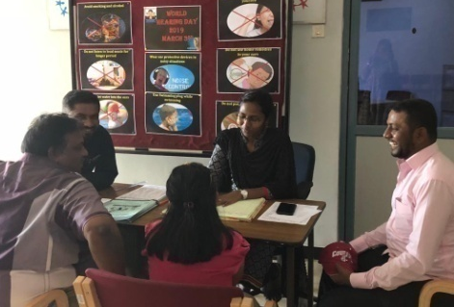
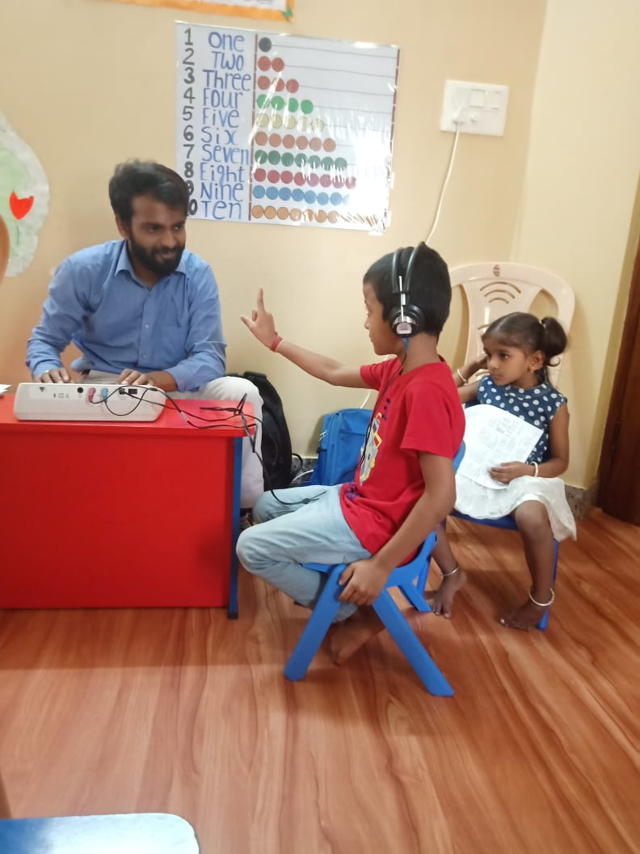
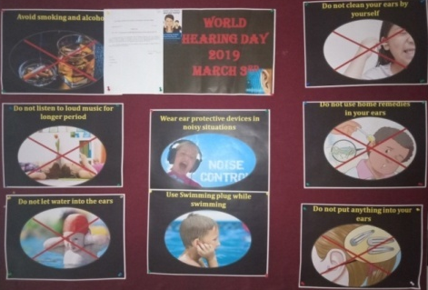
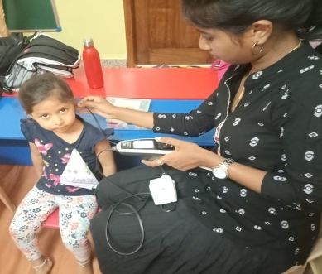
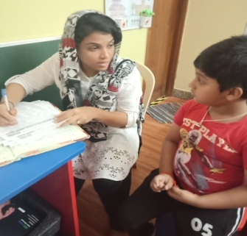

2. Camp details-in one format (pages 57-58)
Date | Name of the Place | Total Registered | Total identified with communication disorders |  |  | No of Hearing aid issued | Psychology
Date | Name of the Place | Total Registered | Ear related disorder (ears) | Hearing loss (ears) | Speech language disorders | No of Hearing aid issued | Psychology
28.06.2018 | Hospet, Bellary District and organized by Rotary Club, Hospet. | 271 | 49 | 140 | 56 | 99 | 26
02.02.2019 | Chamrajnagara Camp-Seva Bharathi Trust Public School | 130 | 60 | 26 | 14 | - | ---
03.02.2019 | Chamrajnagara Camp-Seva Bharathi Trust Public School | 33 | 38 | 48 | 4 | - | ---
22.02.2019 | Kumbh Mega Health Mela-Buxar, Bihar | 39 | 15 | 12 | 1 | 4 | ---
23.02.2019 | Kumbh Mega Health Mela-Buxar, Bihar | 55 | 9 | 36 | 2 | 44 | ---
31.12.2018 | Sargur (Paediatric camp) | 101 | 05 | 04 | 04 | -- | ---
14.01.2019 | Pediatric camp- Annur | 58 | 03 | -- | 02 | - | ---
19.02.2019 | Bheemanahalli,HD kote (Paediatric camp) | 53 | 01 | 00 | 02 | - | ---
14.03.2019 | Udburu | 08 | 03 | 04 | 03 | -- | ---
21.03.2019 | Talakadu-Community Camp | 09 | - | 18 | -- | -- | ---
12.04.2019 | Bachegowdanahalli | 40 | 01 | 06 | 05 | -- | --
18.04.2019 | Sarguru | 12 | -- | 24 | -- | -- | --
21.05.2019 | M C Thalallu | 53 | 02 | 02 | 02 | -- | --
24.05.2019 | Itna | 86 | 01 | 02 | 05 | -- | --
Total |  | 951 | 187 | 322 | 199 | 147 | 26

3. The follow up details in table 2a is disorder specific. The follow up data in table 2b is NBS/OSC centre and disorder specific.
Table 2a: Details of the overall results of follow-up evaluation for newborns and infants

Categories | Total
Clinically Normal (CN) | 924
ENT disorders (ENT) | 78
Auditory Maturation delay (AMD) | 07
Hearing disorder (HI) | 305
Speech &language disorder (SLD) | 139
Multiple disorder (MD) | 40
Incomplete testing (IT) | 182
Total registered for follow up testing | 1317

Table 2b: Details of the overall test results of follow up program at each NBS & OSC centers

Centers | CN | ENT | AMD | HI | SLD | MD | IT | Total
AIISH | 65 | 0 | 0 | 6 | 0 | 0 | 9 | 80
OSCs | 158 | 0 | 3 | 6 | 2 | 1 | 15 | 185
Ajmer NBS | 13 | 0 | 0 | 17 | 3 | 0 | 106 | 142
Cuttack NBS | 54 | 1 | 2 | 75 | 0 | 5 | 0 | 137
Imphal NBS | 110 | 23 | 2 | 25 | 45 | 2 | 0 | 195
Jabalpur NBS | 15 | 1 | 0 | 17 | 6 | 7 | 2 | 48
Puducherry NBS | 349 | 0 | 0 | 60 | 21 | 1 | 45 | 155
Ranchi NBS | 7 | 42 | 0 | 30 | 57 | 7 | 5 | 120
Lucknow NBS | 153 | 11 | 0 | 69 | 5 | 17 | 0 | 255
Total | 924 | 78 | 07 | 305 | 139 | 40 | 182 | 1317

4. World Cerebral Palsy Day- 5th Oct 2018
The main objective of celebration of this day was to generate awareness and share information in the community about cerebral palsy. Dr. Jayashree Shanbal, Head Department of Speech-Language Pathology welcomed the gathering, Dr. Swapna, Chairperson, MSD special clinic enlightened the gathering about the purpose of celebration of the day. Mr. Vivek, computer network administrator, Swamy Vivekananda Youth Movement, Sarguru was the chief guest. The vote of thanks was rendered by Mr. Arun Raj, Staff of Dept. of POCD. The program was compared by Ms. Shobha B.N, member of MSD special clinic, Dept. of Special Education. This was followed by an orientation program for the village Rehabilitation workers and mutispeciality rehabilitation workers. The staff of AIISH delivered lectures on relevant topics. The program ended at 4.00 PM. In addition, an interaction/orientation session was held for parents/caregivers of children with cerebral palsy with Mr. Vivek and his parents between 9.30 to 10.30 AM. He spoke about his journey with cerebral palsy and his father spoke about their struggles and challenges in raising a child with cerebral palsy.

