- ACADEMIC ACTIVITIES/ शैक्षणिकगतिविधियों

- Short-term Training / Orientation Programs organized-
Short-term Training given:09
Sl.  No. | Theme / Topic | Coordinator | Resource person | Target audience | Participants | Date
 | Orientation program on care and maintenance of CI for parents | Dr. Manjula P.,  Ms. Megha,  Mr. Jawahar Antony | Ms. Anjali Bhat, Clinical Specialist, Cochlear India Pvt. Ltd. | Caregivers | 31 | 27.04.18
 | Hands on workshop on Programming of Cochlear Implants | Dr. Manjula P.,  Ms. Megha,  Mr. Jawahar Antony | Ms. Anjali Bhat, Clinical Specialist, Cochlear India Pvt. Ltd. | II M.Sc students | 41 | 28.04.18
 | Orientation on supervision of cases in LTU | Dr. AshaYathiraj | Dr. AshaYathiraj&  Dr. Geetha C. | Staff | 03 | 17.05.18
 | Orientation of new products and software updates of HAC products by M/s HAC | Dr. Ramadevi KJS | Dr. Ramadevi KJS | Staff | 14 | 08.06.18
5 | Orientation of new products and software updates of Phonak products by M/s. Phonak | Dr. Sharath Kumar | Dr. Sharath Kumar | Staff | 12 | 14.06.18
6 | Parent Interaction Program for the primary caregivers of clients with hearing impairment | Dr. Asha Yathiraj,  Ms. Jyothi S.,  Ms. Nayana | Dr. Asha Yathiraj,  Ms. Jyothi S., Ms. Nayana | Parents | 14 | 15.06.18
7 | HE,  HAT–An  overview  & observation | Dr. Rajalakshmi K.& Mr. Darga  Baba | Dr. Aparna A JNMC  Belagavi | Students | 01 | 14.08.18

Sl.  No. | Theme / Topic | Coordinator | Resource person | Target audience | Participants | Date
8 | HE,  HAT–An  overview  &  observation | Dr. Rajalakshmi K.& Mr. Darga  Baba | Dr. Tejaswini J.S.,  JNMC  Belagavi | Students | 01 | 28.08.18
9 | HE,  HAT–An  overview  &  observation | Dr. Rajalakshmi K.& Mr. Darga  Baba | Dr. Yashaswini K  AAMC, Bijapur | Students | 01 | 28.08.18

Orientation programs organized:3

Sl.No. | Theme / Topic | Coordinator | Target audience | Venue | Date
 | Parent interactionprogram for primary caregivers of clients with hearing impairment | Dr. Asha Yathiraj  Ms. Jyothi  Ms. Nayana Kumari | Parents | Listening Training Unit | 15.06.18
 | Listening training by Ms. Jaspal Choudhary, Habilitation Specialist, Cochlear Medical Device India Pvt. Ltd., Mumbai | Dr. Asha Yathiraj,  Mr. Antony,  Ms. Megha, | Staff & students of AIISH | Seminar Hall, Department of Audiology | 15.02.19
 | Program for parents with children with cochlear implant on Care and maintenance | Dr. Asha Yathiraj, Mr. Antony,  Ms. Megha, | Parents | AIISH | 01.03.19

- Clinical Observation postings of students from other Institutes : 03
Sl. No. | Theme / Topic | Course / Institute | Target audience | Coordinators | No. of participants | Date
 | HE, HAT–An overview & observation | Apollo Hospital, Bengaluru | Dr. Deeksha Thakur | Dr. RajalakshmiK &  Mr. Darga Baba | 1 | 07.05.18
 | HE, HAT–An overview & observation | Apollo Hospital | Dr. Namratha S.  Dr. Chaithra S. | Dr. RajalakshmiK &  Mr. Darga Baba | 2 | 21.05.18
 | HE, HAT–An overview & observation | Apollo Hospital | Dr. Ashish S. Shah  Dr. Ameena Ibrahim | Dr. RajalakshmiK &  Mr. Darga Baba | 2 | 25.05.18
 | HE, HAT–An overview & observation | JNMC, Belagum | Dr. Anju Singh  PG ENT | Dr. RajalakshmiK &  Mr. Darga Baba | 1 | 10.7.18
 | HE, HAT–An overview & observation | JNMC, Belagum | Dr. Jahnavi  PG ENT | Dr. RajalakshmiK &  Mr. Darga Baba | 1 | 26.07.18
 | HE, HAT–An overview & observation | JNMC, Belagavi | Dr. Aparna. A  PG ENT | Dr. RajalakshmiK &  Mr. Darga Baba | 1 | 14.8.18
 | HE, HAT–An overview & observation | JNMC, Belagavi | Dr. Tejaswini. J.S  PG ENT | Dr. RajalakshmiK &  Mr. Darga Baba | 1 | 28.08.18
 | HE, HAT–An overview & observation | Al-Ameen, Biijapur | Dr. Yashaswini  PG ENT | Dr. RajalakshmiK &  Mr. Darga Baba | 1 | 28.08.18
 | HE, HAT–An overview & observation | JNMC, Belagavi | Dr. AmreenPatmegar  PG ENT | Dr. RajalakshmiK &  Mr. Darga Baba | 1 | 14.09.18
 | HE, HAT–An overview & observation | JNMC, Belagavi | Dr. Neha Padia  PG ENT | Dr. RajalakshmiK &  Mr. Darga Baba | 1 | 27.09.18
 | HE, HAT–An overview & observation | JNMC, Belagavi | Dr. Samanvaya Soni  PG ENT | Dr. RajalakshmiK &  Mr. Darga Baba | 1 | 09.10.18
 | HE, HAT–An overview & observation | JNMC, Belagavi | Dr. Shivani Gupta  PG ENT | Dr. RajalakshmiK &  Mr. Darga Baba | 1 | 24.10.18
 | HE, HAT–An overview & observation | MMCRI, Mysore | Dr. Prathibha. S  PG ENT | Dr. RajalakshmiK &  Mr. Darga Baba | 1 | 25.10.18 to 26.10.18
 | HE, HAT–An overview & observation | NMCH, Raichur | Dr. Krutika Raghu  PG ENT | Dr. RajalakshmiK &  Mr. Darga Baba | 1 | 26.10.18
 | HE, HAT–An overview & observation | NMCH, Raishur | Dr. Shaasiwi. S  PG ENT | Dr. RajalakshmiK &  Mr. Darga Baba | 1 | 26.10.18
 | HE, HAT–An overview & observation | S.S.Institute of Medical Sciences, Davangere | Dr. Nithin. K  PG ENT | Dr. RajalakshmiK &  Mr. Darga Baba | 1 | 30.11.18 to 31.11.18
 | HE, HAT–An overview & observation | Mandya Institute of Medical Sciences, Mandya | Dr. Rave Ambewade  PG ENT | Dr. RajalakshmiK &  Mr. Darga Baba | 1 | 17.12.18 to 19.12.18
 | HE, HAT–An overview & observation | S.S.Institute of Medical Sciences, Davangere | Dr. Sajitha Schandran  PG ENT | Dr. RajalakshmiK &  Mr. Darga Baba | 1 | 28.12.18
 | HE, HAT–An overview & observation | MMCRI, Mysore | Dr. Akash Aradhya. S  PG ENT | Dr. RajalakshmiK &  Mr. Darga Baba | 1 | 14.01.19 and 16.01.19
 | HE, HAT–An overview & observation | S.S. Institute of Medical Sciences, Davangere | Dr. Abdullah, PG ENT | Dr. RajalakshmiK &  Mr. Darga Baba | 1 | 15.02.19
 | HE, HAT–An overview & observation | KLE Ayurvedic College Belagavi | Dr. Neha Rawat  PG ENT | Dr. RajalakshmiK &  Mr. Darga Baba | 1 | 06.03.19 to 08.03.19
 | HE, HAT–An overview & observation | College of Community Sciences, UAS, Dharwad | UG – Community sciences External students | Dr. RajalakshmiK &  Mr. Darga Baba | 8 | 20.03.19 to 21.03.19
 | HE, HAT–An overview, observation& evaluation | JIPMER, Pondicherry | Nithya  Zimy Dibya | Dr. Sujeet &  Mr. Vikas | 2 | May 21 – June 13, 2018
 | HE, HAT–An overview, observation& evaluation | JIPMER, Pondicherry | Slinsha Babu | Dr. Sujeet &  Mr. Vikas | 1 | 01.10.18 to 26.10.18
 | HE, HAT–An overview, observation& evaluation | JIPMER,  Pondicherry | Nishya Salim | Dr. Sujeet &  Mr. Vikas | 1 | 17.12.18 to 11.01.19
 | HE, HAT–An overview, observation& evaluation | JIPMER,  Pondicherry | Dharani | Dr. Sujeet &  Mr. Vikas | 1 | 04.03.19 to 29.03.19
 | HE, HAT–An overview, observation& evaluation | Gurugobind Singh Medical College, Punjab | Tarun  Tania | Dr. Sujeet &  Mr. Vikas | 2 | 13.04.18 to 19.05.18
 | HE, HAT–An overview, observation& evaluation | Gurugobind Singh Medical College, Punjab | Simran Hans Ninderjeet Kaur | Dr. Sujeet &  Mr. Vikas | 2 | 21.05.18to 01.07.18
 | HE, HAT–An overview, observation& evaluation | Gurugobind Singh Medical College, Punjab | Avtar Singh Parminderdeep Kaur | Dr. Sujeet &  Mr. Vikas | 2 | 13.01.19 to 10.02.19
 | HE, HAT–An overview, observation& evaluation | Gurugobind Singh Medical College, Punjab | Parul  Mayank Sharma Ritika Khokar | Dr. Sujeet &  Mr. Vikas | 3 | 01.01.19 to 25.02.19
 | HE, HAT–An overview, observation& evaluation | Gurugobind Singh Medical College, Punjab | Manu  Manpreet | Dr. Sujeet &  Mr. Vikas | 2 | 28.02.19to 08.03.19
 | HE, HAT–An overview, observation& evaluation | Gurugobind Singh Medical College, Punjab | Gurpinder Navleen | Dr. Sujeet &  Mr. Vikas | 2 | 11.03.19 still in in JC Block
 | HE, HAT–An overview, observation& evaluation | Netaji Subhash Chandra Bose Medical College, Jabalpur | Dollin Johnson Rajvarsha Lodhi | Dr. Sujeet &  Mr. Vikas | 2 | 07.01.19to 25.01.19
 | HE, HAT–An overview, observation& evaluation | Netaji Subhash Chandra Bose Medical College, Jabalpur | Sam Jose K K Singh | Dr. Sujeet &  Mr. Vikas | 2 | 11.03.19 to 28.03.19
 | HE, HAT–An overview, observation& evaluation | Ashtavakra Institute of Rehabilitation, New Delhi | Nitin Dogra  Bhawna Sharma Sakshi Singh Apurva Singh | Dr. Sujeet &  Mr. Vikas | 4 | 01.07.18 to 27.08.18
 | HE, HAT–An overview, observation& evaluation | Ashtavakra Institute of Rehabilitation, New Delhi | Ishita Kapoor  Mahima Chauhan Ankit Ray Rahul Bhagat | Dr. Sujeet &  Mr. Vikas | 4 | 03.09.19 to 29.10.19
 | HE, HAT–An overview, observation& evaluation | Ashtavakra Institute of Rehabilitation, New Delhi | Muhul Dahiya Nitika Bahuguna Simran | Dr. Sujeet &  Mr. Vikas | 3 | 01.11.19 to 28.12.19
 | HE, HAT–An overview, observation& evaluation | Ashtavakra Institute of Rehabilitation, New Delhi | Parul Mayank Sharma Ritika Khokhar | Dr. Sujeet &  Mr. Vikas | 3 | 01.01.19 to 25.02.19

C) Seminars / Conferences / Workshops

Organized – at AIISH - 05
Sl.No. | Name | Title of the program | Venue | Date
1 | Dr. Manjula P & Mrs. Megha | Seminar on “orientation program on care and maintenance of cochlear implants for parents |  | 27.04.18
2 | Dr. Asha Yathiraj &  Mr. Antony | Hands-on workshop on “Programming of cohlear Implants” |  | 28.04.18
3 | Dr. Ramadevi | Fine tuning of digital hearing aids-For individuals with  hearing impairment | Department of Audiology | 27.09.18
4 | Dr. Asha Yathiraj  Dr. Devi. N  Dr. Chandni Jain  Dr. C. Geetha  Ms. Megha  Ms. Jyothi  Mr. Antony | National Seminar on “Candidacy and mapping issues in cochlear anomalies and cochlear nerve defects.  National Seminar on “Need for measuring outcome in cochlear implant”  National workshop on “Listening training for individuals with hearing impairment | Department of Audiology | 11.02.19  to  13.02.19
5 | Dr. Devi. N  Mr. Vivek A | Workshop on Ear mould Technology | Department of Audiology | 13.02.19  to  14.02.19

Attended within AIISH : 07
Sl.No. | Theme | Coordinator | Program | Date
1 | National Workshop on Educating the Educator organized by the department of Speech Language Sciences | Dr. AshaYathiraj, D. Manjula P.,  Dr. Rajalakshmi K., Dr. Ajith Kumar,  Dr. Sandeep M., Dr. Prawin Kumar,  Dr. Niraj Kumar, Dr. Geetha C.,  Dr. Sreeraj K., Dr. PrashanthPrabhu | Workshop | 10.05.18 & 11.05.18
2 | Speech processing for voice, speech and hearing disorders (WSPD) 2018 | Dr. Devi. N | Conferences | 08.09.18 & 09.09.18
3 | Speech processing for voice, speech and hearing disorders (WSPD) 2018 | Dr. Geetha C. | Conferences | 08.09.18 & 09.09.18
4 | Speech processing for voice, speech and hearing disorders (WSPD) 2018 | Dr. Sharath | Conferences | 08.09.18 & 09.09.18
5 | Speech processing for voice, speech and hearing disorders (WSPD) 2018 | Mr.Vikas | Conferences | 08.09.18 & 09.09.18
6 | Speech processing for voice, speech and hearing disorders (WSPD) 2018 | Dr. Antony. J | Conferences | 08.09.18 & 09.09.18
7 | Speech processing for voice, speech and hearing disorders (WSPD) 2018 |  | Conferences | 08.09.18 & 09.09.18

Attended outside AIISH: 17
Sl. No. | Theme / Topic | Name of the Person | Program | Date | Venue
1 | 11th ISHA-KSB Conference | Dr. Sujeet Kumar Sinha | Conferences | 14.09.18 to 16.09.18 | Munnar
2 | 11th ISHA-KSB Conference | Dr. Sreeraj K. | Conferences | 14.09.18 to 16.09.18 | Munnar
3 | 16th CIGICON – 2018 | Dr. Niraj Kumar Singh | Conference | 30.11.18 to 01.12.18 | Surat
4 | 16th CIGICON 2018 | Dr. Prawin Kumar | Conference | 30.11.18 to 01.12.18 | Surat
5 | 51st ISHCON - 2019 | Dr. Asha Yathiraj | Conferences | 08.02.19 10.02.19 | Bengaluru
6 | 51st ISHCON - 2019 | Dr. Manjula P | Conferences | 08.02.19 10.02.19 | Bengaluru
7 | 51st ISHCON -2019 | Dr. Animesh Barman | Conferences | 08.02.19 10.02.19 | Bengaluru
8 | 51st ISHCON - 2019 | Dr. Ajith Kumar U | Conferences | 08.02.19 10.02.19 | Bengaluru
9 | 51st ISHCON - 2019 | Dr. Sandeep M | Conferences | 08.02.19 10.02.19 | Bengaluru
10 | 51st ISHCON - 2019 | Dr. Prawin Kumar | Conferences | 08.02.19 10.02.19 | Bengaluru
11 | 51st ISHCON - 2019 | Dr. Niraj Kumar Singh | Conferences | 08.02.19 10.02.19 | Bengaluru
12 | 51st ISHCON -2019 | Dr. Nisha | Conferences | 08.02.19 10.02.19 | Bengaluru
13 | BISHACON 2019 | Dr. Sujeet Kumar | Conferences | 16.03.19 to 17.03.19 | Bhodgaya
14 | BISHACON 2019 | Dr. Animesh Barman | Conferences | 16.03.19 to 17.03.19 | Bhodgaya
15 | BISHACON 2019 | Dr. Sreeraj . K | Conferences | 16.03.19 to 17.03.19 | Bhodgaya
16 | BISHACON 2019 | Dr. Prashanth Prabhu | Conferences | 16.03.19 to 17.03.19 | Bhodgaya
17 | BISHACON 2019 | Ms. Jyothi S | Conferences | 16.03.19 to 17.03.19 | Bhodgaya

D) Staff Enrichment /In-house trining proggrammes
Attended at Department of Audiology- 13

Sl. No. | Name, designation and institutional affiliation of Resource Person | Topic of lecture | Coordinator | No. of Participants | Date
1 | Ms. Shubhaganga, Audiologist Gr-I | Using thresholds in noise to identify hidden hearing loss in humans | Dr. Sujeet Kumar Sinha, HOD-Aud. | 36 | 05.04.18
2 | Ms. Shantala P. | Wireless Accessories | Dr. Sujeet Kumar Sinha | 33 | 10.05.18
3 | Ms. Sneha P. | Adhear product developed by MEDEL Pvt. Ltd. | Dr. Sujeet Kumar Sinha | 32 | 16.05.18
4 | Ms. Nanitha | TVR Chair | Dr. Sujeet Kumar Sinha | 31 | 30.05.18
5 | Ms. Priya K.P.,  Research Officer | Fully implantable cochlear implant | Dr. Sujeet Kumar Sinha | 44 | 06.06.18
6 | Dr. Ajith Kumar U. | Orientation about the software Moodle | Dr. Sujeet Kumar Sinha | 43 | 05.09.18
7 | Ms. Merin Mathews | Orientation about the software Naida Link Cross Solutions | Dr. Sujeet Kumar Sinha | 35 | 26.09.18
 | Mr. Mayur Pathak | World Hering Forum | Dr. Sujeet Kumar Sinha | 28 | 26.12.2018
8 | Ms. Amrutha Varshini | Health and Wellness centre | Dr. Sujeet Kumar Sinha | 45 | 02.01.2019
9 | Ms. Megha | 3D Virtualis | Dr. Sujeet Kumar Sinha | 50 | 09.01.2019
10 | Mr. R. Rajesh Kumar | B81 Bone vibrator | Dr. Sujeet Kumar Sinha | 42 | 16.01.2019
11 | Mr. Rakshith | Ear Check middle ear analyzer | Dr. Sujeet Kumar Sinha | 53 | 23.01.2019
12 | Mr. Sam Publius | Oticon OPM system | Dr. Sujeet Kumar Sinha | 51 | 30.01.2019
13 | Ms. Shezeen | Livio AI hearing aid | Dr. Sujeet Kumar Sinha | 41 | 06.02.2019
Attended by staff outside AIISH : 2

Sl. No. | Name | Title of the program | Venue | Date
 | Dr. Chandni Jain | Hindi workshop on Hindi Prashikshan Kariyakram | Central Institute of Indian Languages, Mysuru | 14.06.18 to 15.06.18
 | Dr. Asha Yathiraj,  Dr. Manjula P. & Dr. Chandni Jain | Webinar on Teaching Learning Methods for under graduation programs in speech and hearing by Dr. Ciraj, Deputy Director Manipal Centre for Professional and Personal development organized by ISHA | Online | 21.06.18

- Invited talks delivered /Guest lectures by the Staff

Within AIISH : 27

Sl.  No. | Name, designation and institutional affiliation of Lecturer | Title of the program | Topic of lecture | Date
1 | Dr. Ganapathy M.K. | Staff Enrichment Program, Department of Special Education, AIISH | Cochlear Implants | 22.06.18
2 | Dr. Animesh Barman | Orientation to B.ASLP students | Structure of the program, Speech and hearing profession | 29.06.18
3 | Dr. Ajith Kumar U. | Orientation to B.ASLP students | Issues related to hostel | 29.06.18
4 | Dr. Sujeet Kuamr Sinha | Orientation to B.ASLP students | Code of Conduct | 29.06.18
5 | Dr. Devi N. | Orientation to B.ASLP students | Issues related to hostel | 29.06.18

Sl.  No. | Name, designation and institutional affiliation of Lecturer | Title of the program | Topic of lecture | Date
6 | Dr. Prashanth Prabhu | Workshop by Department of POCD, AIISH | Development and creation of E platform for FAQ’s on  communication disorders | 06.09.18 to 11.09.19
7 | Dr. Geetha C. | Conducted by Department of POCD, AIISH | Development and creation of E-platform for FAQ’s on communication disorders | 06.09.18 to 11.09.19
8 | Dr. Devi N. | Conducted by Department of POCD, AIISH | Development and creation ofE-platform for FAQ’s on  communication disorders | 06.09.18 to 11.09.19
9 | Dr. Sreeraj K. | Conducted by Department of POCD, AIISH | Development and creation of E-platform for FAQ’s on communication disorders | 06.09.18 to 11.09.19
10 | Dr. Hemanth Shetty | Conducted by Department of POCD, AIISH | Development and creation of E-platform for FAQ’s on communication disorders | 06.09.18 to 11.09.19
11 | Dr. Asha Yathiraj | National Seminar on “Candidacy and mapping issues in cochlear anomalies and cochlear nerve defects”, Department of Audiology, AIISH, Mysuru | “Candidacy for cochlear implant in children” and “Mapping issues in special cases” | 11.02.19
12 | Dr. Asha Yathiraj | National Seminar on “Outcome measures of cochlear implant’ Department of Audiology, AIISH, Mysuru | “Need for measuring outcome in cochlear implant” | 12.02.19
13 | Dr. Asha Yathiraj | National Seminar on “Listening training for individuals with hearing impairment” | “Pre-requisites and strategies for listening training” | 13.02.19

Sl.  No. | Name, designation and institutional affiliation of Lecturer | Title of the program | Topic of lecture | Date
14 | Dr. Manjula | National Seminar on “Candidacy and mapping issues in cochlear anomalies and cochlear nerve defects”, Department of Audiology, AIISH, Mysuru | “Candidacy for cochlear implant in adults” and “Overview on Mapping cochlear implant” | 11.02.19
15 | Dr. Chandni | National Seminar on “Outcome measures of cochlear implant” Department of Audiology, AIISH, Mysuru | “Methods to assess outcome in adults (Behavioral)” | 12.02.19
16 | Dr. Devi. N | “Listening training for individuals with hearing impairment” Department of Audiology, AIISH, Mysuru | “Listening training for adults” | 13.02.19
17 | Ms. Megha | “Listening training for individuals with hearing impairment” Department of Audiology, AIISH, Mysuru | “Identify listening strategies and critical evaluation of the therapy videos of young children” and “Identify listening strategies and critical evaluation of the therapy videos of older children” | 13.02.19
18 | Mr. Jawahar Antony | “Listening training for individuals with hearing impairment” Department of Audiology, AIISH, Mysuru | “Identify listening strategies and critical evaluation of the therapy videos of young children” and “Identify listening strategies and critical evaluation of the therapy videos of older children” | 13.02.19

Sl.  No. | Name, designation and institutional affiliation of Lecturer | Title of the program | Topic of lecture | Date
19 | Ms. Jyothi | “Listening training for individuals with hearing impairment” Department of Audiology, AIISH, Mysuru | “Identify listening strategies and critical evaluation of the therapy videos of young children” and “Identify listening strategies and critical evaluation of the therapy videos of older children” | 13.02.19
20 | Dr. Devi. N | Workshop on Ear Mould Technology | ‘Introduction on ear moulds and its different styles; Materials used in ear mould making’ and ‘Need for Acoustics modification of ear moulds’ | 13.02.19
21 | Dr. Hemanth | Workshop on Ear Mould Technology | Hard mould processing procedure and Soft mould processing procedure (including UV method) | 13.02.19
22 | Mr. Jayaram. M. T | Workshop on Ear Mould Technology | ‘Precautions for ear impression and flowing technique’ | 13.02.19
23 | Mr. Jayaram. M. T | Workshop on Ear Mould Technology | Hard mould processing procedure’ and ‘Soft mould processing procedure’ | 14.02.19
24 | Dr. Devi. N | Workshop on Ear Mould Technology | Practical demonstrarion on ‘Acoustic modifications in ear mould’ | 14.02.19
25 | Mr Sudarshan B | Workshop on Ear Mould Technology | Ear impression technique with hands on training. | 14.02.19
26 | Dr. Asha Yathiraj | National Service Scheme, AIISH, Mysuru | Sharing precious time and experience with NSS | 25.03.19.
27 | Dr. Sandeep M | Seminar on Ageing and Eldelry Care on Communication Disorders: Strategic Guidelines, organized by dept. of POCD, AIISH | ‘Identification, Management and Prevention of Hearing related Disorders in the Elderly’. | 11.01. 19

Outside AIISH - 21
Sl. No. | Name, designation and institutional affiliation of Lecturer | Title of the program& Place | Topic of lecture | Date
 | Dr. Sujeet Kumar Sinha, | 2 days RCI-CRE accredited annual conference of Telangana audiologist and speech language patholosits association (Telangana State Branch of ISHA), 1st TASLPACON 2018, KMS hospital, Hyderabad | Assessment and management of vestibular disorders | 21.04.18  to  22.04.18
 | Dr. Sujeet Kumar Sinha, | Speech and hearing association of India, West Bengal Branch, 1st SHAIWBCON at AYJNISHD (D), Regional Centre, Kolkata-90, West Bengal | Vestibular assessment and management setting up a vestibular assessment unit | 21.04.18  to  22.04.18
 | Dr. Prawin Kumar | Training for Associate Fellow of Industrial Health Course Students at ROHCS, Bengaluru | - Demonstration on instruments for audiological evaluations  - Auditory and Non-Auditory effects  - Audiological evaluations for NIHL | 31.05.18 & 01.06.18
 | Dr. Devi N. | Training for Associate Fellow of Industrial Health Course Students at ROHCS, Bengaluru | - Introduction to noise and its measure-ments  - Hearing conservation program  - Strategies for prevention of NIHL  - Selection and fitting of Ear protective devices | 31.05.18 & 01.06.18
5 | Dr. Prashanth Prabhu | Baby Memorial Hospital, Calicut | Recent advances in Vestibular Assessment | 04.08.18
6 | Dr. Asha Yathiraj | Dr. S.R. Chandrashekar Institute of Speech & Hearing, Bangalore | Training children with (C)APD at AUDISHCON 2018 | 29.09.18

Sl. No. | Name, designation and institutional affiliation of Lecturer | Title of the program& Place | Topic of lecture | Date
7 | Dr. Sreeraj. K | Dr. S.R. Chandrashekar Institute of Speech & Hearing, Bangalore | ‘Tinnitus Assessment and Rehabilitation’ at AUDISHCON 2018 | 29.09.18
8 | Dr. Prashanth Prabhu | Dr. S.R. Chandrashekar Institute of Speech & Hearing, Bangalore | “Hearing Aid fitting techniques in ANSD” at AUDISHCON 2018 | 29.09.18
9 | Dr. Devi N. | 4 day workshop for Teachers of KVS in South Zone region at Kendriya Vidyalaya Sangathan, ZIET, Mysuru | Hearing Loss- Definition, Characteristics, identification and strategies | 24.09.18  to  27.09.19
10 | Dr. Sujeet Kumar Sinha | 11th ISHA-KSB Conference at Munnar, Kerala |  | 14.09.18 to 16.09.18
11 | Dr. Ganapathy M.K. | National Seminar on “New Frontiers in Audiology” organized by Department of Hearing Studies, AUDISHCON 2018 | Acoustic Change Complex | 27.09.18 to 29.09.18
12 | Dr. Prawin Kumar | Workshop organized at Vikasa Soudha, Bengaluru | Status of Newborn Screening for Hearing in Karnataka | 10.09.18
13 | Dr. Prashanth Prabhu | 3rd Annual Conference “AUDISHCON 2018” at Dr. SRC Insitute of Speech and Hearing, Bengaluru | "Assessment and Management of Auditory Neuropathy Spectrum Disorders" | 29.09.18
14 | Dr. Asha Yathiraj | WHO workshop on ear and hearing care in South East Asia Region, MAMC,  New Delhi, | WHO Multi-country workshop on Ear and Hearing Care in SEA region and Technical Advisory Group | 03.10.18 to 05.10.18
15 | Dr. Asha Yathiraj | Mysuru | Decision on early referral for Cochlear Implants in those with congenital neonatal hearing loss’ | 18.11.18

Sl. No. | Name, designation and institutional affiliation of Lecturer | Title of the program& Place | Topic of lecture | Date
16 | Dr. Chandni Jain | ZEIT, KV, Mysore | Hearing Loss- Definition, Characteristics, identification and strategies | 27.11.18
17 | Dr. Sandeep M | National seminar on ‘’New Frontiers in Audiology-AUDISHCON 2018, organized by Dr. S.R. Chandrashekhar institute of Speech and Hearing | ‘Use of FFR in Diagnostics’ | 27.09.18 to 29.09.18
18 | Dr. Sandeep M | Audiology Seminar on Middle Ear (AuSOME), Organized by Nitte Institute of Speech and Hearing at Justice K.S. Hegde Hospital, Mangaluru. | ‘Decoding the concept of Immittance’. | 12.02.19
19 | Dr. Sandeep M | Audiology Seminar on Middle Ear (AuSOME), Organized by Nitte Institute of Speech and Hearing at Justice K.S. Hegde Hospital, Mangaluru. | ‘Differential Diagnosis of Middle Ear Disorders’ | 12.02.19
20 | Dr. Sandeep M | One-day Seminar organized by Marthoma College of Special Education Kasaragudu | ‘A review on the routine audiological evaluation’ | 12.02.19.
21 | Dr. Asha Yathiraj | JSS Institute of Speech and Hearing, Mysuru. | National conference on “Cognition, Hearing and Speech-Language Processing” | 01.03.19 to 02.03.19

- Service in Academic bodies of other organizations(Name of the organization, role, tenure)

Name of the faculty | Service rendered
Dr. Asha Yathiraj | - Conducted Internal open viva-voce of Mr. Pebbili Gopi Kishore as Chairperson –BOS (SLP) on 03.04.18  - Doctoral committee member for Intrenal viva of Mr. Sreeraj  - Served as chairperson-BOS (Aud) for the internal open viva voce of Ms. Nisha  - Internal examiner for Practical viva of II M.Sc (Students) on 05.05.18  - Attended pre-thesis colloquium of Mr. Jithinraj B. as Chairperson of BOS, Audiology on 21.06.18  - Examiner at University of Mysore  - Attended pre-thesis colloquium of Mr. Nike on 04.07.18 as Chairperson of BOS, Audiology  - Committee member for Ph.D. viva  - Chaired BOE meeting for Special Education and Speech and Hearing
Dr. P. Manjula | - Doctoral committee member for Intrenal viva of Mr. Sreeraj  - Served as room superintendent for B.ASLP integrated semester scheme and B.Ed.Spl.Ed. (HI) CBCS Scheme –April/May 2018  - Nominated for taking classes on course work titled Research Methodology for the year 2018-19  - Doctoral committee member for Intrenal viva of Ms. Nisha  - Deputy chief superintendent for entrance exam for UG/PG programs 2018-19  - Deputy Chief Superintendent for the entrance exam 2018 for UG/PG programmes at All India Institute of Speech and Hearing, Manasagangotri, Mysuruon 26.05.18  - Attended BOE meeting for Speech and Hearing
Dr. Rajalakshmi K. | - Served as examiner at Manipal University  - Served as external examiner for evaluation of thesis of Manonmaniam Sundaranar University, Tirunelveli, Tamil Nadu  - Served as room superintendent for B.ASLP integrated semester scheme and B.Ed.Spl.Ed. (HI) CBCS Scheme –April/May 2018  - Doctoral committee member for Intrenal viva of Ms. Nisha  - Invigilator for entrance exam for UG/PG programs 2018-19 on 26.05.18  - Internal examiner for Practical viva of I M.Sc (Students) on 05.05.18  - Examiner at University of Mysore  - External examiner at Manonmaniam Sundaranar University on 13.08.18 & 14.08.18

Name of the faculty | Service rendered
Dr. Ajith Kumar U. | - Served as external examiner on 16.04.18  - Served as examiner of Kerala University  - Served as examiner of BharatiVidyapeeth, Pune  - Doctoral committee member for Intrenal viva of Mr. Sreeraj  - Served as guide & chairperson of doctoral committee for Intrenal viva of  - Ms. Nisha  - Member of Anti Ragging Squad  - Attended pre-thesis colloquium of Mr. Jithinraj B. as Doctoral Committee member on 21.06.18  - Examiner at University of Mysore  - Attended pre-thesis colloquium of Mr. Nike G. as Doctoral Committee member on 04.07.18  - Attended BOE meeting for Speech and Hearing
Dr. Sandeep M. | - Served as examiner of Kerala University  - Served as examiner of BharatiVidyapeeth, Pune  - Served as examiner for PG students at Manipal university on 22.05.18 Examiner at Mangalore University  - Examiner at SRMC on 19.06.18 & 20.06.18
Dr. Sujeet Kumar Sinha | - Served as external examiner at Manipal University  - Served as examiner for PG/UG students at Manipal University on 22.05.18 & 23.05.18
Dr. Prawin Kumar | - Examiner at Manipal University,  - Examiner for SRM University
Dr. Devi N. | - Examiner at JIPMER  - Served as room superintendent for B.ASLP integrated semester scheme and B.Ed.Spl.Ed. (HI) CBCS Scheme –April/May 2018  - Examiner at University of Mysore  - Examiner Bangalore University  - Examiner Kerala University  - BOE member of Bangalore University  - Member of Anti Ragging Squad
Dr. Niraj Kumar Singh | - Served as examiner of Kerala University  - Served as examiner of Bharati Vidyapeeth, Pune  - Examiner at Kerala University
Dr. Chandni Jain | - Served as examiner of Kerala University  - Served as examiner for UG students at Manipal university  - Served as examiner at SRM university
Dr. Geetha C. | - Served as examiner for UG students at Manipal university
Name of the faculty | Service rendered
Dr. Niraj Kumar Singh | - Served as examiner of Kerala University  - Served as examiner of BharatiVidyapeeth, Pune
Dr. Sreeraj K. | - Examiner at Manipur University
Dr. PrashanthPrabhu | - Member of Selection committee for the post of Audiologist and Speech Therapist by District Rehabilitation Center (DRC), Mysuru at DC office on 23.07.2018.  - served as an External Examiner at Holy Cross College, Tiruchirapalli  - Delivered a talk on the topic "Post Graduation Program - Preparation for Entrance Exam' for III BASLP students organized by Internship and Placement Cell on 25.03.2019

Participation in Committees/Taskforces & Panels set-up by other organizations/agencies
(Name of the committee, organization, purpose, role, tenure)

Dr. Manjula P. | - Attended state cochlear committee meeting on 7.05.18 at Bangalore  - Participated in a meeting organized at Nimhans with regard to hearing aid rate control on 18.05.18  - Attended Cochlear Implant Committee meeting regarding technical specifications of CI devices for the year 2018-19 at Bangalore on 30.05.18  - Attended meeting at JSS institute of speech and hearing to select candidates for admission to Ist year MSLP for the year 2018-19 on 22.06.18.
Dr. Sujeet Kumar Sinha | - Served as Chairperson for 1st SHAIWBCON held on 21-22 April 2018 at AYJNISHD (D), Regional Centre, Kolkata-90, West Bengal  - Attended meeting for providing financial assistance to hearing disable students at University of Mysore on 28.05.18  - Attended meeting at JSS university to identify disabled candidates.
Dr. Ajith Kumar U | - Participated in a meeting organized at Nimhans with regard to hearing aid rate control on 18.05.18.

II. RESEARCH ACTIVITIES/ अनुसंधानगतिविधियाँ

- Funded Research Projects

- Extramural Research Projects :
- Completed Projects : 2018-19 - Nil
- New research project initiated/Approved - Three

Sl. No. | Title | Investigators | Funding source | Grant amount
1 | Auditory and cognitive consequences of dys-synchronours auditory nerve activity | Dr. Ajith Kumar U. – PI  Dr. Sandeep M. - CI | DST | 44,00,000
2 | Neuro-audiological profiling of children with special language impairment | Dr. Animesh Barman& PI  Dr. Swapna N  CI-Dr. PrashanthPrabhu | DST | 33,88,200
3 | Auditory and cognitive consequences of dys-synchronous auditory nerve activity | Dr. Ajith Kumar U. - PI | DST | 33,28,400

- Ongoing research project : 3
Sl.No. | Title of the Project | Investigator | Founding source | Amount
1. | fMRI & ERP evidence for improvement in Audio-visual integration in individuals with ANSD post speech reading training | Dr. Rajalakshmi K. | DST | 35.29
2. | Auditory processing and auditory cognitive measures in carriers of mutated genes that cause hearing loss | Dr. Sandeep M. | DST(3 years) | 47.52
3. | Efficacy of computer based traiing module on auditory and cognitive skills in children with central auditory processing disorders | Dr. Prawin Kumar | DST(3 years) | 28.49

- Intramural Research Projects :

- Completed Projects : Intra-mural - Nil

- New research project initiated: Intra-mural (ARF projects) - 7 (2018-19)
Sl. No. | Title of the project | Principal Investigator /  Co-Investigator | Project | Amount
1 | Electrophysiological Assessment of Auditory and Vestibular Neural Functioning in Individuals with Diabetes Mellitus | PI - Dr. Prawin Kumar  CI - Dr. M Bhanukumar,  Dr. Niraj Kumar Singh,  Mr. Vipin Ghosh &  Dr. Kumari Apeksha | ARF | 4,88,000
2 | Development of Phonemically balanced word lists in Tamil Language for adults | PI - Dr. Geetha C  CI - Dr. Devi N | ARF | 4,88,000
3 | Relationship between Auditory Abilities and Iron Deficiency Anemia in Adolescent Girls | PI - Dr. Chandni Jain  CI - Dr. Chetak K B &  Mr. Vipin Ghosh | ARF | 5,33,000
4 | Implementation and Validation of Portable Virtual Acoustic Spatial Training (VAST) Programme for Remediation of Spatial Deficits in Listeners with Sensorineural Hearing Impairment (SNHL): A Longitudinal Time – Series Study | PI - Dr. Ajith Kumar U  CI - Dr. Nisha K V | ARF | 4,85,000
5 | Behavioral and Electro Physiological Correlates of Lexical Semantic Activation in High and Low Proficient Bilinguals | PI - Dr. Sandeep M &  Dr. Abhishek B P  CI - Dr. Chandni Jain | ARF | 4,88,000
6 | Speech Identification in the Non-aided ear in Monaural Hearing Aid Users | PI - Prof. Asha Yathiraj | ARF | 4,93,000
7 | Development of AIISH Hyperacusis Assessment Toolbox for Individuals with Tinnitus Associated with Hyperacusis | PI - Dr. Prashanth Prabhu P | ARF | 4,93,000

iii) Ongoing research project initiated in 2017 -18 : Intra-mural (ARF) - 07

Sl. No. | Title of the project | Objectives | Principal Investigator /  Co-Investigator | Project | Amount
1 | Encoding of speech and music at auditory brainstem (frequency following response) with and without hearing aid | To investigate frequency following response for speech and music between unaided and aided responses for individuals with hearing impairment | Dr. Devi N.-PI | ARF | 5.18
2 | Auditory processing in children with speech sound disorders | To assess audtitory processing in children with speech sound disorders | Dr. Chandni Jain-PI  Ms. Priya M.B.-CI | ARF | 5.25
3 | Relationship between hearing aid benefit and auditory processing abilities in elderly individuals with hearing impairment | Helps in modifying the protocol of hearing aid ftting and in planning an effective rehabilitation program based on the needs of the client | Dr. Geetha C.-PI  Dr. Chandi Jain-CI | ARF | 5.25
4 | Auditory temporal processing in older Adults: Behavioral and Electrophysiological measures Auditory systems | To compare behavioural and electrophysiological measures to study temporal processing in older adults | Mr. Ganapathay M.K.-PI  Dr. Hemanth N-CI  Mr. PrashanthPrabhu-PI | ARF | 5.18
5 | Computer based Audiological Evaluation Software | To develop clinical masking software and to identify issues in the developed software for ways in which it would improved, to document training effect maintenance effect from audilogy students on the usefulness of the developed software | Dr. Hemanth N.-PI  Dr.Manjula P.-CI | ARF | 8.74
6 | The Genetics of Sensorineural Hearing Loss | To carryout the segregation analysis in the parents and siblings for identifed mutations and to do parallel sequencing of exons of all non-human genes and human orthologues of mouse genes | Dr. Rajalakshmi K - PI | ARF | 28.79
7 | Prevalence of Parental Consanguinity in Children with Communication Disorders a Survey based Study | To study the prevalence of communication disorders in Dharward district | Mr. Sreeraj K. & -PI  Dr. Jijo P.M. | ARF | 5.14

- Doctoral and Post-Doctoral Programs

- Doctoral Degree Awarded - 06
Sl. No. | Name | Topic | Guide | Awarded on
1 | Sreeraj K | Audiological profile and management of tinnitus in individuals with normal hearing | Prof. Manjula P. | 12.04.18
2 | Nisha K.V | Effect of training regime on behavioural and electrophysiological correlates of auditory spatial processing in individuals with sensorineural hearing loss | Dr. Ajith Kumar U  Guide | 09.05.18
3 | M.P. Reuben Jebaraj | Influence of hearing aid fitting strategies on speech recognition in individuals with sloping hearing loss | Prof. Manjula P.  Guide | June 18
4 | Jithin Raj B | Audiovisual perception of acoustically enhanced speech in individuals with auditory neuropathy spectrum disorders | Dr. Sandeep M.  Guide | 17.03.18
5 | Kumari Apeksha | Effect of noise and amplification on speech perception in individuals 6with auditory neuropathy spectrum disorder-electrophysiological and behavioural study | Dr. Ajith Kumar U  Guide | 27.09.18
6 | G. Nike Gnanateja | Effect of Speech intelligibility on the cortical entrainment to the temporal envelop of speech | Dr. Sandeep M.  Guide | 11.01.19

b. Doctoral Degree under Progress - 29

Sl. No. | Name | Topic | Guide/Co-guide
1 | Megha | Auditory cognitive and neuro-physio -logical basis of hearing aid acclimatization | Dr. Sandeep M.  Guide
2 | Priyanka V | Temporal processing abilities audi -tory working memory and speech perception in noise in vocal musicians, violinists and non-musicians | Prof. Rajalakshmi K.  Guide
3 | Srikar V | Auditory continuity and perceptual restoration of speech in noise-relationship with speech intellibility in individuals with normal hearing and cochlear hearing loss | Dr. Animesh Barman  Guide
4 | Arunraj K | Clinical validation of Wide band absorbance Tympanometry in detecting middle ear disorders | Prof. Animesh Barman  Guide
Sl. No. | Name | Topic | Guide/Co-guide
5 | Jawahar Antony P | Stream percept with sinusoidally amplitude modulated stimuli and its relation with speech perception in noise in individuals with normal hearing and Sensorineural hearing loss | Prof. Animesh Barman  Guide
6 | Pawan M | Investigation of mechanism underlying poor speech perception in individuals with cochlear hearing loss based on recovered envelope cues and the contribution of temporal fine structure cues in sequential segregation | Prof. Rajalakshmi K  Guide
7 | Mamatha N.M | Effect of auditory processing abilities on academic performance in Kannada speaking primary school children | Prof. Asha Yathiraj  Guide
8 | Anu Prasad | Auditory processing in children with benign epilepsy with centro temporal spikes/rolandic epilepsy | Prof. Rajalakshmi K  Guide
9 | Prajna Nayak | Fundamental frequency (f0) encoding and speech perception in noise | Prof. Rajalakshmi K  Guide
10 | Vignesh S.S. | Evaluation of brainstem functions in multiple sclerosis using auditory vestibular test battery | Prof. Rajalakshmi K  Guide
11 | Dhanya M | Perceptual cues of Coarticulation in Malayalam in Normal Hearing and Hearing impaired individuals | Dr. Sandeep M  Guide
12 | Rakesh Gatla | Auditory processing and speech perception abiliites in carriers of mutated genes that cause hearing loss (Tentative) | Dr. Sandeep M  Guide
13 | Yashashwini L | Categorical perception and processing of speech and music stimuli in individuals with and without music training (Tentative) | Dr. Sandeep M  Guide
14 | Darga Baba Fakaruddin | Effect of Age, Hearing Loss and Working Memory on Speech Recognition in Naïve Hearing aid Users. | Prof. Rajalakshmi K  Guide
15 | Vikas M.D. | Effects of temporal resolution, working memory and personality on benefit of hearing aids in older adults | Dr. Manjula P.  Guide
16 | Anoop B. J. | Cognitive and ERP measures of informational masking in young and elderly normal hearing individuals | Dr. Ajith Kumar U.  Guide
17 | ShubhaTak | Loudness perception in children using hearing aids and children using cochlear implant | Dr. AshaYathiraj  Guide
18 | Shreyaank | Comparison of contralateral suppression of otoacoustic emission between children with APD and children with ADHD | Dr. AshaYathiraj  Guide
Sl. No. | Name | Topic | Guide/Co-guide
19 | Shailaja Shukla | Cognitive Linguistic Processing in Typically Aging Kannada speaking individuals | Dr. Manjula P.  Co-Guide
20 | Priyanka Jaisinghani | Validation of Speech Enhancement and Noise Reduction Strategies in Individuals with Sensorineural Hearing Loss and Auditory Neuropathy Spectrum Disorders. | Dr. Manjula P.  Guide
21 | Sreena E N | Preferred Compression Amplification Setting for Individuals with Varying Audiogram Configuration | Dr. Manjula P.  Guide
22 | Sahana V | Auditory and cognitive profiling in normal hearing individuals with occupational noise exposure | Dr. Ajith Kumar U  Guide
23 | Jim Saroj Winston | Effect of short-term musical training on psycho-acoustical, electrophysiological and working memory measures | Dr. Ajith Kumar U  Guide
24 | Priyadharshini K. | Effect of Auditory Training Using Envelope Enhanced Speech on Speech Perception Abilities in Persons with Auditory Neuropathy Spectrum Disorder | Dr. Ajith Kumar U  Guide
25 | Ms Reesha | Efficacy of Computer-Based Auditory Separation Training in Children with Auditory Processing Disorders. | Dr. Prawin Kumar Guide
26 | Ms. Merin Mathews | Audio-Visual Speech Perception in Individuals with ANSD: Effect of Audio-Visual Training Evidenced through ERP and Behavioural Measures. | Dr. Rajalakshmi K. Guide
27 | Ms. Krupa Saira George | Effect of Native and Non-Native Babble Background on Speech Identification of Individuals with Normal Hearing and Hearing Impairment. | Dr. Rajalakshmi K. Guide
28 | Ms. Shubhaganga | Influence of education, employment and gender on auditory processing and cognition in older adults. | Dr. AshaYathiraj Guide
29 | Ms. Deepashree | Auditory brainstem responses and oto-acoustic emissions in infants born to mothers with iron deficiency anaemia | Dr. Ajith Kumar U  Guide

- PG Dissertations Completed- 36 II M.Sc (Audiology) students submitted their Master’s dissertation under the guidance of the staff of the Audiology Department.

Sl. No. | Name of the candidate | Title of the dissertation research proposal | Guide
1 | Amruthavarshini B | Comparison of performance on SPIN-K between non-native Kannada speakers having Malayalam as native language and native Kannada speakers | DrAsha Yathiraj
2 | Jain Slesha N. | Comparison of performance on SPIN-K between non-native Kannada speakers having Hindi as native language and native Kannada speakers | Dr. Asha Yathiraj
3 | Nayana P V | Lexical Neighbourhood Test for Children in Malayalam (LNT-M) | Dr. Asha Yathiraj
4 | Aishwarya Lakshmi | Comparison of objective and subjective approaches  for verification of RIC hearing aids | Dr. Manjula P.
5 | Harish Kumar M.K | Effect of attitude towards hearing loss on hearing aid outcomes | Dr. Manjula P.
6 | Angeline | Development of video for counseling hearing aid users and check its efficacy using hearing aid handling skills | Dr. Rajalakshmi K.
7 | Chandan R | Noise induced hearing loss effect and awareness in city bus drivers | Dr. Rajalakshmi K.
8 | Nikhil J. | Internet based cognitive behavioural therapy for adults with tinnitus in India | Dr. Rajalakshmi K.
9 | Varsha C S | Relationship between some aspects of Temporal processing and speech in noise scores in individuals with normal hearing | Dr. Animesh Barman
10 | Rucha | Efferent Auditory Pathway and language learning | Dr. Ajith Kumar U.
11 | Varsha | Auditory working memory skills in normal hearing individuals exposed industrial noise | Dr. Ajith Kumar U.
12 | Shezeen | Relationship between contralateral inhibition of otoacoustic emissions and speech perception in noise: effect of signal to noise ratio and linguistic load | Dr. Ajith Kumar U.
13 | Khatri Ehteshaam Anwar Hussein | Effect of Varying Interstimulus Interval on Multifrequency ABR | Dr. Sandeep M.
Sl. No. | Name of the candidate | Title of the dissertation research proposal | Guide
14 | Shruthi G N | Effect of noise on context dependant brainstem encoding of speech | Dr. Sandeep M.
15 | Sam Publius A. | Practice effects of odd ball paradigm in P300 responses | Dr. Sandeep M.
16 | Mayelmeit Lepcha | Vestibular problem in individuals with sensorineural hearing loss | Dr. Sujeet Kumar Sinha
17 | Mayur Pathak | Speech evoked aided cortical potentials in adults using hearing aids | Dr. Prawin Kumar
18 | Mangal Yadav | Sentence perception abilities in presence of noise among hearing aid users | Dr. Prawin Kumar
19 | Udhayakumar R | Comparison of syllabic and dual compression on non-linear hearing aid processed Malayalam chimeric sentences | Dr. Devi N.
20 | Vinayagar P.T | Comparison of syllabic and dual compression on non-linear hearing aid processed Kannada chimeric sentences | Dr. Devi N.
21 | Shiyaam Sundar | Outcome of experienced users of wireless synchronization  digital hearing aids using Speech, Spatial and Qualities questionnaire. | Dr. Geetha C.
22 | RajaSuman | The influence of Proficiency of the non-native background language on Speech recognition of native language | Dr. Geetha C.
23 | Rajesh | The effect of insertion gain and preferred gain on speech intelligibiliy | Dr. Geetha C.
24 | Chandan Kumar Nayak | Gap detection test using MLP -Development of normative in children (9-11 years) | Dr. Chandni Jain
25 | Prithivi.T | Gap detection test using MLP -Development of normative in children (7-9 years) | Dr. Chandni Jain
26 | Adithya Sugathan | Chained frequency specific tone burst stimuli for aided ABR threshold estimation in individuals with SNHL | Mr. Sreeraj K.
27 | Megha K N | Effect of noise exposure and aging on ABR and OAEs | Mr. Sreeraj K.
28 | Radhika Mathur | Correlation of self-assessment measures for tinnitus handicap with quality of life and its relation to psychoacoustic factors | Mr. Sreeraj K.

Sl. No. | Name of the candidate | Title of the dissertation research proposal | Guide
29 | Rakshith | Assessment of Localization and Cognitive Ability in Individuals with Hearing Impairment: A study on Simulated Road Traffic Environment | Dr. Hemanth N.
30 | Sujan | Frequency Discrimination Treatment and Relapse on Tinnitus: A Single Subject Design | Dr. Hemanth N.
31 | Vishwaraj | Prevalence and Audiological Characteristics of Single Sided Deafness in Individuals with Sensorineural Hearing Loss reported to AIISH 2015-2018 | Dr. Hemanth N.
32 | Chaitra K C | Binaural Interaction Component for Speech Evoked ABR in Older adults. | Mr. Ganapathy M.K.
33 | Suprabha Kappadi | Effect of Occupational Noise exposure on Efferent Auditory System. | Mr. Ganapathy M.K.
34 | Ananya Basappa | Evaluation of temporal processing abilities in individuals with hypertension. | Mr. Prashanth Prabhu
35 | Anup Ghimire | Development of low frequency word lists in Nepali language | Mr. Prashanth Prabhu
36 | Disha P Karnad | Evaluation of distortion product otoacoustic emission input output function in individuals with auditory neuropathy spectrum disorder | Mr. Prashanth Prabhu

- PG Dissertations Under progress:40 II M.Sc (Audiology) students doing their Master’s dissertation under the guidance of the staff of the Audiology Department.
Sl. No. | Name of the candidate | Title of the dissertation research proposal | Guide
1 | Aakanksha Pandey | Effect of physical activity on P300 and working memory | Dr. Chandni Jain
2 | Abinaya R | Psychoacoustic measure of Temporal processing and speech perception in older adults with normal hearing and Hearing aid users of 4 channel V/s 12 channel hearing aids. | Dr. K Rajalakshmi
3 | Acharekar Rashmi Madhukar | Evaluation of utricular function using ocular vestibular evoked myogenic potentials and subjective visual vertical test in Individuals with sensorineural hearing loss without vestibular disease | Dr. Sujeet Kumar Sinha
Sl. No. | Name of the candidate | Title of the dissertation research proposal | Guide
4 | Advaith B | Cross sectional study of personality, Anxiety and depression in individuals with Auditory neuropathy spectrum disorders | Ms. Mamatha N M
5 | Ajay H M | Audiometric profiling on small scale flour mill workers | Dr. K Rajalakshmi
6 | Amit Kumar | Sensitivity and specificity of smartphone based hearing testing applications | Dr. Ganapathy
7 | Anarse Chhandase Shrikanth | Functioning of olivocochlear bundle and speech perception in noise: Effect of Age | Dr. Dr. Ajith Kumar U
8 | Anupama R | Relationship between contralateral inhibition of otoacoustic emissions and speech perception in noise: Effect of age, signal to noise ratio and masker | Dr. Ajith Kumar U
9 | Aparna U | Effect of speech babble on listening effort and mental fatigue in Malayalam-Kannada bilingual speakers | Dr. Hemanth N
10 | Ashique Rahman M | Effect of Yoga on Auditory processing abilities in older adults | Ms. Mamatha N M
11 | Bhalerao Sanketh Satish | Effect of physical activity on psychophysical abilities and speech perception in noise | Dr. Chandni Jain
12 | Biswajith Pradhan | Contalateral suppression of Distortion product otoacoustic emission fine structure on Industrial workers | Dr. Prawin Kumar
13 | Darshan Hiremath | Effect of speech enhancement on listening effort and fatigue in individuals with hearing impairment older adults | Dr. Hemanth N
14 | Divya Mary Jose | Effect of hearing aid bandwidth on speech identification in children using bimodal devices | Dr. Manjula P
15 | Durga S | Effect of hearing aid bandwidth on cortical evoked responses in bimodal cochlear implantees | Dr. Manjula P
16 | Durga S Kumar | Prevalence of auditory neuropathy spectrum disorders in children( January 2018 - December 2018) | Dr. Prawin Kumar
Sl. No. | Name of the candidate | Title of the dissertation research proposal | Guide
17 | Faheema Luquman Ali | Cortical encoding of speech and non speech in Individuals with Auditory neuropathy spectrum disorders | Dr. Ganapathy
18 | Jagrati Sharma | Music touches where words alone can’t | Dr. K Rajalakshmi
19 | Jumana Mithalaj A K | Effect of vocal musical training on temporal resolution, frequency discrimination and speech perception in noise in children | Dr. Ajith Kumar U
20 | Patil Mohini Shirish | Assessment of otolith organs and semicircular canal function in individuals with diabetes mellitus | Dr. Sujeet Kumar Sinha
21 | Kamalakannan K. | Influence of number of frequency bands, envelope and fine structure cues on perception of tamil chimeric sentences | Dr. N Devi
22 | Kavitha G. S. | Input/output function of DPOAE in instrumental musicians | Dr. Sreeraj K
23 | Kavya S Murthy | Contralateral suppression of distortion product otoacoustic emissions input-output function in individuals with auditory neuropathy spectrum disorders | Dr. Prasanth Prabhu
24 | Kishore Kumar Bharshetty | Outcome evaluation of listening training interventions with/ without focused counseling on experiences of caregiver’s having children with hearing impairment | Ms. Mamatha N M
25 | Kriti Arora | Effect of type of stimuli on the benefit derived from envelope enhancement in individuals with ANSD | Dr. Sandeep M
26 | Lavanya H.S. | Clinical utility of various binaural interaction tests in the assessment of CAPD | Dr. Chandni Jain
27 | Neha Banerjee | Evaluation of auditory stream segregation in individuals with cochlear pathology and auditory neuropathy spectrum disorder | Dr. Prasanth Prabhu
28 | Penwal Suman | Effect of cross motor activities on auditory integration | Dr. Asha Yathiraj
29 | Priya Khader | Efferent system functioning in pediatric population using DPOAE input and output function | Dr. Sreeraj K
Sl. No. | Name of the candidate | Title of the dissertation research proposal | Guide
30 | Ritu A. Venkatesh | Effect of different artifact rejection levels on ABRs and ALLRs | Dr. Sandeep M
31 | Santosh Kumar Patel | cVEMP & oVEMP tuning curve in individual with diabetes mellitus | Dr. Sujeet Kumar Sinha
32 | Saranya M. | Evaluation of differential sensitivity for frequency, intensity and duration in individuals with hypertension | Dr. Prasanth Prabhu.
33 | Satish Kumar Patel | Effect of stimulus polarity on context dependent brainstem encoding of speech | Dr. Sandeep M
34 | Sharanya K Kumar | Contralateral Suppression of Transient Evoked Otoacoustic Emissions in School Going Children for Various Noise Types | Dr. Sreeraj K
35 | Sneha Uttakalika | The relationship between some aspects of temporal processing and speech in noise in older adults with normal hearing | Dr. Animesh Barman
36 | Sonia C. | Effect of noise induced hearing loss on difference limen for frequency, intensity and duration | Dr. N Devi
37 | Sridhar S | Comparison on perception of envelope and temporal fine structure cues in unaided and aided conditions using kannada chimeric sentences | Dr. N Devi
38 | Vanapalli Yamini | Temporal processing abilities in individuals with blindness | Dr. Asha Yathiraj
39 | Vishnu Mohan | Effect of ageing on efferent auditory system | Dr. Ganapathy
40 | Yashwanth Kumar | Listening effort and fatigue in individuals with noise induced hearing loss | Dr. Hemanth N

D. Research Paper Publications/ Presentations

Presented at National/International Conferences /Seminars

National : 60

1 | Basavanahalli Jagadeesh, A., Kumar, A. (2018). | Informational masking during working memory task. HeAL 2018, Hearing Across the Lifespan, held at Cernobbio, Lake Como, Italy between 7th& 9th June 2018. | Oral
2 | Jithin Raj Balan, Sandeep Maruthy (2018). | The effect of acoustic-enhancement on audio-visual perception in individuals with auditory neuropathy spectrum disorders. KSB, 15-16 September 2018, Kerala, Munnar | Oral
3 | Chandni Jain, Kirti Joshi (2018). | Effect of age on modulation detection threshold. KSB, 15-16 September 2018, Kerala, Munnar. | Oral
4 | Sneha. P, Devi. N (2018). | Frequency Following Response for music with and without hearing aids. KSB, 15-16 September 2018, Kerala, Munnar. | Oral
5 | Geetha Chinnaraj 1, Chandni Jain 2, Keerthi Sringari Parmeshwara (2018) | Effect Of Age On Binaural Integration Using Dichotic Digit Test  KSB, 15-16 September 2018, Kerala, Munnar | Oral
6 | Geetha Chinnaraj, Chandni Jain and Keerthi Sringari Parmeshwara (2018). | Effect of age and hearing loss on Auditory processing abilities. WSPD 2018, 8-9 September 2018, Mysuru | Poster
7 | Udhayakumar R and Devi N.(2018). | Comparison between syllabic Compression Processed and Unprocessed Malayalam Chimeric Sentences. WSPD 2018, 8-9 September 2018, Mysuru | Oral
8 | Chandni Jain, Priya M.B. and Kirti Joshi (2018). | Auditory processing in children with speech sound disorders. WSPD 2018, 8-9 September 2018, Mysuru | Oral
9 | Priyanka Jaisinghani, Manjula P. and Ajish K. Abraham (2018). | Systematic Review on the Performance Evaluation of Speech Enhancement Strategies in Individuals with Normal Hearing and Those with Hearing Loss. WSPD 2018, 8-9 September 2018, Mysuru | Oral
10 | Geetha Chinnaraj, Chandni Jain, Keerthi Sringari Parameshwara (2018). | Effect of age on binaural integration using Dichotic Digit test. 11th annual conference of ISHA, 15-16 September 2018, Kerala. | Oral
11 | Monika Tetwal, Chandni Jain and Devi N.(2018). | Temporal Processing and Working Memory in Children and Adults with Stuttering. WSPD 2018, 8-9 September 2018, Mysuru | Poster
12 | Sneha P and Devi N.(2018) | Neural Processing of speech and music with and without hearing aids. WSPD 2018, 8-9 September 2018, Mysuru | Poster
13 | Balan, J.R., &Maruthy, S. (2018). | speech perception and cortical potentials in individuals with Auditory Neuropathy Spectrum Disorders organized by Dept. of speech and Hearing, Manipal Academy of higher education on 11th and 12th October, 2018 | Oral
14 | Lekshmi J.L., Abnamole, S. & Prabhu, P. (2018). | Evaluation Of Frequency Following Response Using Speech Stimulus In Bharatanatyam Dancers And Non-Dancers. Presented At Wespac-2018 Held At New Delhi On 11th-15th November 2018. | Oral
15 | Shobhan, B., Madhu S.B., & Prabhu, P. (2018). | Effect of Filtered Speech on Speech Identification Scores of Telugu speaking Young Adults with normal hearing. Presented at WESPAC-2018 held at New Delhi on 11th-15th November 2018. | Oral
16 | Banoth Shoban, G. Jeevan, S P Pruthvik and Jain Chandni (2018) | Validation of smartphone threshold audiometry, Presented at WESPAC-2018 held at New Delhi on 11th-15th November 2018. | Oral
17 | Asha Yathiraj, Vanaja C.S.(2019) | Sensitivity and Specificity of â€˜Temporal Ability Screening Testâ€™ (TAST) in older adults, presented at 51st ISHCON - held at Bengaluru from 8th to 10th February 2019 | Oral
18 | Udhayakumar R, Devi N (2019) | Comparison of syllabic and dual compression Hearing Aid Processed Malayalam Chimeric Sentences, presented at 51st ISHCON - held at Bengaluru from 8th to 10th February 2019 | Oral
19 | Niraj Kumar, Nainitha K K, Prawin kumar (2019) | Identifying the Safe Stimulus Intensity for Cervical Vestibular-Evoked Myogenic Potentials, presented at 51st ISHCON - held at Bengaluru from 8th to 10th February 2019 | Oral
20 | Raghav Jha, Prawin Kumar, Aditi Gargeshwari, Niraj Kumar (2019) | Otolith and Semicircular canal function in individuals with calcium homeostasis dysfunction, presented at 51stISHCON - held at Bengaluru from 8th to 10th February 2019 | Oral
21 | Nisha KV, Ajith Kumar (2019) | Auditory Neural Correlates of Spatial Training in Listeners with Sensorineural Hearing Impairment: A High Density Electroencephalography Study, presented at 51st ISHCON - held at Bengaluru from 8th to 10th February 2019 | Oral
22 | Hemanth N (2019) | Frequency discrimination task in game format to treat tinnitus, presented at 51st ISHCON - held at Bengaluru from 8th to 10th February 2019 | Oral
23 | Akshatha Yogendra, Prawin Kumar, Swapna N, Animesh Barman, Arun raj K (2019) | Effect of occupational noise on audiometric thresholds in industrial workers, presented at 51st ISHCON - held at Bengaluru from 8th to 10th February 2019 | Oral
24 | Nayana M, Tejaswini Shambhu, Arunraj K, Swapna N, Prawin Kumar (2019) | Prevalence of hearing impairment and risk factors in newborns under neonatal hearing screening program in southern city of Karnataka, presented at 51st ISHCON - held at Bengaluru from 8th to 10th February 2019 | Oral
25 | Srikar Vijayasarathy, Meghana Mohan, Pratibha Nagalakshmi N G, Animesh Barman (2019) | Indications of Hidden Hearing Loss in subjects with â€˜normalâ€™ hearing exposed to occupational noise, presented at 51st ISHCON - held at Bengaluru from 8th to 10th February 2019 | Oral
26 | Alka C K, Monam Sinha, Ardra K, Prashanth Prabhu P (2019) | Evaluation of difference limen for frequency, intensity and duration in individuals with visual impairment, presented at 51st ISHCON - held at Bengaluru from 8th to 10th February 2019 | Oral
27 | Amrutha Varshini B, Slesha Jain, Asha Yathiraj (2019) | SPIN-K in Non-Native Kannada speakers: Comparison of Native Hindi and Malayalam Speakers who are Non-native Kannada Speakers, presented at 51st ISHCON - held at Bengaluru from 8th to 10th February 2019 | Oral
28 | Anu Sara Anish, Devika Vijayan, Annika Shiju, Rama Devi S, Shanthala S P, Prashanth Prabhu P (2019) | Audio-Vestibular Findings In An Adult With Arnold Chiari Malformation, presented at 51st ISHCON - held at Bengaluru from 8th to 10th February 2019 | Oral
29 | Ardra K, Monam Sinha, Alka C K, Prashanth Prabhu P (2019) | Assessment Of Binaural Integration Abilities In Individuals With Visual Impairment, presented at 51st ISHCON - held at Bengaluru from 8th to 10th February 2019. | Oral
30 | Biswajit Pradhan, Prawin Kumar, Reesha O. Abdul Hussain (2019) | Test retest reliability of contralateral suppression of distortion product otoacoustic emission fine structure in individuals with normal hearing. , presented at 51st ISHCON - held at Bengaluru from 8th to 10th February 2019 | Oral
31 | Durga S Kumar, Aparna U, Reesha O.Abdul Hussain, Prawin Kumar (2019) | Perception of Speech In Presence of Noise on Native And Non-Native Listeners, presented at 51st ISHCON - held at Bengaluru from 8th to 10th February 2019 | Oral
32 | Durga S Kumar, Saranya M, Devi N, Chandni Jain (2019) | Medial olivocochlear functioning and speech perception in noise in Polycystic ovary syndrome (PCOS) , presented at 51st ISHCON - held at Bengaluru from 8th to 10th February 2019 | Oral
33 | Ehteshaam Anwar Hussein, Sandeep Maruthy (2019) | Effect of Varying the Interstimulus Interval on Multi Frequency Auditory Brainstem Response, presented at 51st ISHCON - held at Bengaluru from 8th to 10th February 2019 | Oral
34 | Haripriya T, Gopika Vinod, Hiba Sherin, Indira C P, Sandeep Maruthy (2019) | The role of mocb in central auditory processing, presented at 51st ISHCON - held at Bengaluru from 8th to 10th February 2019 | Oral
35 | Hrishitha V M, Neha Mansoor Ali, Vibhuti Sharma, Jeslin Jose, Prashanth Prabhu P (2019) | Does martial art training improve binaural integration? Â€“ a preliminary study, presented at 51st ISHCON - held at Bengaluru from 8th to 10th February 2019 | Oral
36 | Husna Firdose, Niraj Kumar Singh (2019) | Age related changes in Inter-frequency Amplitude Ratio of Ocular Vestibular-Evoked Myogenic Potentials, presented at 51st ISHCON - held at Bengaluru from 8th to 10th February 2019 | Oral
37 | Indira C P, Sandeep Maruthy (2019) | Performance intensity function of speech perception in noise- the effects of linguistic redundancy and hearing loss, presented at 51st ISHCON - held at Bengaluru from 8th to 10th February 2019 | Oral
38 | Kavitha G S, Madhumanti Chakraborty, Devi N, Prashanth Prabhu P (2019) | Distortion product otoacoustic emissions input output function in individuals with and without musical abilities, presented at 51st ISHCON - held at Bengaluru from 8th to 10th February 2019 | Oral
39 | Kirti Joshi, Chandni Jain (2019) | Test retest reliability of various psychoacoustic measures using Maximum Likelihood Procedure,presented at 51st ISHCON - held at Bengaluru from 8th to 10th February 2019 | Oral
40 | Kumari Apeksha, Ajith Kumar (2019) | Effect of Acoustic Features on Discrimination Ability in Individuals with Auditory Neuropathy Spectrum Disorder: An Electrophysiological and Behavioural Study, presented at 51st ISHCON - held at Bengaluru from 8th to 10th February 2019 | Oral
41 | Nisha K V, Ajith Kumar (2019) | Application of Virtual Acoustic Technology for Auditory Spatial training in listeners with Sensorineural hearing impairment, presented at 51st ISHCON - held at Bengaluru from 8th to 10th February 2019 | Oral
42 | Ritwik Jargar, Rohit Bhattacharyya, Nethra R, Darshita K, Mesmin Rajkumar, Prashanth Prabhu P (2019) | Test re-test relaibility of distortion product input-output function â€“ a preliminary study, presented at 51st ISHCON - held at Bengaluru from 8th to 10th February 2019 | Oral
43 | Sam Publius, Sandeep Maruthy (2019) | Effect of familiarization to odd ball paradigm task on P300, presented at 51st ISHCON - held at Bengaluru from 8th to 10th February 2019 | Oral
44 | Shreya Sivaramakrishnan, Malavika Puthiyadam, Indira V, Pooja SV, Prashanth Prabhu P (2019) | Evaluation of auditory stream segrgation through profile analysis in children with abacus training, presented at 51st ISHCON - held at Bengaluru from 8th to 10th February 2019 | Oral
45 | Shreyank P. Swamy, Asha Yathiraj (2019) | Contralateral suppression of TEOAEs using Global and Half-octave bands: Comparison of Reliability in Children and Adults, presented at 51st ISHCON - held at Bengaluru from 8th to 10th February 2019 | Oral
46 | Srikanth Nayak (2019) | Estimation of gap detection thresholds in adults using cortical auditory evoked potentials, presented at 51st ISHCON - held at Bengaluru from 8th to 10th February 2019 | Oral
47 | Chandni Jain, Priya M B, Kirti Joshi (2019) | Relationship between Temporal processing and Phonological awareness in Children with Speech Sound Disorders, presented at 51st ISHCON - held at Bengaluru from 8th to 10th February 2019 | Oral
48 | Varsha M Athreya, Animesh Barman (2019) | Temporal Resolution: Behavioural measure and its Neural Correlates in Individuals with Normal Hearing Sensitivity, presented at 51st ISHCON - held at Bengaluru from 8th to 10th February 2019 | Oral
49 | PrashanthPrabhu, P, Banumathi, Deepika H.S. &Thanushree K (2019) | Does blood group affect differential sensitivity for frequency, intensity and duration – a preliminary study, presented at BISHACON 2019, Bodhgaya, from 16th to 17th March 2019. | Oral
50 | Dr. Prawin Kumar, Mangal Chandra Yadav (2019) | Sentence perception abilities in presence of noise among hearing aid users, presented at BISHACON 2019, Bodhgaya, from 16th to 17th March 2019. | Oral
51 | SreerajKonadath, Suma Chatni, AkshayMahadeva (2019) | Noise levels across different land use patterns in the city of Mysuru, presented at BISHACON 2019, Bodhgaya, from 16th to 17th March 2019. | Oral
52 | JyothiShivaswamy, Sreeraj K, Animesh Barman, Sujeet Kumar Sinha (2019) | Prevalence of communication disorders across different parts of India, presented at BISHACON 2019, Bodhgaya, from 16th to 17th March 2019. | Oral
53 | Sujeet Kumar Sinha, Anuj Kumar Neupane (2019) | Effect of aging on tympanometric findings in Indian population, presented at BISHACON 2019, Bodhgaya, from 16th to 17th March 2019. | Oral
54 | Sujeet Kumar Sinha (2019) | Cervical and ocular vestibular evoked myogenic potentials together can predict the contralateral ears involvement in individuals with Meniere’s disease, presented at BISHACON 2019, Bodhgaya, from 16th to 17th March 2019. | Oral
55 | BansalShalini, SinhaSujeet Kumar (2019) | Complete peripheral vestibular function test in severe to profound hearing loss individual, presented at BISHACON 2019, Bodhgaya, from 16th to 17th March 2019. | Oral
56 | SrikarVijayasarathy, Dr. Animesh Barman (2019) | Individual variability of Phonemic restoration of speech in noise and its correlation with speech in noise performance in individual with normal hearing, presented at BISHACON 2019, Bodhgaya, from 16th to 17th March 2019. | Oral
57 | Mr. Sandeep Kumar; Ms. SanjidaHussain; Dr. Prawin Kumar (2019) | Effect of Age on Auditory Discrimination and Temporal Resolution Abilities in School Going Children, presented at BISHACON 2019, Bodhgaya, from 16th to 17th March 2019. | Poster
58 | Dr. Prawin Kumar; Dr. Swapna N; Dr. KavitaSachdeva, Mr. AnupGhimire (2019) | Newborns hearing screening in india: current status in nbs NSCBMC, JABALPUR, presented at BISHACON 2019, Bodhgaya, from 16th to 17th March 2019. | Poster
59 | Dr. Prawin Kumar; Dr. Swapna N; Ms. Pavana; Mr. EhteshaamKhatri (2019) | Comparison between government and private hospitals outcome in connection with newborn hearing screening in mysore city, presented at BISHACON 2019, Bodhgaya, from 16th to 17th March 2019. | Poster
60 | AnupGhimire, Nirnay Kumar Keshari, SachidanandSinha, VibhutiBirthare (2019) | Validation of tinnitus handicap inventory in Hindi language, presented at BISHACON 2019, Bodhgaya, from 16th to 17th March 2019. | Poster

- Research Papers Published

In-house publications : Nil

- National : 2

May 2018 | Niraj Kumar Singh, RajeshwariGovindaswamy, NirmalaJagadish (2018). Efficcacy of vestiulo-ocular reflex gain and refixation saccades of video head impulse test in identifying vestibular pathologies. Indian Journal of Otology, Volume 23, Issue 4 (Pg 247-251). DOI-10.4103/indianjotol.indianjotol_7617
June 18 | Devi N, Kumar UA. (2018). Identification of NOTE-50 with stimuli variation in individuals with and without musical training. Journal of Indian Speech Language Hearing Association;32:34-8.

International : 18

Yathiraj, A., & Vanaja, C. S. (2018). Criteria to Classify Children as Having Auditory Processing Disorders. American Journal of Audiology, 27, 173
Devi. N, Arpitha. V, & Khyathi J. G (2018). Development of questionnaire for auditory localization. The Journal of International Advanced Otology, 14 (2): 197 – 201.
Nayana M. ,Keerthi Sringari Parmeshwara &Chinnaraj Geetha (2019). Effect of number of talkers and language of babble on acceptable noise level in Kannada listeners. Hearing Balance & Communication. Published Online on 08.01.2019.
Priyanka V. K,, Rajalakshmi K 2019, Exploring music Induced Auditory Porcessing Differences among vocalists, violinists and non-musicians. International Jouornal of Health Sciences & Research. Vol. 9 (2), Page – 13-21.

Megha & Maruthy S. (2019). Auditory and cognitive attributes of Hearing Aid acclimatization in individuals with sensorineural hearing loss.American Journal of Audiology, In press.

Maruthy S., Hariram V., Shukla S., & Priya M.B. (2019). Consequence of Long Standing Auditory Neuropathy Spectrum Disorder on Voice. Journal of Indian Speech & Hearing Association, In press

Dhatri S.D., Gnanateja G.N., Kumar U.A., & Maruthy S. (2018). Gender-bias in the sensory representation of infant cry. Neuroscience Letters, 678, 138-143.

Balan, J. & Maruthy, S. (2018). Dynamics of speech perception in the auditory-visual mode: An empirical evidence for the management of ANSD.Journal of Audiology & Otology, 22(4): 197–203.

Balan, J. & Maruthy, S. (2018). Relative contribution of visual cues and acoustic enhancement strategies in improving speech perception of individuals with auditory neuropathy spectrum disorders. Indian Journal of Otology, 24(3), 139-147.

Joseph, J, Suman, A, Jayasree, G.K., & Prabhu, P. (2018). Evaluation of Contralateral Suppression of Otoacoustic Emissions in Bharatanatyam Dancers and Non-Dancers. J Int Adv Otol. DOI: 10.5152/iao.2018.5645.

Narne, V. K., Prabhu, P., Van Dun, B., & Moore, B. C. (2018). Ripple Glide Direction Discrimination and Its Relationship to Frequency Selectivity Estimated Using Notched Noise. Acta Acustica united with Acustica, 104(6), 1063
Prabhu, P., Chandrashekhar, A., Cariappa, J., & Ghosh, N. (2018). Effect of Blood Group on Ultrahigh Frequency Auditory Sensitivity. International Archives of Otorhinolaryngology, 24(4), 364
Nikhil, J., Megha, K. N., & Prabhu, P. (2018). Diurnal changes in differential sensitivity and temporal resolution in morning-type and evening-type individuals with normal hearing. World journal of otorhinolaryngology-head and neck surgery, 4(4), 229-233.
Prabhu, P., & Jamuar, P. (2018). Evaluation of Dizziness Handicap in Adolescents and Adults with Auditory Neuropathy Spectrum Disorder. International archives of otorhinolaryngology, 22(1), 14
Prabhu, P., Chandrashekar, A., Jose, A., Ganeshan, A., & Kiruthika, L. (2018). Development and Administration of Chronic Suppurative Otitis Media Questionnaire-12 (COMQ-12) and Chronic Otitis Media Outcome Test-15 (COMOT-15) in Kannada. International archives of otorhinolaryngology, 22(2), 108.
Nanjundaswamy, M., Prabhu, P., Rajanna, R. K., Ningegowda, R. G., & Sharma, M. (2018). Computer-Based Auditory Training Programs for Children with Hearing Impairment-A Scoping Review. International archives of otorhinolaryngology, 22(1), 88-93.
Jain, C., Dwarakanath, V. M., & Amritha, G. (2019). Influence of subcortical auditory processing and cognitive measures on cocktail party listening in younger and older adults. International Journal of Audiology, 58, 87-96.
Dwarakanath, V. M., Mohan, P., Patel, S. (2018). Effects of phototherapy on outer hair cell function in infants with hyperbilirubinemia. Journal of Indian Speech, Language and Hearing Association, 32(2), 52-55.

- Papers published in conference / Seminar Proceedings : 61

Seminar proceedings of CIGICON : 2
Seminar proceedings of ISHACON : 32
Seminar proceedings in BISHACON : 13

- Books 1 published : Nil

- Books chapters published : 2

Prabhu, P. (2018) | Late Onset Auditory Neuropathy Spectrum Disorder: A Psychosocial Perspective. In Handbook of Research on Psychosocial Perspectives of Human Communication Disorders (pp. 1-11). IGI Global.
Prabhu, P. (2018). | Application of Advanced Hearing Aid Technology in Pediatric Hearing Aid Fitting. In Emerging Trends in the Diagnosis and Intervention of Neurodevelopmental Disorders (pp. 76-84). IGI Global

- Books/Manuals/Seminar Proceedings edited - Nil

- Journal Editorship - 08

Dr. Asha Yathiraj | Editoral Board Member of AYJNISHD-Journal of Cochlear Implant
Dr. Manjula P. | Associate Editor (Hearing)-JAIISH
Dr. Ajith Kumar U. | Editor of American Journal of Audiology
Dr. Sandeep M. | Editor of American Journal of Audiology
Dr. Prawin Kumar | Editor-JISHA
Mr. Prashanth Prabhu | Editorial panel member of an International Journal titled EC Neurology
Dr. Hemanth N. | International editorial reviewer board of Journal of Audiology and Otology
Mr. Sharath Kumar | Assitant Editor-JAIISH

- Scholarly Reviewing Activities - 12

Dr. Sandeep M. | Reviewer of JAIISH
Dr. Prawin Kumar | Reviewer of JISHA
Dr. Devi N | Reviewer of JISHA
Dr. Chandni Jain | Reviewer of JISHA
Dr. Geetha C. | Reviewer of JISHA
Dr.Prashanth Prabhu | Reviewer of Journal of Indian Speech and Hearing  Reviewer of International Archives of  Otorhinolaryngology  Reviewer of Journal of Audiology and Otology  Reviewer of American Journal of Audiology  Reviewer of Archives of Acoustics
Dr. Hemanth N. | Biosciences, Biotechnology Research Asia International Journal of Audiology

III. CLINICAL SERVICES: GENERAL/नैदानिक ​​सेवाओं :आम

- General Clinical services

- Hearing Evaluation: The hearing evaluation section of the Department of Audiology specializes in assessment of the hearing abilities of the individuals. The clinical services of the department have been imparted to individuals in a wide age range extending from one hour after birth to individuals of 100 years of age. The detailed evaluation is carried out on all the clients registered at the institute with the complaint of hearing loss and/or symptoms associated with hearing loss. A battery of tests is administered using the state-of-the-art equipment on clients complaining of problem in hearing. These clients visit the institute from all over the country as well as abroad. In addition to the detection of retrocochlear pathologies, the physiological and electro- physiological tests also play an important role in identification clients with functional hearing loss, whose number has shot owing to their desire of availing the facilities meant for individuals with hearing disability. Below mentioned table gives the details of clients seen for hearing evaluation.

Hearing Evaluation | Apr. | May | Jun | Jul | Aug | Sep | Oct | Nov | Dec | Jan | Feb | Mar | Total
Clients seen in OPD | 1302 | 1430 | 1360 | 00 | 1398 | 00 | 00 | 00 | 00 | 00 | 00 | 00 | 5490
Clients evaluated for in JC Block | 1192 | 1045 | 1398 | 1235 | 865 | 1144 | 981 | 922 | 1208 | 1236 | 1243 | 1056 | 13525
Client seen in camp | 00 | 00 | 0 | 140 | 00 | 00 | 00 | 00 | 00 | 00 | 00 | 00 | 140
Ears with diff degrees of HL | 00 | 00 | 00 | 00 | 00 | 00 | 00 | 00 | 00 | 00 | 00 | 00 | 00
Normal hearing | 139 | 203 | 295 | 230 | 198 | 281 | 230 | 187 | 239 | 302 | 112 | 200 | 2616
Minimal | 100 | 85 | 128 | 67 | 55 | 93 | 80 | 79 | 116 | 82 | 92 | 91 | 1068
Mild | 96 | 91 | 139 | 99 | 59 | 94 | 91 | 81 | 105 | 86 | 91 | 83 | 1115
· Moderate | 104 | 96 | 134 | 98 | 67 | 85 | 88 | 85 | 96 | 80 | 75 | 104 | 1112
· Moderately severe | 64 | 63 | 97 | 89 | 64 | 77 | 65 | 54 | 80 | 69 | 95 | 72 | 889
· Severe | 88 | 63 | 102 | 121 | 50 | 54 | 47 | 58 | 55 | 66 | 135 | 64 | 903
· Profound | 140 | 132 | 209 | 170 | 113 | 71 | 80 | 92 | 108 | 173 | 01 | 142 | 1431
. Minimal to mild | 00 | 01 | 01 | 00 | 03 | 01 | 01 | 00 | 04 | 03 | 06 | 04 | 24
. Mild to moderate | 03 | 07 | 09 | 15 | 11 | 01 | 04 | 05 | 06 | 01 | 15 | 07 | 84
. Mod.to modtly severe | 00 | 10 | 10 | 08 | 01 | 03 | 04 | 05 | 07 | 01 | 09 | 10 | 68
. Modtly severe to sev. | 07 | 04 | 10 | 13 | 06 | 04 | 00 | 07 | 11 | 04 | 25 | 15 | 106
. Severe to profound | 27 | 07 | 31 | 18 | 15 | 22 | 10 | 05 | 27 | 17 | 01 | 18 | 198
. Moderate to severe | 00 | 01 | 01 | 00 | 00 | 00 | 00 | 00 | 00 | 00 | 100 | 00 | 102
. Sloping | 75 | 75 | 70 | 83 | 53 | 70 | 64 | 83 | 80 | 107 | 239 | 106 | 1105
Ears tested having | 00 | 00 | 00 | 00 | 00 | 00 | 00 | 00 | 00 | 00 | 00 | 00 | 00
. Conductive hearing | 277 | 219 | 316 | 236 | 170 | 232 | 211 | 208 | 267 | 247 | 214 | 192 | 2789
. Mixed hearing loss | 360 | 338 | 453 | 414 | 306 | 364 | 305 | 260 | 362 | 317 | 336 | 262 | 4077
. SN hearing loss | 640 | 292 | 701 | 635 | 399 | 521 | 549 | 505 | 610 | 629 | 623 | 597 | 6701
Clients with unil HL | 151 | 112 | 149 | 119 | 75 | 126 | 128 | 103 | 149 | 125 | 111 | 119 | 1467
Clients with bil HL | 932 | 810 | 1088 | 977 | 668 | 839 | 738 | 678 | 910 | 916 | 968 | 820 | 10344
Ears with Aud. Dys-synchrony | 08 | 10 | 09 | 11 | 03 | 12 | 10 | 04 | 10 | 08 | 08 | 09 | 102
Clients with APD | 02 | 02 | 02 | 01 | 00 | 01 | 01 | 00 | 01 | 03 | 02 | 00 | 15
Clients with Funl HL | 11 | 08 | 12 | 07 | 09 | 08 | 08 | 03 | 21 | 09 | 13 | 16 | 125
Clients - tinnitus evaln | 31 | 11 | 20 | 26 | 15 | 25 | 27 | 20 | 21 | 18 | 25 | 16 | 255
Clients for PTA | 1161 | 1009 | 1348 | 1180 | 829 | 1087 | 942 | 857 | 1134 | 1185 | 1183 | 1000 | 12915
Clients for Sp.Aud | 1161 | 1005 | 1346 | 1189 | 828 | 1080 | 940 | 854 | 1130 | 1189 | 1195 | 1007 | 12924
Clients for Immitt. evln | 1187 | 1006 | 1341 | 1194 | 831 | 1099 | 940 | 872 | 1166 | 1197 | 1206 | 1023 | 13062
Clients for OAE | 353 | 280 | 445 | 404 | 287 | 404 | 379 | 319 | 444 | 460 | 426 | 314 | 4515
Clients for ABR | 332 | 247 | 375 | 356 | 231 | 312 | 221 | 214 | 313 | 305 | 347 | 267 | 3520
Clients for VEMP | 00 | 00 | 00 | 01 | 09 | 10 | 04 | 00 | 04 | 16 | 49 | 38 | 131
Clients for VHIT | 00 | 00 | 00 | 01 | 00 | 03 | 00 | 00 | 01 | 05 | 16 | 17 | 43
Clients for BOA | 47 | 25 | 43 | 39 | 23 | 47 | 29 | 33 | 63 | 36 | 42 | 35 | 462
Clients for VRA | 12 | 07 | 08 | 08 | 06 | 10 | 09 | 07 | 06 | 16 | 18 | 34 | 141
Clients for LLR | 1 | 00 | 01 | 01 | 00 | 02 | 00 | 00 | 02 | 00 | 00 | 01 | 8

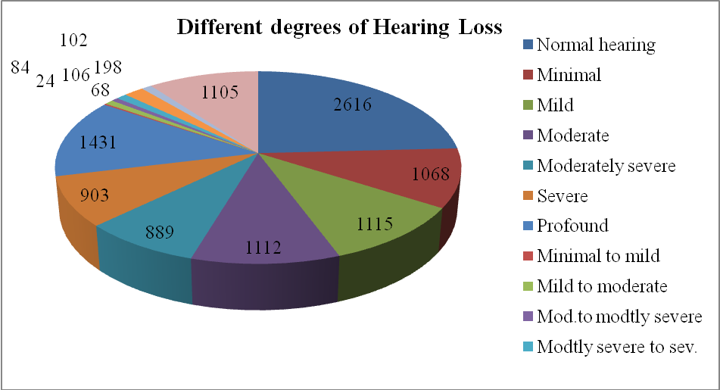

Hearing evaluation - age wise statistics

Hearing Evaluation-Males
Age | Apr. 18 | May | June | July | Aug. | Sep. | Oct. | Nov. | Dec. | Jan. 19 | Feb | Mar | Total
0-1 | 11 | 12 | 16 | 10 | 08 | 09 | 04 | 13 | 19 | 14 | 11 | 09 | 136
2-5 | 97 | 66 | 64 | 78 | 64 | 82 | 67 | 47 | 85 | 66 | 87 | 63 | 866
6-10 | 43 | 46 | 51 | 41 | 43 | 52 | 38 | 31 | 44 | 39 | 55 | 32 | 515
11-15 | 28 | 47 | 69 | 43 | 32 | 31 | 25 | 23 | 30 | 42 | 18 | 19 | 407
16-20 | 37 | 29 | 54 | 46 | 38 | 31 | 22 | 28 | 28 | 24 | 25 | 34 | 396
21-25 | 48 | 21 | 52 | 40 | 19 | 39 | 21 | 23 | 28 | 31 | 42 | 37 | 401
26-30 | 37 | 31 | 47 | 30 | 27 | 29 | 35 | 23 | 36 | 39 | 38 | 45 | 417
31-35 | 37 | 30 | 35 | 40 | 21 | 36 | 29 | 31 | 32 | 46 | 42 | 45 | 424
36-40 | 33 | 22 | 54 | 32 | 19 | 30 | 29 | 21 | 43 | 29 | 37 | 29 | 378
41-45 | 35 | 31 | 32 | 35 | 34 | 25 | 36 | 27 | 43 | 32 | 45 | 37 | 412
46-50 | 34 | 31 | 40 | 40 | 23 | 41 | 22 | 33 | 37 | 42 | 40 | 34 | 417
51-55 | 44 | 44 | 45 | 45 | 22 | 43 | 34 | 30 | 46 | 51 | 38 | 38 | 480
56-60 | 10 | 30 | 58 | 59 | 27 | 52 | 29 | 34 | 37 | 58 | 30 | 44 | 468
61-65 | 60 | 44 | 66 | 48 | 46 | 45 | 48 | 44 | 52 | 46 | 59 | 39 | 597
66-70 | 55 | 42 | 52 | 60 | 49 | 69 | 51 | 47 | 60 | 56 | 54 | 59 | 654
71-75 | 45 | 39 | 50 | 46 | 38 | 47 | 39 | 26 | 50 | 59 | 48 | 43 | 530
76-80 | 25 | 31 | 28 | 33 | 24 | 23 | 26 | 38 | 47 | 36 | 38 | 23 | 372
81-85 | 16 | 11 | 15 | 19 | 15 | 13 | 17 | 13 | 16 | 14 | 16 | 23 | 188
86-90 | 6 | 03 | 06 | 12 | 02 | 07 | 07 | 6 | 03 | 09 | 05 | 04 | 70
91+ | 3 | 01 | 00 | 04 | 01 | 03 | 04 | 5 | 05 | 01 | 01 | 03 | 31
Total | 704 | 611 | 834 | 761 | 552 | 707 | 583 | 543 | 741 | 734 | 729 | 660 | 8159

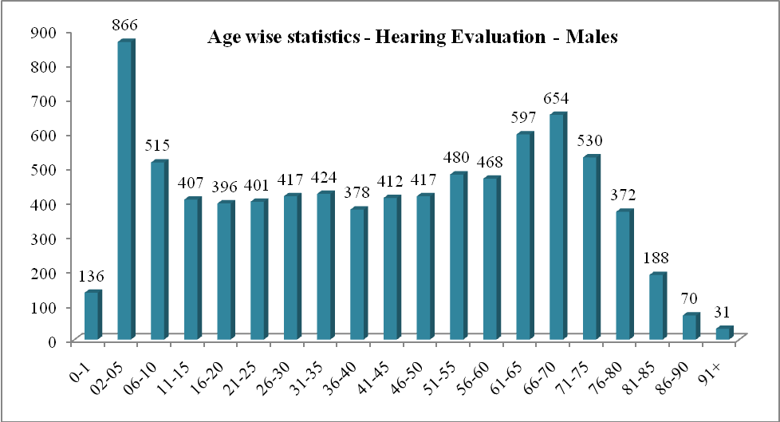
Hearing Evaluation - Females
Age | Apr | May | June | July | Aug | Sept. | Oct. | Nov | Dec | Jan. 19 | Feb. | Mar. | Total
0-1 | 10 | 09 | 06 | 05 | 03 | 06 | 04 | 12 | 15 | 09 | 12 | 10 | 101
2-5 | 68 | 39 | 53 | 51 | 40 | 61 | 44 | 31 | 65 | 65 | 66 | 60 | 643
6-10 | 36 | 27 | 30 | 32 | 23 | 26 | 29 | 18 | 26 | 31 | 62 | 20 | 360
11-15 | 12 | 28 | 25 | 31 | 21 | 15 | 19 | 8 | 19 | 49 | 21 | 11 | 259
16-20 | 17 | 18 | 47 | 35 | 25 | 11 | 20 | 13 | 11 | 16 | 24 | 18 | 255
21-25 | 23 | 13 | 23 | 21 | 09 | 21 | 21 | 23 | 19 | 17 | 30 | 18 | 238
26-30 | 36 | 29 | 45 | 24 | 23 | 21 | 20 | 23 | 27 | 35 | 27 | 22 | 332
31-35 | 27 | 24 | 36 | 25 | 13 | 23 | 20 | 22 | 30 | 22 | 26 | 09 | 277
36-40 | 39 | 35 | 48 | 33 | 24 | 32 | 20 | 27 | 36 | 33 | 33 | 29 | 389
41-45 | 26 | 28 | 33 | 29 | 19 | 25 | 30 | 16 | 32 | 28 | 24 | 32 | 322
46-50 | 29 | 24 | 32 | 24 | 19 | 33 | 27 | 52 | 39 | 28 | 33 | 20 | 360
51-55 | 28 | 34 | 37 | 25 | 09 | 27 | 26 | 21 | 23 | 33 | 42 | 24 | 329
56-60 | 34 | 26 | 38 | 37 | 24 | 36 | 28 | 39 | 34 | 39 | 33 | 32 | 400
61-65 | 31 | 19 | 34 | 36 | 22 | 33 | 28 | 21 | 35 | 33 | 38 | 24 | 354
66-70 | 32 | 32 | 34 | 24 | 19 | 26 | 16 | 21 | 23 | 23 | 29 | 26 | 305
71-75 | 21 | 32 | 22 | 21 | 10 | 24 | 29 | 5 | 17 | 20 | 17 | 19 | 237
76-80 | 13 | 08 | 15 | 10 | 05 | 11 | 09 | 5 | 10 | 15 | 11 | 13 | 125
81-85 | 04 | 06 | 05 | 09 | 05 | 06 | 06 | 1 | 05 | 04 | 05 | 06 | 62
86-90 | 01 | 02 | 01 | 02 | 00 | 0 | 02 | 1 | 01 | 01 | 01 | 03 | 15
91+ | 01 | 01 | 00 | 00 | 00 | 0 | 00 | 0 | 00 | 01 | 00 | 00 | 03
Total | 488 | 434 | 564 | 474 | 313 | 437 | 398 | 359 | 467 | 502 | 534 | 396 | 5366

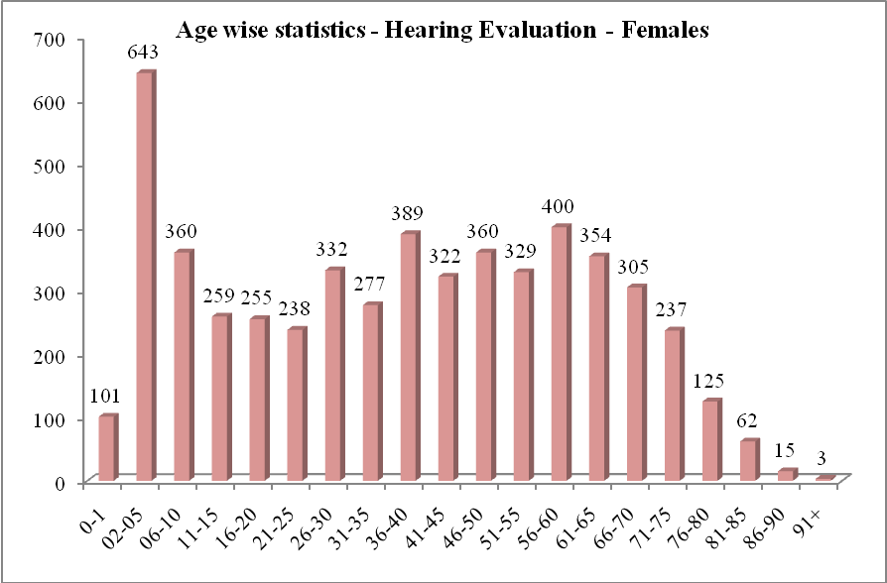
- Hearing Aid Trial: The department is well equipped with real time analyzers, which enables the audiologist to carryout measurement of electro-acoustic characteristics of hearing aids. The measurement has helped in the certification of new trial hearing aids. This provides information on whether a hearing aid procured or received meets standard specifications or not. Measurement of electro-acoustic characteristics of hearing aids was carried-out. Rehabilitation through amplification devices is one of the major activities of the department. The availability of the state-of-art equipment has made it possible to refer clients as young as two years for cochlear implant. The programming of the cochlear implants is being carried out for clients. This device has revolutionized rehabilitation to move ‘deaf’ children to ‘hearing’ zone. The details of no. of clients who have availed different rehabilitative facilities are mentioned below:-
Hearing Aid Trial | Apr.18 | May | Jun | Jul. | Aug. | Sep. | Oct. | Nov. | Dec. | Jan.19 | Feb. | Mar | Total
No. of clients seen for HAT | 601 | 518 | 628 | 620 | 472 | 623 | 542 | 510 | 587 | 537 | 539 | 491 | 6668
HAs prescribed at AIISH | 495 | 417 | 534 | 500 | 421 | 462 | 403 | 412 | 462 | 408 | 381 | 396 | 5291
. Body level hearing aids | 48 | 61 | 56 | 28 | 37 | 39 | 37 | 33 | 33 | 39 | 30 | 18 | 459
· Analogue BTE | 9 | 00 | 00 | 16 | 38 | 00 | 00 | 56 | 61 | 64 | 14 | 00 | 258
· Digital BTE | 378 | 294 | 395 | 385 | 291 | 376 | 296 | 276 | 319 | 244 | 287 | 317 | 3858
· Trimmer Digital BTE | 0 | 02 | 00 | 02 | 00 | 00 | 02 | 00 | 00 | 00 | 03 | 02 | 11
. Mini BTE | 13 | 06 | 11 | 14 | 11 | 06 | 02 | 03 | 00 | 00 | 00 | 00 | 66
· Digital ITE | 0 | 00 | 00 | 00 | 00 | 00 | 00 | 00 | 00 | 00 | 00 | 00 | 0
· Digital ITC | 3 | 00 | 04 | 04 | 02 | 04 | 04 | 02 | 02 | 01 | 02 | 01 | 29
· Digital CIC | 1 | 07 | 07 | 02 | 00 | 07 | 07 | 01 | 04 | 04 | 04 | 02 | 46
. Digital RIC | 41 | 47 | 61 | 49 | 41 | 30 | 60 | 38 | 40 | 54 | 41 | 56 | 558
Testing for CI candidacy | 3 | 04 | 02 | 08 | 02 | 02 | 02 | 03 | 07 | 01 | 01 | 02 | 37
No. of clients recommended
Auditory training | 82 | 65 | 109 | 149 | 126 | 116 | 117 | 100 | 102 | 104 | 94 | 88 | 1252
Speechreading | 7 | 04 | 06 | 07 | 10 | 05 | 04 | 07 | 03 | 08 | 11 | 06 | 78
HA prescribed on exchange | 0 | 00 | 00 | 02 | 00 | 00 | 00 | 00 | 01 | 00 | 00 | 00 | 3
Unaided/aided audiograms | 89 | 90 | 121 | 107 | 74 | 78 | 87 | 69 | 75 | 92 | 94 | 85 | 1061
Aided audiogram for CI | 20 | 22 | 25 | 27 | 15 | 17 | 04 | 16 | 10 | 20 | 13 | 15 | 204
BOA | 5 | 11 | 18 | 09 | 06 | 14 | 11 | 08 | 02 | 01 | 09 | 05 | 99
Aided VRA | 8 | 06 | 08 | 10 | 06 | 09 | 08 | 08 | 02 | 03 | 12 | 16 | 96
Conditioning | 115 | 108 | 129 | 134 | 104 | 111 | 93 | 79 | 82 | 96 | 94 | 82 | 1227
Programming of digital HA | 263 | 226 | 316 | 301 | 237 | 283 | 224 | 230 | 289 | 239 | 251 | 235 | 3094
Reprogramming of HA | 00 | 00 | 0 | 129 | 94 | 130 | 109 | 104 | 127 | 88 | 110 | 126 | 1017
No. of IGO done | 0 | 104 | 121 | 00 | 01 | 00 | 00 | 00 | 0 | 00 | 00 | 00 | 226
EAC of hearing aids done | 5 | 00 | 00 | 06 | 05 | 10 | 06 | 10 | 04 | 07 | 02 | 01 | 56
Retrial with CEM | 69 | 13 | 12 | 41 | 30 | 27 | 27 | 29 | 21 | 43 | 45 | 24 | 381
Recommended for ear plugs | 2 | 46 | 74 | 01 | 00 | 00 | 00 | 00 | 01 | 00 | 00 | 00 | 124
Unaided & aided LLR done | 0 | 00 | 00 | 00 | 00 | 00 | 00 | 00 | 00 | 00 | 00 | 00 | 00
Rec. for CI candidacy | 11 | 00 | 00 | 13 | 08 | 14 | 14 | 15 | 10 | 08 | 14 | 06 | 113
 |  |  |  |  |  |  |  |  |  |  |  |  | 26312
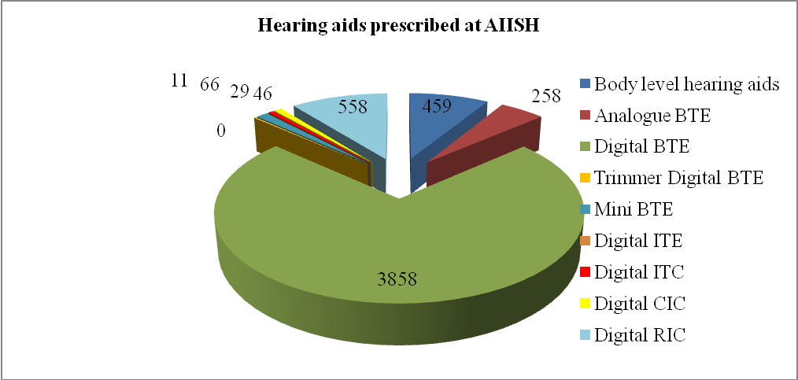

Age wise statistics
Hearing Aid Trial-Males
Age | Apr.18 | May | June | July | Aug. | Sep. | Oct. | Nov. | Dec. | Jan. 19 | Feb. | Mar. | Total
0-1 | 2 | 02 | 06 | 06 | 02 | 04 | 1 | 4 | 00 | 00 | 00 | 01 | 28
2-5 | 91 | 73 | 87 | 87 | 62 | 63 | 75 | 66 | 65 | 67 | 61 | 52 | 849
6-10 | 26 | 32 | 37 | 37 | 44 | 27 | 25 | 24 | 28 | 27 | 23 | 15 | 345
11-15 | 14 | 25 | 27 | 27 | 24 | 16 | 13 | 12 | 08 | 14 | 07 | 04 | 191
16-20 | 9 | 12 | 06 | 06 | 07 | 06 | 02 | 7 | 11 | 03 | 03 | 05 | 77
21-25 | 8 | 04 | 09 | 09 | 08 | 05 | 02 | 4 | 04 | 07 | 05 | 04 | 69
26-30 | 4 | 02 | 05 | 05 | 04 | 04 | 06 | 2 | 04 | 02 | 02 | 05 | 45
31-35 | 8 | 03 | 04 | 04 | 03 | 05 | 01 | 4 | 04 | 03 | 06 | 09 | 54
36-40 | 2 | 01 | 07 | 07 | 01 | 04 | 04 | 3 | 04 | 02 | 03 | 03 | 41
41-45 | 7 | 09 | 05 | 05 | 05 | 13 | 05 | 6 | 09 | 09 | 10 | 09 | 92
46-50 | 20 | 04 | 08 | 08 | 07 | 08 | 05 | 8 | 05 | 07 | 05 | 08 | 93
51-55 | 12 | 14 | 19 | 19 | 07 | 34 | 16 | 15 | 17 | 22 | 20 | 16 | 211
56-60 | 24 | 17 | 29 | 29 | 13 | 32 | 15 | 18 | 23 | 31 | 13 | 23 | 267
61-65 | 38 | 37 | 29 | 29 | 23 | 40 | 38 | 29 | 43 | 27 | 39 | 23 | 395
66-70 | 40 | 32 | 28 | 28 | 30 | 50 | 43 | 27 | 45 | 34 | 42 | 41 | 440
71-75 | 28 | 28 | 32 | 32 | 38 | 41 | 49 | 29 | 48 | 44 | 35 | 34 | 438
76-80 | 18 | 20 | 26 | 26 | 25 | 35 | 27 | 37 | 52 | 40 | 33 | 32 | 371
81-85 | 12 | 08 | 18 | 18 | 16 | 15 | 18 | 11 | 15 | 09 | 10 | 14 | 164
86-90 | 9 | 04 | 04 | 04 | 03 | 05 | 06 | 9 | 07 | 10 | 06 | 03 | 70
91+ | 0 | 00 | 02 | 02 | 00 | 02 | 05 | 3 | 04 | 01 | 00 | 03 | 22
Total | 372 | 327 | 388 | 388 | 322 | 409 | 356 | 318 | 396 | 359 | 323 | 304 | 4262

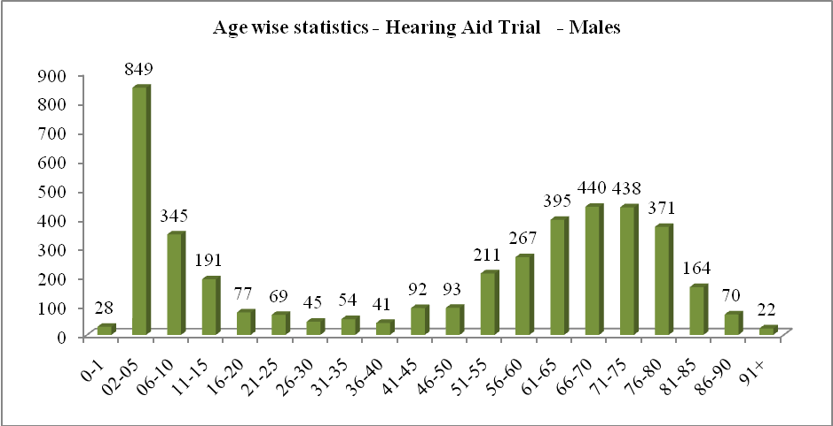

Hearing Aid Trial-Females
Age | Apr | May | Jun | Jul | Aug | Sep | Oct | Nov | Dec | Jan | Feb | Mar | Total
0-1 | 1 | 02 | 02 | 01 | 01 | 01 | 01 | 1 | 01 | 00 | 01 | 00 | 12
2-5 | 63 | 44 | 54 | 67 | 48 | 51 | 44 | 57 | 47 | 39 | 53 | 31 | 598
6-10 | 32 | 26 | 30 | 34 | 17 | 22 | 22 | 20 | 16 | 17 | 19 | 15 | 270
11-15 | 7 | 10 | 14 | 17 | 07 | 08 | 10 | 9 | 07 | 07 | 04 | 04 | 104
16-20 | 2 | 05 | 14 | 07 | 05 | 02 | 03 | 3 | 02 | 03 | 05 | 01 | 52
21-25 | 1 | 04 | 04 | 04 | 00 | 05 | 03 | 1 | 01 | 04 | 06 | 04 | 37
26-30 | 7 | 04 | 02 | 02 | 00 | 01 | 02 | 0 | 02 | 01 | 01 | 07 | 29
31-35 | 5 | 04 | 02 | 00 | 03 | 01 | 02 | 2 | 00 | 02 | 02 | 01 | 24
36-40 | 4 | 09 | 09 | 03 | 01 | 02 | 04 | 3 | 07 | 03 | 03 | 04 | 52
41-45 | 7 | 04 | 05 | 03 | 04 | 04 | 01 | 2 | 06 | 06 | 05 | 03 | 50
46-50 | 8 | 05 | 05 | 03 | 03 | 04 | 04 | 3 | 07 | 08 | 08 | 07 | 65
51-55 | 11 | 09 | 13 | 11 | 02 | 09 | 07 | 10 | 18 | 16 | 11 | 15 | 132
56-60 | 10 | 10 | 21 | 13 | 12 | 16 | 19 | 16 | 11 | 12 | 12 | 19 | 171
61-65 | 14 | 11 | 11 | 16 | 14 | 24 | 16 | 12 | 21 | 11 | 20 | 20 | 190
66-70 | 17 | 20 | 16 | 15 | 12 | 21 | 15 | 18 | 14 | 17 | 28 | 24 | 217
71-75 | 20 | 15 | 13 | 18 | 10 | 26 | 21 | 17 | 15 | 15 | 18 | 14 | 202
76-80 | 13 | 05 | 16 | 11 | 05 | 11 | 06 | 9 | 09 | 09 | 15 | 15 | 124
81-85 | 5 | 04 | 08 | 06 | 07 | 05 | 05 | 8 | 06 | 04 | 04 | 02 | 64
86-90 | 2 | 00 | 01 | 01 | 00 | 01 | 01 | 1 | 1 | 03 | 00 | 01 | 12
91+ | 0 | 00 | 00 | 00 | 00 | 00 | 00 | 0 | 00 | 01 | 01 | 00 | 2
Total | 229 | 191 | 240 | 232 | 151 | 214 | 186 | 192 | 191 | 178 | 216 | 187 | 2407

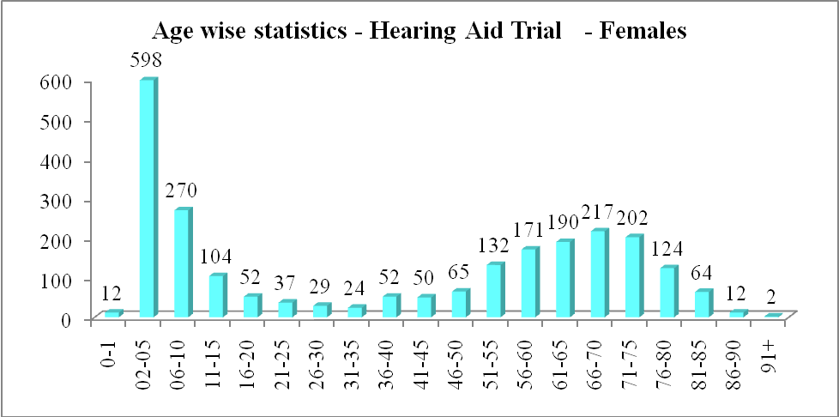

- Earmold: Ear moulds are designed to conduct the amplified sounds from the hearing aids into the ear canal and to the tympanic membrane. A well-fitting ear mould is as important as a hearing aid. Ear moulds provide a snug fit and holds the hearing aid in position. Custom ear moulds are essential to get maximum benefit from the hearing aid. In addition, acoustic modifications are done in the custom ear moulds to optimize the hearing aid benefit and also to overcome certain problems such as tolerance problem, occlusion problem encountered in the clients. Custom ear moulds, hard and soft ear moulds are made for clients who were prescribed and issued hearing aids. Ear mould making facilities is made available across the country with the implementation of Central Prosthetic Lab. The central prosthetic lab had received ear impressions from different states to be processed as ear molds. The details of activities carried-out in the ear mould lab at AIISH and the ear moulds processed at camps are given below

Earmold lab |  | Apr |  | May |  |  | Jun |  | Jul |  | Aug |  | Sep |  | Oct |  | Nov |  | Dec |  | Jan |  | Feb |  | Mar |  | Total
Clients attended |  | 445 |  | 649 |  |  | 610 |  | 512 |  | 416 |  | 481 |  | 551 |  | 328 |  | 241 |  | 375 |  | 452 |  | 415 |  | 5475
New clients |  | 145 |  | 199 |  |  | 240 |  | 215 |  | 142 |  | 221 |  | 175 |  | 120 |  | 90 |  | 155 |  | 181 |  | 160 |  | 2043
Old clients |  | 300 |  | 450 |  |  | 370 |  | 381 |  | 274 |  | 260 |  | 376 |  | 208 |  | 151 |  | 220 |  | 271 |  | 255 |  | 3516
At Camp |  | 00 |  | 00 |  |  | 00 |  | 67 |  | 00 |  | 00 |  | 00 |  | 00 |  | 00 |  | 00 |  | 73 |  | 00 |  | 140
Ear impressions taken |  | 706 |  | 1121 |  |  | 1035 |  | 1024 |  | 669 |  | 701 |  | 338 |  | 00 |  | 00 |  | 00 |  | 00 |  | 00 |  | 5256
Free-of-cost |  | 229 |  | 361 |  |  | 338 |  | 325 |  | 218 |  | 178 |  | 578 |  | 145 |  | 89 |  | 217 |  | 00 |  | 171 |  | 2849
100% payment |  | 475 |  | 759 |  |  | 697 |  | 629 |  | 451 |  | 523 |  | 0 |  | 381 |  | 248 |  | 419 |  | 610 |  | 521 |  | 5713
Ear imprn taken-camp |  | 0 |  | 0 |  |  | 0 |  | 70 |  | 0 |  | 0 |  | 0 |  | 0 |  | 0 |  | 00 |  | 146 |  | 0 |  | 216
CPL impressions |  | 2 |  | 1 |  |  | 0 |  | 0l |  | 0 |  | 0 |  | 338 |  | 2 |  | 0 |  | 00 |  | 00 |  | 0 |  | 340
EMs completed |  | 710 |  | 1000 |  |  | 1100 |  | 1009 |  | 652 |  | 689 |  | 908 |  | 523 |  | 329 |  | 600 |  | 200 |  | 300 |  | 8020
No. Mould Lacquered |  | 161 |  | 289 |  |  | 241 |  | 254 |  | 149 |  | 0 |  | 251 |  | 96 |  | 62 |  | 82 |  | 55 |  | 140 |  | 1780
No. of sound tube issued |  | 132 |  | 191 |  |  | 151 |  | 156 |  | 0 |  | 51 |  | 130 |  | 510 |  |  |  | 103 |  | 115 |  | 159 |  | 1698
Hard regular moulds |  | 32 |  | 72 |  |  | 87 |  | 61 |  | 41 |  | 6 |  | 69 |  | 45 |  | 54 |  | 68 |  | 82 |  | 25 |  | 642
Hard shell mould made |  | 7 |  | 9 |  |  | 4 |  | 02 |  | 1 |  | 390 |  | 8 |  | 0 |  | 5 |  | 07 |  | 00 |  | 03 |  | 436
Soft mould made |  | 344 |  | 518 |  |  | 519 |  | 451 |  | 331 |  | 0 |  | 420 |  | 290 |  | 163 |  | 345 |  | 488 |  | 343 |  | 4212
Hard canal moulds |  | 0 |  | 0 |  |  | 0 |  | 0 |  | 0 |  | 1 |  | 0 |  | 0 |  | 0 |  | 00 |  | 00 |  | 00 |  | 1
Soft canal moulds |  | 0 |  | 5 |  |  | 7 |  | 6 |  | 4 |  | 4 |  | 10 |  | 3 |  | 9 |  | 05 |  | 01 |  | 04 |  | 58
Instant moulds |  |  |  | 4 |  |  | 4 |  | 2 |  | 1 |  | 12 |  | 4 |  | 0 |  | 1 |  | 02 |  | 00 |  | 00 |  | 30
ITC impression made |  | 2 |  | 22 |  |  | 8 |  | 10 |  | 7 |  | 7 |  | 4 |  | 3 |  | 9 |  | 12 |  | 06 |  | 09 |  | 99
Swimmer plug (soft) |  | 14 |  |  |  |  | 10 |  | 5 |  | 4 |  | 0 |  | 6 |  | 15 |  | 9 |  | 02 |  | 03 |  | 03 |  | 71
Swimmer plug (hard) |  | 0 |  | 7 |  |  | 0 |  | 0 |  | 0 |  | 7 |  | 0 |  | 0 |  | 0 |  | 00 |  | 00 |  | 00 |  | 14
No. of ear blocked |  | 8 |  | 0 |  |  | 4 |  | 7 |  | 8 |  | 112 |  | 14 |  | 4 |  | 0 |  | 09 |  | 06 |  | 06 |  | 178
EMs with aco. modificns. |  | 0 |  | 3 |  |  | 0 |  | 0 |  | 1 |  | 110 |  | 251 |  | 69 |  | 61 |  | 61 |  | 115 |  | 00 |  | 671
CPL moulds completed |  | 2 |  | 0 |  |  | 00 |  | 0 |  | 0 |  | 1 |  | 0 |  | 1 |  | 0 |  | 00 |  | 01 |  | 00 |  | 5
No. of students posted |  | 00 |  | 00 |  |  | 00 |  | 00 |  | 30 |  | 09 |  | 35 |  | 21 |  | 00 |  | 00 |  | 39 |  | 41 |  | 175
State wise statistics |  | 00 |  | 00 |  |  | 00 |  | 00 |  | 00 |  | 00 |  | 00 |  | 00 |  | 00 |  | 00 |  | 00 |  | 00 |  | 00
a) Andhra Pradesh |  | 0 |  | 0 |  |  | 3 |  | 0 |  | 4 |  | 9 |  | 0 |  | 1 |  | 4 |  | 05 |  | 15 |  | 00 |  | 41
b) Karnataka |  | 371 |  | 617 |  |  | 544 |  | 484 |  | 381 |  | 382 |  | 504 |  | 271 |  | 303 |  | 303 |  | 317 |  | 396 |  | 4873
c) Kerala |  | 52 |  | 27 |  |  | 34 |  | 81 |  | 18 |  | 55 |  | 25 |  | 47 |  | 50 |  | 45 |  | 50 |  | 18 |  | 502
d) Tamil Nadu |  | 13 |  | 5 |  |  | 18 |  | 12 |  | 7 |  | 20 |  | 20 |  | 7 |  | 6 |  | 04 |  | 51 |  | 01 |  | 164
e) Telangana |  | 0 |  | 0 |  |  | 0 |  | 0 |  | 1 |  | 2 |  | 0 |  | 1 |  | 0 |  | 00 |  | 03 |  | 00 |  | 7
f) Others |  | 10 |  | 0 |  |  | 11 |  | 577 |  | 5 |  | 13 |  | 2 |  | 1 |  | 10 |  | 09 |  | 16 |  | 00 |  | 96
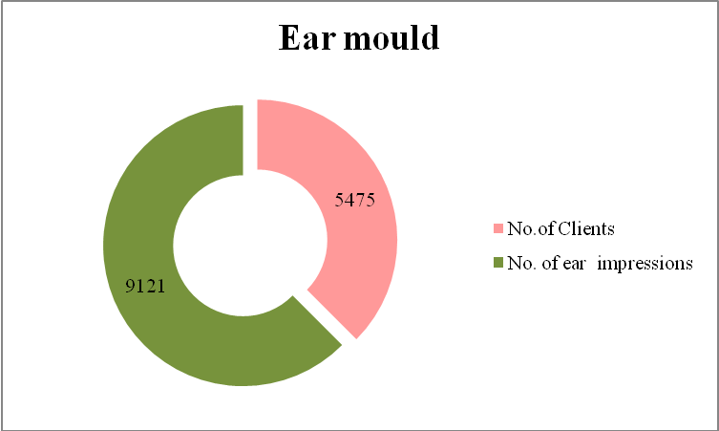
Age-Wise statistics

Ear moulds-Males
Age | Apr. |  | May |  | Jun | July |  | Aug |  | Sept. |  | Oct. |  | Nov. |  | Dec. |  | Jan. |  | Feb |  | Mar |  | Total
0-1 | 11 |  | 07 |  | 07 | 08 |  | 06 |  | 12 |  | 09 |  | 02 |  | 02 |  | 03 |  | 08 |  | 04 |  | 115
2-5 | 57 |  | 74 |  | 28 | 77 |  | 67 |  | 65 |  | 82 |  | 38 |  | 15 |  | 56 |  | 92 |  | 57 |  | 705
6-10 | 48 |  | 99 |  | 45 | 56 |  | 45 |  | 37 |  | 63 |  | 24 |  | 11 |  | 40 |  | 42 |  | 30 |  | 462
11-15 | 10 |  | 48 |  | 15 | 40 |  | 21 |  | 18 |  | 23 |  | 23 |  | 06 |  | 04 |  | 15 |  | 06 |  | 180
16-20 | 17 |  | 16 |  | 21 | 19 |  | 10 |  | 09 |  | 09 |  | 08 |  | 07 |  | 00 |  | 12 |  | 12 |  | 139
21-25 | 05 |  | 04 |  | 16 | 07 |  | 08 |  | 09 |  | 07 |  | 01 |  | 05 |  | 04 |  | 04 |  | 06 |  | 95
26-30 | 03 |  | 02 |  | 19 | 05 |  | 05 |  | 03 |  | 08 |  | 02 |  | 02 |  | 04 |  | 02 |  | 04 |  | 91
31-35 | 05 |  | 02 |  | 32 | 06 |  | 07 |  | 01 |  | 03 |  | 02 |  | 03 |  | 04 |  | 10 |  | 10 |  | 97
36-40 | 01 |  | 08 |  | 08 | 04 |  | 03 |  | 09 |  | 08 |  | 04 |  | 03 |  | 03 |  | 07 |  | 07 |  | 93
41-45 | 08 |  | 08 |  | 21 | 06 |  | 04 |  | 11 |  | 14 |  | 03 |  | 01 |  | 02 |  | 08 |  | 05 |  | 92
46-50 | 07 |  | 11 |  | 19 | 04 |  | 12 |  | 12 |  | 05 |  | 07 |  | 02 |  | 06 |  | 06 |  | 02 |  | 111
51-55 | 09 |  | 10 |  | 03 | 08 |  | 03 |  | 13 |  | 06 |  | 09 |  | 09 |  | 12 |  | 08 |  | 02 |  | 106
56-60 | 09 |  | 14 |  | 28 | 20 |  | 05 |  | 19 |  | 10 |  | 06 |  | 15 |  | 16 |  | 06 |  | 16 |  | 120
61-65 | 14 |  | 20 |  | 11 | 25 |  | 15 |  | 19 |  | 23 |  | 11 |  | 13 |  | 07 |  | 08 |  | 13 |  | 118
66-70 | 10 |  | 30 |  | 25 | 11 |  | 10 |  | 18 |  | 19 |  | 13 |  | 11 |  | 17 |  | 16 |  | 21 |  | 145
71-75 | 25 |  | 16 |  | 08 | 18 |  | 30 |  | 14 |  | 14 |  | 12 |  | 20 |  | 12 |  | 10 |  | 17 |  | 168
76-80 | 05 |  | 08 |  | 10 | 10 |  | 08 |  | 19 |  | 16 |  | 15 |  | 21 |  | 13 |  | 12 |  | 05 |  | 99
81-85 | 04 |  | 06 |  | 02 | 05 |  | 08 |  | 09 |  | 08 |  | 05 |  | 04 |  | 08 |  | 08 |  | 11 |  | 81
86-90 | 02 |  | 02 |  | 09 | 02 |  | 01 |  | 02 |  | 04 |  | 04 |  | 01 |  | 10 |  | 02 |  | 01 |  | 31
91+ | 00 |  | 00 |  | 01 | 01 |  | 00 |  | 00 |  | 01 |  | 00 |  | 01 |  | 01 |  | 00 |  | 01 |  | 06
Total | 250 |  | 385 |  | 328 | 332 |  | 268 |  | 299 |  | 332 |  | 189 |  | 152 |  | 222 |  | 08 |  | 230 |  | 3054

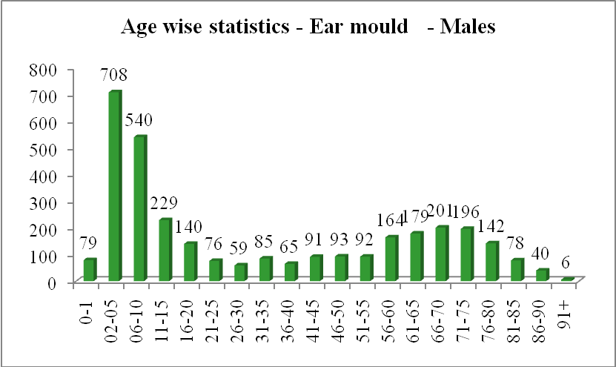

Ear moulds-Females
Age | Apr | May | June | July | Aug | Sep | Oct | Nov | Dec | Jan | Feb | Mar | Total
0-1 | 09 | 04 | 09 | 03 | 07 | 08 | 04 | 03 | 01 | 06 | 09 | 06 | 69
2-5 | 70 | 57 | 15 | 66 | 35 | 46 | 57 | 40 | 08 | 33 | 37 | 46 | 510
6-10 | 32 | 67 | 31 | 38 | 41 | 44 | 52 | 21 | 07 | 23 | 40 | 32 | 428
11-15 | 08 | 35 | 20 | 26 | 04 | 07 | 09 | 08 | 16 | 05 | 16 | 06 | 160
16-20 | 10 | 09 | 19 | 15 | 05 | 05 | 09 | 00 | 05 | 01 | 07 | 06 | 91
21-25 | 10 | 09 | 28 | 09 | 03 | 04 | 02 | 00 | 05 | 02 | 03 | 01 | 76
26-30 | 02 | 03 | 11 | 06 | 03 | 01 | 03 | 02 | 02 | 16 | 05 | 05 | 59
31-35 | 08 | 02 | 15 | 09 | 00 | 01 | 00 | 05 | 02 | 18 | 02 | 04 | 66
36-40 | 07 | 07 | 05 | 05 | 05 | 05 | 01 | 02 | 03 | 15 | 05 | 02 | 62
41-45 | 04 | 06 | 12 | 10 | 04 | 02 | 12 | 05 | 03 | 10 | 04 | 03 | 75
46-50 | 03 | 09 | 13 | 10 | 03 | 07 | 05 | 05 | 02 | 03 | 07 | 08 | 75
51-55 | 01 | 10 | 19 | 11 | 03 | 06 | 06 | 06 | 10 | 04 | 07 | 07 | 90
56-60 | 00 | 16 | 19 | 10 | 04 | 14 | 18 | 08 | 04 | 04 | 09 | 14 | 120
61-65 | 06 | 06 | 32 | 07 | 11 | 09 | 07 | 06 | 08 | 02 | 08 | 11 | 113
66-70 | 12 | 08 | 17 | 17 | 04 | 08 | 09 | 16 | 04 | 01 | 07 | 14 | 117
71-75 | 09 | 10 | 09 | 10 | 05 | 13 | 14 | 07 | 04 | 07 | 05 | 11 | 104
76-80 | 01 | 06 | 05 | 07 | 03 | 01 | 05 | 02 | 04 | 01 | 03 | 05 | 43
81-85 | 02 | 00 | 00 | 02 | 06 | 01 | 04 | 03 | 01 | 02 | 01 | 03 | 25
86-90 | 01 | 00 | 01 | 03 | 02 | 00 | 02 | 00 | 00 | 00 | 01 | 01 | 11
91+ | 00 | 00 | 02 | 00 | 00 | 00 | 00 | 00 | 00 | 00 | 00 | 00 | 02
Total | 195 | 264 | 282 | 264 | 148 | 182 | 219 | 139 | 89 | 153 | 176 | 185 | 2296

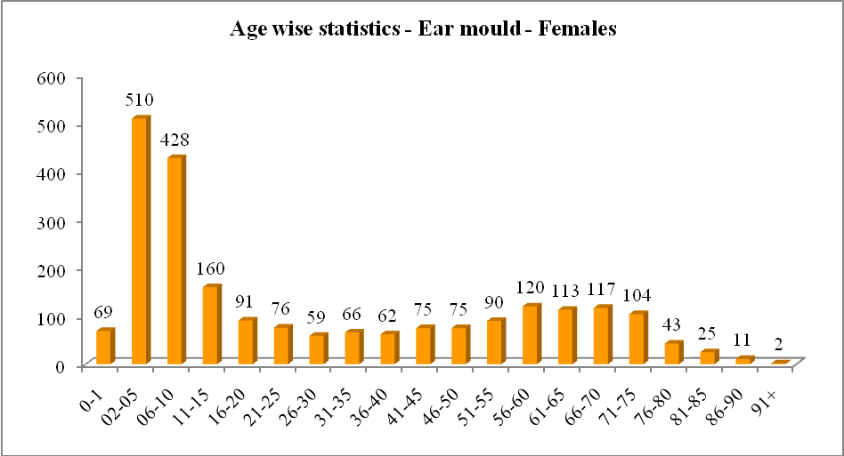v

Revenue generated (Ear mould) – in Rs.

Month | Spares | Post | Making ear moulds
April – 18 | 7845 | 455 | 103670
May | 10340 | 840 | 165890
June | 8380 | 990 | 163130
July | 9750 | 690 | 145710
August | 5675 | 240 | 100740
September | 6420 | 570 | 127170
October | 8365 | 600 | 132730
November | 4540 | 480 | 92970
December | 3890 | 330 | 50430
January 19 | 4570 | 630 | 105480
February | 8600 | 300 | 147645
March | 10040 | 390 | 103330
TOTAL | 88415 | 6515 | 1438895

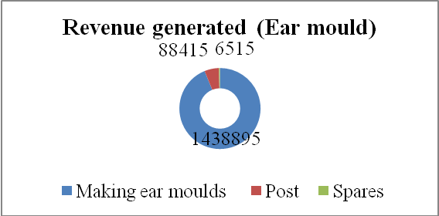

- Specialized Clinical Services

i) Listening Training Unit: Listening training unit (LTU) is committed to provide aural rehabilitation to the needy. The listening training is provided to not only the clients who use hearing devices such as hearing aids and cochlear implants but also to those with (Central) auditory processing disorders. In addition, training is also imparted to individuals suffering from tinnitus or hyperacusis. The training activity is mainly conducted by the student clinicians under the supervision of the staff. Some of the staff members are also directly involved in training of the clients fitted with cochlear implants. The details of the clients who have undergone listening training is provided in the table below:
Listening Training Unit
Listening Training Unit | Apr | May | Jun | July | Aug | Sep | Oct | Nov | Dec | Jan | Feb | Mar | Total
Clients seen | 257 | 59 | 202 | 270 | 268 | 279 | 298 | 231 | 265 | 271 | 305 | 293 | 2998
Sessions taken | 1051 | 329 | 852 | 1328 | 1066 | 1022 | 1013 | 896 | 915 | 1101 | 1420 | 1685 | 12678
Clients for whom demo therapy given | 46 | 19 | 22 | 23 | 15 | 14 | 24 | 22 | 25 | 16 | 19 | 15 | 260
New clients | 36 | 13 | 48 | 37 | 19 | 30 | 31 | 20 | 29 | 34 | 22 | 29 | 348
Repeat clients | 221 | 46 | 154 | 233 | 249 | 249 | 267 | 211 | 236 | 237 | 283 | 264 | 2650
Clients discharged | 24 | 01 | 08 | 11 | 11 | 09 | 08 | 09 | 14 | 08 | 09 | 10 | 122
Clients discontinued | 41 | 06 | 07 | 18 | 20 | 14 | 16 | 20 | 15 | 23 | 10 | 36 | 226
Pre-school sessions attended | 00 | 00 | 18 | 00 | 00 | 00 | 00 | 00 | 00 | 00 | 00 | 00 | 18
Clients given training in Hindi | 30 | 06 | 48 | 21 | 20 | 23 | 28 | 25 | 34 | 36 | 34 | 34 | 339
Clients with CI trained | 57 | 22 | 295 | 56 | 62 | 66 | 65 | 57 | 59 | 61 | 64 | 63 | 927
Sessions for clients with CI taken | 310 | 184 | 04 | 371 | 369 | 334 | 314 | 307 | 283 | 391 | 453 | 466 | 3786
Clients with tinnitus attended therapy | 08 | 00 | 07 | 13 | 10 | 03 | 06 | 02 | 00 | 00 | 04 | 08 | 61
Sessions for clients with tinnitus | 12 | 00 | 01 | 18 | 17 | 05 | 06 | 05 | 00 | 00 | 03 | 14 | 81
Clients with ANSD | 02 | 00 | 07 | 01 | 01 | 00 | 00 | 02 | 00 | 00 | 00 | 00 | 13
Sessions for clients with ANSD | 08 | 00 | 00 | 06 | 08 | 00 | 00 | 06 | 00 | 00 | 00 | 00 | 28
Clients with hyperacusis | 00 | 00 | 00 | 00 | 00 | 00 | 00 | 00 | 00 | 01 | 00 | 00 | 01
Clients with CAPD | 00 | 00 | 00 | 00 | 00 | 00 | 00 | 00 | 00 | 04 | 00 | 00 | 04
Sesseions dor clientswith CAPD | 00 | 00 | 00 | 00 | 00 | 00 | 00 | 00 | 00 | 00 | 00 | 00 | 00
Clients for speech reading | 00 | 00 | 00 | 00 | 00 | 00 | 101 | 00 | 00 | 00 | 00 | 00 | 101
Clients for observn for session HA fitting | 00 | 70 | 202 | 00 | 00 | 00 | 28 | 00 | 00 | 00 | 00 | 00 | 300
Total no. ofStudents posted | 00 | 00 | 00 | 98 | 118 | 88 | 65 | 85 | 152 | 131 | 137 | 07 | 881

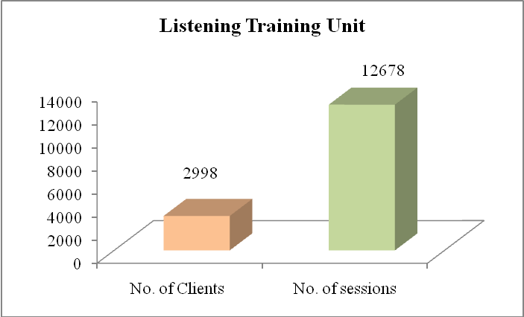

- Implantable Hearing Device Unit: The activities of this unit include selection of candidates, mapping/ programming, trouble shooting of implantable hearing devices such as cochlear implant, bone-anchored hearing aids and middle ear implants. Rehabilitation of individuals using such devices is also undertaken.

Implantable Hg. Devices Unit
 | Apr | May | Jun | Jul | Aug | Sep | Oct | Nov | Dec | Jan | Feb | Mar | Total
No. of cases seen | 28 | 35 | 36 | 32 | 21 | 22 | 17 | 21 | 21 | 24 | 19 | 26 | 302
a) Non-ADIP | 02 | 17 | 17 | 11 | 09 | 06 | 03 | 03 | 05 | 04 | 03 | 05 | 85
b) ADIP-CI | 09 | 06 | 05 | 05 | 02 | 05 | 01 | 03 | 03 | 04 | 01 | 05 | 49
c) RBSK-SAST | 17 | 12 | 14 | 16 | 10 | 11 | 13 | 15 | 13 | 10 | 15 | 16 | 162
No. of switch on | 08 | 02 | 01 | 01 | 01 | 04 | 00 | 07 | 02 | 02 | 0 | 02 | 30
a) Non-ADIP | 00 | 00 | 00 | 00 | 00 | 00 | 00 | 00 | 00 | 00 | 0 | 01 | 01
b) ADIP-CI | 01 | 00 | 01 | 00 | 01 | 00 | 00 | 00 | 00 | 01 | 0 | 01 | 5
c) RBSK-SAST | 07 | 02 | 01 | 01 | 00 | 04 | 00 | 07 | 02 | 01 | 0 | 00 | 25
No. of sessions | 37 | 44 | 40 | 36 | 23 | 22 | 18 | 23 | 29 | 26 | 20 | 28 | 346
a) Non-ADIP | 02 | 19 | 17 | 14 | 09 | 06 | .03 | 03 | 05 | 04 | 04 | 06 | 89.03
b) ADIP-CI | 13 | 06 | 05 | 05 | 03 | 05 | 01 | 03 | 03 | 05 | 01 | 06 | 56
c) RBSK-SAST | 22 | 19 | 18 | 17 | 11 | 11 | 14 | 17 | 21 | 17 | 15 | 16 | 198
Mapping for CI | 33 | 41 | 33 | 11 | 14 | 23 | 17 | 19 | 17 | 22 | 16 | 25 | 271
a) Non-ADIP | 01 | 17 | 13 | 02 | 05 | 03 | 02 | 02 | 01 | 04 | 02 | 04 | 56
b) ADIP-CI | 11 | 06 | 05 | 16 | 02 | 05 | 01 | 02 | 00 | 04 | 01 | 06 | 59
c) RBSK-SAST | 21 | 18 | 15 | 07 | 07 | 11 | 14 | 15 | 16 | 14 | 13 | 16 | 167
Troubleshooting CI devices | 04 | 03 | 07 | 03 | 14 | 06 | 01 | 03 | 12 | 05 | 04 | 28 | 90
a) Non-ADIP | 01 | 02 | 04 | 03 | 04 | 03 | 01 | 01 | 04 | 00 | 02 | 06 | 31
b) ADIP-CI | 02 | 00 | 00 | 01 | 01 | 01 | 00 | 01 | 03 | 01 | 02 | 06 | 18
c) RBSK-SAST | 01 | 01 | 03 | 36 | 09 | 02 | 00 | 01 | 05 | 04 | 00 | 16 | 78
Counselling for CI clients | 37 | 38 | 40 | 14 | 23 | 29 | 18 | 23 | 29 | 26 | 20 | 20 | 317
- Non-ADIP | 02 | 19 | 17 | 05 | 09 | 06 | 03 | 03 | 05 | 04 | 04 | 04 | 81
- ADIP-CI | 13 | 06 | 05 | 17 | 03 | 06 | 01 | 03 | 03 | 05 | 01 | 01 | 64
- RBSK-SAST | 22 | 19 | 18 | 04 | 11 | 17 | 14 | 17 | 21 | 17 | 15 | 15 | 190

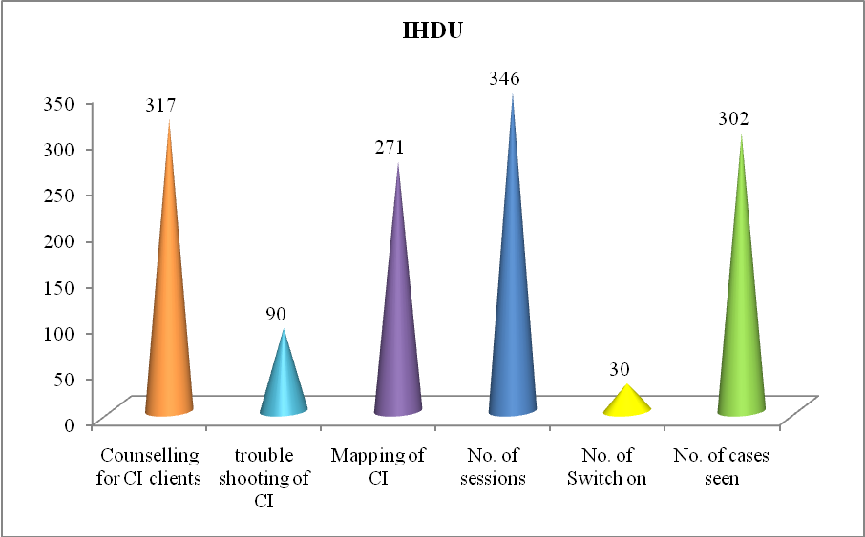

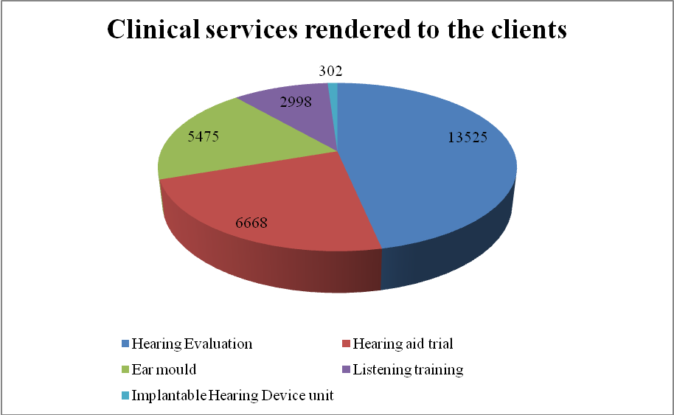

Official Lang. Implementation
 | Apr | May | Jun | Jul | Aug | Sep | Oct | Nov | Dec | Jan | Feb | Mar | Total
Clients given training in Hindi LTU | 68 |  |  | 64 |  |  | 78 |  |  | 60 |  |  | 270
Correspondance through mail | 2049 |  |  | 3013 |  |  | 2303 |  |  | 2105 |  |  | 9470
Correspondance through letters | 498 |  |  | 112 |  |  | 168 |  |  | 91 |  |  | 869
Certificates issued | 498 |  |  | 498 |  |  | 449 |  |  | 580 |  |  | 2025
Others (formats/labels) | 95 |  |  |  |  |  |  |  |  |  |  |  | 95
TOTAL |  |  |  |  |  |  |  |  |  |  |  |  | 12729

- Clinical Support Services/ नैदानिक ​​समर्थनसेवाएं
Certificates Issued

Certificate issued | April | May | June | July | Aug | Sept | Oct | Nov. | Dec. | Jan | Feb | Mar | Total
Financial aid (pension of GOK) | 113 | 97 | 175 | 169 | 83 | 91 | 75 | 88 | 122 | 125 | 160 | 122 | 1420
Admission to regular school | 00 | 00 | 00 | 00 | 00 | 00 | 00 | 00 | 00 | 00 | 08 | 04 | 12
Admission to deaf school | 00 | 01 | 01 | 01 | 00 | 00 | 01 | 00 | 00 | 00 | 01 | 00 | 05
Physically handicapped | 00 | 07 | 01 | 03 | 01 | 03 | 04 | 02 | 02 | 14 | 07 | 14 | 58
Tax exemption | 00 | 02 | 04 | 01 | 03 | 01 | 01 | 01 | 04 | 01 | 01 | 03 | 22
Education scholarship | 00 | 00 | 01 | 03 | 02 | 00 | 00 | 00 | 00 | 01 | 00 | 00 | 07
Driving licence | 02 | 01 | 01 | 01 | 00 | 00 | 00 | 00 | 00 | 01 | 00 | 00 | 06
LIC | 00 | 00 | 00 | 00 | 02 | 00 | 00 | 01 | 00 | 00 | 00 | 00 | 03
CI | 14 | 09 | 06 | 08 | 31 | 06 | 04 | 07 | 00 | 10 | 15 | 04 | 114
Estimation certificate for hearing aids | 29 | 14 | 41 | 36 | 31 | 24 | 20 | 13 | 06 | 39 | 30 | 36 | 319
Reimbursement letters | 01 | 01 | 00 | 00 | 00 | 01 | 00 | 00 | 21 | 00 | 00 | 02 | 26
Certificate issued at camp | 00 | 00 | 00 | 00 | 00 | 00 | 00 | 00 | 00 | 00 | 00 | 00 | 00
Total | 159 | 132 | 230 | 222 | 153 | 126 | 105 | 112 | 155 | 191 | 222 | 185 | 1992

IV. EXTENSION ACTIVITIES

Communication Disorders Screening Camps (Details such as venue, staff deputed, No. of clients seen, Assessment & Rehabilitation Details)

Sl.No. | Date | Camp | Staff Deputed | No. of Cases seen | No. of impressions taken
1 | 28.06.18. | camp organized at Hospet | Mr. Darga Baba, Mr. Sanjeev M.R., Mr. Sudarshan | 140 | 70
2 | 11.02.19 to 24.02.19 | Camp at Andaman and Nicobar | Dr. Sreeraj, Dr. Prashanth Prabu and Mr. Vivek |  | 146

V. TECHNOLOGICAL CONSULTANCY SERVICES/तकनीकीपरामर्शसेवाएं :

- Dr. Rajalakshmi K Proof read, corrected and wrote foreward in Kannada for theBrochure on Cochlear Implants prepared by Vaghdevi School, Bengaluru.

VI. Central facilities – Nil
VII. Placement Cell Activities – Nil
VIII. Awards and Honors
Academic
Sl. No. | Name | Paper/Name of the award | Venue | Date
1 | Jithin Raj Balan, Sandeep Maruthy (2018). | Best paper award “The effect of acoustic-enhancement on audio-visual perception in individuals with auditory neuropathy spectrum disorder”s | KSB, , Kerala, Munnar | 15.09.18 to 16.08.18
2 | Chandni Jain, Kirti Joshi (2018). | Best paper award - Effect of age on modulation detection threshold. | KSB, Kerala, Munnar | 15.09.18 to 16.08.18
3 | Devi. N, Renuka & Akshay M (2018) | Best paper award – Adaptive Machine Learning – An Innovative Hearing aid Technology. | ICEECCOT-2018, Mysuru | 14.12.2018 to 15.12.18
4 | Dr. Animesh Barman | Padmashree Prof. S. Rameswaran Endowment Oraion | 51st National Conference of Indian Speech and Hearing Association held at Bengaluru | 08.02.19 to 10.02.19
5 | Dr. Asha Yathiraj,(2019) | Dr. N. R. Chaudhary Memorial Award for Best paper in Audiology for the paper titled ‘“Sensitivity and specificity of Temporal Ability Screening Test (TAST) in older adults’ | 51st National Conference of Indian Speech and Hearing Association held at Bengaluru | 08.02.19 to 10.02.19
6 | Apeksha k & Ajith Kumar U (2019) | Dr. Raghunathan Memorial Award – For the Best paper in Audilogy for the paper titled “Effect of acoustic features on discrimination ability in individuals with auditory neuropathy spectrum disorder: An Electro physiological and behavioural study. | 51st National Conference of Indian Speech and Hearing Association held at Bengaluru | 08.02.19 to 10.02.19
7 | Nayana M, Tejaswini S. Arunraj k, Prawin Kumar & swapna N (2019) | Mukesh Award for Best paper in Audiology. Paperr titled “Prevalence of Heang impairment and risk factors in newborns under neonatal hearing screening program in Southern City of Karnataka. | 51st National Conference of Indian Speech and Hearing Association held at Bengaluru | 08.02.19 to 10.02.19
8 | Sujeet Kumar Sinha,  Animesh Barman,  Sreeraj K  Jyothi S (2019) | Prevalance of Communication Disorders across different parts of India | BISHACON 2019 | 16.03.19 to 17.03.19
9 | Sujeet Kumar,Anuj Kumar Neupane, Krithika Gururaj (2019) | Effect of aging on typmpanetric findings in Indian population | BISHACON 2019 | 16.03.19 to 17.03.19

Extra Curricular Activities – Incluced in XV additional services
Eminent Visitors
VISITORS/आगंतुकों -
Sl. No. | Visitor | No. | Date
 | Visit of Ms. Vandana Jain, Joint Secretary, Ministry of Health and Welare | 01 | 09.04.18 to 10.04.18
 | Expert committee of UGC visited the institute. |  | 04.05.18 to 05.05.18
 | Joint secretary to department for Official Language Implementation | 01 | 19.06.18
 | Visit of students from Purdue University, USA | 01 | 11.07.18
 | Mr. Brett Lee, Cochlear’s ambassador for hearing visited at the Department of Audiology followed by an interaction programme with the students of AIISH. | 01 | 07.09.18

ANY OTHER/कोईदूसरा

- Additional Services (Academic/Administrative) Rendered by the Faculty and Staff
Name | Services
Dr. AshaYathiraj | - Served as Incharge Director between 21-23 May 2018  - Served as Incharge HOD-Audiology on 23-24 May 2018  - Oriented regarding supervision of cases in LTU to Mr. Nagaraju B., Ms. Shantala andMs. Shubhaganga.  - Member of Reception Committee of 53rd Annual Day celebrations, 09.08.18  - Member of Reception Committee of 53rd Annual Day celebrations, 09.08.18  - Organizer for Webinar, MyISHA, Mysuru  - Resource person in ISHA Webinar in July 2018  - Attended and served as an expert in WHO Multi-country workshop on Ear and Hearing Care in SEA region and Technical Advisory Group in New Delhi from  - 3rd to 5th Oct. 2018.  - Attended orientation of Grammarly software tool conducted by Dr. Shijith, LIO on 03.10.18  - Attended special GBA ISHA on 07.10.2018  - Chairperson Listening Training Unit (LTU)  - Chairperson Implantable Hearing Devices Unit (IHDU)
Dr. P. Manjula | - Attended meeting on 06.04.18 as Chairperson for the committee to review posts identified for persons with disabilities  - Served as room superintendent for B.ASLP integrated semester scheme and B.Ed.Spl.Ed. (HI) CBCS Scheme –April/May 2018  - Nominated for taking classes on course work titled Research Methodology for the year 2018-19  - Deputy chief superintendent for entrance exam for UG/PG programs 2018-19  - Deputy Chief Superintendent for the entrance exam 2018 for UG/PG programmes at All India Institute of Speech and Hearing, Manasagangotri, Mysuruon 26.05.18  - Member of Reception Committee of 53rd Annual Day celebrations, 09.08.18  - Member of Reception Committee of 53rd Annual Day celebrations, 09.08.18  - Resource person at Webinar ISHA  - Attended Standing Purchase committee meeting in AIISH on 19.09.18.  - Attended hearing aid related meeting at AIISH on 01.09.18  - Attended HDDU meeting on 24.10.18  - Member Implantable Hearing Devices Unit (IHDU)  - Chairperson Hearing Device Dispensing Unit (HDDU)
Dr. Rajalaskhmi K | - Served as room superintendent for B.ASLP integrated semester scheme and B.Ed.Spl.Ed. (HI) CBCS Scheme –April/May 2018  - Member of Reception Committee of 53rd Annual Day celebrations, 09.08.18  - Member of Reception Committee of 53rd Annual Day celebrations, 09.08.18
Dr. Animesh Barman | - Coordinator of entrance examination of UG & PG  - Member for counseling for admission to M.Sc (Aud/SLP) programmes for the year 2018-19  - Chairperson of Anti Ragging Squad  - CBCS coordinator for B.ASLP  - Member of Reception Committee of 53rd Annual Day celebrations, 09.08.18  - Member Secretary of Search Committee for ‘Best Employee Award’ of 53rd Annual Day celebrations, 09.08.18  - Member of Reception Committee of 53rd Annual Day celebrations, 09.08.18  - Member Secretary of Search Committee for ‘Best Employee Award’ of 53rd Annual Day celebrations, 09.08.18  - Committee member for ARF presentation  - Committee member for Ph.D. viva  - Member Secretary - Facility for Advanced Auditory Research (FAAR)  - Nominated as ISO auditor for Department of Speech Language Sciences  - Member of FAAR  - Provided international and national (ANSI /ASA) standards related to audiology  - Relieved as Liaison officer for SC/ST/OBC and Dr. R. Rajasudhakar is nominated for the same.  - Corrected modules prepared by the staff  - Relieved as Vice President -AIISH-Gymkhana  - Nominated as Academic Coordinator from 01.01.18 to 31.12.19  - Formed guidelines for institutional endowment awards
Dr. Ajith Kumar U | - Member of Anti Ragging Squad  - Attended hearing aid related meeting at AIISH on 01.09.18  - Chairperson - Psychoacoustic Lab (PAL)  - Attended orientation of Grammarly software tool conducted by Dr. Shijith, LIO on 03.10.18
Dr. Sandeep M. | - Submitted APAR forms of 16 staff to Directors office  - Attended orientation of Grammarly software tool conducted by Dr. Shijith, LIO on 03.10.18  - Committee member for ARF presentation  - Nominated as General secretary for MyISHA  - Attended BOE meeting for Special Education  - Chairperson Electrophysiology Lab (EPLAB)  - Member - Facility for Advanced Auditory Research (FAAR)  - Attended meeting with the Director with regard to revision of ISO process manual of  - Served as reporting officer for verifying APAR of staff  - Served as auditee during internal ISO audit of the department  - Coordinator of EPLAB  - Coordinator of FAAR  - Member of LTU
Dr. Sujeet Kumar Sinha | - Invigilator for entrance exam for UG/PG programs 2018-19  - Attended Purchase meeting on 08.06.18  - Nominated as class mentor for III BASLP B sec for the year 2018-19  - Deputed to NSCBMC to help out with RCI inspection  - Member of Reception Committee of 53rd Annual Day celebrations, 09.08.18  - Member of Reception Committee of 53rd Annual Day celebrations, 09.08.18  - Nominated as EC member for MyISHA  - Attended HDDU meeting on 24.10.18  - Administrative and Others  - Relieved as NSS officer
Dr. Prawin Kumar | - Served as room superintendent for B.ASLP integrated semester scheme and B.Ed.Spl.Ed. (HI) CBCS Scheme –April/May 2018  - Deputed for the entrance exam 2018 for UG/PG programmes as Deputy Chief Superintendents at Composite Regional Centre for Persons with Disabilities, PMRT building, GMC hospital campus, Guwahati on 26.05.18  - Served asInchargeHOD-POCD between 14-18 May 2018  - Served as CBCS coordinator from 04.06.18 to 14.06.18 in the absence of  - Dr. Geetha C.  - Visited K.R. Nagar and Akkihebbalu outreach center on 21.06.2018  - Attended meeting in connection official language implemnentation at Lalit Mahal, Mysuru on 20.06.2018.  - Visited Sargur, OSE center on 06.07.18 from POCD  - Attended special GBA ISHA on 07.10.2018  - Member Secretary Psychoacoustic Lab (PAL)  - Assessment for extension of contract employees  - Served as Chairperson of Accommodation committee during 50thISHACON-18  - Posted in POCD for two half days per week for the year 2018 & 19 and serving as Incharge Head in the absence of HOD-POCD  - Member of committee to scrutinize the applications for the post of JRF & Software Engineer of extramural project  - Chairperson for stock verification of clinical psychology and garden equipments
Dr. Devi N. | - Internal examiner for practical exam in Special Education for II semester B.Ed.Spl.Edn. (HI) on 10.04.18  - Internal examiner for practical exam in Special Education for IV semester B.Ed.Spl.Edn. (HI) on 12.04.18  - Served as room superintendent for B.ASLP integrated semester scheme and B.Ed.Spl.Ed. (HI) CBCS Scheme –April/May 2018.  - Invigilator for entrance exam for UG/PG programs 2018-19 on 26.05.18  - Member of Anti Ragging Squad  - Nominated as class mentor for II BASLP B sec for the year 2018-19  - Chairperson of Decoration Committee of 53rd Annual Day celebrations, 09.08.18  - Chairperson of Decoration Committee of 53rd Annual Day celebrations, 09.08.18  - Member of Board of Examiners for UG Speech and Hearing (semester scheme) 2018-19 examinations of Bangalore University  - Member of Local organizing committee member for WSPD 2018 , 08-09 September 2018, at AIISH  - Attended the meeting of Board of Examiners, UG-Bangalore University on 11.09.18  - Member Listening Training Unit (LTU)  - Member - Practical Lab  - Nominated as Warden for girls hostel from 01.01.18 to 31.12.19  - Took over the charges of Warden-/Ladies hostel  - Member secretary for Stage management and program coordination committee for AIISH AAWAZ 19  - Chairperson for stock verification of SLP, TCPD and camp unit
Dr. Niraj Kumar Singh | - Reported to AIISH on 02.04.18  - Served as room superintendent for B.ASLP integrated semester scheme and B.Ed.Spl.Ed. (HI) CBCS Scheme –April/May 2018  - Internal examiner for Practical viva of I M.Sc (Students) on 05.05.18  - Deputed for the entrance exam 2018 for UG/PG programmes as Deputy Chief Superintendents at Ali Yavar Jung National Institute of Speech and Hearing Disabilities (Divyangjan) (AYJNISHD), Eastern Regional Centre, Bonhoogly, Kolkata on 26.05.18  - Member of Accommodation/Hospitality committee of 53rd Annual Day celebrations, 09.08.18  - Member of Accommodation/Hospitality committee of 53rd Annual Day celebrations, 09.08.18  - Member secretary Electrophysiology Lab (EPLAB)
Dr. GeethaC. | - Internal examiner Practical viva – B.Sc students (II BASLP)  - Served as room superintendent for B.ASLP integrated semester scheme and B.Ed.Spl.Ed. (HI) CBCS Scheme –April/May 2018.  - Invigilator for entrance exam for UG/PG programs 2018-19 on 26.05.18  - Nominated as Superintendent during M.Sc Jun 2017 exams-  - Nominated as class mentor for II M.Sc (Aud) B sec for the year 2018-19  - CBCS coordinator for M.Sc (Aud)  - Member of Local organizing committee member for WSPD 2018 , 08-09 September 2018, at AIISH  - Examiner for Bangalore University.  - Attended HDDU meeting on 24.10.18  - Attended LD clinic meeting on 25.10.18  - Member Implantable Hearing Devices Unit (IHDU)  - Member Secretary - Practical Lab  - Chairperson for stock verification of Guest house and ladies hostel  - Member for filling up of various positions on regular basis at the institute which included Hostel Superintendent, Sign Language Teacher, Cognitive Psychologist, Clinical Psychologist, Executive Assistant Gr-II, Technician
Dr. Chandini Jain | - Served as room superintendent for B.ASLP integrated semester scheme and B.Ed.Spl.Ed. (HI) CBCS Scheme –April/May 2018  - Internal examiner for practical exam in Special Education for IV semester B.Ed.Spl.Edn. (HI) on 12.04.18  - Semester scheme and B.Ed.Spl.Ed. (HI) Invigilator for entrance exam for UG/PG programs 2018-19  - Nominated as class mentor for I M.Sc (Aud) B sec for the year 2018-19 Member of Local organizing committee member for WSPD 2018 , 08-09 September 2018, at AIISH  - Member Listening Training Unit (LTU)  - Chairperson - Practical Lab  - Coordinator of Practical lab  - Chairperson for accommodation committee for DHLS coordinators meet  - Chairperson for stock verification of Academic & Knowledge Park
Ms. Mamatha N M, | - Invigilator for entrance exam for UG/PG programs 2018-19  - Member of Practical lab  - Modified Practical lab module and prepared template  - Attended International Day of Yoga (Guinness world records-Official Attempt) at Mysore Race Course, Mysuru  - Member Secretary for stock verification of SLP, TCPD and camp unitMember - Facility for Advanced Auditory Research (FAAR).
Dr. Sreeraj K. | - Internal examiner Practical viva – B.Sc students (I BASLP)  - Core committee member for entrance examination of UG and PG  - Member of councelling of BASLP students for the year 2018-19  - Member for counseling for admission to M.Sc (Aud/SLP) programmes for the year 2018-19  - Relocated to NSCBMC, Jabalpur for RCI inspection  - Member Secretary of Cultural activities committee of 53rd Annual Day celebrations, 09.08.18  - Member Secretary of Cultural activities committee of 53rd Annual Day celebrations, 09.08.18  - Member Electrophysiology Lab (EPLAB)  - Nominated as NSS Officer  - Prepared FAQs  - Member Secretary for stock verification of ENT and library  - As NSS officer organized NSS camp at Andaman & Nicobar Islands between 05.02.18 to 14.02.18
Dr. Prashanth Prabhu P | - Internal examiner Practical viva – B.Sc students (II BASLP)  - Served as room superintendent for B.ASLP integrated semester scheme and B.Ed.Spl.Ed. (HI) CBCS Scheme –April/May 2018.  - Nominated as Superintendent during M.Sc Jun 2017 exams-  - Deputed for the entrance exam 2018 for UG/PG programmes as Deputy Chief Superintendents at Maulana Azad Medical College, Bahadur Shah ZafarMrag,  - New Delhi on 26.05.18  - Nominated as class mentor for I BASLP B sec for the year 2018-19  - Member of Invitation, Publicity and Information committee of 53rd Annual Day celebrations, 09.08.18  - Member of Invitation, Publicity and Information committee of 53rd Annual Day celebrations, 09.08.18  - Member Psychoacoustic Lab (PAL)  - As NSS officer organized NSS camp at Andaman & Nicobar Islands between 05.02.18 to 14.02.18  - Chairperson for stock verification of Gents hostel and International guest house
Dr. Ramadevi KJS | - Invigilator for entrance exam for UG/PG programs 2018-19 on 26.05.18  - Member of Invitation, Publicity and Information committee of 53rd Annual Day celebrations, 09.08.18  - Member of Invitation, Publicity and Information committee of 53rd Annual Day celebrations, 09.08.18  - Attended HDDU meeting on 24.10.18  - Member Secretary Hearing Device Dispensing Unit (HDDU).
Mr. Darga Baba | - Invigilator for entrance exam for UG/PG programs 2018-19 on 26.05.18  - Member of Invitation, Publicity and Information committee of 53rd Annual Day celebrations, 09.08.18
Ms. Revathi K.R. | - Invigilator for entrance exam for UG/PG programs 2018-19 on 26.05.18.
Ms. Dhanalakshmi T | - Member Secretary for stock verification of Academic & Knowledge Park  - Member for stock verification of ENT & Library.
Ms. Megha | - Invigilator for entrance exam for UG/PG programs 2018-19 on 26.05.18  - Member Implantable Hearing Devices Unit (IHDU).
Mr. Arunraj K | Invigilator for entrance exam for UG/PG programs 2018-19 on 26.05.18.
Mr. Nagaraju B. | - Invigilator for entrance exam for UG/PG programs 2018-19 on 26.05.18  - Member of Invitation, Publicity and Information committee of 53rd Annual Day celebrations, 09.08.18  - Member Hearing Device Dispensing Unit (HDDU)
Dr. Sharath Kumar | - Invigilator for entrance exam for UG/PG programs 2018-19 on 26.05.18  - Member Secretary of catering committee of 53rd Annual Day celebrations, 09.08.18  - Member of Local organizing committee member for WSPD 2018 , 08-09 September 2018, at AIISH  - Member - Facility for Advanced Auditory Research (FAAR)
Ms. Jyothi S. | - Invigilator for entrance exam for UG/PG programs 2018-19 on 26.05.18  - Member of Cultural activities committee of 53rd Annual Day celebrations, 09.08.18  - Member Secretary Listening Training Unit (LTU).
Mr. Vikas M.D | - Invigilator for entrance exam for UG/PG programs 2018-19 on 26.05.18  - Member of Stage management, program coordination, Audio-visual & lighting arrangements committee of 53rd Annual Day celebrations, 09.08.18  - Member of Local organizing committee member for WSPD 2018 , 08-09 September 2018, at AIISH  - Member Electrophysiology Lab (EPLAB)  - Member - Practical Lab
Mr. Vivek A. | - Invigilator for entrance exam for UG/PG programs 2018-19 on 26.05.18  - Member of Cultural activities committee of 53rd Annual Day celebrations, 09.08.18.
Dr. Ganapathy M K | - Internal examiner Practical viva – B.Sc students (I BASLP)  - Served as room superintendent for B.ASLP integrated semester scheme and B.Ed.Spl.Ed. (HI) CBCS Scheme –April/May 2018.  - Supportive staff during entrance exam for UG/PG programs 2018-19 on 26.05.18  - Nominated as Superintendent during M.Sc Jun 2017 exams-  - Assistance to Coordinator of 53rd Annual Day celebrations, 09.08.18  - Member Implantable Hearing Devices Unit (IHDU).
Dr. Hemanth N. | - Organized practical viva for UG students  - Served as room superintendent for B.ASLP integrated semester scheme and B.Ed.Spl.Ed. (HI) CBCS Scheme –April/May 2018  - Fabrication of 3D-localization setup and specification document was submitted to stores on 20.04.18.  - Invigilator for entrance exam for UG/PG programs 2018-19 on 26.05.18  - Internal examiner for Practical viva of II M.Sc (Students) on 05.05.18  - Nominated as Superintendent during M.Sc Jun 2017 exams Invigilator for entrance exam for UG/PG programs 2018-19 on 26.05.18  - Member Secretary of Accommodation/Hospitality committee of 53rd Annual Day celebrations, 09.08.18  - Internal examiner Practical viva – B.Sc students (II BASLP)  - Served as room superintendent for B.ASLP integrated semester scheme and B.Ed.Spl.Ed. (HI) CBCS Scheme –April/May 2018.  - Deputed for the entrance exam 2018 for UG/PG programmes as Deputy Chief Superintendents at Maulana Azad Medical College, Bahadur Shah ZafarMrag,  - New Delhi on 26.05.18  - Nominated as class mentor for I BASLP B sec for the year 2018-19  - Member of Invitation, Publicity and Information committee of 53rd Annual Day celebrations, 09.08.18  - Member of Invitation, Publicity and Information committee of 53rd Annual Day celebrations, 09.08.18  - Member Psychoacoustic Lab (PAL)
Mr. Jawahar Antony P | - Invigilator for entrance exam for UG/PG programs 2018-19 on 26.05.18  - Member of catering committee of 53rd Annual Day celebrations, 09.08.18  - Member of Local organizing committee member for WSPD 2018 , 08-09 September 2018, at AIISH  - Member Secretary Implantable Hearing Devices Unit (IHDU).
Mr. Jithin Raj B. | - Invigilator for entrance exam for UG/PG programs 2018-19 on 26.05.18  - Member of catering committee of 53rd Annual Day celebrations, 09.08.18.
Mr. Arunraj | - Chairperson for Stalls for AIISH AAWAZ 18  - Member of Stage management, program coordination, Audio-visual & lighting arrangements committee of 53rd Annual Day celebrations, 09.08.18.
Mr. Sudarshan B. | Attended few camps organized from AIISH for taking ear mould impression
Mr. Jayaram T. | Attended few camps organized from AIISH for taking ear mould impression
Mr. Kumarswamy | Attended few camps organized from AIISH for taking ear mould impression
Mr. Dilip Kumar | Attended few camps organized from AIISH for taking ear mould impression
Mr. Rakesh G | - Staff incharge for practical classes for I BASLP  - Member of Decoration Committee of 53rd Annual Day celebrations, 09.08.18
Ms. Shubha Tak | Invigilator for entrance exam for UG/PG programs 2018-19 on 26.05.18
Mr. Shreyank P. Swamy | Invigilator for entrance exam for UG/PG programs 2018-19 on 26.05.18
Ms. Yashaswini L. | Invigilator for entrance exam for UG/PG programs 2018-19 on 26.05.18
Ms. Nayana | - Invigilator for entrance exam for UG/PG programs 2018-19 on 26.05.18.  - Member of Cultural activities committee of 53rd Annual Day celebrations, 09.08.18  - Member Listening Training Unit (LTU).
Ms. Indira C.P. | Invigilator for entrance exam for UG/PG programs 2018-19 on 26.05.18.
Mr. Rajesh | Invigilator for entrance exam for UG/PG programs 2018-19 on 26.05.18.
Merin susan | Invigilator for entrance exam for UG/PG programs 2018-19 on 26.05.18.
Ms. Shantala | - Attended orientation program on supervision of cases in LTU organized by Dr. AshaYathiraj, LTU-Charipersonon 17.05.18.
Ms. Shubaganga | - Invigilator for entrance exam for UG/PG programs 2018-19 on 26.05.18  - Attended orientation program on supervision of cases in LTU organized by Dr. AshaYathiraj, LTU-Charipersonon 17.05.18.  - Member of Decoration Committee of 53rd Annual Day celebrations, 09.08.18.
Mr. Subramanya | Invigilator for entrance exam for UG/PG programs 2018-19 on 26.05.18
Ms. Keerthi S.P. | Member of Decoration Committee of 53rd Annual Day celebrations, 09.08.18
Dr. Nisha K.V. | Member of Local organizing committee member for WSPD 2018 , 08-09  September 2018, at AIISH

