Information on Plan Project for Annual Report (1.4.18 to 31.3.2019)

Title of the Plan Project: Survey of Persons with Communication Disorders by Trained ASHA workers in the Districts of Mysuru, Mandya and Chamarajanagar

A survey of persons with communication disorders in the districts of Mysuru, Mandya and Chamarajanagara is an on-going project with Dr. S.R. Savithri, Former Director, AIISH as the Principal Investigator and Dr. R. Rajasudhakar, Reader in Speech Science, AIISH, Dr. Priya M.B., Lecturer in Speech Science and Dr. H. Sudharshan, Hon. Secretary, Karuna Trust as Co-Investigators. The activities that are carried out in the reporting year were from Level IV of Phase 3 of the plan project. Training was provided to the ASHA workers for carrying out the survey before mobilizing them into the villages/towns. Totally, three training programmes were organized in which 200 ASHA/Anganwadi workers were trained. Each of the training programs was conducted for an entire full-day.

The training program comprised of three lectures and interaction (question and answer) sessions, followed by hands on training on how to administer survey questionnaire, booklet, check lists, high risk register (HRR) and referral slip. Three detailed lectures were delivered on the topics like (i) Speech disorders in children and adults, (ii) Language disorders in children and adults and (iii) Hearing disorders in children and adults. The areas covered in the three lectures were causes, symptoms, preventive measures and management options available for various communication disorders such as mental retardation, learning disability, cleft lip and palate, voice disorders, laryngectomy, autism, cerebral palsy, articulation disorders, dysarthria, apraxia, aphasia and hearing impairment.

Table 1: Total number of PHCs, villages and population screened in the reporting year
Districts | Locality |  | No. of PHCs | No. of villages | Total Population  Screened for communication disorders
Districts | Taluk | Hobli/Town | No. of PHCs | No. of villages | Total Population  Screened for communication disorders
Mysuru | Hunsur | Hanagudu  Kasaba 2 | 9  1 | 119  25 | 71,199  17,810
Chamarajanagar | Chamarajanagar | Chandakkavadi  Haradanahalli | 5  5 | 49  41 | 60,217  56,968
Total | 2 taluks | 4 hoblis | 20 PHCs | 234  villages | 2,06,194

200 ASHA workers performed the survey during the reporting year. Totally 2,06,194 persons were surveyed in the specific hoblis of three districts to identify persons with communication disorders. The details of taluk, hobli, number of PHCs, villages and population are given in table 1.
The data analysis for estimating prevalence of communication disorders is started and is yet to be completed in a couple of months. The number of identified individuals with communication disorders in the above two districts were roughly about 6285 persons. Figure 1 depicts the ASHA workers who attended the training program at AIISH.

a) | 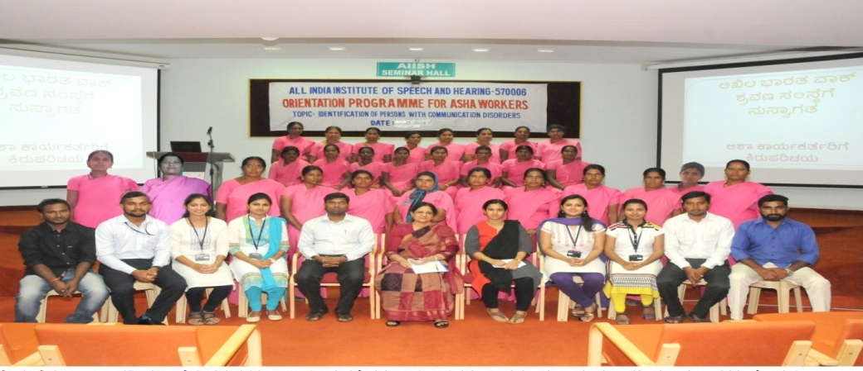
b) | 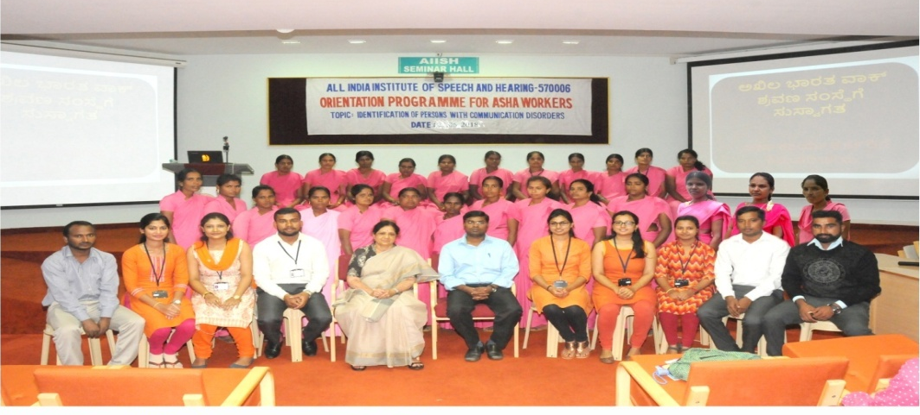
c) | 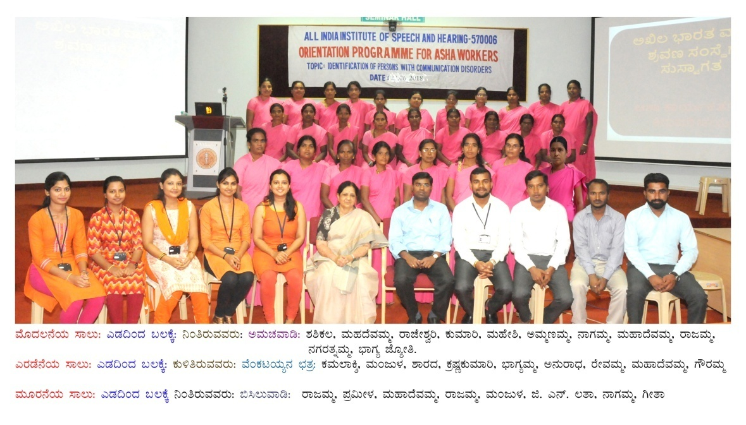

d) | 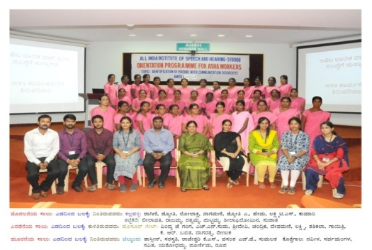
e) | 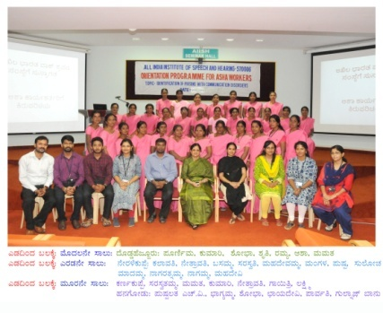
f) | 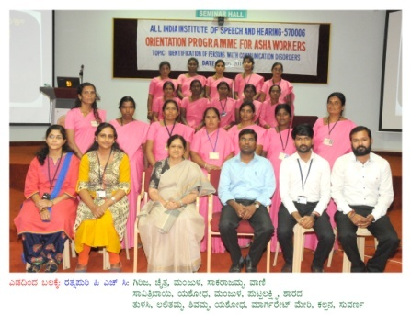
g) | 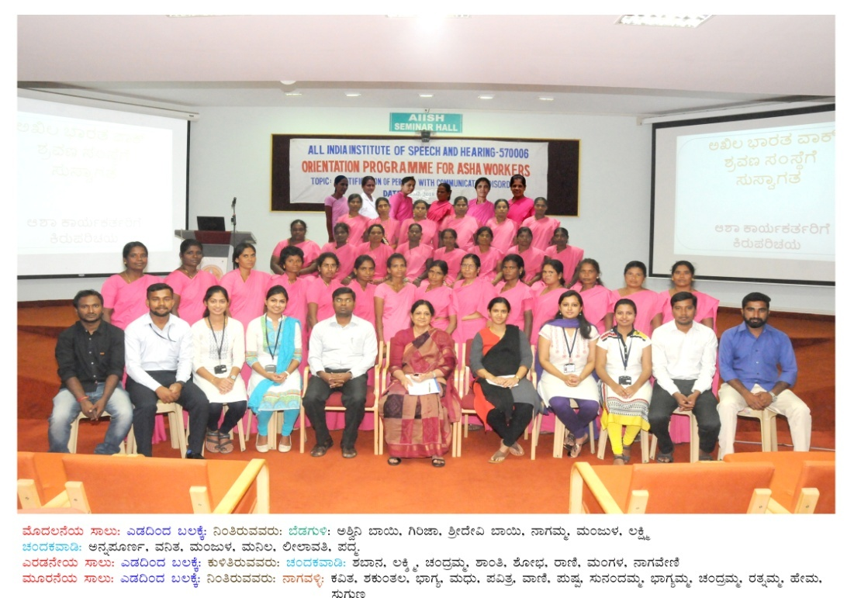

Figure 1: Training program attended by ASHA workers of Chamarajanagar (a – c, g) and Mysuru (d - f) districts, along with Project personnel.
Dr. R Rajasudhakar
Co-Investigator of the project

