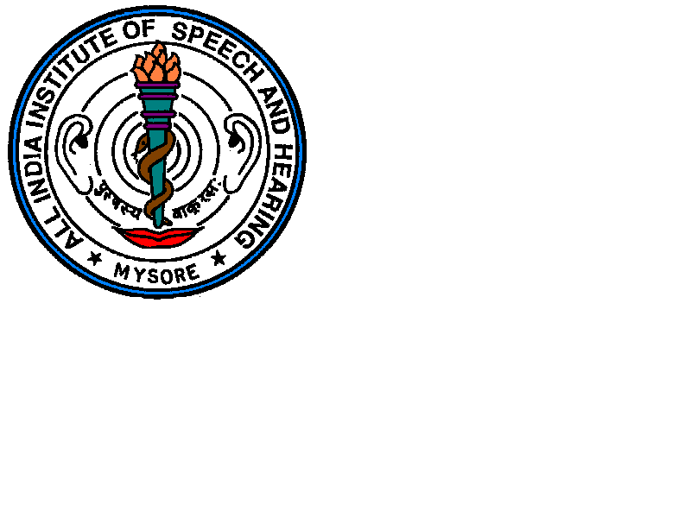
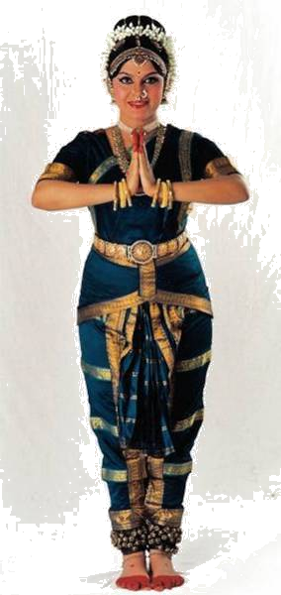
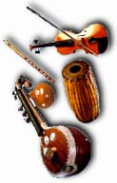
ALL INDIA INSTITUTE OF SPEECH AND HEARING: MYSORE-06
ALL INDIA INSTITUTE OF SPEECH AND HEARING
GYMKHANA
MANASAGANGOTHRI
MYSORE – 570 006

AIISH GYMKHANA

SH/ आईश जिमखाना/AIISH-Gymkhana/2018-19 07.05.2019 07.03.1

जिमखाना अध्यक्ष को प्रस्तुत/Submitted to the President, AIISH Gymkhana
Sub: Report regarding the Gymkhana events – Annual day 2018 and Events from January to March 2019.
The Institute Annual Day was conducted on 9.8.2018. The chief guests were Dr. Kapil Mohan, Director General, Administrative Training Institute, Mysuru and Shri. V.S. Basavaraju, State Commissioner for Persons with Disabilities, Bangalore.
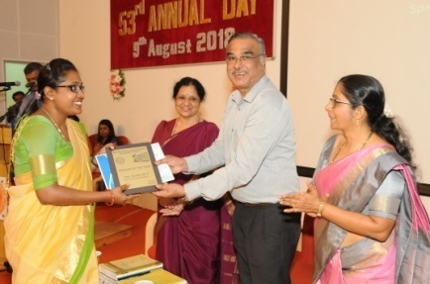
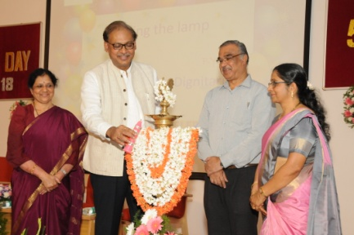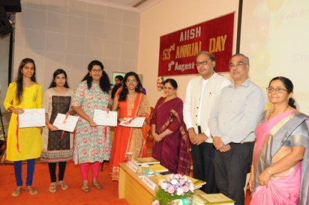
The evening function guests for Annual Day 2018 were Mrs. Bhagirathi Bhai Kadam, Director, Rangayana and Mrs. Vaishnavi Gangubai Hanagal, Hindustani Classical Vocalist.
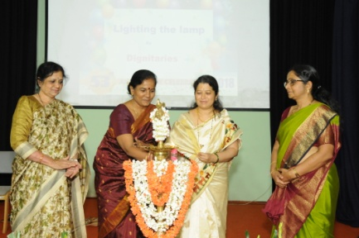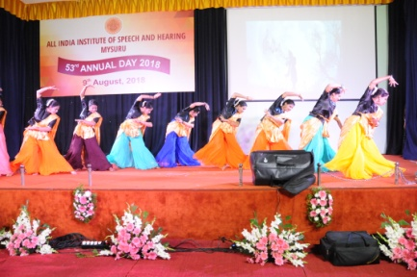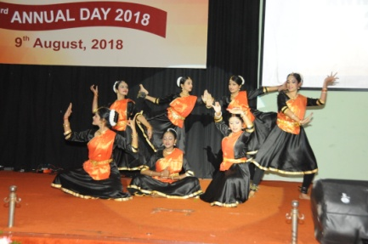

01.01.2019
Christmas and New Year celebrations were held in the quadrangle by AIISH Gymkhana on 01.01.2019. The event started at 11 AM, with a cake cutting ceremony by Director and the staff who are getting superannuated in 2019. The program started with a welcome note by Ms. Riddi Wadhwa, I M Sc student. Director conveyed her greetings to staff and students on the occasion of New Year. The stage event was followed by high tea.

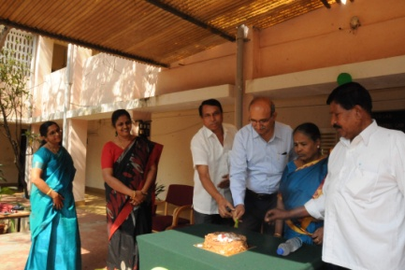
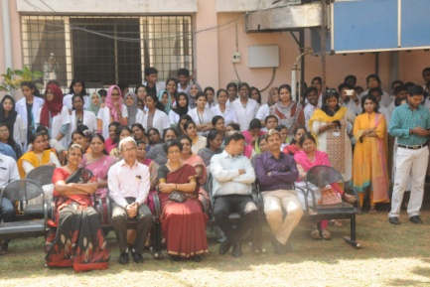

26.01.2019
On the occasion of Republic Day, flag hosting and cultural events were held on 26th January, 2019. Ms. Parnika and Ms. Sara from I. M.Sc SLP, hosted the program for the day. The program was inaugurated by Maj. Gen. Mohan Muttagikar, Retd. Doctor, Armed forces. The flag hosting was done at 8.25 followed by various cultural events from staff and students of AIISH. The gathering was welcomed by Dr. N Sreedevi, Gymkhana Vice president. The cultural events had a major attraction from children of Preschool who performed a skit for 15minutes. Chief Guest, Dr. Mohan Muttagikar highlighted few issues on the government amendments, the importance of constitution and also about the committee constituted during the constitution formation. AIISH Director Dr. Pushpavathi presided over the program. The program concluded with vote of thanks by Mr. Prajwal, General Secretary, AIISH Gymkhana. The event was followed with breakfast to staff, students and children of preschool and their parents.
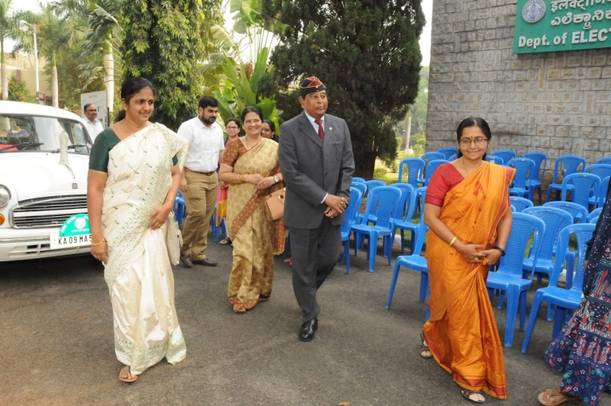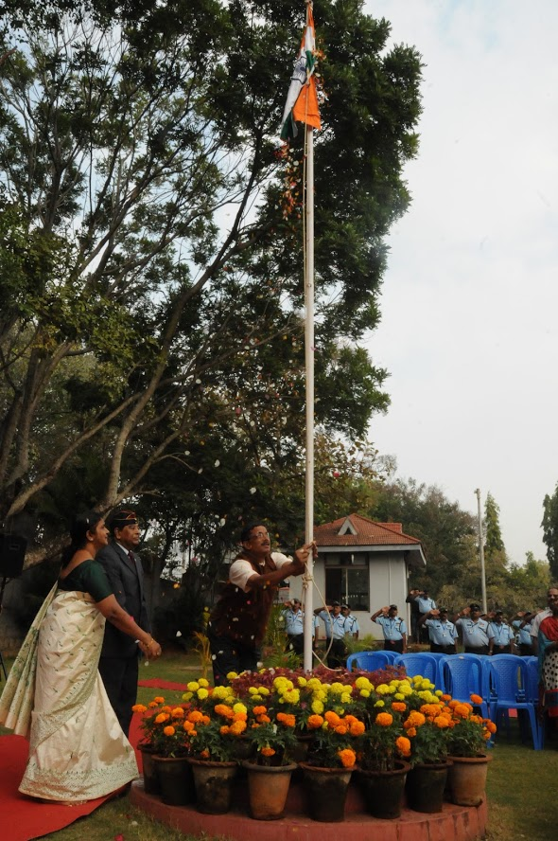
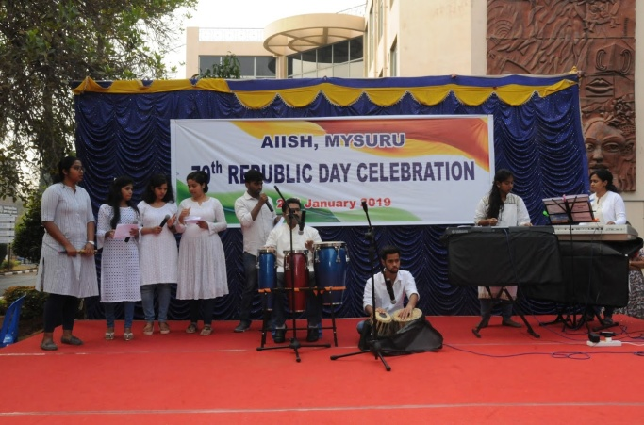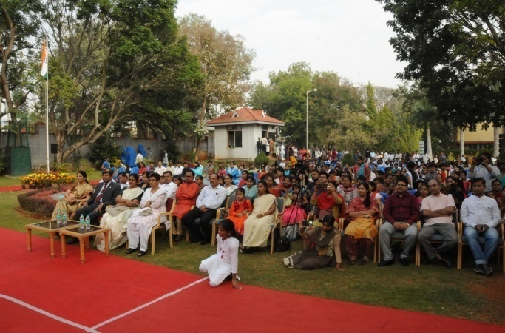
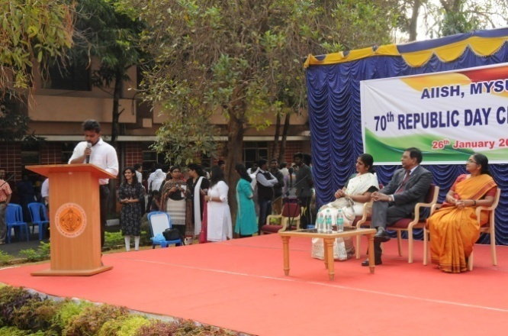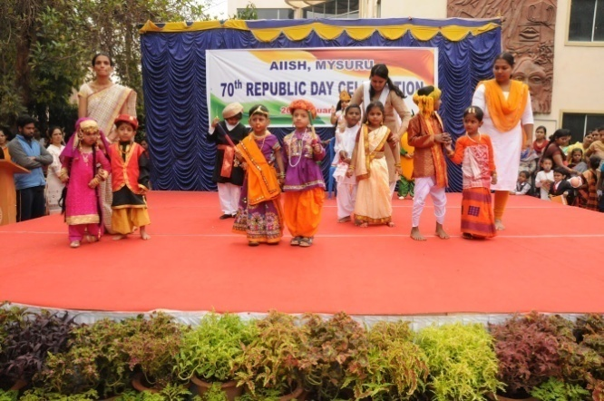

29.01.2019
Talents day for staff and students of AIISH was held on 29.01.2019 at Gymkhana, Panchavati Campus. The categories were singing, dance and best talent for extraordinary performance. 1st prize was bagged by Mr. Girish K S for singing, 2nd M.Sc students and 1st B.Sc bagged 1st prize and 2nd prize respectively in dance category. Best talent was bagged by Mr. Girish K S and Ms. Jumana M for male and female categories respectively.

31.01.2019
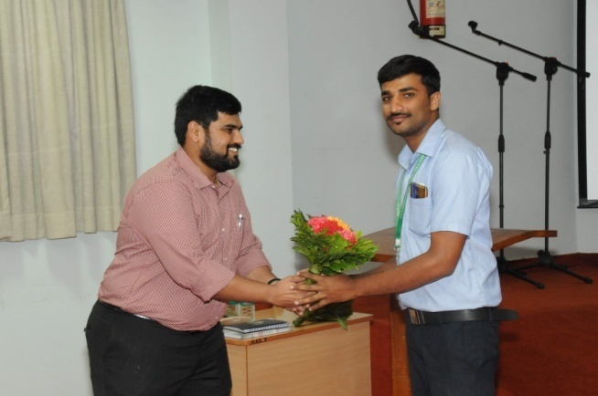
A talk on Ayurveda Awareness was scheduled for the staff and students of AIISH on 31.01.2019 between 4.30 PM to 5.30 PM. Dr. Madhusudan and Dr. Manasa from JSS Ayurveda Medical College and Hospital, Mysuru were the resource persons. The topic had covered areas such as the present day health scenario, the benefits through Ayurvedic treatments, and the treatment facility available at JSS Ayurveda Medical College. The talk also highlighted on the CGHS, insurance schemes available. Dr. N Sreedevi, Vice President Gymkhana welcomed the resource persons and gathering, Mr. Vikas M D, joint secretary proposed the vote of thanks.

04.02.2019
Movie night was held on 04.02.2019 for staff and students of AIISH. This was held as a fund raising event for AIISH AAWAZ 2019 and a movie named “Wonder” was held at Seminar Hall, Knowledge Park. More than 400 students had registered for the program. The movie was played from 6.30 pm to 9 pm.
28.02.2019
Mr. Sreenivasa, staff of AIISH superannuated on 28.02.2019. AIISH Gymkhana had arranged a farewell party for Mr. Sreenivasa. Mr. Sreenivasa along with family members graced the occasion. Staff from various departments shared their memories and experiences with Mr. Sreenivasa. Dr. N Sreedevi welcomed the staff, Mr. Sreenivasa and his family. Dr. M Pushpavathi, Director, AIISH felicitated him and Ms. Geetha M P concluded the program with vote of thanks. A token of appreciation for his service was handed over to Mr. Sreenivasa from AIISH Gymkhana.
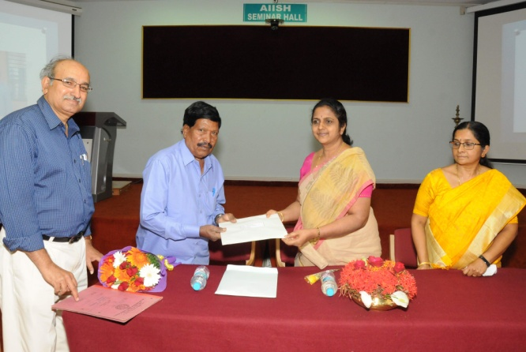
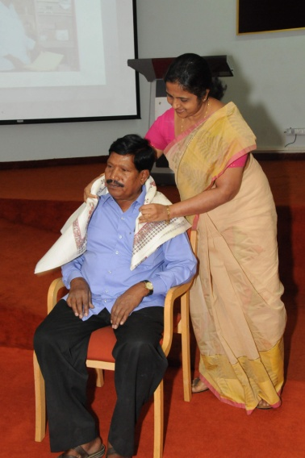

01.03.2019
On the occasion of National Science Day several competitions were held on 01.03.2019 at Seminar Hall, Academic Block. The program was organized from AIISH Gymkhana. 2 events were conducted, Dream Innovation and Pick and Speak under Audiology and Speech Language Pathology category. About 200 students from various classes participated. Participation was mandatory from each class. Almost 2-4 students from each section participated for each event.
The program commenced at 5.45 pm. Dr. Ajith Kumar. U and Dr. Santosh M served as judges for the events. Ms. Neha Yadav gave a welcome note and briefed about the National Science Day. The event winners were awarded with cash prize.
- Dream innovation had ideas in Audiology especially electrophysiological tests; ease of testing, phone apps and hearing aid technologies, and in speech language pathology the ideas were about evaluation procedures, brain mapping techniques etc. Winners were Mr. Sabin and team, I M.Sc SLP and runners were shared by Ms. Kristi and team, I M.Sc Aud and Mr. Ankit and team, II BASLP.
- Pick and Speak had various authors related to Audiology and Speech Language Pathology. The winners were Ms. Mehulla Jain, II BASLP and runners were Ms. Sai Shruthhi, II BASLP.
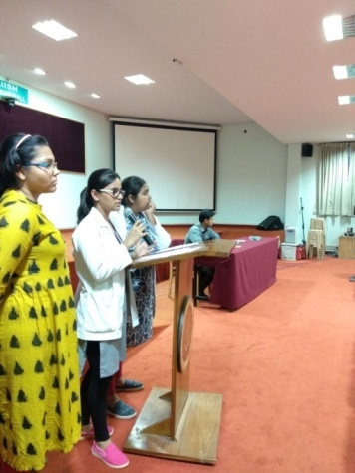
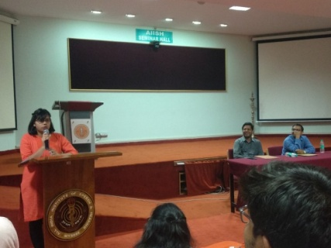
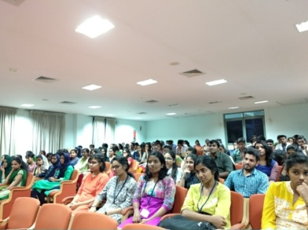
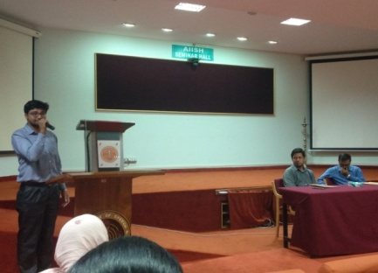

Overall the program had an impact as many of them brushed up on authors from the field of speech and hearing in order to participate in the competition and also had good ideas which were appreciated by the judges. Dr. Ajith Kumar guided students to review the ideas with literature studies and modify ideas in the form of research papers, dissertations or projects in collaboration with engineering colleges or other sources. Ms. Chethana P, cultural secretary concluded the program with vote of thanks.
05.03.2019
Stabmi LIVE BAND and Auto Expo was held on 05.03.2019 at Panchavati Campus, AIISH Gymkhana. This was held as a fund raising and promotional event for AIISH AAWAZ 2019. More than 250 people registered for the program. More than 10 wintage cars and more than 25 bikes were displayed for the crowd. The cars and bikes make ranged from 1952 to 2005 displayed at the Gymkhana campus. The live band played retro and rock music from Hindi, Malayalam, Kannada and Tamil to the crowd.
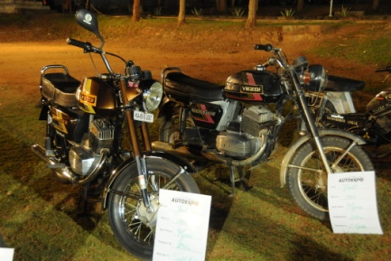
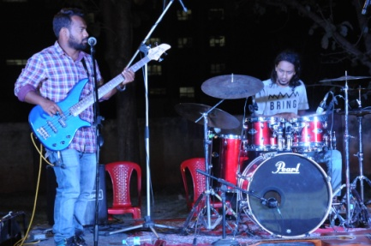
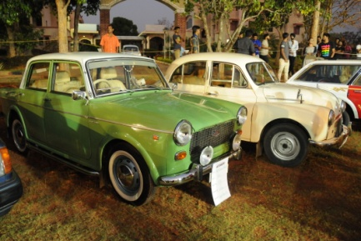
10.03.2019
ZUMBA was organized as a part of World Women’s day and promotional event of AIISH AAWAZ 2019 on 10.03.2019. The program was held at Pavilion ground, University grounds, Mysuru. The program was organized by a professional trained Zumba trainer. More than 80 participants graced this occasion. The program was held between 7 am to 9 am on 10.3.2019.
AIISH AAWAZ on 16th and 17th March 2019
AIISH AAWAZ, inter college cultural extravaganza was held on 16th and 17th March 2019 at Panchavati Campus, AIISH Gymkhana. 32 events were held for the two days. More than 25 colleges registered and participated in various events. Colleges from various parts of India registered for the event, including JSS ISH Dharwad, JSSISH Mysuru, NIE Mysuru, Mysore Medical College, JCE Mysuru, JSS Ayurveda College, JSS College of Nursing etc. Winners were awarded with cash prizes. Trophies were awarded to Fashion show winners – students of AIISH, Overall rolling trophy – JSSISH, Mysuru. Various committees had formed in order to organize the event. Staff and students were part of these committees for better co-ordination of the program.
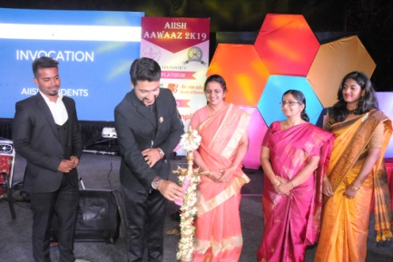
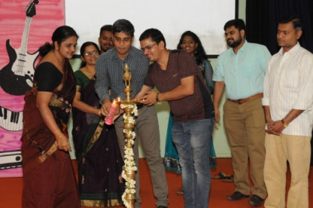
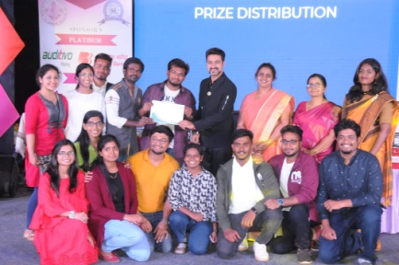
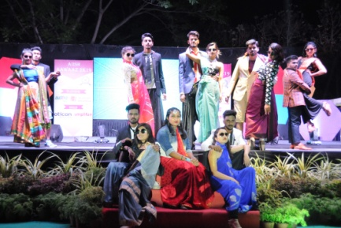
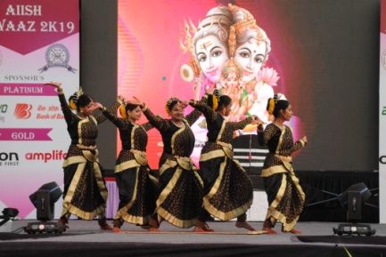
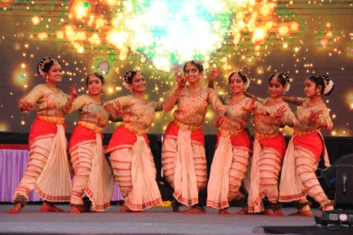

28.03.2019
Mr. Hanumantha, staff of AIISH superannuated on 29.03.2019. AIISH Gymkhana had arranged a farewell party for him. Mr. Hanumantha along with family members graced the occasion. Staff from various departments shared their memories and experiences with him. Dr. N Sreedevi welcomed the staff, Mr. Hanumantha and his family. Dr. M Pushpavathi, Director, AIISH felicitated him and a token of appreciation for his service was handed over to Mr. Hanumantha from AIISH Gymkhana. Ms. Geetha M P concluded the program with vote of thanks.
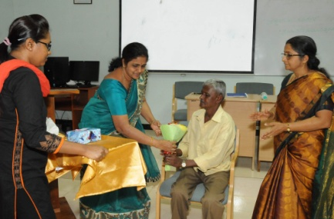
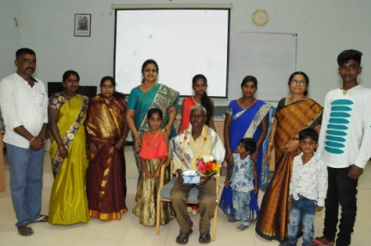

डॉ। एन श्रीदेवी/ Dr. N Sreedevi
उपाध्यक्ष / Vice President
आईश जिमखाना/ AIISH Gymkhana

