INVESTIGATORS

Principal Investigator | Dr. S.R. Savithri
 | Director, All India Institute of Speech & Hearing,
 | Manasagangothri, Mysuru 570006
 | From 25.01.2017 to 31.07.2017
 | From 17.10.2017 to 31.01.2018
 | Dr. Asha yathiraj
 | Director, All India Institute of Speech & Hearing,
 | Manasagangothri, Mysuru 570006
 | From 08.08.2017 to 16.10.2017
Co- Investigators | Dr. R. Rajasudhakara
 | Reader in Speech Sciences
 | All India Institute of Speech & Hearing,
 | Manasagangothri, Mysuru 570006
 | From 25.01.2017 to 31.01.2018
 | Ms. Priya M.B.
 | Lecturer in Speech Sciences
 | All India Institute of Speech & Hearing,
 | Manasagangothri, Mysuru 570006
 | From 25.01.2017 to 31.01.2018
 | Dr. H. Sudharshan
 | Hon. Secretary
 | Karuna Trust, Plot No 81-82
 | Ooty Road, Mysuru 570025
 | From 25.01.2017 to 31.01.2018

STAFF DETAILS
Appointed by All India Institute of Speech & Hearing, Mysuru
Speech language Pathologists | Ms. Aishwarya Nikkam
Grade 1 | From 25.01.2017 to 31.01.2018
 | Ms.Sushma Manjunath
 | From 24.01.2017 to 03.07.2017
 | Ms Rakshitha. S
 | From 24.01.2017 to 05.10.2017
 | 16.11.2017 to 31.01.2018
 | Mr. Deepak P.
 | From 25.01.2017 to 15.11.2017
 | Mr. Darshan Acharya
 | From: 25.01.2017 to 05.10.2017
 | Mr. Akshay M
 | From: 18.07.2017 to 17 .10.2017
 | Ms. Chayashree P D
 | From 26.10.2017 to 31.01.2018
 | Mr. Rakesh C V
 | From: 25.01.2017 to 01.06.2017
 | Mr. Abhijith M.
 | From 30.10.2017 to 31.01.2018
 | Mr. Sumanth A V
 | From: 14.06.2017 to 31.01.2018
 | Ms. Archana Rao
 | From 26.10.2017 to 31.01.2018
Speech & Hearing Technicians | Mr. S. Niranjan
 | From 25.01.2017 to 28.02.2017
 | Mr. Ashwath.K
 | From 24.01.2017 to 31.01.2018
 | Mrs. Tejaswini. G. M
 | From 24.01.2017 to 17.02.2017
 | Mrs. Poornima S.
 | From 25.01.2017 to 31.01.2018
 | Ms.Harshitha. K. C
 | From 23.02.2017 to 31.01.2018
 | Mr. Sumanth Kumar C S
 | From 25.01.2017 to 31.01.2018
 | Ms. Pooja R
 | From 25.01.2017 to 31.01.2018
Appointed by Karuna Trust, Mysuru

Co ordinator | Mr. B. Anand
 | From 11.05.2015 to 30.11.2016
Field Supervisors | Mr. Sandeep B.R.
 | From 25.01.2017 to 31.01.2018
 | Mr. Chandankumar C S
 | From 24.01.2017 to 31.01.2018
 | Mr. I Mani
 | From 25.01.2017 to 31.01.2018

PREAMBLE | The activities in Level IV, Phase 2 of the survey was based on the prototype established and revised for all the activities in Levels I, II, III and Level IV Phase 1 of the project. The survey in Level IV, Phase 2 included three districts (1) Hunsur Taluk of Mysuru district included villages in (i) Gavadagere Hobli which was located at a distance of 70 Kms from the All India Institute of Speech and Hearing (AIISH), Mysuru and (ii) Kasaba Hobli located at distance of 60 Kms from AIISH. The total population surveyed in Gavadagere Hobli and Kasaba Hobli was 62,543 (2) Pandavapura Taluk of Mandya district included villages in (i) Kasaba I Hobli which was located at a distance of 43.4 Kms from the All India Institute of Speech and Hearing (AIISH), Mysuru (ii) Melukote Hobli located at a distance of 51kms from the AIISH. The total population surveyed in the two Hoblis of Pandavapura Taluk was 81,563. (3) Chamarajanagara Taluk of Chamarajanagara district included villages in Harave Hobli which was located at a distance of 62.3 KMs from the All India Institute of Speech and Hearing (AIISH), Mysuru (Appendix1). The total population surveyed in the Harave Hobli of Chamarajanagara Taluk was 80,572.  The protocol followed in Level IV Phase 2 was similar to that of Level IV Phase 1 in terms of selection and training procedure for ASHA Workers and the process and outcome rehabilitation modules followed. The ASHA Workers were selected from the respective villages targeted for survey at this level and were trained.  The project aimed to follow up 100% of persons identified with various communication disorders during survey. The follow up of persons identified with communication disorders was done by carrying out series of camps arranged in the nearby PHCs for evaluation. Despite the arrangements made and cost borne for their travel from respective villages to the camp site and back, most of the patients identified with communication disorders could not come to camp for evaluation due to various reasons such as non availability of a caregiver to accompany elderly patients to camp, lack of interest to undergo evaluation despite repeated counselling, busy with their work (loss of daily wages, health issues etc), out of station/not available on the days fixed for the camps, resolved/consulted elsewhere/problem not present on the days fixed for the camps (for example, ear pain, ear discharge, throat pain etc.), consulted nearby health centres for treatment, other reasons such as loss of daily wages and refusal to acknowledge that they have communication disorders. However, for reasons that were reported for not coming to camp for evaluation, a team of Speech Language Pathologists and Audiologists conducted evaluations at their homes (door to door).
THE PROJECT |  | The Objectives in level IV, Phase II of the survey in Hunsur Taluk of Mysuru district were to (a) train ASHA Workers (for village survey) for identification of various communication disorders in (i) Hunsur Taluk, with a total population of 62,543 persons by conducting house to house survey in: 38 villages of Gavadagere Hobli falling under 4 PHC’s with 9,360 houses and population of 38,561; Kasaba Hobli with 5,977 houses and population of 23,982 amounting to an overall population of 62,543, (ii) Pandavapura Taluk with a total population of 81,536 persons by conducting house to house survey in: 117 villages of Melukote and Kasaba I Hoblis falling under 5 PHC’s with 19,686 houses and population of 81,536 , (iii) Chamarajanagara Taluk with a total population of 80,572 persons by conducting house to house survey in: 58 villages of Harave Hoblis falling under 5 PHC’s with 19,746 houses and population of 80,572. (b) conduct the survey using materials that were field tested in Level I, which included Demographic sheets, Short checklist for screening persons with communication disorders, Checklist to screen for developmental milestones in hearing, speech and language disabilities, High Risk Register for screening persons with communication disorders, Referral slips to be used by ASHA Workers, Survey booklet to enter the details after house to house survey by the ASHA Workers, Resource Manual for the ASHA Workers (in English and Kannada), Feedback questionnaire regarding communication disorders for ASHA Workers, Questionnaire to check awareness for communication disorders among the general public. (c) establish the prevalence percentage of communication disorders for the population surveyed in the selected regions in this level of the project. (d) facilitate evaluation and diagnoses for persons identified with various communication disorders through the survey and ensure that they seek professional services of Speech-Language pathologists at the All India Institute of Speech & Hearing, Mysuru, and to (e) provide guidance and counseling support for tertiary rehabilitation process for those with established diagnosis of communication disorders.
METHOD
Selection of ASHA Workers |  | ASHA Workers, who were catering to other health related screening programs of the Karnataka Government, were recruited for the survey. A total of 34 ASHA Workers were recruited to carry out survey in the villages of Gavadagere Hobli of Hunsur Taluk of Mysuru District and 22 ASHA Workers were recruited to carry out the survey in Kasaba Hobli (belonging to Hunsur Taluk) of Mysuru District, 79 ASHA Workers were recruited for survey in Kasaba I & Melukote Hobli (Pandavapura Taluk – Rural), 73 ASHA Workers were recruited for survey in Harave Hobli (Chamarajanagara Taluk).
Duration and details of the Survey |  | The survey was conducted in single phase and the duration of the project was 12 months (from 24.01.2017 to 31.01.2018). The details are presented in Table 1.
Table 1.

Details of survey in Mysuru, Mandya and Chamarajanagara District

Sl. No. | District | Hobli/s | Total No. of PHCs | Total No. of villages | Total No. of  houses | Total  population screened for communication disorders | No.  of ASHA Workers included
1 | Mysuru villages  (Rural) | Gavadagere | 4 | 38 | 9,360 | 38,561 | 34
 |  | Kasaba | 2 | 35 | 5,977 | 23,982 | 22
 |  | Sub Total | 6 | 73 | 15,337 | 62,543 | 56
2 | Mandya villages  (Rural) | Kasaba I | 3 | 49 | 12,101 | 49,643 | 49
 |  | Melukote | 2 | 68 | 7585 | 31,920 | 30
 |  | Sub Total | 5 | 117 | 19,686 | 81,563 | 79
3 | Chamarajanagara villages (Rural) | Harave | 5 | 5 | 19,746 | 80,572 | 73
 |  | Total | 16 | 195 | 54,769 | 2,24,678 | 208

ASHA Workers recruited |  | Figures 1 and 2 shows ASHA Workers of Gavadagere Hobli and Kasaba Hobli recruited in Level IV Phase II in Hunsur Taluk of Mysuru district, Figures 3 to 5 shows the ASHA Workers recruited in Level IV Phase 2 in Pandavapura Taluk of Mandya district, Figures 6 to 9 shows the ASHA Workers recruited in Level IV Phase 2 in Chamarajanagara Taluk, Chamarajanagara district.  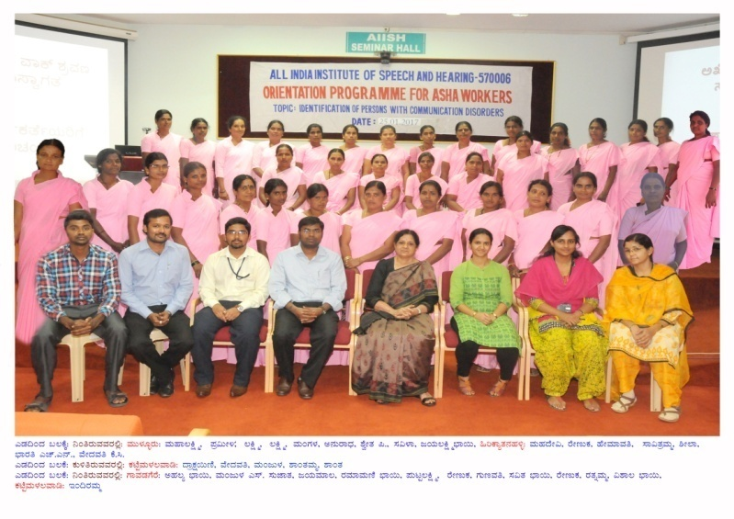  Figure1:ASHA Workers selected from PHCs of (i) Gavadagere (ii) Hirikyathanahalli (iii) Mulluru and (iv) Kattemalalavadi for Level IV Phase II in Hunsur Taluk of Mysuru District
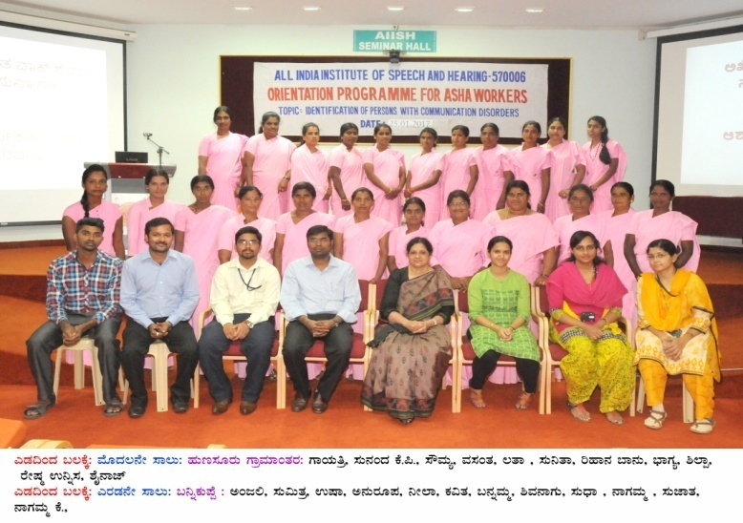
Figure 2: ASHA Workers selected from PHCs of Kasaba Hobli (i) Bannikuppe (ii) Hunsur Rural for Level IV Phase II in Hunsur Taluk of Mysuru District
 |  | 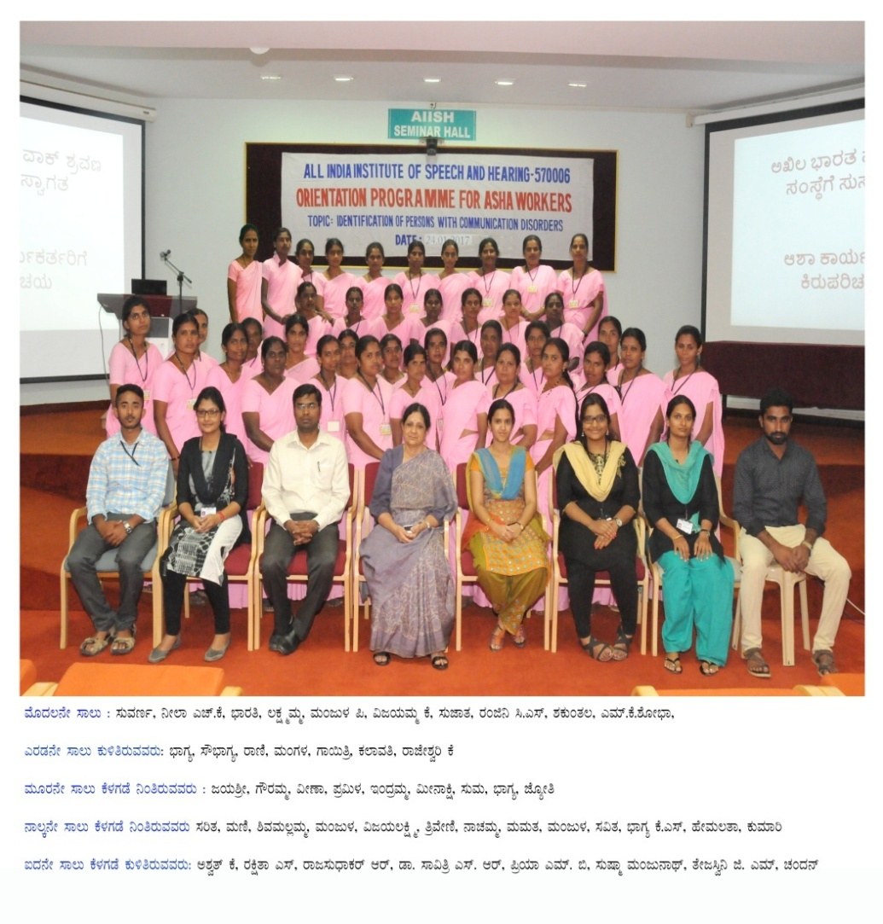 Figure 3: ASHA Workers selected from (i) Narayanapura (ii) Bellale (iii) Kerethonnuru for Level IV Phase 2 in Pandavapura Taluk of Mandya District.
 |  | 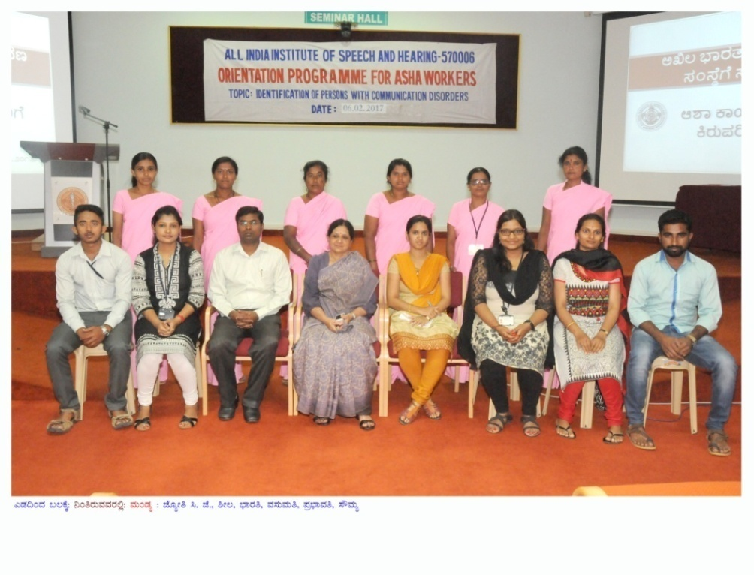Figure 4: ASHA Workers selected from (i) Narayanapura (ii) Chikkabyadrahalli (iii) Kerethonnuru for Level IV Phase 2 in Pandavapura Taluk of Mandya District who missed orientation on day 1(24.01.2017) and attended on day 2 (6.02.2017)
 |  | 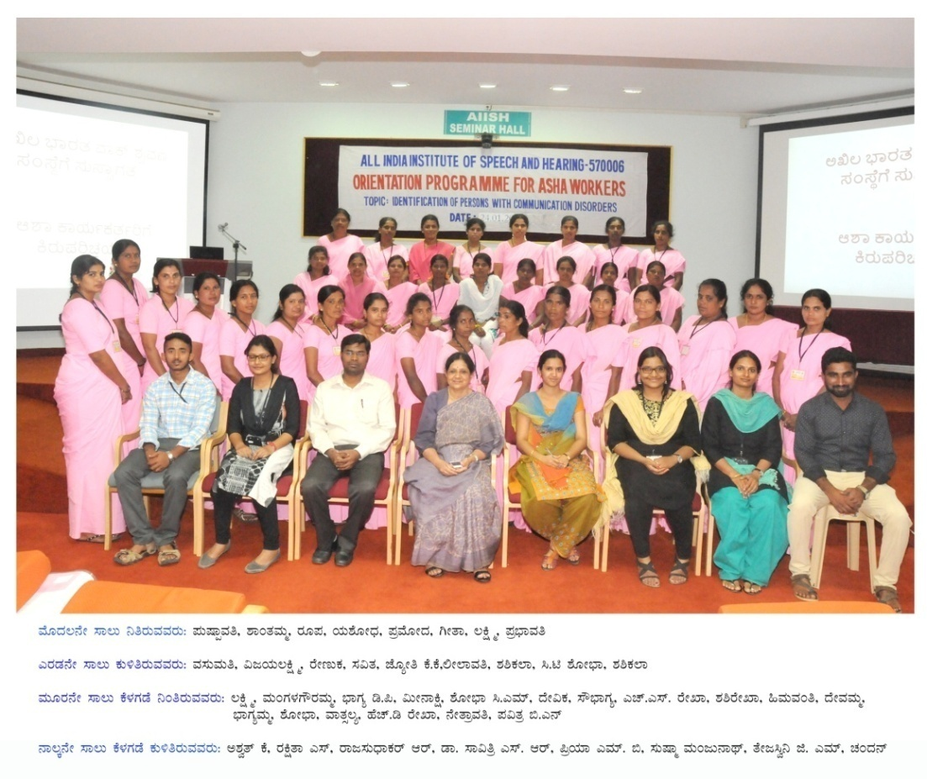Figure 5: ASHA Workers selected from (i) Melkote and (ii) Chikkabyadrahalli Kyathanahalli for Level IV Phase I in Pandavapura Taluk of Mandya District
 |  | 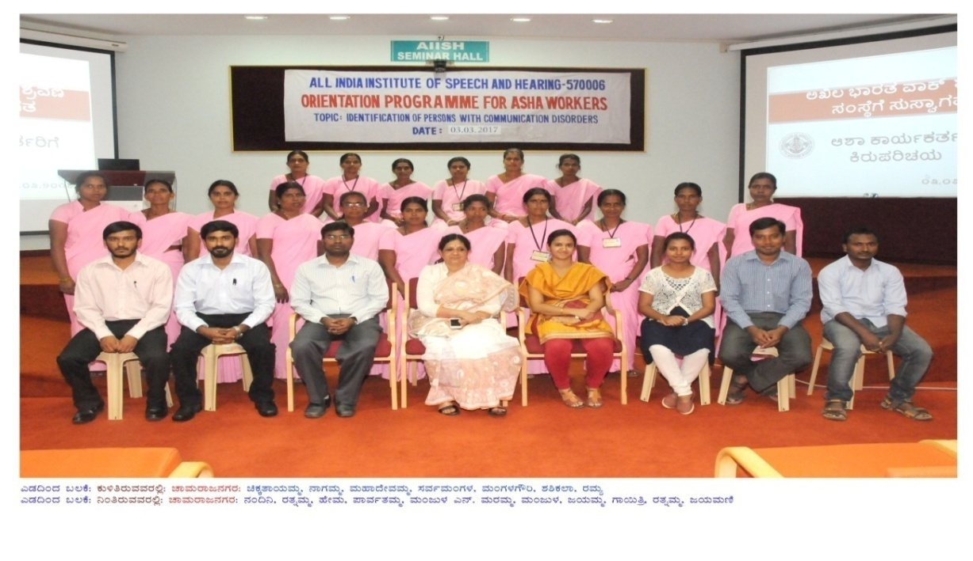Figure 6: ASHA Workers selected from Harave PHC for Level IV Phase II in Chamarajanagar Taluk (Harave Hobli) of Chamarajanagara District.
 |  | 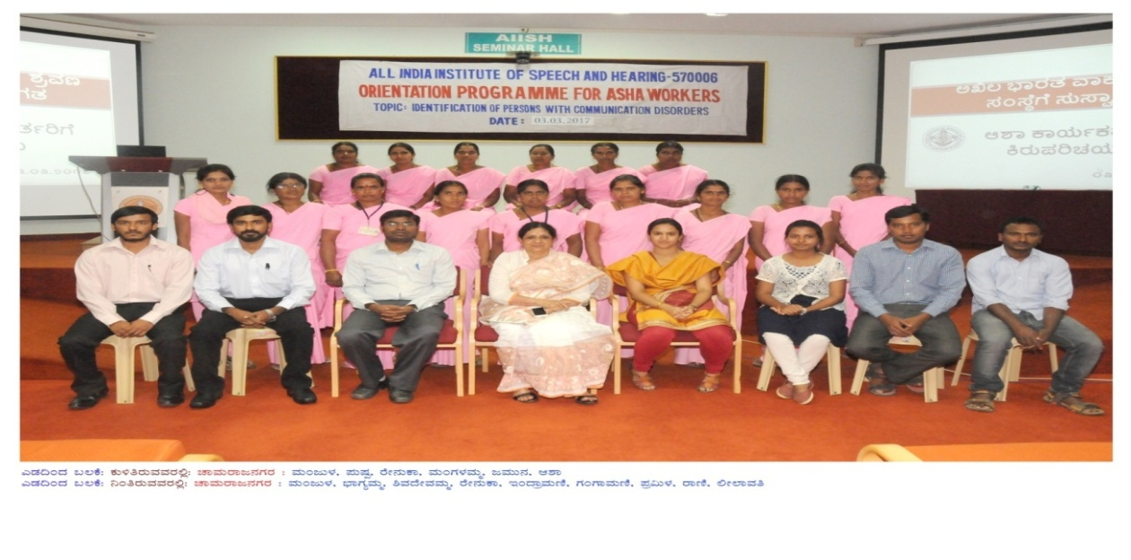Figure 7: ASHA Workers selected from Aralikatte PHC for Level IV Phase II in Chamarajanagar Taluk (Harave Hobli) of Chamarajanagara District.
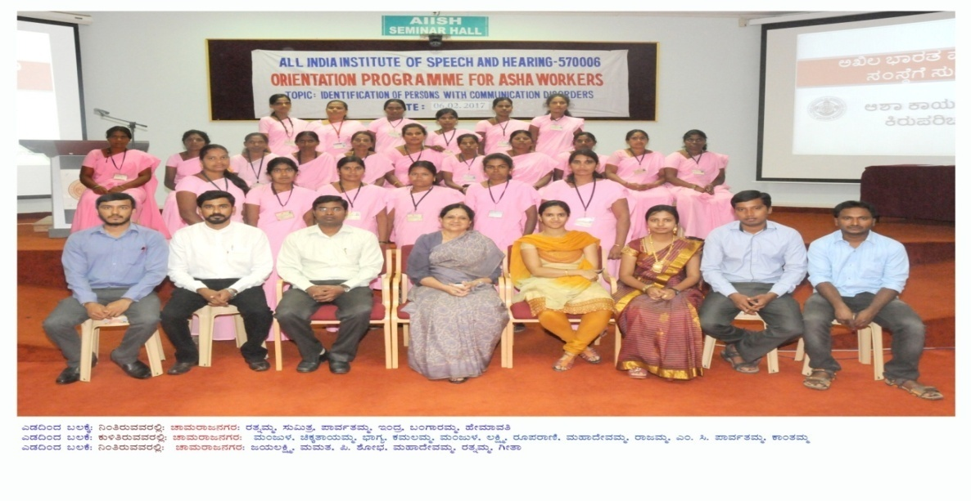
Figure 8: ASHA Workers selected from Panyadahundi PHC and Kotthalavadi PHC for Level IV Phase II in Chamarajanagar Taluk (Harave Hobli) of Chamarajanagara District.
 |  | 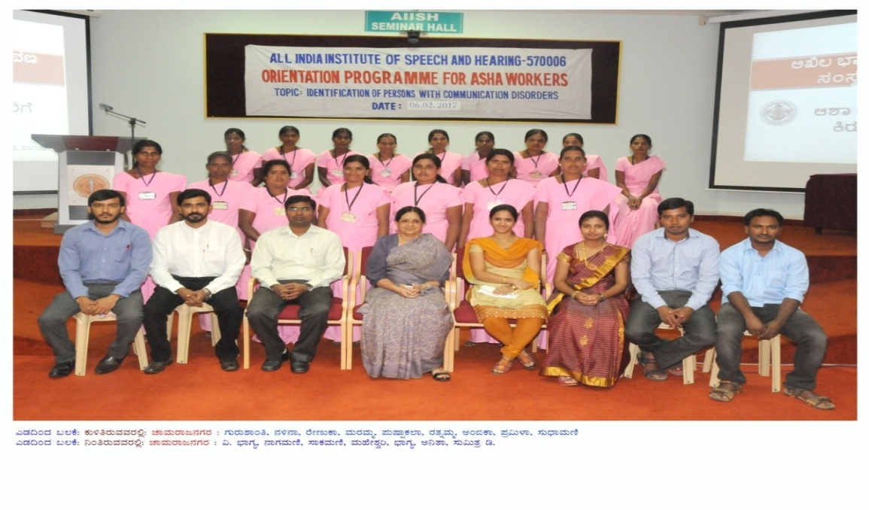Figure 9: ASHA Workers selected from Udigala PHC for Level IV Phase II Chamarajanagar Taluk (Harave Hobli) of Chamarajanagara District.
Training of ASHA Workers |  | Two batches of ASHA Workers were trained at AIISH, Mysuru. ASHA Workers were oriented and trained to (a) identify the characteristics and high risk factors of various communication disorders seen in children and adults [facilitated through provision of a printed manual prepared in Bilingual text (English-Kannada) as given in Appendix 1.7 of Level 1 report, and also through audio visual input by Speech-Language Pathologists and Audiologists, (b) use the checklists and protocols provided to them to facilitate identification of persons at risk or with communication disorders when they conduct house to house survey in villages and town, and (c) use the data entry sheets, referral slips and their identification codes appropriately while filling the details after the survey.
 |  | The ASHA Workers were supervised and guided in the field by the Field Supervisors and Speech and Language Technicians under the supervision of the Speech Language Pathologists Grade I and the investigators. They were guided to refer the persons identified as having communication disorders to the All India Institute of Speech and Hearing (AIISH) and/or Camps held at various PHCs.
Details on Geographical locations, Population & ASHA workers |  | The villages in Gavadagere Hobli and Kasaba Hobli of Hunsur Taluk are located at a distance of 70 kms and 60 kms from AIISH, Mysuru, respectively and in Pandavapura Taluk the villages in Kasaba I Hobli and Melkote Hobli are located at a distance of 43.4 kms and 51 kms from AIISH, respectively and in Chamarajanagara The villages in Harave Hobli are located at a distance of 62.3 kms from AIISH, respectively (Appendix 1)  Geographical locations covered in Mysuru, Mandya and Chamarajanagara districts in Level IV Phase 2 are given in tables 2 to 4.
Table 2
Details of Gavadagere Hobli and Kasaba Hobli of Hunsur Taluk in Mysuru district
Gavadagere Hobli |  |  | Kasaba Hobli
List of Villages in PHCs of Gavadagere,Mulluru, Hirikyathanahalli & Kattemalalavadi |  | List of Villages in PHCs of Bannikuppe & Hunsur Rural
 | A |  | A
 | Gavadagere PHC |  | Bannikuppe PHC
 | Gavadagere |  | Bannikuppe
 | Kereyuru |  | Marulayyanakoppalu
 | Shankaregowdanakoppalu |  | Kadanakoppalu
 | Chikkadiganahalli |  | Mudalakoppalu
 | Kallikoppalu |  | Maraduru
 | Jabgere |  | Madugirikoppalu
 | Manchabayanahalli |  | Agaranahalli
 | Biligere |  | Kebbekoppalu
 | Manuganahalli |  | Udduru
 | Maragowdanahalli |  | Doddegowdanakoppalu
 | Mailamburu |  | Tenkalakoppalu
 | B |  | Kalegowdanakoppalu
 | Mulluru PHC |  | Jadaganakoppalu
 | Mulluru |  | Hosuru
 | Hejjodlu |  | Madahallikoppalu
 | Undavadi |  | B
 | Boregowdanakoppalu  (Atthiguppe) |  | Hunsur Rural PHC
 | Krishnapura |  | Halechikkahunsur
 | Hulyalu |  | Hanchya
 | Machabayanahalli |  | Kottigehadi
 | Thondalu |  | Ahamadnagara
 | Mulluru Colony |  | Pakshirajapura
 | Lakkanakoppalu |  | Azadnagara
 | Shiriyuru |  | Govindanahalli
 | Kanthegowdanakoppalu |  | Somanahalli
 | C |  | Beejaganahalli
 | Hirikyathanahalli PHC |  | Reddykoppalu
 | Hirikyathanahalli |  | Mantikoppalu
 | Shirenahalli |  | Uyigowdanahalli
 | Maruru |  | Uyigowdanahalli Hosuru
 | Chitkyathanahalli |  | Siddanakoppalu
 | Harave |  | Ramapattana
 | Haraveramenahalli |  | Kirujaji
 | Keragalakoppalu |  | Emmekoppalu
 | Haravekallahalli |  | Mukanahalli
 | D |  | Sunkalmanti
 | Kattemalalavadi PHC |  | Bachahalli
 | Kattemalalavadi
 | Agrahara
 | Kattemalalavadikoppalu
 | Marurukavalu
 | Kirusodlu
 | G.T.Colony
 | Honnenahalli
 |  | Gavadagere Hobli | Kasaba Hobli
Total No. of Villages |  | 38 | 35
Total No. of ASHA Workers included in the survey |  | 34 | 22
Total No. of Houses included in the survey |  | 9,360 | 5,977
Total Population in the survey |  | 38,561 | 23,982
Total population |  | 62,543

Table 3
Details of Kasaba 1 and Melkote Hoblis of Pandavapura Taluk in Mandya District
Kasaba I Hobli |  | Melkote Hobli
List of Villages in Bellale Kerethonnur & Chikbyadrahalli PHCs |  | List of Villages in Narayanpura & Melkote CHC
 | A |  | A
 | Bellale PHC |  | Narayanpura PHC
 | Bellale |  | Narayanpura
 | Halebeedu |  | Nalenahalli
 | Hosakote |  | Marmalli
 | Singrigowdanakoppalu |  | Hosahalli
 | Manikyanahalli |  | Singapura
 | Cheekanahalli |  | V B Halli
 | Mudalakoppalu |  | Kamanayakanahalli
 | Chittanahalli |  | Javaregowdanakoppalu
 | Athigalli |  | Yaregowdanahalli
 | S Kodgalli |  | Kuppalli
 | Madrahalli |  | Maharashtradakoppalu
 | Sunkathonnur |  | Sanabadakoppalu
 | Heggadahalli |  | Devegowdanahalli
 | Kurahatty |  | Sanaba
 | Kalenahalli |  | B M Koppalu
 | Nallahalli |  | Thirumalapura
 | Heeregowdanakoppalu |  | B T Koppalu
 | Vadesamudra |  | Kadaba
 | Chikkakoppalu |  | Sanaba Hosabadavane
 | Doddakoppalu |  | Illenahalli
 |  |  | Mollenahalli
 |  |  | K G Koppalu
 |  |  | Marasanahalli
 | B |  | Lingapura
 | Kerethonnuru PHC |  | K manchanahalli
 | Lakshmisagara |  | Ashoknagar
 | Kerethonnur |  | kanakanahalli
 | Santhanahalli |  | Kodala
 | Chandre |  | Shettahalli
 | Patanageri |  | Doddagowdanahalli
 | Desavalli |  | B
 | Madeshwarapura |  | MelkotePHC
 | Neelanahalli |  | Amruthi
 | Beevinakuppe |  | Sangapura
 | Ingalakuppe |  | Shambunahalli
 | T S Chathra |  | Hosahalli
 | Shikaripura |  | Kanganahalli
 |  |  | hosahalli
 | Banaghatta |  | M R Koppalu
 | Ballenathiguppe |  | Rampura
15. | K Hosuru |  | P Kallahalli
16. | Kenchanahalli |  | Anuganahalli
 |  |  | kanganahalli
 | C |  | M Shettahalli
 | Chikkabyadrahalli PHC |  | Arakanakere
1. | Chikkabyadarahalli |  | Kajji Koppalu
2. | Chikkade |  | Ballighatta
3. | Pattasomanahalli |  | Naranapura
4. | Nuggahalli |  | Madenahalli
5. | Anavalu |  | Kodagahalli
6. | Chikkamaralli |  | Melukote(A)
7. | Kanaganamaradi |  | Kadalgere
8. | Hiremarahalli |  | Laxmipura
9. | G Hosuru |  | Kadenahalli
10. | Doddabyadarahalli |  | Garudapura
11. | Thimmanakoppalu |  | Doddigatta
12. | Thalashasana |  | Menagra
 |  |  | Narahalli
 |  |  | Thalekere
 |  |  | Geejaganahalli
 |  |  | G Singapura
 |  |  | CH Koppalu
 |  |  | A G Koppalu
 |  |  | Nyamnahalli
 |  |  | Devarahalli
 |  |  | Jakkanahalli
 |  |  | Gowdagere
 |  |  | T G Koppalu
 |  |  | Total
Total No. of villages |  |  | 117
Total No. of ASHA/ included in the survey |  |  | 79
Total No. Houses included in the survey |  |  | 19,686
Total Population included in the survey |  |  | 81,563

Table 4
Details of Harave hobli in Chamarajanagara Taluk, Chamarajanagara district

Harave hobli
List of Villages in Panyadahundi PHC, Kothalavadi PHC & Harave PHC. |  | List of Villages in Aralikatte & Udigala CHC
 | A |  | A
 | Panyadahundi PHC |  | Aralikatte PHC
 | Heggotara |  | Aralikatte
 | Mutthige |  | Kebbepura
 | Panyadahundi |  | Kulagana
 | Badanaguppe |  | Ihirebeguru
 | Bedarapura |  | Chikkabeeguru
 | Melajipura |  | Kulagana
 | Bendarawadi |  | Kilalipura
 | Megalahundi |  | Ramapura
 | Mariyala |  | Sagade
 | Mariyalada hundi |  | Bettadapura
 | Kadahally |  | Kumachahally
 | Masagapura |  | Kengaki
 | Madapura |  | Mudnakodu
 | Mallayanapur |  | Kottegowdana hundi
 | Kiragasur |  | B
 | Kerehalli |  | Udigala PHC
 | Bhujuganapura |  | Udigala
 | Heggavadi |  | Uthavalli
 | B |  | Shivapura
 | Kotthalavadi PHC |  | Yedapura
 | Kothalavadi |  | Thammadahalli
 | Ugenadahundi |  | Devalapura
 | Bokkepura |  | K.K hundi
 | Chikakempanahundi |  | Badagalapura
 | Katnavadi |  | Mallaiahnapura
 | C |  | Moodalapura
 | Harave PHC
1. | Kalkunda
2. | Harave
3. | Halepura
4. | Kethahalli
5. | Hosalli
6. | Veeranapura
7. | Maleyur
8. | Mukkadahalli
9. | Deshegowdanapura
10. | Kalpura
11. | Kalanahundi
 |  |  | Total
Total No. of villages |  |  | 58
Total No. of ASHA/ included in the survey |  |  | 73
Total No. Houses included in the survey |  |  | 19,746
Total Population included in the survey |  |  | 80,572

Time line |  | The time line for Level IV Phase II of the survey, including follow up evaluation and guidance offered to persons identified with communication disorders was as shown in Figure 10.
Activity | Months
 | 0-4  Months |  |  | 4-8 Months | 8-12 Months
Selection of ASHA Workers
Survey Program
Evaluations of persons with communication disorders at Camps
House visits (Door to Door Screening)
Report preparation

Figure 10: Timeline of the project
Follow up procedures for evaluation of persons identified with communication disorders through the survey |  | 100 % follow up of all the identified persons were carried out. The persons identified with communication disorders from various villages of Gavadagere Hobli and Kasaba Hobli of Hunsur Taluk, Kasaba 1 and Melkote Hoblis of Pandavapura Taluk and Harave Hobli of Chamarajaranagara was referred to the series of camps arranged through the project by the institute at various PHCs in order to carry out evaluation, diagnosis and referral for further rehabilitation needs. Detailed evaluation, diagnosis and further rehabilitation process was undertaken by Speech-Language Pathologists and Audiologists. Despite this attempt, the persons who could not come for camps for evaluation were evaluated by Speech Language Pathologists and Audiologists at their door step/house visits in order to meet the 100 % follow up criteria. Table 5 provides the details of series camps conducted in several PHCs.
Table 5
Details of series camps conducted in Mysuru, Mandya and Chamarajanagara District.
Sl.  No | Taluk/District |  | Location | Camp held on | Actual number of persons evaluated
 | Hunsur Taluk, Mysuru District |  | Hirikyathanahalli | 24/03/17 | 162
 |  |  | Hirikyathanahalli | 21/04/17 | 103
 |  |  | Kattemalalavadi | 28/04/17 | 156
 |  |  | Kattemalalavadi | 22/05/17 | 189
 |  |  | Mulluru | 29/05/17 | 151
 |  |  | Gavadagere | 23/06/17 | 189
 |  |  | Mulluru | 28/07/17 | 133
 |  |  | Mulluru | 11/08/17 | 130
 |  |  | Bannikuppe | 13/10/17 | 233
 |  |  | Bannikuppe | 10/11/17 | 215
 |  |  | Hunsur Rural | 08/12/17 | 171
 |  |  | Total |  | 1,832
12. | Pandavapura Taluk, Mandya District |  | Udigala | 10/04/17 | 168
13. |  |  | Uthavalli | 08/05/17 | 150
14. |  |  | Kothalvadi | 09/05/17 | 215
15. |  |  | Udigala | 30/06/17 | 167
16. |  |  | Megalhundi | 21/07/17 | 163
17. |  |  | Panyadahundi | 21/08/17 | 144
18. |  |  | Nanjadevanapura | 06/10/17 | 156
19. |  |  | Madapura | 30/10/17 | 126
20. |  |  | Harave | 17/11/17 | 185
21. |  |  | Maliyuru | 27/11/17 | 188
22. |  |  | Aralikatte | 15/12/17 | 171
23. |  |  | Sagade | 22/12/17 | 146
 |  |  |  | Total | 1,979
24. | Chamarajanagara Taluk, Chamarajanagara District |  | Bellale | 10/03/17 | 160
25. |  |  | Bellale | 17/03/17 | 140
26. |  |  | Sunkathonnur | 24/04/17 | 129
27. |  |  | Chikkabyadrahalli | 16/05/17 | 155
28. |  |  | Chikkabyadrahalli | 19/05/17 | 141
29. |  |  | Sunkathonnur | 12/06/17 | 089
30. |  |  | Kerethonnur | 24/07/17 | 193
31. |  |  | Hiremaralli | 18/08/17 | 140
32. |  |  | Yeregowdanahalli | 27/10/17 | 203
33. |  |  | Melkote | 20/11/17 | 228
 |  |  |  | Total | 1,578

Checking awareness for communication disorders in General Public |  | A questionnaire was prepared to test the awareness of general public (representing various strata of the society in the areas where survey was conducted) with regard to the types of communication disorders (Appendix 1.9 in Level 1 report). These were administered to the target groups before the initiation of survey and after the termination of this leg of survey (Pre hoc-22.02.2017 and Post hoc-05.02.2018) in Hunsur Taluk and (Pre hoc–24.01.2017 and Post hoc- 31.01.2018) in Pandavapura and Chamarajanagara Taluk. The responses were analyzed for awareness about types of communication disorders in general public.
Feedback about Facilities at AIISH and Supervisory Facilities for ASHA Workers |  | In order to obtain a feedback about the experience of survey and to tap their satisfaction level, ASHA Workers were administered the questionnaire in Kannada language with a forced choice option. Each question had to be answered by rating their response under any one of the column (rating scale) which was as follows: 4 = Highly Satisfactory, 3 = Satisfactory, 2 = Needs Improvement and 1 = Not Satisfactory. The questionnaire consisted of 14 questions belonging to two categories. The first category (Questions 1 to 9) included questions on various facilities available at AIISH where the patients identified with communication disorders were referred for evaluation and intervention wherever necessary. The second category (Questions 10 to 14) included questions addressing issues related to the Field Supervisors (Social Workers appointed by Karuna Trust, and Speech and Language Technicians appointed by AIISH, Mysuru). As per the assigned schedule of work, the supervisors monitored the work of ASHA Workers of Mysuru, Mandya and Chamarajanagara District, when they carried out house to house survey in the villages and during the follow up of persons identified with communication disorders. The ASHA Workers surveyed every house of the village that was assigned to them. The questionnaire was administered after the completion of the survey by these personnel. Since all the personnel could read and write, they were informed to go through the instructions carefully and seek clarifications in case of doubts and then proceed to answer the questions.
Feedback about Awareness of Communication Disorders and Related Issues in the Public |  | In order to check for awareness in the public regarding communication disorders after the survey ended in the selected areas, a questionnaire (Appendix 1.9 of Level 1) with forced choice options as ‘yes’/‘no’ was administered. Initially, the questionnaires were distributed among general public belonging to nine categories in the villages and Town of Hunsur, Pandavapura and Chamarajanagara Taluk, which included: (a) Agriculturists (b) Manual Labourers (c) Businessmen (d) Gram Panchayat members (e) Professionals (f) Home Makers (g) Government Employees (h) Private Organization and (i) Students. In Hunsur Taluk, a total of 504 questionnaires were distributed among the general public out of which 482 were filled and subjected to analysis. The nine different target groups in the public included (a) Agriculturists- 55 (b) Manual Labourers- 51 (c) Businessmen- 55 (d) Gram Panchayat members- 54 (e) Professionals- 51 (f) Home Makers- 54 (g) Government Employees- 54 (h) Private Organization - 53 and (i) Students- 55. In Pandavapura Taluk, a total of 774 questionnaires were distributed among the general public out of which 632 were returned and subjected to analyses including (a) Agriculturists -70 (b) Manual Labourers- 70 (b) Businessmen - 82 (c) Gram Panchayat members- 71 (d) Students- 70 (e) Professionals - 71 (f) Government Employees – 69 (g) Private Employees- 70 and (h) Home Makers- 59. In the villages and Town of Chamarajanagara Taluk, a total of 675 questionnaires were distributed among the general public out of which 545 were returned and subjected to analyses which included (a) Agriculturists -59 (b) Manual Laborers- 58 (c) Businessmen - 58 (d) Gram Panchayat members- 55 (e) Professionals -55 (f) Home Makers- 61 (g) Government Employees – 69 (h) Private Employee- 51 and (i) Students- 79.  There were 3 domains in the questionnaire to tap the awareness of the following:  Domain 1: Hearing Impairment and Ear diseases  This section included a total of 18 questions on Hearing Impairment (HI) and ear diseases. For the sake of analyses, these were further subdivided into 3 sub domains denoted as follows:  Sub domain Code Questions related to  HI 1 Risk factors leading to hearing impairment  HI 2 Hearing impairment  HI 3 General awareness of hearing impairment  Domain 2: Speech & Language Disorders  This section included 55 questions on various Speech and language disorders (SLD). For the sake of analyses, these were further subdivided into 10 sub domains denoted as follows:  Sub domain Code Questions related to general awareness of  SLD 1 Speech and language disorders  SLD 2 Mental retardation  SLD 3 Learning disability  SLD 4 Cerebral Palsy  SLD 5 Autism  SLD 6 Aphasia  SLD 7 Cleft lip and palate  SLD 8 Articulation disorders  SLD 9 Fluency disorders  SLD 10 Voice disorders  Domain 3: Lifestyle & related.  This section included 29 questions on Lifestyle (LS) related to Communication disorders. For the sake of analyses, these were further subdivided into 7 sub domains denoted as follows:  Sub domain Code Questions related to  LS 1 Social aspects  LS 2 Vocational aspects  LS 3 Entertainment aspects  LS 4 Literacy aspects  LS 5 Personality aspects  LS 6 Physical aspects  LS 7 Economical aspects
 |  | The respondents were asked to read each question (if they were literate) or listen to the field supervisor who read out the questions one by one to them and indicate/respond as ‘yes’ or ‘no’. Each question was so framed that a ‘yes’ answer indicated positive awareness and ‘no’ answer indicated no awareness. The questionnaire was administered and responses obtained from these persons after the survey was completed in the villages where the respondent resided. The duration between giving the questionnaire to the respondent (if literate) and collecting the filled questionnaire from them varied from 1 to 4 weeks. For those who were not literate, the questions were read out by the field supervisors or the ASHA Workers and responses obtained on the same day.
 |  | The total scores for ‘yes’ (scored as 1 for each ‘yes’ response) and ‘no’ (scored as zero for each ‘no’ response) from each individual‘s questionnaire across domains and sub domains were computed and the group scores derived. The data was analyzed using SPSS 21.0 software. Since the data sample size was small and was derived on nominal scale, non parametric tests were used for the analysis.

