INVESTIGATORS

Principal Investigator | Dr. S.R. Savithri
 | Director, All India Institute of Speech & Hearing,
 | Manasagangothri, Mysuru 570006
 | From 01.07.2014 to 30.10.2015
Co- Investigators | Dr. R. Manjula
 | Professor of Speech Pathology
 | All India Institute of Speech & Hearing,
 | Manasagangothri, Mysuru 570006
 | From 01.07.2014 to 30.10.2015
 | Dr. H. Sudharshan
 | Hon. Secretary
 | Karuna Trust, Plot No 81-82
 | Ooty Road, Mysuru 570025
 | From 01.07.2014 to 30.10.2015

STAFF DETAILS

Appointed by All India Institute of Speech & Hearing, Mysuru

Speech and Language Pathologists Grade 1 | Ms. Aishwarya Nikkam  From 01.07.2014 to 30.10.2015
Ms. Gaganashree, R.
From 19.11.2014 to 30.10.2015
Ms. Yashomathi
From 02.03.2015 to 30.10.2015
Ms. Harshitha Ramesh
From 06.03.2015 to 30.09.2015
Ms. Sushma Manjunath
From 06.03.2015 to 30.10.2015
Ms. Preethi, R.
From 16.03.2015 to 30.10.2015
Speech & Hearing Technicians | Mr. S. Niranjan  From 01.07.2014 to 30.10.2015
Ms. Umadevi H.M.
From 26.02.2015 to 30.10.2015
Mr. C.S. Sumanth Kumar
From 02.03.2015 to 30.10.2015
Mr. Ashwath K.
From 02.03.2015 to 30.10.2015
Mrs. Poornima S.
From 02.03.2015 to 30.10.2015
Mrs. Tejaswini G.M.
From 05.03.2015 to 30.10.2015
Appointed by Karuna Trust, Mysuru

Co ordinator | Mr. B. Anand  From 31.09.2014 to 30.10.2015
Field Supervisors | Mr. Rajesh C. K.  From 01.07.2014 to 30.10.2015
Mr. Puneeth Kumar
From 01.02.2015 to 19.03.2016
Mr. Imani
From 01.04.2015 to 30.10.2015

PREAMBLE | The Level III of the survey included Srirangapattana Taluk of Mandya district [villages (rural) and town (urban)] with a total population of 1,78,432. The protocol followed in Level III was similar to that of Level I and II in terms of selection and training procedure for ASHA workers and the process and outcome rehabilitation modules followed. Seventy eight ASHA workers were recruited and trained to conduct the survey in the villages of Srirangapattana Taluk. Since the services of ASHA workers are not available in the towns, 3 ANMs (Auxiliary Nurse Midwife) were recruited and trained to conduct the survey in the Srirangapattana Town. The ANMs were supported by Speech-Language Pathologists and Speech and Language Technicians of the project during the survey of the town population.  Few changes were made in the procedure used to evaluate persons identified with various communication disorders during this level of the survey (a) In the previous levels (Levels I and II), the detailed evaluation and follow up of persons identified with communication disorders was carried out in the Outreach Service Centers (OSCs) of the institute located at Hullahalli (Nanjangud Taluk of Mysore district), Akkihebbalu (K.R.Pete Taluk of Mandya district) and Gumballi (Yelandur Taluk of Chamarajanagara district). But referrals for further evaluation of persons identified with communication disorders in Srirangapattana taluk was made to All India Instititute of Speech and Hearing (AIISH), Mysuru, instead of the OSCs by the ASHA workers as it was closer compared to OSCs. (b) With the purpose of meeting the target of evaluating 100% of the persons identified with communication disorders, and also to help them with the transportation, all the persons identified with communication disorders were provided transportation to and from their respective villages/town to AIISH by the Karuna Trust, Mysuru. (c) Those persons who could not come to AIISH due to various reasons (loss of daily wages, out of station, health issues etc) were evaluated at series of camps organized and conducted by AIISH and Karuna Trust together at several Primary Health Centers (PHCs). Apart from the Speech-Language pathologists and Speech and Language technicians of the project, a team of professionals participated in the camps (ENT Doctor, Clinical Psychologist, Audiologists and Ear mould technician) in order to complete the evaluations in the camp venue and ensure that counselling, hearing aid prescription/distribution and follow up advice for further rehabilitation is carried out. (d) Those who failed to attend the camps were evaluated by Speech-Language pathologists and Audiologists at their respective homes.
THE PROJECT | The Objectives in Level III of the project were (a) to train ASHA Workers for identification of various communication disorders in a total population of 1,52,918 persons by conducting house to house survey in  127 villages of Arakere, K.Shettahalli, Belagola and Kasaba Hoblis falling under 8 PHC’s and 1 CHC (Arakere) with 35,490 houses and 1,52,918 population (b) to train 3 ANMs for identification of various communication disorders in a total population of 25,514 persons in Srirangapattana town by conducting house to house survey of 4,818 houses (c) to conduct the survey using material field tested in Level I, which included Demographic sheets, Short checklist for screening persons with communication disorders, Checklist to screen for developmental milestones in hearing, speech and language disabilities, High Risk Register for screening persons with communication disorders, Referral slips to be used by ASHA Workers and ANMs, Survey booklet to enter the details after house to house survey by the ASHA Workers and ANMs, Resource Manual for the ASHA Workers (in English and Kannada) which was also used by the ANMs, Feedback questionnaire for ASHA Workers, Questionnaire to check awareness for communication disorders among the general public (d) Establish the percentage prevalence of communication disorders in the population surveyed (d) Facilitate evaluation and diagnoses for persons identified with various communication disorders through the survey and ensure that they seek professional services of Speech-Language pathologists and Audiologists at the All India Institute of Speech & Hearing, Mysuru.(e) Provide guidance and counseling support for tertiary rehabilitation process for those with established diagnosis of communication disorders.
METHOD
Selection of ASHA Workers & ANMs | Seventy eight ASHA Workers, who were catering to other health related screening programs of the Karnataka Government, were recruited to carry out survey in the villages of Srirangapattana Taluk of Mandya district and 3 ANMs were recruited to carry out the survey in Srirangapattana town (belonging to Srirangapattana taluk) of Mandya district.
Duration of the Survey | The survey was conducted in single phase, initially covering the villages, followed by the town of Srirangapattana Taluk. The duration of the project was 16 months (from 1.7.2014 to 30.10.2015). The details are presented in Table 1.  Table 1  Details of survey in Srirangapattana Taluk of Mandya District  Sl No. Villages/ Town of Sriranga-pattana Taluk Hobli/s No. of PHCs / CHC No. of villa-ges No. of houses Total popu- lation screened for commu-ni-cation disorders No. of ASHA Work-ers / ANM  1 Sriranga-pattana Villages (Rural) Arakere 2 40 10,351 43,783 24  K.Shettahalli 3 41 8,702 37,042 23  Belagola 3 23 10,214 42,498 17  Kasaba 1 23 6,223 29,595 14  Sub Total 9 127 35,490 1,52,918 78  2 Sriranga-pattana Town (Urban) 4,818 25,514 3  Total 40,308 1,78,432 81
ASHA workers recruited | Figures 1 to 3 show ASHA Workers recruited for the survey
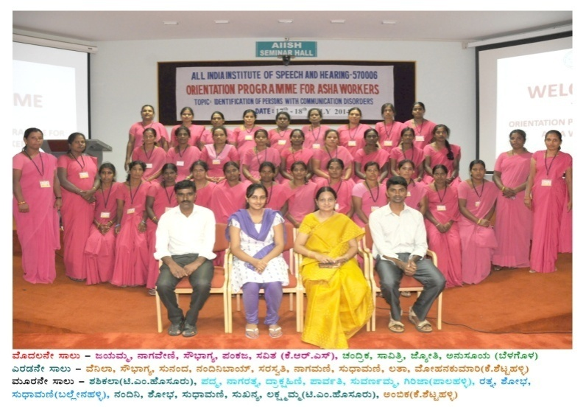
Figure 1: ASHA Workers selected from PHCs of (i) K.R.S (ii) Belagola (iii) K.Shettahalli (iv) T.M.Hosur (v) Palahalli & (vi) Ballenahalli

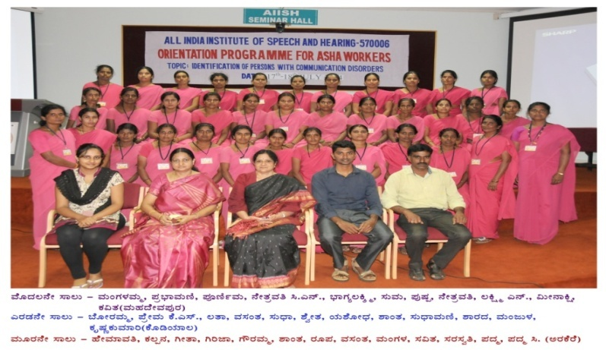

Figure 2: ASHA Workers selected from PHCs of (i) Mahadevapura (ii) Kodiyala & (iii) Arakere

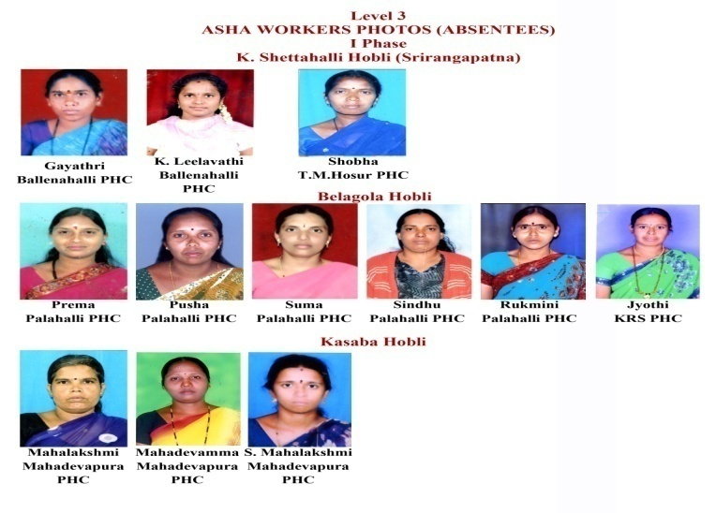

Figure 3: ASHA Workers selected from PHCs of (i) Ballenahalli (ii) T.M.Hosur (iii) Palahalli (iv) K.R.S &(v) Mahadevapura

Training of ASHA workers & ANMs | Two batches of ASHA Workers were trained for two days respectively at AIISH, Mysuru. ANMs were trained in the nearby PHC of the Taluk for one day. ASHA Workers and ANMs were oriented and trained to (a) Identify the characteristics and high risk factors of various communication disorders seen in children and adults [facilitated through provision of a printed manual prepared in Bilingual text (English-Kannada) as given in Appendix 1.7 of Level 1 report, and also through audio visual input by Speech-Language Pathologists and Audiologists (b) Use the checklists and protocols provided to them to facilitate identification of persons at risk or with communication disorders when they conduct house to house survey in villages and town, and (c) Use the data entry sheets, referral slips and their identification codes appropriately while filling the details after the survey.
 | The ASHA Workers and ANMs were supervised and guided in the field by the Field Supervisor and Speech and Hearing technician under the supervision of the Speech Language Pathologists Grade I and the investigators. They were guided to refer the persons identified as having communication disorders to the All India Institute of Speech and Hearing at Mysuru.
Geographical location, Population & ASHA workers in the survey | The villages in the hoblis surveyed were located at a distance from AIISH, Mysuru (a) Arakere hobli - 45 kms, (b) K. Shettahalli hobli - 40 kms (c) Belagola hobli - 30 kms and (d) Kasaba hobli - 30 kms (Appendix 1). Table 2 provides the details of Arakere and K. Shettihalli hobli and Table 3 provides the details of Belagola and Kasaba hoblis. Table 4 shows the overall summary.
Table 2

Details of Arakere & K. Shettahalli Hoblis of Srirangapattana Taluk in Mandya district.
Arakere Hobli |  | K. Shettahalli Hobli
List of Villages in Arakere CHC & Kodiyala PHC |  | List of Villages in PHCs of K. Shettahalli, T.M. Hosur & Ballenahalli
 | A |  |  | A
 | Arakere CHC |  |  | K. Shettahalli PHC
 | Arakere-A |  |  | K. Shettahalli
 | Arakere-B |  |  | Gowripura
 | Mandya Koppalu |  |  | Srinivasa Agrahara
 | Gendehosahalli |  |  | Kiranguru
 | Manigowdanahundi |  |  | Baburayana Koppalu
 | Neralekere |  |  | M.B. Koppalu
 | Ballekere |  |  | Sabbankuppe
 | Madrahalli |  |  | M. Shettahalli
 | Doddapalya |  |  | Garudanahukkada
 | Mundukadore |  |  | Gananguru
 | Basavanapura |  |  | Kodishettipura
 | Shanthi Koppalu |  |  | Mallegowdana Koppalu
 | Odiyandahalli |  |  | Chinnenahalli
 | Gobbaragala |  |  | Siddapura
 | Chindegowdana Koppalu |  |  | Kengal Koppalu
 | Kalkere |  |  | B
 | Marasinganahalli |  |  | T.M. Hosur PHC
 | K.G. Koppalu |  |  | T.M. Hosur
 | Bettahalli |  |  | Kallenahalli
 | Garakahalli |  |  | Kallenahalli Shed
 | Palyadoddi |  |  | Jakkanahalli
 | Maralagala |  |  | Alagudu
 | Chinnanayakanahalli |  |  | Channanakere
 | Karighatta |  |  | Hunjanakere
 | Hangarahalli |  |  | Neelana Koppalu
 | Chikkapalya |  |  | Allapatna
 | B |  |  | Gowdahalli
 | Kodiyala PHC | 11. |  | Sriramapura
 | Kodiyala |  |  | C
 | Hunnasanahalli |  |  | Ballenahalli PHC
 | Doddaharohalli |  |  | Ballenahalli
 | Chikkaharohalli |  |  | Chindagiri Koppalu
 | Tadagavadi |  |  | Nelamane
 | Mollenahalli |  |  | Kudalakuppe
 | Bannahalli |  |  | Darasaguppe
 | Pihalli |  |  | Kaparana Koppalu
 | Haldahalli |  |  | Rampura
 | Gamanahalli |  |  | Lallipalya
 | Chottenahalli |  |  | Kadatanalu
 | K.M. Koppalu |  |  | Arathi Hukkada
 | D.G.Koppalu |  |  | Hanumanthanagara
 | A. K. Koppalu |  |  | Kempegowdana Koppalu
 |  |  |  | Achappana Koppalu
 |  |  |  | Mookana Koppalu
 |  |  |  | Doddegowdana Koppalu
Total No. of villages |  |  | 81
Total No. of ASHA Workers included in the survey |  |  | 47
Total No. Houses included in the survey |  |  | 19,053
Total Population included in the survey |  |  | 80,825

Table 3

Details of Belagola and Kasaba Hoblis of Srirangapattana Taluk in Mandya district.
Belagola Hobli |  | Kasaba Hobli
List of Villages in Belagola PHC, Palahalli PHC & Krishnarajasagara (KRS) PHC |  | List of Villages in Mahadevapura PHC
 | A |  |  | A
 | Belagola PHC |  |  | Mahadevapura PHC
 | Belagola–A |  |  | Mahadevapura
 | Belagola–B |  |  | Mahadevapurabore
 | Bastipura |  |  | Chennahalli
 | Ambedkarnagar |  |  | Hebbadi
 | Anganahalli |  |  | Hebbadihundi
 | Kuppedada & MCF Circle |  |  | Hampapura
 | Hulikere |  |  | Huralikyathanahalli
 | M.N.P.M. Colony |  |  | Melapura
 | B |  |  | Hosur
 | Palahalli PHC |  |  | Nagayanahundi
 | Palahalli-A |  |  | Goromalla (Indiranagar)
 | Pallahalli-B |  |  | Krishnapura
 | Bommuru Agrahara |  |  | Naguvinahalli & Naguvinahalli Colony
 | P. Hosahalli |  |  | Hosundi
 | Karekura |  |  | Taripura
 | Mogarahalli Manti |  |  | Bidarahalli
 | Hosaananduru |  |  | Chikkankanahalli
 | C |  |  | Sugganahalli
 | KRS PHC |  |  | Kokkarehundi
 | KRS |  |  | Bonthagalli
 | KRS–A |  |  | Chandagalu
 | KRS–B |  |  | Belavadi
 | Majjigepura |  |  | Brahmapura
 | Homgalli
 | Bazarline KRS
 | Hosundavadi
 | Shankalli Koppalu
Total
Total No. of villages |  |  |  | 46
Total No. of ASHA Workers included in the survey |  |  |  | 31
Total No. Houses included in the survey |  |  |  | 16,437
Total Population included in the survey |  |  |  | 72,093

Table 4

Overall Details of four Hoblis and Town of Srirangapattana Taluk in Mandya district.
Sl. No. | Total No. of Hoblis | Total No. of PHC/CHC | Total No. of villages covered | Total no. of  houses covered | No. of ASHA Workers included/ANM | Total population screened for communication disorders
1 | Rural
 | 4 | 9 | 127 | 35,490 | 78 | 1,52,918
2 | Urban (Srirangapattana Town)
 |  |  |  | 4,818 | 3 | 25,514
 | Total |  |  | 40,308 | 81 | 1,78,432

Time line | The time line for Level III of the survey, including follow up evaluation and guidance offered to persons identified with communication disorders was as shown in Figure 4.  Activity Months  0-1 Month 2- 12 Months 13- 16 Months  Recruitment of SLPs Grade 1, SHTs & Field Supervisors  Selection of ASHA Workers  Selection of ANMs  Survey Program  Evaluations of persons with communication disorders identified at AIISH  Camps  Report preparation  Figure 4: Timeline of the project
Follow up procedures for evaluation of persons identified with communication disorders through the survey | 100 % follow up of all the identified persons were carried out. The persons identified with communication disorders from various villages in the four hoblis of Arakere, K.Shettahalli, Belagola and Kasaba were referred to All India Institute of Speech & Hearing, Mysuru. Detailed evaluation, diagnosis and further rehabilitation process was undertaken by Speech-Language Pathologists and Audiologists. Persons who could not come to AIISH, were referred to series camps (ten camps held from April to November 2015) that were organized and conducted jointly by AIISH and Karuna Trust at various PHCs to carry out evaluation, diagnosis and referral for further rehabilitation needs. Despite this attempt, few persons with communication disorders could not attend the camps and these persons were evaluated by SLPs and audiologists at their door step in order to meet the 100 % follow up criteria. Table 5 provides the details of series camps conducted in several PHCs.
Table 5

Details of series camps conducted in PHCs of Srirangapattana Taluk in Mandya district.
Sl.  No | Camp held on | PHCs | No. of persons with communication disorders called for the camp | Actual number of persons evaluated | No of persons who did not report to the camp
 | 10.04.2015 | K. Shettahalli | 147 | 123 | 24
 | 15.04.2015 | Arakere | 155 | 137 | 18
 | 17.04.2015 | Belagola | 99 | 81 | 18
 | 19.06.2015 | Srirangapatna Town-Hospital | 102 | 97 | 5
 | 22.06.2015 | Srirangapatna District Hospital | 142 | 122 | 20
 | 24.06.2015 | Srirangapatna District Hospital | 74 | 69 | 5
 | 26.06.2015 | Srirangapatna District Hospital | 82 | 73 | 9
 | 28.10.2015 | Arakere | 192 | 109 | 83
 | 30.10.2015 | Arakere | 173 | 90 | 83
 | 02.11.2015 | Belagola | 179 | 105 | 74
 |  | Total | 1,345 | 1,006 | 339

Checking awareness for communication disorders in ASHA workers& ANMs, & General Public | A questionnaire was prepared to test for awareness of communication disorders and facilities available for the rehabilitation at AIISH among the ASHA Workers recruited for the survey (Appendix 1.8 in Level I report). Another questionnaire was prepared to test the awareness of general public (representing various strata of the society in the areas where survey was conducted) with regard to the types of communication disorders (Appendix 1.9 in Level 1 report). These were administered to the target groups before the initiation of survey and after the termination of this leg of survey (30.07.2014 and 23.10.2015 respectively). The responses are analyzed and reported under results section.
Feedback about Facilities at AIISH and Supervisory Facilities for ASHA Workers & ANMs | In order to obtain a feedback about the experience of survey and to tap their satisfaction level, ASHA workers were administered a questionnaire (see Appendix 1.8 of Level 1 report) in Kannada language with a forced choice option wherein each question had to be answered by ticking their response under any one of the column (rating scale) which was as follows: 4 = Highly Satisfactory, 3 = Satisfactory, 2 = Needs Improvement and 1 = Not Satisfactory. The questionnaire consisted of 14 questions belonging to two categories. The first category (Question 1 to 9) included questions on various facilities available at the AIISH [All India Institute of Speech & Hearing, Mysuru] where the patients identified with communication disorders were referred for evaluation and intervention wherever necessary. The second category included questions (Question 10 to 14) addressing issues related to the Field Supervisors (Social Workers appointed by M/s Karuna Trust, and Speech and Language Technicians appointed by AIISH, Mysuru). As per the assigned schedule of work, the supervisors monitored the work of ASHA Workers (at Arakere, Belagola, K.Shettahalli and Kasaba hoblis of Srirangapatna Taluk of Mandya District), when they carried out house to house survey in the villages and during the follow up of persons identified with communication disorders to AIISH. The ASHA Workers surveyed every house of the village that was assigned to them. The questionnaire was administered after the completion of the survey by these personnel. Since all the personnel could read and write they were informed to go through the instructions carefully and seek clarifications in case of doubts and then proceed to answer the questions.  It may be noted that awareness amongst ANMs could not be checked as there were only 3 ANMs and their survey work was supported by the SLPs and SLTs of the project.
Feedback about Awareness of Communication Disorders and Related Issues in the Public | In order to check for awareness in the public regarding communication disorders after the survey ended in the selected areas, a questionnaire (see Appendix 1.9 of Level 1) with forced choice options as ‘yes’/‘no’ was administered. There were 3 parts (domains) in the questionnaire to tap the awareness on the effects of the following: Domain 1: Hearing Impairment and ear diseases Domain 2: Speech & Language Disorders and Domain 3: Lifestyle & related (same as in the Level 1). The questionnaires were distributed among 800 general public in the villages of Arakere, Belagola, K.Shettahalli and Kasaba hoblis & Srirangapattana town of Srirangapattana Taluk of Mandya District, belonging to 8 main target groups, which included: (a) Agriculturists in Srirangapattana Rural (35) and Srirangapattana town (10) (b) Manual Labourers in Srirangapattana Rural (9) and Srirangapattana town (14) (c) Businessmen/Private Organisation in Srirangapattana Rural (38) and Srirangapattana town (28) (d) Grampanchayat members in Srirangapattana Rural (17) (e) Students in Srirangapattana Rural (42) and Srirangapattana town (7) (f) Professionals in Srirangapattana Rural (46) and Srirangapattana town (20) (g) Government Employees in Srirangapattana Rural (54) and Srirangapattana town (3) and (h) Home Makers in Srirangapattana Rural (41) and Srirangapattana town (7).
There were 3 domains in the questionnaire to tap the awareness on the effects of the following:

Domain 1: Hearing Impairment and Ear diseases
This section included a total of 18 questions on Hearing Impairment (HI) and ear diseases. For the sake of analyses, these were further subdivided into 3 subdomains denoted as follows:
Sub domain | Code | Questions related to
 | HI 1 | Risk factors leading to hearing impairment
 | HI 2 | Hearing impairment
 | HI 3 | General awareness of hearing impairment

Domain 2: Speech & Language Disorders
This section included 55 questions on various Speech and language disorders (SLD). For the sake of analyses, these were further subdivided into 10 sub domains denoted as follows:
Sub domain | Code | Questions related to general awareness of
 | SLD 1 | Speech and language disorders
 | SLD 2 | Mental retardation
 | SLD 3 | Learning disability
 | SLD 4 | Cerebral Palsy
 | SLD 5 | Autism
 | SLD 6 | Aphasia
 | SLD 7 | Cleft lip and palate
 | SLD 8 | Articulation disorders
 | SLD 9 | Fluency disorders
 | SLD 10 | Voice disorders

Domain 3: Lifestyle & related.
This section included 29 questions on Lifestyle (LS) related to Communication disorders. For the sake of analyses, these were further subdivided into 4 sub domains denoted as follows:
Sub domain | Code | Questions related to
 | LS 1 | Social aspects
 | LS 2 | Literacy aspects
 | LS 3 | Personality aspects
 | *LS 4 | Vocational, Entertainment, Physical & Economical aspects

(* LS 4 included only one question each for each domain and hence it was grouped together)

 | The respondents were asked to read each question (if they were literate) or listen to the field supervisor who read out the questions one by one to them and indicate/respond as ‘yes’ or ‘no’. Each question was so framed that a ‘yes’ answer indicated positive awareness and ‘no’ answer indicated no awareness. The questionnaire was administered and responses obtained from these persons after the survey was completed in the villages where the respondent resided. The duration between giving the questionnaire to the respondent (if literate) and collecting the filled questionnaire from them varied from 1 to 4 weeks. For those who were not literate, the questions were read out by the field supervisors or the ASHA Workers and responses obtained on the same day.
 | The total scores for ‘yes’ (scored as 1 for each ‘yes’ response) and ‘no’ (scored as zero for each ‘no’ response) from each individual‘s questionnaire across domains and sub domains were computed and the group scores derived. The data was analyzed using SPSS 21.0 software. Since the data sample size was small and was derived on nominal scale, non parametric tests were used for the analysis.

