Investigators of the Project

Principal Investigator: | (Late) Dr. Vijayalakshmi Basavaraj
 | Former Director, All India Institute of Speech & Hearing,
 | Manasagangothri, Mysuru 570006
 | From 20.9.2010 to 19.3.2011
 | &
 | Dr. S.R. Savithri
 | Director, All India Institute of Speech & Hearing,
 | Manasagangothri, Mysuru 570006
 | From 5.12.2011 to 5.06.2012
Co- Investigators | Dr. R. Manjula
 | Professor of Speech Pathology
 | All India Institute of Speech & Hearing,
 | Manasagangothri, Mysuru 570006
 | From 20.9.2011 to 5.06.2012
 | Dr. H. Sudharshan
 | Hon. Secretary
 | Karuna Trust, Plot No 81-82
 | Ooty Road, Mysuru 570025
 | From 20.9.2010 to 5.06.2012

Manpower of the Project

Appointed by All India Institute of Speech & Hearing, Mysuru

Research Officer | Ms. Pragathi, E
 | From 20.9.2010 to 20.3.2012
 | &
 | Ms. Aishwarya Nikkam
 | From 26.3.2012 to 5.06.2012
Speech & Hearing Assistant | Mr. S. Niranjan
 | From 29.9.2010 to 5.06.2012
Appointed by Karuna Trust, Mysuru

Co ordinator | Dr. C.K. Kanthraj
 | From 20.9.2010 to 5.06.2012
Field Supervisor | Mr. Rajesh C. K
 | From 20.9.2010 to 5.06.2012

Grants

Source of Funds | Ref No. & Date | Amount in Rs.
AIISH Research Funds (ARF) | SH/CDN/ARF/3.94/2010-11 dt 16/09/2010 (16.9.2010 – 20.3.2012) | 662000
From Plan Grants | SH/CDN/ARF/3.94/2011-12 dt 21/03/2012 | 393100
Release to Karuna Trust | SH/Dir/Karuna Trust/2010-11 dt13.7.2010 | 546000
Release to Karuna Trust | SH/Dir/Karuna Trust/ 2011-12 dt 26.12.2011 | 498000
 | Total | 20,99,100

PREAMBLE  Definition of Communication,  Speech, Language &  Hearing | Communication is the exchange of meanings between individuals through a common system of symbols (Hegde, 2007). Communication bridges the gap between any two individual or groups of people. Communication is the essence of life and involves exchange of thoughts, messages, or information through speech or use of signs, writing etc. ‘Speech’ and ‘Language’ are parts of the larger process of communication. Speech is an established communicative system of arbitrary and conventionalized acoustic symbols, produced mainly by action of the muscles of the respiratory and upper alimentary tracts (Travis, 1957). Speech sounds are combined in various ways to form the language units that are used for verbal communication. Development of speech follows a course up to age 12 because humans acquire adult-like speech motor control by adolescence. The speech of the child changes with different stages of language acquisition and this is very important to differentiate normal individuals from those with deviant language or delay in language acquisition. Language is a complex and dynamic system of conventional symbols that is used in various modes for thought and communication (Hegde, 2007). The relationship between all the linguistic forms (individual sounds, meaningful units and the combination of these units) is specified by the rules of language (Bloom & Lahey, 1978). Every human being is born into a language or to be precise, into a linguistic condition. The ear is an organ of hearing, presenting a mechanism through which sound waves are conducted and converted into electrical signals. These signals are conveyed to the brain, where they are interpreted into meaningful units (Schneiderman & Potter, 2002). Hearing refers to the auditory sensation and cognitive perception of sound (Sahley & Musiek, 2015). The sense of ‘hearing’ plays an important role in the acquisition of speech and language process in an individual. The period from birth to 3-5 years is often considered as the "critical period" for the development of normal speech and language. Normal hearing in the first six months of life is critical for the development of normal speech and language skills.
Communication disorders | A communication disorder is an inability to understand or use speech and language and relate to others in society. Communication disorders include speech disorders (articulation, fluency, voice problems etc.), language disorders (impaired comprehension and/or use of spoken, written, and other types of symbols) or hearing disorders (impaired hearing sensitivity). Communication disorders express themselves with or without co morbid disorders in children, adults and geriatric population. There are a variety of communication disorders due to hearing impairment, mental retardation, cerebral palsy, learning disability, autism, brain injury, etc. Speech and Language disorders may be acquired before, during or after birth. Language disorders could be acquired or seen from birth or during developing years. These disorders are generally categorized as Adult language disorders (For example Aphasia) and child language disorders (For example, Specific language impairment, Learning disability, Autism Spectrum Disorders etc.) depending on the age of onset of these disorders.  Effective communication skills are central to a successful life for all the individuals. Any impairment leading to communication disorders affects communication because there are restrictions in communicating meaning, thoughts, ideas etc in an attempt to create shared understanding. Communication disorders are one of the common and widespread problems that affects social and emotional well-being, cognition, behaviour, academic and psychosocial well being (Baker & Blackwell, 2004). They also have a devastating, detrimental and an invariably adverse impact on the individuals and their family’s psychological well-being. Communication is an essential part of maintaining a healthy family. The way a family functions is based on how the family communicates. If a member of a family has any communication disorder, the process of communication becomes complicated because it creates secondary impact on social, emotional, financial and overall lifestyle of the family.  Hearing disorder is the most prevalent congenital abnormality in newborns (Finitzo & Crumley, 1999). It is one of the most common sensory disorders and the common causes are sensorineural and/or conductive malfunctions of the ear. The impairment may occur during or shortly after birth (congenital or early onset) or caused post-natal or may have late onset (genetic factors, trauma or disease). Hearing loss may be pre-lingual (i.e., occurring prior to speech and language acquisition) or post-lingual (i.e., occurring after the acquisition of speech and language).
Need for early identification of communication disorders | Early identification and appropriate intervention within the first six months of life have been demonstrated to prevent or reduce many of the adverse consequences of communication disorders and facilitate language acquisition (Yoshinaga-Itano, Sedey, Coulter, & Mehl, 1998).  Since hearing loss in infants is silent and hidden, great emphasis is placed on early detection, reliable diagnosis, and timely intervention (Spivak, Datzell, Berg, Bradley, & Cacace, 2000). Even children who have mild or unilateral permanent hearing loss may experience difficulties with speech understanding, especially in a noisy environment, as well as problems with educational and psycho-social development (Bess, Tharpe, Bess, & Tharpe, 1988; Culbertson & Gilbert 1996). Children with hearing loss frequently experience speech-language deficits and exhibit lower academic achievement and poorer social-emotional development than their peers with normal hearing.  Identification of the types of communication disorder in persons is carried out through community based screening or institutional based testing procedures. The assessment of communication disorders may take 1 to 3 hours per person. But, rehabilitation of individuals with speech and language disorders is a long process and will take a long time. This is in particular more crucial in children identified with language disorders. Hence there is ominous need for national programs which stress on early identification of communication disorders.
Status of rehabilitation and community based programs in other countries | Developed countries have established a high standard of health care. Primary services include the early detection of congenital hearing loss and the initiation of auditory rehabilitation before six months of age.  In developing countries, barefoot doctors and health auxiliaries began to emerge from the mid 1950s and became a nationwide programme from the mid 1960s, ensuring basic health care (Zhu, Ling, Shen, Lane, & Hu, 1989; see also Hsiao, 1984; Sidel, 1972; Shi, 1993). Partly in response to the success of this movement and partly in response to the inability of conventional allopathic health services to deliver basic health care, a number of countries subsequently began to experiment with the village health worker concept (Sanders, 1985). The early literature emphasizes the role of the Village Health Workers (VHWs), which was the term most commonly used at that time as not only (and possibly not even primarily) a health care provider, but also as an advocate for the community and an agent of social change, functioning as a community mouthpiece to fight against inequities and advocate community rights and needs to government structures (Werner, 1981).  A widely accepted definition by WHO Study Group (WHO, 1989) states that the Community Health Workers (CHWs) should be members of the communities where they work, should be selected by the communities, should be answerable to the communities for their activities, should be supported by the health system but not necessarily a part of its organization, and have shorter training than professional workers. The use of CHWs in the US began during the 1960s to expand access to health care for underserved communities such as the poor and ethnic minorities (Heath, 1967). Initially, CHWs were trained to provide general health education, parenting education, and patient advocacy (Giblin, 1989).  Over the past 4 decades, CHWs' roles have evolved to serve as liaisons between community members and providers; promote community advocacy and community capacity building; provide cultural mediation, counseling, social support, and culturally appropriate health education; promote attendance at appointments and adherence to medication and other medical regimens; and promote delivery of direct health care services (Institute of Medicine, 2003; Rosenthal, 1998; Swider, 2002). Collective functions of CHWs are to increase access to health care, empower individual and community members, improve behavioral outcomes in individuals and communities, and decrease health care costs (Swider, 2002). In carrying out these functions, CHWs have been used in many types of programs, such as primary and secondary cancer prevention, immunizations, maternal and child care, smoking cessation, hypertension screening and management, diabetes management, nutrition, community mental health, sexual risk reduction, AIDS prevention, and asthma management (Center for Disease Control, 1994; Witmer, Seifer, Finocchio, Leslie, & O'Neil, 1995). Despite the multifaceted roles and functions of CHWs, no single accepted definition exists for CHWs or any of the other associated titles commonly applied to lay health workers (Giblin, 1989; Witmer et al., 1995).  Community Health Workers (CHW) programmes implemented as part of wider health sector reform processes, aiming to enhance accessibility and affordability of health services to rural and poor communities within a PHC approach, can be found in numerous low-income countries, including India in the 1970s and 1980s. Indonesia structured its health system in 1982, with a focus on district health development. Village Health Volunteers, selected and paid by local communities, became part of health posts set up within each district. Their activities included family planning, health education, growth monitoring, nutrition support, immunization and treatment, particularly of diarrheal diseases. Initial reports showed remarkable results.  In Nigeria, CHW programmes evolved from the work of volunteer health workers whose work started in the late 1960s in the primarily agricultural Maradi Department, along the Nigerian frontier, with a population of 7, 30,000 people (Fournier & Djermakoye, 1975). Since 1963, Niger had a rural extension service (animation rurale), which promoted community development schemes characterized by voluntary participation. In the Ministry of Health in Niger, a 10-year plan from 1965 to 1974 set out the principles governing the training of village health workers and traditional birth attendants. In Ghana, the Ministry of Health (MoH) introduced substantial number of community or village health workers in the late 1970s as part of a substantial review and reorganization of MoH activities aimed at implementing PHC strategies (Morrow, 1983). The initiative was driven by the MoH and integrated into the National Health Service structure, with the MoH providing training, technical supervision and necessary supplies.  ‘Programa Agente Comunitario de Saude’ is a large-scale, government-initiated and driven CHW programme in Brazil that started in the mid-1980s in the north-eastern state of Ceara (Cufino Svitone, Garfield, Vasconcelos, & Araujo Craveiro, 2000). Primary health care lessons from the northeast of Brazil: The Agentes de Saude Program. Pan American Journal of Publich Health, 7(5): 293–302. This was integrated into the National Family Health Programme (Programa Sauda da Familia - PSF) in 1994 (Gilroy & Winch, 2006; Lobato & Burlandy, 2000; McGuire, 2002). The programme led to a 32% drop in infant mortality within five years and a substantial increase in exclusive breastfeeding (Cufino Svitone et al., 2000). As of 2004, the programme covered about 66 million people nationally and nearly 40% of the entire population. The results showed that when the programme was combined along with other socioeconomic developments, there was a consistently associated reduction in infant mortality. The policy implication is that a broad based approach to improving child health, with primary health care at its core, can make considerable improvements in outcomes (Macinko, Guanais, de. Fatima, & de. Souza, 2006). By early 2006, 60% of the population was looked after by 25,000 health teams. In areas covered by family health teams, hospitalization has dropped from 52 to 38 per 10,000 in three year’s duration.  Today’s renewed focus on the use of CHWs has its rationale primarily in a recognition that service needs, particularly in remote and underprivileged communities, are not met by existing health services, particularly given increased needs created by HIV/AIDS in many countries and worsening health worker shortages. CHWs are used primarily to render basic, mostly curative health services within homes and communities and to assist health professionals with their tasks. An overview of the CHW programs across the world is presented in the table 1.  Table 1:  An overview of CHW programs across the world  Note: CHA- Community Health Assistant; CHW- Community Health Workers;  PITCH-People Improving the Community Health.
  Sl N0 | Reported by | Country | Program | Training | Service Provided
  1 | Zeighami, Zeighami, Javidian, & Zimmer, 1977 | Iran | Health workers knowledge, attitude and practice (KAP) about family planning and gender differences in effectiveness of family planning | KAP survey was conducted after 14 months of training. Sample included 1308 eligible couples [from two sites: project (658) and control site (650)] | Health workers (both gender) were effective in implementing family planning strategies among the eligible couples
  2 | Hathirat, 1983 | Thailand | Abbots | 3 weeks | Primary Health Care
  3 | Robinson & Larson, 1990 | Colombia | Colombia Research National Care | 3 Months | Primary Health Care
  4 | Bender & Pitkin, 1987 | Nicaragua | Evolution and current status of VHWs | Addressed fundamental shift of wealth and power considering the PHC program | Malaria decreased 39% from 1977-1983, polio eradicated, measles, whooping cough and tetanus extinct
  5 | Campos, Ferreira, Souza, & Aguiar, 2004 | Brazil | CHA | 6 – 8 Months | Health education, Referrals
  6 | Melany, Ron & Jane, 2006 | USA | PITCH | - | Health Insurance Enrollment, Smoking Cessation
  7 | Perez Findley, Mejia, & Martinez, 2006 | USA | Community Voices CHW Program | 2-3 Months | Health Insurance Enrollment, immunization, Asthma Management
  8 | US Department of Health and Human Services, 2007 | USA | CHW Program | - | Member of delivery services, navigator, screening and health education, out-reach enrolling informing agent and organizer for camps in community
Status of rehabilitation and community based programs in India | The huge burden of communication disorders are preventable and avoidable in India as well as other countries by giving much emphasis to the early identification and early intervention of the disorder, but it is estimated that only about 2% - 8% of people with disabilities have access to rehabilitation services and approaches (Hartley, 1998). Due to an apparent paucity of published data and peer-reviewed survey studies, it is difficult to assess the aggregate number of individuals in the rural areas who have communication disorders. Even a child's overall future and success can be improved greatly through early identification of communication disorders and subsequent intervention.  A large national CHW scheme was established in the late 1970s that aimed to provide one CHW for every 1000 population in order “to provide adequate health care to rural people and to educate them in matters of preventive and promotive health care” (Bose, 1983; Chatterjee, 1993). As reported by Bose (1983) and Chatterjee (1993), the programme ran into problems in most states within a few years due to resistance from the medical profession, demands for payment, vacillating government policies with regard to funding, not well anchored in and owned by communities and role confusion between CHWs and multipurpose health workers. Also, the CHWs were trained for a very limited scope of curative tasks, excluding preventive or promotive work, leading to frustration and demotivation among themselves and the communities they served. Another large-scale programme called the Mitanin Programme was initiated by the government in Chhattisgarh in 2002. Mitanin are women, selected from their communities, who receive altogether 20 days of training and who work closely with primary health staff. The programme is seen to be following the long tradition of Indian CHW programmes and was preceded by intensive studies of these previous experiences (SOCHARA, 2005). The programme was evaluated by the Society for Community Health Awareness, Research and Action (SOCHARA) at the request of the Chhattisgarh government in early 2005.  Summary of the reports on various programs in India based on studies conducted using CHWs is listed in the table 2.  Table 2  Reports of Indian studies conducted using CHWs  Majority of the persons with communication disorders in the urban areas seek professional advice at the centers and institutions mostly located in the urban areas. The rural population in India is placed at 83.3 crores compared to the urban population of 37.7 crores as per the Census 2011 (http://censusindia.gov.in/2011-prov-results/paper2/data_files/india/ Rural_Urban_2011.pdf). There are many at district and taluk levels who are unaware of (a) availability of rehabilitation services to overcome the communication disorders and that, majority of the disorders can be overcome if identified early and preventive measures undertaken, and (b) the centers and institutions across the country which are rendering rehabilitation services for persons with communication disorders. The situation is even more depressing in rural areas.
  Sl.  No. | Author | Program | Training | Service Provided
  1 | Kumar Deodhar, & Murthy (1978) | CHW scheme, 1978 | 6.6 weeks | Primary Health Care
  2 | Leslie (1985) | CHW scheme, 1977 | 3 months | Primary Health Care
  3 | Bhattacharji et al., (1986) | Project/ Vellore India | 20 days | Primary Health Care
  4 | UNICEF (2004) | VHG Scheme | 3 months | Primary Health Care
  5 | Joel, Sathyaseelan, Jayakaran, Vijayakumar, Muthurath-nam & Jacob, (2003) | Examine the knowledge of chronic psychosis among health workers of a rural community health program in South India. | At the Rural Unit for Health and Social Affairs  (RUHSA), included 80 CHWs volunteers to come up with a vignette describing a typical patient with chronic  Psychosis. | Seventy (87.5%) of subjects had at least one non-biomedical explanation for the psychosis (e.g. black magic, evil spirits as cause, non disease concept, seeking treatment from traditional healers or temples and not seeking medical help).
  6 | Kotecha & Karkar (2005) | Health status of integrated child development service workers | 280 Anganwadi workers  AWW | - Anemia prevalence was 72.3%  - Prevalence of severe, moderate and mild anemia among AWWs was 0.7%, 15.7% and 55.8% respectively. The fundamental question raised was regarding the capabilities of ICDS AWWs to provide all the services and their capacity to imbibe from the training provided to them for NHED
Rural Public Health Care Missions in India | In India, the rural public health care system in many States and regions is reported to be unsatisfactory leading to pauperization of poor households due to expensive private sector health care. India is in the midst of an epidemiological and demographic transition – with the attendant problems of increased chronic disease burden and a decline in mortality and fertility rates leading to an ageing of the population (Government of India, NRHM-ASHA (2005) Module Guidelines, Ministry of Health and Family Welfare, New Delhi). It was recognized that the CHWs can make a valuable contribution to community development and, more specifically, can improve access to and coverage of communities with basic health services. Improvement in the health outcomes in the rural areas is directly related to the availability of the trained human resources there.  The National Rural Health Mission (NRHM) was launched in the year 2005 to enhance the effectiveness of public health care system especially in rural areas. The main aim of NRHM is to provide accessible, affordable, accountable, effective and reliable primary health care, and bridging the gap in rural health care through creation of a cadre of Accredited Social Health Activist (ASHA). The objective of the NRHM is to strengthen the healthcare delivery system with a focus on the needs of the poor and vulnerable sections among the rural population. The ASHA programme is considered as being vital to achieving the goal of increasing community participation with the health system, and is one of the key components of the NRHM, a flagship programme of the central government of India.  The general norm is ‘One ASHA per 1000 population’. ASHA must be primarily a woman resident of the same village -‘Married / Widow / Divorced’ and preferably in the age group of 25 to 45 years having commitment for social work. ASHA should have effective communication skills, leadership qualities and be able to reach out to the community. She should be a literate woman with formal education up to Eighth Class. ASHA will undergo series of training to be completed in 23 days spread over a period of 12 months to acquire efficiency in counseling, identifying health related problems and necessary actions to tackle the situations. ASHA will take steps to create awareness and provide information to the community on determinants of health such as nutrition, basic sanitation & hygienic practices, healthy living and working conditions, information on existing health services and the need for timely utilization of health & family welfare services. The Mission also seeks to provide minimum two Auxiliary Nurse Mid-wives (ANMs) at each Sub Health Centre (SHC) and three Staff Nurses to ensure round the clock services in every PHC. The out-patient services are strengthened through posting/ appointment on contract of AYUSH doctors over and above the Medical Officers posted in PHCs (Shashank et.al, 2013).  On a smaller scale, Non-governmental Organizations (NGOs) in India, like so many other countries, has seen a number of successful projects. They have also played successful role in NRHM. The NRHM has established partnerships with NGOs for establishing the rights of households to health care. Besides advocacy, NGOs are involved in building capacity at all levels, monitoring and evaluation of the health sector, delivery of health services, developing innovative approaches to health care delivery for marginalized sections or in underserved areas and aspects, working together with community organizations and Panchayat Raj institutions, and contributing to monitoring the right to health care and service guarantees from the public health institutions. A Mentoring group has been set up at the national level for ASHAs to facilitate the role of NGOs. Grants-in-aid systems for NGOs are established at the District, State and National levels to ensure their full participation in the Mission (Government of India, NRHM-ASHA (2005) Module Guidelines, Ministry of Health and Family Welfare, New Delhi).
Incidence and Prevalence of Communication disorders | ‘Incidence’ is a measure of the probability of occurrence of a given medical condition/disorder in a population within a specified period of time.  ‘Prevalence’ is the proportion of a population found to have a condition (typically a disease or a risk factor). It is arrived at by comparing the number of people found to have the condition with the total number of people studied, and is usually expressed as a fraction, as a percentage or as the number of cases per 10,000 or 100,000 people. ‘Point prevalence’ is the proportion of a population that has the condition at a specific point in time. ‘Period prevalence’ is the proportion of a population that has the condition at some time during a given period (e.g., 12 month prevalence), and includes people who already have the condition at the start of the study period as well as those who acquire it during that period. ‘Lifetime prevalence (LTP)’ is the proportion of a population that at some point in their life (up to the time of assessment) have experienced the condition.  According to the Census 2001, there are 2.19 thousand people (SIC) with disabilities in India who constitute 2.13 % of the total population (Census 2001). Out of the 21,906,769 people with disabilities, 12,605,635 are males and 9,301,134 females and this includes persons with visual, hearing, speech, locomotor and mental disabilities (Census 2001).  In comparison with 1981 sample survey, the NSSO 1991 survey which followed the same methodology reported that the prevalence has marginally increased. In 1991 survey the prevalence in rural areas was placed at 1.99% as against 1.84% in 1981. The prevalence in urban areas in 1991 was placed at 1.58% as against 1.42% in 1981 with the total figure reflected per 100,000 persons. Table 3 shows the reported findings of NSSO (1991) regarding the marginal to substantial decline in the prevalence and incidence of speech and hearing disabilities  Table 3  Marginal to substantial decline in the prevalence and incidence of speech and hearing disabilities by NSSO (1991)  The NSSO (1991) survey reported the distribution of persons (persons per 1000 distribution) with speech and hearing disability across ages in rural and urban regions as shown in table 4.  Table 4  Survey reports of persons with speech and hearing disability across ages in rural and urban regions NSSO (1991)  The National Sample Survey Organization (NSSO, 2002) estimated that the number of persons with disabilities in India is 1.8% (49-90 million) of the Indian population and 75% of persons with disabilities live in rural areas, 49% of the disabled population is literate and only 34% are employed. The NSSO (2002) survey includes persons with visual, hearing, speech, locomotor and mental disabilities. The prevalence of disability was marginally higher among males than females with a prevalence rate for males at 2% and for women 1.5% (Census 2001; NSSO 2002). According to NSSO (2002), about 8.4% and 6.1% of the total estimated households in rural and urban India, respectively, reported to have at least one disabled person. Among the rural residents, the prevalence of disability was 1.85% and that among the urban was 1.50%. NSSO (2002) also reports the incidence rates for males as 77 and 75 per 100,000 in rural and urban population respectively, as against 61 and 58 per 100.000 in rural and urban population respectively among females. Urban/rural differences varied, ranging from 2 to 117 per 100,000 persons in rural India and from 11 to 132 per 100,000 persons in urban India. The incidence rate was highest in Andhra Pradesh and lowest in Assam. The prevalence rates for disability varied in different states with a range of 0.67% to 2.71% in Delhi and 2.61% in Lakshadweep (excluding Arunachal Pradesh where the rate was only 27 per 81,000,000). The prevalence rates among males were higher than females in all the states.  Summarizing the NSSO estimates, Klasing (2007) suggested that there were 12 million disabled people in 1981, 16.15 million in 1991 and 18.49 million in 2002, which constitute 1.8, 1.9 and 1.9 percent of the total population respectively.  The Ministry of Welfare and Women development (1984) reports that the incidence per lakh population for speech is 304 in rural sector, and 279 in urban sector; and for hearing is 558 in rural sector and 390 in urban sector.  Pandey and Advani (1995) estimated the majority of disabled people in India live in rural areas. A rural-urban ratio of 80:20 was born out by both the (1981 and 1991, NSSO surveys), while the NSSO (2002) survey showed a rural-urban ratio of 76:24. The survey was conducted in two states of India; Andhra Pradesh and Rajasthan, with the classification of types of disability as locomotor disability, visual impairment, speech and hearing impairment, mental retardation, mental illness, leprosy and multiple disabilities. The Rajasthan survey reported 1,021 disabled individuals in 50 villages in 12 blocks from 6 districts and 37% females were disabled in rural area. The age wise distribution in the age range of 15 years was 23%, 42% with 15 to 35 years, 30% between 35-60 years and 5% with 60years and above. They also classified prevalence rate of speech and hearing impairment as 11% and mental retardation as 4%. In Andhra Pradesh survey 1,843 disabled people were identified in 41 villages in 24 mandals from 16 districts, with the gender division of 42% disabled persons from rural areas. Even here they followed the same classification, with the age distribution of 25% in 15 years, 41% in 15 to 35 years, 29% in 35 to 60 years and 4% in the age range of 60years and above & the type of disability of speech and hearing disorders with 15% and mentally retarded 4%.  Ganesh, Das and Shashi (2008), reported that the overall prevalence of disability was 6.3%, of which 80% had multiple disabilities. Pati (2004), reported a prevalence of disability in Karnataka as 2.02%, with higher percentage in the age group of 45-59 years, and in females (2.14%) than males (1.89%). Singh (2008), reported the prevalence of disability as 4.8%, with higher percentage in the age of > 55 years (31%) compared to 25-54 years (5.4%) and <25 years (0.1%). Higher prevalence was reported in females compared to males.  Seema (1999) conducted a survey at All India Institute of Speech and Hearing (AIISH). The information about children who visited AIISH in the duration of 1997 to 1988 was collected from 5000 case files. A total of 3270 had speech and language disabilities and 1730 had ENT problems. The speech and language disabilities were categorised into eleven types such as Delayed speech and language with Hearing loss (1223-37.40%), Delayed speech and language with Mental retardation (460-14.06%), Delayed speech and language with cerebral palsy (50-1.53%), Delayed speech and language with Cleft lip/cleft palate (24-0.73%), Delayed speech and language with Autism (20-0.61%), Delayed speech and language (365-11.16%), Fluency disorders (225-6.88%),Voice disorders (64-1.95%), Dyslexia (30-0.92%), Articulation disorders (117-3.58%), and multiple disorders (457-13.97%).  In another survey by Sreeraj, Suma, Jayaram, Sandeep, Mahima and Shreyank (2013) done in the rural population (Keelara village of Mandya district in Karnataka), it was reported that the prevalence of individuals at risk for communication disorders was 6.07%. Among those at risk, the prevalence of audiological and or otological disorder was found to be 90.58% and that of speech and language disorder was 9.42%.  Overall, the prevalence rate according to Census (2001) for speech disorders is 7% and hearing disorders is 6% while NSSO (2002) cites the prevalence for speech disorders as 10% and hearing disorders as 15%. The differences in estimates of census, 2001 and NSSO, 2002 for different types of disabilities may be because of lack of universal definitions and criteria of disabilities used during surveys. The actual number of speech, language and hearing disorders may be even more because NSSO survey excluded children from birth to 4 years.  Considering all these, the prevalence of speech, language and hearing disorders may be somewhere between 1.8% and 6.3%. As per the statistics, 6.3% of persons would have communication disorders.
  1981 |  |  |  | 1991
  Sector | Male | Female | Per lakh Persons | Male | Female | Per lakh Persons
  Prevalence rate | Hearing Disability
  Rural | 595 | 510 | 573 | 498 | 435 | 467
  Urban | 386 | 395 | 390 | 325 | 355 | 339
  Incidence rate
  Rural | 20 | 18 | 19 | 16 | 14 | 15
  Urban | 14 | 15 | 15 | 11 | 14 | 12
  Prevalence rate | Speech Disability
  Rural | 379 | 228 | 304 | 333 | 208 | 273
  Urban | 342 | 207 | 279 | 285 | 182 | 237
  Incidence rate
  Rural | 6 | 2 | 4 | 6 | 4 | 5
  Urban | 7 | 3 | 5 | 5 | 4 | 5
  Age at onset (years)
  Type of disability | 0-4 | 5-9 | 10-14 | 15-19 | 20-24 | 25-29 | 30-34 | 35-44 | 45-59 | 60 & above | Total
  Type of disability | Rural
  Hearing | 9 | 6 | 12 | 9 | 11 | 10 | 12 | 41 | 280 | 609 | 1000
  Speech | 42 | 23 | 24 | - | 10 | - | 12 | 25 | 262 | 594 | 1000
  Urban
  Hearing | 7 | 13 | 10 | 11 | 9 | 14 | 13 | 55 | 215 | 651 | 1000
  Speech | 35 | 39 | 9 | - | 23 | - | 7 | 27 | 287 | 572 | 1000
THE PROJECT | This project was proposed to initially strengthen the clinical activities of the three Outreach Service Centers (OSCs) of the Department of Prevention of Communication Disorders (POCD) of All India Institute of Speech and Hearing (AIISH) the details of which are as shown in Table 5.  Table 5  Details of the Outreach Service Centers (OSC’s)  The OSC’s in Hullahalli and Akkihebbalu started functioning from November 2009 and the OSC in Gumballi started functioning from July 2010. The three OSC centers differed in terms of the infrastructure, manpower, number of villages included, population coverage and the number and type of health programs (both central and state schemes) that were initiated and implemented.
  Sl. No. | Location of the OSC’s | Hobli | Taluk | District and State
  1 | Primary Health Center,  Hullahalli | Hullahalli | Nanjangud | Mysuru,  Karnataka
  2 | Primary Health Center,  Akkihebbalu | Akkihebbalu | K.R.Pete | Mandya,  Karnataka
  3 | Primary Health Center,  Gumballi | Santhemaralli | Yelandur | Chamarajanagara, Karnataka
The three Primary Health Centers (PHC’s) where the OSC’s are housed, had intrinsic differences in terms of the grades offered for the PHC, administrative control (under the Ministry of Health and Family Welfare, Karnataka or NGO), the number of population catered to, number of villages attached to PHC, infrastructure at the PHC, general approach to health rehabilitation and other issues. The PHC at Akkihebbalu and Hullahalli were under the control of Ministry of Health and Family Welfare, Karnataka and the PHC at Gumballi on the other hand differed with reference to the administrative control (managed by Karuna Trust, an NGO in Mysuru), and the Accredited Social Health Activists (ASHA) workers were engaged in the implementation of health programs of the Karnataka State.

The Level 1 of the project was proposed to conduct house to house survey to identify persons with speech, language and hearing disorders (hereinafter referred to as communication disorders) in Mysore, Mandya and Chamarajanagara districts of Karnataka state. All the villages attached to the Hullahalli Hobli of Nanjangud Taluk in Mysore District, Akkihebbalu Hobli of K.R.Pete Taluk and Santhemaralli Hobli of Yelandur Taluk in Chamarajanagara district were included for the survey in Level I.

In Akkihabbalu and Hullahalli Hoblis, a vertical model of survey was conducted, wherein volunteers from homemakers and high school students were selected and trained by AIISH in a predetermined manner to facilitate house to house survey of persons with communication disorders. In the Santhemaralli Hobli attached to Gumballi OSC, an integrated model of survey was proposed with the intention of including ASHA workers (who are actively involved in health schemes for other conditions such as mental health, leprosy program, immunization, mother child care etc) and training them for identification of persons with communication disorders also during house to house survey in the villages.

The Objectives of the project were as follows:

- Training ASHA workers in Gumballi Hobli and Volunteers (including home makers and high school students) for identification of various communication disorders in a total population of 2,11,466 persons by conducting house to house survey in:
- 77 villages of Hullahalli hobli of Nanjangud taluk in Mysuru district, falling under 6 PHCs with 15,623 houses and 1,01,852 population.
- 54 villages of Akkihebbalu hobli of K.R.Pete taluk in Mandya district, falling under 5 PHCs with 6,071 houses and 37,521 population.
- 31 villages of Gumballi hobli of Yelandur taluk in Chamarajanagara district, falling under 4 PHCs with 11,018 houses and 72,093 population.

- Preparing/field testing checklists, questionnaires and protocols as listed below for use in the survey:
- Demographic sheets
- Short checklist for screening persons with communication disorders.
- Checklist to screen for developmental milestones in hearing, speech and language disabilities.
- High Risk Register for screening persons with communication disorders.
- Referral slips to be used by ASHA workers and the volunteers.
- Survey booklet to enter the details after house to house survey by the ASHA workers and the volunteers.
- Resource Manual for the ASHA workers and volunteers (in English and Kannada).
(Copies in Appendix 1.1 to 1.7).

- Identifying prevalence of communication disorders for the population surveyed in the selected regions in this level of the project.

- Facilitating evaluation and diagnoses for persons identified with various communication disorders through the survey and ensure that they seek professional services of Speech-Language Pathologists and Audiologists in the Outreach Rehabilitation Service Centers run by AIISH located at Gumballi, Akkihebbalu and Hullahalli PHC centers.

- Providing guidance and counseling support for tertiary rehabilitation process for those with established diagnosis of communication disorders.

METHOD
Selection of ASHA Workers and Volunteers | ‘Homemakers’ (women volunteers who were not employees of any other group of health workers) with a minimum education of Higher primary education and could speak read and write in Kannada were selected from respective villages or nearby villages where the survey was planned. They were screened and interviewed before involving them in the project for survey in Akkihebbalu and Hullahalli hoblis. There were 22 and 39 homemakers recruited as volunteers in the Akkihebbalu hobli and Hullahalli hobli of K.R.Pete Taluk and Nanjangud taluk respectively.  For the selection of volunteers from high schools (studying in 8th and 9th grade), a list of students willing to participate in the survey on weekends was first obtained from the headmasters/headmistresses of schools in various villages. They were interviewed before involving them in the project for survey in Akkihebbalu and Hullahalli hoblis. . There were 10 and 19 student volunteers recruited in the Akkihebbalu hobli and Hullahalli hobli of K.R.Pete Taluk and Nanjangud taluk respectively.  51 ASHA workers, who were catering to other health related screening programs in Gumballi were recruited in the Gumballi hobli of Yelandur taluk.
Duration of the Survey (in four phases) | The survey was conducted in four phases in Level 1. The overall duration of survey was 18 months from 21/09/2010 to 20/03/2012 in Level 1 and the details are shown in Table 6.  Table 6  Duration of the survey in the three districts
  Sl No. | District | Taluk | Hobli
  1 | Mandya | K.R. Pete | Akkihebbalu
  2 | Mysore | Nanjangud | Hullahalli
  3 | Chamraja-nagara | Yelandur | Gumballi
Summary Data of Volunteers and Survey (Four Phases) | The details of Home maker Volunteers (in K.R.Pete & Nanjangud Taluk) are presented tables 7, 8, 12, 13, 15, 16, 18 and 19 and ASHA Workers (in Yelandur taluk) are given in table 9, 14, 17 and 20.  It may be noted that volunteers from high schools (recruited from 8th and 9th Std in Govt. High Schools) were recruited in Hullahalli and Akkihebbalu on a trial basis only in Phase 1. Due to non availability of their continuous services, they were not continued in Phase 2 of Level 1 survey. The details of high school volunteers in Phase 1 are given in Table 10 & 11.
Table 7
Details of the Volunteers (Homemakers) from Akkihebbalu in Phase 1
Sl. No. | Name of the volunteer | Identification No. | Villages Surveyed
1. | Shobha | AH - 01 | Akkihebbal
2. | Geetha J.N. | AH - 02 | Jainahalli, Mudlapura
3. | Nageshwari | AH - 03 | Machaholalu, Singanahalli
4. | Asha A.L. | AH - 04 | Vaddaragudi, Dadadahalli  Mookanakopplu
5. | Asha | AH - 05 | Alambadi, Hosa Mavinakere  Ippanahalli

 | 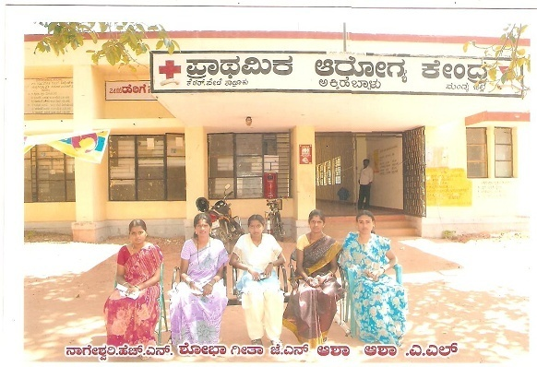
Table 8
Details of the Volunteers (Homemakers) from Hullahalli in Phase 1

Sl. No. | Name of the volunteer | Identification No. | Villages Surveyed
1. | Manjula | HU- 01 | Hullahalli
2. | Lakshmamma | HU- 02 | Hullahalli
3. | Jayalakshmamma | HU- 03 | Belele, Shiramalli
4. | Jyothi | HU- 04 | Madapura, Karya  Mainskaggaluru
5. | Prema | HU- 05 | Kembal
6. | Nirmala | HU- 06 | Ahalya, Rampura
7. | Rajamma | HU- 07 | Kurihundi
8. | Shaila | HU- 08 | Hegdahalli, Mobahalli  Kongalli
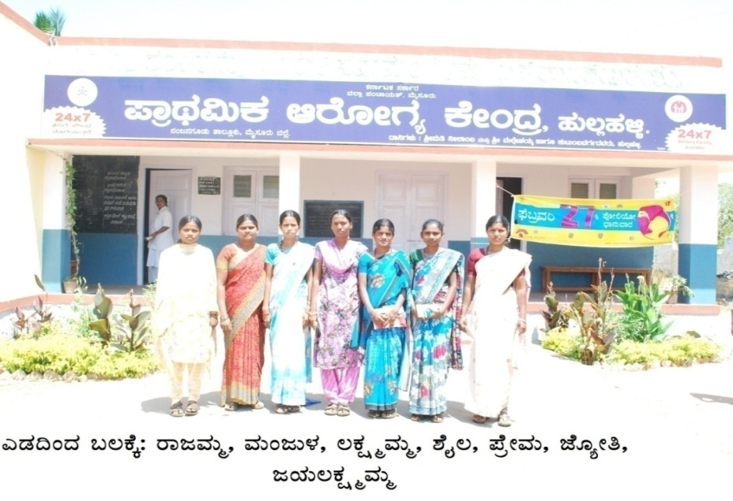

 | Note: Services of Mrs. Nirmala was discontinued due to irregularity in the work.
Table 9
Details of the ASHA workers from Gumballi in Phase 1
Sl. No. | Name of the volunteer | Identification. No. | Villages Surveyed
1. | Umamaheshwari | GU- 01 | Gumballi
2. | Nagamani | GU- 02 | Gumballi
3. | Lakshmi | GU- 03 | Uppinamole
4. | Shivamma | GU- 04 | Yaragamballi
5. | Sunitha S. | GU- 05 | Dasanahundi
6. | Prema N. | GU- 06 | Y K mole
7. | Savithramma | GU- 07 | Y K mole
8. | Mahadevi | GU- 08 | Y K mole
9. | Pushpalatha | GU- 09 | Changasahalli
10. | Rajeshwari | GU- 10 | Changasahalli
11. | Indrani | GU- 11 | Komanapura
12. | Sannamma | GU- 12 | Yaragamballi
13. | Vijaya | GU- 13 | Yaragamballi
14. | Bhagyalakshmi | GU- 14 | Krishnapura
15. | Pramiladevi | GU- 15 | Yaragamballi
16. | Mangalamma | GU- 16 | Ganigannur
17. | Sumalatha | GU- 17 | Komanapura
18. | Sannamma | GU- 18 | B R Hills
19. | Kamala | GU -19 | B R Hills

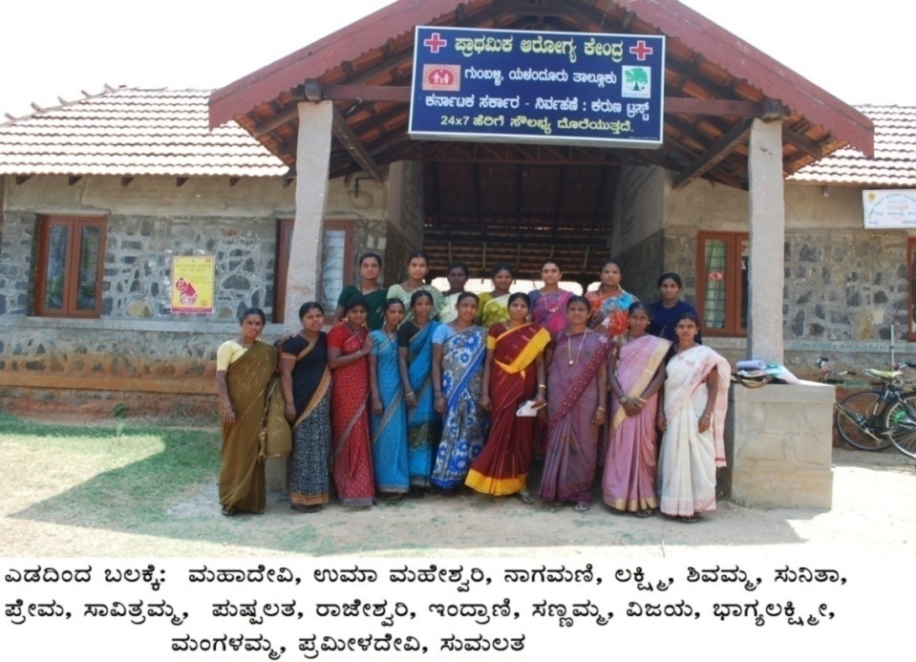
Note: Services of Mrs. Sannamma and Mrs.Kamala were discontinued due to irregularity in the work

Table 10
Details of the High-School Student Volunteers from Akkihebbalu in Phase 1
Sl. No. | Name of the student volunteer | Identification No. | Villages Surveyed
1 | Sandyashree A.M. | HS - 1/C | Akkihebbalu
2 | Vijaykumar N. | HS - 1/D | Akkihebbalu
3 | Mahesh J.R. | HS - 2/C | Jainahalli
4 | Ashwini M.B. | HS - 2/D | Mudlapura
5 | Suprith M.D. | HS - 3/C | Machaholalu
6 | Sumanth S.P. | HS - 3/D | Singanahalli
7 | Dharmaraj | HS - 4/C | Vaddragudi
8 | Chaithra M.S. | HS - 4/D | Dadadahalli
9 | Biresh A.M. | HS - 5/C | Mookana koppalu
10 | Manjunath N. | HS - 5/D | Alambaadi &  Hosa Mavinkere
Note: Volunteers from high schools (8th and 9th std) were recruited in Hullahalli and Akkihebbalu on a trial basis only in Phase 1. Due to non availability of their continuous services, they were not continued in Phase 2 of Level 1 survey.

Table 11
Details of the High School student volunteers from Hullahalli in Phase 1
Sl No. | Name of the student volunteer | Identification No. | Villages Surveyed
1 | Thangaraj R. | HS - 1/C | Hullahalli A
2 | Ramya R. | HS - 2/C | Hullahalli B
3 | Girish M. | HS - 3/C | Shirmalli
4 | Mahesh | HS - 3/C | Shirmalli
5 | Krishna Nayak | HS - 3/E | Belale
6 | Preethi B. | HS - 4/C | Maadaapura
7 | Girish K.M. | HS - 4/D | Kaggaluru & Kaaryamains
8 | Shivakumar B. | HS --5/C | Bidaragudu
9 | Mahesh M. | HS - 5/D | Hallikerehundi
10 | Kumar M. | HS --5/E | Kembale
11 | Hemashree | HS - 6/C | Rampura
12 | Prema | HS - 6/D | Rampura
13 | Rangaswamy | HS - 6/E | Gowdru hundi
14 | Nijaguna | HS - 6/F | Ahalya
15 | Srinivasa K. | HS - 7/C | Kurihundi
16 | Guruprasad | HS - 8/C | Kongalli
17 | Yogesh H.J. | HS - 8/D | Heggadahalli
18 | Manoj H. | HS - 8/E | Heggadahalli
19 | Praveen M.N. | HS - 8/F | Moballi & Gandigrama

Table 12
Details of the Volunteers (Homemakers) from Akkihebbal in Phase 2
Sl. No. | Name of the volunteer | Identification. No. | Villages Surveyed
1. | Shoba | AH – 6 | Beeruvalli, Nandipura Arenahalli Colony
2. | Prabhavathi S.R. | AH – 7 | Sakshibeedu
3. | Deepika C.R. | AH – 8 | Hosa Dudukanahalli  Halle Dudukanahalli  Natanahalli
4. | Pankaja | AH – 9 | Gubbahalli, Beekanahalli
5. | Yashodamma | AH - 10 | Moodanahalli  Manchibeedu
6. | Leelavathi | AH – 11 | Chowda Samudra  Hangaramudhanahalli.

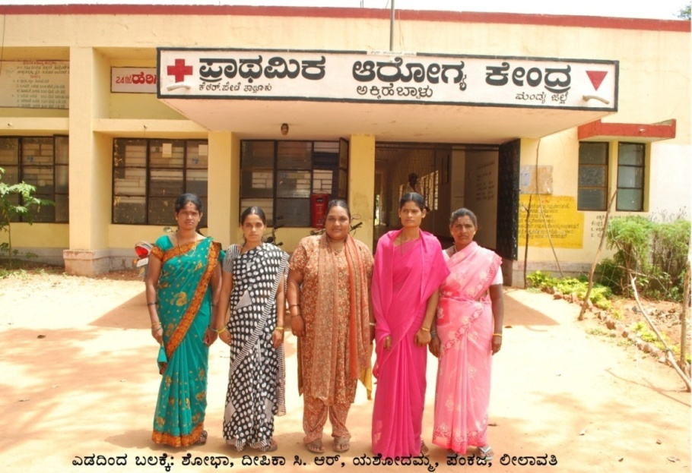

Note: The service of Mrs. Prabhavathi S.R. was discontinued due to irregularity in the work.

Table 13
Details of the Volunteers (Homemakers) from Hullahalli in Phase 2

Sl. No. | Name of the volunteer | Identification. No. | Villages Surveyed
1. | Manjula S. | HU-01 | Kappusoge
2. | Lakshmamma | HU-02 | Madanahalli,Huchaganni  J P Hundi
3. | Jayalakshmamma J.V. | HU-03 | Ibjala
4. | Jyothi | HU-04 | Duggahalli, Yalehalli
5. | Prema | HU-05 | Kannenuru, Alayanapura
6. | Nagarathna | HU-09 | Chandravadi, Motha
7. | Puttamma P. | HU-10 | Haradanahalli
8. | Sudha A.S. | HU-11 | Akala, Basapura
9. | Savitha K. | HU-12 | Kattur
10. | Gayathri | HU-13 | Kadaburu, Rajur
11. | Shruthi M.S. | HU-14 | Nellithalapura
12. | Sakamma | HU-15 | Taraganahalli

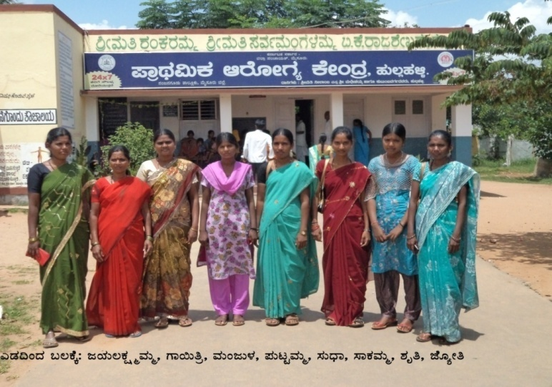

Note: The services of Mrs Lakshmamma, Mrs. Prema, Mrs. Nagarathna and Mrs. Savitha K. were discontinued due to irregularity in the work.

Table 14
Details of the ASHA workers from Gumballi in Phase 2
Sl. No. | Name of the volunteer | Identification. No. | Villages Surveyed
1. | Mahadevamma P | GU - 20 | Gowdahalli
2. | Mahadevamma, M | GU - 21 | Gowdahalli
3. | Yashodha | GU - 22 | Alkere Agrahara
4. | Sudhamani | GU – 23 | Mallarapalya
5. | Ambika | GU - 24 | Boodhithittu
6. | Bhagyamma | GU - 25 | Yeriyuru
7. | Chikamma | GU – 26 | Yeriyuru
8. | Nagamma | GU – 27 | Yeriyuru
9. | Mahadevamma | GU – 28 | Yeriyuru
10. | Leelavathi | GU – 29 | T. Hosur
11. | Padma | GU – 30 | Bannisarige &  Rampura
12. | Manjula | GU – 31 | Bannisarige &  A Devarahalli
13. | Rajamma | GU – 32 | Chamalapura &  Shivakalli

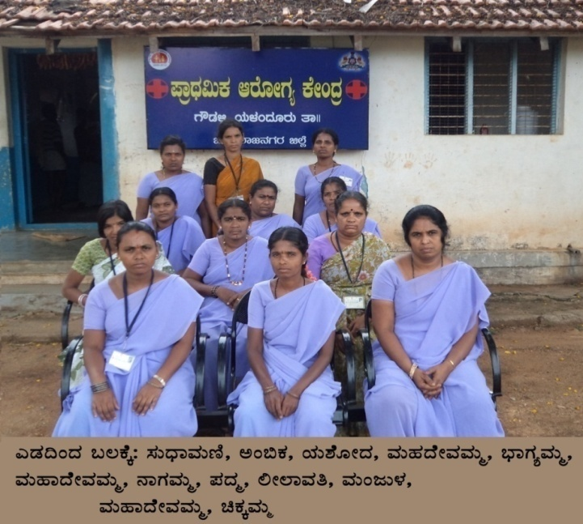

Note: The service of Mrs Rajamma was discontinued due to irregularity in the work.

Table 15
Details of the Volunteers (homemakers from Akkihebbal in Phase 3
Sl. No. | Name of the volunteer | Identification. No. | Villages Surveyed
1. | Sheela H.P. | AH-12 | Belthuru &  Kattekyathanahalli
2. | Asha | AH-13 | Basavanahalli,  Somanathapura &  Guduganahalli
3. | Pushpa | AH-15 | Ambigarahalli &  Sangapura
4. | Bhavitha | AH-14 | Somanahalli
5. | Suguna | AH-16 | Momballi
6. | Deepa | AH-17 | Alambadi kavalu
7. | Bhavya | AH-18 | Pura

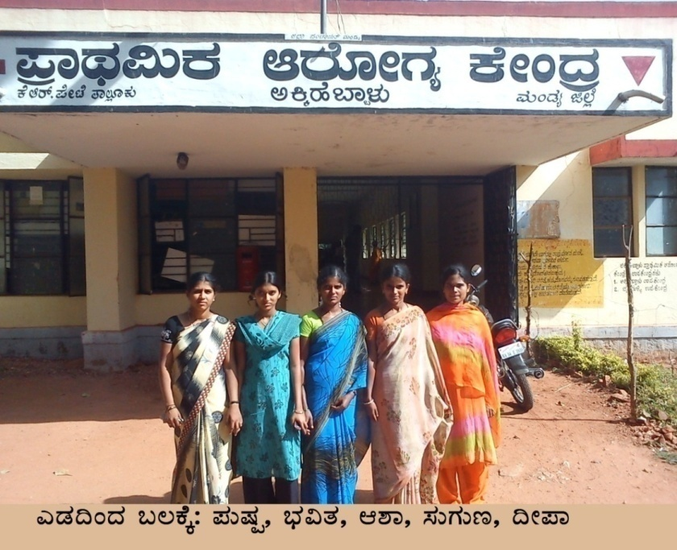

Note: The services of Mrs Sheela H.P. and Bhavya were discontinued due to irregularity in the work.

Table 16
Details of the Volunteers (Homemakers) from Hullahalli in Phase 3
Sl. No. | Name of the volunteer | Identification. No. | Villages Surveyed
1. | Gowramma K.C. | HU-16 | Kellupura  Mellahalli
2. | Manjula S | HU-17 | Kadajetti  Madakehundi
3. | Nagalakshmi G. | HU-18 | Hariyuru  Jalahalli  Chennapatna
4. | Manjula | HU-19 | Hura
5. | Roopa C. | HU-20 | Siddegowdanahundi
6. | Shruthi | HU-21 | Yadahalli
7. | Kavitha | HU-22 | Malkundi
8. | Jyothi | HU-22 (b) | M Kongalli

 | 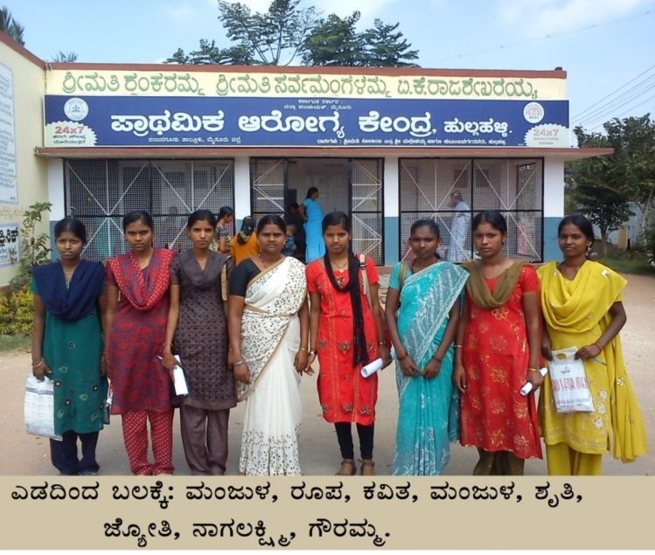
Table 17
Details of the ASHA workers from Gumballi in Phase 3
Sl. No. | Name of the volunteer | Identification. No. | Villages Surveyed
1. | Gowramma | GU-33 | Yelanduru
2. | Shivamma P. | GU-34 | Yelanduru
3. | Mangalamma | GU-35 | Yelanduru
4. | Lakshmi | GU-36 | Yelanduru
5. | Mahadevi | GU-37 | Yelanduru
6. | Prabhavathi | GU-38 | Ambele
7. | Yashoda C. | GU-39 | Ambele
8. | Sunanda | GU-40 | Ambele

 | 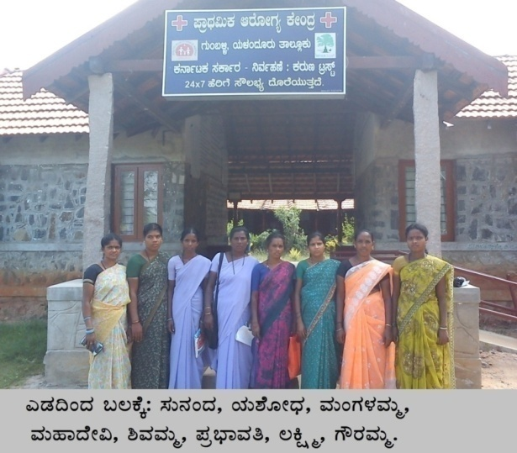
Table 18:
Details of the Volunteers (Homemakers) from Akkihebbalu in Phase 4
Mandagere PHC
Sl. No. | Name of the volunteer | Identification. No. | Villages Surveyed
1. | Rathna | AH-19 | Bevinahalli,  Bevinahalli koppalu
2. | Mangala | AH-20 | Gadde hossuru  Chikamandagere koppalu
3. | Sudha M.N. | AH-21 | Shravanahalli,  Uddinabore
4. | Premila M.N. | AH-22 | Mandagere
Alenahalli PHC
Sl. No. | Name of the volunteer | Identification. No. | Villages Surveyed
1. | Yashodamma | AH-23 | - Honnenahalli  - Honnenahalli kodi  - Honnenahalli kere  - Honnenahalli koppalu
2. | Shoba | AH-24 | - Alenahalli  - Kythanahalli

 | 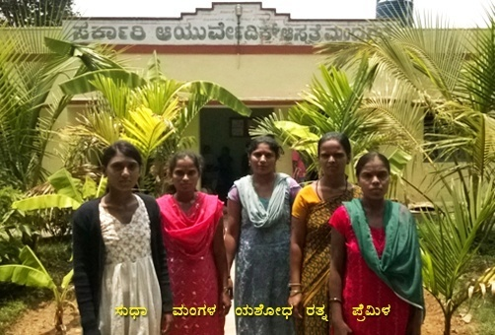
Table 19
Details of the Volunteers (Homemakers) from Hullahalli in Phase 4
Kasuvinahalli PHC
Sl. No. | Name of the volunteer | Identification. No. | Villages Surveyed
1. | Lakshmi | HU-23 | Haginavalu
2. | Nanjamani | HU-24 | Aratale
3. | Mahadevamma | HU-25 | Ambale
4. | Manjula | HU-26 | Ambale
5. | Kalpana | HU-27 | Haginavalu  Siddaiahna hundi
6. | Manjula | HU-28 | Valagere
7. | Mahadevamma | HU-29 | Valagere
8. | Manjula | HU-30 | Kasuvinahalli  Makanapura
9. | Jyothi | HU-31 | Sooralli  Elachigere
10. | Asha | HU-32 | Krishnapura  Lakshmana pura
Maduvinahalli –PHC
Sl. No. | Name of the volunteer | Identification. No. | Villages Surveyed
1. | Roopa | HU-33 | Devarayashetti pura(Hanchipura)
2. | Manjula | HU-34 | Maduvinahalli  Hosbeedu
3. | Nagalakshmi | HU-35 | Anjanapura  Kurubarahatti
Yadiyala -PHC
Sl. No. | Name of the volunteer | Identification. No. | Villages Surveyed
1. | Indumathi | HU-36 | Kandegala
2. | Kavitha | HU-37 | Hadya
3. | Shruthi | HU-38 | Bunkalli &  Hadyada hundi
4. | Indramma | HU-39 | Yadiyala
5. | Rekha | HU-40 | Yadiyala
 | 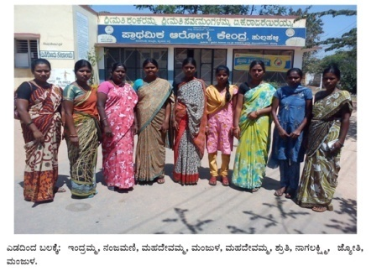
Table 20
Details of the ASHA workers from Gumballi in Phase 4
Sl. No. | Name of the volunteer | Identification. No. | Villages Surveyed
1. | Savitha | GU-41 | Honnur
2. | Yashoda | GU-42 | Kesthuru
3. | Gowramma | GU-43 | Kandahalli
4. | Jayamma | GU-44 | Kesthuru
5. | Nagamani | GU-45 | Kesthuru
6. | Rajamma | GU-46 | Kesthuru
7. | Puttathayamma | GU-47 | Beekanahalli
8. | Yashoda A | GU-48 | Honnuru
9. | Nagarathna K | GU-49 | Duggahatti
10. | Sharadhamba | GU-50 | Honnuru
11. | Puttalingamma | GU-51 | Mellahalli
12. | Vimala | GU-52 | Honnuru
13. | Siddanagamma | GU-53 | Kesthuru
14. | Radha | GU-54 | Honnuru

 | 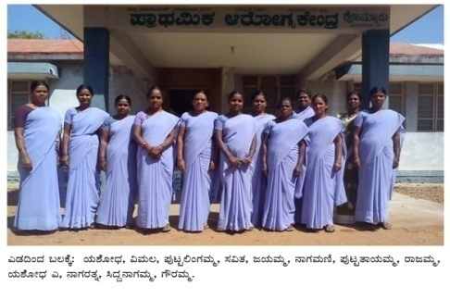
Overview of ASHA workers and Volunteers across the 3 districts | An overview of the number of ASHA workers and volunteers recruited for the survey representing the number of villages and population surveyed by them in the three hoblis across the three districts is shown in Table 21.  Table 21  Overview of the survey carried out by the ASHA workers and Volunteers
  Sl No. | District & Taluk | Hobli | No. of ASHA workers (A)/  Volun-teers (V) | Tot-al No. of PHCs | Total No. of villa-ges survey-ed | Total no. of  houses survey-ed | Total population screened for communication disorders
  1 | Mandya,  K.R.  Pete | Akki-hebbalu | 22 - V | 5 | 54 | 6,071 | 37,521
  2 | Mysore, Nanjangud | Hulla-halli | 40 - V | 6 | 77 | 15,623 | 1,01,852
  3 | Chamraja-nagara Yelandur | Gum-balli | 51 - A | 4 | 31 | 11,018 | 72,093
   |  |  | 113 | 15 | 162 | 32,712 | 2,11,466
Training of ASHA workers and Volunteers | ASHA workers from Gumballi PHC (catering to Santhemaralli hobli) and selected Homemaker volunteers and high school students as volunteers from Akkihebbal and Hullahalli hoblis were trained for one day at AIISH, Mysuru. They were oriented and trained to: (a) Identify the characteristics and high risk factors of various communication disorders seen in children and adults [facilitated through provision of a printed manual prepared in Bilingual text (English-Kannada) as given in Appendix 1.7 and also though audio visual input by Speech-Language Pathologists and Audiologists] (b) Use the checklists and protocols provided to them to facilitate identification of persons at risk or with communication disorders when they conduct house to house survey in villages and (c) Use the data entry sheets, referral slips and their identification codes appropriately while filling the details after the survey.
Supervision | The ASHA workers were supervised and guided in the field by the Field Supervisor and Speech and Hearing Assistant under the supervision of the Research officer and investigators. They were supervised and guided to refer the persons identified as having communication disorders to the OSC located in Gumballi PHC. The Homemaker volunteers and high school student volunteers were supervised and guided to refer the persons identified as having communication disorders to the OSC located in the PHCs of Akkihebbalu and Hullahalli.
Phase wise details of Geographical location, Population, ASHA workers &  Volunteers | Since the population to be screened for communication disorders was approximately 2,07,132, as per the PHC records, the survey was conducted in 4 phases: Phase 1 to 4. In Phase 1 of the survey, villages located at a perimeter of 5 kms from the OSC in the three hoblis were included. In Phase 2 of the survey, villages located at a perimeter of 10 kms from the OSC in the three hoblis were included. In Phase 3 of the survey, villages located at a perimeter of 15 kms from the OSC in the three hoblis were included. In Phase 4 of the survey, villages located at a perimeter of >15 kms from the OSC in the three hoblis were included. (Appendix 2). Geographical Locations Covered in different taluks across the four phases are given in table 22, 23, 24, 25 & summary for the same is given in table 26.
Table 22

Details of Phase I of the Survey

MANDYA DISTRICT |  | MYSURU DISTRICT |  | CHAMARAJANAGARA DISTRICT |  | Total
K.R.Pete Taluk |  | Nanjangud Taluk |  | Yelandur Taluk
Akkihebbalu Hobli |  | Hullahalli Hobli |  | Gumballi Hobli
List of Villages in Akkihabbalu PHC & Jainahalli Sub PHC |  | List of Villages in Hullahalli PHC |  | List of Villages in Gumballi PHC
A
- Akkihebbalu |  | - Hullahalli |  | - Gumballi
- Hosa Daddadahalli |  | - Ram pura |  | - Gangawadi
- Hale Daddadahalli |  | - Gowdru Hundi |  | - Dasanahundi
- Machaholalu |  | - Ahalya |  | - Yaragamballi
- Mookanakoppalu |  | - Bidara Gudu |  | - B.R.Hills
- Railway Station |  | - Hallikere Hundi |  | - Komaranapura
- Vaddaragudi |  | - Kembal |  | - Vaddagere
B |  | - Kuri Hundi |  | - Y.K.Mole
Jainahalli – Sub PHC |  | - Mada Pura |  | - Ganiganur
- Jainahalli |  | - Karya |  | - Krishnapura
- Alambaadi |  | - Kaggal Uru |  | - Uppinamole
- Hosa Mudlapura |  | - Shirmali |  | - Changachahalli
- Hale Mudlapura |  | - Belele |  | - Hegdehundi
- Ippanahalli |  | - Kongalli
- Hosamavinakere |  | - Hegdalli
- Singanahalli |  | - Moballi
Total | 14 | 16 |  |  | 13 | 43
Total- No. of Home maker Volunteers (in Akkihebbalu and Hullahalli) and ASHA workers ( in Gumbahalli ) included in the survey | 05 | 08 |  |  | 17 | 30
Total No. Houses surveyed | 2,044 | 4,272 |  |  | 3,529 | 9,845
Total Population surveyed | 10,256 | 29,827 |  |  | 19,920 | 60,003

Table 23

Details of Phase 2 of the Survey

MANDYA DISTRICT |  | MYSURU DISTRICT |  | CHAMARAJANAGARA DISTRICT |  | Total
K.R.Pete Taluk |  | Nanjangud Taluk |  | Yelandur Taluk
Akkihebbalu Hobli |  | Hullahalli Hobli |  | Gumballi Hobli
List of Villages in Berruvalli PHC & Mudnahalli Sub PHC |  | List of Villages in Chandravadi PHC |  | List of Villages in Gowdahalli PHC
 | A
 | Beeruvalli PHC
 | Beeruvalli |  | Chandravadi |  | Gowdahalli
 | Gubballi |  | Motha |  | Malarapalya
 | Nandipura |  | Kappusoge |  | T.Hossuru
 | Arenahalli |  | Alayan Pura |  | Boodhitittu
 | Beekanahalli |  | Kannenuru |  | Shivakalli
 | Colony |  | Katturu |  | Alakere Agrahara
 | Handhi Beekanahalli |  | Akala |  | A.Devarahalli
 | Sakshibeedu |  | Nelitala Pura |  | Chamalapura
 | Hale Dudukanahalli |  | Kadaburu |  | Bannisarige
 | Hosa Dudukanahalli |  | Bassapura |  | Rampura
 | B |  | Rajuru |  | Yeriyuru
 | Mudnahalli – Sub PHC |  | Aragana Halli
 | Mudnahalli |  | Hullhagani
 | Natanahalli |  | Ibsala
 | Chowdasamudra |  | Madana Halli
 | Angara Mudnahalli |  | J. P. Hundi
 | Manchibeedu |  | Yalehalli
 |  |  | Shettalli
 |  |  | Taragana Halli
 |  |  | Duggahalli
Total |  | 15 | 20 |  | 11 | 46
Total- No. of Home maker Volunteers (in Akkihebbalu and Hullahalli) and ASHA workers ( in Gumbahalli ) included in the survey |  | 05 | 08 |  | 12 | 25
Total No. Houses surveyed |  | 1,287 | 4,174 |  | 2,679 | 8,140
Total Population surveyed |  | 9,630 | 21,554 |  | 12,243 | 43,427

Table 24
Details of Phase 3 of the Survey
MANDYA DISTRICT |  | MYSURU DISTRICT |  | CHAMARAJANAGARA DISTRICT |  | Total
K.R.Pete Taluk |  | Nanjangud Taluk |  | Yelandur Taluk
Akkihebbalu Hobli |  | Hullahalli Hobli |  | Gumballi Hobli
List of Villages in Somanahalli PHC & Alambadi Kavalu Sub PHC |  | List of Villages in Hura PHC |  | List of Villages in Yelandur PHC
 | A
 | Somanahalli PHC
 | Somanahalli |  | Hura |  | Yelandur
 | Katte Kyathanahalli |  | Mellahalli |  | Ambele
 | Pura |  | Kellupura
 | Sangapura |  | Siddegowdana Hundi
 | Ambigarahalli |  | Chanpatna
 | Hosa Belthuru |  | Malkund
 | Hale Belthuru |  | M Kongalli
 | B |  | Kadajetti
 | Alambadi Kavalu - Sub PHC |  | Madike Hundi
 | Alambadi Kavalu |  | Shantayan Hundi
 | Basavanahalli |  | Kaggalli Hundi
 | Somanathapura |  | Madalli
 | Guduganahalli |  | Hariyuru
 | Momballi |  | Jalahalli
Total |  | 12 | 14 |  | 02 | 28
Total- No. of Home maker Volunteers (in Akkihebbalu and Hullahalli) and ASHA workers ( in Gumbahalli ) included in the survey |  | 06 | 08 |  | 08 | 22
Total No. Houses surveyed |  | 1,673 | 2,263 |  | 2,240 | 6,176
Total Population surveyed |  | 10.987 | 13,916 |  | 11,249 | 36,152

Table 25
Details of Phase 4 of the Survey

MANDYA DISTRICT |  | MYSURU DISTRICT |  | CHAMARAJANAGARA DISTRICT |  | Total
K.R.Pete Taluk |  | Nanjangud Taluk |  | Yelandur Taluk
Akkihebbalu Hobli |  | Hullahalli Hobli |  | Gumballi Hobli
List of Villages in Mandagere PHC & Alenahalli sub PHC |  | List of Villages in Kasuvina Halli PHC & Maduvinahalli PHC |  | List of Villages in Honnur PHC
 | A |  | A
 | Mandagere PHC |  | Kasuvinahalli PHC |  | Honnur PHC
 | Mandagere |  | Kasuvina Halli |  | Kandahalli
 | Shravanahalli |  | Makana Pura |  | Mellahalli
 | Uddina Bore |  | Byalaru Hundi |  | Duggahalli
 | Chikka Mandagere Koppalu |  | Sooralli |  | Honnur
 | Gadde Hosuru |  | Elachigere |  | Kesturu
 | Bevinahalli Koppalu |  | Siddayana Hundi
 | Bevinahalli |  | Kuguluru
 | B |  | Lakshmanapura
 | Alenahalli PHC |  | Krishna Pura
 | Alenahalli |  | Holagere
 | Honnenahalli |  | Aratale
 | Honnenahalli Kodi |  | Haginavalu
 | Honnenahalli Kere |  | Huskuru
 | Honnenahalli Koppalu |  | Ambale
 | Kyathanahalli |  | B
 |  |  | Maduvinahalli PHC
 |  |  | Maduvina Halli
 |  |  | Hosa Beedu
 |  |  | Anjana Pura
 |  |  | Kurubara Hatti
 |  |  | Hanchi Beedu
 |  |  | Naganna Pura
 |  |  | Ballur Hundi
 |  |  | Indira Nagara
 |  |  | C
 |  |  | Yadiyala PHC
 |  |  | Yadiyala
 |  |  | Bankalli
 |  |  | Kandegala
 |  |  | Hadya
 |  |  | Hadyad Hundi
Total |  | 13 | 27 |  | 05 | 45
Total- No. of Home maker Volunteers (in Akkihebbalu and Hullahalli) and ASHA workers ( in Gumbahalli ) included in the survey |  | 06 | 16 |  | 14 | 36
Total No. Houses surveyed |  | 1,066 | 4914 |  | 2,570 | 8,550
Total Population surveyed |  | 11,926 | 38,681 |  | 16,943 | 67,550

Table 26

Overview of all four Phases of the Survey

Sl. No. | Phases | Total No. of Hoblis | Total No. of PHC | Total No. of villages covered | Total no. of  houses covered | No. of Home maker volunteers and ASHA Workers included | Total population screened for communication disorders
1 | Phase 1 | 03 | 04 | 43 | 9,845 | 30 | 60,003
2 | Phase 2 | 03 | 04 | 46 | 8,140 | 25 | 43,427
3 | Phase 3 | 03 | 04 | 28 | 6,176 | 22 | 36,152
4 | Phase 4 | 03 | 06 | 45 | 8,551 | 36 | 67,550
Total |  | 12 | 18 | 162 | 32,712 | 113 | 2,07,132

Time line | The time line for level 1 of the survey, including follow up evaluation and guidance offered to persons identified with communication disorders was as shown in Figure 1 (Overall 21 months from 20.9.2010 to 5.6.2012).  Figure 1: Timeline of the project
  Activity | Period in Months
  Activity | 0-1 | 2- 19 | 20 – 21
  Recruitment of personnel of the Project
  Selection and training of ASHA workers, Homemakers
  Volunteers and High school students
  Survey Program
  Evaluations of persons with communication
  disorders at OSC’s
  Evaluations of persons with communication
  disorders at Camps
  Report writing
Follow up procedures for evaluation of persons identified with communication disorders through the survey | 100 % follow up of all the identified persons was carried out. The persons identified with communication disorders from various villages in the hoblis of Hullahalli, Akkihebbalu and Gumballi were referred to the Outreach Service Centers (OSCs) of the All India Institute of Speech & Hearing, Mysuru at the PHCs of Hullahalli, Akkihebbalu and Gumballi respectively. At the OSCs, detailed evaluation, diagnosis and further rehabilitation process was undertaken by Speech-Language Pathologists and Audiologists. For those persons who could not attend the OSCs, they were referred to series camps arranged through the project by the institute at various PHCs in order to carry out the activities of evaluation, diagnosis and referral for further rehabilitation needs. Despite this attempt few could not attend the camps. The purpose was to ensure evaluation of 100 % of the persons identified with various communication disorders and recommend further rehabilitation process.
Checking awareness for communication disorders in ASHA workers, Volunteers & General Public | A questionnaire was prepared to test for awareness of communication disorders and facilities available for the rehabilitation of such individuals among the ASHA workers/volunteers recruited for the survey (Appendix 3 A). Another questionnaire was prepared to test the awareness of general public (representing various strata of the society in the villages where survey was conducted) with regard to the types of communication disorders (Appendix 3 B). These were administered to the target groups before the termination of this leg of survey (post hoc - 06.08.2012 to 30.08.2012). The responses are analyzed and reported under results section.

