**TIN: 33240863890**

**CST - 1010497/19/1/10**

**To July /18/ 2017**

**Mr.Shiji Kumar**

**Mysore**

**890 4430 355**

**Subject: Unitech’s Document Management Solutions.**

Dear Sir,

We would like to thank you for your Interest in Unitech Document Management Solutions. Reference to our discussion we are pleased to submit our techno-commercial proposal for your kind perusal.

We would like to reiterate that we are very keen on enhancing our business relationship with your prestigious company and would look forward to a mutually beneficial business relationship.

Thanking you in anticipation of your valued order and assuring you of our best of services at all times.

Yours truly,

For **Unitech Imaging Systems India Pvt Ltd**

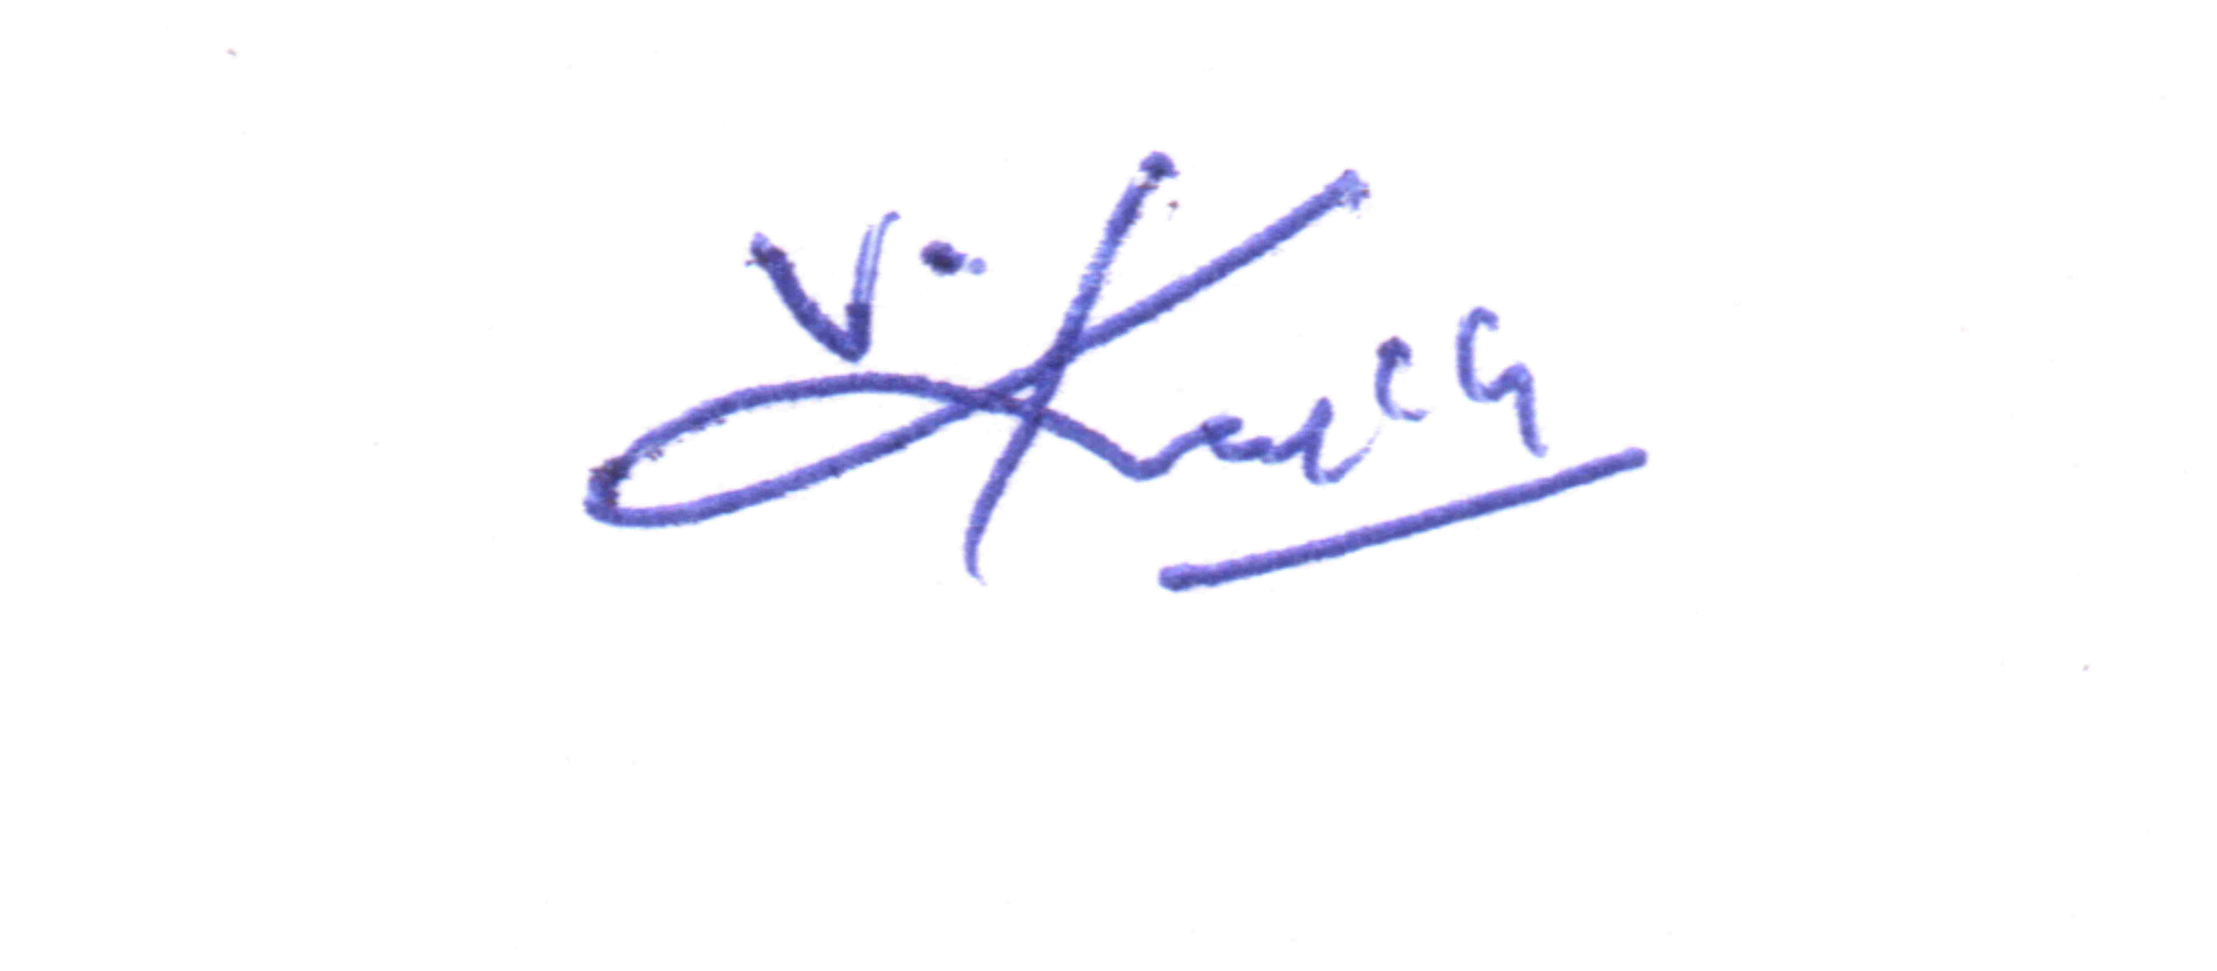

**V Karthik**

**Managing Director**

(Enclosed techno-commercial proposal)

**Commercial Proposal for Colour Machine**

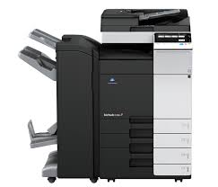

|  |  |  |  |
| --- | --- | --- | --- |
| **Description** | Basic Rate | Qty | Total Basic Price |
| **Konica Minolta Bizhub C 258**  **A3 Colour digital printer**   * **25 cpm,** * **Copy** * **Network Printer** * **Network Scanner** * **2 Trays** * **Multi By Pass Tray** * **Duplex** * **Upto 300 GSM** * **1200 DPI** | 2,20,000 | 01 | 2,20, 000 |
| **Total** |  |  | 2,20,000 |

**Commercial Proposal for Colour Machine**

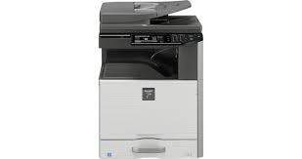

|  |  |  |  |
| --- | --- | --- | --- |
| **Description** | Basic Rate | Qty | Total Basic Price |
| **Sharp DX 2000 U**  **A3 Colour digital printer**   * **20 cpm,** * **Copy** * **Network Printer** * **Network Scanner** * **2 Trays** * **Multi By Pass Tray** * **Duplex** * **Upto 300 GSM** * **600 DPI** | 1,48,000 | 01 | 1,48,000 |
| **Total** |  |  | 1,48,000 |

* **AMC Can be taken with us after warranty Period**
* **Consumables, spares can be supplied by us**

**TERMS & CONDITIONS:**

Warranty : 6 months for sharp

3 months or 30,000 copies whichever is earlier Konica Minolta

Delivery : Immediate

Payment : 100% against P.O

Taxes : 28% Gst Applicable

Thanking You

For **Unitech Imaging Systems India Pvt.Ltd,**

**Angelin**

**Sales Manager**

**9382 9382 42**