**Library and Information Centre**

The Library and Information Centre (LIC) of the institute is the foremost learning resource centre pertaining to communication disorders in the country. It is enriched with one of the world’s best collection of speech and hearing information sources. Founded along with the institute in the year 1965, the LIC is housed in a three-storey building of 26, 000 sq.ft. With its outstanding collection of information resources, traditional and technology based information services and comfortable and large learning space, the LIC has been catering to the information needs of students, researchers, teachers and practitioners of speech and hearing and allied areas in the institute as well as those across the nation.

**Objective**

Theobjective of the LIC is to satisfy the information requirements of persons working in the field of communication disorders.

**Information Resources**

The LIC holds a variety of information sources on communication disorders both in print and electronic formats. The traditional print resources include books, journals, theses and dissertations. The electronic resources are constituted of e-books, e-journals, online databases CD-ROMs and digital research repository.

**Print Books:** The LIC has a vast collection of print books pertaining to audiology, speech language pathology, speech language sciences, and allied areas such as special education, clinical psychology and linguistics. Almost all the books on the subject matter of communication disorders published from different parts of the world are being procured by the library.Totally there are more than 14000 books and great majority of them are on communication disorders.

**Print Journals and Bound Volumes**: With a view to keep the professionals abreast of the latest developments, the LIC subscribes to all the major national and international journals pertaining to communication disorders. Currently, 109 journals are subscribed of which 36 are available in print format. Upon completion of a volume, the journal issues are bound into one and keep for reference**.** Totally we havemore than3000bound volumes of periodicals.

**Theses and Dissertations:** The LIC has a good collection of research reports based on the research works carried out in the institute at different levels. These include postgraduate dissertations, doctoral theses and funded research project reports on various aspects of communication disorders.

**E-books:** The LIC has a collection of 176 E-books procured directly by the institute from 4 major publishers in the field, namely Taylor & Francis, Elsevier, Cambridge University Press and Wiley Black. In addition, it is providing access to more than 3000 E-books on communication disorders and allied areas selected from the N-LIST E-book collection.

**E-journals:** Majority of the journals pertaining to communication disorders are availableonline.Of the 109 journals subscribed during the calendar year, 98 are in electronic format. In addition to the directly subscribed 98 E-journals, LIC is getting access to more than 3000 biomedical E-journals as part of ERMED consortium and NLIST.

**Online Databases**: The LIC subscribes two reputed online bibliographic databases in the field of communication disorders published by Proquest Incorporation namely, COMDISDOME, which covers communication disorders literature worldwide and LLBA (Linguistics and Language Behaviour Abstract) which covers international literature in linguistics and related disciplines in the language sciences.

**Digital Repository:** All the reports of the research activities taking place in the institute on various aspects of communication disorders are being digitized to make available on the digital repository over the web portal. There are options for author, keyword, title and subject based searching as well as simple and advanced searching of postgraduate dissertations, doctoral theses, independent project reports and departmental project reports on the repository. Totally there are around one lakh pages of research reports in the repository.

**CD-ROM Resources:** The LIC is having acollection ofmore than 300CD-ROM resourcespertaining to communication disorders.

**Information Services**

The LIC provides both traditional and electronic information services to the user community. The major traditional information services provided are: (a) Reference Servicein which qualified information professionals assist the users in matters such as identification of required information, evaluation of information resources and usage of various types of information resources, (b) Book Lending Service in which books are issued on loanfor a period of time to the users, (c)Reprographic Servicein which photocopying of library resources are provided.

The electronic information services provided include (a) Internet Service at the computer centre of the LIC with the facility for accommodating thirty five users at a time, (b) National Library and Information Services Infrastructure for Scholarly Content (N-LIST), an electronic information service by the UGC-INFLIBNET for higher education institutions in which the users can access thousands of e-books and e-journals using user name and password, (c)Web Portal based Servicesin whicha variety of information services are provided through our web portal at [www.aiish.ac.in](http://www.aiish.ac.in) such as Online Public Access Catalogue (OPAC) service, Digital Research Repository service, access to the subscribed and freely available e-Journals, e-books and online databases and, (d) Plagiarism Checking Service in which the research papers and reports prepared by the staff and students are checked for plagiarism using TURNITIN, the world’s most widely used plagiarism checking software.

**Major Milestones**

**1968-69**

* Received more than 3000 speech and hearing books and learning resources from the Wendell Johnson Speech and Hearing Center, University of Iowa, USA, as gift.

**1976-77**

* Launched Card Catalogue and Kardex based periodical control

**1978-79**

* Completed Classified Indexing of the whole collection.

**2001-02**

* The LIC was shifted to a new multi-storey building.
* Internet Centre was launched

**2003-04**

* The LIC was upgraded to Category III based on the the recommendation of the expert committee constituted by the Ministry of H&FW, Govt.of India.

**2004-05**

* Automation work completed using LIBRIS software.
* Online Public Access Catalogue was launched.

**2008-09**

* Started providing ERMED service of the Ministry of H&FW, Govt. of India to access more than 2500 national and international journals on medicine and allied health.

**2009-10**

* The LIC web portal and digital repository was launched and started providing free access to the institute digital repository over the web.

**2010-11**

* Started procuring e-books and online databases.
* Automated the entire in-house activities using ‘Book Magic’ an integrated library management system.

**2011-12**

* Organized the information resources using Dewey Decimal Classification, 23rd Ed.
* Extended the electronic information services to the 11 DHLS centres of the institute spread across the country by launching Virtual Private Network (VPN).

**2012-13**

* Started providing the National Library and Information Services Infrastructure for Scholarly Content (N-LIST) service of UGC-INFLIBNET.

**Research Activity under Progress**

Electronic publishing of the Journal of All India Institute of Speech and Hearing using Open Source Software.

**Upcoming Projects and Areas of Expansion**

* Setting up of language laboratory
* Implementation of electromagnetic security and CCTV surveillance system
* Launching of multimedia resource centre
* Up-gradation of Internet centre to a high-tech learning centre
* Design and development of national digital repository on communication disorders

**Staff Details**

* Dr. Shijith Kumar C, Library and Information Officer
* **M. Mahadeva,** Assistant Library and Information Officer
* **B. Nandeesha,** Sr. Library and Information Assistant
* **Nidheesh David Kuruvila,** Sr. Library and Information Assistant
* **M. Nanjunda Swamy,**  Library and Information Assistant
* **P. Lokesh,** Library Assistant
* **K. Chowdaiah,** Library Attendant
* **V. Raju,** Library Attendant

**Contact Details**

Dr. Shijith Kumar C, Library and Information Officer

Phone: 0821-2514449 extn 150

E-Mail: [lio@aiishmysore.in](mailto:lio@aiishmysore.in)

Website: [www.aiish.ac.in](http://www.aiish.ac.in)

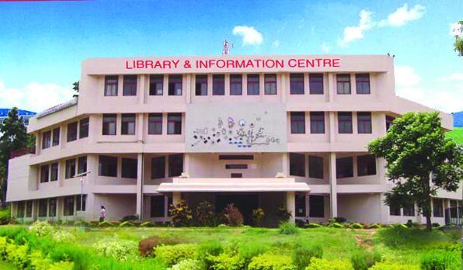

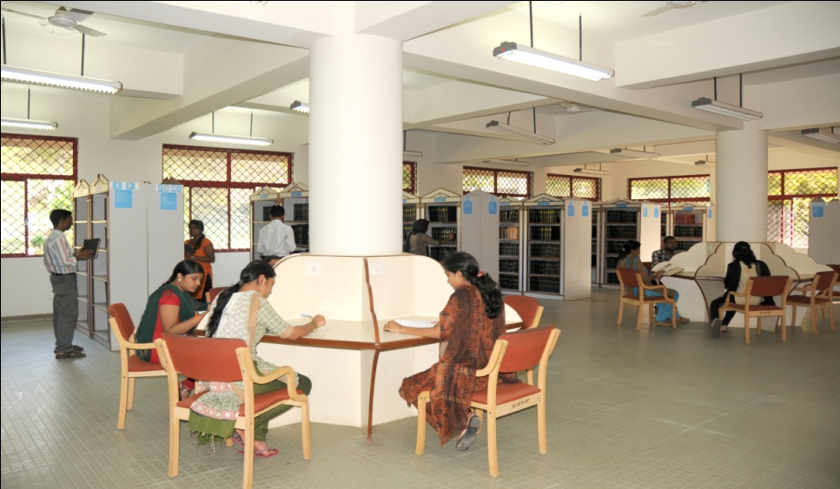

ALL INDIA INSTITUTE OF SPEECH AND HEARING

**LIBRARY AND INFORMATION CENTRE**

SH/LIC/NAAC 22.02.13

Sub: Departmental Brochure in connection with NAAC-Furnishing Information-reg.

Submitted to the Director.

With reference to the above, please find enclosed the material pertaining to the Library and Information Centre.

Library and Information Officer