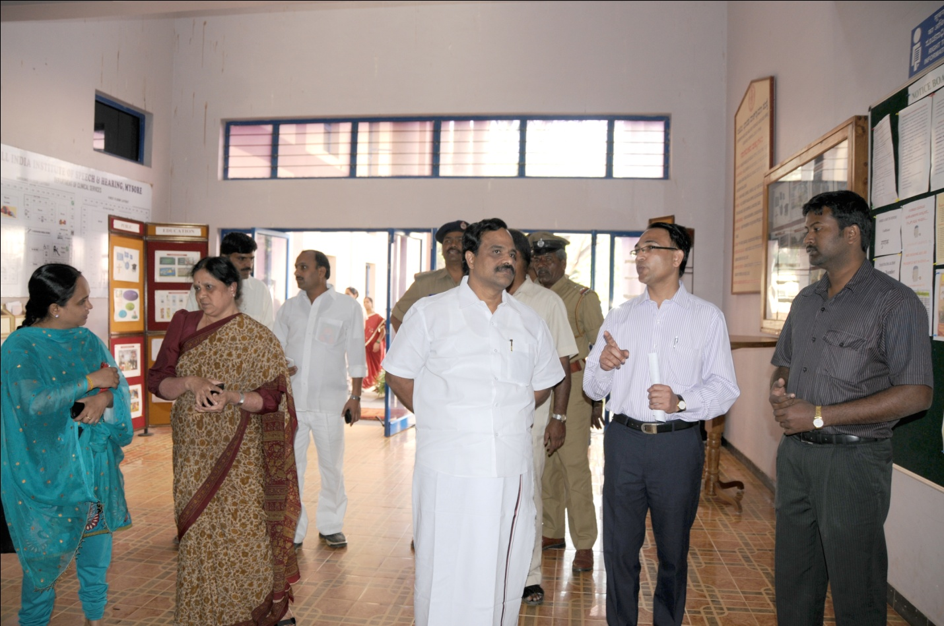

Mr. S. Gandhiselvan, Minister of State for H& FW visiting the Department of Clinical Services