DEPARTMENT OF PREVENTION OF COMMUNICATION DISORDERS (POCD)

ANNUAL REPORT APRIL 2011 TO MARCH 2012

1. **MANPOWER DEVELOPMENT**
2. **ACADEMIC ACTIVITIES**
3. **Short-term training programs**

The department carried out short-term training activities in the report year. Three candidates from Bangladesh were given orientation on prevention, identification and management of communication disorders. They also observed new born hearing screening program being carried out at various hospitals/immunization centres. Details of the short-term training program are given in Table 1. The objective of the program was to sensitize the candidates on the ways for prevention and early identification of communication disorders.

*Table 1: Candidates from Bangladesh who attended short-term training program*

|  |  |  |
| --- | --- | --- |
| *SN* | *Candidate* | *No. of days* |
| 1 | Mr. Mazharul Islam Manik Audiometrician, Dhaka | 3 days (29th of July, 1st and 2nd of august 2011) |
| 2 | Ms.Sabrina Babur  Speech Language Pathologist | 5 days (22nd of August to 26th of August) |
| 3 | Ms.Edna Eugine Fernandez  Speech Language Pathologist | 7 days (21th of October to 30th of October) |

1. **Orientation programs /Seminar/ Conference /Workshop/conducted:**

Several orientation programs were conducted at AIISH and outside AIISH on prevention, early identification and management of hearing impairment. The objective of these orientation programs was to create awareness among the target group on prevention and early identification of communication disorders. Table 2 gives the details of the orientation programs.

*Table 2: Orientation Programs conducted by the department of POCD*

|  |  |  |  |  |  |  |  |  |  |
| --- | --- | --- | --- | --- | --- | --- | --- | --- | --- |
| *Date* | *Target group* | *Staff who gave the orientation* | | *Topic* | | *No. of students + Staff* | | *Venue* | |
| At AIISH | | | | | | | | | |
| 20.4.2011 | Selected ASHA Health workers, Homemakers, Volunteers | | Dr. R Manjula, Pragathi E,  Prashasthi P | | Prevention and early identification on communication disorder,  Hands on training in the use of Checklists, HRR and Survey material | | 24 | | Department of POCD,AIISH |
| 20.9.2011 | Homemakers, Volunteers, Hullahalli & Akkihebbalu | | Dr. R. Manjula, Ms. E. Pragathi | | Prevention and early identification of communication disorders | | 34 | | Department of POCD, AIISH |
| 7.10.2011 | Students, SCVDS School of Nursing, Mysore | | Prof. R Manjula, Mr. Arun Raj, Ms. Divyashree M S, Mr. Rohith, Ms.Yashaswini. | | Prevention and early identification of communication disorders. | | 28+2 | | Department of POCD, AIISH |
| 14.10.2011 | Students, SCVDS School of Nursing, Mysore | | Prof. R Manjula,  Ms.Divyashree M S, Mr. Rohith, Ms.Yashaswini, Mr. Madhu, Mr. Adithya K. | | Prevention and early identification of communication disorders. | | 28 + 2 | | Department of POCD, AIISH |
| 31.10.2011 | Students, Kamakshi School of Nursing, Mysore | | Prof. R Manjula, Mr. Arun Raj, Mr. Madhu K, Ms.Divyashree M S, Mr. Adithya K, Mr. Rohit, Ms.Yashaswini. | | Prevention and early identification of communication disorders. | | 18 + 2 | | Department of POCD, AIISH |
| 4.11.2011 | Students, Kamakshi School of Nursing, Mysore | | Mr. Arun Raj, Ms.Yashaswini | | Prevention and early identification of communication disorders. | | 28 + 2 | | Department of POCD, AIISH |
| 11.11.2011 | Intern Students, BMH school of Nursing, Jayalakshmipuram, Gokulam, Mysore**.** | | Mr. Prashasti , Mr. Adithya K | | Prevention and early identification of communication disorders | | 33 + 2 | | Department of POCD, AIISH |
| 14.11.2011 | IIIyear Students, BMH school of Nursing, Jayalakshmipuram, Gokulam,  Mysore**.** | | Mr AdithyaK, Ms Prajna | | Prevention and early identification of communication disorders. | | 30 students + 1 staff | | Department of POCD, AIISH |
| 18.11.2011 | IIyear Students, BMH School of Nursing Jayalakshmipuram, Gokula, Mysore. | | Mr Madhu, Ms Swathi | | Prevention and early identification on communication disorders. | | 31 students + 2 staff | | Department of POCD, AIISH |
| 21.11.2011 | IIIyear students , Apollo School of Nursing, Adichunchunagiri Road, Kuvempu Nagar,  Mysore | | Mr Adithya , Ms Anjana | | Prevention and early identification on communication disorders. | | 30 students + 2 staff | | Department of POCD, AIISH |
| 22.11.2011 | Students, Nataraja School of Nursing Hosmutt, Near Shankar Mutt, Mysore | | Mr Adithya , Ms Divyashree | | Prevention and early identification on communication disorders. | | 41 students + 3 staff | | Department of POCD,AIISH |
| 25.11.2011 | IIyear students, Apollo school of Nursing, Adichunchunagiri Road, Kuvempu Nagar,  Mysore | | Mr.Madhu, Ms. Anisha | | Prevention and early identification on communication disorders. | | 30 students + 2 staff | | Department of POCD, AIISH |
| 23.1.2012 | Mother Teresa School of Nursing, #29, Block 18, Srirampura Main Road, Vivekananda Nagar, Mysore-23 | | Mr. Adithya K, Ms. Prajna Nayak | | Prevention and Early Identification on communication disorders. | | 26+1 | | Department of POCD,AIISH |
| 27.1.2012 | Mother Teresa School of nursing, #29, Block 18, Srirampura Main Road, Vivekananda Nagar, Mysore-23 | | Ms. Sunitha E,  Ms. Swathi V.M | | Prevention and Early Identification on communication disorders. | | 34+1 | | Department of POCD,AIISH |
| 30.1.2012 | Mother Teresa School of Nursing, #29, Block 18, Srirampura Main Road, Vivekananda Nagar, Mysore-23 | | Ms. Sunitha E,  Ms.Anisha | | Prevention and Early Identification of communication disorders. | | 31+1 | | Department of POCD, AIISH |
| 31.1.2012 | BGS Academy for Nursing Science, Apollo BGS hospital premises, Adichunchunagiri Road, Kuvempunagar, Mysore -23 | | Ms.Sunitha E, Ms.Prajna Nayak | | Prevention and Early Identification of communication disorders. | | 41+1 | | Department of POCD, AIISH |
| 3.2.2012 | Dr. Surendra V H H, Joint Director of Factories (Medical), Department of factories, boilers, industrial safety and health and  Dr. Prashanth K B, Occupational health specialist and ENT surgeon in Jindal steel plant | | Mr. Arun Raj | | Industrial screening programs | | 2 | | Department of POCD, AIISH |
| 6.2.2012 | Nursing trainees from  Mother Teresa School of Nursing, Vivekananda Nagar, Mysore-23 | | Ms.Prajna Nayak & Ms.Sunitha E | | Orientation on  Prevention and Early Identification of communication disorders. | | 18 + 1 | | Department of POCD, AIISH |
| Outside AIISH | | | | | | | | | |
| 20.9.2011 | General Public | | Mr. Madhu K, Mr. Prashasthi P | | Facilities available at Outreach Service Centre | | ~ 100 | | Hullahalli |
| 13.10.2011 | Home makers, volunteers | | Ms. E. Pragathi | | Prevention and early identification on communication disorder | | 7 | | Gumballi ( outreach service center) |
| 2.12.2011 | Staff, Govt.High School, Hullahalli | | Mr. Madhu K | | Orientation on Communication Disorders in children and School Screening Program | | 9 | | Govt.High School, Hullahalli |
| 8.12.2012 | Staff, Govt. High School, Akkihebbalu | | Mr. Madhu K | | Orientation to Communication Disorders in children and School Screening Program | | 6 | | Govt. High School, Akkihebbalu |
| 8.12.2012 | Staff, Govt. Junior College, Akkihebbalu | | Mr. Madhu K | | Orientation to Communication Disorders in children and School Screening Program | | 5 | | Govt. Junior College, Akkihebbalu |
| 12.12.2011 | Staff, Govt. Primary School, Hullahalli | | Mr. Madhu K | | Orientation to Communication Disorders in children and School Screening Program | | 12 | | Govt. Primary School, Hullahalli |
| 12.12.2012 | Staff, Govt. Primary School, Akkihebbalu | | Mr. Madhu K | | Orientation to Communication Disorders in children and the School Screening Program | | 3 | | Govt. Primary School, Akkihebbalu |
| 19.12.2012 | Staff, Poornachandra Vidya Samsthe, Akkihebbalu | | Mr. Madhu K | | Orientation to Communication Disorders in children and the School Screening Program | | 9 | | Poornachandra Vidya Samsthe, Akkihebbalu |
| 20.12.2011 | Staff, JSS High School, Hullahalli | | Mr. Adithya K. | | Orientation to Communication Disorders in children and the School Screening Program | | 10 | | JSS High School, Hullahalli |
| 22.12.2012 | Staff, SKI School, Akkihebbalu | | Mr. Madhu K | | Orientation to Communication Disorders in children and the School Screening Program | | 4 | | SKI School, Akkihebbalu |
| 27.12.2012 | Staff, Sri Adishakthi ITI College, Akkihebbalu | | Mr. Madhu K | | Orientation to Communication Disorders in children and the School Screening Program | | 5 | | Sri Adishakthi ITI College, Akkihebbalu |
| 29.12.2011 | Staff, Shreekanteshwara Public School, Hullahalli | | Mr. Adithya K. | | Orientation to Communication Disorders in children and the School Screening Program | | 8 | | Shreekanteshwara Public School, Hullahalli |
| 17.1.2012 | Staff, Govt. Lower Primary School, Hosadadahalli | | Mr. Madhu K | | Orientation for Teachers on Communication Disorders in children and the School Screening Program | | 2 | | Govt. Lower Primary School, Hosadadahalli |
| 19.1.2012 | Staff, Govt. Higher Primary School, Vaddaragudi | | Mr. Madhu K | | Orientation for Teachers on Communication Disorders in children and the School Screening Program | | 5 | | Govt. Higher Primary School, Vaddaragudi |
| 19.1.2012 | Staff, Govt. Lower Primary School, Maachaholalu | | Mr. Madhu K | | Orientation for Teachers on Communication Disorders in children and the School Screening Program | | 2 | | Govt. Lower Primary School, Maachaholalu |
| 19.1.2012 | Staff, Govt. Higher Primary School, Singanahalli | | Mr. Madhu K | | Orientation for Teachers on Communication Disorders in children and the School Screening Program | | 5 | | Govt. Higher Primary School, Singanahalli |
| 23.1.2012 | Students & Staff, Maharshi Public School, Vishveshwara Nagar, Mysore | | Mr. Adithya K.  Ms. Prajna Nayak | | Prevention and Early Identification on communication disorders. | | 160+4 | | Maharishi Public School, Vishveshwara Nagar, Mysore |
| 7.2.2012 | Staff,  JSS Primary School, Hullahalli | | Mr. Adithya K. | | Orientation Prevention and Identification of Communication Disorders in children and School Screening Program | | 7 | | JSS Primary School, Hullahalli |
| 9.2.2012 | Staff, Govt. Urdu Lower Primary School, Holedadadahalli | | Mr. Madhu K | | Orientation Prevention and Identification of Communication Disorders in children and School Screening Program | | 3 | | Govt. Urdu Lower Primary School, Holedadadahalli |
| 13.2.2012 | Staff, Govt. Higher Primary School, Jainanahalli | | Mr. Madhu K | | Orientation Prevention and Identification of Communication Disorders in children and School Screening Program | | 5 | | Govt. Higher Primary School, Jainanahalli |
| 16.2.2012 | Staff, JSS Lower Primary School, Hullahalli | | Mr. Adithya K. | | Orientation Prevention and Identification of Communication Disorders in children and School Screening Program | | 4 | | JSS Lower Primary School, Hullahalli |
| 17.2.2012 | Staff, Govt. Lower Primary School, Hosamadalapura | | Mr. Madhu K | | Orientation Prevention and Identification of Communication Disorders in children and School Screening Program | | 2 | | Govt. Lower Primary School, Hosamadalapura |
| 17.2.2012 | Staff, Govt. Lower Primary School, Halemadalapura | | Mr. Madhu K | | Orientation Prevention and Identification of Communication Disorders in children and School Screening Program | | 1 | | Govt. Lower Primary School, Halemadalapura |
| 24.2.2012 | Staff, Govt. Higher Primary School, Alambadi | | Mr. Madhu K | | Orientation Prevention and Identification of Communication Disorders in children and School Screening Program | | 5 | | Govt. Higher Primary School, Alambadi |
| 27.2.2012 | Staff, Govt. Higher Primary School, Alambadi | | Mr. Madhu K | | Orientation Prevention and Identification of Communication Disorders in children and School Screening Program | | 7 | | Govt. Higher Primary, School Alambadi |
| 30.3.2012 | Staff, Government Lower Primary School, Gokulam II Stage, Mysore | | Ms. Prajna Nayak &  Ms. Swathi VM | | Orientation Prevention & Identification of Communi-cation Disor-ders in children and School Screening Program | | 2 | | Government Lower Primary School, Gokulam II Stage, Mysore |
| 30.3.2012 | Staff, Mathrumandali Sishu Vihara, Gokulam II Stage, Mysore | | Ms. Prajna Nayak &  Ms. Swathi VM | | Orientation Prevention and Identification of Communication Disorders in children and School Screening Program | | 4 | | Mathrumandali Sishu Vihara, Gokulam II Stage, Mysore |
| 30.3.2012 | Staff, Mathrumandali Govt. Primary School, VV Mohalla, Mysore | | Ms. Prajna Nayak &  Ms. Swathi VM | | Orientation Prevention and Identification of Communication Disorders in children and School Screening Program | | 2 | | Mathrumandali Govt Primary School, VV Mohalla, Mysore |

1. **Clinical observation posting of students from other institutes:** Nil
2. **Seminars/ Conferences /Lectures /Workshops:**
3. **Conducted:** Nil
4. **Attended:**

The staff of the department attended different programs conducted at AIISH and outside, details are provided in Table 3.

*Table 3: Seminars/ Conferences /Lectures/Workshops attended by staff of POCD department in the report year*

|  |  |  |  |  |
| --- | --- | --- | --- | --- |
| *Sl. No.* | *Date* | *Title of the program* | *Organized by* | *Staff deputed* |
| 1 | 30.6.2011 & 1.7.2011 | National symposium on exploring areas of research in cognitive sciences | Department of Speech Language Sciences, AIISH, Mysore. | Ms.Nayana, Ms. Efrana |
| 2 | 23.9.2011 | Updates on Occupation Health and Safety | Department Of Factories, Boilers, Industrial Safety And Health, Bangalore | Dr. R Manjula, Mr. Arun Raj |
| 3 | 10.11.2011&11.11.2011 | National seminar on stroke | Department of Clinical Services, AIISH, Mysore. | Ms Yashaswini |
| 4 | 18.11.2011&19.11.2011 | National seminar on recent advances in cochlear implant technology | Department of Audiology, AIISH, Mysore | Mr Rohith, Mr.Adithya K |
| 5 | 10-12.02.12 | International course on Tinnitus retraining therapy : Theoretical basis and clinical implementation of TRT, to serve in rehabilitation of individuals with tinnitus and/or hyperacusis | Dept. of ENT, Univ. College of Medical Sciences and GKB Hospital, New Delhi | Dr. Manjula P |
| 6 | 15.02.12 | Cochlear implant technology: Cochlear implant products and technology including speech coding strategies, software, objective measurements etc. | Seminar Hall, AIISH, Mysore | Dr. Manjula P |

1. **Guest Lectures:**

A lecture by Dr. H. Sudarshan, Right livelihood award winner, Karuna Trust on ‘Reaching the Unreached’ on 19.3.2012 was attended by Dr. P. Manjula, Mr Madhu K, Mr. Rohith H, Ms. Swathi V M, Ms. Anisha A B, Ms. Divyashree M S and Ms. Sunitha E.

1. **Additional Academic Services by Faculty and Staff:**
2. Invited Talks - Nil
3. Curriculum Development: Nil
4. Development of material to support learning: Nil
5. Service in Academic bodies of other organizations

**Dr. Manjula P**

* HOD-Prevention of Communication Disorders Department wef. 06.01.12.
* Chairperson – Internship Committee, AIISH
* Incharge of Hearing aid dispensing unit
* Member, BOE University of Mysore, Mumbai, Mangalore and Bangalore University
* Coordinator, NPPCD
* Vice-President, AIISH Gymkhana
* Attended PG paper valuation, Mysore University.
* Attended a meeting regarding Board of Appointment of Examiners (BOAE) in University of Mysore on 06.03.12.

1. Membership in professional organizations:

**Dr. Manjula P**

* Life member of Indian Speech & Hearing Association
* Life member of Cochlear Implant Group of India
* Member of Rehabilitation Council of India

1. Participation in committees/Taskforces and Panels set up by other organizations/agencies: Nil
2. Any other: Nil
3. **RESEARCH ACTIVITIES**
4. **Research projects**

* **Completed Research Projects (Report yet to be submitted)**

|  |  |  |  |  |
| --- | --- | --- | --- | --- |
| *Title* | *Objectives* | *Investigators* | *Funding source* | *Grant amount (Rs.)* |
| Prediction of speech identification scores using speech intelligibility index | To develop a transfer function to predict speech recognition scores from the pure tone thresholds. | Dr. Asha Yathiraj  **Dr. Manjula P**  Dr. Vanaja CS  Mr. Heramba G | AIISH  Research  Fund | 2,25,000/- |
| Servicing and repair of hearing aids: A profile | To list out the complaints, cost of repair/servicing of ADIP/HADS hearing aids | **Dr. P. Manjula**  Dr. Ramadevi K.J.  Ms. N. Devi  Ms. Kalai Selvi | AIISH Research Fund | 3,13,000/- |

* **New Research Projects (Initiated during 2011-12)**

|  |  |  |  |  |
| --- | --- | --- | --- | --- |
| *Title* | *Objectives* | *Investigators* | *Funding source* | *Grant amount* |
| Quantification of the effects of noise on speech recognition | To evaluate the effect of noise of speech recognition using SNR loss | **Dr. Manjula P**  Ms. Megha | AIISH  Research Fund | 2,96,000 |
| Development of phonemically balanced word lists in Kannada for adults | To develop PB word lists in Kannada for adults | **Dr. Manjula P**  Ms. Geetha C  Mr. Sharath K | AIISH  Research Fund | 3,16,000 |
| Hearing conservation Program attitudes of employers and employees and the need for intervention module | * To investigate the employers and employees attitude towards the   Hearing conservation program.   * To develop questionnaires for employers and employees regarding   the awareness on noise exposure, its and consequences;  To motivate them in incorporation of hearing  conservation program. | **Mr Arunraj** K  Ms. Devi N | AIISH  Research Fund | 3,26,000 |
| Process evaluation and comparison of the modules of Outreach Service Centers as a factor of type of volunteers engaged in the activity (*) | To compare the outcome and impact of rehabilitation modules adapted in three outreach service centers located at Akkihebbalu, Hullahalli and Gumballi of the Department of Prevention of Communication disorders (POCD) , All India Institute of Speech and hearing, Mysore. | **Dr. R Manjula,** Ms. E.Pragathi, Mr Niranjan Das | AIISH  Research Fund | 6,62,000 |

**---------------------------------------------------------------------------------------------*Note*:- (*):** till 6.1.2012

* **Ph.D Under Progress**

|  |  |  |
| --- | --- | --- |
| *Name* | *Topic* | *Guide* |
| Geetha C, Lecturer | Optimization of compression parameters in hearing aids using aided audibility index | Dr. Manjula P |
| Sharath Kumar K.S., Clinical Assistant | Effect of noise reduction algorithms (NRA) in hearing aids on acoustic and perceptual measures | Dr. Manjula P |
| M.K. Ganapathy, JRF | Effect of age and noise on acoustic change complex – An electrophysiological study | Dr. Manjula P |
| N. Hemanth, JRF | The effect of amplification on objective measure at brainstem and cortical level and behavioural measure in individuals with peripheral hearing impairment | Dr. Manjula P |
| M.P. Reuben Jebaraj, JRF | Influence of hearing aid fitting strategies on speech recognition in individuals with sloping hearing loss | Dr. Manjula P |

1. **Research Papers Published**

**i) Papers Published in National /International Journals**

1. **International**

Prashanth Prabhu, P., Vijay Kumar Yadav Avilala, & **P. Manjula** (2012). Predisposing Factors in Individuals with Late-Onset Auditory Dys-Synchrony. *Asia Pacific Journal of Speech, Language and Hearing*, Vol.15, (1), 41-50.

1. **Research papers presented at national / International conferences/seminars:**

Nil

1. **Research papers in press.:** Nil
2. **Book Published:** Nil
3. **Book Chapters Published:** Nil
4. **Books in press:** Nil
5. **Books / Seminar proceedings Edited:** Nil
6. **Scholarly Reviewing Activities:**
7. **Reviewer for Scholarly Journals**

**Dr. Manjula P -** Reviewer for JISHA

**ii) Reviewer for Scholarly Conference Papers**

**Dr. Manjula P -** Reviewer for 44th ISHA conference poster / platform session papers.

**iii) Reviewer for Research Projects**

**Dr. Manjula P -** ARF research Projects

1. **CLINICAL SERVICES**
2. **General Clinical Services:**

**Clinical services carried out by POCD Department:**

The department carried out screening, diagnostic and rehabilitation activities in the institute, and outside AIISH (in Mysore and outside Mysore). The details are as follows:

1. Screening new born infants and children for communication disorders:

* 11 hospitals and 2 Immunization centres in Mysore city
* 2 PHC/CHC centres (CHC centre of Santhemaralli, Yelandur Taluk & PHC Centre of Hullahalli, Nanjangud Taluk).

1. School screening: Was carried out in Mysore and in and around outreach service centres.
2. Clinical Services at Outreach Service Centres of the POCD Department:

* PHC centre, Hullahalli, Nanjangud Taluk, Mysore district
* PHC centre, Akkihebbalu, K.R. Pete Taluk, Mandya district
* CHC centre, Santhemaralli, Yelandur Taluk, Chamarajanagar district
* PHC centre, Gumballi, Yelandur Taluk, Chamarajanagar district

1. Hearing Screening/evaluation of industrial workers: Hearing of industrial workers exposed to noise was carried out at the institute.
2. Speech, language and hearing screening camps were conducted to cater clinical services to those unreached.
3. Further, follow-up of individuals identified to be at-risk for various communication disorders in speech and hearing camps, infant screening, school screening and villages attached to the Outreach Service Centres of the department at:

* PHC centre, Hullahalli, Nanjangud Taluk, Mysore district
* PHC centre, Akkihebbalu, K.R. Pete Taluk, Mandya district
* CHC centre, Santhemaralli, Yelandur Taluk, Chamarajanagar district
* PHC centre, Gumballi, Yelandur Taluk, Chamarajanagar district

**1. Screening new born infants and children for communication disorders:**

Screening newborn focuses on neonates and infants. In this program, neonates and infants are screened for communication disorders using the following tools to identify the risk factors that could lead to communication disorders:

* High Risk Register for communication disorders
* Behavioral Observation Audiometry (BOA)
* Oto Acoustic Emission screening (OAE)
* Screening Checklists.

In the report year, screening program was carried out throughout the year in 12 hospitals/immunization centres in Mysore. These centres include Apollo BGS Hospital (AH), Basappa Memorial Hospital (BMH), Combined Hospital (CH), Harsha Hospital (HH), Kamakshi Hospital (KH), KR Hospital (KRH), Makkalakoota Immunization Center (MIC), Mission Hospital (MH), Immunization centre at Mission Hospital (ICMH), N.P.C Hospital (NPC), Nazarbad, S.M.T.D.H Hospital (SMTDH), Vidyaranyapuram, & St. Joseph Hospital (SJH). Details of the number of infants screened and referred for detailed evaluations are given in Table 4. Figures 1 to 8 give the details of the infant screening including the high risk factors.

*Table 4: Total number of infants screened and referred in 12 hospitals/immunization centers in Mysore city*

|  |  |  |  |  |
| --- | --- | --- | --- | --- |
| *Months (2011-12)* | *No. Screened*  *Male Female* | | *Total no. of infants screened* | *Total Referred for follow-up* |
| April | 458 | 435 | 893 | 118 |
| May | 557 | 517 | 1074 | 162 |
| June | 489 | 507 | 996 | 109 |
| July | 454 | 524 | 978 | 80 |
| August | 503 | 495 | 998 | 105 |
| September | 587 | 544 | 1131 | 195 |
| October | 573 | 532 | 1105 | 181 |
| November | 515 | 471 | 986 | 138 |
| December | 608 | 558 | 1166 | 137 |
| January | 654 | 627 | 1281 | 156 |
| February | 629 | 565 | 1194 | 135 |
| March | 669 | 560 | 1229 | 113 |
| **Total** | **6696** | **6335** | **13031** | **1629** |

*Figure 1:* Total number of infants screened at various hospitals/immunization centres in Mysore

*Figure 2:* Gender-wise break-up of infants screened in various hospitals/immunization centres in Mysore

*Figure 3*: No. of male and female infants passed / referred to AIISH for detailed evaluation at various hospitals/immunization centres.

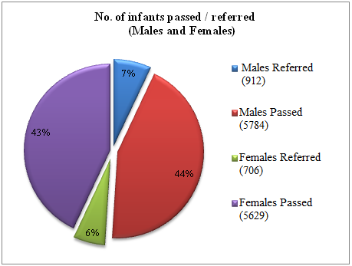

*Figure 4*: No. of male and female infants screened and found to be at-risk in various hospitals /immunization centres in Mysore city

*Figure 5*: Distribution of high risk factors in infants screened at various hospitals/immunization centres in Mysore city

*Figure 6:* Distribution of prenatal factors in infants screened for high risk at various hospitals /immunization centres in Mysore city

*Figure 7:* Distribution of natal factors in infants screened for high risk at various hospitals/immunization centre in Mysore city

*Figure 8*: Consanguinity, sibling history and family history as risk factors in infants screened at various hospitals/immunization centres

(Note: * 8642 had no siblings)

Parents were counseled regarding identification of any delay or deviancies in normal developmental milestones of speech, language, hearing, motor and other related domains that affect the development of communication skills in children. They were provided checklist to help them to monitor the development of the infant and if any delay / deviations were noted they were advised to visit the institute for a detailed investigation and further management.

* + 1. **Hearing evaluation of industrial workers**

A total of 132 employees were screened for hearing in Karnataka Silk Industries Co. (KSIC) for hearing abilities in the academic year 2011-2012 and referred for detailed evaluation to the institute. Out of them, 32 employees were tested for hearing abilities. Most of the employees of this industry had high frequency sloping sensorineural hearing loss due to exposure to high noise level. The employees were counseled regarding the need to use hearing protective devices to protect their hearing ability. The employers were also counseled regarding attenuation of noise level at the source and transmission path. The details of the hearing evaluation of the employees are represented in Figure 9.

*Figure 9*: Total number of KSIC employees evaluated for hearing at AIISH

* + 1. **Follow-up activities of POCD Department:**

All referred clients (infant screening) were followed up through telephonic calls and individual letters written to client/ parents / caregivers of infants at-risk for communication disorders. Complete test battery was administered to each individual who were found to be at- risk. Figures 10 and 11 depict the statistics related to this activity.

*Figure 10:* Total number of clients visited AIISH for detailed evaluation

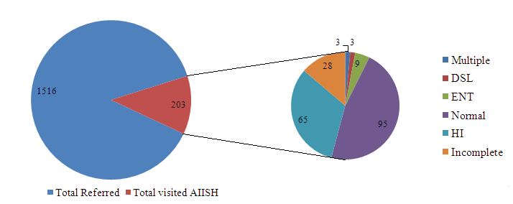

*Figure 11:* Communication disorders identified through detailed evaluation

1. **Specialized Clinical Services: Nil**
2. **Clinical Support Services to Patients and Family: Nil**
3. **Clinical Electronic Services: Nil**
4. **EXTENSION ACTIVITIES**
5. **Rehabilitation and Education through Distant Mode:**

New born screening was initiated at Cuttack and Imphal centres. The clinical activities of the New Born Screening at Neonatal Care Unit (NCU) at SCB Medical College & Hospital (SCBMCH), Cuttack centre was started in December 2011. The clinical activity of the New Born Screening at Regional institute of Medical Science & Hospital, Imphal was started in February 2012. Two staff members (Audiologist & Speech Language Pathologist Grade I and Speech & Hearing technician) were appointed for the clinical activities to be carried out at each of these centres. Individuals in charge of infant screening at the extension centres at Cuttack and Imphal were oriented regarding the infant screening protocols through video conference.

*Table 5: Details of infants screened for communication disorders at Cuttack (from December 2011)*

|  |  |  |  |  |  |  |
| --- | --- | --- | --- | --- | --- | --- |
| *Months* | *Male* | *Female* | *No. of*  *infants screened* | *Male* | *Female* | *No. of*  *infants referred* |
| December | 16 | 11 | 27 | 08 | 04 | 12 |
| January | 83 | 59 | 142 | 33 | 24 | 57 |
| February | 92 | 49 | 141 | 33 | 22 | 55 |
| March | 81 | 55 | 136 | 34 | 14 | 48 |
| **Total** | **272** | **174** | **446** | **108** | **64** | **172** |

Figure 12: *Details of infants screened for communication disorders at Cuttack*

*(From December 2011)*

*Table 6: Details of Infants screened for communication disorders at Imphal (from February 2012)*

|  |  |  |  |  |  |  |
| --- | --- | --- | --- | --- | --- | --- |
| *Months* | *Male* | *Female* | *No. of infants screened* | *Male* | *Female* | *No. of infants referred* |
| February | 15 | 10 | 25 | 02 | 02 | 04 |
| March | 71 | 56 | 127 | 06 | 02 | 08 |
| **Total** | **86** | **66** | **152** | **08** | **04** | **12** |

Figure 13: *Details of infants screened for communication disorders at Imphal (from February 2012)*

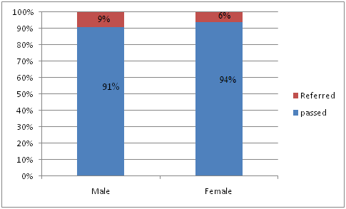

1. **Prevention of Communication Disorders**

The clinical activities are carried out in the Outreach Service Centres of the department. The four centres include

* PHC centre, Hullahalli, Nanjangud Taluk, Mysore district – Initiated from 23rd November 2009
* PHC centre, Akkihebbalu, K.R. Pete Taluk, Mandya district – Initiated from 24th November 2009
* CHC centre, Santhemaralli, Yelandur Taluk, Chamarajanagar district (only infant screening) – Initiated from 28th July 2010
* PHC centre, Gumballi, Yelandur Taluk, Chamarajanagar district – Initiated from 28th July 2010

The objective of the Outreach Service Centres (OSCs) is to provide diagnostic and speech-language therapeutic facilities for the persons residing in the rural areas nearby the selected Outreach Service Centres. Closely connected with this program, through a research funded program (AIISH Research Project), two groups of volunteers were selected and trained to promote the cause of prevention and early identification of communication disorders. These included (1) ASHA workers attached to the Gumballi Outreach Centre and selected women volunteers in the Hullahalli and Akkihebbalu Centre (2) Selected student volunteers from high schools of nearby schools (8th and 9th grade) to assist the ASHA workers and women volunteers.

The following activities were carried out in the OSCs during the report year:

1. Empower and train the ASHA workers, selected women volunteers and selected high school children in prevention and early identification of communication disorders.
2. Orientation and sensitization program for senior health assistants, members of the Village Panchayat, NGOs working in the village and other health workers attached to the village.
3. Distribution of Public Education Materials and Resource Materials among the public and the persons with communication disorders.

The following clinical activities are carried out as routine in these Outreach Service Centres:

* E.N.T evaluation
* Infant screening
* Audiological evaluation
* Speech-Language evaluation
* Speech-Language therapy
* Hearing aid trial and distribution of hearing aids under ADIP Scheme
* Earmold impression and distribution
* Counseling and Guidance services

Figures 14 to 17 show the details of clients seen in the three outreach service centres.

*Fig 14: Details of infants, children and adults screened in outreach service centres (OSC):*

*Hullahalli and Gumballi*

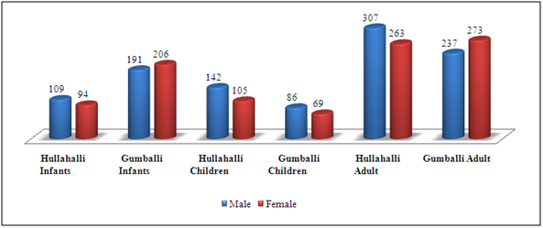

*Figure 15: Details of children and adults screened in OSC; Akkihebbalu*

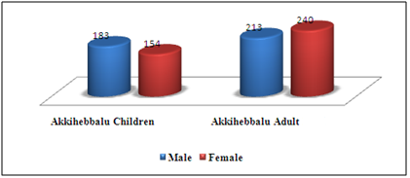

Figure 16: *Details of cases with different communication disorders of all OSCs*



Figure 17: *Details of hearing aids prescribed and ear mold taken in all 3 OSCs*

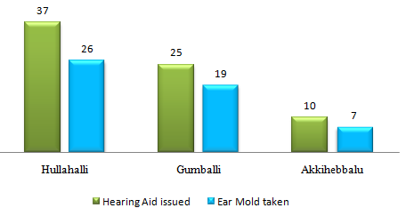

1. **Screening Camps for Communication Disorders**
2. **School screening:** a screening program for communication disorders was conducted for school and college students. School screening was conducted in different villages (in and around Hullahalli and Akkihebbalu) such as Hullahalli, Akkihebbalu, Hosadadadahalli, Haledadadahalli, Vaddaragudi, Singanahalli, Maachaholalu, Jainarahalli, Hosamudalaapura, Hale Mudalaapura, Alambaadi and Dudukanahalli. Children from 23 schools (Primary schools-17; high schools-5 and ITI college-1) were screened. The screening program consisted of 2 parts, orientation of school teachers and screening.

**Part 1: Orientation of school teachers**

Orientation program was conducted for the teachers regarding identification of communication disorders which can be seen in school-aged population. A checklist was prepared which help teachers to identify different communication disorders. Teachers were instructed to administer the checklist on each student and identify the students who have communication disorders. They were also oriented on prevention early identification and management of communication disorders.

**Part 2: Screening for communication disorders**

A screening test was done for the students which included hearing screening, screening for speech and language disorders, and screening for academic problems among the students. Otoscope, audiometer and immittance meter were used to screen the hearing ability. An informal articulation test was used to check the articulation and fluency of the student; rapid automated protocol-Kannada was used to check language and reading writing ability of the students.

Students who failed in this protocol were referred to the PHC (OPSC) for further testing on a specified day. Teachers and heads of the schools were informed about referral of students to PHC for further testing. Diagnostic tests were administered at the OSC and were advised regarding management. The screening program was started in December 2011

|  |  |  |  |  |  |  |  |  |  |  |  |  |  |  |  |  |
| --- | --- | --- | --- | --- | --- | --- | --- | --- | --- | --- | --- | --- | --- | --- | --- | --- |
| ***Month 2011-12*** | ***OSC*** | ***Male*** | | | | | | | ***Female*** | | | | | | | ***Grand total*** |
| ***Hg*** | ***Sp*** | ***Lg*** | ***ENT*** | ***Multi*** | ***Other*** | ***Total*** | ***Hg*** | ***Sp*** | ***Lg*** | ***ENT*** | ***Multi*** | ***Other*** | ***Total*** |
| Dec. | Hullahalli | 4 | 9 | 14 | 10 | 9 | 2 | *48* | 4 | 5 | 11 | - | 6 | 1 | *27* | **75** |
| Akkihebbalu | 1 | 18 | 32 | 8 | 9 | 2 | *70* | - | 3 | 11 | 8 | 3 | 2 | *27* | **97** |
| Jan. | Hullahalli | - | 4 | 2 | - | 3 | - | *9* | - | 1 | - | 1 | - | - | *2* | **11** |
| Akkihebbalu | - | 4 | 21 | 4 | 11 | - | *40* | - | 3 | 9 | 2 | 2 | - | *16* | **56** |
| Feb. | Hullahalli | 1 | 1 | 1 | 2 | - | - | *5* | - | - | - | - | - | - | *0* | **5** |
| Akkihebbalu | - | 6 | 6 | 22 | 8 | - | *42* | - | 2 | 9 | 20 | 5 | - | *36* | **78** |
| Mar. | Hullahalli | 1 | - | 4 | 16 | 1 | - | 22 | - | 1 | - | 9 | 1 | - | 11 | **33** |
| Akkihebbalu | 4 | 3 | 7 | 4 | 5 | - | 23 | 2 | 2 | 5 | 1 | 5 | - | 15 | **38** |
| Mysore | 1 | - | 2 | 0 | 0 | 0 | 3 | 3 | - | 2 | - | - | - | 4 | **8** |
|  | **Total** | **12** | **45** | **89** | **66** | **46** | **4** | **262** | **9** | **17** | **47** | **41** | **22** | **3** | **138** | **401** |

*Table 7: Total number students identified in different categories of disorders*

*Figure 18: Total no. of students screened and referred in OSCs*

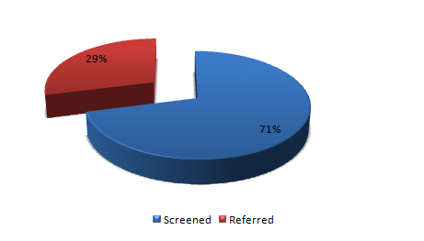

Photos showing school screening in progress:

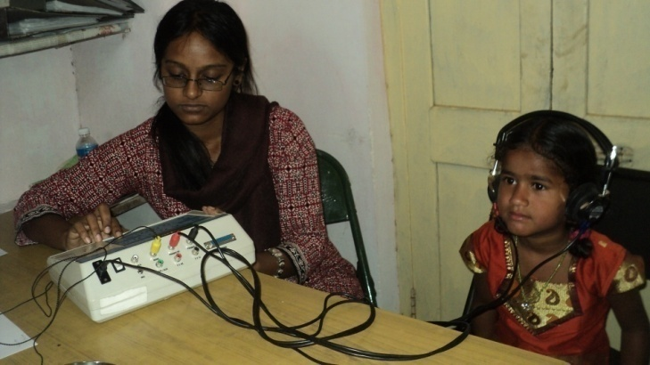

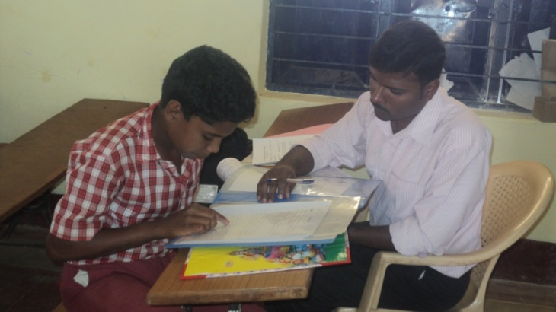

*Figure 19: Details of students with different communication disorders identified during school screening at OSCs.*

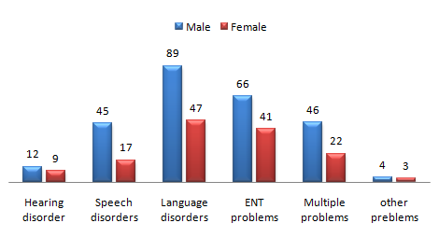

1. **Camps to screen individuals with speech, language and hearing disorders:**

Several camps were conducted at various places within Karnataka in the report year by the institute. These camps were majorly sponsored by NGOs, SSA, several state and district sponsored agencies. The details of individuals evaluated and referred to the institute for follow-up and clients who were issued hearing aids and certificates are shown in Tables 8, 9 and 10 and Figures 21 to 23.

*Table 8: Details of camps to evaluate individuals with speech, language and hearing disorders*

|  |  |  |  |  |
| --- | --- | --- | --- | --- |
| *Place where camp was held* | *Date* | *Sponsoring Organization* | *Total No. of clients*  *evaluated* | *Total No. of clients*  *referred* |
| Hosanagar,  Shimoga | 28/4/2011 | JCI, Kodachadri | 245 | 13 |
| Belaku Ashradhama | 13/5/2011 | Belaku Ashradhama | 4 | 4 |
| Mandya | 24/2/2011 | Rotary Inner Wheel, Mandya | 76 | 70 |
| Mysore | 03/03/2012 | Megha Health Mela by District Health Committee | 35 | 20 |
| Keelara, Mandya | 09/03/12, 10/03/12 | AIISH, Mysore | 15,441 | 938 |
| **Total no. of clients evaluated/referred** | | | **15801** | **1045** |

*Figure 20: Details of total no. of individuals screened and referred at camps:*

*Table 9: Details of individuals and disorders identified at camps*

|  |  |  |  |  |  |  |
| --- | --- | --- | --- | --- | --- | --- |
| *Disorder* | *Kodachadri* | *Belaku* | *Mandya* | *Mysore* | *NSS* | *Total* |
| Hearing | 108 | 4 | 33 | 13 | 160 | 318 |
| Voice | 0 | 0 | 1 | 0 | 6 | 7 |
| Articulation | 0 | 0 | 2 | 0 | 5 | 7 |
| Fluency | 1 | 0 | 6 | 0 | 15 | 22 |
| Language | 44 | 0 | 9 | 3 | 35 | 91 |
| Multiple | 2 | 0 | 9 | 6 | 20 | 37 |
| MR | 40 | 0 | 8 | 0 | 57 | 105 |
| ENT | 50 | 0 | 5 | 7 | 231 | 293 |
| Others | 0 | 0 | 3 | 6 | 0 | 9 |
| **Total** | **245** | **4** | **76** | **35** | **529** | **889** |

*Figure 21: Distribution of Speech Language and Hearing Disorders in clients screened at various camps organized*

*Table 10: Details of No. of individuals who availed benefits at Hosanagar and NSS camps:*

|  |  |
| --- | --- |
| Hearing disability - certificate issued | 1 |
| Mental retardation - certificate issued | 39 |
| Issue of hearing aids | 123 |

*Figure 22: Individuals who benefitted from camps in the report year 2011- 2012*

1. **Public Lecture Series:** Nil
2. **TECNOLOGICAL CONSULTANCY SERVICES:**

On 3rd Feb. 2012, Dr. Surendra V H H, Joint Director of factories (Medical), Department of factories, boilers, industrial safety and health visited department of POCD along with Dr. Prashanth K B, Occupational health specialist and ENT surgeon in Jindal steel plant (JSW steel ltd.,). Departmental activities were oriented on industrial screening programs. The procedure which the department of POCD carries out were explained in detail and listed below.

1. Orientation program regarding the harmful effects of noise on ear
2. Administration of questionnaire to employees who are exposed to noise
3. Hearing screening for all the employees
4. Terms and conditions to be followed before carrying out hearing screening
5. Payment for hearing screening and the diagnostic evaluation to the institute

After the discussion, Dr. Prashanth K B. requested to conduct only the orientation program regarding the harmful effects of noise as the hearing screening has been regularly carried out by the trained specialist in their industry. Finally, a visit was made to JBO (Jubilant Organosys), Nanjangud and a meeting occupational specialist of JBO was held to discuss the same topic.

1. **CENTRAL FACILITIES**
2. **Library and information services -**
3. **Public Information Activities -**
4. **AIR program (Akashvani, Mysore):**

|  |  |  |  |
| --- | --- | --- | --- |
| **Sl. No.** | **Resource person** | **Topic** | **Date** |
| 01 | Dr. Manjula P | An interview feature on various issues related to hearing impairment during a program on Women issues (Mahila ranga program) titled ‘Dhwanigondu daari’ was broadcast by AIR, Mysore during a regular feature titled ‘Belagutite Mahila Jyothi’, | 27.08.11 |

**---------------------------------------------------------------------------------------------------**

1. **Participation in expo to educate public and staff/students from college**

|  |  |  |  |  |
| --- | --- | --- | --- | --- |
| 30.3.2012 & 31.3.2012 | *Staff:*  Ms. Sunitha E,  Mr. Madhu K | Participated in a science exhibition to create awareness regarding Communicati-on Disorders, and | *No. visited:* Approximately 500 individuals | Scientific Exhibition organized by Gnanavedike, Yuvaraja College, Mysore |

1. **Material Development**

**Public education materials** (PEM): PEM were prepared to create awareness regarding hearing, speech, language and other communication disorders. Some of the materials prepared earlier were translated in different languages to be used by the common people.

*Table 11: Public education material prepared / under process in the report year*

|  |  |  |
| --- | --- | --- |
| *Sl. No* | *Name of the material* | *Languages* |
| I | *Materials Printed* | |
| 1. | Referral card (OSC) | Kannada |
| 2. | School screening checklist for teachers | Kannada, English |
| II | *Material being processed for printing* | |
|  | Data sheets | *Oriya, Manipuri and Hindi* |
|  | Flipcharts on hearing | English and Kannada |
| 3. | Puzzle book on communication disorders | English |
| III | *Material under preparation and field testing* | |
| 1. | Know and prevent - checklist | Hindi, Kannada |
| 2. | Voice Pamphlet | English |
| 3. | Fluency Pamphlet | English |
| 4. | Pamphlet on Hearing impairment in children | English |
| 5. | Pamphlet on Hearing impairment in Adult | English |
| 6. | Pamphlet on Types of Hearing aids | English |

1. **AWARDS AND HONOURS RECEIVED BY FACULTY AND STAFF –**
2. EXTRA CURRICULLAR ACTIVITIES
3. AIISH GYMKHANA:
4. Ms Anisha A.B received IPrize in Solo Song competition
5. Mr. Madhu .K & Ms Anisha A.B received IIPrize in Group Song competition.
6. **NSS:** The staff of the department participated in the camps conducted by the NSS.

**OTHERS: Nil**

1. **MAJOR EVENTS OF THE YEAR**: Initiation of newborn screening program at Cuttack and Imphal centres.
2. **EMINENT VISITORS:**

|  |  |  |
| --- | --- | --- |
| Sri. K. Chandramouly IAS | Hon’ble Secretary, Ministry of Health and Family Welfare, Govt. of India, New Delhi | 09.08.11 |
| Dr. K. S. Sriprakash, | Vice Chancellor, RGUHS, Bangalore | 09.08.11 |
| Dr. K.S. Rangappa, | Vice-Chancellor, Karnataka State, Open University, Mysore | 09.08.11 |
| Dr. G.Y. Nagaraja | Joint Director (HI), Karnataka Health System Development & Reform Project, K.R. Circle  Bangalore – 560 001 | 09.08.11 |
| Shri Pradhan P.K | Special Secretary and Mission Director (NRHM), Ministry of Health and Family Welfare, Government of India, New Delhi | 05.10.11 |
| Sri S Gandhiselvan | Hon’ble Minister of State for Health and Family Welfare, GOI, New Delhi | 23.01.12 |

1. **ANY OTHERS:**

**Dr. Manjula P**

* Attended project proposal review committee meeting at ICMR at New Delhi on 13.04.11.
* Attended meeting regarding creation of posts with reference to RCI norms on 23.06.11 & 27.06.11.
* Served as member of the ARF proposal review committee on 20.06.11.
* Served as member, Organizing Committee, National Symposium on Exploring areas of research in cognitive sciences, held on 30.06.11 & 01.07.11 at AIISH, Mysore.
* Attended meeting with CPWD Electrical Engineers on 05.07.11, as a member of the building committee.
* Attended meeting reg. Hearing Aid Dispensing Scheme (HADS) in the board room on 13.07.11.
* Member, Reception Committee of 46th Anniversary celebrations.
* Coordinator of 46th Anniversary celebrations of the institute. Attended a meeting in this connection on 12.07.11.
* Attended purchase committee meeting in the board room on 28.07.11.
* Member, Selection committee meeting (projects and contract posts) held at AIISH on 26.09.11.
* Attended meeting with Shri P.K. Pradhan, Special Secretary and Mission Director (NRHM), Ministry of Health and Family Welfare, GOI, New Delhi at boardroom of the Director’s Office on 05.10.11.
* Coordinator for ‘Open day’ celebrations held on 04.11.11.
* Chairperson: Walk-in-interview through video conferencing for selection of suitable candidate for the post of Audiologist/Speech Language Pathologist Gr.I. on 21.12.11.
* Attended meeting on funding for cochlear implant with Sri R. Guru, Chairman, M/s. Rangsons group & Mysore Agenda Task Force at boardroom, AIISH, Mysore on 10.01.12.
* Chairperson, screening committee to scrutinize the applications received against Advertisement No.4/20 for Group ‘B’ Technical posts on 23.12.11.