ANNUAL REPORT 2011 – 2012

HORTICULTURE SECTION

The Horticulture section is responsible for maintaining the outlook of the institute. The main objective is to provide natural environment and maintain the premises with natural beauty. The section develops and maintains the garden and lawn in the AIISH main campus and panchavati campus to provide lively atmosphere.

**Activities**

The activities carried during the reporting year are as follows.

1. **Maintenance**

The section is maintaining the lawn, shrubs, rose garden, flower beds, ornamental trees, and ornamental plants in the institute premises by taking proper care in providing sufficient water, fertilizer, trimming, mowing, weeding and pruning.

1. **Nursery**

The nursery area is of about one acre where all kinds of plant propagation activities are undertaken. Current year, the section develops around 2,000 ornamental potted plants which are put to decorate departments and sections of the institute. Also, in the nursery grows annual and bi-annual flowering plants for beautification of the campus.

1. **Development**

In the current year around 5850 Sq.ft. area of Mexican lawn has been developed around rose garden adjacent to Department of Clinical Service and Old Engineering section and the pop-up sprinkler system has been installed near rose garden. Initiative has been taken to develop kitchen garden behind the ladies hostel.

The Horticulture Section was conducted “Tree planting Programme” on 22.11.2011 at AIISH main campus. Dr. S.R Savithri, Director, AIISH, inaugurated the programme by planting coconut plant. Students and staffs of the institute participated and planted around 100 no’s of various varieties of fruit plants.

. 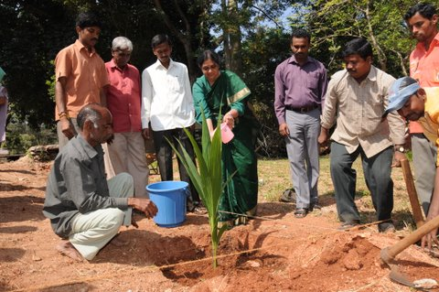

The Horticulture section participated in the “Dasara Horticultural Flower show of 2011” conducted by State Horticulture Department from 28.09.2011 to 09.10.2011 at Curzon park, Mysore. The institute won the 8 First prizes, 3 Second prizes and 3 third prizes for arranging various types of flower groups. Apart from this, the institute won 5 First prizes and 1 Second prize for well garden maintenance and growing various flowers in pots and beds at the institute.

