SH/Gymkhana/AR/2012-13 19.04.2012

Sub: Annual report 2012-13 – reg.

Re: SH/LIC/AR/2011-12 dated 16.04.2012)

Submitted to the Director,

With reference to the above, please find enclosed the annual report of the AIISH Gymkhana for the year 2011-12.

Vice President- Gymkhana

**AIISH Gymkhana Annual Report 2011-12**

AIISH Gymkhana is an association of staff and students of the institute. Gymkhana is a platform for recreational, sports, social and cultural activities of staff and students of AIISH. It is housed in the Panchavati campus with facilities for indoor games as well as outdoor games and activities. It also houses a well equipped gym with a trainer. Following are the activities carried out during the report year.

**7 September**

**Talent Day**: Gymkhana organized Talent Day on 7 Septemebr 2011 for the institute students. was organized for AIISH students on 7.9.11. As part of the program student members of AIISH showcased their talents in dance, music, poetry, sketching, painting, etc. Around fifty students participated in the program.

26th August 2011

1. **Honoring children of staff members who have secured high marks in their studies:** AIISH Gymkhana organized the Talents day and Pratibha Puraskar for children of staff members on 26th August 2011. As part of the program, children of staff members showcased their talents in dance, music, recitation, sketching, painting, etc. Around fifteen children in the age range of 3- 15 years participated in the program. Mementoes and certificates were distributed to the children as a token of appreciation.

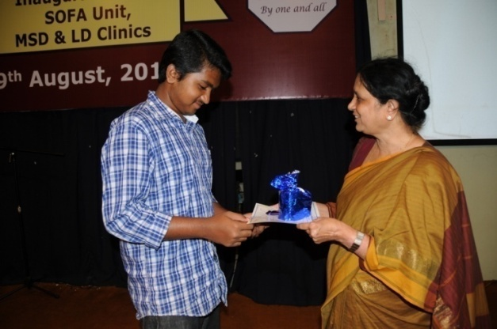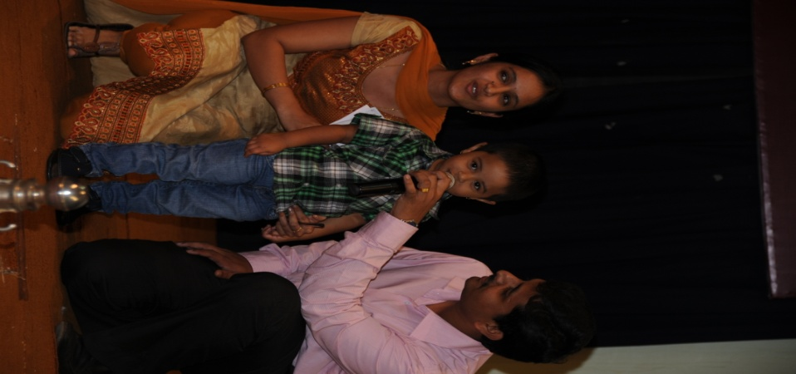

Children of staff members who secured highest marks in X standard, II PUC and degree courses were honored with Pratibha Puraskar which included a cash prize of Rs. 500/-, Rs. 750/- and Rs. 1000/- respectively. Around eight children were honored with the Pratibha Puraskar including a certificate along with the cash prizes.

**9th August**

1. **Annual day** was organized on 9th August 2011. Various cultural activities were presented by staff, students of institute and preschool children. Felicitation was done to
2. Meritorious students:

* Gold medal for first rank student in B.Sc.(2010-2011): Ms. M. S. Lakshmi
* Best Student Clinician: Ms. Gargi Singh
* Best Clinical Case Presentation: Ms. Melita Moses Ms. Swathi S.
* Best Journal Presentation: Ms. Aporva H. M. Ms. Giten E George Ms. Sahana P. Mr. T. J. Jobish

1. 25 years of service:

* Dr. S. R. Savithri, Director
* Mrs. Vijayashree, SLP Gr.I
* Sri M. B. Sadanandamurthy, Electrician
* Sri L. Premkumar, LDC
* Sri M. Shivashankara, Clinical Attendant
* Sri S. V. Prakash, Clinical Attendant
* Sri V. Raju, Ayah

1. Retired staff during 10/7/11 to 9/8/11

* Sri Papanna, Mali
* Sri K. M. Venkatesha, Peon
* Sri M. K. Seetharam, Electronics engineer
* Sri Padam Bahadur, Watchman

1. **Annual General body meeting of AIISH Gymkhana** was conducted on14th September 2011. The new office bearers **of AIISH Gymkhana** was formed on

President : Prof. S.R. Savithri, Director AIISH

Vice President: Prof. P. Manjula

Jt. Secretary: Mr. Brajesh Priyadarshi

Sports Secretary: Dr. M. Sandeep

Treasurer: Mr. Md. Kaleemulla

General Secretary: Mr. Vivek Sharma

Cultural Secretary: Ms. M.S. Gagana

Joint Sports Secretary: Mr. R. Supreeth

Ex-officio members:

Dr.G. Jayarama - Canteen Committee Chairman

Mr. Ajish Abraham – Warden, Gents Hostel

Ms. C. Geetha - Warden, Ladies Hostel

Mr. Sreeraj.K - NSS Program Officer

Staff Representatives: Mr. P. Gopi Kishore (Class A)

Mr. Sharath Kumar (Class B)

Mr. A. Vivek (Class C)

Class Representatives:

JRF representative: Mr. Abhishek Aradhya

I B.Sc. Section A: Ms. V. Anumitha

I B.Sc. Section B: Ms. Stuthi Sharma

II B.Sc. Section A: Mr. P.S. Abhishek

II B.Sc. Section B: Mr. Harisha Gowtham

III B.Sc. Section A: Ms. B. Mahalakshmi

III B.Sc. Section B: Mr. Shreyank P. Swamy

Internship (AIISH Batch): Ms. S. Swathi

I M.Sc. (Aud) Section A: Mr. Hijas Md.

I M.Sc. (Aud) Section B: Ms. Vinni Chabra

II M.Sc. (Aud): Mr. Zubin Vinod

I MSc (SLP) Sedtion A: Ms. Pooja Behera

I M.Sc. (SLP) Section B: Ms. Thulasi Prasad

II M.Sc. (SLP): Mr. Prasanna Hegde

PGDCL: Ms. Natasha Rehman

BSEd(HI): Ms. Leela Rani

DHLS: Mr. Vivekanand Kumar

DHAET: Mr. P. Mahadeva Prasad

**4th November 2011**

1. **AIISH Open Day** **2011-12** was celebrated on 4th November 2011. On this occasion, the public and school children were educated on various aspects of communication disorders through an exhibition. Public, school children and teachers participated in large numbers (1700 no.). Various competitions were conducted for children, both children with disabilities and typically developing children.
2. **National Day celebrations**:
   1. Independence Day on August 15.8.2011
   2. Republic Day on 26.1.2012

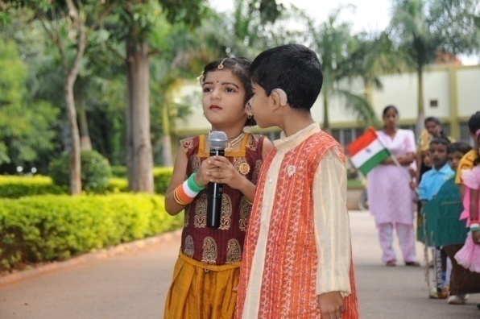

1. The students participated in the **Yuva sambhrama and Yuva dasara** programs being held as part of Dasara celebrations. Dasara Yuva Sambhrama performance by students was under the supervision of Dr. M. Sandeep, Ms. Suma Chatni and Mr. Varun U.

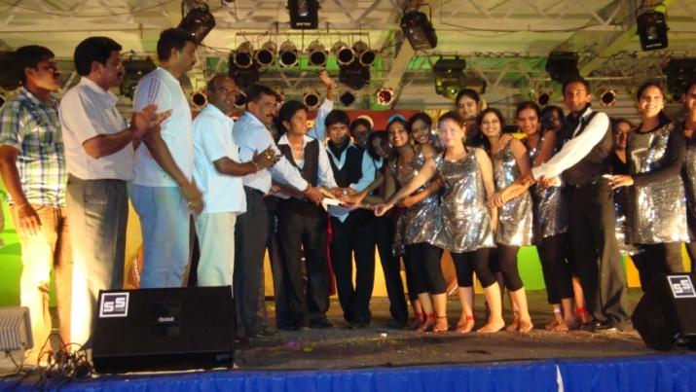

1. **A Dandiya night** was organized on24th Sept. 2011, on the occasion of Navarathri.
2. **Cultural competitions** were conducted for the staff and students members of gymkhana

from 1.2.11 to10.2.12. The list of members who prizes in various competitions is given in Table 1. The prizes were distributed on the Science Day celebrations on 28.2.12.

Table 1: Prize winners of Cultural Competitions conducted by Gymkhana

|  |  |  |  |  |
| --- | --- | --- | --- | --- |
| ***SN*** | ***Title of the event*** | | ***Prize*** | ***Name of the prize winners*** |
|  | *Staff* | | | |
| 1. | Light Music – Solo | I Prize  II Prize | | Ms. Anisha James  Ms. N. Swapna |
| 2. | Music – Group | I Prize  I Prize | | *Puneeth & Group:*   * Mr. Puneeth; Mr.Ravishankar; Mr. Paramesh; Mr. Ravi; Mr. Chethan; Mr. Raghavendra   *Kannada Rockers*   * Mr. Anoop; Ms. Pragathi; Mr. Madhu; Ms. Dathri;   Ms. Priya MB; Ms. Anisha James; Ms. Suma |
|  | *Staff & Students* | | | |
| 3. | Salad making | I Prize  II Prize | | Ms. Jyothi S  Ms. J Uma R Monica |
| 4. | Chaat making | I Prize  II Prize | | Ms. J Uma R Monica  Ms. C Impu |
| 1. | Rangoli | I Prize  II Prize | | Ms. N. Devi  Ms. H.M. Apoorva (II MSc Aud) |
| 2. | Mehendi | I Prize  II Prize | | Ms. N. Devi  Ms. M. Rithu (I MSc - SLP) |
| 3. | Spot photography | I Prize  II Prize | | Ms. Pavan Kamble (Intern)  Ms. Supreetha (Intern) |
| 4. | Ikebana | I Prize  II Prize | | Ms. Uma R Monica  Ms. N. Devi |
|  | *Students* | | | |
| 5. | Dance - Solo | I Prize  II Prize | | Ms. Zeena (III BSc)  Ms. Preethismitha (I BSc) |
| 6. | Group dance | I Prize  II Prize | | *Indira & group (Interns):*  Ms. Indira; Ms. Supreetha; Ms. Grace; Ms. Srushti;  Ms. Neethu; Ms. Veena; Ms.Mamatha  *Raheela & group (II MSc):*  Ms. Raheela; Ms. Deepashree; Ms. Arpitha; Ms. Deepthi; Ms. Apoorva; Ms. Sindhusha |
| 7. | Music – Solo singing | I Prize  II Prize | | Ms. Anali V. Bhat  Mr. Girish |
| 8. | Music – Duet singing | I Prize  II Prize | | * Ms. Anjali & Ms. Amritha Kishore (III BSc) * Ms. Sarga & Ms. Joana (I BSc) * Mr. Jagacharan & Ms. Maria (I BSc) * Mr. Girish & Ms. Yashaswini (III BSc) |
| 9. | Music – Group singing | I Prize  II Prize | | *Girish & group*   * Mr. Girish; Ms. Zeena; Ms. Yashaswini; Ms. Amritha Kishore; Ms. Anjali Bhat; Ms. Usha; Mr. Thareeque   *Amulya & group*   * Ms. Amulya P Rao; Ms. Varsha; Ms. Shishira;   Ms. Bilvashree; Ms. Aparijitha; Ms. Vijetha |
| 10. | Duet dance | I Prize  II Prize | | * Ms. Supreetha & Ms. Indira (Interns) * Ms. Vinni & Ms. Prerana (I MSc-Aud) * Ms. Usha & Ms. Madhuri (III BSc) |

1. **National Science Day**: This was celebrated on 28.2.12, and Dr. P. Nagabhushan, Prof of Comoputer Sciences, UOM, Mysore was the chief guest and the resource person who delivered a lecture on ‘**Research bent of mind’**. On the occasion of National Science Day celebration at the institute, prizes were distributed to the winners of ***Elocution*** and ***Treasure Hunt*** competitions. Table 2 shows the competitions and the prize winners.

Table 2: Prize winners of Science Day competitions held on 24.2.2012 and 27.2.2012:

|  |  |  |  |
| --- | --- | --- | --- |
|  | *Event* | *Prize* | *Name of the member* |
| 1. | Elocution | I Prize  II Prize | Ms. Vishnu Priya (I BSc)  Ms. Stuti (I BSc) |
| 2. | Treasure Hunt | I Prize  II Prize: | Ms. Mr. Sunil Kumar Ravi; Mr. G Kike Gnanateja;  Ms. Ramya V; Ms. Pooja Umesh; Ms. Swathi S; Mr. Kirti Joshi; Mr. Abhijit M  Ms. M B Priya; Mr. K S Sharath Kumar; Mr. Akash Juneja; Mr. Shreyank P Swamy; Ms. Merin Susan;  Mr. Kapali S Nayak |

**Kannada Rajyotsava Day**: This was celebrated on 08.1.11, Prof. Aravind Malagatti from Kuvempu Institute of Kannada Studies, UOM, Mysore was the Chief Guest for this. On this occasion several Public Education Pamphlet on hearing impairment and haring devices in Kannada were released. As part of this, several competitions were arranged for the gymkhana members. They included Pick-and-speak (for Kannadigas and non-Kanadigas), Quiz and essay writing (topic ಬ್ರಷ್ಟಾಚಾರ ನಿರ್ಮೂಲನೆಯಲ್ಲಿ ಯುವಕರ ಪಾತ್ರ OR ಇಂದಿನ ಪ್ರಪಂಚದಲ್ಲಿ ಗಾಂಧಿ ಜಿಯವರ ಮೌಲ್ಯಗಳು).

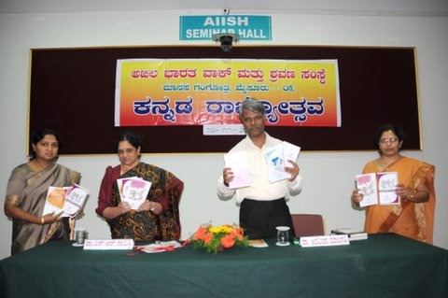

1. **AIISH Aawaaz 2012:** AIISH Gymkhana organized the inter-collegiate cultural festival on 16th, 17th and 18th of March 2012. The program was inaugurated on 16th March 2012 by Dr. B.V. Rajaram, Director Rangayana, Mysore; and Star Singer Ms. Divya was the Guest of Honor. The Valedictory Ceremony was on 18th March 2011 and Sri. Ravi Belagere, the noted journalist, writer and actor from Bangalore was the chief guest. The competitions conducted were: Fashion show; Variety Entertainment; Group dance; Skit; Pencil sketch; Quiz; Face painting; Mock Press; Antakshari; Dumb Charades; Verbattle; Mehendi and Spot photography. The students of AIISH won the rolling trophy for best overall performance and Variety entertainment. The JSS ISH won the rolling trophy for Best Fashion Show.

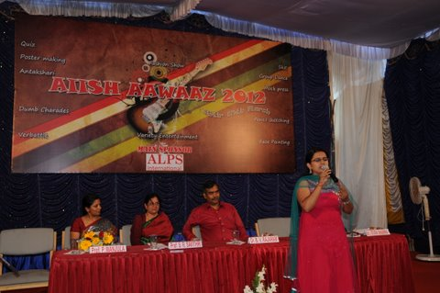 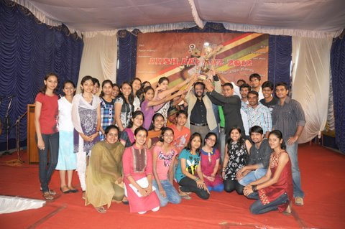

**12. Awards in intercollegiate competitions:**

**a. Mr. Shreyank (III BSc Sp & Hg)** won six I prizes, fifteen II prizes and three III prizes in Mysore University intercollegiate Swimming Competitions.

**b. Abhivyakth 2011-** intercollegiate competitionconducted by MMC&RI, Mysore**:**

* + - * Group song I prize by Purple Fusion group of AIISH students
* Solo song I Prize (western and non-filmy)
* Solo song II Prize (filmy)

1. Students from our institute performed and won prizes during the inter collegiate competitions conducted by the University of Mysore.

* II prize in group song by Purple Fusion group.
* I prize in solo western by Ms. Amrutha Kishore.
* III Prize in Filmy solo singing by Ms. Anjali Bhat

1. A talk by Ms. Veena Rammohan on **Chinese acupuncture, Acupressure and Reflexology technique** was arranged on 3.4.12. Students and staff members benefitted from the camp.
2. A **Yoga Camp** is being conducted from 28.03.12 to 27.04.12. The Resource Person is

Dr. G. Jayaram, Reader in Clinical Psychology. Students and staff members are attending the program

1. **Loan from staff and student welfare funds**: The following staff members received loan from the SSWF:
   1. Mr. Harish Kumar: Rs. 10,000
   2. Mr. Mahadeva (Senior) Rs. 5,000
   3. Mr. Hanumantha: Rs. 10,000
   4. Mr. K Nagaraj: Rs. 10,000
   5. Ms. J Kalyani : Rs. 10,000
2. **Farewell programs**: Farewell program was arranged for the following staff members and students:
   1. Mr. K.M. Venkatesha on 31.5.2011
   2. Mr. M.K. Seetharam and Mr. Padam Bahadur on 29.6.2011
   3. Mr. Mallikarjunaiah, Accountant on 04.01.2012
   4. The outgoing students of AIISH on 23/6/2011