# ALL INDIA INSTITUE OF SPEECH AND HEARING, MYSORE-6

**DEPARTMENT OF CLINICAL SERVICES**

SH/DCS/Annual Report/ 2012-13 Date: 19.04.2012

**ANNUAL REPORT 2011-12**

**Submitted to the Director:**

Sub: Submission of Annual report 2011-2012 reg.

Ref: No.SH/LIC/AR/2011-12 dated 02.04.2012

With reference to the above, please find herewith the Annual report of Department of Clinical services from April 2011 to March 2012. This placed for your kind information.

**HOD Clinical Services**

1. ACADEMIC ACTIVITIES
2. Short-term Training Programs- Nil

* Theme /Topic
* Coordinator
* Objectives
* Target Audience
* Number of Participants
* Date

1. Orientation Programs – Nil

* Theme /Topic
* Coordinator
* Objectives
* Target Audience
* Number of Participants
* Date

1. Clinical Observation Posting of Students from Other Institutes

|  |  |  |  |  |
| --- | --- | --- | --- | --- |
| **Sl.No** | **Number of Students** | **Course** | **Institute** | **Date** |
| 1 | 27 | M. Ed | Ashokan Mane M.Ed College, Kolapur M.P | 01.03.12 |
| 2 | 96 | B. Ed | Karnataka state women’s university, Bijapur Dist | 01.03.12 |
| 3 | 107 | B. Ed | M.L.M.N College of Teacher Education, Chikmanagalore | 22.03.12 |
| 4 | 47 | M. Ed | Little flower convent higher secondary school, Chennai | 29.03.12 |
| 5 | 3 | Engineering | Aparna Surendran College of engineering, Trivandrum | 07.02.12 |
| 6 | 42 | D.Ed | S.R.S D.Ed college pillekeranahally, Chitradurga | 13.02.12 |
| 7 | 29 | B. Ed | Sri Padmavathi Mahka Viswa Vidyalaya, Special B.Ed, Tirupathi, Chittol, A.P | 15.02.12 |
| 8 | 19 | Science | V.H.D Home science college, Bangalore | 16.02.12 |
| 9 | 10 | M.Ed | RIE, Mysore | 21.02.12 |
| 10 | 21 | **-** | Navis college of Education, A.P | 23.02.12 |
| 11 | 4 | Engineering | Vidya Vikas first grade college Myosre | 24.02.12 |
| 12 | 7 | Degree | SIBER school of social work, Kolhapur | 24.02.12 |
| 13 | 42 | Degree | RIE, Mysore | 29.02.12 |
| 14 | 32 | - | Monfort Centre for education Tura, Meghalaya West garo hills | 13.01.2012 |
| 15 | 21 |  | Dr. A.V. Baliga Institute Brahmavar, Udupi | 20.01.2012 |
| 16 | 9 | MPH Post graduation | Dept of Community Medicine, JSS Medical College Mysore | 30.01.2012 |
| 17 | 16 | Nursing | Mother Teresa Nursing College Mysore | 30.01.2012 |
| 18 | 30 | - | Block Education Officer Rural | 22.12.2011 |
| 19 | 55 | - | Rural Homese College UAS, Dharward | 08.11.2011 |
| 20 | 33 | - | Gangadhar, AH-3 Nursing tutors, B.M. Hospital | 11.11.11 |
| 21 | 31 | - | B.M Hospital Mysore | 18.11.11 |
| 22 | 41 | Nursing | Nalairaja school of nursing, Mysore | 22.11.11 |
| 23 | 3 | M.Ed | Dos in Education Manasagangothri, Mysore university, Mysore | 25.11.11 |
| 24 | 16 | Nursing | Kamakya School for Nursing, Mysore | 31.10.2011 |
| 25 | 28 | DHLS | DHLS | September, 2011 |
| 26 | 41 | - | KRH, Mysore |
| 27 | 51 | - | Stell Maries College, Chennai | August, 2011 |
| 28 | 2 | - | Ramya Architect college, Bangalore |
| 29 | 3 | - | RIE, Mysore |
| 30 | 32 | - | Sarvodaya College of Education, Virajpet, S. Coorg | July, 2011 |
| 31 | 30 | D.Ed | Shri Gangdhareshwara D.Ed College, Somahally, Gundalpet | June, 2011 |
| 32 | 38 | - | J.S.S college of Nursery Saraswathipuram, Mysore |
| 33 | 79 | - | Perunthalavan Kamarajan Govt. college Pondicherry | April, 2011 |
| 34 | 1 | E.N.T | KVG Medical College and Hospital, Sullia (D.K) | 15.04.2011 |

1. Seminars/Conferences/Workshops

|  |  |  |  |  |  |  |
| --- | --- | --- | --- | --- | --- | --- |
| **Sl. No** | **Them/Topic** | **Coordinator** | **Objectives** | **Target Audience** | **Number of Participants** | **Date** |
| 1 | National Workshop on Phonological Disorders: Clinical Perspectives | Ms. Priya M.B | The objectives of discussing these issues and bringing about a consensus to follow a common protocol across the country. The objective also included providing the participants with practical training on assessment and management of phonological disorders. | Speech-Language Pathologists | 200 | 06th January, 2012 |
| 2 | Seminar on Rights and Acts for Persons with Disability | Mr. Prashanth .R | To craft a better world including persons with disabilities in global development. | Students, professionals and the general public, Law College, Students | 285 | 5th December, 2011 |
| 3 | National Seminar on Stroke | Ms. Preethi T. Thomas | The program is to gain knowledge in the area neurological conditions and the associated speech and language disorders. | Speech-Language Pathologists, audiologists, Psychologist, Medical professionals, Occupational therapist, Physiotherapist and Medical Social Workers. | 130 | 10-11 November, 2011 |
| 4 | International Stuttering Awareness Day (ISAD) | Ms. Sangeetha Mahesh | To orient teachers and create awareness about Stuttering | Teacher trainees | 200 | 24th October 2011 |
| 5 | Seminar on Speech and Language therapy, Behavioral management, Physical and motor management and curriculum support | Ms. Geetha M.P | Sensitizing teachers about communication disorders | Teachers | 15 | 15th September 2011 |
| 6 | Seminar on Sensitizing parents of special children about child development | Ms. Geetha M.P | Sensitizing parents about communication disorders | Parents | 50 | 28th September 2011 |
| 7 | Seminar on Dietary intakes and concerns in typically developing children and persons with communication disorders | Ms. Prathima | To provide knowledge about the importance of Nutrition and maintain of healthy diet in children with communication disorders. | Caregivers who are availing speech and language therapy for their children | 85 | 25th July 2011 |

1. Guest Lectures - Nil
2. Additional Academic Services by the Faculty and Staff
3. Invited Talks

* Dr. S.P. Goswami (2012). Disability Act and Dementias- Sociolegal Issues. Served as a speaker in the continuing education program at the 44th National Conference of the ISHA held at Hyderabad on 19th January 2012
* Dr. S.P Goswami (2011) Delivered a lecture on “Revised Right days Act” in the seminar **“*Rights and Acts for Persons with Disability*”** on 05.12.2011
* Dr. S.P Goswami (2011) Delivered a lecture on “The Speech and Language Management for persons with Stroke” in the National Seminar “National Seminar on Stroke” on 10-11th November, 2011
* Ms. Sangeetha M (2011) Delivered a guest lecturer on Stuttering on 29th October, 2011
* Ms. Sangeetha M (2011) A lecture an overview and Identification of Speech disorders in school going children was conducted to on 20th sept 2011(Teachers) IERT’s of Lakshadweep under SSA program- Oriented a self help support group ‘Aashiana’, Mysore (Participant of C4D2) on Govt. schemes, benefits and concessions for persons with differentially abled.
* Mr. Prashanth R (2011) Presented scientific paper “Living with Stroke community Rehabilitation” in the National Seminar on Stroke on 10.11.2011

1. Curriculum Development - Nil
2. Development of Materials to Support Learning- Nil
3. Service in Academic bodies of other organizations-

**Dr. S.P. Goswami**

* Served as external examiner at the University of Mangalore, Bangalore, Mysore, SRMU Chennai and PGIMER Chandigarh,
* Served as a associate editor for JISHA- 2011
* Serving as editor JISHA from 2012

**Ms. Sangeetha M**

* External examiner to conduct viva for diploma students (TTCHH) on 13.04.11 and 15.04.11

1. Membership in professional organizations (ISHA, RCI)

|  |  |  |  |
| --- | --- | --- | --- |
| **Sl. No** | **Name of the Faculty/ Staff** | **RCI** | **ISHA** |
| 1 | Dr. S.P Goswami | A00260 | L - 369 |
| 2 | Ms. Sangeetha M | A13415 | L-359 |
| 3 | Ms. Vijayashree | - | - |
| 4 | Ms. Preethi T. Thomas | A13042 | L - 1086 |
| 5 | Ms. M.P. Geetha | A22938 | L - 1496 |
| 6 | Mr. Gopi Sankar R | A06847 | L - 973 |
| 7 | Ms. Sujatha V. Shastry | - | - |
| 8 | Ms. Prathima | - | - |
| 9 | Ms. Priya M.B | A17057 | L - 1186 |
| 10 | Mr. Varun Uthappa | - | L - 1901 |
| 11 | Ms. Seema | A24264 | L - 834 |

1. Participation in Committees/ Taskforces and Panels set up by other organizations/agencies.
2. Dr. S.P Goswami

* Serving as HOD, Clinical services.
* Serving as Member – Fluency, AAC, ASD, SOFA, LD, MSD units
* Serving as Editor – JISHA.
* Serving as Member, Anti ragging squad.
* Serving as member for the computerization of Dept. of Clinical Services
* Served as a member for Empowerment of Persons with disability for the formulation of 12th Five year plan Ministry of Social Justice and empowerment, GOI.
* Prepared a brief outline about the disbursement of funds under the patient welfare fund
* Served as a member in the selection panel for the post of AMRO, Clinical Assistant, Research Assistant and Clinical Supervisor on January 2012
* Served as a member in the selection panel for the post of Speech-Language Pathologist and Audiologist for various projects on March 2012.

1. Ms. Sangeetha M

* Catering committee as a part of Open Day celebration, 2011

1. Mr. Gopi Sankar R

* Serving as Member - Canteen Committee
* Serving as Member secretary - U-Sofa unit
* Stock verification officer
* Serving as District coordinator for NPPCD, Tumkur, Karnataka, India
* In charge for solo and singing competition for staff – Gyhmkhana Activity

1. Ms. Preethi T. Thomas

* Member of the special children games committee for open day celebrations, 2011
* Member for Cuhoo-Cuhoo AIISH, News letter

1. Ms. Priya M.B

* Served as a judge for duet dance competition – Gyhmkhana Activity
* Member of the special children’s competition committee for open day celebrations, 2011
* Member of the Editorial committee of AIISH Newsletter Cuhoo-Cuhoo
* Serving as member of Internship coordination committee
* Member of the team chosen to furnish the International Guest House

1. Any Other

II. **Research Activities**

1. Research Projects

|  |  |  |  |  |  |
| --- | --- | --- | --- | --- | --- |
| **Sl.No** | **Title** | **Investigator/ Coordinator** | **Funding agency** | **Remarks** | **Year** |
|  | Screening Test for acquisition of Syntax in Hindi : An Adaption of STASK | Dr. Vijayalaksmi Basavaraj  Dr. S.P. Goswami  Mr. Brajesh Priyadarshi | AIISH Research Fund | Completed | 2011-12 |
|  | Field Testing of Manual of Adult Non- Fluent Therapy-in Kannada | Dr. S.P. Goswami  Ms. Jayashree C. Shanbal | AIISH Research Fund | Completed | 2011-12 |
|  | Assessment battery for children with Language based Learning Disability (ABC-LLD)- Phase II | Ms. Jayashree C. Shanbal  Dr. S.P. Goswami | AIISH Research Fund | Completed | 2011-12 |
|  | Screening Test for acquisition of Syntax in Malayalam (STAS-M) | Ms.Preethi Thomas & Dr.S.P.Goswami | AIISH Research Fund | Completed | 2011-12 |
|  | Computerized Screening Test for acquisition of Syntax in Hindi (STAS-H) | Mr.Ajish Abrahim  Dr. Vijayalaksmi Basavaraj  Dr. S.P. Goswami  Mr. Brajesh Priyadarshi | AIISH Research Fund | Ongoing | 2011-12 |
|  | Screening Test for acquisition of Syntax in Telgu (STAS-T) | Mr.Gopi Kishore & Dr.S.P.Goswami | AIISH Research Fund | Ongoing | 2011-12 |
|  | Development of Audio-Video Database for communication disorders | Mr. R. Gopi Sankar, Dr.S.P.Goswami, Ms.Preethi Thomas, | AIISH Research Fund | Ongoing | 2011-12 |
|  | Pattern of recovery in children with stuttering | Dr.Y.V.Geetha & Ms.Sangeetha Mahesh | AIISH Research Fund | Ongoing | 2011-12 |
|  | Treatment efficacy using Response Cost in Children with Stuttering | Dr.Y.V.Geetha & Ms.Sangeetha Mahesh | AIISH Research Fund | Ongoing | 2011-12 |
|  | Developmental Pattern of Children with Down’s syndrome: An exploratory study (Kannada) - Phase I | Dr.M.Pushpavathi,  Ms. Preethi Thomas  Dr. Venkatesh.S, Mr.Siddesh & Mr.Jayakaran | AIISH Research Fund | Ongoing | 2011-12 |
|  | Audio Visual Resource Manual on Voice Disorders | Dr.M.Pushpavathi, Dr. Jayanthi Ray, Mr.R.Gopi Sankar, DR.H. Sundarraju, Dr.Girish Kulkarni | AIISH Research Fund | Ongoing | 2011-12 |
|  | Speech Characteristics in Children with Oral Clefts Pre & Post Surgery: A Longitudinal Study | Dr.M.Pushpavathi, Dr.H.V.Sathish,  Mr.R.Gopi Sankar | AIISH Research Fund | Ongoing | 2011-12 |
|  | Early intervention module for parents of children with cleft lip palate in Kannada & English Phase (I) | Dr.M.Pushpavathi,  Mr. Gopi Kishore,  Mr. R. Gopi Sankar,  Dr.H.V.Sathish, | AIISH Research Fund | Ongoing | 2011-12 |
|  | Development of Verbal Test of Attention in Children -Phase 1 | Ms. Priya M. B.,  Ms.Sangeetha Mahesh,  Dr. S. Venkatesan | AIISH Research Fund | Ongoing | New 2011-12 |
|  | Screening and Diagnostic Test Materials and Intervention Manuals for Communication Disorders | Dr. S.P. Goswami,  Ms. Priya M. B. | AIISH Research Fund | Ongoing | New 2011-12 |
|  | Sub Typing dyslexia: Application of ERP measures | Dr. Jayashree C. Shanbal, Ms. Mamatha N.M & Mr. R. Gopi Sankar | AIISH Research Fund | Ongoing | New 2011-12 |
|  | Clinical Evaluation of Language Fundamentals- Preschool (2nd Edition) for Kannada- speaking, English Language Learners | Ms. Priya M.B | AIISH Research Fund | Ongoing | New 2011-12 |
|  | An adaptation of Early reading scale (ERS) in Hindi | Dr. S.P. Goswami  Mr. Brajesh Priyadarshi | AIISH Research Fund | Ongoing | New 2011-12 |
|  | Development of Manual for adult non-fluent and fluent aphasia therapy in- Hindi, English, Tamil, Malayalam Telgu and Marathi | Dr. S.P. Goswami  Mrs. Preethi T Thomas | Department of Science and technology | Ongoing | New 2011-12 |
|  | Development of Cognitive and Linguistic Intervention Manual: : Malayalam Speaking Persons with Dementia ( CLIM: MPD) | Dr. S.P. Goswami  Mrs. Preethi T Thomas | Department of Health Research- ICMR | Ongoing | New 2011-12 |

1. **Doctoral and Post Doctoral Programs**

iii) Under Progress

|  |  |  |  |
| --- | --- | --- | --- |
| **Sl.No** | **Title** | **Candidate** | **Guide** |
| 1 | Linguistic variability in Mono lingual and bilingual children with stuttering | Ms.Sangeetha Mahesh | Dr. Y.V.Geetha |
| 2 | Some Acoustic and perceptual parameters in Cleft Palate Speech: A Pre-post operative condition | Mr.Gopi Sankar | Dr. M.Pushpavathi |
| 3 | A comparative study on content and processes of Semantic memory in Malayalam Speaking persons with Dementia & Aphasia | Ms. Preethi T | Dr. S.P. Goswami |
| 4 | Test battery for Phonological Representations in Kannada Speaking Children | Ms. Priya M.B | Dr. R.Manjula |
| 5 | Development and Standardization of comprehension test in Hindi Language for Persons with Aphasia | Mr. Santhosh Kumar | Dr. S.P. Goswami |
| 6 | Computerized Auditory Visual Integration Training for Communication in persons with Aphasia- In Tamil (CAVICAT) | Mr. Radhakrishnan | Dr. S.P. Goswami |
| 7 | Semantic Judgment in Monolingual & Bilingual persons with Broca’s Aphasia: An ERP study | Mr. L. Sampath Kumar | Dr. S.P. Goswami |

1. Research Papers Presented at National/International. Conferences /Seminars

**National Paper Presented:**

* Dr. S.P. Goswami (2012). Disability Act and Dementias- Sociolegal Issues. Served as a speaker in the continuing education program at the 44th National Conference of the ISHA held at Hyderabad on 19th January, 2012.
* Dr. S.P. Goswami (2012). Posture paper titled Regression as a sign of Linguistic progress in typically developing children in the 44th National Conference of the ISHA held at Hyderabad from 20-22 January, 2012.

**International. Conferences**

* Geetha, Y.V., **Sangeetha, M**., Aishwarya, A., & Priyanka, B. (2011). Recovery in children with stuttering, paper presented at 9th Oxford dysfluency conference, 1-4th Sept, 2011, Oxford, UK.
* **Sangeetha, M.,** Geetha, Y.V., & Bhuvaneshwari, N. (2011). Evidence based practice using response cost in children with stuttering, paper presented at 9th Oxford dysfluency conference, 1-4th September, 2011, Oxford, UK.
* **Gopi Sankar. R** & M.Pushpavathi (2012). An acoustic study of sibilant /s/ in individual with cleft lip and palate, *Paper presented in the International symposium on frontiers of research on speech and music*, Gurgaon on 18th & 19th, Jan, 2012.
* Gnanavel K, Sahana M, Gopi Sankar R & Pushpavathi M (2012). Influence of vowels on consonants in nasalance values of individuals with submucous cleft palate, *paper presented in International symposium on frontiers of research on speech and music*, on 18th & 19th, Jan, 2012 at Gurgaon
* Sahana M, Gnanavel K, Gopi Sankar R &Pushpavathi M (2012). Nasalence measures in individuals with submucous cleft palate: pre & post operative Comparison, *paper presented in the International symposium on frontiers of research on speech and music*, on 18th & 19th, Jan, 2012 at Gurgaon

1. **Research Papers Published**
2. **Papers Published in National**
3. Kumar, S., Goswami S.P. (2012). Phonology comprehension Deficits in Persons with Aphasia. *Language in India www.languageindia.com*, 12:2, 643 – 658. ISSN 1930-2940.
4. Arya ,P., Goswami ,S.P., Gupta, A., & Batra, R. (2011). Correct Information Unit (CIU) as a Measure of Communicative Informativeness and Efficiency in Persons with Aphasia. Journal of All India Institute of Speech and Hearing, 30, 130-137. ISSN 0973-662X.
5. **Papers Published in Conference/Seminar Proceedings.**
6. Goswami S.P., Brajesh .P., Maiteryee .R., & Malik.P., (2012). Regression as a sign of Linguistic progress in typically developing children, published in the 44th ISHA-Con souvenir. Pg. no 202 to 203
7. **Gopi Sankar. R** & M.Pushpavathi (2012). An acoustic study of sibilant /s/ in individual with cleft lip and palate, *Proceedings of the International symposium on frontiers of research on speech and music*, 273-275.
8. Gnanavel K, Sahana M, **Gopi Sankar R** & Pushpavathi M (2012). Influence of vowels on consonants in nasalance values of individuals with submucous cleft palate, *Proceedings of the International symposium on frontiers of research on speech and music*, 64-68.
9. Sahana M, Gnanavel K, **Gopi Sankar R** & Pushpavathi M (2012). Nasalence measures in individuals with submucous cleft palate: pre & post operative Comparison, *Proceedings of the International symposium on frontiers of research on speech and music*, 25-29.
10. **Research Papers in Press**
11. Kumar, S., Goswami S.P. (2012). Semantic comprehension Deficits in Persons with Aphasia. *Journal of Indian Speech-Language and Hearing Association- in press*
12. **Books Published**
13. Goswami, S.P. (2011). Language Assessment in Children with Hearing Impairment. In Yathiraj, A. *Aural Rehabilitation of children with Hearing Impairment, pp32*-45. A publication of Indira Gandhi Open University, New Delhi. ISBN No. 978-81-266-5271-6
14. Goswami, S.P., Jayashree C. Shanbal, Samasthitha S., Navitha U., Chaitra S. & Ranjini Mohan.(2011). *Manual for Adult Aphasia Therapy in Kannada (MAAT-K)*. The publication of All India Institute of Speech and Hearing, Mysore. ISBN No. 978-93-81-854-17-0
15. Book Chapters Published - Nil

1. Books in Press - Nil
2. Books/Seminar Proceedings Edited - Nil
3. Scholarly Reviewing Activities
4. Reviewer for Scholarly Journals-

**Dr. S.P Goswami**- Served as reviewer for the JISHA

**Mr. Gopi Sankar R**. Served as reviewer for the Cleft Palate cranio-facial Journal

1. Reviewer for Scholarly Conference Papers

**Dr. S.P Goswami**- Served as reviewer for the scientific papers for 44th ISHA-CON

iii) Reviewer for Research Projects

III.Clinical Services

General Clinical Services

**Clinical services:**

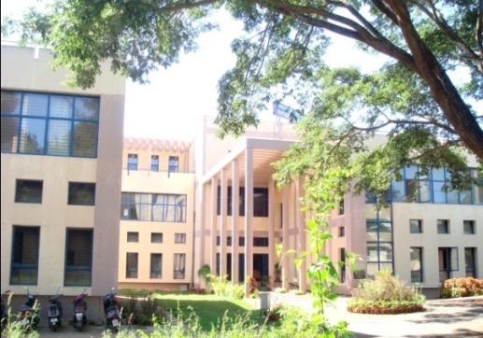A total of **47,756** ***person’s*** have been registered during the year with various types of speech, hearing and language disorders. This includes **19,382** ***new person’s*** and **28,374** persons who have made ***repeat visits*** for the evaluation of their problems. A total of **7,370** and **13,109** persons were seen in speech and language OPD and audiology OPD respectively.

A total of **7,370** person’s were evaluated in detail for various speech, language problems. The needy persons were also evaluated for associated ENT and psychological problems by the faculty and staff from the respective departments.

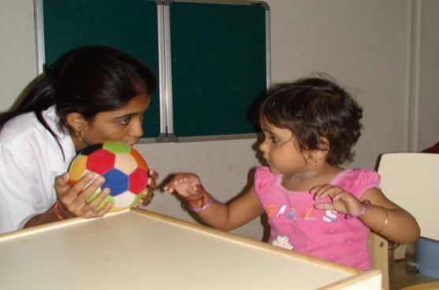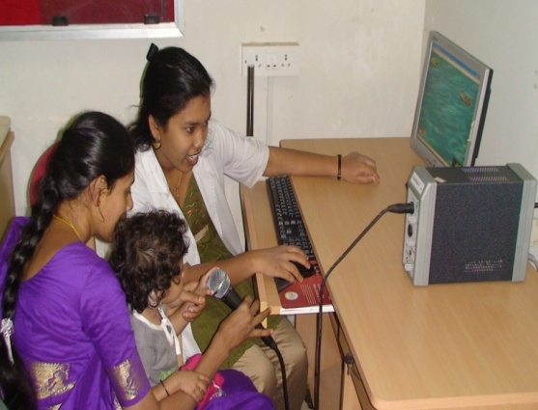Persons requiring further management were given various Speech-Language therapies for a period of 45 minutes every day. A total of **5,566** person’s were attended various speech and language therapy for the year April –11 to March -12.A total of **32,275** which includes individual speech and language therapy sessions, Special Clinics (Fluency, ASD, U-Sofa and MSD) **5,089** therapy sessions were given in the year April-11 to March -12. The faculty and clinical staff provide supervision and counseling along with support and guidance to parents for home training.

In addition, the persons were referred for various other therapy programs (for e.g. Physiotherapy, Occupation therapy, Autism therapy, etc) by the concerned supervisors.

Following tables 1-9 are depicting the statistics of persons registered in the department and other statistics.

**Table 1: State wise distribution of person’s registered from April 11 – March 12**

|  |  |  |  |
| --- | --- | --- | --- |
| **States** | **Male** | **Female** | **Total** |
| Andra Pradesh | 119 | 33 | 152 |
| Assam | 12 | 5 | 17 |
| Bangaladesh | 5 | 0 | 5 |
| Bihar | 10 | 2 | 12 |
| Chattisgarh | 2 | 1 | 3 |
| Delhi | 3 | 4 | 7 |
| Goa | 2 | 1 | 3 |
| Gujarat | 4 | 0 | 4 |
| Hariyana | 2 | 1 | 3 |
| Himachal Pradesh | 0 | 1 | 1 |
| Jarkhand | 9 | 4 | 13 |
| Karnataka | 11175 | 6884 | 18059 |
| Kashmir | 1 | 0 | 1 |
| Kerala | 488 | 247 | 735 |
| Madhya Pradesh | 3 | 4 | 7 |
| Maharastra | 18 | 3 | 21 |
| Malaya | 0 | 0 | 0 |
| Maldives | 3 | 3 | 6 |
| Manipur | 2 | 1 | 3 |
| Meghalaya | 1 | 0 | 1 |
| Orissa | 13 | 4 | 17 |
| Over Seas (Nepal) | 5 | 4 | 9 |
| Punjab | 0 | 0 | 0 |
| Rajasthan | 11 | 2 | 13 |
| Tamil Nadu | 159 | 92 | 251 |
| Tripur | 0 | 0 | 0 |
| Union Territories | 4 | 1 | 5 |
| Uttar Pradesh | 9 | 5 | 14 |
| Uttaranchal | 1 | 1 | 2 |
| West Bengal | 14 | 4 | 18 |
| **Total** | **12075** | **7307** | **19382** |

**Figure 1:State wise distribution of person’s registered from April 11-March 12**

|  |  |  |  |
| --- | --- | --- | --- |
| **Age Group** | **Male** | **Female** | **Total** |
| 0-5 | 2104 | 1372 | 3476 |
| 5-10 | 1377 | 795 | 2172 |
| 10-20 | 1775 | 1012 | 2787 |
| 20-40 | 3047 | 2020 | 5067 |
| 40-60 | 1987 | 1330 | 3317 |
| 60-80 | 1610 | 713 | 2323 |
| 80+ | 175 | 65 | 240 |
| **Total** | **12075** | **7307** | **19382** |

**Table 2: Age wise statistic of person’s registered from April 11-March 12**

**Figure 2 : Age wise statistic of person’s registered from April 11-March 12**

**Table 3: Total Number of Person’s registered at Medical records, from April 11-March 12**

|  |  |  |  |  |  |
| --- | --- | --- | --- | --- | --- |
| **Months** | **New Persons** | **Repeat Persons** | **Total Persons** | **No of Working Days** | **Daily Average** |
| April | 1542 | 2365 | 3907 | 18 | 217 |
| May | 2006 | 2717 | 4723 | 21 | 224 |
| June | 1797 | 2859 | 4656 | 22 | 211 |
| July | 1798 | 2809 | 4607 | 21 | 219 |
| August | 1357 | 2328 | 3685 | 21 | 175 |
| September | 1583 | 2146 | 3729 | 21 | 177 |
| October | 1766 | 2335 | 4101 | 19 | 215 |
| November | 1587 | 2263 | 3850 | 20 | 192 |
| December | 1675 | 2276 | 3951 | 21 | 188 |
| January | 1556 | 2457 | 4013 | 21 | 191 |
| February | 1299 | 2014 | 3313 | 20 | 165 |
| March | 1416 | 1805 | 3221 | 21 | 153 |
| **Total** | **19382** | **28374** | **47756** | **246** | **194** |

**Table 4: Statistics of person’s seen in Speech & Audiology OPD from Apr 2011 – Mar 12**

|  |  |  |  |  |  |  |  |  |  |  |  |  |  |  |
| --- | --- | --- | --- | --- | --- | --- | --- | --- | --- | --- | --- | --- | --- | --- |
| **Particulars** | | **Apr** | **May** | **June** | **July** | **Aug** | **Sep** | **Oct** | **Nov** | **Dec** | **Jan** | **Feb** | **March** | **Total** |
| Total diagnostic cases | New | 595 | 786 | 614 | 530 | 375 | 432 | 645 | 453 | 557 | 155 | 354 | 438 | **5934** |
| Repeat | 150 | 93 | 156 | 133 | 72 | 74 | 74 | 49 | 55 | 101 | 62 | 87 | **1106** |
| Total | 745 | 879 | 770 | 663 | 447 | 506 | 719 | 502 | 612 | 556 | 446 | 525 | **7370** |
| Speech Lang. OPD | | 745 | 879 | 775 | 663 | 447 | 506 | 719 | 502 | 612 | 556 | 446 | 525 | **7370** |
| Audiology OPD | | 959 | 1305 | 1175 | 1230 | 973 | 1154 | 1189 | 1103 | 1089 | 1082 | 879 | 971 | **13109** |

**Figure 3 : Statistics of person’s registered in Medical records, and seen in Speech & Audiology from OPD from Apr 2011 – Mar 12**

**Table 5: Person’s seen in Diagnostic OPD (Speech-Language) disorder wise from April 2011 –March 12**

|  |  |  |  |  |  |  |  |  |  |  |  |  |  |  |  |  |  |  |  |  |  |  |
| --- | --- | --- | --- | --- | --- | --- | --- | --- | --- | --- | --- | --- | --- | --- | --- | --- | --- | --- | --- | --- | --- | --- |
| **Disorders** | **Language disorders** | | | **Voice**  **disorders** | | | **Fluency disorders** | | | **Articulation disorders** | | | **Multiple** | | | **Normal** | | | | **Total** | **Hindi** | |
| **Months** | **Child** | **Adult** | **Geriatric** | **Child** | **Adult** | **Geriatric** | **Child** | **Adult** | **Geriatric** | **Child** | **Adult** | **Geriatric** | **Child** | **Adult** | **Geriatric** | **Child** | | **Adult** | **Geriatric** |  |  | |
| April | 504 | 46 | 7 | 9 | 10 | 8 | 51 | 18 | 0 | 59 | 8 | 0 | 0 | 0 | 0 | 21 | | 4 | 0 | 745 | 24 | |
| May | 526 | 60 | 7 | 15 | 24 | 8 | 89 | 21 | 0 | 70 | 9 | 0 | 1 | 0 | 0 | 37 | | 10 | 2 | 879 | 42 | |
| June | 513 | 51 | 4 | 14 | 37 | 12 | 37 | 23 | 0 | 22 | 4 | 1 | 8 | 1 | 0 | 28 | | 15 | 0 | 770 | 54 | |
| July | 366 | 52 | 4 | 17 | 26 | 6 | 27 | 25 | 0 | 18 | 11 | 3 | 53 | 4 | 0 | 20 | | 27 | 4 | 663 | 47 | |
| Aug | 264 | 35 | 7 | 9 | 17 | 15 | 23 | 23 | 0 | 16 | 7 | 2 | 0 | 0 | 0 | 12 | | 16 | 1 | 447 | 40 | |
| Sep | 297 | 38 | 4 | 14 | 25 | 6 | 22 | 32 | 0 | 25 | 6 | 1 | 6 | 0 | 0 | 13 | | 12 | 5 | 506 | 44 | |
| Oct | 398 | 26 | 7 | 22 | 28 | 9 | 71 | 17 | 0 | 55 | 7 | 2 | 24 | 0 | 0 | 30 | | 19 | 4 | 719 | 30 | |
| Nov | 276 | 52 | 6 | 22 | 27 | 12 | 26 | 19 | 2 | 21 | 4 | 5 | 11 | 0 | 0 | 7 | | 12 | 0 | 502 | 34 | |
| Dec | 358 | 46 | 10 | 19 | 26 | 14 | 22 | 13 | 0 | 46 | 2 | 1 | 5 | 0 | 0 | 41 | | 9 | 0 | 612 | 33 | |
| Jan | 326 | 43 | 4 | 23 | 33 | 11 | 21 | 20 | 0 | 28 | 7 | 1 | 10 | 1 | 0 | 19 | | 9 | 0 | 556 | 27 | |
| Feb | 266 | 36 | 4 | 6 | 19 | 7 | 25 | 16 | 0 | 24 | 4 | 1 | 0 | 0 | 0 | 22 | | 9 | 7 | 446 | 27 | |
| Mar | 303 | 35 | 7 | 16 | 34 | 8 | 31 | 13 | 1 | 25 | 7 | 3 | 18 | 0 | 0 | 24 | | 0 | 0 | 525 | 33 | |
| Total | **4397** | **520** | **71** | **186** | **306** | **116** | **445** | **240** | **3** | **409** | **76** | **20** | **136** | **6** | **0** | **274** | | **142** | **23** | **7370** | **435** | |
| Disorder wise | **4988** | | | **608** | | | **688** | | | **505** | | | **142** | | | **439** | | | |  |  | |
| Overall | **7370** | | | | | | | | | | | | | | | | | | |
|  | | | | |

**Figure 4: Disorders-wise distribution of diagnostic person’s seen in OPD- Speech/ language Apr 2011 –March 12**

**Table 6: Statistics of Rehabilitation Services provided in the Department of Clinical Services Apr 2011– March 2012**

|  |  |  |  |  |  |  |  |  |  |  |  |  |  |  |  |  |
| --- | --- | --- | --- | --- | --- | --- | --- | --- | --- | --- | --- | --- | --- | --- | --- | --- |
| **Disorders-wise distribution of Therapy person’s from Apr 2011 – Mar 12** | | | | | | | | | | | | | | | | |
| **Disorders** | **Language Disorders** | | | | **Voice**  **Disorders** | | | **Fluency Disorders** | | | **Articulation Disorders** | | | **Multiple**  **Disorders** | |  |
| **Months** | **Child** | **Adult** | | **Geriatric** | **Child** | **Adult** | **Geriatric** | **Child** | **Adult** | **Geriatric** | **Child** | **Adult** | **Geriatric** | **Child** | **Adult** | **Total** |
| April | 312 | 9 | | 7 | 0 | 8 | 1 | 36 | 19 | 0 | 30 | 4 | 0 | 60 | 2 | 488 |
| May | 419 | 11 | | 3 | 0 | 6 | 0 | 55 | 22 | 0 | 30 | 3 | 0 | 49 | 1 | 599 |
| June | 293 | 6 | | 1 | 1 | 4 | 0 | 14 | 19 | 0 | 10 | 2 | 0 | 54 | 1 | 405 |
| July | 363 | 10 | | 4 | 0 | 5 | 1 | 15 | 26 | 0 | 9 | 2 | 0 | 68 | 0 | 503 |
| Aug | 346 | 15 | | 3 | 0 | 2 | 2 | 9 | 27 | 0 | 10 | 2 | 0 | 60 | 0 | 476 |
| Sep | 324 | 18 | | 6 | 0 | 1 | 0 | 13 | 28 | 0 | 7 | 2 | 0 | 53 | 1 | 453 |
| Oct | 344 | 17 | | 2 | 3 | 6 | 0 | 33 | 15 | 1 | 12 | 4 | 0 | 67 | 2 | 506 |
| Nov | 295 | 13 | | 6 | 0 | 4 | 3 | 8 | 11 | 1 | 8 | 10 | 0 | 50 | 0 | 409 |
| Dec | 193 | 7 | | 7 | 1 | 3 | 1 | 8 | 11 | 0 | 12 | 2 | 0 | 34 | 1 | 280 |
| Jan | 367 | 16 | | 5 | 2 | 8 | 1 | 6 | 13 | 0 | 18 | 0 | 0 | 69 | 0 | 505 |
| Feb | 355 | 16 | | 5 | 1 | 8 | 0 | 3 | 8 | 0 | 9 | 1 | 0 | 64 | 0 | 470 |
| Mar | 359 | 11 | | 6 | 0 | 8 | 0 | 6 | 11 | 0 | 9 | 0 | 0 | 60 | 1 | 471 |
| Total | 3970 | 149 | | 55 | 8 | 63 | 9 | 206 | 210 | 2 | 164 | 32 | 0 | 688 | 9 | **5565** |
| Disorder wise | **4174** | | | | **80** | | | **418** | | | **196** | | | **697** | |
| Overall total | **5565** | | | | | | | | | | | | | | |
|  | | | | | | | | | | | | | | |

**Figure 5: Disorders-wise distribution of therapy person’s from Apr 2011 –March 12**

**Table 7: Clinical Services in the Special Clinic from April 2011 - March12**

|  |  |  |  |  |  |  |  |  |  |  |  |  |  |  |  |  |  |  |  |  |
| --- | --- | --- | --- | --- | --- | --- | --- | --- | --- | --- | --- | --- | --- | --- | --- | --- | --- | --- | --- | --- |
| **Disorders** | **Fluency unit** | | | | **\*Autism Spectrum Disorder** | | | **\*U- Sofa** | | | **\*MSD** | | | **Total** | **Sessions** | | | | | **Total Sessions** |
| **Months** | **Child** | **Adult** | | **Geriatric** | **Child** | **Adult** | **Geriatric** | **Child** | **Adult** | **Geriatric** | **Child** | **Adult** | **Geriatric** | **FU** | **ASD** | **U-Sofa** | | **MSD** |
| **April** | 38 | 25 | | 0 | 0 | 0 | 0 | 0 | 0 | 0 | 0 | 0 | 0 | 63 | 351 | 0 | 67 | | 0 | **418** |
| **May** | 45 | 20 | | 0 | 0 | 0 | 0 | 0 | 0 | 0 | 0 | 0 | 0 | 65 | 367 | 0 | 95 | | 0 | **462** |
| **June** | 6 | 17 | | 0 | 0 | 0 | 0 | 0 | 0 | 0 | 0 | 0 | 0 | 23 | 93 | 0 | 14 | | 0 | **107** |
| **July** | 16 | 34 | | 0 | 0 | 0 | 0 | 0 | 0 | 0 | 0 | 0 | 0 | 50 | 371 | 0 | 72 | | 0 | **443** |
| **Aug** | 12 | 34 | | 0 | 0 | 0 | 0 | 0 | 0 | 0 | 0 | 0 | 0 | 46 | 306 | 0 | 18 | | 0 | **324** |
| **Sep** | 21 | 31 | | 0 | 0 | 0 | 0 | 0 | 0 | 0 | 0 | 0 | 0 | 52 | 265 | 0 | 20 | | 0 | **285** |
| **Oct** | 42 | 24 | | 0 | 0 | 0 | 0 | 0 | 0 | 0 | 0 | 0 | 0 | 66 | 306 | 0 | 13 | | 0 | **319** |
| **Nov** | 17 | 23 | | 0 | 2 | 0 | 0 | 0 | 0 | 0 | 3 | 0 | 0 | 45 | 230 | 0 | 24 | | 0 | **254** |
| **Dec** | 16 | 22 | | 0 | 14 | 0 | 0 | 3 | 0 | 0 | 0 | 0 | 0 | 55 | 169 | 67 | 10 | | 0 | **246** |
| **Jan** | 9 | 22 | | 2 | 64 | 0 | 0 | 8 | 2 | 0 | 2 | 0 | 0 | 109 | 142 | 304 | 41 | | 16 | **503** |
| **Feb** | 13 | 17 | | 0 | 64 | 1 | 0 | 9 | 2 | 0 | 18 | 3 | 0 | 127 | 158 | 507 | 44 | | 143 | **852** |
| **Mar** | 13 | 35 | | 0 | 85 | 1 | 0 | 17 | 3 | 0 | 34 | 2 | 0 | 190 | 164 | 484 | 99 | | 129 | 876 |
| **Total** | **248** | **304** | | **2** | **229** | **2** | **0** | **37** | **7** | **0** | **57** | **5** | **0** | **891** | **2922** | **1362** | **517** | | **288** |  |
| **Disorder wise** | **554** | | | | **231** | | | **44** | | | **62** | | | **5089** | | | | | **5089** |
| **Overall total** | **891** | | | | | | | | | | | | | |
| *Special clinic centralized with effect from January, 2012 | | | | | | | | | | | | | | |

**Figure 6: Clinical Services in the Special Clinic from April 2011 - March12**

**Specialized clinical services:**

Allied professionals such as Pediatrician, Neurologist, Plastic surgeon, Prosthodontist, Phonosurgeon, physiotherapist and occupational therapists provide consultancy services for better patient care and management. The detailed statistics regarding the specialized clinical services provided during the months April 2011-March 2012 are given in Table: 8

**Table 8: Person’s seen in specialized clinical services and consultant specialists April 11 - March 12**

|  |  |  |  |  |  |  |  |  |  |  |  |  |  |  |
| --- | --- | --- | --- | --- | --- | --- | --- | --- | --- | --- | --- | --- | --- | --- |
|  | | **Apr** | **May** | **June** | **July** | **Aug** | **Sep** | **Oct** | **Nov** | **Dec** | **Jan** | **Feb** | **March** | **Total** |
| PT | Cases | 79 | 90 | 33 | 44 | 20 | 29 | 25 | 22 | 59 | 45 | 36 | 41 | 523 |
| OT | Cases | 86 | 109 | 108 | 112 | 61 | 66 | 69 | 62 | 61 | 43 | 34 | 49 | 860 |
| Neurologist | | 45 | 51 | 49 | 42 | 50 | 28 | 32 | 23 | 56 | 30 | 41 | 52 | 499 |
| Pediatrician | | 31 | 38 | 24 | 39 | 30 | 27 | 21 | 25 | 34 | 19 | 27 | 32 | 347 |
| Phonosurgeon | | 3 | 1 | 1 | 5 | 3 | 2 | 3 | 0 | 2 | 2 | 0 | 0 | 22 |
| Plastic surgeon | | 20 | 31 | 18 | 10 | 15 | 12 | 7 | 17 | 12 | 3 | 16 | 5 | 166 |
| Prosthodontist | | 3 | 4 | 2 | 1 | 0 | 4 | 4 | 4 | 2 | 0 | 2 | 1 | 27 |
| Orthodontist | | 6 | 6 | 6 | 1 | 3 | 1 | 7 | 4 | 0 | 3 | 7 | 1 | 45 |

**Figure 7: Person’s seen in specialized clinical services and consultant specialists April 11 - March 12**

**Figure 8: Person’s seen in PT/OT from April 11-March 12**

**Table 8: Person’s seen in specialized clinical services April 11 - March 12**

|  |  |  |  |  |  |  |  |  |  |  |  |  |  |  |
| --- | --- | --- | --- | --- | --- | --- | --- | --- | --- | --- | --- | --- | --- | --- |
|  | | **Apr** | **May** | **June** | **July** | **Aug** | **Sep** | **Oct** | **Nov** | **Dec** | **Jan** | **Feb** | **March** | **Total** |
| **PT** | **Cases** | 121 | 134 | 43 | 53 | 39 | 42 | 39 | 37 | 60 | 80 | 82 | 81 | 811 |
| **Session** | 828 | 759 | 303 | 356 | 269 | 329 | 293 | 280 | 496 | 614 | 754 | 703 | 5984 |
| **OT** | **Cases** | 139 | 148 | 159 | 178 | 158 | 120 | 128 | 133 | 121 | 129 | 115 | 122 | 1650 |
| **Session** | 686 | 833 | 1085 | 1174 | 1085 | 723 | 757 | 977 | 954 | 1069 | 967 | 951 | 11261 |

**Table 9: Details regarding Person’s attending Therapy from April 11- March 12**

|  |  |  |  |  |  |  |  |  |  |  |  |  |  |
| --- | --- | --- | --- | --- | --- | --- | --- | --- | --- | --- | --- | --- | --- |
| **Details regarding Person’s attending Therapy, April 110 March 12** | | | | | | | | | | | | | |
| **Particulars** | **Apr** | **May** | **June** | **July** | **Aug** | **Sep** | **Oct** | **Nov** | **Dec** | **Jan** | **Feb** | **Mar** | **Total** |
| No. of Cases | 488 | 599 | 405 | 503 | 476 | 453 | 506 | 409 | 280 | 505 | 470 | 471 | 5565 |
| Therapy New Cases | | | | | | | | | | | | | **1587** |
| Therapy Repeat Cases | | | | | | | | | | | | | **3978** |
| No. of Sessions | 2600 | 2560 | 2200 | 3270 | 3400 | 3020 | 2900 | 2070 | 1800 | 3025 | 2870 | 2560 | **32275** |
| Demo therapy Cases | 94 | 106 | 70 | 60 | 31 | 46 | 66 | 32 | 45 | 60 | 39 | 29 | 678 |
| Cases discharged | 15 | 20 | 15 | 30 | 20 | 10 | 15 | 15 | 20 | 15 | 20 | 20 | 215 |
| No. of Hindi Cases | 12 | 17 | 20 | 13 | 7 | 16 | 14 | 7 | 6 | 22 | 12 | 19 | 165 |
| Gp parent Counseling | 0 | 0 | 0 | 0 | 0 | 0 | 0 | 0 | 0 | 0 | 0 | 0 | 0 |
| Correspond. (email/ FU) | 15 | 14 | 20 | 28 | 74 | 19 | 16 | 13 | 19 | 15 | 10 | 4 | 247 |
| Certificates Issued | 25 | 37 | 26 | 24 | 18 | 12 | 13 | 8 | 9 | 9 | 7 | 18 | 206 |
| Case report Issued | 40 | 41 | 102 | 90 | 46 | 62 | 50 | 68 | 58 | 66 | 54 | 60 | 737 |

**REPORTS AND CERTIFICATE ISSUED**

|  |  |  |
| --- | --- | --- |
| **Sl.No** | **Particulars** | Total |
| 1 | Transfer certificate | 39 |
| 2 | Case reports | 737 |
| 3 | Attendance certificates | 85 |
| 4 | School admission certificate/  Language exemption certificate | 167 |
| 5 | Correspondence by e-mail | 130 |
| 6 | Correspondence by Letter | 159 |

**Assistance provided to the needy persons under Patient Welfare Fund (PWF):**

|  |  |  |  |  |  |  |
| --- | --- | --- | --- | --- | --- | --- |
| **Sl.No** | **Case No** | **Name** | **Gender/Age** | **Diagnosis** | **Financial assistance towards** | **Amount** |
| 1 | 334180 | M.V.Kemparaju | M / 84 | Severe mixed HL | Hearing Aid-EIKONEL78 | Rs.2,405/- |
| 2 | 235693 | Ibrahim Sait | M / 60 | Mod Severe to severe mixed HL | Hearing Aid- EIKONE BM79 | Rs.1,418/- |
| 3 | 305266 | Chikka Madappa | M / 58 | Bilateral Profound HL | Hearing Aid- EIKONE BM79 | Rs.1,418/- |
| 4 | 334553 | Irfan | M / 4 | B/L Severe HL | Hearing Aid-EIKON BM 98 Strong | Rs.1,786/- |
| 5 | 246299 | P.T.Ramrao | M / 72 | Bilateral Severe SNHL | Hearing Aid-ELKON BM 79 Strong | Rs.1,786/- |
| **Total Assistance provided to the needy persons under Patient Welfare Fund (PWF) for the year 2011-12** | | | | | | **Rs. 8813/-** |

**Revenue generated from April 2011 to March 2012**

|  |  |
| --- | --- |
| **Revenue generated from** | **Amount** |
| Medical records | 4,70,972 |
| Therapy charges | 4,29,012 |
| Certificate /evaluations | 44,405 |
| Kuteera/dharmasala | 2,20,525 |
| Misllaneous - handout and books | 25,744 |
| **Total** | **11,90,658** |

VI.Central Facilities

1. Library and Information Services- Nil
2. Public Information Activities

* RCI education programs telecasted from 10.00 am to 4.30 pm daily in the Dept of Clinical Services.

1. Major Events of the Year with a brief account
2. **International Stuttering Awareness Day (ISAD):**

International Stuttering Awareness Day (ISAD) was celebrated on 24th October 2011 by Department of Clinical Services. As a part of celebration, an orientation program was conducted on “Stuttering”. The target group for the program were “Teacher trainees”. The main objective of this program was to orient teachers and create awareness about Stuttering.

Around Two hundred and fifty (250) teacher trainees from different colleges of Mysore, parents, children and adults with stuttering attended the program. The program commenced at 9:30 a.m. and extended till 2:00 p.m. P**re test** was conducted for the participants to check their awareness level about Stuttering before the commencement of the program. The program was inaugurated by lighting the lamp. Dr S.R. Savithri, Director, Mrs Sangeetha M, Clinical Lecturer, Headmaster, Chayadevi D.Ed college and Devappa. Y. K, a former client of AIISH, together joined in lighting the lamp.

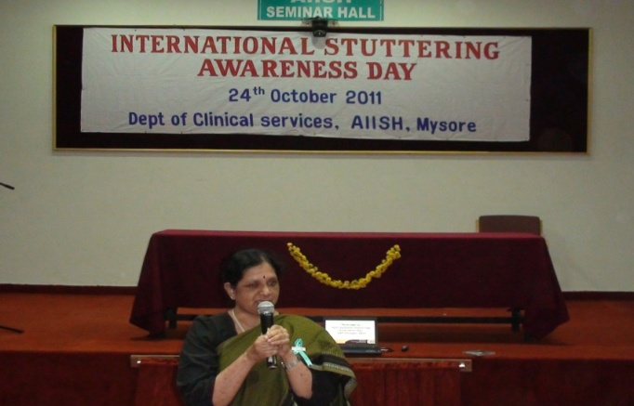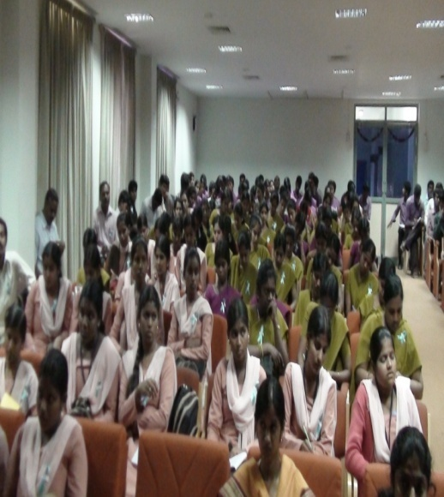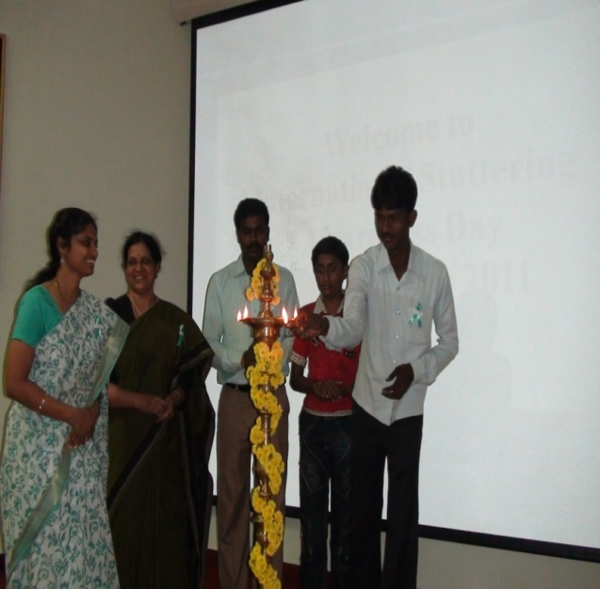

1. **International Day of Persons with Disabilities celebrations:-**

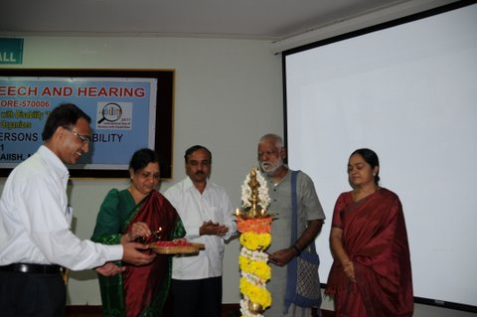The International Day of Persons with Disabilities is observed on 3rd December 2011 all over the globe. The theme for 2011 was **“Together for a better world for all: Including persons with disabilities in development”**.Persons with disabilities make up an estimated 15 per cent of the world’s population. Almost one-fifth of the estimated global total of persons living with disabilities, encounter significant difficulties. Furthermore, a quarter of the global population is directly affected by disability, as caregivers or family members.

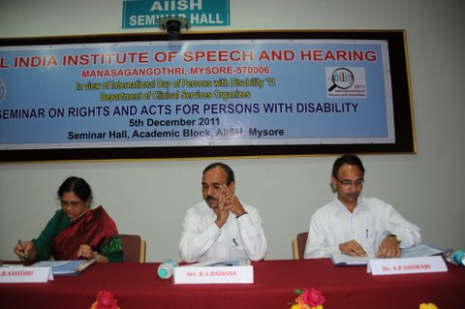International Day of Persons with Disability provides an opportunity to initialize action to reach the target of full and equal pleasure of human rights and contribution in society by persons with disability. In view of this, the Department of Clinical Services conducted a seminar on Rights and Acts for Persons with Disability on 5th December 2011. The objective of the seminar was to craft a better world including persons with disabilities in global development.

The Seminar was an open platform for students, professionals and the general public in view of creating awareness about the rights and Acts for persons with disability. There were about two hundred and eighty five participants who attended the seminar. The program commenced at 9:30 am. The inaugural function was graced by Sri.K.V.Rajanna, Commissioner for Disabilities Government of Karnataka, Dr. S.R.Savithri, Director, AIISH and Dr. S.P.Goswami, HOD- Clinical Services.

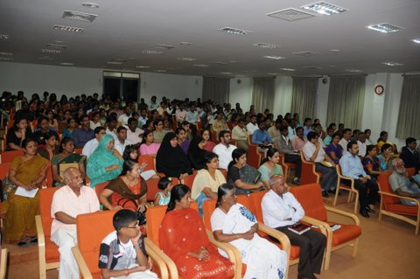The sessions of the one day seminar started with the topic of ‘Breaking the barriers for persons with disability’ which was finely crafted with the knowledge and words of the resource person which served the purpose of the seminar by the interactive discussion from the delegates. During the course of the seminar, a clear insight was given to the audience regarding Accessibility for persons with disability, Right to education, Certification, Legal Rights and Acts for persons with disability. Each resource person’s years of practical experience and knowledge in their own domain was imparted to the participants in the scheduled time.

During the inaugural function, as a mark of recognition, six achievers along with the best mother were felicitated during the seminar. People like them are the ones who have proved themselves in their functional area and succeeded to bring over social change in the society and to reframe the terminology ‘disabled’ to ‘differentially abled’.

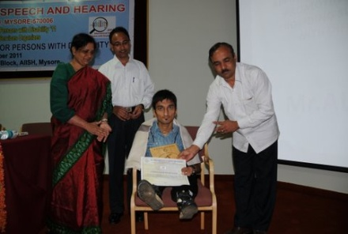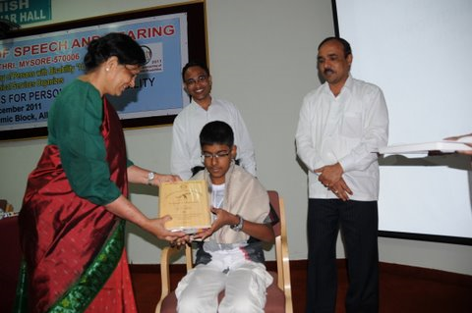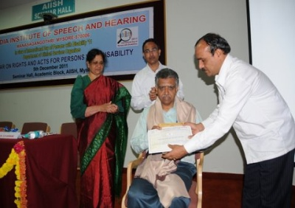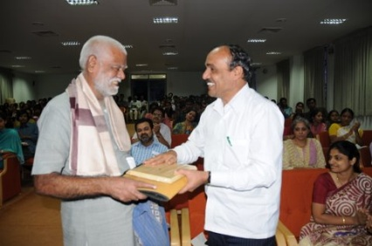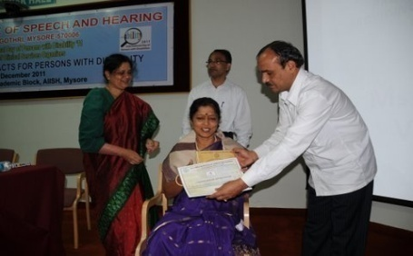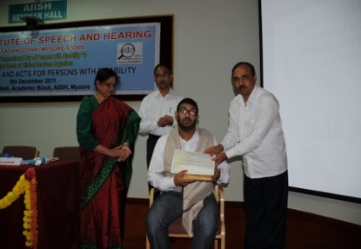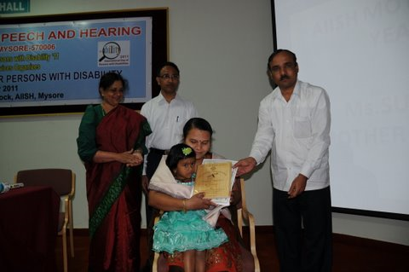

A cultural evening was organized together by the Department of Clinical Services and Department of Special Education in AIISH Gymkhana. The Children from preschool performed cultural activities and the program was cherished by the participation of the employees of AIISH.

1. **Dementia week:**

The Department of clinical services celebrated the National Dementia awareness week 18th September to 24th September 2011 with special emphasis on World Alzheimer’s day, which is observed on 21st September 2011. The program was conducted to create awareness among the general public and the students about Alzheimer’s disease through the display of posters, banners, pamphlets and the videos on dementia were displayed in the clients waiting area.

1. **International Deafness day:**

The international deafness day was held on 26th September 2011 in the Department of Clinical Services. Various activities such as pamphlets, painting, drawing and matching were conducted for the children with hearing impairment. The posters on international deafness day were also displayed to create awareness about hearing impairment from among the parents and the general public as a whole. The children who participated in the various activities were acknowledged with the prizes as a token of appreciation.

1. Press Releases and Media Coverage- Nil
2. Details of Institute Publications during the year- Nil
3. Material Development:

* Handouts on the signs and symptoms of stroke and the effective quick steps to take following stroke in view of National Seminar on Stroke.
* Prepared a list of Speech and Hearing Centers all over India.

VII.Awards and Honors Received by Faculty and Staff - Nil

VIII.Extra Curricular Activities- Nil

1. AIISH GYMKHANA
2. NSS
3. OTHERS

Ix.MAJOR EVENTS OF THE YEAR- Department of clinical services

x. Eminent Visitors

* Shri. S. Gandhiselvan, Hon’ble Minister of state for Health and Family Welfare, Govt of India, New Delhi visited at 3.00 P.m on 23.01.2012