**ALL INDIA INSTITUTE OF SPEECH AND HEARING: MYSORE – 570006**

No. SH/ACA/AR/2012-13 11.4.2012

Submitted to the Director:

Sub: Preparation and submission of draft material for Annual Report for

the year 2011-12.

Ref: AIISH Circular SH/Lib/AR/2011-12, 2.4.2012.

Please find enclosed the material for Annual Report for the period 1.4.2011 to 31.3.2012 pertaining to Academic Section.

Academic Coordinator

**ALL INDIA INSTITUTE OF SPEECH & HEARING: MYSORE-6**

**ACADEMIC SECTION**

**A) EDUCATIONAL ACTIVITIES**

**I. Academic Programs offered during 2011-12**

The institute continued to offer 3 Diploma, 2 P.G. Diploma, 2 undergraduate, 3 postgraduate, 2 doctoral programs and a Post Doctoral Fellowship as in the previous year. Thus, during the year, the institute offered 10 different programmes. Of these programs the Diploma in Hearing Language and Speech was conducted through video conferencing mode. The institute undertook the challenge of offering this programme to 12 study centers and having classes through video conferencing mode. All the degree programs had the approval of the University of Mysore and/or the Rehabilitation Council of India. In all 195 diploma, 190 undergraduate, 6 P.G. Diplomas and 137 post graduate students underwent training. In addition, 25 researchers pursued their Ph.D. and Post Doctoral Fellowship.

**II. New Academic Programs offered during 2011-12**

NIL

**New admission**

BASLP continued to be the well sought after professional program in the country with 505 students appearing for the BASLP entrance examination conducted at Delhi, Kolkata, Guwahati, Mumbai, Chennai and Mysore. The entrance examinations for M.Sc. were conducted at Mysore and 133 and 172 students appeared for M.Sc. (Speech Language Pathology), M.Sc. (Audiology) entrance examination, respectively.

**Students currently studying for each programme:**

The details regarding the various programmes, Gender-wise distribution of seats, Statewise distribution of the admissions during the year 2011-12 is given below:

|  |  |  |
| --- | --- | --- |
| Name of the programme | No. of seats available | No. of intake |
| Diploma (HA & ET) | 25 | 3 |
| DTY(DHH) | 20 | 2 |
| DHLS (AIISH, Mysore) | 25 | 13 |
| DHLS (Puducherry Center) | 25 | 21 |
| DHLS (Imphal, Center) | 25 | 22 |
| DHLS (Mumbai Center) | 25 | 7 |
| DHLS (Delhi Center) | 25 | 14 |
| DHLS (Shimla Centre) | 25 | 10 |
| DHLS (Ajmer Centre) | 25 | 10 |
| DHLS (Jabalpur, Centre) | 25 | 21 |
| DHLS (Jharkhand Centrer) | 25 | 13 |
| DHLS (CuttackCentre) | 25 | 11 |
| DHLS (Lucknow Centre) | 25 | 23 |
| DHLS (Bhagalpur Centre) | 25 | 25 |
| BASLP | 62 | 62 |
| B.S.Ed. (Hearing Impairment) | 20 | 6 |
| PGDCLSLP | 10 | 6 |
| M.Sc. (Speech-Language Pathology) | 36 | 32 |
| M.Sc. (Audiology) | 36 | 33 |
| Ph.D. (Audiology) | 4 | 3 |
| Ph.D. (Speech-Language Pathology) | 4  (backlog-3) | 7 |
| **Total:** | **520** | **344** |

Table 1: Details of admissions in 2011-12

**III. Total student strength**

**Genderwise distribution of seats of the admission during the year 2011-12**

|  |  |  |  |  |
| --- | --- | --- | --- | --- |
| **Name of the course** | | **Male** | **Female** | **Total** |
| Diploma (HA&ET) | | 3 | - | 3 |
| DTY(DHH) | | - | 2 | 2 |
| DHLS | | 102 | 88 | 190 |
| B.Sc. (Sp. & Hg.) |  | 13 | 49 | 62 |
| B. S. Ed. (HI) |  | 1 | 5 | 6 |
|  |  |  |  |  |
| PGDCL-SLP |  | - | 6 | 6 |
| M.Sc. (Audiology) |  | 19 | 14 | 33 |
| M.Sc. (SLP) |  | 9 | 23 | 32 |
| Ph. D. |  | 9 | 1 | 10 |
| **Total:** |  | **156** | **188** | **344** |

**State-wise distribution of seats of the admission during the year 2011-12**

|  |  |
| --- | --- |
| **State** | **No. of seats** |
| [Andaman and Nicobar Islands](http://en.wikipedia.org/wiki/Andaman_and_Nicobar_Islands) |  |
| [Andhra Pradesh](http://en.wikipedia.org/wiki/Andhra_Pradesh) | 11 |
| [Arunachal Pradesh](http://en.wikipedia.org/wiki/Arunachal_Pradesh) |  |
| [Assam](http://en.wikipedia.org/wiki/Assam) | 3 |
| [Bihar](http://en.wikipedia.org/wiki/Bihar_(India)) | 35 |
| [Chandigarh](http://en.wikipedia.org/wiki/Chandigarh) |  |
| [Chhattisgarh](http://en.wikipedia.org/wiki/Chhattisgarh) | 2 |
| [Dadra and Nagar Haveli](http://en.wikipedia.org/wiki/Dadra_and_Nagar_Haveli) |  |
| [Daman and Diu](http://en.wikipedia.org/wiki/Daman_and_Diu) |  |
| [Delhi](http://en.wikipedia.org/wiki/Delhi) | 8 |
| [Goa](http://en.wikipedia.org/wiki/Goa) |  |
| [Gujarat](http://en.wikipedia.org/wiki/Gujarat) |  |
| [Haryana](http://en.wikipedia.org/wiki/Haryana) | 3 |
| [Himachal Pradesh](http://en.wikipedia.org/wiki/Himachal_Pradesh) | 11 |
| [Jammu and Kashmir](http://en.wikipedia.org/wiki/Jammu_and_Kashmir) |  |
| [Jharkhand](http://en.wikipedia.org/wiki/Jharkhand) | 13 |
| [Karnataka](http://en.wikipedia.org/wiki/Karnataka) | 69 |
| [Kerala](http://en.wikipedia.org/wiki/Kerala) | 38 |
| [Lakshadweep](http://en.wikipedia.org/wiki/Lakshadweep) |  |
| [Madhya Pradesh](http://en.wikipedia.org/wiki/Madhya_Pradesh) | 22 |
| [Maharashtra](http://en.wikipedia.org/wiki/Maharashtra) | 13 |
| Manipur | 23 |
| [Meghalaya](http://en.wikipedia.org/wiki/Meghalaya) |  |
| [Mizoram](http://en.wikipedia.org/wiki/Mizoram) |  |
| [Nagaland](http://en.wikipedia.org/wiki/Nagaland) |  |
| [Orissa](http://en.wikipedia.org/wiki/Orissa) | 13 |
| [Pondicherry](http://en.wikipedia.org/wiki/Pondicherry) | 12 |
| [Punjab](http://en.wikipedia.org/wiki/Punjab,_India) |  |
| [Rajasthan](http://en.wikipedia.org/wiki/Rajasthan) | 11 |
| [Sikkim](http://en.wikipedia.org/wiki/Sikkim) |  |
| [Tamil Nadu](http://en.wikipedia.org/wiki/Tamil_Nadu) | 17 |
| [Tripura](http://en.wikipedia.org/wiki/Tripura) |  |
| [Uttar Pradesh](http://en.wikipedia.org/wiki/Uttar_Pradesh) | 35 |
| [Uttarakhand](http://en.wikipedia.org/wiki/Uttarakhand) | 1 |
| Uttaranchal |  |
| [West Bengal](http://en.wikipedia.org/wiki/West_Bengal) | 1 |
| Overseas | 3 |
| **Total:** | **344** |

**IV. Ph.D. Program**

1. **No. of Part-time scholars (Ph.D.) currently working: 20**
2. **No. of Full-time scholars (Ph.D.) currently working: 25**
3. **Degree awarded: 1**
4. **Thesis submitted: 6**
5. **Under progress: 39**

**V. Post Doctoral Program**

Dr. Mahalakshmi Prasad, PDF submitted her thesis.

**VI. Educations Stipend / Fellowship provided:**

**VII. Other Financial Assistance**

Details of the stipend given to diploma, undergraduate, post graduate students and fellowships given to doctoral students are shown in table below. Apart from this, students were also given financial assistance to attend and present papers at various National and International Seminars. Ms. Pravesh Arya, Doctoral student received fellowship from ICMR to attend the International Conference.

|  |  |
| --- | --- |
| **Name of the Programme** | **Stipend per month**  **(in Rs.)** |
| Diploma programmes | 250.00 |
| B.Sc. (Sp. & Hg.) | 400.00 |
| B.Sc. (Internship) | 1500.00 |
| B. S. Ed. (HI) | 400.00 |
| M.Sc. (Audiology) | 650.00 |
| M.Sc. (SLP) | 650.00 |
|  |  |
| PG Diploma programmes (PGDCL-SLP) | 500.00 |
|  |  |
| Ph. D. (1st and 2nd year) | 14000.00 + HRA |
| Ph. D. (3rd year) | 15000.00 + HRA |
| Post Doctoral Fellowship | 18750.00 + HRA |

**VIII. Internship details:**

Sixth batch of internship students successfully completed their internship training for a period of ten months. This training enabled the students to transfer their theoretical knowledge to clinical practice. Their posting in centers/institutions outside AIISH provided them with greater exposure to clinical population and settings different from that of AIISH. Internship students were actively involved in the outreach programs of the institute. They participated in a door to door survey of individuals with speech and hearing problems which was conducted as a part of the National Program on Control and Prevention of Deafness.

**IX. Academic Degrees Awarded**

**No. of students awarded Degree programme-wise:**

A total of 45 B.Sc (Sp.&Hg.), 3 B.S.Ed. (Hearing Impairment), 36 M.Sc. (Audiology), 35 M.Sc. (Speech-Language Pathology), 5 M.S.Ed. (Hearing Impairment), and 2 P.G. Diploma in Clinical Linguistics for SLP students successfully completed their training program in the academic year 2010-11. A brief summary of the results are given below:

|  |  |  |  |
| --- | --- | --- | --- |
| **Programme** | **No of students appeared** | **Overall pass** | **Percentage** |
|  |  |  |  |
|  |  |  |  |
|  |  |  |  |
| B.Sc. (Sp. & Hg.) | 45 | 42 | 95% |
| B.S.Ed. (HI) | 3 | 2 | 70% |
|  |  |  |  |
| M.Sc. (Audiology) | 36 | 33 | 92% |
| M.Sc. (SLP) | 35 | 28 | 80% |
| M. S. Ed. (HI) | 5 | 5 | 100% |
| PGDCL | 2 | 2 | 100% |
|  |  |  |  |
|  |  |  |  |

**B. Awards and Honors received by students**

***Manohar Memorial Award for Best paper in Audiology*** ***to Mr. Jithin P. Jacob and Swathi C.S.*** III B.Sc. (Sp. & Hg.) students for the paper titled ***Training related changes in the efferent auditory system*** under the guidance of ***Dr. M. Sandeep, Lecturer in Audiology,*** at the 44th ISHACON held at Hyderabad from 20-22 January 2012.

***Best paper Award*** to ***Mr. Jithin P. Jacob***, III B.Sc. (Sp. & Hg.) student for the paper titled ***Laryngeal Aerodynamic Parameters in Indian Adult Normally Speaking Population*** under the guidance of ***Mr. Gopi Kishore, Lecturer in Speech Pathology***, at the ***FRSM 2012*** held at New Delhi from 18-19 January, 2012.

The following awards were presented to the students at the convocation held at the University of Mysore:

* Mr. Varun Uthappa was awarded *P.D. Manohar Gold Medal* for securing highest marks in M.Sc. (Speech-Language Pathology) in June 2011 examinations.
* Ms. Pragathi Rao was awarded *Arathi Venkataraman Gold Medal* for securing highest marks in M.Sc. (Audiology) in June 2011 examinations.

**Institute Awards:**

* Ms. Lakshmi M.S. was awarded *Sri. D.K. Venkatesh Murthy Medal* for securing I rank in B.Sc. (Speech & Hearing) in May 2011 examinations.
* Mr. Varun Uthappa was awarded *Smt. Jayalakshamma Medal* and *Friends United* *Organization Endowment Scholarship* for securing highest marks in M.Sc. (SLP) in June 2011 examinations.
* Ms. Gargi Singh was awarded *Abhilasha Award* for best student clinician in Final M.Sc. for the year 2010-11.

**Any other:**

**A) Short-term Training Programs**

2 students from Dhaka, Bangladesh attended the Short term training program at this institute from July to August 2011.

**B) Details of Guest Lecture /Orientation program:**

***Dr. CKN Raja, Former Professor & Head, Depaartment of Law, Manasagangothri,*** has delivered a lectureon ***Constitution of India*** to I & II B.Sc. (Speech & Hearing) and B.S.Ed. (HI) students between ***5.30 pm to 7.00 pm*** on ***20.4.2011*** at AIISH.

***Dr. S. Mahesh, Professor, SJCE, Mysore*** has delivered a lectureon ***Environmental Science*** to B.S.Ed. (HI), I & II B.Sc. (Speech & Hearing) students between ***5.30 pm to 7.00 pm*** on ***5.5.2011*** at AIISH.

Dr. Asha Yathiraj, Professor of Audiology & Academic Coordinator, attended an orientation program regarding CBCS & CAGP in the University of Mysore on 16.8.2011.

Orientation about CBCS scheme to the faculty of the institute by Prof. P. Nagabhushan, Professor & HOD, Dept. of Studies, Manasagangtothri, Mysore, on 16.9.2011 at AIISH.

***Dr. S. Mahesh, Professor, SJCE, Mysore*** has delivered a lectureon ***Environmental Science*** to III B.Sc. (Speech & Hearing) students between ***4.30 pm to 6.30 pm*** on 3***.2.2012*** at AIISH.

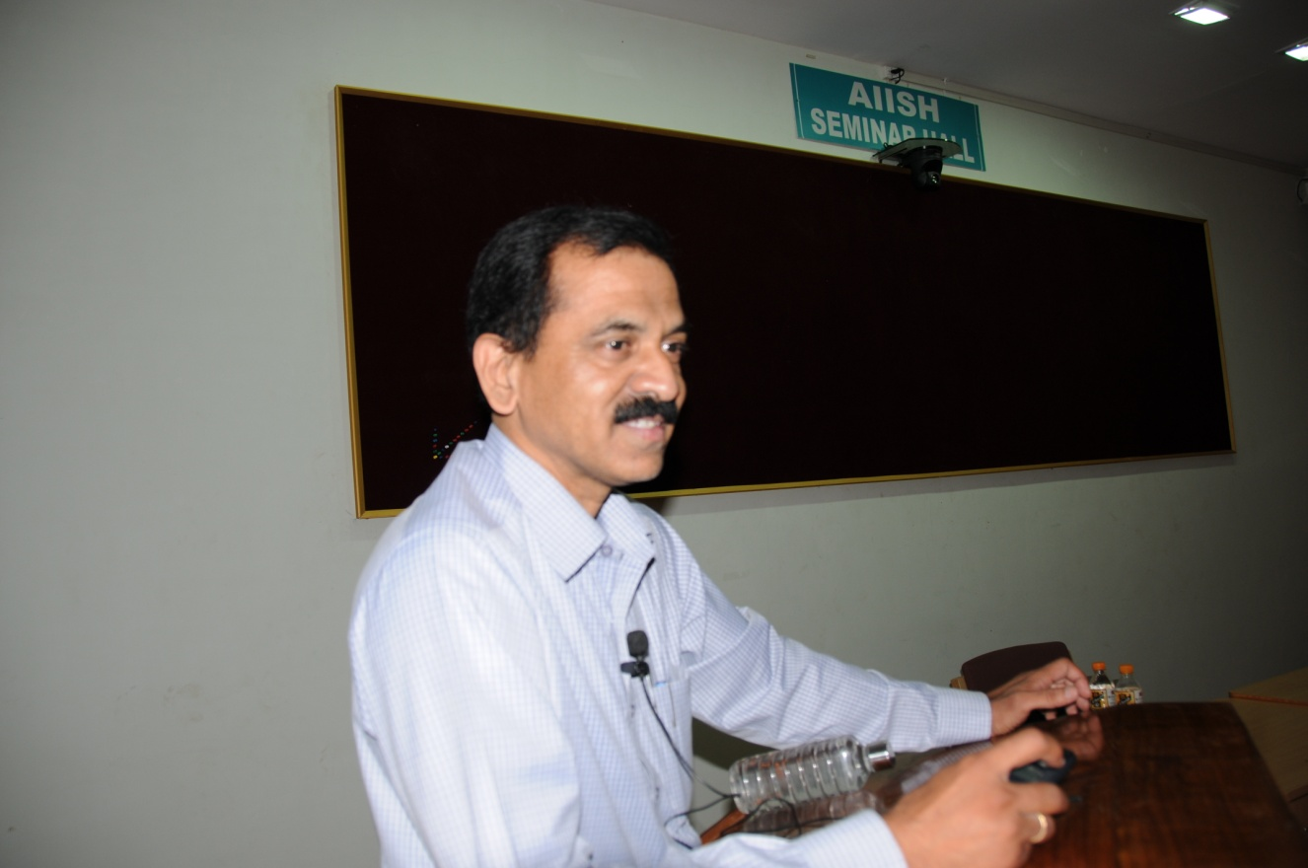

***Smt. N. Vanishree, Faculty, JSS Law College, Mysore*** has delivered a lectureon ***Constitution of India*** to I B.Sc. (Speech & Hearing) and B.S.Ed. (HI) students between ***4.30 pm to 6.30 pm*** on ***17.2.2012*** at AIISH.

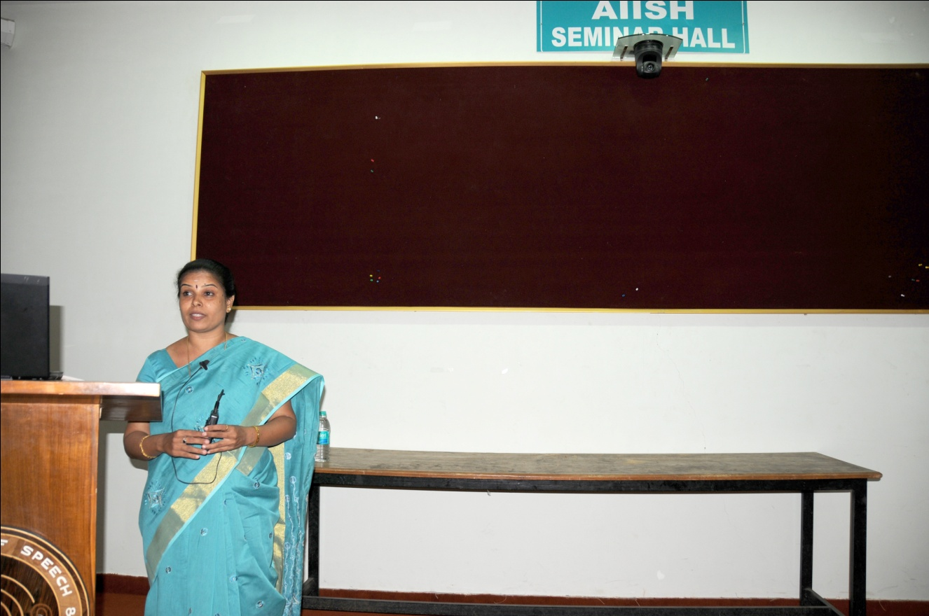

**Guest faculty**

Expertise in allied area in speech and hearing such as Paediatrics, Pathology, Neurology and Genetics were augmented by inviting visiting faculty from other premier institutions such as K. R. Hospital, Mysore; JSS Medical College, Mysore; BGS Apollo Hospital, Mysore; who imbibed the students with their expert knowledge. This has enabled the institute to fulfill the commitment made to the student fraternity in imparting higher education. The names and area of expertise of the visiting faculty is given in the table below:

|  |  |
| --- | --- |
| **Name of the subject** | **Name of the visiting faculty** |
| Neurology | Dr. Somanath Vasudev |
| Pediatrics | Dr. Rajendra Kumar |
| Genetics | Dr. Shamsundar |
| Pathology | Dr. A. L. Hemalatha |
| Epidemiology | Dr. S.N. Manjunath |
| Special Education | Dr. I.P. Gowramma |

Academic Coordinator