OBITUARY / DEDICATION

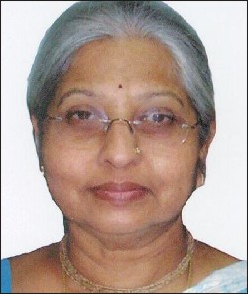

It is with deep sorrow that we mourn the sad demise of our former Director, Dr.Vijayalakshmi Basavaraj, who left us on 19th March 2011. As the Director of the institute, she contributed immensely towards its progress and development.
We dedicate the 46th Annual Report of the institute to Dr.Vijayalakshmi Basavaraj with deep appreciation of her bold leadership, unyielding passion for success and outstanding commitment which helped to fortify the institute’s position as the national leader in the area of Speech and Hearing.

