**ALL INDIA INSTITUTE OF SPEECH AND HEARING: MYSORE-6**

**DEPARTMENT OF SPEECH-LANGUAGE PATHOLOGY**

No.SH/SLP/AR/2011-12 29.4.2011

Submitted to the Director:

Sub: Material for Annual Report for the year 2010-11.

Ref: Circular No. SH/Lib/AR/2010-11 dt. 11.4.2011.

With reference to the above, please find enclosed the Material for Annual Report for the year 2010-11 in the prescribed format.

HOD, Speech-Language Pathology

Encl: Hard copy and soft copy (CD) 1 copy each.

**ALL INDIA INSTITUTE OF SPEECH & HEARING: MYSORE – 570 006**

**DEPARTMENT OF SPEECH-LANGUAGE PATHOLOGY**

**1) Academic Activities**

# 

B. **Short-term Training Program**

The staff and research fellows of the department conducted the following,

|  |  |
| --- | --- |
| **Name/Topic of the Program** | Communication disorders –An overview. Speech disorders and their assessment and management |
| **Objectives** | To orient regarding the different communication disorders and their rehabilitation |
| **Organized Department/Section/Unit** | Dept. of speech-Language Pathology |
| **Targeted Audience** | Shama.R.Chilakwad, student of Presentation secondary school, Miltown country, Kerry, Ireland |
| **Number of Participants** | 1 |
| **Date** | 9.6.10 |

|  |  |
| --- | --- |
| **Name/Topic of the Program** | Introduction to communication, language and speech disorders |
| **Objectives** | To sensitize about early identification and intervention of communication disorders |
| **Organized Department/Section/Unit** | Department of Speech Language Pathology |
| **Targeted Audience** | Masters in Dental sciences (Coorge institute of Dental Sciences) |
| **Number of Participants** | 2 |
| **Date** | 14.06.2010 |

|  |  |
| --- | --- |
| **Name/Topic of the Program** | Introduction to speech and language disorders |
| **Objectives** | To give orientation and training regarding speech and language disorders |
| **Organized Department/Section/Unit** | Dept of Speech Language Pathology |
| **Targeted Audience** | Postgraduate students, Dept of pedodontics, Coorg Institute of Dental Sciences, Virajpet |
| **Number of Participants** | 7 |
| **Date** | 8th and 29th July 2010 |

|  |  |
| --- | --- |
| **Name/Topic of the Program** | Introduction to Communication, language and speech disorders |
| **Objectives** | To sensitize about early identification and intervention of communication disorders |
| **Organized Department/Section/Unit** | Department of Speech Language Pathology |
| **Targeted Audience** | Intern (University of Applied Sciences, Utrecht.) |
| **Number of Participants** | 2 |
| **Date** | 10.08.2010 |

|  |  |
| --- | --- |
| **Name/Topic of the Program** | Speech and language disorders |
| **Objectives** | To give orientation and training regarding speech and language disorders |
| **Organized Department/Section/Unit** | Dept of Speech Language Pathology |
| **Targeted Audience** | Postgraduate students, KIMS, Hubli |
| **Number of Participants** | 1 |
| **Date** | 21st October 2010 |

|  |  |
| --- | --- |
| **Name/Topic of the Program** | Speech and language disorders: Assessment and management |
| **Objectives** | To give orientation and training regarding speech and language disorders and management of the same |
| **Organized Department/Section/Unit** | Dept of Speech Language Pathology |
| **Targeted Audience** | Postgraduate students, KIMS, Hubli |
| **Number of Participants** | 2 |
| **Date** | 23rd December 2010 |

|  |  |
| --- | --- |
| **Name/Topic of the Program** | Introduction to Communication, Language and Speech disorders |
| **Objectives** | To sensitize about early identification and intervention of communication disorders |
| **Organized Department/Section/Unit** | Department of Speech Language Pathology |
| **Targeted Audience** | Post Graduation in Dental sciences |
| **Number of Participants** | 3 |
| **Date** | 10.01.2011 |

|  |  |
| --- | --- |
| **Name/Topic of the Program** | Speech and language disorders: Assessment and management |
| **Objectives** | To give orientation and training regarding speech and language disorders and management of the same |
| **Organized Department/Section/Unit** | Dept of Speech Language Pathology |
| **Targeted Audience** | Postgraduate students, Coorg Institute of Dental Sciences |
| **Number of Participants** | 4 |
| **Date** | 03.02.11 |

**C. In-house Training Program-**

|  |  |
| --- | --- |
| **Organized Department** | Dept. of Speech & Language Pathology |
| **Coordinator/ Conducted by** | Dr. R. Manjula & Dr. N.Swapna |
| **Theme** | Training to use Digital Swallow workstation |
| **Objectives** | Operation, recording and analysis of data using Digital Swallowing Workstation |
| **Target Audience** | Faculty, staff, research fellows from  from different departments of AIISH |
| **No. of Participants** | 45 |
| **Date** | 11.10.2010 & 2.11.2010 |

|  |  |
| --- | --- |
| **Organized Department** | Dept. of Speech-language pathology |
| **Coordinator** | ,Dr. Swapna & Ms. Shylaja |
| **Theme** | To orient about the tests of Nonword repetition available in the Department of Speech-Language Pathology functioning |
| **Objectives** | Tests of Nonword repetition |
| **Target Audience** | Staff from different Departments of the Institute |
| **No. of Participants** | 35 |
| **Date** | 18.11.10 |

|  |  |
| --- | --- |
| **Organized Department** | Speech-Language Pathology |
| **Coordinator** | Dr. Jayashree.C.Shanbal |
| **Theme** | Inhouse training program on Dyslexia Screening Test |
| **Objectives** | Administration and clinical implication of Dyslexia Screening Test |
| **Target Audience** | SLPs, Audiologists, Clinical Psychologists, Special Educators |
| **No. of Participants** | 25 |
| **Date** | 9-11-2010 |

|  |  |
| --- | --- |
| **Organized Department** | Dept of Speech Language Pathology |
| **Coordinator** | Dr.Vandana.V.P |
| **Theme** | Cognitive Linguistic Quick Test by Nancy Helm Estabrooks (2001 |
| **Objectives** | Orientation about the test |
| **Target Audience** | Speech Language Pathologists |
| **No. of Participants** | 14 |
| **Date** | 26th October 2010 |

|  |  |
| --- | --- |
| **Organized Department** | Department of Speech Language Pathology |
| **Coordinator** | Mr. P. Gopi Kishore & Ms. Sripallavi |
| **Theme** | ‘Phonological Abilities Test’ and ‘Test Of Word Knowledge (TOWK) |
| **Objectives** | To create awareness about the test and its administration procedure and interpretation |
| **Target Audience** | professionals from various departments |
| **No. of Participants** | 24 |
| **Date** | 03.12.2010 |

**D. Seminar/Conference/Workshop conducted**

|  |  |
| --- | --- |
| **Organizing Department** | Dept. of Speech Language Pathology |
| **Coordinator** | Dr. M. Pushpavathi |
| **Theme** | Clinical research methods in communication disorders by Dr. Giri Hegde |
| **Objectives** | To provide insight on the different research methodology applied in the field of communication disorders |
| **Target Audience** | II M.sc ( SLP ), II M.Sc ( aud ), faculty, JRF |
| **No. of participants** | 80 |
| **Date** | 7.12.2010 |

|  |  |
| --- | --- |
| **Organizing Department** | Dept. of Speech Language Pathology |
| **Coordinator** | Dr. M. Pushpavathi |
| **Theme** | Scientific report writing |
| **Objectives** | To provide guidelines on the framework of statement of the research, writing method and reporting the research findings |
| **Target Audience** | Faculty, JRF , |
| **No. of participants** | 30 |
| **Date** | 11.12.2010 |

|  |  |
| --- | --- |
| **Organizing Department** | Dept. of speech-language pathology |
| **Coordinator** | Dr. M. Pushpavathi |
| **Theme** | Pragmatic skills and its application in ASD on 10.9.2010 by Mrs. Rajashree Sreerangarajan |
| **Objectives** | To orient on different activities to enhance pragmatic skills in children with ASD |
| **Target Audience** | I MSc (SLP) and III BSc students and parents |
| **No. of participants** | 80 approx. |
| **Date** | 12. 8.10. |

|  |  |
| --- | --- |
| **Organizing Department** | Dept. of speech-language pathology |
| **Coordinator** | Dr. Swapna and Dr. Pushpavathi |
| **Theme** | Preparing young children with autism spectrum disorder to learn language |
| **Objectives** | To orient regarding activities to be carried out in young children with autism to learn language |
| **Target Audience** | I MSc (SLP) and III BSc students and parents |
| **No. of participants** | 80 approx. |
| **Date** | 12. 8.10. |

|  |  |
| --- | --- |
| **Organizing Department** | Dept. of Speech Language Pathology |
| **Coordinator** | Ms. Jayashree.C.Shanbal |
| **Theme** | Workshop on Assessment & Intervention of ASD for Caregivers by Mr. Milind Sonawane |
| **Objectives** | To orient the SLP and caregivers on the principle of different methods of therapeutic intervention method for children with ADHD |
| **Target Audience** | Caregivers and Speech Language Pathologists |
| **No. of participants** | 60 |
| **Date** | 30.12.2010 |

**Glimpses of the Workshop/seminars conducted by the Dept**

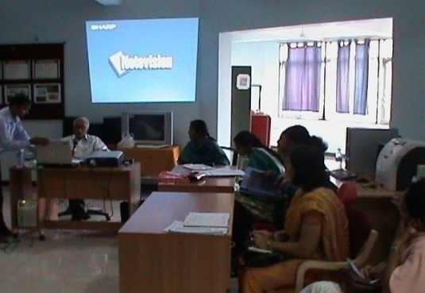 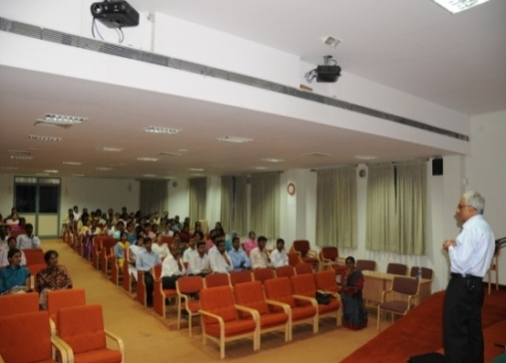

Workshop on Report Writing by Workshop on Clinical research methods in Dr. Giri Hegde communication disorders by Dr. Giri Hegde

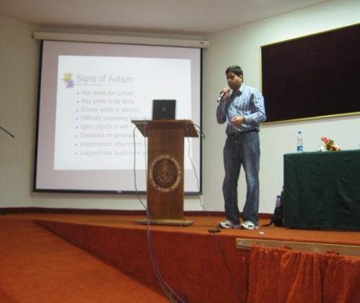

**s**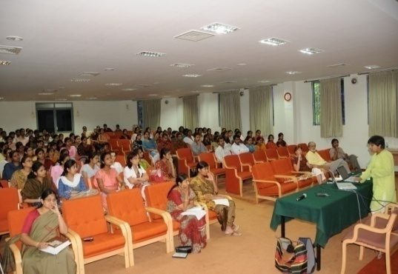

Workshop on Assessment & Intervention Workshop on Preparing Young

of ASD for Caregivers by Children with ASD to learn language

Mr. Milind Sonawane by Ms. Jyothi Murthy, Speech-Language

Pathologist and Coordinator of Speech

Language Services, TIEE, California

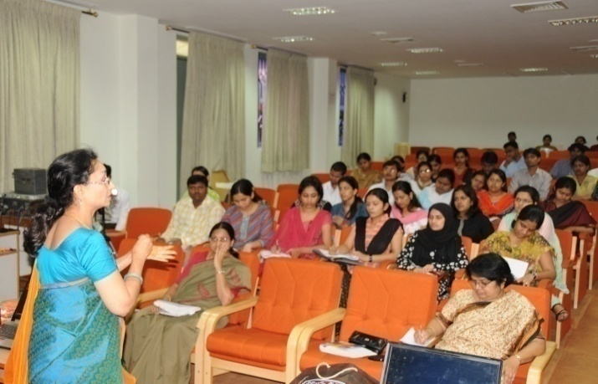

Workshop on Pragmatic skills and its application in ASD by Ms. Rajashree Sreerangarajan, Speech Language Pathologist , Palo Alto California, USA.

**II. Seminar/Conference/Workshop attended by the faculty**

**Dr. M. Pushpavathi:**

* Attended professional voice care workshop conducted by Department of speech language sciences on 9-10 of December at AIISH
* Attended the faculty development workshop on ‘Pedagogy and evaluation methods’ on 17.11.2010
* Attended a Workshop on “teaching communication disorders associated with cleft lip and palate.” At SRMC, Chennai from 22.10.2010 to 23.10.2010
* Attended Indo cleft conference 2011 from 28.1.11 to 30.1.11 at Chennai
* Attended pre conference seminar on assessment and management of speech disorders in CLP conducted at Indo cleft -2011 on 28.1.11 at Chennai

**Dr. K.C. Shyamala:**

* Attended the faculty development workshop on ‘Pedagogy and evaluation methods’ on 17.11.2010
* Attended national seminar on communication disorders in children and Dysphagia as resource person from 4th – 6th, March, 2011, at Hyderabad

**Dr. R. Manjula:**

* Attended 2nd National conference on AAC and Assistive Technology for persons with disabilities”, held at Chennai from 9/7/2010 to 10/7/2010
* Chaired a scientific session on “AAC and early intervention held on 9th July 2010.
* Served as resource person in the workshop on “Preparation of ICF training modules for master trainers and rehabilitation professionals in the field of speech and hearing handicapped” held at AYJNIHH, Mumbai on 24.1.2011.
* Attended the guest lecture on “Student assessment procedures” by Dr. Rangamani G.N on 27.1.2011 from 1.30 to 4.00 pm.
* Attended the following CRE workshops:
* “Evidenced based practice in speech, language and communication impairments’ by Dr. Janice Murray, Manchester Metropolitan University, UK, conducted at the Indian Institute of Cerebral palsy, Kolkata on 2nd February 2011.
* “ AAC: working with persons who have profound disabilities” by Dr. Juliet Goldbart, Manchester Metropolitan University, UK, conducted at the Indian Institute of Cerebral palsy, Kolkata on 2nd February 2011.
* Attended workshop on ‘MATLAB PROGRAM’ conducted by the Dept of Electronics, AIISH on 27th and 28th March 2011.

**Dr. N. Swapna:**

* Attended the faulty development workshop on ‘Pedagogy and evaluation methods’ on 17.11.2010.
* Attended the seminar on ‘education on the global front’ organized on account of International Education week on 19.11.2010.
* Attended the seminar on ‘Research design in clinical sciences’ by Dr. M.N Hegde on 7.12.2010.
* Attended the seminar on ‘Assessment of student learning outcomes’ by Dr. G.N Rangamani on 27.1.2011.

**Served as resource person for the following workshops:**

* Participated as a resource person for the workshop on ‘Learning Disability’ and delivered a lecture on ‘Intervention Strategies in Classroom Settings’ on 7th Oct 2010.
* Served as a resource person and presented on the topic ‘Interpreting evaluation reports for planning instruction’ in the workshop on ‘Management of children with multiple disabilities in inclusive and special setups’ on 16th March 2011.

**Served as resource person for the following programs:**

|  |  |
| --- | --- |
| **Organized Department** | Dept. of Psychology |
| **Coordinator** | Dr. S. Venkatesan |
| **Resource person** | Dr. Swapna |
| **Theme** | Language therapy |
| **Objectives** | To orient about the activities carried out to facilitate language skills in children with communication disorders |
| **Target Audience** | Participants of C4D2 course |
| **No. of Participants** | 10 approx. |
| **Date** | 22.4.10 |

|  |  |
| --- | --- |
| **Organized Department** | Dept. of Psychology |
| **Coordinator** | Dr. S. Venkatesan |
| **Resource person** | Dr. Swapna |
| **Theme** | ‘Intervention strategies for communication problems in school settings’ |
| **Objectives** | To orient about the activities carried out to improve academic skills in a classroom situation for children with communication disorders |
| **Target Audience** | Participants enrolled under SSA in Karnataka |
| **No. of Participants** | 40 approx/ each program. |
| **Date** | 15.7.10 , 20.8.10, 11.11.2010 |

**Dr. Jayashree C. Shanbal:**

|  |  |
| --- | --- |
| **Organizing Department** | Clinical Services |
| **Coordinator** | Dr. Goswami |
| **Theme** | Workshop on Assessment and Management of Learning Disability |
| **Objectives** | To orient on assessment of learning disability |
| **Target Audience** | Special Educators |
| **No. of participants** | 25 |
| **Date** | 5.10.2010 |

**Ms. Vasantha Lakshmi M.S:**

* Ms. Vasantha Lakshmi M S : Workshop on ‘Choice Based Credit System’, held by University of Mysore, Mysore on 16.09.2010 at Department of Microbiology, Manasagangotri, Mysore

**Mr. Gopi Kishore:**

* Attended pre conference seminar on assessment and management of speech disorders in CLP conducted at Indo cleft -2011 on 28.1.11 to 30.1.2011 at Chennai
* Attended Seminar on Voice Update on 28th & 29th September 2010 At SRMC, Chennai
* Attended Seminar on Preparing Young children with Autism to learn language on 12.8.2010 at AIISH, Mysore.

**E. Academic Programs and Meeting Attended by Faculty and Staff (other than seminars and conference)**

**Dr. M. Pushpavathi:**

* Member, BOS, University of Mangalore
* Member, Preparation of entrance exam question papers for MSc (SLP ) and attended the work from 2-3 Dec 2010.
* Attended a workshop on Choice Based Credit System (CBCS) organized by the AIISH
* Member of the screening committee for Group B officers 13.1.2011
* Attended BOE ( sp. ed ) meeting on 12.11.10
* Chairperson of the publicity and information committee for the 45th AIISH annual day
* Conducted Practical examination for VI sem Bsc ( SLP ) students on 19.05.10
* Served as member of screening committee (DPC) for Group B & C staff for financial upgradation under the modified assured career progression scheme held on 17.1.2011
* Prepared draft proposal of 12th five year plan of department of speech language pathology and presented the same on 25.1.2011.
* Chief superintendent for Bsc entrance exam on 5.6.10
* AIISH coordinator for central valuation held for PG and UG examination on June 20101
* Member for selection of DHLS students
* Visited Mumbai DHLS center for inspection t on 6.9.10 to 8.9.10
* Chairperson for the interior decoration of the international guest house Served as a member in the doctoral committee meeting held for Mr. Gopi Sankar, Mr. Gopi Kishore
* Attended meeting on 2nd AIISH Alumnus meet held at AIISH on 7th Jan 2011
* Chairperson for stage management committee for a national symposium on exploring areas of research in cognitive science which will be held in 30 June to Ist July

**Dr. K.C. Shyamala:**

* Modification of syllabus was done w.r.t. credit based system for special BOS meeting and circulation.
* Attended Valuation Work &Clinical viva-voice at SRMC, Chennai from 23rd -24th June 2010.

**Dr. R. Manjula:**

* Nominated and served as a member of the Committee constituted by the University of Mysore to review and award research status to JSS Speech and Hearing Institute, Mysore. Inspected JSS institute with the committee on 6.5.2010.
* Meeting with Director AIISH and HOD, CREDM to finalize the topics for series orientation lectures to the health workers and public at Hullahalli Outreach Service Centre and Akkihebbalu Outreach Service Centre of the POCD Department.
* Served as a member in the Selection Committee for the post of Clinical psychologist Grade II on 22.4.2010.
* Prepared the draft material submitted to the DHHS, Ministry of Health and Family Welfare, New Delhi (along with Dr. P. Manjula, HOD, Dept. of Audiology) for the subtopic on “Retaining UG, PG and Ph.D holders in the country” with respect to the proposal on Upgradation of AIISH as Superspecialty Centre of Excellence on 23.4.2010.
* Meeting with Dr. H. Sudharshan, Hon. Secretary of Karuna trust, Dr. Kantharaj, I/c Coordinator, Mysore Branch, Karuna Trust, along with Director, AIISH on 10.5.2010.
* Attended meeting on Tender opening for Omni bus of AIISH on 18.5.2010 from 4 pm to 5.30 pm.
* Member of the Committee to review the doctoral thesis of Ms. Shilpashree in the Pre submission colloquium held on 29.5.2010 from 12 noon to 2.00 pm.
* Visited Gumballi Primary Health centre along with Director AIISH on 4.5.2010 from 10 am to 3.30 pm.
* Coordinated tele lecture series addressed to the Health workers through video conferencing system connected to Hullahalli and Akkihebbalu villages on 3.5.2010 to 7.5.2010 and 10.5.2010 to 11.5.201.
* Served as a member of the committee to select Supervisor for Extension Service centers of POCD department at Karuna trust on 2nd June between 11 am to 2 pm.
* Provided Guidelines to open a school and vocational centre for special children in Mysore to Mr. Jagannath, Chairman, of World Academy of Science, Humanities, Education and Literature (WASHEL), India Chapter, on 4th and 7th June 2010.
* Attended DHLS meet on 18th June and 29th June 2010. Chaired a scientific session on “AAC and early intervention held on 9th July 2010 at the 2nd National conference on AAC and Assistive Technology for persons with disabilities”, held at Chennai from 9/7/2010 to 10/7/2010
* Visited Gumballi Outreach Service Centre on 28.7.2010 with the staff of POCD.
* Served as member of the committee to review Ph.D thesis of Ms. Hema N
* I/c for arrangements for lunch and dinner for dignitaries w.r.t. the inauguration of the “Bodhi” Gents hostel on 17th September 2010.
* Conducted annual inspection of Delhi DHLS centre from 22.9.2010 to 24.9.2010.
* I/c for arrangements for lunch and dinner for dignitaries w.r.t. 43rd meeting of the finance committee of the institute on 8.10.2010.
* On 22.10.2010, as part of the AAC Awareness month for 2010, competitions were conducted for the AAC users ( 17 No) and their caregivers (15 No). 3 competitions were held for children and 2 for their caregivers. The 3 competitions for children included “thimmana thota”, “combined activity including manual signs” and “story narration”. For the caregivers, the games included “Guess and win” and “Mime a story”.
* Wrote the course structure, syllabus and terms and conditions of Post Graduate Diploma in Augmentative and Alternative Communication (PGDAAC)
* Coordinated the ‘Expert Committee meet’ to deliberate on PGDAAC on 12.11.2010.
* Served as a panelist in the “Inhouse faculty development workshop on pedagogy” held on 17.11.2010 from 9.30 am to 1.30 pm.
* Served as Member Secretary in the meeting held in Director’s chamber with dr. H. Sudharshan, Hon. Secretary, Karuna Trust, Mysore on 15.11.2010.
* Member Secretary of the Committee nominated for conducting new born screening at 3 DHLS centres of Ajmer, Cuttack and Imphal from December 2010
* Member, preparation of Entrance Question papers for M.Sc (SLP) from 6.12.2010 to 9.12.2010.
* Reviewed two DST proposals on Cognition.
* Convened meeting of member of the committee for new born screening on 21.12.2010
* Attended meeting on 2nd AIISH Alumnus meet held at AIISH on 7th Jan 2011
* Coorinated the meeting on new born screening program in 3 DHLS centres (Ajmer, Cuttack and Imphal) as member secretary on 6.1.2011 and 18.1.2011.
* Served as member of screening committee (DPC) for Group D staff for financial upgradation under the modified assured career progression scheme held on 17.1.2011.
* Prepared draft proposal of 12th five year plan of POCD department and presented the same on 25.1.2011.
* Served as a member in the doctoral committee meeting held for two candidates on 31.1.2011
* Attended meeting with a group of delegates from Norwegian university of Science and Technology, NTNU on 9th February 2011.

**Mr. Brajesh Priyadarshi:**

* Attended a workshop on Choice Based Credit System (CBCS) organized by the University of Mysore.
* Attended a workshop on Choice Based Credit System (CBCS) organized by the AIISH.
* Attended a workshop on “Writing Research Proposal” organized by the Department of Speech Language Pathology, AIISH.
* Attended **‘**South Asian Languages Analysis (SALA) Round table’ held at Central Institute of Indian Languages (CIIL), Mysore from 06.01.2011 to 08.01.2011.
* Attended department meeting on XIIth five year plan proposal in the Department of Speech-Language Pathology, AIISH.
* Modification of M.Sc. SLP Syllabus for course titled: LA 050: Clinical Linguistics & Multilingual Issues in Communication.
* Attended a meeting for PGDCL (SLP) program at the Deptt. of Speech Language Pathology, AIISH.
* Participated in DHLS coordinators meet (two days).

**Dr. N. Swapna:**

* Attended a meeting/orientation with the academic coordinator regarding the BASLP entrance exam on 1.6.10.
* Attended a DHLS coordinators meeting with the Director on 27.8.10.
* Attended a mentor meeting with the Academic coordinator on 23.9.2010 for an orientation regarding the submission of student attendance in soft copy.
* Serving as the mentor for I MSc (SLP) students.
* Served as internal examiner for conducting the practical examination for the DTYHI students.
* Nominated as the DCS for Chennai center for conducting the BASLP entrance exam 2010. Organized and conducted the exam for the Chennai center on 5th June 2010.
* Nominated as chairperson, Cultural committee, Annual day programme held on 9.8.2010 and carried out the duties assigned.
* Nominated as coordinator of the Hindi week celebration and assisted in conducting the competitions. Also organized the competition on slogan writing in Hindi and judged the slogan entries. Also assisted the Hindi coordinator in preparing and distributing the certificates and gift amount.
* Nominated as chairperson of committee for conducting competitions for special childrenon account of open day celebrations on . Carried out three meetings with members and submitted a budget for the same to the Director. Carried out the duties as a chairperson.
* Nominated to assist the Director in compiling the articles based on dissertation of postgraduate students (SLP) 2009-10.
* Nominated as a member of LTU (special unit). Attended a meeting with the chairperson and other members of LTU (special unit) on 1.12.2010.
* Attended the meeting at the Ministry of Science and Technology, New Delhi on 13th and 14th December 2010 to present a project proposal.
* Nominated as a member to monitor new born infant screening. Attended the meeting with the Director, chairperson and other members to discuss the duties on 21.12.2010.
* Visited the Shimla DHLS center on 15th and 16th Dec 2010 for inspection of the center for new born screening and for conducting practical training program for the students.
* Visited the Ajmer DHLS center on 31st Jan 2011 for inspection of the center for new born screening.
* Nominated as a custodian for post graduate sp & hg examinations from 7.2.11 to 18.2.11.

Nominated as a member to monitor new born infant screening

.

**Dr. V.P. Vandana:**

* Attended the duties in Help desk for B.Sc entrance examination (1.30pm to 5.30pm) on 2nd June 2010
* Attended Board room meeting for B.Sc entrance examination on 4th June 2010
* Attended BSc entrance examination invigilation (10.00am to 1.00pm Room No 7, Academic block
* Participated in Neuroscan Demo –‘Department of Speech Language Sciences’ on 3rd June 2010
* Member, ‘Stage committee’ as a part of Institute Day on 9th August 2010
* Appointed as Member of Library committee OM No.SH/Dir/2010-11 dated 24.06.2010
* Incharge for arrangement of exhibition in the POCD meeting hall in connection with the visit of dignitaries for 43rd meeting of the Finance Committee at AIISH on 8th November 2010
* Attended Library committee meeting on 27th November 2010 at 12.00pm in the meeting room of AIISH Library
* Staff Incharge for Special Events Committee for Open Day on 29th October 2010
* Was in the organising committee for the meeting for discussion of syllabus for PGDAAC 12th Nov 2010
* Submitted proposal for starting Unit for Cerebral Palsy to the Head of Department of Speech Language Pathology
* Submitted the list of most essential books for MS Ed (HI) for the subject EDSC 1.8 Management of Communication skills and OE 010: Motor Speech Disorders in Children to Director, AIISH.
* Participated in Inhouse training program on Digital Swallow station on 2nd November 2010 at 10.30am in the Speech Pathology Lab
* Participated in Inhouse faculty development workshop on Pedagogy and evaluation methods in the Seminar Hall, Academic section on 1.11.2010 from 9.30 am to 1.00pm
* Prepared and submitted proposal for initiating a Unit for Cerebral Palsy to Director, AIISH
* Was in the organizing committee for the seminar on “Clinical research methods in communication disorders” held on 7th December2010 from 9.00 am to 5.30pm by Dr.Giri Hegde, Prof.Emeritus of Speech Language Pathology, California State University, Fresno, USA
* Attended Workshop on “Professional writing” by Prf. Giri Hegde-Prof Emeritus of Speech Language Pathology-California Sate University, Fresno, US in the Speech Pathology Lab from 9.00am to 2.00pm on 11th December 2010 (organized by Dept of SLP)
* Arranged exhibition in the Speech Pathology Lab on 29th December 2010 as a part of visit of Shri Dinesh Trivedi, Hon’ble Minister of State for Health and Family Welfare, Govt of India
* Attended workshop on ‘Assessment and Management of Autism’ by Mr.Milind Sonawane, Sr Speech Pathologist, Ireland, held in the Seminar Hall AIISH from 10.00am to 1.30pm (organized by Dept of SLP)
* Prepared fliers and invitation card for AIISH Alumni meet 2011
* Organised and attended meeting regarding twelth five year plan on 18th January 2011 along with Prof.Shyamala Chengappa and Prof.R.Manjula in the Speech Pathology Lab from 3.30pm to 5.30pm. Prepared outline of activities to be projected in the 12th five year plan 2012-2017 as discussed in the meeting.
* Compiled 12th five year plan of dept of speech language pathology
* Attended guest lecture on ‘Student assessment procedures’ by Dr. G.N..Rangamani, Visiting Full-Bright Scholar from 1.30pm to 3.30pm in the Seminar Hall on 27th January 2011
* Member of the committee for AIISH Alumni meet 2011
* Meeting with Prof.Asha Yathiraj regarding AIISH Alumni meet 2011 on 9th and 10th February 2011. Exported e mail ID’s from Dr.S.P.Goswami as a part of AIISH Alumni preparation

**Mr. Gopi Kishore:**

* Attended Lecture on “Inhouse Faculty Development program on Pedagogy and Evaluation Methods” at AIISH, Mysore on 17.11.2010**.**
* Attended Inhouse training program on Test of Repetition and Early Repetition Battery on 16.11.2010, at AIISH.

**F. Visits Abroad: NIL**

**G. Details of Guest Faculty visited the Institute and Lecture delivered**

Guest lecture by Ms. Rajashree Sree Rangarajan, Senior SLP, HOD speech pathology, Palo Aleo, California on ‘Pragmatic intervention-Application in ASD’ on 12.8.10 at the Institute.

* Guest lecture on Workshop on preparing young children with ASD to learn languageby Ms. Jyothi Murthy, Speech-LanguagePathologist and Coordinator of Speech Language Services, TIEE, California on 12.8.10 at the Institute
* Guest lectureBy Dr. Giri HegdeProf. Emeritus of Speech Language Pathology, California State University, Fresno, USA on 7th December on Clinical research methods in communication disorders and on professional writing on 11.12.10
* Guest lecture on “ Assesment and intervention of ASD for caregivers

by Mr. Milind Sonawane , Speech language therapist , Ireland on 30.12.10

**H. Guest Lectures delivered by the Faculty and Staff outside the Institute**

|  |  |
| --- | --- |
| **Name of the Faculty & Department** |  |
| **Organization and Event of Presentation** |  |
| **Topic** |  |
| **Date** |  |

1. **Additional Academic/Administrative Responsibilities of the Faculty and Staff**

**Dr. M. Pushpavathi**

* Chairperson for the interior decoration of the international guest house
* Chair person , Unit for structural orofacial Anomalies from June 2010
* Coordinator, DHLS Mumbai center
* Serving as BOE, University of Mysore
* Member, BOS, University of Mangalore
* Serving as Treasurer.AIISH Alumni Association

**Dr. K.C. Shyamala**

* Serving as Overall Coordinator – DHLS
* Serving as coordinator ASD Unit
* Serving as chairperson of the library committee
* Serving as coordinator, PGDCL-SLP
* Served on International Editorial Board of Asia Pacific Journal of Speech, Language and Hearing published at San Diego, USA.
* Served on the Editorial Board of JAIISH, Mysore
* Served as Chairperson, Service Betterment Committee
* Served as Chairperson, complaints of Sexual harassment Committee
* Served on Editorial Board of AIAN (Annals of Neurology), New Delhi
* Served on Editorial Board of CIA, Bangalore
* Served as Member BOS (Sp. & Hg.), Mysore
* Served as member BOS Osmania University of A.P. and Calicut University
* Coordinator for monthly report preparations of DHLS
* Serving as member, Postdoctoral Committee at AIISH.
* Member, BOS & BOE of Bangalore & Kerala University
* Served as Chair person DPC Committee
* Served as member, Quarters allotment committee.
* Serving as CVO for AIISH
* BOE Work of Mysore University done.

**Dr. R. Manjula**

* Serving as HOD, Department of Prevention of Communication Disorders from 28/1/08
* Serving as Co-ordinator, AAC Unit from 2003.
* Serving as a reviewer on the editorial board of Journal of Indian Speech Language and Hearing Association.
* Served as Member Secretary, Public Grievances and Redressal committee from 30/1/2006 to 13/9/2010. Handed over charge to Dr. H. Sunder Raju on 13/9/2010.
* Serving as one of the member on the Editorial Board, Journal of All India Institute of Speech and Hearing, Mysore.
* Serving as coordinator for DHLS program of AIISH at New Delhi. Handed over charge of DHLS Shimla centre on 6/9/2010 to Ms. Priti Nair.
* Serving as Member, BOE and BOS at ISH, Bangalore.
* Serving as Member, BOS and BOE, Mysore University
* Serving as Member, Internal Research Committee for review of ARF Research projects.
* Serving as Member, anti ragging committee.
* Serving as Vice President of ISAAC- India Chapter

**Mr. Brajesh Priyadarshi:**

* Served as HOD In charge of Department of Material Development.
* Served as HOD In charge of Department of Speech Language Pathology.
* Served as the DHLS Coordinator, Bhagalpur study centre.
* Served as custodian for the valuation of PG examination paper
* Modification of M.Sc. SLP Syllabus for course titled: LA 050: Clinical Linguistics & Multilingual Issues in Communication.
* Translation of POCD materials in Hindi Language.
* Reviewed the Hindi version of Annual Report – 2009-10.
* Edited the Hindi translation of module -1 of Introduction to Disabilities and Handicaps.

**Dr. N. Swapna**

* Serving as mentor for I MSc (SLP) students and PGDCL-SLP.
* Nominated as the Coordinator for Puducherry center for the DHLS course.
* Arranged for the SLP at Puducherry center to assist Director in the Annual conference of otolaryngologists of India and sound hearing 2030 held at Chennai from 6th to 9th Jan 2011.
* Nominated to assist the Director in compiling the articles based on dissertation of postgraduate students (SLP) 2009-10. Compiled and corrected the articles. Ms. Gayathri, Ms. Shylaja and Ms. Devika, research assistants assisted in formatting the articles. Gave it to the printer (chap prints)
* Visited the Ajmer DHLS center on 31st Jan 2011 for inspection of the center for new born screening.

**Ms. Vasanthalakshmi.M.S.**

* Guidance given to faculty/staff/JRFs/ regarding statistical analysis of their data.
* Preparation of part of 12th Five Year Plan (Centre for Biostatistics)
* Preparation of modified syllabus for I M. Sc (CBCS for the paper “Statistics in Speech – Language and Hearing”.
* Ms. Vasantha Lakshmi.M.S. : Statistical assistance given to 84 research works which include dissertations, projects and scientific papers.

**Mr. Gopi Kishore:**

* Member , Unit for structural orofacial Anomalies from June 2010
* Attended faculty meet at seminar hall, academic block on 23.09.10 and the feedback regarding the topics discussed was sent to the Directors office on 28.09.10.
* Attended invigilation duty for M.Sc. examinations on forenoon of 2nd February, 2011.
* As a Member of USOFA, organized and participated team assessment sessions for individuals with cleft lip and palate on 2nd, 9th, and 23rd February.
* Attended Phonosurgeon clinics on all the Wednesdays of the month.
* Physical verification of the technical equipment in the Department of Pre-school and Special Education was done and the report of the same was submitted.
* Assessment and therapy materials were purchased for the unit of Structural and Oro Facial Anomalies.
* Attended two committee meetings and organized exhibition as a Member of the Exhibition committee for exhibiting departmental activities on the occasion of Annual day, 9th August, 2010.
* Presented U-SOFA activities to guests visited AIISH on Annual day, 9th August, 2010.
* Attended seminar on ‘Preparing young children with Autism to learn language’ on 12.8.2010 at seminar Hall, Academic Block, AIISH between 10:00 am to 1:00 pm.
* Attended seminar on ‘Intervention of pragmatics in children with Autism’ on 12.8.2010 at seminar Hall, Academic Block, AIISH between 2:00 to 4:00 pm.
* Attended Research Proposal presented by II M.Sc. students on the afternoons of 17th and 19th August, 2010.
* Attended In-House training program on Digital Swallow Workstation conducted by department of Speech Language Pathology on 11th October, 2010.
* Attended lecture on ‘Choice Based Credit System’ by Dr. Guru from the Mysore University.
* As a member of the exhibition committee for ‘Open day’ (29th August), attended exhibition committee meeting and organized exhibiting the materials from the department of SLP.
* Orientation is given on ‘Instrumentation used in the diagnosis and management of Speech Language disorders’ to a student from Ireland on 9th June, 2010 (10:00am to 1:00pm).
* Help desk for B.Sc. entrance examination (10:00am to 1:00pm) on 4th June 2010.
* Board room meeting for B.Sc entrance examination on 4th June 2010.
* B.Sc entrance exam invigilation (10:00am to 1:00pm) on 5th June 2010 at Academic block.
* Supervising and taking practical classes to the interns posted in U-SOFA.

**2) Research Activities**

1. **Research Projects:**
2. **Projects with Extramural Funding:**

|  |  |
| --- | --- |
| **Title** | **Language and Brain organization in Normative Multilingualism** |
| **Objectives** | The aim of the project is to investigate code switching between languages among bilinguals and among multilinguals. Language proficiency and Code switching would be examined separately in bilinguals and in multilinguals |
| **Principal Investigator** | Dr. Shyamala. K.C |
| **Funding Agency** | Department of Science and Technology (DST) |
| **Fund** | 12, 84,000 for 3 years from 2009 |
| **Status** | Ongoing |
| **Brief Achievement in 2010-11** | Developed language proficiency questionnaire – Data collected for 20-40 years – bilinguals and multilingual – Data collection is going on for 41-69 years bilingual/multilingual. Analysis for 20-40 years age group and writing review of literature is in progress. |

1. **Projects with ARF Funding:**

**Dr. M. Pushpavathi:**

|  |  |
| --- | --- |
| **Title** | Effect of Palatal Obturator on Speech |
| **Objectives** | The project is aimed to analyse the speech characteristics with respect to acoustical and perceptual aspects before and after providing different types of speech appliances to clients with repaired/unrepaired maxillofacial anamolies |
| **Department** | Dept. of Speech Language Pathology |
| **Principal Investigator & Co-Investigator** | Dr. M. Pushpavathi, Dr. N. Sreedevi, Dr. Dakshayini.M, |
| **Amount** | Rs. 4,98,000 |
| **Status** | Ongoing – from October 2010 |
| **Summary of work done in 2010-11** | The documentation of three different cases (an adult with unrepaired cleft, an adult sub mucous cleft and a child with repaired cleft) with respect to audio visual recording of prosthesis preparation and speech analysis is completed. |

|  |  |
| --- | --- |
| **Title** | Audio Visual resource manual on Voice Disorders |
| **Objectives** | This project aims to compile the audio visual data bank of different cases with voice disorders and provide clinical insight on the assessment and management of cases with voice disorders |
| **Department** | Dept. of Speech Language Pathology |
| **Principal Investigator & Co-Investigator** | Dr. M. Pushpavathi, Dr. Jayanthi Ray, Dr. Sundarraj.H, Mr. Gopi Sankar and Dr. Girish Kulkarni |
| **Amount** | Rs. 4,98,000 |
| **Status** | Ongoing from October 2010 |
| **Summary of work done in 2010-11** | The assessment tools with respect to case history and other details have been compiled. Video script for instrumentation and case history is prepared. Three different cases of voice disorders are completely recorded from the assessment to the rehabilitation. |

|  |  |
| --- | --- |
| **Title** | Speech Characterstics in children with oral cleft – Pre and post surgery a Longitudinal study |
| **Objectives** | The project is aimed to analyse the speech characteristics (articulatory, resonatory and speech intelligibility) in different cases with cleft palate before and after surgery |
| **Department** | Dept. of Speech Language Pathology |
| **Principal Investigator & Co-Investigator** | Dr. M. Pushpavathi, Dr. Sathish.H, Mr. Gopi Sankar |
| **Amount** | Rs. 4,98,000 |
| **Status** | Ongoing from Feb. 2011 |
| **Summary of work done in 2010-11** | Public education material on rehabilitation of cleft lip and palate in Kannada is prepared. The assessment checklist for toddlers with cleft palate is compiled. |

|  |  |
| --- | --- |
| **Title** | Speech Characterstics in children with oral cleft – Pre and post surgery a Longitudinal study in Malayalam |
| **Objectives** | The project is aimed to analyse the speech characteristics (articulatory, resonatory and speech intelligibility) in different cases with cleft palate before and after surgery |
| **Department** | Dept. of Speech Language Pathology |
| **Principal Investigator & Co-Investigator** | Dr. M. Pushpavathi, Dr. Sherry Peters, Dr. Subramni Iyer |
| **Amount** | Rs. 4,98,000 |
| **Status** | Ongoing |
| **Summary of work done in 2010-11** | Material for nasometer assessment has been compiled and review of articles have been done |

|  |  |
| --- | --- |
| **Title** | Speech Characterstics in children with oral cleft – Pre and post surgery a Longitudinal study in Telugu |
| **Objectives** | The project is aimed to analyse the speech characteristics (articulatory, resonatory and speech intelligibility) in different cases with cleft palate before and after surgery |
| **Department** | Dept. of Speech Language Pathology |
| **Principal Investigator & Co-Investigator** | Dr. M. Pushpavathi, Dr. Srinivas Ghosla Reddy, Dr. Swati Ravindran |
| **Amount** | Rs. 4,98,000 |
| **Status** | Ongoing |
| **Summary of work done in 2010-11** | Memorandum of understanding between the Hospitals has been signed. Material for nasometer assessment has been compiled and review of articles have been done |

|  |  |
| --- | --- |
| **Title** | Early intervention module for parents of children with cleft lip and palate in Kannada & English (Phase I) |
| **Objectives** | This project is focused on developing early intervention module for children (below 3 years) with cleft palate and to provide training for parents to work on improving speech intelligibility, articulation. |
| **Department** | Dept. of Speech Language Pathology |
| **Principal Investigator & Co-Investigator** | Dr. M. Pushpavathi  Dr. Sathish V.H  Mr. Gopi Kishore, Mr. Gopisankar |
| **Amount** | Rs. 6,07,000/ |
| **Status** | Ongoing |
| **Summary of work done in 2010-11** | The video recording on improving auditory discrimination, articulation and improving resonance and speech intelligibility in children with CLP has been done and the same is in use to provide training for the parents. |

**Dr. K.C. Shyamala:**

|  |  |
| --- | --- |
| **Title** | **Development and Standardization of Boston Naming Test in bilinguals (Kannada - English and Telugu – English)** |
| **Objectives** | To develop the Boston Naming Test in Different Languages |
| **Department** | **Dept. of Speech Language Pathology** |
| **Principal Investigator** | Dr. Shyamala. K.C |
| **Amount** | Rs.4,06,000.00 |
| **Status** | Completed (2010) |
| **Summary of the work done 2010-11** | Confrontation naming has long been recognized as one of the most sensitive tasks for identifying and quantifying neurogenic language deficits. The Boston Naming Test (BNT) (Kaplan, Goodglass & Weintraub, 1983) is the single most frequently used test of visual confrontation naming in Western countries. The BNT has been used in the evaluation of patients with focal left and right CVAs, with diffuse brain damage resulting from head injury, anoxia or progressive dementia such as Alzheimer’s disease. The BNT published norms include 84 normal adults (ages 18 – 59) with scores grouped according to those with greater or less than 12 years of education, and 82 aphasic adults with performance divided into 6 severity levels. The BNT has been translated and standardized in many languages like Spanish, and has been used with patients with aphasia, dementia, etc.  To date, this BNT has not been standardized in any of the Indian languages. Hence a first step toward accurate interpretation of naming performance of Indian clinical populations was to develop BNT in Kannada and Telugu and obtain normative data on healthy adults who are proficient in Kannada and Telugu languages. Both goals were accomplished. |

|  |  |
| --- | --- |
| **Title** | **Cognitive Linguistic Deficits in Aphasia** |
| **Objectives** | The aim of the project is to investigate cognitive linguistic deficits in Individuals with aphasia |
| **Department** | **Dept. of Speech Language Pathology** |
| **Principal Investigator** | Dr. Shyamala. K.C |
| **Fund** | 2,62,000.00 |
| **Status** | Completed (2010) |
| **Summary of the work done 2010-11** | . The debate on whether cognition and language are related and whether cognition precedes language or vice versa still continues .It has been observed that there is considerable overlap in the cognitive and language domain. Several studies have been done in the area of cognitive deficits in aphasia on various cognitive domains such as attention, memory, orientation, scanning, visual neglect, reasoning/problem solving and integration. But none of the studies has given in depth information of those deficits on language skills in individuals with aphasia in our context.  20 normal healthy adult individuals and 20 matched right handed individuals with aphasia following left hemisphere damage are assessed for various cognitive domains using Western aphasia Battery (WAB), Addenbrooke’s cognitive Examination-revised (ACE-R) and Cognitive Linguistic Assessment protocol for adults (CLAP) as a part of cognitive linguistic assessment protocol. The subjects were analyzed for various cognitive linguistic deficits present. The results revealed that individuals with Aphasia showed deficits in most of the cognitive domains with decreasing order of affected cognitive skills with decrease in the severity. |

|  |  |
| --- | --- |
| **Title** | **Genotyping and a Genetic association study in Autism** |
| **Objectives** | The aim of the project is to investigate the genotyping and genetic association in children with autism as the number and role of genes playing in Autism are still not clear |
| **Department** | **Dept. of Speech Language Pathology** |
| **Principal Investigator** | Dr. Shyamala. K.C |
| **Fund** | 5,72,000.00 |
| **Status** | ongoing |
| **Summary of the work done 2010-11** | Data collection in progress. Review of literature completed. Blood samples collected for 140 patients including 50 Autistic cases, parents and siblings  DNA extraction is done with 120 samples and stored in 80 C  Primer designed for 5 SNPs which are selected for Genogyping |

|  |  |
| --- | --- |
| **Title** | **Language performance of Kannada – English (K-E) bilingual individuals with Dementia** |
| **Objectives** | Hence, the primary purpose of the current project is to develop & establish preliminary normative data if Dementia Assessment Battery in Kannada & English and to compare the Language performance on Kannada-English bilingual speakers with dementia |
| **Department** | **Dept. of Speech Language Pathology** |
| **Principal Investigator** | Dr. Shyamala. K.C |
| **Fund** | 5,92,000.00 |
| **Status** | ongoing |
| **Summary of the work done 2010-11** | Introduction and review completed. Data collection of 4 geriatrics and 29 adults completed |

|  |  |
| --- | --- |
| **Title** | **Development and standardization of Noun Verb picture Battery in Kannada and Malayalam** |
| **Objectives** | The objective of the project is to provide a resource for the clinical practice in speech language pathology and also for the research in aphasiology, neuro- and psycholinguistic disciplines. |
| **Department** | **Dept. of Speech Language Pathology** |
| **Principal Investigator & Co-invesigator(s)** | Mr. Gopee Krishnan, Mrs. Shivani Tiwari, Dr. Rajashekar. B, Dr. Shyamala. K.C |
| **Fund** | 5,92,000.00 |
| **Status** | ongoing |
| **Summary of the work done 2010-11** | Review and data collection completed. Analysis is in progress. |

|  |  |
| --- | --- |
| **Title** | **Reading Acquisition in children learning two distinct orthographies Malayalam and English** |
| **Objectives** | the present study aims at investigating reading acquisition in children learning to read two distinct orthographies, Malayalam and English simultaneously |
| **Department** | **Dept. of Speech Language Pathology** |
| **Principal Investigator Co- Investigators** | Mrs. Shivani Tiwari, Dr. Shyamala. K.C, Dr. Rajashekar. B, Mr. Gopee Krishnan |
| **Fund** | 3,16,000.00 |
| **Status** | ongoing |
| **Summary of the work done 2010-11** | Review & Data collection completed. Analysis is in progress. |

|  |  |
| --- | --- |
| **Title** | **Standardization of Western Aphasia Battery (WAB) in Telugu Monolinguals and Telugu –English (T-E) Bilinguals.** |
| **Objectives** | To standardize WAB in Telugu language |
| **Department** | **Dept. of Speech Language Pathology** |
| **Principal Investigator** | Dr.Shyamala.K.C |
| **Fund** | 3,16,000.00 |
| **Status** | ongoing |
| **Summary of the work done 2010-11** | Western Aphasia Battery (Kertesz, 1979) is considered as one of the important assessment tools and is most frequentlyused in clinics all over India for the assessment of individuals with aphasia and allied disorders. It is a good test for clinical utility but the results are not valid unless we have our own norms. We are presently following western norms and there are no Indian norms for bilingual population involving languages like Telugu obtained so far.  Such a test would help in identifying the aphasic, describing the aphasia and classifying it into various subgroups not only for the purpose of diagnosis but also for planning therapy and estimating prognosis. Such a test would be very useful for speech and language therapists dealing with Telugu aphasic population, since one of the primary concern of speech language pathologists is to assess and improve the communication skills in individuals with aphasia. |

**Dr. R. Manjula:**

|  |  |
| --- | --- |
| **Title** | Comparison of muscle potentials of synergistic and antagonistic primary masticatory muscles as a function of age and task |
| **Objectives** | To analyze and compare the muscle potentials of synergistic and antagonistic primary masticatory muscles in three groups of participants (children, adults and geriatric) and two tasks (non speech and speech) using EMG module of the Digital Swallow workstation |
| **Department** | Dept. of Speech-Language Pathology |
| **Principal Investigator & Co-Investigator** | Dr. R. Manjula & Dr. N. Swapna |
| **Amount** | 2.57 lakhs |
| **Status** | Ongoing |
| **Summary of work done in 2010-11** | Data collection and analysis is in progress .Statistical analysis and reporting to be completed |

|  |  |
| --- | --- |
| **Title** | Development and field testing of low cost supportive and mobility aids appliances for persons with physical disability – Phase I |
| **Objectives** | To analyze and compare the muscle potentials of synergistic and antagonistic primary masticatory muscles in three groups of participants (children, adults and geriatric) and two tasks (non speech and speech) using EMG module of the Digital Swallow workstation |
| **Department** | Dept. of Speech-Language Pathology |
| **Principal Investigator & Co-Investigator** | Dr. R. Manjula  Mr. Siddesh, N.S.,  Mr. Harish Pai, K.,  Mr. Jayakaran G.T. |
| **Amount** | 2,28,350 lakhs |
| **Status** | Ongoing |
| **Summary of work done in 2010-11** | Preparation of prototype aids is completed and report writing is in progress. |

|  |  |
| --- | --- |
| **Title** | A study of motor control in persons with mild and severe stuttering under conditions of motor stress |
| **Objectives** | To analyze and compare the articulatory patterns for bilabial utterances of persons with stuttering and control normal subjects using Articulograph AG 500 |
| **Department** | Dept. of Speech-Language Pathology |
| **Principal Investigator & Co-Investigator** | Dr. R. Manjula &  Dr. H. Venkatagiri |
| **Amount** | 6,02,000 lakhs |
| **Status** | Ongoing |
| **Summary of work done in 2010-11** | Data collection and analysis is in progress. |

|  |  |
| --- | --- |
| **Title** | Development of a “Key word signing” manual in English for Indian context |
| **Objectives** | To develop a “Key word signing” manual standardized for the Indian population |
| **Department** | Dept. of Speech-Language Pathology |
| **Principal Investigator & Co-Investigator** | Dr. H. Venkatagiri &  Dr. R. Manjula |
| **Amount** | 3,70,000 lakhs |
| **Status** | Ongoing |
| **Summary of work done in 2010-11** | Data collection and analysis is in progress. |

|  |  |
| --- | --- |
| **Title** | Process evaluation and comparison of the modules of Outreach Service centre’s as a factor of type of volunteers engaged in the activity |
| **Objectives** | To compare the feasibility and viability of training women homemakers ( volunteers) and ASHA workers in prevention and identification of communication disorders in the geographical location of three outreach service centres |
| **Department** | Dept. of Speech-Language Pathology |
| **Principal Investigator & Co-Investigator** | Dr. Vijayalakshmi Basavaraj,  Dr. R. Manjula &Dr. H. Sudharshan |
| **Amount** | 6,62,000 lakhs |
| **Status** | Ongoing |
| **Summary of work done in 2010-11** | Data collection and analysis is in progress. |

**Mr. Brajesh Priyadarshi:**

|  |  |
| --- | --- |
| **Title** | Screening Test for acquisition of Syntax in Hindi : An Adaption of STASK |
| **Objectives** | To develop Screening Test for acquisition of Syntax in Hindi |
| **Department** | Speech-Language Pathology, AIISH |
| **Principal Investigator & Co-Investigator** | Dr. Vijayalakshmi Basavaraj (Principal Investigator), Dr. S.P.Goswami, (Co-Investigator), **Brajesh Priyadarshi** (Co-Investigator) |
| **Amount** | 4.57 lakhs. |
| **Status** | Completed |
| **Summary of work done in 2010-11** | Report writing in progress |

|  |  |
| --- | --- |
| **Title** | Computerized Screening Test for acquisition of Syntax in Hindi (STASH): An Adaption of STASK. |
| **Objectives** | To develop a module on Computerized Screening Test for acquisition of Syntax in Hindi (STASH |
| **Department** | Speech-Language Pathology, AIISH |
| **Principal Investigator & Co-Investigator** | Mr. Ajish K. Abraham (Principal Investigator) Dr. Vijayalakshmi Basavaraj (Co-Investigator), Dr. S.P.Goswami, (Co-Investigator), **Brajesh Priyadarshi** (Co-Investigator). |
| **Amount** | 5.80 lakhs. |
| **Status** | Ongoing |
| **Summary of work done in 2010-11** | Software modalities has been developed |

**Dr. Jayashree.C.Shanbal:**

|  |  |
| --- | --- |
| **Title** | Assessment Battery for Children with Learning Disability (ABCLLD)-Phase II |
| **Objectives** | To develop an assessment battery for children with learning disability |
| **Department** | Dept. of Speech Language Pathology |
| **Principal Investigator & Co-Investigator** | Dr. Jayashree. C. Shanbal, PI  Dr. S.P. Goswami, Co-PI |
| **Amount** | Rs. 5.77 lakhs |
| **Status** | Data collection completed and data analysis is in progress |
| **Summary of work done in 2010-11** | Test material was developed with the help of SLPs. Schools were surveyed for data collection. The material was administered on a pilot data. The final test material was finalized. The test material was administered on participants from different schools in Mysore. Data coding and analysis is in progress. |

|  |  |
| --- | --- |
| **Title** | Assessment Battery for Children with Learning Disability (ABCLD)-Phase I |
| **Objectives** | To develop an screening tool for children with learning disability |
| **Department** | Dept. of Speech Language Pathology |
| **Principal Investigator & Co-Investigator** | Dr. Jayashree. C. Shanbal, PI  Dr. S.P. Goswami, Co-PI |
| **Amount** | Rs. 5.71 lakhs |
| **Status** | Received review report of the submitted project report |
| **Summary of work done in 2010-11** | Test material was developed with the help of SLPs. Schools were surveyed for data collection. The material was administered on a pilot data. The final test material was finalized. The test material was administered on participants from different schools in Mysore. Data coding and analysis was done. Report was prepared on the findings of the study and submitted for reviewing. The report was reviewed with corrections. |

|  |  |
| --- | --- |
| **Title** | Field Testing of Manual of Adult Non- Fluent Therapy-in Kannada |
| **Objectives** | To field test Manual of Adult Non- Fluent Therapy-in Kannada |
| **Department** | Clinical Services |
| **Principal Investigator & Co-Investigator** | Dr. S.P. Goswami &  Dr. Jayashree C. Shanbal |
| **Amount** | Rs. 5.71 lakhs |
| **Status** | Completed and submitted |
| **Summary of work done in 2010-11** | Manual of Adult Non- Fluent Therapy-in Kannada was field tested on individuals with Aphasia (Broca’s aphasia, TMA and Global aphasia). |

|  |  |
| --- | --- |
| **Title** | Field Testing of Manual of Adult Fluent Therapy-in Kannada |
| **Objectives** | To field test Manual of Adult Fluent Therapy-in Kannada |
| **Department** | Clinical Services |
| **Principal Investigator & Co-Investigator** | Dr. S.P. Goswami &  Dr. Jayashree C. Shanbal |
| **Amount** | Rs. 5.77 lakhs |
| **Status** | Data collection in progress |
| **Summary of work done in 2010-11** | Manual of Adult Fluent Therapy-in Kannada was field tested on individuals with fluent aphasia. |

**Dr. N. Swapna:**

|  |  |
| --- | --- |
| **Title** | “Digital tutorial for pre-reading skill (A supplement to the intervention module for preschool children with communication disorders)” |
| **Objectives** | 1. To develop a digital tutorial on the activities to enhance pre-reading skill as detailed in the intervention module for preschool children with communication disorders. 2. To evaluate the efficacy of the digital tutorial in training the special educators, speech-language pathologists and parents/caregivers in imparting the pre-reading skill in children with special needs in the age group of 3-6 years. |
| **Department** | Dept. of Speech-Language Pathology |
| **Principal Investigator & Co-Investigator** | Dr. Swapna.N -PI  Dr.K.S. Prema -PI  Dr. Y.V Geetha - Co PI |
| **Amount** | 5,41,000 |
| **Status** | Ongoing |
| **Summary of work done in 2010-11** | Two project staff (one research officer with MSc (Sp & hg) and one research assistant with MSEd) were appointed from 1st Oct 2010 for the project. Script writing for the pre-reading skill tutorial (phase I and II) consisting of 150 activities has been accomplished and the video recording of these activities is underway |

|  |  |
| --- | --- |
| **Title** | “Word and Nonword repetition test for children in Kannada” |
| **Objectives** | To develop a word and a nonword repetition test in Kannada language (along the lines of NRT and PSRep) for children in the age group of 3-6 years. |
| **Department** | Dept. of Speech Language Pathology |
| **Principal Investigator & Co-Investigator** | Dr. Swapna.N -PI |
| **Amount** | 3,06,000 |
| **Status** | Ongoing |
| **Summary of work done in 2010-11** | One project staff (research officer with MSc (Sp & hg) has been appointed from 13th Sept. 2010. Stimuli (words and nonwords) have been prepared and data collection has been carried out. Analysis of the subject’s responses is underway. |

**Ms. Vasantha Lakshmi M S**

|  |  |
| --- | --- |
| **Title** | Process Evaluation of DHLS program conducted through Actual Vis-à-vis virtual mode |
| **Objectives** | To undertake a process evaluation of DHLS program conducted through virtual mode of instruction at various centers across the country |
| **Department** | Speech-Language Pathology |
| **Principal Investigator,**  **Chief Investigator**  **& Co-Investigator** | Dr.Vijayalakshmi Basavaraj  Prof. S.Venkatesan  Ms.Vasantha Lakshmi M S |
| **Amount** | Rs. 1,96,000 |
| **Status** | Ongoing (Commenced in 2007-08 and extended) |
| **Summary of work done in 2010-11** | Report prepared for the year 2009-10 and 2010-11 data collected |

**Dr. V.P. Vandana:**

|  |  |
| --- | --- |
| **Title** | Adaptation and standardization of Cognitive Linguistic Quick Test in Kannada (CLQT-K): Comparison between monolinguals (Kannada) and bilinguals(Kannada-English) |
| **Objectives** | To adapt and standardize CLQT into Kannada |
| **Department** | Dept. of Speech Language Pathology |
| **Principal Investigator & Co-Investigator** | Dr.Vandana.V.P (PI) and Prof.Shyamala.K.C (Co-PI) |
| **Amount** | 3.4 lakhs |
| **Status** | Ongoing |
| **Summary of work done in 2010-11** | Data collection completed, statistical analysis in progress, introduction first draft corrected |

**Mr. Gopi Kishore:**

|  |  |
| --- | --- |
| **Title** | 1. Screening Test for Acquisition of Syntax in Telugu (STAS-T): An Adaption of STASK |
| **Objectives** | To develop a valid and standardized test for the assessment of syntax in Telugu language |
| **Department** | Department of Speech Language Pathology |
| **Principal Investigator & Co-Investigator** | Mr.P. Gopi Kishore  Dr. S.P. Goswami  Dr. Vijaya Lakshmi Basavaraj |
| **Amount** | **3,01,000/-** |
| **Status** | Ongoing |
| **Summary of work done in 2010-11** | * Stimulus material was prepared and the same was tested for the content validity * Conducted pilot study on 40 subjects and minor changes were made to the stimulus * Reviewed related literature * Data collection is going on. |

1. **Other Research Projects:**

|  |  |
| --- | --- |
| **Title** |  |
| **Objectives** |  |
| **Department** |  |
| **Principal Investigator & Co-Investigator** |  |
| **Funding Agency** |  |
| **Amount** |  |
| **Status** |  |
| **Summary of work done in 2010-11** |  |

1. **Research papers presented at National/International Conference / Seminar / Scientific Forums**

**Dr. M. Pushpavathi:**

|  |  |
| --- | --- |
| **Name, Designation, Department of Faculty** | Dr. M. Pushpavathi, Reader & HOD-Dept. of Speech Language Pathology |
| **Co-author (s) if any** | Mr. Gopisankar |
| **Title of the Paper** | * Nasalence value for Rainbow and Zoo passage of non native English speakers |
| **Name of the Conference** | INDO Cleft -2010 conference held at AIIMS, NewDelhi on 24.04.10. |

|  |  |
| --- | --- |
| **Name, Designation, Department of Faculty** | Dr. M. Pushpavathi, Reader & HOD-Dept. of Speech Language Pathology |
| **Co-author (s) if any** |  |
| **Title of the Paper** | * Prevention of voice problems and maintenance of healthy voice |
| **Name of the Conference** | national workshop on Voice assessment and management held at AIISH from 9-10 of December |
| **Name, Designation, Department of Faculty** | Dr. M. Pushpavathi, Reader & HOD-Dept. of Speech Language Pathology |
| **Co-author (s) if any** |  |
| **Title of the Paper** | * Speech Production |
| **Name of the Conference** | Indocleft -2011 on 29.1.11 at Chennai |

|  |  |
| --- | --- |
| **Name, Designation, Department of Faculty** | Dr. M. Pushpavathi, Reader & HOD-Dept. of Speech Language Pathology |
| **Co-author (s) if any** |  |
| **Title of the Paper** | Prosthodontic management of challenging cases with CLP |
| **Name of the Conference** | Indocleft -2011 on 29.1.11 at Chennai |

|  |  |
| --- | --- |
| **Name, Designation, Department of Faculty** | Dr. M. Pushpavathi, Reader & HOD-Dept. of Speech Language Pathology |
| **Co-author (s) if any** | Ms. Indu Thammaiah and Ms. Jasmine |
| **Title of the Paper** | Awareness of parents of CLP on the nature of Cleft palate |
| **Name of the Conference** | Indocleft -2011 on 30.1.11 at Chennai |

|  |  |
| --- | --- |
| **Name, Designation, Department of Faculty** | Dr. M. Pushpavathi, Reader & HOD-Dept. of Speech Language Pathology |
| **Co-author (s) if any** | Ms. Indu Thammaiah |
| **Title of the Paper** | Early intervention module for children with cleft palate |
| **Name of the Conference** | Indocleft -2011 on 30.1.11 at Chennai |

**Dr. K.C. Shyamala:**

|  |  |
| --- | --- |
| **Name, Designation, Department of Faculty** | Dr. Shyamala, K.C, Professor in Lang. Pathology-Dept. of Speech Language Pathology |
| **Co-author (s) if any** | Ms. Deepa M.S |
| **Title of the Paper** | Generative discourse production: Assessment and functional Maintenance plan for bilingual (Kannada –English) persons with dementia. |
| **Name of the Conference** | 4th Annual conference “*coming of age: dementia in 21st century”* at University of Stirling, Excel, London, United Kingdom from 19th to 24th October 2010. |

|  |  |
| --- | --- |
| **Name, Designation, Department of Faculty** | Dr. Shyamala, K.C, Professor in Lang. Pathology-Dept. of Speech Language Pathology |
| **Co-author (s) if any** |  |
| **Title of the Paper** | Contemporary issues and Concepts of PDD & ASD |
| **Name of the Conference** | National Seminar on Communication disorders in children and Dysphagia 4th – 6th, March, 2011, at Hyderabad |

|  |  |
| --- | --- |
| **Name, Designation, Department of Faculty** | Dr. Shyamala, K.C, Professor in Lang. Pathology-Dept. of Speech Language Pathology |
| **Co-author (s) if any** |  |
| **Title of the Paper** | Assessment and Intervention approaches in PDD and ASD |
| **Name of the Conference** | National Seminar on Communication disorders in children and Dysphagia 4th – 6th, March, 2011, at Hyderabad |

**Dr. R. Manjula:**

|  |  |
| --- | --- |
| **Name, Designation, Department of Faculty** | Dr. R. Manjula, Prof. of Speech Pathology, Dept. of Speech-Language Pathology |
| **Co-author (s) if any** | Nil |
| **Title of the Paper** | Augmentative and Alternative Communication and Education |
| **Name of the Conference** | 3rd National conference of ISAAC India Chapter at IICP, Kolkata from 2nd to 4th Feb 2011. |

**Dr. Jayashree.C.Shanbal:**

|  |  |
| --- | --- |
| **Name, Designation, Department of Faculty** | Jayashree. C. Shanbal (as co-author) |
| **Co-author (s) if any** | Sangeetha, G., and Vrunda, C. |
| **Title of the Paper** | Translation priming in bilingual children with learning disability |
| **Name of the Conference** | ISHA Con, Kolkata |

|  |  |
| --- | --- |
| **Name, Designation, Department of Faculty** | Jayashree. C. Shanbal (as co-author) |
| **Co-author (s) if any** | Sharon Susan Sam & Anjali Maratt |
| **Title of the Paper** | Diagnosing Learning Disabilities in Children: A Speech Language Pathologist Perspective |
| **Name of the Conference** | National Seminar on Language Acquisition/ Learning, Trivandrum, Kerala |

**Dr. N. Swapna:**

|  |  |
| --- | --- |
| **Name, Designation, Department of Faculty** | Dr. Swapna.N, Lecturer in Speech Pathology, Dept. of speech–language pathology |
| **Co-author (s) if any** | Ansu, A, Grace, Shylaja, K., & Swapna.N |
| **Title of the Paper** | Nonword repetition in sequential and simultaneous bilinguals |
| **Name of the Conference** | Paper presented (Poster presentation) at the ISHA conference held at Kolkata on 22nd Jan 2011 |

|  |  |
| --- | --- |
| **Name, Designation, Department of Faculty** | Dr. Swapna.N, Lecturer in Speech Pathology, Dept. of speech–language pathology |
| **Co-author (s) if any** | Shylaja, K, Swapna.N |
| **Title of the Paper** | Nonword repetition in children with specific language impairment: An exploratory study |
| **Name of the Conference** | Paper presented (Oral presentation) at the 8th Asia Pacific Conference on Speech, Language & Hearing held between 11th - 14th January 2011,Christchurch New Zealand. |

|  |  |
| --- | --- |
| **Name, Designation, Department of Faculty** | Dr. Swapna.N, Lecturer in Speech Pathology, Dept. of speech–language pathology |
| **Co-author (s) if any** | Manju, M Swapna.N |
| **Title of the Paper** | Verbal perseveration in Malayalam-English bilingual elderly individuals |
| **Name of the Conference** | Paper presented (Oral presentation) at the 8th Asia Pacific Conference on Speech, Language & Hearing held between 11th - 14th January 2011,Christchurch New Zealand. |

**Mr. Gopi Kishore:**

|  |  |
| --- | --- |
| **Name, Designation, Department of Faculty** | **P. Gopi Kishore, Lecturer in Department of Speech Language Pathology** |
| **Co-author (s) if any** | Remya H Y, Ranjini G.C, Kanthima V Namboothiri |
| **Title of the Paper** | **Efficacy of voice therapy in sulcus vocalis: A single case study** |
| **Name of the Conference** | **Frontiers of Research in Speech and Music** |

1. **Research Papers Published:**
2. **Papers published in National/International Journals.**

**Dr. K.C. Shyamala:**

|  |  |
| --- | --- |
| **Name, Designation, Department of Faculty** | Dr. K.C. Shyamala,Prof. in Language Pathology, Dept. of Speech Language Pathology |
| **Co-author (s) if any** | Vishnu K.K., Maya Leela, Subba Rao T.A |
| **Title of the Paper** | A Comparative Study on the Efficacy of Two Different Clinical Language Intervention Procedures |
| **Journal Name, Volume & Issue** | Online Journal [www.languageinindia.com](http://www.languageinindia.com) ,Vol. 10 May 2010.ISSN 1930-2940 pp 182 – 196. |

|  |  |
| --- | --- |
| **Name, Designation, Department of Faculty** | Dr. K.C. Shyamala,Prof. in Language Pathology, Dept. of Speech Language Pathology |
| **Co-author (s) if any** | Vishnu.K.K. Arya Abraham, Sapna Bhat, |
| **Title of the Paper** | Fast Mapping of Novel Words: A Cross-Linguistic Study. |
| **Journal Name, Volume & Issue** | International Journal of Mind, Brain & Cognition, Vol.1, No.1 pp 58-70. |

|  |  |
| --- | --- |
| **Name, Designation, Department of Faculty** | Dr. K.C. Shyamala,Prof. in Language Pathology, Dept. of Speech Language Pathology |
| **Co-author (s) if any** | Ravi Kumar, Haripriya G |
| **Title of the Paper** | Verbal interaction and input in Hearing impaired, |
| **Journal Name, Volume & Issue** | Online journal www.languageinindia.com, Vol 10, pp 27-36. |

**Dr. R. Manjula:**

|  |  |
| --- | --- |
| **Name, Designation, Department of Faculty** | R. Manjula (co-authored) |
| **Co-author (s) if any** | Rupela, V. |
| **Title of the Paper** | Diadochokinetic assessment in Persons with Down Syndrome |
| **Journal Name, Volume & Issue** | Asia pacific Journal of Speech. Language and Hearing.  Vol 13,No 2, p 109-120, 2010 |

|  |  |
| --- | --- |
| **Name, Designation, Department of Faculty** | R. Manjula (co-authored) |
| **Co-author (s) if any** | Rupela, V. & S. L. Velleman |
| **Title of the Paper** | Phonological processes in Kannada speaking adolescents with Down Syndrome |
| **Journal Name, Volume & Issue** | Clinical Linguistics & Phonetics.  Vol 24 (6), p 431-450, Jun 2010. |

|  |  |
| --- | --- |
| **Name, Designation, Department of Faculty** | R. Manjula (co-authored) |
| **Co-author (s) if any** | Priya M.B |
| **Title of the Paper** | Effect of posture on respiratory and phonatory measures in typically developing children: Implications in cerebral palsy |
| **Journal Name, Volume & Issue** | Journal of Indian Speech Language and Hearing Association, Vol 24, No. 2, 2010, 109-120 |

|  |  |
| --- | --- |
| **Name, Designation, Department of Faculty** | Dr. M. Pushpavathi, Reader & HOD-Dept. of Speech Language Pathology |
| **Co-author (s) if any** | Jocine Gloria chandrabose , Kenneth St Louis , shabina Raoof |
| **Title of the Paper** | Awareness of stuttering among prospective teachers of Mysore ”. |
| **Name of the Conference** | Journal of AIISH, Vol.29, N0 2, 2010, p144-152 |

|  |  |
| --- | --- |
| **Name, Designation, Department of Faculty** | Dr. M. Pushpavathi, Reader & HOD-Dept. of Speech Language Pathology |
| **Co-author (s) if any** | S. Venkatesan , K. Purushotham |
| **Title of the Paper** | Adjustment patterns in Voice disorders ”. |
| **Name of the Conference** | Journal of ISHA, Vol.25, N0 1, 2011, p21-31 |

**Mr. Brajesh Priyadarshi:**

|  |  |
| --- | --- |
| **Name, Designation, Department of Faculty** | Brajesh Priyadarshi, Lecturer in Linguistics, Deptt. of SLP. |
| **Co-author (s) if any** | B. M. Kartikeyan |
| **Title of the Paper** | “Comparison of Coarticulatory Effects in speech of Tamil Speaking Children and Adults with Down’s Syndrome: An Acoustic Explanatory Study” |
| **Journal Name, Volume & Issue**  (National) | Indian Linguistics: Journal of the Linguistic Society of India, Volume 71, December 2010 (ISSN: 0378-0759), page 105-112. |

|  |  |
| --- | --- |
| **Name, Designation, Department of Faculty** | Brajesh Priyadarshi, Lecturer in Linguistics, Deptt. of SLP. |
| **Co-author (s) if any** | Shyamala. K. C., Basanti Devi, and Vishnu.K.K. |
| **Title of the Paper** | Co- authored the paper titled: “*Comparison of Markedness of Lexical Semantic Abilities in Normal Children and Children with Hearing Impairment.”* |
| **Journal Name, Volume & Issue**  Online (International) | Language in India, Volume - 10 : 11 November 2010 (ISSN 1930-2940) pg. no. 398-408. |

|  |  |
| --- | --- |
| **Name, Designation, Department of Faculty** | Jayashree.C. Shanbal  Lecturer in Language Pathology |
| **Co-author (s) if any** | Chaithra,S & Prathima, S. |
| **Title of the Paper** | Phonological awareness skills and reading in children who are at risk for learning disability: role in the indian context? |
| **Journal Name, Volume & Issue** | The Journal of All India Institute of Speech and Hearing, 29-2 |

|  |  |
| --- | --- |
| **Name, Designation, Department of Faculty** | Dr. Swapna.N, Lecturer in Speech Pathology, Dept. of speech–language pathology |
| **Co-author (s) if any** | Steby, S. Sindhupriya, C., Rupali, M., |
| **Title of the Paper** | Cognitive-linguistic abilities in bilingual children |
| **Journal Name, Volume & Issue** | JAIISH, 2010, 29, No.1, 1-11. |

|  |  |
| --- | --- |
| **Name, Designation, Department of Faculty** | Dr. Swapna.N, Lecturer in Speech Pathology, Dept. of speech–language pathology |
| **Co-author (s) if any** | Sushma, M. Amulya, P.R., Ranjini, M., |
| **Title of the Paper** | Fast mapping in typically developing Kannada speaking toddlers |
| **Journal Name, Volume & Issue** | JAIISH, 2010, 29, No.1, 55-62. |

**Internal (AIISH) Publications**

|  |  |
| --- | --- |
| **Name, Designation, Department of Faculty** | Dr. M. Pushpavathi, Reader & HOD-Dept. of Speech Language Pathology |
| **Co-author (s) if any** | Devi.T.R. |
| **Title of the Paper** | Normative nasalence value in Malayalam language |
| **Journal Name, Volume & Issue** | Student Research at AIISH, Vol.VII Part-B, Speech-Language Pathology59-64 |

|  |  |
| --- | --- |
| **Name, Designation, Department of Faculty** | Dr. M. Pushpavathi, Reader & HOD-Dept. of Speech Language Pathology |
| **Co-author (s) if any** | Akaksha Guptha |
| **Title of the Paper** | Reliability of perceptual voice evaluation of voice using CAPE –V rating scale in Indian Context ”. |
| **Journal Name, Volume & Issue** | Student Research at AIISH, Vol.VII Part-B, Speech-Language Pathology. 98-113 |

|  |  |
| --- | --- |
| **Name, Designation, Department of Faculty** | Dr. M. Pushpavathi, Reader & HOD-Dept. of Speech Language Pathology |
| **Co-author (s) if any** | Pravesh Arya. |
| **Title of the Paper** | Normative nasalence value in Hindi language”. |
| **Name of the Conference** | Student Research at AIISH, Vol.VII Part-B, 187-198 |

|  |  |
| --- | --- |
| **Name, Designation, Department of Faculty** | Dr. M. Pushpavathi, Reader & HOD-Dept. of Speech Language Pathology |
| **Title of the Book /Conference Proceedings** | * Prevention of voice problems and maintenance of healthy voice” in proceedings of the national workshop on Voice assessment and management” p85-101 |
| **Publisher and Place** | AIISH, Mysore |

|  |  |
| --- | --- |
| **Name, Designation, Department of Faculty** | Swapna. N. |
| **Co-author (s) if any** | Manju, M |
| **Title of the Paper** | Verbal Perseveration in Malayalam-English Bilinguals |
| **Journal Name, Volume & Issue** | Student research at AIISH (articles based on dissertation done at AIISH), Volume VIII: 2009-10, Part-B, 150-158. |
| **Publisher and Place** | AIISH, Mysore |

|  |  |
| --- | --- |
| **Name, Designation, Department of Faculty** | Swapna. N. (2011 |
| **Co-author (s) if any** | Maria, P. R |
| **Title of the Paper** | Some aspects of syntax in 4-7 year old typically developing Malayalam speaking children |
| **Journal Name, Volume & Issue** | Student research at AIISH (articles based on dissertation done at AIISH), Volume VIII: 2009-10, Part-B, 159-166 |
| **Publisher and Place** | AIISH, Mysore |

.,

|  |  |
| --- | --- |
| **Name, Designation, Department of Faculty** | Swapna. N. (2011). |
| **Co-author (s) if any** | Shylaja, K., |
| **Title of the Paper** | Nonword repetition in children with language impairment |
| **Journal Name, Volume & Issue** | Student research at AIISH (articles based on dissertation done at AIISH), Volume VIII: 2009-10, Part-B, 263-272. |
| **Publisher and Place** | AIISH, Mysore |

|  |  |
| --- | --- |
| **Name, Designation, Department of Faculty** | Ms.Vasantha Lakshmi M S,  Lecturer in Biostatistics,  Department of Speech-Language Pathology |
| **Authors** | Vijayalakshmi Basavaraj, Venkatesan S, Vasantha Lakshmi M S, Purusotham P |
| **Title of the Paper** | Pilot study on process evaluation of DHLS program conducted through real vis-à-vis virtual modes : 2007-08 |
| **Journal Name, Volume & Issue** | Journal of All India Institute of Speech and Hearing (JAIISH), Vol.29, No.2, 2010, page 283-292 |

|  |  |
| --- | --- |
| **Name, Designation, Department of Faculty** | Ms.Vasantha Lakshmi M S,  Lecturer in Biostatistics,  Department of Speech-Language Pathology |
| **Authors** | R.Vasudeva and Vasantha Lakshmi M S |
| **Title of the Paper** | Burr Distribution as limit distribution of Extremes of a random number of random variables |
| **Journal Name, Volume & Issue** | mySCIENCE (Biannual Science Journal of the University of Mysore), Volume IV (2), Issue 2009 (published in 2010), page 120-129 |

**(ii) Papers published in National/International Conference/Seminar Proceedings**

|  |  |
| --- | --- |
| **Name, Designation, Department of Faculty** | **Dr. K.C. Shyamala, Prof. in language Pathology, Dept. of Speech Language Pathology** |
| **Co-author (s) if any** |  |
| **Title of the Paper** | Bilingual Aphasia |
| **Name of the Conference** | ISBA on 4th -5th Jan 2010. |

|  |  |
| --- | --- |
| **Name, Designation, Department of Faculty** | Brajesh Priyadarshi, Lecturer in Linguistics, Deptt. of SLP. |
| **Co-author (s) if any** | Rupali Mathur and Mohana P. |
| **Title of the Paper** | “Developing Protocol to Enhance Word Retrieval Ability Using Componential Analysis for Individuals with Aphasia” |
| **Name of the Conference** | 2nd National Women’s Science Congress, held at AIISH, Mysore. |

|  |  |
| --- | --- |
| **Name, Designation, Department of Faculty** | Jayashree.C. Shanbal  Lecturer in Language Pathology |
| **Co-author (s) if any** | Sneha George, Preeti Thomas, Padmatharini, K.S |
| **Title of the Paper** | Linguistic profiling in bilingual aphasia |
| **Name of the Conference** | International Symposium on Bilingual Aphasia |

|  |  |
| --- | --- |
| **Name, Designation, Department of Faculty** | Jayashree.C. Shanbal  Lecturer in Language Pathology |
| **Co-author (s) if any** | Manju Mohan,P., Lakshmi.S. Mohan, Maria Rappai, Louisa, B. Suting |
| **Title of the Paper** | Mental lexicon organization in L1 and L2 in Bilingual Aphasics: An investigation through prototypicality and Hierarchical models |
| **Name of the Conference** | International Symposium on Bilingual Aphasia |

|  |  |
| --- | --- |
| **Name, Designation, Department of Faculty** | Dr. Swapna.N, Lecturer in Speech Pathology, Dept. of speech–language pathology |
| **Co-author (s) if any** | Manju, M. Swapna.N |
| **Title of the Paper** | Verbal perseveration in a Bilingual aphasic. |
| **Name of the Conference** | Proceedings of the International Symposium on Bilingual aphasia held on 4th and 5th Jan 2010, 185-190. |

|  |  |
| --- | --- |
| **Name, Designation, Department of Faculty** | Dr. Swapna.N, Lecturer in Speech Pathology, Dept. of speech–language pathology |
| **Co-author (s) if any** | Swapna.N, Raheela, Q., & Priyanka |
| **Title of the Paper** | Speed of processing in children with learning disability on linguistic and nonlinguistic tasks |
| **Name of the Conference** | Proceedings of the Second National Women’s Congress held from 7th to 9th November 2009, 251-255. |

**Mr. Gopi Kishore**

|  |  |
| --- | --- |
| **Name, Designation, Department of Faculty** | P. Gopi Kishore, Lecturer in Department of Speech Language Pathology |
| **Co-author (s) if any** | -- |
| **Title of the Paper** | Rehabilitation of voice in professional voice users |
| **Name of the Conference** | National Workshop on Professional Voice Assessment and Management |

1. **Books/ Book Chapters Published:**

|  |  |
| --- | --- |
| **Name, Designation, Department of Faculty** |  |
| **Co-author (s) if any** |  |
| **Title of the Book and / Chapter** |  |
| **Publisher and Place** |  |

1. **Books/Conference Proceedings Edited**

|  |  |
| --- | --- |
| **Name, Designation, Department of Faculty** |  |
| **Title of the Book /Conference Proceedings** |  |
| **Publisher and Place** |  |
|  |  |

1. **Peer-review for Journal**

|  |  |
| --- | --- |
| **Name, Designation, Department of Faculty** | Dr. R. Manjula  Professor of Speech Pathology  Department of Speech and Language Pathology, AIISH |
| **Title of the Journal** | Journal of All India Institute of Speech and Hearing  Journal of Indian Speech and Hearing Association |
| **Publisher** | 1. AIISH, Mysore 2. ISHA, India |

1. **Doctoral program**
2. **Degree Awarded:**

|  |  |  |  |
| --- | --- | --- | --- |
| Name of the Student | Title | Guide | Status |
| Preeja Balan | Mother-child interaction: Communication  in children with cerebral palsy  using AAC | Dr. R. Manjula | **Ph D**  **Awarded** |

1. **Thesis Submitted:**

|  |  |  |  |
| --- | --- | --- | --- |
| Name of the Student | Title | Guide | Status |
| Ms. Shilpashri H.N. | Development of Pragmatic Skills in Autism Spectrum Disorders | Dr. K.C. Shyamala | **Submitted** |
| Ms.Vasantha Lakshmi M S (Subject – Statistics) | Limit theorems for sums, extremes and related stochastic processes | Dr. R. Vasudeva,  Professor,  D.O.S. in Statistics,  Manasagangotri,  Mysore | **Submitted in December** 2010 |

1. **Under Progress:**

|  |  |  |  |
| --- | --- | --- | --- |
| Name of the Student | Title | Guide | Status |
| Ms. Deepa M.S | Discourse in Bilingual individuals with Demantia and Aphasia | Dr. K.C. Shyamala | Ongoing |
| Ms. Hema. N | Discourse Analysis in Bilingual Aphasic & Non Aphasic TBI | Dr. K.C. Shyamala | Ongoing |
| Ms.Namrata Rai | Language Assessment In Toddlers and Late Talkers/SLI | Dr. K.C. Shyamala | Ongoing |
| Ms.Sunitha Sendil | Intervention In Autism Spectrum Disorders | Dr. K.C. Shyamala | Ongoing |
| Ms. Maria Grace Teresa | Emergence of expressive Morphology in Malayalam speaking children with & without ASD. | Dr. K.C. Shyamala | Ongoing |
| Mr. Sunil Kumar. R | An even related brain potentials study of language processing of Kannada-English Bilingual Aphasia | Dr. K.C. Shyamala | Ongoing |
| Mr. Santosh Kumar | Development and standardization of comprehension test in Hindi language for persons with Aphasia | Dr. S.P. Goswami | Ongoing |
| Mr. Sampath Kumar Lagishetty | Semantic judgment in Monolingual and Bilingual persons with Brocas Aphasia – An ERP Study | Dr. S.P. Goswami | Ongoing |
| Mr. Gopi Sankar | Some acoustical and perceptual parameters of cleft palate speech : Pre - post surgery | Dr. M.Pushpavathi | Ongoing |
| Mr. Gopi Kishore. P | Efficacy of Eclectic Voice Program in the treatment of Hyperfunctional Voice Disorders | Dr. M.Pushpavathi | Ongoing |
| Mr. Gnanavel.K | Speech Characteristics in Velopharyngeal dysfunctions – Pre-Post Surgery | Dr. M.Pushpavathi | Ongoing |
| Mrs. Mili Mary Mathew | Development of gesture and speech in typically developing infants | Prof. R. Manjula | Ongoing |
| Mrs. M.B.Priya | Test Battery for Assessment of Phonological representations in Kannada Speaking Children | Prof. R. Manjula | Ongoing |

**Dissertations completed in 2009-2010**

|  |  |  |
| --- | --- | --- |
| **Title** | **Candidate** | **Guide** |
| Agrammatism in children with Mental Retardation | Liveem. M. T. | Dr. Shyamala K.C. |
| Agrammatism in children with Hearing Impairment | Ashwathy | Dr. Shyamala K.C. |
| Agrammatism in children with Autism | Shafna | Dr. Shyamala K.C. |
| WAB in Telugu | Sri Pallavi | Dr. Shyamala K.C. |
| Spoken language proficiency in bilingual children with Learning Disability | Mohana | Dr. Shyamala K.C. |
| Performance of stutterers on self select reaction time paradigm using speech and non speech tasks | Mahesh B.V.M | Dr.R. Manjula |
| Comparison of signed vocabulary of Indian sign language (ISL) users with that of Signed English (SE) | Yashomathi | Dr.R. Manjula |
| Resource manual for training children with communication disorders (3-8 years) in multisensory skills | S. Priyashri | Dr.R. Manjula |
| A self-therapy manual in English for the management of speech and swallowing disorders in persons with Parkinson’s disease | Gayathri Krishnan | Dr.R. Manjula |
| Verbal perseveration in Malayalam – English bilinguals | Ms. Manju Mohan | Dr. N. Swapna |
| Nonword Repetition in children with language impairment : An Exploratory Study | Ms. Shylaja | Dr. N. Swapna |
| Developmental patterns of syntax in 3-6 year old Malayalam speakers – A computerized approach | Ms. Maria | Dr. N. Swapna |
| Treatment Manual for Persons with Anomic Aphasia | Anil Kumar | Ms. Jayashree.C.S |
| Cognitive Communicative Assessment Protocol for Persons with Dementia in Malayalam (CCAPD-M) | Anjana | Ms. Jayashree.C.S |
| English Language Test for Indian Children (ELTIC) | Bhuvaneshwari | Ms. Jayashree.C.S |
| Treatment manual for children with dyslexia | Ranjini Rajan | Ms. Jayashree.C.S |
| Effects of Aging on Naming in Bilingual Older Adults. | Sharon Susan Sam | Ms. Jayashree.C.S |

**Dissertations in Progress 2010-11**

|  |  |  |
| --- | --- | --- |
| **Title** | **Candidate** | **Guide** |
| Development of pressure consonants articulation drill material in Malayalam for cleft palate population | Wishly Mammen. | Dr.M. Pushpavathi |
| Development of pressure consonants articulation drill material in Kannada for cleft palate population | Keerthi Prasad, | Dr.M. Pushpavathi |
| Development of pressure consonants articulation drill material in Telugu for cleft palate population | Hemalatha P | Dr.M. Pushpavathi |
| Implicit Language processing in LD | Varun Uthappa | Dr. Shyamala K.C. |
| Implicit Language processing in MR | Priyanka shilat | Dr. Shyamala K.C. |
| Verb and noun processing in bilingual persons with Aphasia | Nayana | Dr. Shyamala K.C. |
| A study of the non manual markers in words across different grammatical categories in Indian Sign Language users | Ms. Gargi Singh | Dr.R. Manjula |
| Performance of typically developing children between 4-5 years on two tongue array module using Digital swallowing workstation | Ms. K.S. Padmatharini | Dr.R. Manjula |
| Performance of typically developing children between 4-5 years for swallowing sound on cervical auscultation module in Digital swallowing workstation | Ms. Midula Kasim | Dr.R. Manjula |
| Quality of life of individuals with Right Hemisphere Damage – Relevance of cognitive communication disorder | Aditya | Ms.Jayashree Shanbal |
| Adaptation of TROLL to identify children at risk for Learning disability | Merlin | Ms.Jayashree Shanbal |
| Resource Manual for Learning disability with CAPD | Lydia | Ms.Jayashree Shanbal |
| Cognitive Linguistic Abilities in Simultaneous and Sequential Bilingual Children | Sangeetha G.S | Dr. Swapna.N |
| Narrative abilities of Individuals with Down Syndrome | Sneha G | Dr. Swapna.N |
| Symbolic Play and Language: Its Relationship in Children with Mental Retardation | Sheela.S | Dr. Swapna.N |

**3) CLINICAL SERVICES**

1. **General Clinical Services and Statistics of Various Departments**
2. **Speech and language Assessment:**

**Diagnostic services (Evaluation of cases from April 2010 to March 2011)**

|  |  |
| --- | --- |
| Type of the disorder | Total No. of cases evaluated |
| 1. Language Disorder : childhood   : Adult | **3951** |
| 1. Speech Disorders 2. Voice disorders 3. Disorders of Phonology 4. Disorders of Fluency 5. Resonance | **56**  **73**  **68**  **48** |

1. **Speech and Language Rehabilitation**

**Therapeutic program: Supervision of cases with Speech-Language disorders ((Evaluation of cases from April 2010 to March 2011))**

|  |  |
| --- | --- |
| Type of the disorder | Total No. of cases supervised |
| 1. Language Disorders : Childhood   : Adult | **1272** |
| 2. Speech disorders:  a) Voice disorders  b) Disorders of Phonology  c) Disorders of fluency  d) Resonance | **16**  **110**  **26**  **64** |

1. **Specialized Clinical Services of Departments**

**SPECIAL CLINIC**

**AUGMENTATIVE AND ALTERNATIVE COMMUNICATION (AAC)**

**REPORT ON THE CELEBRATION OF AUGMENTATIVE AND ALTERNATIVE COMMUNICATION (AAC) AWARENESS MONTH**

The Augmentative and Alternative Communication (AAC) Special clinic at the All India Institute of Speech and Hearing, Manasagangothri, Mysore, has been conducting various activities to educate the genereal public about its rehabilitation program, as part of AAC Awareness month every year. This year too, various activities were conducted in the month of October 2010 as a part of the program.

1. **Competitions for the AAC users and their caregivers:**

The activities of AAC special clinic at AIISH is coordinated by Dr. R. Manjula, Professor of Speech Pathology and the day to day activities are conducted by Mrs. Aruna Kamath, Speech-Language Pathologist. Games were conducted as part of the competition by the AAC clinic on 22.10.2010. For 17 AAC clients who used various modalities to communicate, such as orthographic symbols, picture symbols and makaton signs, two competitive activities each were conducted for the clients using AAC and the caregivers as follows:

***Activity 1: Speed of communication through their respective modalities:***

The special children had to communicate as fast as possible, their daily routines using their respective modes of communication.

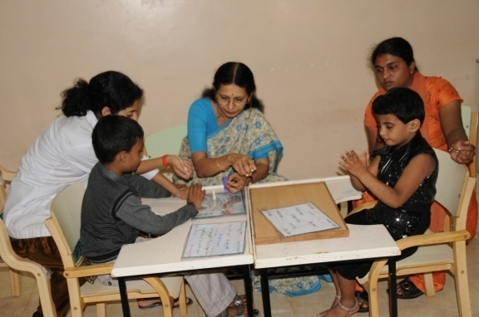

***Activity 2: A concept game called “Thimmana thota” (Thimma’s Garden)***

This was a concept game which included pictorial and orthographic symbols of the farmer’s house as well as the animals that were reared by Thimma. The special child was instructed to narrate this story through their communication mode.

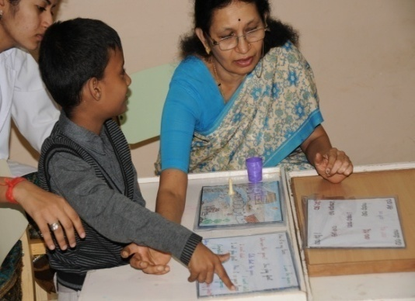 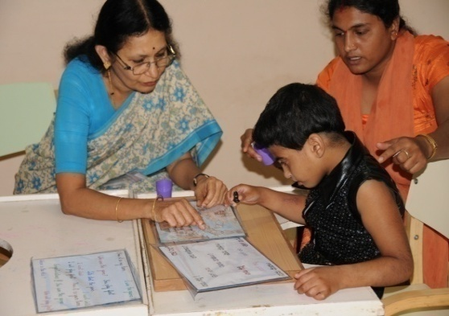

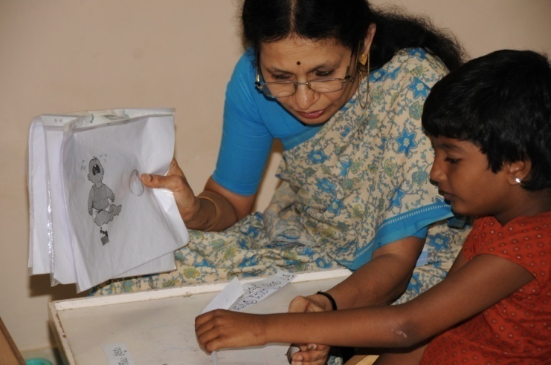

***Activity 3: “Guess and win” for the caregivers***:

The caregivers had to interpret and write the answers for the manual sign cards supplied to them (Makaton system)

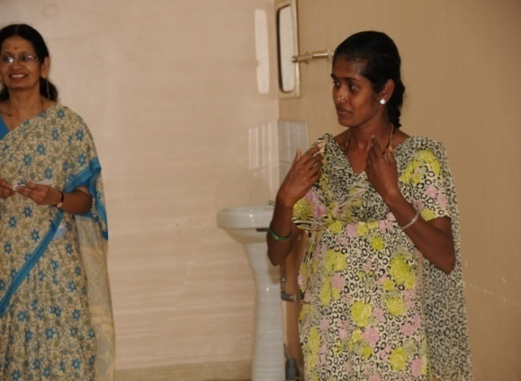

***Activity 4: “Mime a story” for the caregivers:***

The caregivers were given orthographic clues of parts of stories which they had to mime and ask the audience (other caregivers) to interpret their actions.

1. **Distribution of prizes to the winners in Activity 1,2,3 and 4:**

The winners were given the prizes on 29th October 2010 in public function held at the institute as a part of the “Open day” celebration” of the institute.

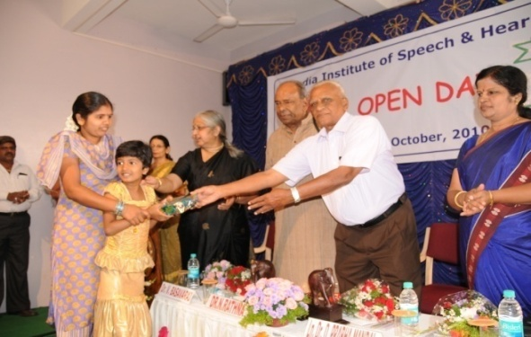

1. **Augmentative and Alternative communication (AAC) as a theme for the ‘Open Day’ of All India Institute of Speech and Hearing (AIISH)**

AIISH keeps its doors open to the public on one day in a year to the public and celebrates this day as “Open Day”. This year the “Open Day” was celebrated on 29.10.10. A theme is selected for each year based on which the activities and exhibitions will be organized. ***This year, the theme was AAC with the caption of the theme being “Communication without barriers”.*** See the banner in this photo!

1. **Release of brochures on AAC in English and Kannada for distribution among the public:**

As a part of the celebration of “Open Day” theme as AAC, brochures on AAC in English and Kannada languages were developed by the AAC Unit and released by the dignitaries (Dr. N. Rathna, Ex Director, AIISH and AYJNIHH as chief guest, Dr. Prabha Mandal, Guest of Honor and presided by Dr. Vijayalakshmi Basavaraj, Director, AIISH ) on this day.

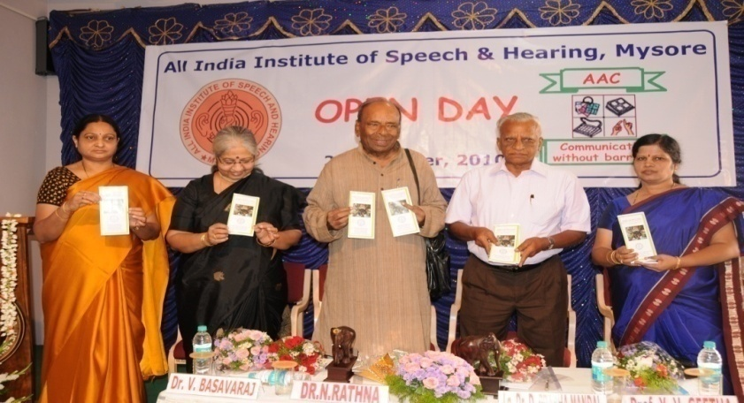

1. **Games for school children and public as a part of the “Open Day” celebration on the theme of AAC:**

Focusing on the theme of “Communication without barriers” as a part of AAC sensitization activities, games were conducted for children who visited from more than 25 schools (approximately 1100 children) in Mysore and Mandya district, adolescents and adults from various colleges and general public. These games involved signs, symbols and other alternative modes other than speech which are mostly used for clients using AAC. The games included:

1. ***Mime the word:*** The participant had to mime the word and communicate with the partner
2. ***Interpret Makaton symbols:*** Specified number of pictures representing the vocabulary in Makaton signs had to be recalled by the participant after a timed exposure to the symbols.
3. ***Make a sentence using symbol:*** Participants were required to construct sentences using symbols (PICS, Orthographic symbols etc)
4. ***Read my lips:*** A common word would be said without voice which had to be interpreted by the participant.
5. ***Finger Spelling:*** Participants were introduced with the symbols for the finger speeling and they had to identify the letter in the alphabet after sometime.
6. ***Riddle me this:*** After exposing the participants to alphabet chart of manual signs, the participants were shown flashcards of words formed using these signs which they had to read and write.
7. ***Read a story (Bliss symbols):*** participants were required to encode a word or sentence using the prompts on a chart with Bliss symbols.
8. ***Read the dots:*** Participants were required to recall the letters from the alphabet chart based on Braille.
9. ***Drill your vocabulary:*** Participants were required to make as many words as possible based on a letter cue.
10. ***Twist your brain:*** Picture based symbols were used. Participants were required to select an opposite symbol of the target symbol shown to them.

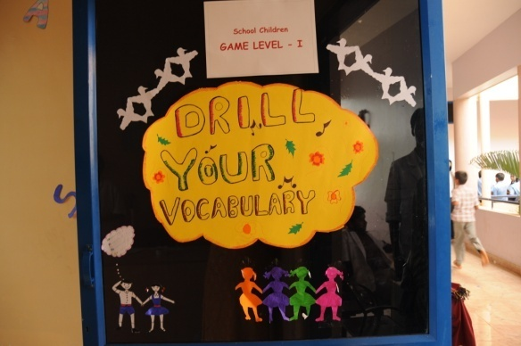 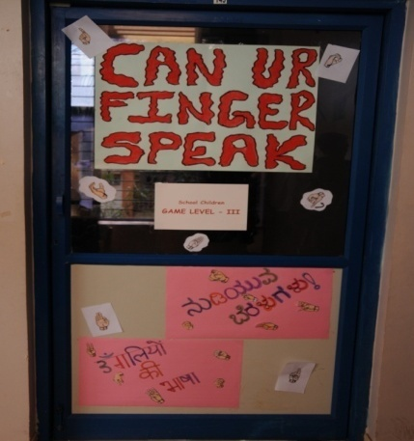

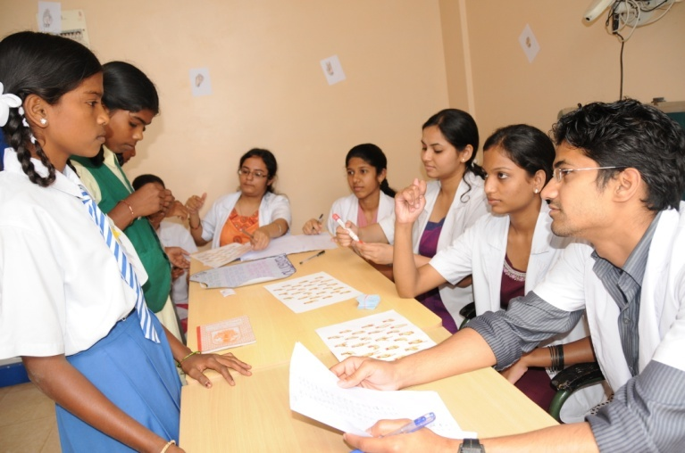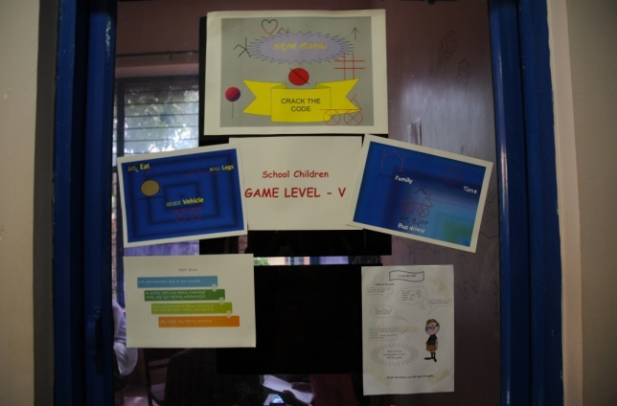

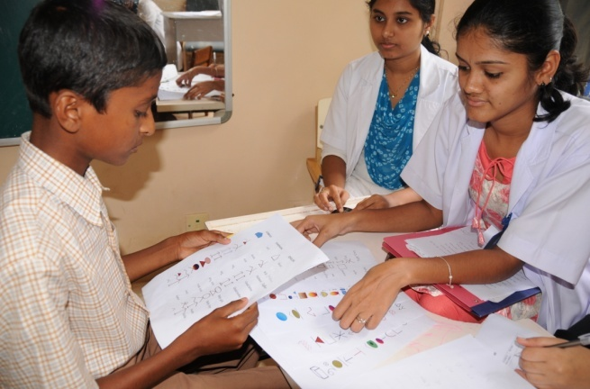 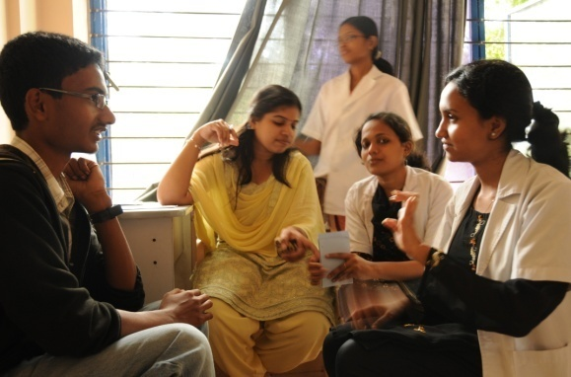

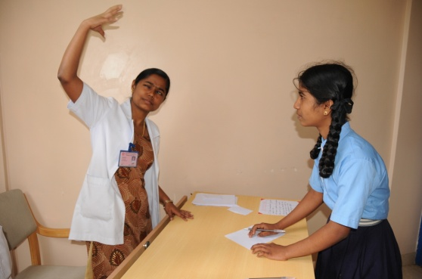

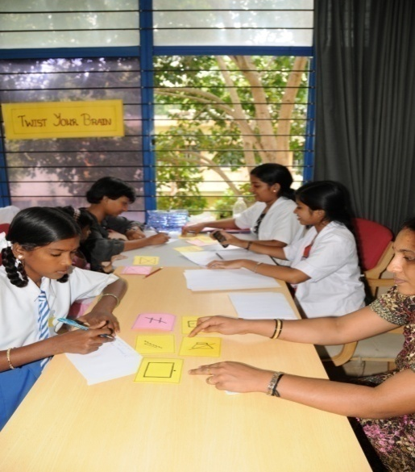 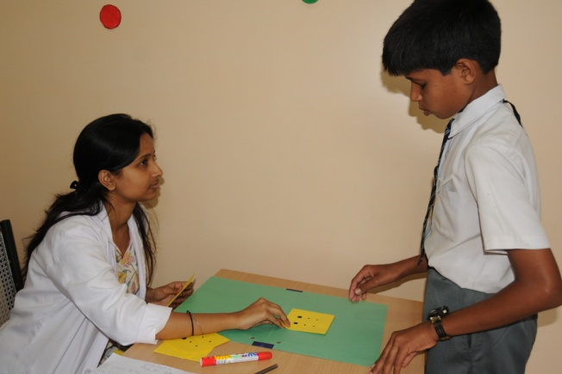

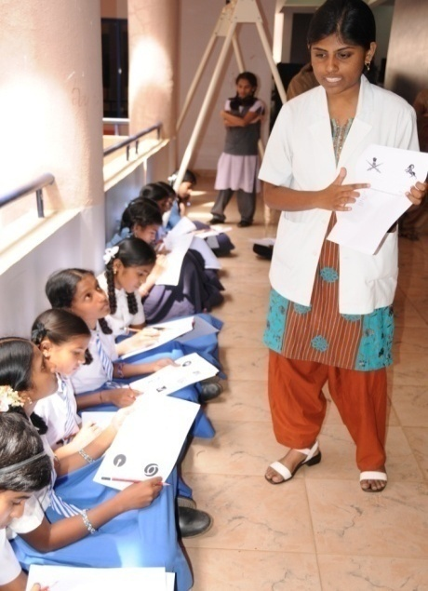 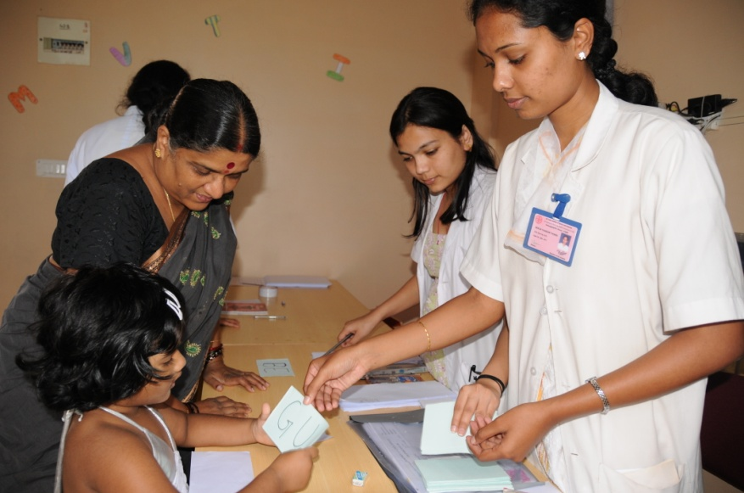

1. **Alternative Augmentative Communication Unit (AAC): Statistics of clinical activities of the unit from April 2010 to March 2011**

|  |  |
| --- | --- |
| Details | **Total No. of cases** |
| 1. New cases evaluated | 18 |
| 1. Evaluation Sessions | 19 |
| 1. Therapy cases seen | 236 |
| 1. Therapy Sessions | 1392 |
| 1. D.T. Cases | 01 |
| 1. Home training cases | 03 |

1. **Autism Spectrum Disorders Unit(ASD): Statistics of clinical activities of the Unit from April 2010 to March 2011**

|  |  |
| --- | --- |
| Details | **Total** |
| 1. No. of cases evaluated | 234 |
| 1. No. of assessment sessions | 236 |
| 1. No. of therapy cases | 643 |
| 1. No. of therapy sessions | 3605 |
| 1. No. of D.T. cases | 36 |
| 1. No. of cases discharged | 19 |
| 1. No. of cases discontinued | 01 |
|  |  |

**OCCUPATIONAL THERAPY (SENSORY INTEGRATION)**

**Annual Statistics:** April 2010 – March 2011

**Diagnostics:**

No of cases evaluated: 177

No of assessment sessions: 177

**Therapy:**

No of therapy cases: 792

No of therapy sessions: 3938

**Re-evaluation:**

No of cases evaluated: 45

No of assessment sessions: 45

1. **Unit for Structural Craniofacial Anamolies (U-SOFA): Statistics of clinical activities of the Unit from April 2010 to March 2011**

|  |  |  |
| --- | --- | --- |
|  | **Pediatric** | **Adult** |
| Diagnostics |  |  |
| No. of clients evaluated by plastic surgeon | **129** | **22** |
| No. of clients evaluated by prosthodontist | **28** | **9** |
| No of cases seen by orthodontist | **59** | **9** |
| Rehabilitation Recommended |  |  |
| No of cases recommended for orthodontic treatment | **11** | **3** |
| No. of clients recommended for surgery | **48** | **3** |
| No. of clients recommended for speech therapy | **71** | **6** |
| No. of client recommended for Prosthesis | **2** | **2** |
| **Details of rehabilitation** |  |  |
| No. of session taken for preparation of prosthesis | **24** | **7** |
| No. of speech prosthesis prepared | **4** | **2** |
| No. of cases attended speech and lang. therapy | **125** | **5** |
| Total No of cases attended Demonstration therapy | **20** | **0** |
| No of sessions ( D.T ) | **123** | **0** |
| No of speech and language therapy sessions held | **633** | **0** |
| manpower development |  |  |
| No of undergraduate students trained |  | **70** |
| No of internee trained |  | **44** |
| No of postgraduate students trained |  | **68** |
| Short term training |  | **-** |
| Audio Visual Material development |  |  |

**Glimpses of U-SOFA Activities:**

**Therapy activities**

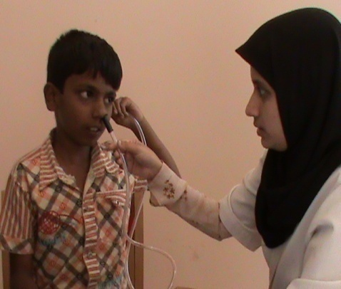 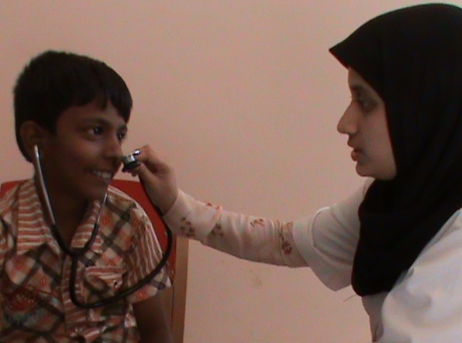

**Prosthesis Preparation Multidisciplinary Approach**

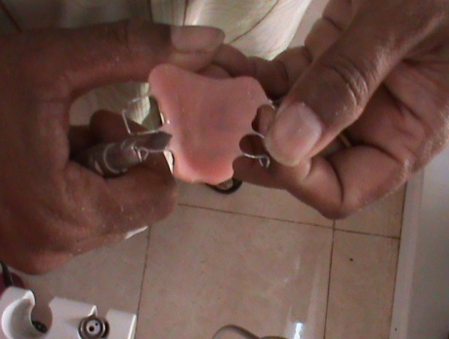 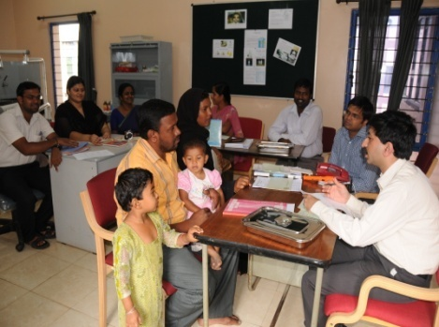

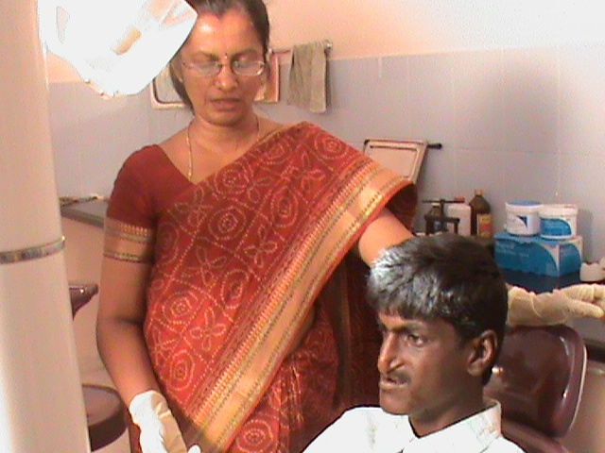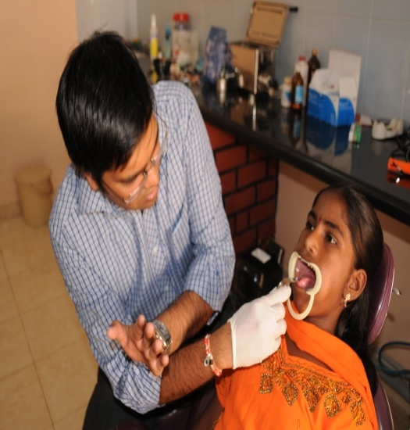

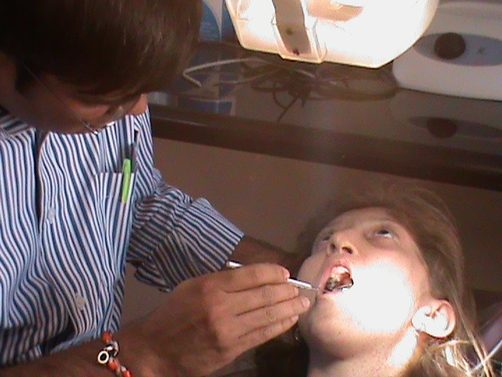

**4) TECHNOLOGICAL CONSULTANCY SERVICES**

**5) EXTENSION ACTIVITIES**

1. **Rehabilitation & Education through Distance Mode**

**Dr. Jayashree.C.Shanbal:**

* Delivered talk on Management of Learning disability on 17.3.2011

1. **Prevention of Communication Disorders**
2. **Publicity and Information**
3. **Camps**
4. **Orientation Program**
5. **Public Lecture Series**

**Dr. M. Pushpavathi:**

* Served as a resource person on the topic “effect of cleft lip and palate on speech “on 27.11.10

**6) CENTRAL FACILITIES**

1. **Library and Information Services**
2. **Materials Development**
3. Handout for ASD in English
4. Handout for Stroke and Aphasia – English
5. Handout for CP – English
6. Handout for Dysarthria – English
7. Handout for Stuttering - English

**U-SOFA Unit:**

**Audio Visual Material:**

* **Development of a Resonance Manual on introduction to cleft lip and cleft palate – Part I and Assessment of cleft lip and cleft palate – Part II**

The above two manuals are developed for providing orientation to 1st B.Sc students. The students were oriented regarding the causes, assessment and management of cleft lip and cleft palate using this manual. They were later oriented about the therapeutic activities and documentation of the therapy procedures.

* + **Photo Album on Cleft lip and Cleft Palate:**

This photo album consists of various types of cleft lip and cleft palate across different age groups. It also consists of photos with respect to pre and post surgical corrections of the cleft lip and cleft palate. This album is developed to provide insight to different types of cleft lip and cleft palate to the students.

* **Hand Book on Prosthesis:**

This handbook consists of information on parts of the prosthesis, preparation of prosthesis, different types of prosthesis, candidacy and contraindications for prosthetic rehabilitation, merits and demerits. Exclusive audio visuals were collected for three cases and the same were compiled in the form of slides. This will be used for orientation to internship and M.Sc (SLP) students.

* **Manual on velopharyngeal closure:**

This manual is mainly developed for providing practical information on velopharyngeal physiology, assessment and management. The manual consist 308 slides along with video recording of videofloroscopy images to provide better understanding of velopharyngeal closure. Along with this therapy technique for improving resonance and articulation is also been included which are demonstrated by the team members of U-SOFA.

* **Clinical module for assessment and management of craniofacial anomalies:**

In order to provide clinical exposure on assessment and management of clients with maxillofacial anomalies, the video recording of counseling sessions, therapy sessions by the faculty are recorded and the same has been used for orienting the students.

* **Development of handout for parents having children with cleft lip and palate in kannada.**

This handout has information on causes, and management issues related to cleft lip and palate. This also has a section on speech therapy methods which can be used by parents.

* **Development of data bank on different types of cleft lip and palate cases:**

The development of audio visual databank includes audio, video recording of cleft lip and cleft palate clients performance on articulation test, spontaneous speech/conversation, counting, diodochokinetic test, video of structures of oral cavity, oral sentences and nasal sentences has been initiated. Forty speech samples of clients with different types of repaired / unrepaired cleft lip and palate has been video recorded. Eighteen audio files were analyzed for temporal and spectral characteristics using PRAAT software. The same will be used for practical classes for M.Sc(SLP).

**7) AWARDS AND HONORS RECEIVED BY FACULTY AND STAFF**

**Nil**

**8) EXTRA CURRICULAR ACTIVITIES**

1. **NSS**
2. **AIISH GYMKHANA**

**Mr. Brajesh Priyadarshi:**

Nominated and served as Member Secretary, Catering Committee for theOpen Day celebration at AIISH.

Attended 2 meetings in connection with the Open Day celebration at AIISH.

**Dr. Jayashree.C.Shanbal:**

Staff Member Secretary, AIISH Gymkhana –conducted and organized activities such as Open day, National Science Day, Women’s Day, AIISH Aawaaz 2011

1. **Others**

**9) ADMINISTRATIVE ACTIVITIES**

1. **Official Language Implementation**
2. **Information on Personnel**
3. **Appointments**
4. **Regular**
5. **Contract**
6. **Deputation**
7. **Project Staff**
8. **Promotion**
9. **Resignation/Retirement**
10. **Obituary**
11. **Major constructions**
12. **Particulars of Equipments Purchased**

|  |  |
| --- | --- |
| 1. HP computer with accessories | 6 Nos. |
| 1. Speech & Language Diagnostic Tests | 23 Nos. |
| 1. PASW AMOS – 18.0 – 10 users | 1 No. |
| 1. 1512A-Swing frame & accessories | 1 No. |
| 1. 1512 – Vestibular/ swing system | 1 No. |
| 1. DAF-1000 with Earphone and Mic | 2 units |
| 1. Oral Motor fods (Jaw exercise) | 2 sets |
| 1. Articulatory tools | 2 sets |
| 1. Servox Easy voice with Microphone | 1 Unit |
| 1. Speech sounds – CD | 1 No. |
| 1. Voice recorders (Olympus) | 2 Nos. |
| 1. Voice recorders-Olympus | 5 Nos. |
| 1. Optimist MMX Board | 1 Unit |
| 1. CD | 3 Nos. |
| 1. Allora Key Board with CD | 1 No. each |
| 1. Head gears | 3 Nos. |
| 1. Artic combo | 2 sets |
| 1. Phonology combo | 2 sets |
| 1. Artic games & more | 2 sets |
| 1. Attention & Memory Vol.1 | 1 set |
| 1. Handy cam – Sony digital | 2 Nos. |
| 1. EMG Transducer-7122 | 1 No. |
| 1. Three Channel Manometer -1111-0962 | 1 No. |
| 1. Computer HP | 8 Nos. |
| 1. Tap to talk hardware | 1 set |
| 1. Softwares – Artic combo, Phonology Combo, Artic games & Attention etc. | 2 nos. |
| 1. Nasality visualization | 1 No. |
| 1. NVS Nasal emission software | 1 No. |
| 1. Nasal mask handle- 1020 | 1 No. |
| 1. Nasal emission handle – 1015 | 1 No. |
| 1. Oronasal masks – adult and child | 1 No. each |
| 1. Separator plates | 3 Nos. |
| 1. Calibration ventricle tube | 1 No. |
| 1. Nasalence separator handle – 1013 | 1 No. |
| 1. Lap Top system HP | 2 Nos. |
| 1. Printers 4500 – HP | 2 Nos. |
| 1. Nasometer – 6450 | 1 Unit |
| 1. RMS Spirometre | 2 Units |
| 1. Ambulatory Phonation Monitor | 1 Unit |
|  |  |

1. **Finance Statements**
2. **Others**

**10. EMINENT VISITORS**

* Team of professionals from DPR of Korea reg. Digital Swallowing Station and Departmental activities. The team consisted of Mr. Jong Hyong, Director, Dept. of planning and 3 members from physical rehabilitation centers, DPR, Korea on 1.7.10.
* DHLS coordinators from various centers reg. DSW on 2.7.10.
* Mr. Keshavraj Deshiraju, **A**dditional secretary, Ministry of Health & Family Welfare, Govt. of India
* Mrs. Rajul Padmanabha, Director, Vidyasagar, Chennai to AAC Unit

**11. ANY OTHER**

**HOD-Speech-Language Pathology**