DEPARTMENT OF PREVENTION OF COMMUNICATION DISORDERS (POCD)

ANNUAL REPORT APRIL 2010 TO MARCH 2011

1. **MANPOWER DEVELOPMENT**
2. **Academic Activities: NIL**
3. **Long term Academic programs – Nil**
4. **Short-term Training Program: NIL**
5. **In-House Program: Nil**
6. **Seminar/ Conference /Workshop/ Orientation programs conducted:**

Table 1: Orientation Programs conducted by the department of POCD in the report Year

|  |  |  |  |  |
| --- | --- | --- | --- | --- |
| Date | Topic | Target group | Place | Staff who conducted the program |
| 18/5/2010 | Communication Disorders- Early Identification and Prevention | Social workers and Health workers | Chamaraja-nagar | Mr. Ramesh Chandra. I  Ms. Bhavya.M |
| 19/5/2010 | Communication Disorders- Early Identification and Prevention | Social workers and Health workers | Kollegal | Mr. Ramesh Chandra. I  Ms. Bhavya.M |
| 14/6/2010 | Prevention and early identification of Communication Disorders  Objectives of POCD department | Nursing students,  B.M. Hospital  Mysore | POCD Dept.  AIISH | Ms. Pragathi, E |
| 02/09/2010 | Orientation to carry out survey of the population and identification of persons with communication disorders | * ASHA workers – Gumballi * Selected Women volunteers- Hullahalli and Akkihebbalu | POCD Dept.  AIISH | Dr.Vijaylak-shmi Basavaraj  Dr.R.Manjula  Ms. Pragathi. E  Ms. Bhavya. M |
| 14/12/2010 | Orientation to carry out survey of the population and identification of persons with communication disorders | * ASHA workers – Gumballi * Selected Women volunteers- Hullahalli and Akkihebbalu * Selected High school student volunteers of Gumballi, Hullahalli and Akkihebbalu | POCD Dept.  AIISH | Dr. R. Manjula and  Ms. Pragathi. E |

1. **Academics programs and meetings attended by faculty and staff (other than seminars and conferences)**

**Seminars/ Conferences /Lectures/Workshops Organized by AIISH**

Table 2: Seminars/ Conferences /Lectures/Workshops attended by staff of POCD department in the report year

|  |  |  |  |  |
| --- | --- | --- | --- | --- |
| Sl. No. | Date | Title of the program and other details | Organized by | Faculty / Staff / Research Fellow |
| 1. | 29/1/2011 & 30/1/2011 | National Symposium on evaluation and management of vestibular problems | Department of Audiology, AIISH | Mr. Prashasthi, P  Ms. Yeshaswini, R and  Ms. Sunitha, E. |
| 2. | 15/3/2011 | Principles of Cognitive and Linguistic – Assessment and Management | Department of Speech- Language Sciences, AIISH | Ms. Yeshaswini, R |
| 3. | 27/3/2011 & 28/3/2011 | Workshop on MATLAB program | Department of Electronics, AIISH | Dr.R. Manjula,  Mr. Rohith H and  Ms. Yeshaswini, R |

1. **Visits Abroad –Nil**
2. **Details of guest faculty visited the institute and lecture delivered – Nil**
3. **Details of guest lecturers delivered by faculty and the staff in the institute**
4. **Lecture Series**

A series of lectures on various topics in the field of communication disorders were **organized by the department** **of POCD** through the video conferencing link to Hullahalli, Nanjangud Taluk and Akkihebbalu, K.R. Pete Taluk for different targets groups like ASHA workers, ANMs and general public. The details of the series lectures are as given in Table 3.

Table 3: Lecture series organized by POCD Department in the report year.

|  |  |  |  |  |
| --- | --- | --- | --- | --- |
| Sl. no | Date | Resource person | Topic | Target group |
| 1 | 03.05.2010 | Dr.G.Jayaram, Reader in Clinical Psychology, Dept. of Clinical Psychology, AIISH, Mysore | Signs and symptoms of Mental retardation in children and prevention and early identification of this condition | * 2 Senior Health officers * 3 ASHA workers * 10 Anganwadi workers * 4 General public * 1 Pharmacist |
| *2* | 04.05.2010 | Dr.G.Jayaram, Reader in Clinical Psychology, Dept. of Clinical Psychology, AIISH, Mysore | Signs and symptoms of Mental retardation in children and prevention and early identification of this condition | * 4 ASHA workers * 4 General public * 10 Anganwadi workers |
| 3 | 05.05.2010 | Dr.G.Jayaram, Reader in Clinical Psychology, Dept. of Clinical Psychology, AIISH, Mysore | Signs and symptoms of Mental retardation in children and prevention and early identification of this condition | * 1 PHC staff * 11 General public * 6 Anganwadi workers |
| 4 | 06.05.2010 | Dr.Vijalalakshmi Basavaraj, Director, AIISH | Signs and symptoms of Hearing impairment in children and prevention and early identification of this condition | * 3 ASHA workers * 2 Nurses * 6 Anganawadi workers * 10 General public |
| 5 | 07.05.2010 | Dr.Vijalalakshmi Basavaraj, Director, AIISH | Signs and symptoms of Hearing impairment in children and prevention and early identification of this condition | * 8 ASHA workers * 2 Anganawadi workers * 3 General public |
| 6 | 10.05.2010 | Dr.Vijalalakshmi Basavaraj, Director, AIISH | Signs and symptoms of Hearing impairment in children and prevention and early identification of this condition | * 1 Health worker * 9 General public * 2 ASHA workers * 2 Anganwadi workers |
| 7 | 11.05.2010 | Prof. S. Ventatesan, HOD, Dept. of Clinical Psychology | Signs and symptoms of Learning disability in children and prevention and early identification of this condition | * 8 ASHA workers * 6 General public * 1 Anganawadi workers |

**II. Guest lecturers delivered within the institute**

Table 4: Orientation lectures delivered by staff of POCD Department in the report year.

|  |  |  |  |  |  |
| --- | --- | --- | --- | --- | --- |
| **Sl. No.** | **Date** | **Title of the program and other details** | **Target**  **group** | **Organized by** | **Faculty / Staff / Research Fellow** |
| 1 | 10/4/2010 and 17/4/2010 | Prevention and early Identification of Auditory disorders | B.S.Ed students, AIISH | Department of Special Education, AIISH | Mr. Arunraj K and  Ms. Pragathi, E |

1. **Additional academic responsibilities of the Faculty and Staff**
2. **Academic Programs and Meeting Attended by Faculty and Staff (other than seminars and conference)**

**Dr. R. Manjula, HOD POCD Department**

* Nominated and served as a member of the Committee constituted by the University of Mysore to review and award research status to JSS Speech and Hearing Institute, Mysore. Inspected JSS institute with the committee on 6.5.2010.
* Meeting with Director AIISH and HOD, CREDM to finalize the topics for series orientation lectures to the health workers and public at Hullahalli Outreach Service Centre and Akkihebbalu Outreach Service Centre of the POCD Department.
* Served as a member in the Selection Committee for the post of Clinical psychologist Grade II on 22.4.2010.
* Prepared the draft material submitted to the DHHS, Ministry of Health and Family Welfare, New Delhi (along with Dr. P. Manjula, HOD, Dept. of Audiology) for the subtopic on “Retaining UG, PG and Ph.D holders in the country” with respect to the proposal on Upgradation of AIISH as Superspecialty Centre of Excellence on 23.4.2010.
* Meeting with Dr. H. Sudharshan, Hon. Secretary of Karuna trust, Dr. Kantharaj, I/c Coordinator, Mysore Branch, Karuna Trust, along with Director, AIISH on 10.5.2010.
* Attended meeting on Tender opening for Omni bus of AIISH on 18.5.2010 from

4 pm to 5.30 pm.

* Member of the Committee to review the doctoral thesis of Ms. Shilpashree in the Pre submission colloquium held on 29.5.2010 from 12 noon to 2.00 pm.
* Visited Gumballi Primary Health centre along with Director AIISH on 4.5.2010 from 10 am to 3.30 pm.
* Coordinated tele lecture series addressed to the Health workers through video conferencing system connected to Hullahalli and Akkihebbalu villages on 3.5.2010 to 7.5.2010 and 10.5.2010 to 11.5.201.
* Served as a member of the committee to select Supervisor for Extension Service centers of POCD department at Karuna trust on 2nd June between 11 am to 2 pm.
* Provided Guidelines to open a school and vocational centre for special children in Mysore to Mr. Jagannath, Chairman, of World Academy of Science, Humanities, Education and Literature (WASHEL), India Chapter, on 4th and 7th June 2010.
* Attended Faculty meet which was held on 9.6.2010
* Attended DHLS meet on 18th June and 29th June 2010. Chaired a scientific session on “AAC and early intervention held on 9th July 2010 at the 2nd National conference on AAC and Assistive Technology for persons with disabilities”, held at Chennai from 9/7/2010 to 10/7/2010
* Visited Gumballi Outreach Service Centre on 28.7.2010 with the staff of POCD.
* Served as member of the committee to review Ph.D thesis of Ms. Hema N and Mr. Gopisankar.
* I/c for arrangements for lunch and dinner for dignitaries w.r.t. the inauguration of the “Bodhi” Gents hostel on 17th September 2010.
* Conducted annual inspection of Delhi DHLS centre from 22.9.2010 to 24.9.2010.
* I/c for arrangements for lunch and dinner for dignitaries w.r.t. 43rd meeting of the finance committee of the institute on 8.10.2010.
* On 22.10.2010, as part of the AAC Awareness month for 2010, competitions were conducted for the AAC users ( 17 No) and their caregivers (15 No). 3 competitions were held for children and 2 for their caregivers. The 3 competitions for children included “thimmana thota”, “combined activity including manual signs” and “story narration”. For the caregivers, the games included “Guess and win” and “Mime a story”.
* Wrote the course structure, syllabus and terms and conditions of Post Graduate Diploma in Augmentative and Alternative Communication (PGDAAC)
* Coordinated the ‘Expert Committee meet’ to deliberate on PGDAAC on 12.11.2010.
* Served as a panelist in the “Inhouse faculty development workshop on pedagogy” held on 17.11.2010 from 9.30 am to 1.30 pm.
* Served as Member Secretary in the meeting held in Director’s chamber with dr. H. Sudharshan, Hon. Secretary, Karuna Trust, Mysore on 15.11.2010.
* Member Secretary of the Committee nominated for conducting new born screening at 3 DHLS centres of Ajmer, Cuttack and Imphal from December 2010
* Member, preparation of Entrance Question papers for M.Sc (SLP) from 6.12.2010 to 9.12.2010.
* Reviewed two DST proposals on Cognition.
* Meeting to discuss shifting therapeutic activities of POCD to CREDM on 17.12.2010.
* Convened meeting of member of the committee for new born screening on 21.12.2010
* Attended meeting on 2nd AIISH Alumnus meet held at AIISH on 7th Jan 2011
* Coorinated the meeting on new born screening program in 3 DHLS centres (Ajmer, Cuttack and Imphal) as member secretary on 6.1.2011 and 18.1.2011.
* Served as member of screening committee (DPC) for Group D staff for financial upgradation under the modified assured career progression scheme held on 17.1.2011.
* Prepared draft proposal of 12th five year plan of POCD department and presented the same on 25.1.2011.
* Served as a member in the doctoral committee meeting held for two candidates on 31.1.2011
* Attended meeting with a group of delegates from Norwegian university of Science and Technology, NTNU on 9th February 2011.

1. **Additional responsibilities of the faculty and the staff**

**Dr. R. Manjula, HOD POCD Department**

* Serving as HOD, Department of Prevention of Communication Disorders from 28/1/08
* Serving as Co-ordinator, AAC Unit from 2003.
* Serving as a reviewer on the editorial board of Journal of Indian Speech Language and Hearing Association.
* Served as Member Secretary, Public Grievances and Redressal committee from 30/1/2006 to 13/9/2010. Handed over charge to Dr. H. Sunder Raju on 13/9/2010.
* Serving as one of the member on the Editorial Board, Journal of All India Institute of Speech and Hearing, Mysore.
* Serving as coordinator for DHLS program of AIISH at New Delhi. Handed over charge of DHLS Shimla centre on 6/9/2010 to Ms. Priti Nair.
* Serving as Member, BOE and BOS at ISH, Bangalore.
* Serving as Member, BOS and BOE, Mysore University
* Serving as Member, Internal Research Committee for review of ARF Research projects.
* Serving as Member, anti ragging committee.
* Serving as Vice President of ISAAC- India Chapter

1. **CLINICAL AND OTHER SERVICES**
2. **Clinical Services**

**Rehabilitation/ Clinical services carried out by POCD Department:**

The following clinical activities were carried out by the POCD Department in the report year:

1. Screening new born infants and children for communication disorders:

* 12 hospitals in Mysore city
* 3 Immunization centres in Mysore city
* 2 PHC/CHC centres (CHC centre of Santhemaralli, Yelandur Taluk & PHC Centre of Hullahalli, Nanjangud Taluk).

1. Clinical Services at Outreach Service Centres of the POCD Department:

* PHC centre, Hullahalli, Nanjangud Taluk, Mysore district
* PHC centre, Akkihebbalu, K.R. Pete Taluk, Mandya district
* CHC centre, Santhemaralli, Yelandur Taluk, Chamarajanagar district
* PHC centre, Gumballi, Yelandur Taluk, Chamarajanagar district

1. Hearing Screening of industrial workers
2. Compilation of data from all speech, language and hearing screening camps conducted at the institute
3. Follow-up of individuals identified to be at risk for various communication disorders in speech and hearing camps, infant screening and villages attached to the Outreach Service Centres of the department at:

* PHC centre, Hullahalli, Nanjangud Taluk, Mysore district
* PHC centre, Akkihebbalu, K.R. Pete Taluk, Mandya district
* CHC centre, Santhemaralli, Yelandur Taluk, Chamarajanagar district
* PHC centre, Gumballi, Yelandur Taluk, Chamarajanagar district

**1. Screening new born infants and children for communication disorders:**

Infant screening focuses on neonates and infants. In this program, neonates and infants are screened using the following methods to identify risk factors that could lead to communication disorders:

* High Risk Register for communication disorders
* Behavioral Observation Audiometry (BOA)
* Oto Acoustic Emission screening (OAE)
* Screening Checklists.

In the report year, infant screening program was carried out throughout the year in 12 hospitals in Mysore.

Table 5: Total Number of infants screened in *12 hospitals in Mysore city

[*Basappa Memorial Hospital (B.M.H), Combined Hospital, Harsha Hospital, Kamakshi Hospital, K.R.H Hospital, Makkala Koota Immunization Center, Mission Hospital, Immunization Centre, N.P.C Hospital, S.M.T.D.H Hospital, BGS Apollo & St.Joseph hospital]

|  |  |  |  |  |
| --- | --- | --- | --- | --- |
| *Months* | *Total No of infants screened* | *Male* | *Female* | *Total Referred for follow up* |
| Apr 20010 | 1118 | 552 | 566 | 187 |
| May 2010 | 1100 | 556 | 542 | 159 |
| June 2010 | 1047 | 543 | 504 | 108 |
| July 2010 | 1026 | 554 | 472 | 109 |
| Aug. 2010 | 1162 | 604 | 558 | 117 |
| Sept. 2010 | 1087 | 576 | 511 | 139 |
| Oct. 2010 | 1037 | 570 | 467 | 93 |
| Nov. 2010 | 1080 | 553 | 527 | 60 |
| Dec. 2010 | 976 | 494 | 482 | 61 |
| Jan 2011 | 1008 | 565 | 453 | 186 |
| Feb 2011 | 886 | 453 | 433 | 121 |
| Mar 2011 | 996 | 528 | 468 | 145 |
| **Total** | **12523** | **6548** | **5983** | **1485** |

*Figure 1:* Total Number of infants screened at various Hospitals from April 2010 to March 2011

*Figure 2:* Proportion of Male and Female infants in various Hospitals from April 2010 to March 2011

Parents were counseled regarding identification of any delay or deviancies in normal developmental milestones of speech, language, hearing, motor and other related domains that affects development of communication skills in the children. They were provided checklist to help monitor the development of the infant and if any delay or deviations were noted they were advised to visit the institute for follow up and further action.

* + 1. **Clinical Services at Outreach Service centres of the POCD Department**

The Outreach Service Centres of the department include:

* PHC centre, Hullahalli, Nanjangud Taluk, Mysore district – Initiated from 23rd November 2009
* PHC centre, Akkihebbalu, K.R. Pete Taluk, Mandya district – Initiated from 24th November 2009
* CHC centre, Santhemaralli, Yelandur Taluk, Chamarajanagar district (only infant screening) – Initiated from 28th July 2010
* PHC centre, Gumballi, Yelandur Taluk, Chamarajanagar district – Initiated from 28th July 2010

The objective of initiating the Outreach Service Centres was to provide diagnostic and speech-language therapeutic facilities for the persons residing in the rural areas nearby the selected Outreach Service Centres. Closely connected with this program, through a Research funded program (AIISH Research Project), two groups of volunteers were selected and trained to promote the cause of prevention and early identification of communication disorders. These included (1) ASHA workers attached to the Gumballi Outreach Centre and selected women volunteers in the Hullahalli and Akkihebbalu Centre (2) Selected student volunteers from High schools of nearby schools (8th and 9th grade) to assist the ASHA workers and women volunteers. The following activities were carried out in the report year:

* Empower and train the ASHA workers, selected women volunteers and selected high school children in prevention and early identification of communication disorders.
  + Orientation and sensitization program for senior health assistants, Members of the Village Panchayat, NGO’s working in the village and other Health workers attached to the village.
  + Distribution of Public Education Materials and Resource Materials among the public and the persons with communication disorders

The following clinical activities are carried out as routine in these Outreach Service Centres:

* E.N.T evaluation,
* Infant screening
* Audiological evaluation,
* Speech-Language evaluation,
* Speech-Language therapy,
* Hearing aid trial and distribution of hearing aids under ADIP Scheme,
* Earmold impression and distribution,
* Counseling and Guidance services

Figures 3 to 8 shows the details of clients seen in the three outreach service centres.

*Figure 3:* Details of clients at Hullahalli and Akkihebbalu Outreach Service Centre in the report year.

*Figure 4*: Details of different communication disorders in clients at Hullahalli and Akkihebbalu Outreach Service Centre in the report year.

*Figure 5*: Details of hearing aids issued and ear molds made for clients in Hullahalli and Akkihebbalu Outreach Service Centre in the report year.

*Figure 6*: Details of clients seen at Gumballi-Santhemaralli Outreach Service Centres between August 2010 to March 2011.

*Figure 7*: Details of clients with different communication disorders seen at Gumballi Outreach Service Centre between August 2010 to March 2011.

*Figure 8*: Details of hearing aids issued and ear molds made for clients in Gumballi Outreach Service Centre between August 2011 to March 2011.

*Figure 9***:** Details of clients recommended for speech and language therapy at Hullahalli, Akkihebbalu (April 2010 to March 2011) and Gumballi (August 2010 to March 2011).

* + 1. **Hearing Screening of industrial workers**

A total of 132 employees in Karnataka Silk Industries Co. (KSIC) were screened for hearing abilities. Most of the employees of this industry had high frequency sloping hearing loss due to exposure to high noise level. The employees were counseled regarding the need to use ear protective devices to protect their hearing ability. The employers were also counseled regarding attenuation of noise level at the source and transmission medium. The details of the hearing evaluation of the employees is represented in figure 10.

**Total screened - 132**

*Figure 10:* Total Number of Employers screened for hearing and its outcome

* + 1. **Follow up activities of POCD Department:**

All referred clients (infant screening) were followed up through telephonic calls and individual letters written to client/ parents / caregivers of infants at risk for communication disorders. Complete test battery was administered to each individual who were found to be at risk. Figure 11 and 12 depict the statistics related to this activity.

*Figure 11:* Total number of clients visited AIISH for detailed evaluation

**0.2%**

**0.8%**

**0.5%**

**1%**

**4.6%**

*Figure 12:* Communication disorders identified through detailed evaluation

**EXTENSION ACTIVITIES**

**1. Camps to screen individuals with speech, language and hearing disorders:**

Several camps were conducted at various places within and outside Karnataka in the report year by the institute. These camps were majorly sponsored by NGO’s, SSA, several state and district sponsored agencies. The statistics of individuals evaluated and referred to the institute for follow up and clients who were issued hearing aids and certificates is shown in Table 6 and Figures13 to 15.

Table 6: Details of clients screened in various camps in the report year

|  |  |  |  |  |  |
| --- | --- | --- | --- | --- | --- |
| Month | Place where camp was held | Date | Sponsoring Organization | Total Number of Clients screened/  evaluated | Total Number of Clients referred to AIISH for follow up |
| Apr 2010 | Tarikere, Chikkamagalur district | 23/4/2010 | Rotary Club, Tarikere | 351 | 88 |
| July 2010 | Nanjangud, Mysore Dist. | 11/7/2010 | Mysore District Surgeon Association, Mysore. | 57 | 25 |
| Sulthan Battery | 29/7/2010 | SSA | 277 | 73 |
| Panamaram | 30/7/2010 | SSA | 429 | 171 |
| Sept 2010 | T.Narsipura, Mysore taluk. | 29/9/2010 | Chaitanya Charitable Trust | 96 | 30 |
| Dec. 2010 | Piriyapatna,  Mysore | 7/12/2010 | Chaitanya Charitable Trust, Mysore | 67 | 8 |
| Meke Daatu,  Kanakapura | 12/12/2010 | SGS Hospital,Sri Ganapathy Sachidananda Ashram, Mysore | 94 | 16 |
| Hebbal, Mysore | 16/12/2010 | Lions Club, Mysore | 90 | 13 |
| Feb 2011 | T.Narasipura,  Mysore | 20/2/2011 | Rotary Club,  T. Narasipur | 84 | 5 |
| Hosapet,  Bellary | 23/2/2011 to 25/2/2011 | Rotary Club, Hospet | 244 | 7 |
| Mar 2011 | H.D Kote,  Mysore | 02nd February 2011 & 03rd March 2011 | NSS, AIISH | 582 | 136 |
| Tarikere, Chckmagalur district | 17th March 2011 | Rotary Club, Tarikere | 316 | 19 |
| Devanuru,  Chamarajanagar district | 27th March 2011 | Sri Gurumalleswara Seva Samiti, Devanuru | 159 | 9 |
| **Total** | | | | **2846** | **600** |

**Total number of individuals Screened=2846**

*Figure 13:* Number of Males and Females screened for communication disorders at various camps organized from April 2010 to March 2011

*Figure 14:* Distribution of Speech Language and Hearing Disorders in clients screened at various camps organized from April 2010 to March 2011.

*Figure 15:* Total number of individuals prescribed hearing aids and certificates in the camps held in the report year

* + 1. **Publicity and Information**

**Activities of POCD Department**

Public education materials were prepared to create awareness regarding hearing, speech, language and other communication disorders. Some of the materials prepared earlier were translated in different languages to be used by the common people.

Table 7: Public education material prepared / under the process in the report year

|  |  |  |
| --- | --- | --- |
| *Sl. No* | *Name of the material* | *Languages* |
| I | *Materials Printed* | |
| 1 | 3rd edition of Data Sheet finalized and printed | English |
| 2 | Checklist on communication disorders for use by health workers and volunteers in the Outreach Service centres. | Kannada |
| 3 | Door-to- door survey report booklet for use by health workers and volunteers in the Outreach Service centres. | Kannada |
| 4 | NIHL poster | English |
| 5 | Handout to create awareness on protection of hearing from loud noise during Diwali. | English |
| II | *Material being Processed for Printing* | |
|  | Flipcharts on hearing | English and Kannada |
|  | Flipcharts on ear care | English and Kannada |
|  | Referral card (OSC) | Kannada |
|  | Manual on communication disorders for health workers | English and Kannada |
|  | Brochure on ear discharge | English and Kannada |
| III | *Material under preparation and field testing prepared* | |
|  | Pamphlet on NIHL | English |
|  | Manual on new born hearing screening | English |
|  | Pamphlet on CSOM | English |
|  | Pamphlet on Vocal hygiene for Teachers | English |
|  | Pamphlet on Ear protective devices. | English |
|  | Cross word puzzle on communication disorders | English |
|  | Translation of data sheets, HRR, Do’s and Don’ts | Oriya, Manipuri and Hindi language |

Prof. R. Manjula

HOD, POCD Department

PHOTOGRAPHS OF POCD DEPARTMENT ACTIVITIES

[1]

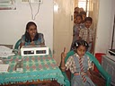

Screening school children at Akkihebbalu outreach service centre

[2]

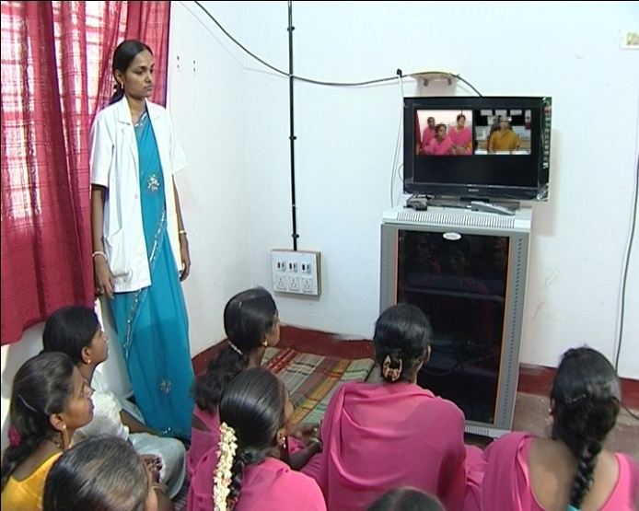

Lecture series through video conferencing link to Akkihebbalu Outreach Service Centre

[3]

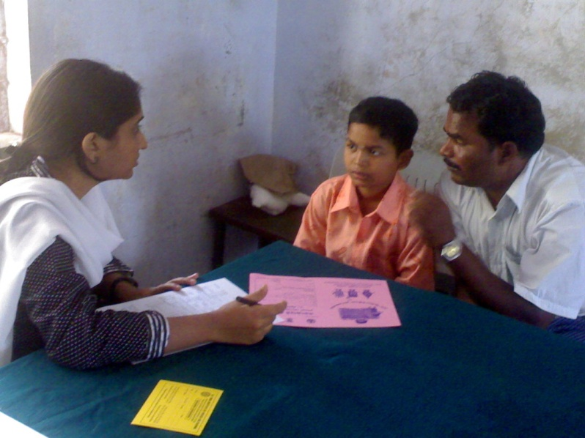

A child being tested for speech language problem in a camp

[4]

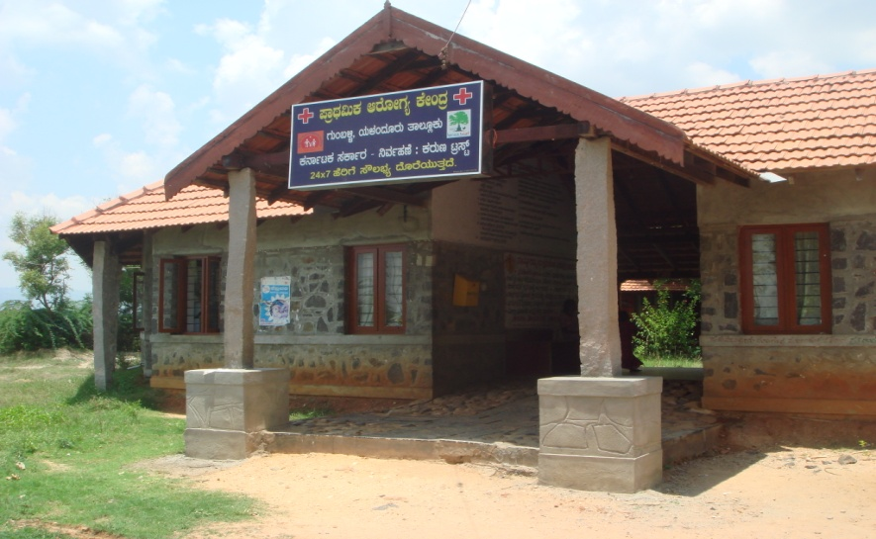

The Primary health centre at Gumballi within which the Gumballi Outreach centre of POCD Department is located

[5] & [6]

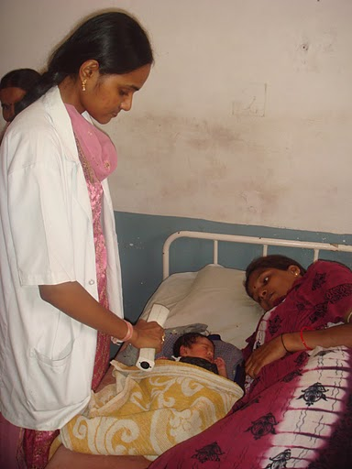 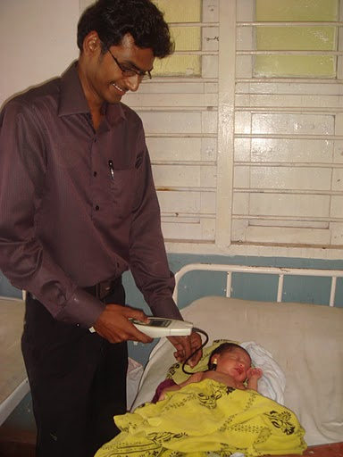

Infant screening at Hullahalli maternity ward

[7]

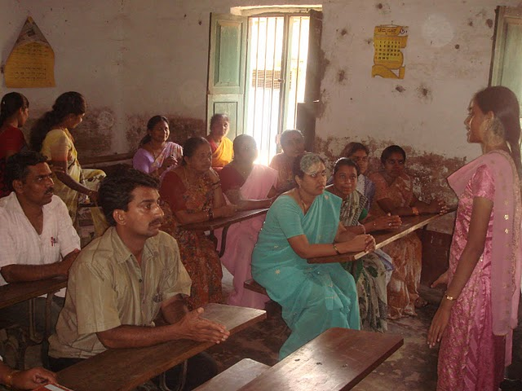

Orientation and sensitization of teachers to prevent and identify communication disorders

[8]

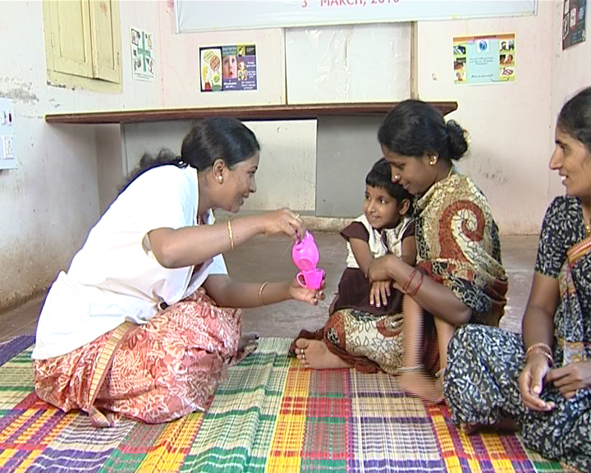

Speech language therapy at the Hullahalli Outreach Service Centre

[9]

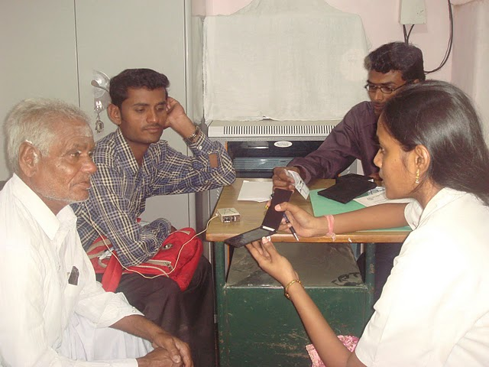

Hearing aid testing and issue to a client in one of the Outreach Service Centres

[10]

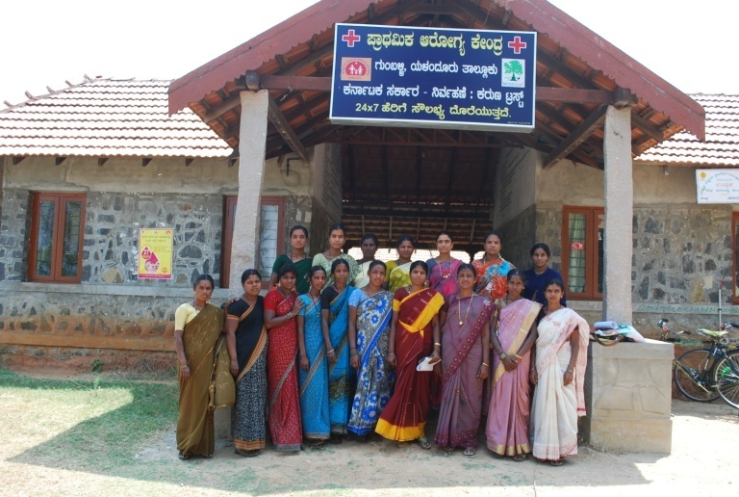

First batch of ASHA workers attached to Gumballi Outreach Service Centre who carried out house to house survey to identify communication disorders in persons residing in nearby villages

[11]

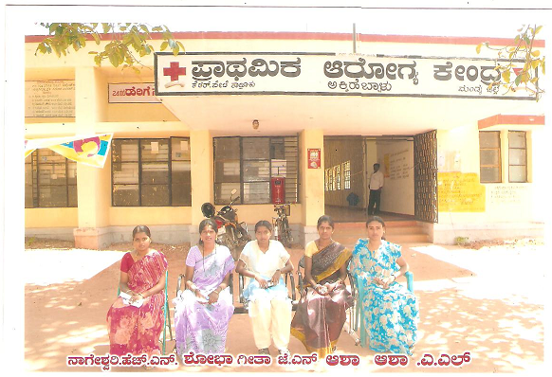

First batch of selected women volunteers attached to Akkihebbalu Outreach Service Centre who carried out house to house survey to identify communication disorders in persons residing in nearby villages.

[12]

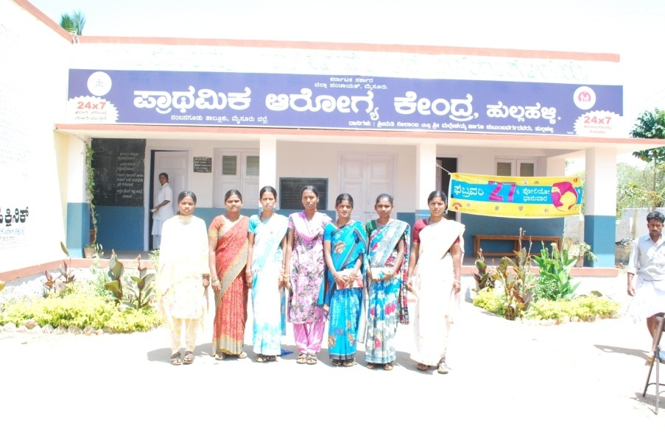

First batch of selected women volunteers attached to Hullahalli Outreach Service Centre who carried out house to house survey to identify communication disorders in persons residing in nearby villages.

[13]

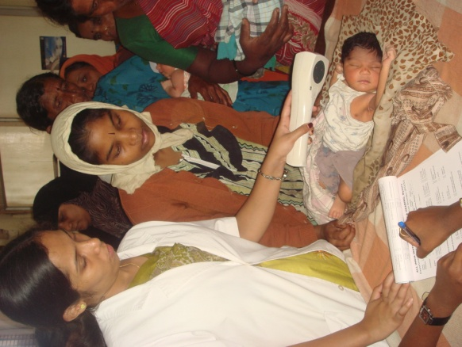

Hearing screening of new born infant at one of the hospitals

Prof. R. Manjula

HOD, POCD Department

DEPARTMENT OF PREVENTION OF COMMUNICATION DISORDERS (POCD)

SH/POCD/Ann. Rep/2011 10.5.2011

Submitted to Director

Sub: Annual report April 2010-March 2011 of POCD Department

Ref: SH/Lib/AR/2010-11 dt 11.4.2011

With reference to the above, please find enclosed the annual report of POCD department for April 2010-March 2011. The soft copy of the same is emailed to [lio@aiishmysore.in](mailto:lio@aiishmysore.in).

Dr. R. Manjula

HOD, POCD Department