No.SH/DCS/AR/2010-2011 28.4.11

**ALL INDIA INSTITUTE OF SPEECH & HEARING: MYSORE - 6**

DEPARTMENT OF CLINICAL SERVICES

**Submitted to the Director:**

Sub: Submission of Annual report 2010-2011 reg.

Ref: No.SH//lib/AR/2010-11 dated 11.04.2011

With reference to the above, please find herewith the Annual report of Department of Clinical services from April 2010 to March 2011. This placed for your kind information.

HOD - Clinical Services

**1. MAN POWER DEVELOPMENT:**

1. **Academic activities:**

The Department of Clinical Services imparts clinical training to diploma, graduate, postgraduate and doctoral students from AIISH for diagnosis and management of persons with speech language, and hearing disorders. The students are provided training in the assessment and management of various types of communication disorders using behavioral standardized tests and state-of-art equipments. In addition to this, their skills are also developed for preparation of teaching aids, clinical documentation of reports, preparation of intervention plans, home training programs and public education materials. The numbers of students trained during the financial year April 10 – March 2011 in Table 1 and 2.

**Table 1: Students trained in the Department during April 2010- March 2011**

|  |  |
| --- | --- |
| **Class** | **No. of students** |
| I BASLP | 62 |
| II BASLP | 62 |
| III BASLP | 44 |
| AIISH Interns | 38 |
| I M.Sc ( SLP) | 36 |
| II M.Sc( SLP) | 35 |
| B.SEd( HI) | 3 |
| M S Ed( HI) | 3 |
| PGDSLP | 3 |
| DHLS | 6 |
| DTYHI | 7 |
| **Total** | **299** |

**Table 2: Short term training for Allied professionals**

|  |  |
| --- | --- |
| **Professions** | No. of people trained |
| ENT / Dental Doctors | 09 |

1. **In house programmes**

1) **Implementation of Diagnostic Module and Therapy Module**

To strengthen the clinical skills of the students diagnostic and therapy modules were developed and introduced to under graduate and postgraduate students. The diagnostic module was prepared on the basis of the workshop titled “In- House Workshop on Clinical Practicum and Internal Assessment”. These modules were based on the theory papers of the each semester. These modules were also modified based on RCI – BASLP syllabus. The module comprises of both diagnostic and therapeutic skills that each student has to undergo. To teach these skills clinical practicum classes were conducted by the clinical staff.

**2)**  **Communication network with student clinicians-ongoing**

In order to develop and improve clinical skills in student clinicians a group E-mail ID was opened and the following documents/resource materials were sent to students, undergraduate and postgraduate students have become member of this group.

1. Pre therapy documents for all the disorders
2. Lesson plan format for various communication disorders in adults and children.
3. Description of stepwise therapy procedures for modified airflow, prolongation technique.
4. Techniques to improve oro motor skills.
5. Response recording sheet.
6. Exemplars and Base rate recording sheet for persons with Fluency disorders.
7. Preparation of Therapy Materials
8. Self –recording sheet for PWS
9. Evidence based practice recording sheet

Developed following items for fluency unit

* Evidence Based Practice
* Self Recording Sheet
* Students recording forms
* Detailed evaluation form for stuttering

1. Home Training materials in Kannada, English, Hindi, Tamil, Telugu & Malayalam for DSL-CP-MR-Aphasia-HI-Autism and Misarticulation.

3) Professional material development

A*. Improvisation of existing test materials*

Most of the test materials used in the department /OPD are worn out due to excessive usage and not in usable condition. Hence the existing test materials were updated with complete information about the tests in a laminated form to make them presentable. Further, soft copies of these tests have been prepared. The following test materials were completed:

1. REELS
2. RELT
3. 3D – LAT
4. SECS
5. Early reading skills
6. Kannada Language test
7. Malayalam Language test
8. Linguistic Profile Test – Kannada, Hindi, Malayalam, Telugu
9. Western Aphasic Battery - Kannada, Hindi, Malayalam
10. Reading Acquisition Profile in Kannada
11. Reading passages in Indian Languages

B. ***Re-printing of new test materials***

The following test materials were photocopied and picture booklets were reprinted (scanned, edited and laminated) for better maintenance of the original document:

1. Naglieri Non Verbal Ability Test
2. The Dyslexia adult screening Test
3. The dyslexia early screening test - 2
4. Dyslexia Screening Test - Junior
5. Dyslexia Screening Test - Secondary
6. The test of everyday attention for children
7. Graded Non-word Reading test
8. Cognitive listening quick test
9. Automated working memory assessment manual
10. Working Memory Rating scale
11. Children’s Test of Non-Word repetition
12. Test of word knowledge
13. The phonological abilities test
14. Childhood autism rating scale
15. Clinical Evaluation of Language Fundamentals – 4th Edition
16. Clinical Evaluation of Language Fundamentals – Preschool – 2nd Edition
17. Bracken’s School Readiness Assessment
18. Test for Reception of Grammar – Version 2
19. The Communication Checklist – Self Report
20. The Communication Checklist – Adult
21. Dementia Questionnaire for People with Learning Disabilities
22. Test of Memory Malingering
23. **Seminar/ conference/workshop conducted:**

* Organized LD work shop for teachers from 4.10.10 to 8.10.10
* Organized Seminar on "Keeping the promise: Mainstreaming disability in the Millennium Development Goals towards 2015 and beyond" on 03.12.10.

1. **Seminar/ conference/workshops attended by faculty/ staff organized by other agencies:**

**Dr.S.P.Goswami**

* Attended international congress on neurology and rehabilitation at Goa from 23.4.10 to 25.4.2010.
* Attended 43rd ISHACON from 21.01.11 to 23.01.11 at Kolkata.

Mr. Gopi sankar.R

* Attended “Assessment and Management of speech disorders related to cleft lip and palate on 28th January 2011 Chennai.
* Attended INDO-Cleft-CON 2011 at Chennai from 28.01.11 to 30.01.11.
* Attended a short term training course in applications of MATLAB in speech and hearing at Manipal from 22nd to 26th March, 2011.

Ms.Priya M.B

* Attended a short term training course in applications of MATLAB in speech and hearing at Manipal from 22nd to 26th March, 2011

1. **Seminar/ conference/workshops attended by faculty/ staff organized by AIISH**

**Dr.S.P.Goswami**

* Attended guest lecture by Dr. D.S.Guru on 20.10.10 on CBCS.
* Attended work shop on Pedagogy and evaluation methods on 17.11.10.
* Delivered a guest lecture on LD and Autism as a part of C4D2 on 21.04.2010.
* Gave a guest lecture on: ‘Rights, Concessions, Privileges, Referrals, Ethics and Legal Perspectives’ on 8th October 2010 in LD Short term training organized in Dept of Clinical Services.

Ms. Sangeetha Mahesh

* Attended half day In-house workshop on Digital swallowing station in Dept. of SLP on 11.10.10
* Attended in house workshop on Dyslexia Screening test on 09.11.10
* Attended workshop on Pedagogy and evaluation methods on 17.11.10 from 9.30-12.30pm in Seminar hall, AIISH
* Attended lecture on ‘Student Assessment’ by Dr.G.Rangamani.
* Served as resources person for 5th batch of C4D2 participants on 23rd April 2010. Delivered lecture on Government schemes, benefits and concessions.
* Served as a Resource person for SSA program on 14.07.10
* Delivered a guest lecture on: ‘Communication Problems in School Children: an Overview’ on 4th October 2010 in LD Short term training organized in Dept of Clinical Services
* Served as a resource person and presented on the topic “Tips for managing children with multiple needs in classroom (special set up) in workshop on management of children with multiple disabilities (16.03.11) inclusive and special set up organized by dept of special education.

**Mr.R.Gopi sankar**

* Presented Doctoral research proposal titled ‘Some Acoustic and perceptual parameters in Cleft Palate Speech: A Pre-post operative condition’.
* Delivered a guest lecture on: ‘Counseling, Preventive Measures, Early Identification and Emergent Literacy Skills’ on 8th October 2010 in LD Short term training organized in Dept of Clinical Services.
* Attended in house training program on Digital Swallowing workstation.
* Attended 2 days workshop on “National Workshop on Professional Voice Assessment & Management” on 9th & 10th December 2010.
* Orientation was given about communication disorders to anganwadi workers & NGO from Mysore district.
* Orientation program to 45 B.Ed from little flower convent students from Chennai.

**Ms.Preethi .T**

* Attended in house orientation program on “Digital swallowing station in Dept. of SLP on 11.10.10”.
* Attended seminar on Research Methods – Dr.M.N.Hegde on 07.12.10.
* Delivered a guest lecture on: ‘Overview on ADHD- types, causes, co-morbid conditions’ on 6th October 2010 in LD Short term training organized in Dept of Clinical Services.

**Ms.Priya M.B**

* Delivered a guest lecture on: ‘Characteristics, Types and Co-morbid conditions of Learning Disability’ on 5th October 2010 in LD Short term training organized in Dept of Clinical Services.
* Attended the in house training program on Digital Swallowing Workstation conducted by the Dept. of Speech Language Pathology on 11.10.10
* Delivered an orientation to NSS volunteers on “Tips to study & write in Examination” as part of NSS activity
* Delivered a lecture on “Fluency Disorders- an Overview” in the ISAD celebrated on 22.11.10
* Delivered an orientation lecture for 33 nursing students and 1 staff from JSS Hospital, Mysore on 13.07.10 about the departments and activities of Clinical Services.
* Orientation to 2 batches of PG students from Coorg Institute of Dental Sciences, Virajpet on 6.07.10 and 26.07.10 respectively.

Ms. Ramya Maitreyee

* Delivered a lecture on “Case Video presentation” on 4.10.10 to 8.10.10 in the LD short term training program organized by Dept. of Clinical Service.
* Attended in house training program on Digital Swallowing Work Station on 11.10.10.
* Attended in house training program on Dyslexia Screening Test-Junior.
* Attended workshop on Introduction to MATLAB on 27th March, 2011 held at AIISH.
* Attended Prof. Rangamani talk on Cognitive Linguistic Assessment and Management on 15.03.11 at AIISH.

**Ms.Geetha M.P**

* Delivered a lecture on “Case Video presentation” on 4.10.10 to 8.10.10 in the LD short term training program organized by Dept. of Clinical Service.
* Attended workshop on “Introduction to MATLAB” which was held on 27th March at AIISH.
* Attended workshop on “Digital Swallowing station” which was held on 11/10/2010.

**Ms.Prathima .S**

* Attended 2 days workshop on “National Workshop on Professional Voice Assessment & Management” on 9th & 10th December 2010.
* Delivered a guest lecture on‘Introduction to Academic Problems: SLPs Perspective’ on 4th October 2010 in LD short term program organized by Dept of Clinical Services.
* Oriented teachers in the above mentioned schools regarding Speech and Language disorders in children. Awareness regarding Voice problems in teachers.

Mr. Amith Kishore

* Delivered a guest lecture ‘Causes of Learning Disability’ on 5th October 2010 in LD short term program organized by Dept of Clinical Services.
* Attended the in house training program on Digital Swallowing Workstation conducted by the Dept. of Speech Language Pathology on 11.10.10
* Attended 2 days workshop on “National Workshop on Professional Voice Assessment & Management” on 9th & 10th December 2010.

Ms.Shwetha .C

* Delivered a guest lecture ‘Role of Interdisciplinary Professionals for Assessment and Management of Learning Disability’ on 5th October 2010 in LD short term program organized by Dept of Clinical Services.

**Ms.Priya Shri S**

* Delivered a guest lecture ‘Assessment and Management aspects of ADHD’ on 6th October 2010 in LD short term program organized by Dept of Clinical Services.

Mr. G.T. Jayakarn:

* Delivered a lecture to 40 SSA resource teachers on the topic “Preventive Physiotherapy in school” on 25.08.2010.
* Delivered a lecture for the participants of C4D2 programme on 19.04.2010.

Mr. Siddesh. N.S.

* Delivered a lecture to 40 SSA resource teachers on the topic “Preventive Physiotherapy in school” on 25.08.2010.
* Delivered a lecture for the participants of C4D2 programme on 19.04.2010.

**H. Additional academic responsibility of the faculty and staff:**

Dr.S.P.Goswami

* Serving as HOD, Clinical services.
* Served as Secretary – ISHA till 23.01.2011.
* Serving as Member for Fluency, LTU, AAC and U-SOFA units.
* Serving as Member, Public Grievances and Redressed committee
* Serving as JC/CC coordinator
* Serving as Coordinator for DHLS program at Ranchi
* Serving as Member, Anti ragging committee
* Served as member for the selection for the post of ear mould technician
* Served as member for BOE university of Mysore.
* Served as Deputy Chief superintend for Kolkata centre on 05.06.10 for BASLP exam
* Served as chairman Exhibition committee in view of institute day celebrations.
* Served as reviewer for the JISHA Vol.24 (2) 2010 and 25 (1), 2011.
* Served as external examiner at PGIMER Chandigarh, Bangalore University and Mangalore University
* Served as returning officer for conducting AIISH Gymkhana Election on 22.09.10
* Served as chairman Exhibition committee in view of Open day celebrations.
* Served as member for CVO meeting
* Served as member for the Implementation of MACP for Group D Employees.
* Coordinated the central evaluation for UG at University of Mysore
* Served as RCI Inspector for the assessment BASLP program at Cochin and Guntur
* Serving as Associate Editor – JISHA.

Ms. Sangeetha Mahesh

* Member- public grievances committee
* Member secretary- Exhibition Committee for Annual day celebration.
* Class mentor for II BSc (SP & Hg).
* Nominated as member of fluency unit
* Member for Exhibition Committee, Open day celebration.
* Member- committee for finalization & acceptance of TV spots.
* Stock verification officer for electrical equipments, ear mould and special consumables ad hearing aids and completed work.
* Organized the video shooting of Clinical Services on 15.03.11 W.R.T documentary film on AIISH.

Mr. R. Gopisankar:

* Attended Suvarna Manasa Exhibition on 20th Feb 2011 at UOM.
* Serving as Member of canteen Committee.
* Member secretary stage committee Open day celebrations.
* Serving as member secretary for U-Sofa unit.
* Member - Exhibition Committee for Annual day celebration.
* Part of Organization committee in ISAD Celebration on 22.11.10.
* Room superintend for B.sc entrance examination.
* Coordinating Professional material development: Updating & revisions of existing test materials.
* Coordinated for Address pamphlets of various speech and hearing centers & schools across India.
* Updated and modification of clinical practicum module based on RCI – BASLP.
* Verified Clinical Practicum Work record sheets for Bsc, Internship & Msc students.

**Ms.Preethi Thomas:**

* Member - Exhibition Committee for Annual day celebration.
* Served as a member for the committee for Pratibha Puraskar and Talents day for AIISH Gymkhana staffs.
* Served as Stock verification officer.
* Bsc-entrance exam invigilator.
* Serving as EC member of AIISH Gymkhana.
* Nominated as member of library committee.
* Member of “Special children’s events for Open day.
* Member in the committee for monitoring the new born-infant screening program in DHLS centers.
* Inspector for the incitation program of New Born Screening Program in Imphal.
* Member of AIISH Alumni Association.
* Member of AIISH News letter committee.
* Preparation, Compilation & modification of home training materials in different language.
* Materials modified: Address pamphlets of various speech and hearing centers & schools across India.
* Attended Suvarna Manasa Exhibition on 21st Feb 2011 at UOM.

Ms.Priya M.B

* Serving as EC member of AIISH Gymkhana.
* Serving as member of Internship coordinator committee.
* Member - Exhibition Committee for Annual day celebration.
* Compilation of dissertations for diagnostic and therapeutic use.
* Member of the school children’s competitions committee for Open day.
* Member of the team chosen to furnish the new International Guest House at Panchavati Campus.
* Attended 2 day NSS camp at Handpost, H.D.Kote from 02.03.11 to 03.03.11.
* Member of cultural committee for Annual day celebration.
* Attended Suvarna Manasa Exhibition on 15th Feb 2011 at UOM.
* Attended the science exhibition competition on 28.02.11 organized at institute of Engineering Mysore.

Ms. Ramya Maitreyee

* Member for school competition committee for Open Day celebrations.
* Attended Suvarna Manasa Exhibition on 17th Feb 2011 at UOM.

Ms. Geetha M.P

* Member for School Children committee for Open Day celebrations.
* Attended Suvarna Manasa Exhibition on 18th Feb 2011 at UOM.

Ms.Shwetha .C

* Attended Suvarna Manasa Exhibition on 19th Feb 2011 at UOM

**1) RESEARCH PROJECTS**

**Research projects completed**

|  |  |  |  |
| --- | --- | --- | --- |
| **Sl.No** | **Title** | **Investigator/ Coordinator** | **Funding agency** |
|  | Field testing of manual for adult non-fluent Aphasia – Kannada (MANAT-K) | Dr. S.P. Goswami  Ms. Jayashree C. Shanbal | AIISH Research Fund |
|  | Assessment Battery for Children with Learning Disability (ABCLD) | Ms. Jayashree.C. Shanbal  Dr. S.P. Goswami | AIISH Research Fund |
|  | Prevalence and nature of Epilepsy in children with communication disorders | Ms. Sangeetha.M & Dr. Y.V. Geetha & Dr. Somnath Vasudev | AIISH Research Fund |

**Research projects on going**

|  |  |  |  |  |
| --- | --- | --- | --- | --- |
| **Sl.No** | **Title** | **Investigator/ Coordinator** | **Funding agency** | **Remarks** |
|  | Screening Test for acquisition of Syntax in Hindi: An Adaption of STASK | Dr. Vijayalaksmi Basavaraj  Dr. S.P. Goswami  Mr. Brajesh Priyadarshi | AIISH Research Fund | Ongoing |
|  | Field Testing of Manual of Adult Non- Fluent Therapy-in Kannada | Dr. S.P. Goswami  Ms. Jayashree C. Shanbal | AIISH Research Fund | Ongoing |
|  | Assessment battery for children with Language based Learning Disability (ABC-LLD)- Phase II | Ms. Jayashree C. Shanbal  Dr. S.P. Goswami | AIISH Research Fund | Ongoing |
|  | Computerized Screening Test for acquisition of Syntax in Hindi (STAS-H) | Mr. Ajish Abrahim  Dr. Vijayalaksmi Basavaraj  Dr. S.P. Goswami  Mr. Brajesh Priyadarshi | AIISH Research Fund | Ongoing |
|  | Screening Test for acquisition of Syntax in Malayalam (STAS-M) | Ms.Preethi Thomas & Dr.S.P.Goswami | AIISH Research Fund | Ongoing |
|  | Screening Test for acquisition of Syntax in Telgu (STAS-T) | Mr.Gopi Kishore & Dr.S.P.Goswami | AIISH Research Fund | Ongoing |
|  | Development of Audio-Video Database for communication disorders | Mr. R. Gopi Sankar, Dr.S.P.Goswami, Ms.Preethi Thomas, | AIISH Research Fund | Ongoing |
|  | Pattern of recovery in children with stuttering | Dr.Y.V.Geetha & Ms.Sangeetha Mahesh | AIISH Research Fund | Ongoing |
|  | Treatment efficacy using Response Cost in Children with Stuttering | Dr.Y.V.Geetha & Ms.Sangeetha Mahesh | AIISH Research Fund | Ongoing |
|  | Developmental Pattern of Children with Down’s syndrome: An exploratory study (Kannada) - Phase I | Dr.M.Pushpavathi,  Ms.Preethi Thomas Dr. Venkatesh.S, Mr. Siddesh & Mr. Jayakaran | AIISH Research Fund | Ongoing |
|  | Audio Visual Resource Manual on Voice Disorders | Dr.M.Pushpavathi, Dr. Jayanthi Ray, Mr.R.Gopi Sankar, Dr. H. Sundarraju, Dr. Girish Kulkarni | AIISH Research Fund | Ongoing |
|  | Speech Characteristics in Children with Oral Clefts Pre & Post Surgery: A Longitudinal Study | Dr.M.Pushpavathi, Dr. H.V. Sathish, Mr.R.Gopi Sankar | AIISH Research Fund | Ongoing |

**2) RESEARCH ACTIVITIES**

1. **Research Publications:**

**Internal AIISH Publications**

Ms. Sangeetha Mahesh

* Submitted revised article titled ‘Prevalence of seizure disorders in children with communication disorders- A preliminary study for JAIISH publication.’
* Dissertation paper article titled ‘Written language skills in children with Dyslexia’ was submitted for AIISH, publication. (Sheetal.R, 2009-10)

**National Publications: Nil**

**Proceedings of Seminars / Workshops: Nil**

**Scientific paper presented in various forums:**

* M.Pushpavathi & R.Gopi Sankar. “Nasalance value for rainbow and zoo passage of non native english speakers” Presented in 9th Annual conference of Indian socity of cleft lip, palate and craniofacial Anomalies on 23rd -25th April 2010.

**Doctoral program: 08**

|  |  |  |
| --- | --- | --- |
| **Title** | **Candidate** | **Guide** |
| Linguistic variability in Mono lingual and bilingual children with stuttering | Ms.Sangeetha Mahesh | Dr.Y.V.Geetha |
| Some Acoustic and perceptual parameters in Cleft Palate Speech: A Pre-post operative condition | Mr.Gopi Sankar | Dr.M.Pushpavathi |
| A comparative study on content and processes of Semantic memory in Malayalam Speaking persons with Dementia & Aphasia | Ms.Preethi T | Dr. S.P. Goswami |
| Test battery for Phonological Representations in Kannada Speaking Children | Ms. Priya M.B | Dr. R.Manjula |
| Development and Standardization of comprehension test in Hindi Language for Persons with Aphasia | Mr. Santhosh Kumar | Dr. S.P. Goswami |
| Computerized Auditory Visual Integration Training for Communication in persons with Aphasia- In Tamil (CAVICAT) | Mr. Radhakrishnan | Dr. S.P. Goswami |
| Variables Influencing Language Outcomes in Children with Cochlear Implants in Indian Context | Ms. Mani Bansal | Dr. S.P. Goswami |
| Semantic Judgment in Monolingual & Bilingual persons with Broca’s Aphasia: An ERP study | Mr. L. Sampath Kumar | Dr. S.P. Goswami |

**Dissertations- submitted: 06**

|  |  |  |
| --- | --- | --- |
| **Title** | **Candidate** | **Guide** |
| Development of Revised Token Test in Oriya | Ms. Bijoyaa Mohapatra | Dr. S.P. Goswami |
| Cognitive Linguistic assessment Protocol in Telugu: An adaptation of CLAP in Kannada | Ms. Veena K.D | Dr. S.P. Goswami |
| Cognitive Linguistic assessment Protocol in Malayalam: An adaptation of CLAP in Kannada | Ms. Lakshmi Mohan | Dr. S.P. Goswami |
|  |  |
| Development of Revised Token Test in Malayalam | Ms. Lincy Mary Varghese | Dr. S.P. Goswami |
| Protocol for measuring participation of Persons with Aphasia | Ms. Rupali mathur | Dr. S.P. Goswami |
| Written language skills in children with learning disability | Ms Sheetal | Ms. Sangeetha.M |

**Dissertations in Progress: 04**

|  |  |  |
| --- | --- | --- |
| **Title** | **Candidate** | **Guide** |
| Development of Beside Screening Test for aphasics in Malayalam | Ms.Kanthima Vasudev | Dr. S.P. Goswami |
| Development of Manual for Treatment of Reading, Writing and Arithmetic for Persons with Adult Aphasia- in Kannada (MTR3A2-K) | Ms.Kruthi H.R | Dr. S.P. Goswami |
| Development of Beside Screening Test for aphasics in Kannada | Ms.Ramya H.Y | Dr. S.P. Goswami |
| Phonetic influences in bilingual children with stuttering (Tentative title) | Ms.Sowmya G.P | Mrs. Sangeetha Mahesh |

**3) CLINICAL AND OTHER SERVICES**

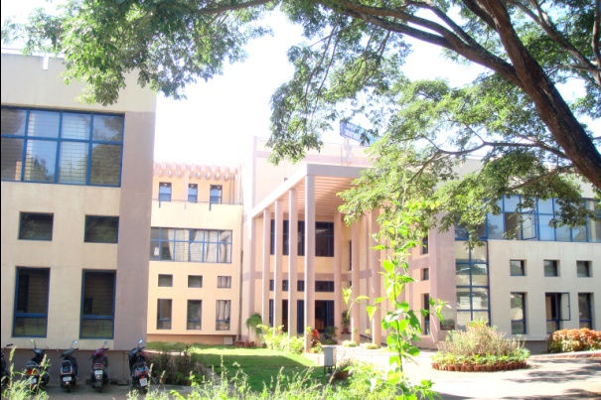**Clinical services:**

A total of **50,504 *persons*** have been registered during the year with various types of speech, hearing and language disorders. This includes **19,551 *new persons*** and **30,953 *persons*** made ***repeat visits*** for the evaluation of their problems.

A total of **7,349** and **13,157** persons were seen in speech and language OPD and audiology OPD respectively.

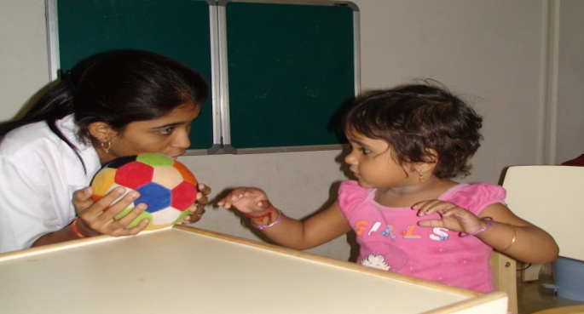A total of **7,349** persons were evaluated in detail for various speech, language problems. The needy persons were also evaluated for associated ENT and psychological problems by the faculty and staff from the respective departments.

Persons requiring further management were given various speech/language therapies for a period of 45 minutes every day. A total of **6,275** persons attended various speech and language therapy for the year April –10 to March -11.A total of **48,660** sessions which includes individual speech and language and fluency therapy sessions were given in the year April-2010 to March -11. The faculty and clinical staff provided supervision and counseling along with support and guidance to 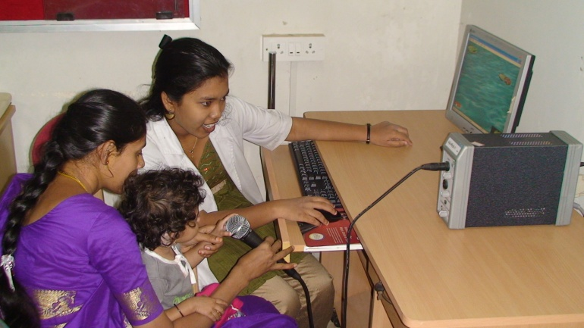parents for home training.

In addition, the persons were referred for various other therapy programs (for e.g. Physio therapy, Occupation therapy, autism therapy, etc) by the concerned supervisors.

Following tables 1-9 are depicting the statistics of persons registered in the department and other statistical details

|  |  |  |  |
| --- | --- | --- | --- |
| **Table 1:** State wise distribution of persons April 10 – March 11 | | | |
| States | Male | Female | Total Cases |
| Andra Pradesh | 108 | 40 | 148 |
| Arunachal Pradesh | 0 | 0 | 0 |
| Assam | 11 | 3 | 14 |
| Bangaladesh | 0 | 0 | 0 |
| Bihar | 11 | 3 | 14 |
| Chattisgarh | 2 | 0 | 2 |
| Delhi | 1 | 1 | 2 |
| Goa | 2 | 1 | 3 |
| Gujarat | 2 | 1 | 3 |
| Hariyana | 4 | 0 | 4 |
| Himachal Pradesh | 0 | 0 | 0 |
| Jarkhand | 3 | 2 | 5 |
| Karnataka | 11221 | 7147 | 18368 |
| Kashmir | 0 | 0 | 0 |
| Kerala | 447 | 256 | 703 |
| Madhya Pradesh | 2 | 2 | 4 |
| Maharastra | 11 | 3 | 14 |
| Malaya | 1 | 0 | 1 |
| Maldives | 8 | 3 | 11 |
| Manipur | 1 | 0 | 1 |
| Meghalaya | 1 | 0 | 1 |
| Orissa | 8 | 0 | 8 |
| Over Seas | 0 | 0 | 0 |
| Punjab | 1 | 0 | 1 |
| Rajasthan | 6 | 0 | 6 |
| Tamil Nadu | 145 | 57 | 202 |
| Tripur | 1 | 0 | 1 |
| Union Territories | 1 | 1 | 2 |
| Uttar Pradesh | 6 | 4 | 10 |
| Uttaranchal | 1 | 0 | 1 |
| West Bengal | 18 | 4 | 22 |
| Total Cases | 12023 | 7528 | 19551 |

**Figure 1:State wise distribution from April 10-March 11**

|  |  |  |  |
| --- | --- | --- | --- |
| **Table 2:** Age wise distribution from April 10 – March 11 | | | |
| Age Groups | Male | Female | Total Cases |
| 00 - 05 | 1881 | 1239 | 3120 |
| 05 - 10 | 1355 | 782 | 2137 |
| 10 - 20 | 1805 | 1189 | 2994 |
| 20 - 40 | 3077 | 2224 | 5301 |
| 40 - 60 | 2107 | 1331 | 3438 |
| 60 - 80 | 1614 | 700 | 2314 |
| 80 & Above | 184 | 63 | 247 |
| Total Cases | 12023 | 7528 | 19551 |

**Table 2: Age wise statistic of persons registered from April 10-March 11**

**Figure 2 : Age wise statistic of Persons registered April 09-March 10**

|  |  |  |  |  |  |
| --- | --- | --- | --- | --- | --- |
| **Table 3: Total Number of Persons registered at Medical records, April 10-March 11** | | | | | |
| **Months** | **New Cases** | **Repeat Cases** | **Total Cases** | **No of Working Days** | **Daily Average** |
| **April** | 1990 | 2780 | 4770 | 20 | 239 |
| **May** | 1789 | 2808 | 4597 | 20 | 230 |
| **June** | 1655 | 2977 | 4632 | 22 | 211 |
| **July** | 1740 | 2847 | 4587 | 22 | 209 |
| **August** | 1566 | 2984 | 4550 | 22 | 207 |
| **September** | 1460 | 2422 | 3882 | 21 | 185 |
| **October** | 1702 | 2358 | 4060 | 20 | 203 |
| **November** | 1589 | 2455 | 4044 | 20 | 202 |
| **December** | 1708 | 2538 | 4246 | 22 | 193 |
| **January** | 1479 | 2270 | 3749 | 19 | 197 |
| **February** | 1464 | 2242 | 3706 | 19 | 195 |
| **March** | 1409 | 2272 | 3681 | 23 | 160 |
| **Total** | **19551** | **30953** | **50504** | **250** | **202** |

Table 4: Statistics of persons seen in Speech & Audiology OPD from Apr 2010 – Mar 11

|  |  |  |  |  |  |  |  |  |  |  |  |  |  |  |
| --- | --- | --- | --- | --- | --- | --- | --- | --- | --- | --- | --- | --- | --- | --- |
| **Particulars** | | **Apr** | **May** | **June** | **July** | **Aug** | **Sep** | **Oct** | **Nov** | **Dec** | **Jan** | **Feb** | **March** | **Total** |
| Total cases registered | New | 799 | 651 | 564 | 652 | 440 | 410 | 515 | 477 | 551 | 494 | 467 | 433 | 6450 |
| Repeat | 103 | 69 | 70 | 97 | 64 | 55 | 71 | 68 | 84 | 55 | 67 | 89 |  |
| Total | 902 | 720 | 634 | 749 | 504 | 465 | 586 | 545 | 641 | 549 | 534 | 520 | 7349 |
| Speech Lang. OPD | | 902 | 720 | 634 | 749 | 504 | 465 | 586 | 545 | 641 | 549 | 534 | 520 | 7349 |
| Audiology OPD | | 1240 | 1002 | 1104 | 1097 | 1153 | 1035 | 1197 | 1112 | 1209 | 1021 | 997 | 990 | 13157 |

**Figure 3 : Statistics of persons seen in Medical records, Speech & Audio OPD from Apr 2010 – Mar 11**

|  |  |  |  |  |  |  |  |  |  |  |  |  |  |  |  |  |  |  |
| --- | --- | --- | --- | --- | --- | --- | --- | --- | --- | --- | --- | --- | --- | --- | --- | --- | --- | --- |
| **Disorders-wise distribution of diagnostic evaluation seen in OPD- Speech/ language Apr 2010 – Mar 11** | | | | | | | | | | | | | | | | | | |
| **Disorders** | **Language Disorders** | | | **Voice**  **Disorders** | | | **Fluency Disorders** | | | **Articulation Disorders** | | | **Multiple**  **Disorders** | | **Normal** | | |  |
| **Months** | **Child** | **Adult** | **Geriatric** | **Child** | **Adult** | **Geriatric** | **Child** | **Adult** | **Geriatric** | **Child** | **Adult** | **Geriatric** | **Child** | **Adult** | **Child** | **Adult** | **Geriatric** | **Total** |
| April | 505 | 5 | 4 | 25 | 34 | 19 | 69 | 27 | 3 | 69 | 11 | 0 | 19 | 1 | 26 | 25 | 2 | 844 |
| May | 373 | 3 | 2 | 21 | 31 | 16 | 55 | 22 | 2 | 67 | 16 | 4 | 21 | 2 | 21 | 11 | 2 | 669 |
| June | 359 | 3 | 3 | 11 | 36 | 9 | 39 | 18 | 1 | 22 | 5 | 3 | 27 | 4 | 3 | 16 | 2 | 561 |
| July | 429 | 4 | 2 | 19 | 29 | 10 | 33 | 17 | 1 | 21 | 5 | 2 | 27 | 3 | 11 | 19 | 3 | 635 |
| Aug | 272 | 3 | 1 | 18 | 27 | 7 | 23 | 17 | 2 | 24 | 2 | 1 | 14 | 1 | 12 | 8 | 0 | 432 |
| Sep | 300 | 6 | 3 | 7 | 28 | 8 | 22 | 18 | 0 | 19 | 6 | 1 | 19 | 3 | 11 | 12 | 2 | 465 |
| Oct | 356 | 5 | 4 | 8 | 17 | 10 | 56 | 24 | 1 | 39 | 8 | 2 | 22 | 2 | 19 | 11 | 2 | 586 |
| Nov | 334 | 4 | 2 | 31 | 37 | 8 | 29 | 13 | 0 | 19 | 6 | 2 | 19 | 1 | 8 | 15 | 2 | 530 |
| Dec | 403 | 3 | 3 | 20 | 36 | 15 | 31 | 19 | 1 | 32 | 4 | 2 | 20 | 7 | 16 | 25 | 4 | 641 |
| Jan | 343 | 3 | 1 | 16 | 34 | 6 | 23 | 16 | 1 | 20 | 7 | 5 | 9 | 1 | 14 | 23 | 0 | 522 |
| Feb | 388 | 4 | 2 | 13 | 25 | 15 | 10 | 11 | 1 | 16 | 5 | 4 | 3 | 2 | 19 | 11 | 5 | 534 |
| Mar | 353 | 3 | 2 | 5 | 27 | 10 | 21 | 23 | 1 | 29 | 8 | 3 | 0 | 0 | 17 | 16 | 3 | 521 |
| Total | **4415** | **46** | **29** | **194** | **361** | **133** | **411** | **225** | **14** | **377** | **83** | **29** | **200** | **27** | **177** | **192** | **27** | **6940** |
| Disorder wise | **4490** | | | **688** | | | **650** | | | **489** | | | **227** | | **396** | | |
| Overall total | **6940** | | | | | | | | | | | | | | | | |

**Table 5: Disorders-wise distribution of diagnostic evaluation seen in OPD- Speech/ language April 10-March 11**

**Figure 4: Disorders-wise distribution of diagnostic evaluation seen in OPD- Speech/ language Apr 2010 –March 11**

**Table 6: Statistics of Rehabilitation Services provided in the Department of Clinical Services Apr 2010– March 2011**

|  |  |  |  |  |  |  |  |  |  |  |  |  |  |  |  |  |
| --- | --- | --- | --- | --- | --- | --- | --- | --- | --- | --- | --- | --- | --- | --- | --- | --- |
| **Disorders-wise distribution of Therapy from Apr 2010 – Mar 11** | | | | | | | | | | | | | | | | |
| **Disorders** | **Language disorders** | | | **Voice**  **disorders** | | | **Fluency disorders** | | | **Articulation disorders** | | | **MULTIPLE** | | | **Total** |
| **Months** | **Child** | **Adult** | **Geriatric** | **Child** | **Adult** | **Geriatric** | **Child** | **Adult** | **Geriatric** | **Child** | **Adult** | **Geriatric** | **Child** | **Adult** | **Geriatric** |  |
| April | 403 | 12 | 2 | 9 | 0 | 0 | 5 | 15 | 0 | 8 | 0 | 0 | 35 | 1 | 0 | **490** |
| May | 474 | 46 | 7 | 10 | 15 | 9 | 2 | 3 | 0 | 3 | 16 | 4 | 20 | 2 | 0 | **611** |
| June | 704 | 55 | 3 | 5 | 1 | 1 | 12 | 0 | 0 | 39 | 3 | 0 | 93 | 6 | 0 | **922** |
| July | 418 | 12 | 1 | 15 | 0 | 0 | 14 | 10 | 0 | 8 | 0 | 0 | 33 | 0 | 0 | **511** |
| Aug | 343 | 80 | 9 | 0 | 17 | 6 | 27 | 16 | 0 | 62 | 9 | 0 | 156 | 36 | 12 | **773** |
| Sep | 288 | 11 | 3 | 0 | 3 | 2 | 6 | 14 | 0 | 7 | 0 | 0 | 70 | 1 | 0 | **405** |
| Oct | 331 | 14 | 4 | 4 | 5 | 1 | 23 | 20 | 0 | 14 | 1 | 0 | 102 | 3 | 0 | **522** |
| Nov | 312 | 14 | 6 | 0 | 6 | 2 | 10 | 6 | 0 | 7 | 2 | 0 | 69 | 2 | 0 | **436** |
| Dec | 246 | 12 | 5 | 2 | 5 | 6 | 4 | 4 | 0 | 10 | 1 | 0 | 70 | 0 | 0 | **365** |
| Jan | 270 | 12 | 4 | 2 | 5 | 5 | 3 | 2 | 1 | 8 | 4 | 1 | 73 | 1 | 0 | **391** |
| Feb | 304 | 11 | 4 | 1 | 6 | 2 | 12 | 11 | 0 | 8 | 2 | 1 | 72 | 2 | 0 | **436** |
| Mar | 294 | 10 | 9 | 1 | 6 | 1 | 11 | 15 | 0 | 9 | 4 | 0 | 62 | 2 | 0 | **424** |
| Total | **4387** | **289** | **57** | **49** | **69** | **35** | **129** | **116** | **1** | **183** | **42** | **6** | **855** | **56** | **12** | **6286** |
| Disorder wise | **4733** | | | **153** | | | **246** | | | **231** | | | **923** | | |
| Over all | **6286** | | | | | | | | | | | | | | |

**Figure 5: Disorders-wise distribution of therapy from Apr 2010 –March 11**

**Table 7: Clinical Services in the Fluency Unit from April 2010 - March11**

|  |  |  |  |  |  |  |  |  |  |  |  |  |  |
| --- | --- | --- | --- | --- | --- | --- | --- | --- | --- | --- | --- | --- | --- |
| **Particulars** | **Apr** | **May** | **June** | **July** | **Aug** | **Sep** | **Oct** | **Nov** | **Dec** | **Jan** | **Feb** | **Mar** | **Total** |
| **No.of** persons | 107 | 94 | 12 | 29 | 43 | 33 | 72 | 31 | 44 | 35 | 27 | 44 | 571 |
| **No.of session** | 509 | 526 | 27 | 194 | 450 | 218 | 390 | 315 | 283 | 208 | 186 | 315 |  |

**Figure 6: Fluency Unit clients seen from April 2010-March 2011.**

**Specialized clinical services:**

Allied professionals such as Pediatrician, Neurologist, Plastic surgeon, Prosthodontist, Orthodontist, Phonosurgeon, physiotherapist and occupational therapists provide consultancy services for better patient care and management. The detailed statistics regarding the specialized clinical services provided during the months April 2010-March 2011 are given in Table: 8

**Table 8:** persons **seen in specialized clinical services and consultant specialists**

**April 10 - March 11**

|  |  |  |  |  |  |  |  |  |  |  |  |  |  |  |
| --- | --- | --- | --- | --- | --- | --- | --- | --- | --- | --- | --- | --- | --- | --- |
|  | | **Apr** | **May** | **June** | **July** | **Aug** | **Sep** | **Oct** | **Nov** | **Dec** | **Jan** | **Feb** | **March** | **Total** |
| PT | Cases | 57 | 52 | 82 | 88 | 91 | 90 | 104 | 109 | 135 | 108 | 105 | 127 | 1148 |
| Session | 298 | 357 | 639 | 870 | 774 | 770 | 571 | 880 | 1157 | 827 | 876 | 986 | 9005 |
| OT | Cases | 74 | 72 | 71 | 90 | 89 | 86 | 88 | 100 | 108 | 129 | 124 | 131 | 1162 |
| Session | 365 | 444 | 440 | 576 | 577 | 592 | 480 | 638 | 795 | 719 | 794 | 924 | 7344 |
| Neurologist | | 50 | 35 | 44 | 42 | 39 | 42 | 44 | 42 | 39 | 49 | 53 | 60 | 539 |
| Pediatrician | | 26 | 26 | 27 | 30 | 26 | 24 | 20 | 23 | 35 | 33 | 31 | 47 | 348 |
| Phonosurgeon | | 0 | 3 | 9 | 5 | 5 | 6 | 7 | 6 | 17 | 4 | 2 | 3 | 67 |
| Plastic surgeon | | 0 | 11 | 21 | 9 | 5 | 9 | 10 | 34 | 13 | 15 | 7 | 15 | 149 |
| Prosthodontist | | 10 | 9 | 5 | 5 | 5 | 4 | 12 | 2 | 3 | 5 | 8 | 3 | 71 |
| Orthodontist | | 0 | 0 | 0 | 0 | 5 | 4 | 5 | 28 | 3 | 8 | 7 | 3 | 63 |

**Figure 7: Persons seen in specialized clinical services and consultant specialists**

**April 10 - March 11**

**Figure 8:** **Persons seen in PT/OT from April 10-March 11**

**Table 9: Details regarding persons attending Therapy from April 10- March 11**

|  |  |  |  |  |  |  |  |  |  |  |  |  |  |
| --- | --- | --- | --- | --- | --- | --- | --- | --- | --- | --- | --- | --- | --- |
| **Particulars** | **Apr** | **May** | **June** | **July** | **Aug** | **Sep** | **Oct** | **Nov** | **Dec** | **Jan** | **Feb** | **Mar** | **Total** |
| No. of Cases | 490 | 611 | 922 | 511 | 773 | 405 | 522 | 436 | 365 | 391 | 436 | 424 |  |
| Therapy New Cases | | | | | | | | | | | | | 2140 |
| Therapy Repeat Cases | | | | | | | | | | | | | 4146 |
| No. of Sessions | 3656 | 3080 | 11064 | 2850 | 3084 | 6300 | 3015 | 2280 | 2110 | 2000 | 2700 | 2900 | 45039 |
| Demo therapy Cases | 24 | 8 | 40 | 45 | 33 | 52 | 65 | 40 | 45 | 39 | 36 | 48 | 475 |
| Cases discharged | 36 | 10 | 16 | 20 | 12 | 12 | 10 | 26 | 31 | 18 | 8 | 9 | 208 |
| No. of Hindi Cases | 19 | 15 | 16 | 35 | 45 | 11 | 15 | 11 | 21 | 15 | 10 | 12 | 225 |
| Gp parent Counseling | 2 | 2 | 2 | 2 | 2 | 2 | 2 | 2 | 2 | 2 | 2 | 2 | 24 |
| Correspond. (email/ FU) | 5 | 0 | 12 | 9 | 12 | 60 | 39 | 16 | 65 | 119 | 26 | 9 | 372 |
| Certificates Issued | 23 | 0 | 15 | 12 | 19 | 6 | 13 | 11 | 19 | 21 | 6 | 17 | 162 |
| Case report Issued | 80 | 0 | 0 | 60 | 51 | 58 | 42 | 44 | 71 | 25 | 27 | 70 | 528 |

**REPORTS AND CERTIFICATE ISSUED**

|  |  |  |
| --- | --- | --- |
| S.No | Particulars | Total |
| 1 | Transfer certificate | **21** |
| 2 | Case reports | **528** |
| 3 | Attendance certificates | **32** |
| 4 | School admission certificate/  Language exemption certificate | **109** |
| 5 | Correspondence by e-mail/letter/FU | **372** |

**New unit inauguration**

Fluency unit was inaugurated in department of clinical services to provide specialized services to the individuals with fluency disorders.

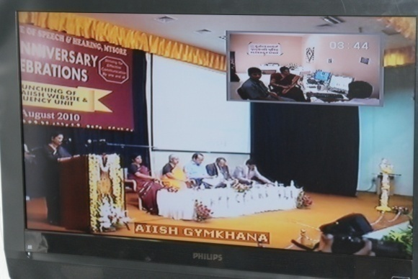 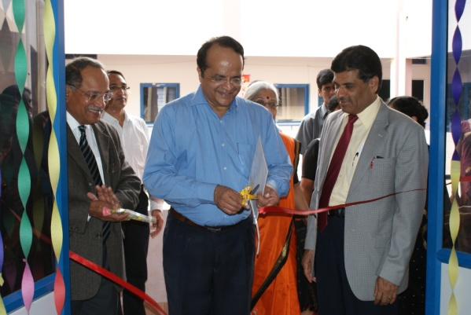

Fluency unit was inaugurated on 9th August 2010 by Prof. V. N. Rajasekharan Pillai, [Dr.S.Ramananda Shetty](http://www.rguhs.ac.in/resumes/vcbiodata.doc) & **Prof.K.S.Rangappa** in Department of Clinical Services

**Extra Curricular Activities:**

Others:

#### Department of Clinical Services Celebrated International Stuttering Awareness Day on 29.10.10

**Report on ‘International Stuttering Awareness Day’**

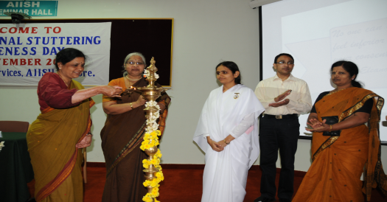International Stuttering Awareness Day was celebrated on 22nd November 2010 organized by Dept of Clinical services. Around one hundred and fifty participants attended the program. The participants included D.Ed trainees from two different colleges, Somani D.Ed College, DIET, Mysore as well as children and adults with stuttering who have availed clinical services at AIISH. The program commenced at 10 A.M. and extended till 2.00 P.M. The welcome address was given by Dr. S.P.Goswami, HOD Clinical Services. The program was inaugurated by Brahma Kumari vani, Brahma Kumari Vishwa Vidyalaya, Srirampura, Mysore. She highlighted the importance of meditation and positive thoughts for a successful career. She also highlighted the importance of orientation programs on communication disorders for teachers and specifically role of teachers in identification of such disorders. Dr S R Savithri, Coordinator of Fluency unit gave a brief overview on stuttering and its awareness. Dr. Vijayalakshmi Basavaraj, Director, AIISH, in her presidential address also stressed the need for more awareness among the teachers on stuttering which will help in developing positive attitude in them. This was then followed by vote of thanks by Mrs. Sangeetha Mahesh.

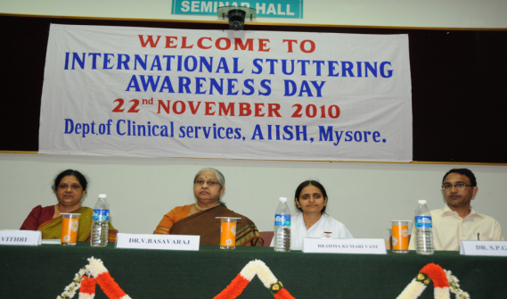The orientation program was conducted on Introduction to Fluency, Stuttering, Characteristic features, Causes, Myths & facts and Role of teachers in the management of Stuttering. The presentations included more on audio and visual samples. Resource persons for the program included Dr. S.R. Savithri, Dr Y.V. Geetha, Mrs. Sangeetha Mahesh, Ms Priya M B, Ms Geetha, Ms Chaitra and Ms Archana. The program concluded with an interactive session with the participants. Representatives from each college gave positive feedback and were happy to participate in the program. Certificates were distributed to the participants in the end.

#### Department of Clinical Services organized Seminar on "Keeping the promise: Mainstreaming disability in the Millennium Development Goals towards 2015 and beyond" on 03.12.10

#### C:\Users\clic3\Desktop\ISAD 2010\New folder\DSC_5767.jpg

#### Department of Clinical Services & Special Education organized “International Day for person with Disability” on 03.12.10

**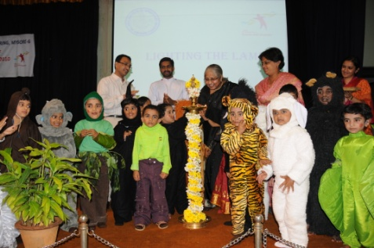**

4. Open day celebration Exhibition was organized in the Department of Clinical Services.

**EQUIPMENTS & FURNITURE PURCHASED:**

|  |  |  |
| --- | --- | --- |
| **Test Material** | | |
| Dyslexia adult screening Test | | 1 No. |
| Test of word knowledge | | 1 No. |
| DST -J | | 1 No. |
| Automated working memory Assessment | | 1 No. |
| Children’s test of non word repetition | | 1 No. |
| Cognitive linguistic quick test | | 1No. |
| Graded non word reading test | | 1 No. |
| Working memory rating scale | | 1 No. |
| CARS | | 1 No. |
| Test of everyday attention for children | | 1 No. |
| Phonological abilities test | | 1 No. |
| DST-S | | 1 No. |
| DEST-2 | | 1 No. |
| **TOTAL** | | **13 Nos.** |
| **Equipments** | | |
| Traction Unit- TM 300 | 1 No | |
| Digi Flex | 5 No’s | |
| Digi extend Finger Exerciser | 3 No’s | |
| Thera Band Progressive Hand trainer | 1 No’s | |
| Trampoline Small | 1 No’s | |
| Trampoline Big | 1 No’s | |
| Telephone with Caller Id | 2 No’s | |
| UNISTIM | 1 No’s | |
| Ahuja SSB 60m Amplifier | 1 No’s | |
| 2ft Column Speakers | 2 No’s | |
| Lamination Machine | 2 No’s | |
| smart Cleaning Systems | 2 No’s | |
| Moist Heat Therapy Unit for PT-OT | 1 No’s | |
| Pierre hand Evaluation set for PT-OT | 1 No’s | |
| Richo Colour Xerox Machine | 1 No’s | |
| HP computer | 5 No’s | |
| HP office jet 4500 printer | 2 No’s | |
| Sony Handy cam | 2 No’s | |
| HP Laser Jet P2055DN | 4 No’s | |
| Q Manager Stainless | 15 No’s | |
| Nasometre | 1 No’s | |
| RMS Helios 401 | 1 No’s | |
| Video voice software speech therapy software | 1 No’s | |
| Foldable Display Boards with spot lights | 10 No’s | |
| Q manger Stainless steel spots | 10 No’s | |
| HP LaserJet 2055dn Printer | 2 No’s | |
| UPS | 10 No’s | |
| EGG - Keypentax | 1 No’s | |
| Executive chairs | 15 Nos | |
| Shore Lapel wireless Micro Phone | 1 No | |
| Aqua guard | 2 Nos | |
| Executive chair with arm | 10 No’s | |
| Baby pram | 2 No’s | |
| Wireless Microphone | 1 No | |
| Plasma TV 50 inch (Model No.TH-50 PV 70HA Sl.No YS8 240035) **(Equipment Shifted)** | 1 Nos. | |
| Philips TV type No.21 PT3443/94R with Sl.No. 003363 **(Equipment Shifted)** | 1 Nos. | |
| Satellite receiver -Sharp vision with remote **(Equipment Shifted)** | 1 Nos. | |
| Dish antenna with LNB receiver | 1 Nos. | |
| **Total Number of equipments procured** | **124 No’s.** | |
| **Furniture’s** | | |
| Steel Open Racks | | 10 Nos. |
| Steel cupboard | | 5 No |
| **TOTAL** | | **15 No’s** |
| **Play Materials** | | |
| Okay play Materials | | 3 Nos |
| Mini Conference | | 2 No’s |
| Senior council | | 7 No’s |
| Party time | | 2 No’s |
| See saw (2030) | | 2 Nos. |
| Play Pool (5010) | | 2 Nos. |
| My Pet Ride on (2090) | | 2 Nos. |
| Humpty Dumpty (2070) | | 2 Nos. |
| Street Hawk (2080) | | 3 Nos. |
| Falcon (2140) | | 3 Nos. |
| Super slide senior | | 1 Nos. |
| Twirly Climber (10200) | | 2 Nos. |
| Adventure made safer Model No. 28 (OPE) | | 1 Nos. |
| Adventure made safer low cost model - (LC-OPE6) | | 1 Nos. |
| Roxy 2-IN-1 (2160) | | 4 Nos. |
| Fun station Model No.3 | | 1 Nos. |
| Fun station Model No.10 | | 1 Nos. |
| 3 way rocker (2010) | | 4 Nos. |
| **TOTAL** | | **43 No’s** |

**VISITORS:**

1. 40 students from Nursing School K.R.Hospital Mysore on 09.11.10.
2. 6 Special Educators from Cara Society male Maldives on 18.11.10.
3. 22 students and 3 faculty Tarahbalu Educational Institute, T.K.Layout Mysore.
4. Sarva Shiksha Abhyan District Program Officers.
5. Block Program officers Resource Teachers from Calicu, Kerala.
6. 19 students and 1 faculty B.S.W Students from St.Aloysius Collage, Managalore.
7. Ms.Harsha Jayasankar student from university school of Design, University of Mysore.
8. Anganwadi workers from KIRIYAPUSHPA 35 visitors visited from Mysore.
9. Orientation program to 45 B.Ed from little flower convent students from Chennai.
10. 33 nursing students and 1 staff from JSS Hospital, Mysore on 13.07.10 about the departments and activities of Clinical Services.
11. 2 batches of PG students from Coorg Institute of Dental Sciences, Virajpet on 6.07.10 and 26.07.10 respectively.

**Superannuated staff:**

1. Mr. C. D. Shanbal - Assitant Medical Records Officer superannuated on 30th June, 2010
2. Mr. Papanna - Mali superannuated on 31st January, 2011

Regular Staff:

1. Mrs. Prathima - IST reported in August, 2010.
2. Mrs. Priya M.B. Speech Language Pathologist Grade-II reported in August, 2010.
3. Ms.Geetha- Speech Language Pathologist Grade-I reported in August 2010.
4. Ms.Ramya- Speech Language Pathologist Grade-II reported in August, 2010.
5. Prashanth. R - Medical Social Worker – reported on 24th January, 2011.

**Contract Staff:**

1. Ms.Priya Shree- Speech Language Pathologist Grade-I
2. Ms.Sharon Susan Sam- Speech Language Pathologist Grade-I
3. Ms. Shwetha.C- Clinical Supervisor
4. Melissa Monteiro SLP Grade-I reported on 07.03.11
5. Ms. Sinthre Smita Shekar Physiotherapist Staff reported on 14.10.10
6. Ms. Nancy A.G Occupational therapist Staff reported on 11.10.10.
7. Ms. Neha Thakur - Physiotherapist reported on 18th April 26, 2010.

ARF Project Staff:

1. Ms. Ranjini Mohan- Speech Language Pathologist Grade-I - D.O.J - August 2010
2. Ms. Laxmi S. Mohan - Speech Language Pathologist Grade-I - August 2010
3. Ms. Bhuvaneshwari - Speech Language Pathologist Grade-I - August 2010
4. Mr. Honey. P - Speech Language Pathologist Grade-Iin October, 2010
5. Ms. Chaitra S. Speech Language Pathologist Grade-I on September, 2010

Resigned:

1. Mr.Amith Kishore resigned on 31.3.2011.
2. Ms.Priya Shree resigned on January 2011.
3. Mr. Karthikeyen B.M- Grade I SLP resigned on 20.07.10