**ALL INDIA INSTITUTE OF SPEECH AND HEARING, MYSORE: 570 006**

**DEPARTMENT OF CLINICAL PSYCHOLOGY**

SH/CLI.PSY/AR2010-11 4.05.2011

Submitted to the Director,

Sub: Annual report for the Year 2010-11. – Reg.

Ref: Circular No. SH/Lib/AR/2010-11 dt. 11.04.11

I am here with submitting the contents to be considered for inclusion in the Annual Report for the year 2010-2011 according to the revised format for your kind perusal. Further, a CD with few action photos and the soft copy of the annual report is handed over to Library for the needful.

HOD-CLINICAL PSYCHOLOGY

**DEPARTMENT OF CLINICAL PSYCHOLOGY**

**ANNUAL REPORT 2010-11**

**(01.04.2010 to 31.03.11)**

1. **ACADEMIC ACTIVITIES**
2. **Long Term Academic Programs/Courses (Include all the Programs:** UG/PG/Diploma/PhD
3. **Ongoing Programs**

The Department of Clinical Psychology is primarily concerned with psychosocial aspects of communication disorders either from the standpoint of research, training and/or clinical practice. The theoretical and practical training of B.Sc. and M.Sc. Speech and Hearing, M.S.Ed., D.H.L.S., D.T.Y.DH.H students in the area of clinical psychology was carried out as per course curriculum and their training schedule. The students posted to the Department were trained in case history taking, testing and counseling under supervision of departmental staff.

1. **New Academic programs**

Not applicable

1. **Stipend/Fellowship**

Not applicable

1. **Other Financial Assistance**

Not applicable

1. **Short-term Training Programs**

**Name of the faculty/staff: Dr.S.Venkatesan, Dr.G.Jayarama, Ms.Amrita Kanchan & Mrs.U.Pratibha**

|  |  |  |  |  |
| --- | --- | --- | --- | --- |
| Sl. No. | Date | Title of the program | Target Group | Venue/Organizer |
| 1. | 19-23.04.2010 | 5th contact Program for parents under Certificate Course for Caregivers of Children with Developmental Disabilities (C4D2) | 15 parents | AIISH, Mysore |
| **Name of the faculty: Dr.S.Venkatesan, Dr.G.Jayarama &Mr.Freddy Antony** | | | | |
| 1. | 31.05.2010- 11.06.2010 | 12th contact program on ‘Sensitization on Academic problems in school Children for Teachers in Karnataka’ | 34 IERTs | AIISH, Mysore |
| 2. | 12-23.07.2010 | 13th contact program on ‘Sensitization on Academic problems in school Children for Teachers in Karnataka’ | 29 IERTs | AIISH, Mysore |
| 3. | 16-27.08.2010 | 14th contact program on ‘Sensitization on Academic problems in school Children for Teachers in Karnataka’ | 32 IERTs | AIISH, Mysore |
| 4. | 8-19.11.2010 | 15th contact program on ‘Sensitization on Academic problems in school Children for Teachers in Karnataka’ | 38 IERTs | AIISH, Mysore |

1. **In-house Training Programs**

**Dr. S. Venkatesan**

## Workshop on Pedagogic Practices in AIISH for PG/UG courses, 50 faculty Members on 17.11.2010 at AIISH

**Mr. Freddy Antony**

* Resource Person for workshop “Management of children with Multiple Disabilities in Inclusive and Special Setups” organized by the Department of Special Education at AIISH on 16.03.2011.Topic – Identification of Special Needs
* Talk on “Dept. of clinical Psychology: an Overview” for the target group of SSA Kollam, Kerala on 29.03.2011.

1. **Seminars/Conferences/workshops Conducted**

Not applicable

1. **Academic programs and Meetings Attended by Faculty and Staff (Other than Seminars and Conferences**)

**Dr. S. Venkatesan**

1. Served as External Examiner for Evaluation of M. Phil. Medical & Social Psychology for 11 students at the Department of Clinical Psychology, Sweekaar Rehabilitation Institute for Handicapped, Secunderabad: AP, affiliated to Osmania University, Hyderabad, between 2-4th July, 2010

2. Served as External Examiner for Evaluation of Ph.D. Thesis submitted by Sri V Surendran vide the topic titled ‘A study of Cognitive functioning in children with acute Lymphoblastic Leukemia pre and post medical oncological treatment’ submitted at the Department of Psychology, University of Madras, Chennai, in 3rd September, 2010.

3. Served as External Examiner for Evaluation of M.Sc. Clinical Psychology for 15 students at the Department of Clinical Psychology, Kuvempu University, Shimoga, in January, 2011.

1. **Visits abroad**

Not applicable

1. **Details of Guest Faculty Visited the Institute and Lecture Delivered**

The Department organized a **guest lecture** on “**Professional Identity of Clinical Psychologist in India: where are we- An Introspection”** by **Dr. Sivaratnamma L Vaya,** Director, Institute of Behavior Sciences and Directorate of Forensic Sciences, Gandhi Nagar, Gujarat.

1. **Details of guest lectures delivered by Faculty and Staff outside the Institute**

## Dr. S. Venkatesan

1. Participated as Expert Member in First Regional Parents Meet hosted by Mysore District Patents Association for Empowering Developmentally Disabled and sponsored by NIMH, Secunderabad for 150 parents on 3rd to 4th July 2010 at JSS Polytechnic for the Differently Abled Persons, Mysore.
2. Interactive Meet for Discussion on FAQs while parenting toddlers and preschool aged children, 100 parents on 20.11.2010 at Mitra Jyothi Montessori School, Kagadaspura, Bangalore.
3. Invited Lecture on ‘Learning Disability: The Continuing Challenge’ National Seminar on Learning Disability; Approaches, Challenger and Provisions on 29-30.11.2010 at Department of Social Sciences, Lady Doak College, Madurai
4. Invited as Key Note Speaker at Ramakrishna Mission Vivekananda University, Kovai forNational Seminar on Mental Retardation: Inclusive Education for Children with Mental Retardation- An Introspection on 25-27.2.2011
5. Orientation Program on ‘Substance Abuse’ for 120 High School Students of DMS RIE, Mysore on 16.02.2011.
6. Basics of Child Development, Child Psychology & Assessment; learning Disability for 120 students of I & II Year PG Diploma in Mental Health & Counseling at Manasa Education Foundation under Kuvempu University, Shimoga held at Shimoga.
7. Served as Chief Guest and Key Note Speaker in the Seminar on “Positive Psychology-A Road to Well-Being’ organized by Department of Psychology, SBRRR Mahajana First Grade College, Mysore, on 21st March, 2011.
8. **Additional Academic Responsibilities of the Faculty and Staff**

**Dr. S. Venkatesan**

* Advisor for GOI Project under MSJE, Member in project Advisory Committee. Expert Review of ‘Simple tool for Intellectual Assessment’ being developed and standardized by NIMH, Secunderabad on February 2911.
* Nominated as Coordinator to monitor implementation of provisions of UN Convention for Rights of Persons with Disability (UNCRPD) w.e.f. June, 2010
* Coordinator for AIISH-SSA project.
* Coordinator, Certificate Course for caregivers of children with Developmental Disabilities (C4D2).
* Member Secretary –AIISH Ethics Committee
* Nominated as Expert Member, Board of Editors, Journal of Disability Management and Special Education, Ramakrishna Mission Vivekananda University from January 2011.

**Dr. G. Jayarama**

* DHLS Ajmer Centre Coordinator
  + Coordinator - Monthly public lecture series program.

## Mr. Freddy Antony

* Coordinator, DHLS, RIMS Imphal Centre.

Mrs. U. Pratibha

* In-charge of Practicum for DTYDHH.

**Mr. Sanjeev K Gupta**

* In-charge of Practicum for DTYDHH.

1. **RESEARCH ACTIVITIES**
2. **Research Projects**
3. Project with Extramural Funding

|  |  |
| --- | --- |
| Title of the Project | Sensitizing Teachers on Academic Problems in School children in Karnataka |
| Principal Investigator | Dr. S. Venkatesan |
| Project Staff | P.M.Krupakshari(Project Assistant) Sowmya (Steno) |
| Funding Agency | SSA |
| Fund | Rs.14 Lakhs |
| Status | First Phase Completed |
| **Summary:** AIISH Mysore and SSA Karnataka, joined hands to address academic problem in primary school children, by organising “Sensitivity training” to about 1000 IERTs. A dedicated team of resource persons covered various topics related to academic problem, their assessment and remediation through lectures, case history taking, group discussion, individual case presentation etc. Each 12 day program covered 40 participants, every month through 15 batches completed during 2010-11. The program included a course manual in English/Kannada along with in built schemes to evaluate them, the resource persons, participants and program implementation. It is expected that a 2nd phase of this program will be initiated shortly. | |

|  |  |
| --- | --- |
| Title of the Project | “Impact Evaluation of Training Courses in Rehabilitation and Special Education under Rehabilitation Council of India”. |
| Principal Investigator | Dr. Vijayalakshmi Basavaraj and Dr. S. Venkatesan |
| Project Staff | Vasudha K.G. |
| Funding Agency | RCI, Ministry of Social justice & Empowerment, Government of India. |
| Fund | Rs. 2.22 Lakhs |
| Status | Ongoing |
| **Summary:** This study followed a cross sectional group comparison design where by important parameters were evaluated such as:   1. Teacher-Pupil Evaluation 2. Process and Outcome Evaluation 3. Temporal or Time Based Evaluation like Baseline, Mid-term and Terminal Evaluation 4. Content Evaluation and 5. Utility Evaluation   Field visits and data collection is completed and data analysis is ongoing. | |

1. **Project with ARF Funds**

|  |  |
| --- | --- |
| Title of the Project | “Development and Standardization of Autism Behavior Check list for Disability Estimation” (A2E) |
| Principal Investigator | Dr. S. Venkatesan |
| Project Staff | Shilpa. P.Augustine |
| Fund | Rs.4.85Lakhs |
| Status | Ongoing |
| **Summary:** It is the aim of this project, to identify a specific set of behavioral features that characterize most of the children diagnosed as autism or related conditions; to develop a comprehensive checklist to enable their diagnosis and certification. Data collection for pilot study, pilot data collected from 26 cases of children with communication disorders by method of observation, interviewing parents, use of checklist is in progress. A departmental presentation and review about project was done. | |

|  |  |  |
| --- | --- | --- |
| Title of the Project | Process evaluation of DHLS Program conducted through Actual vis-à-vis Virtual Modes | |
| Principal Investigators | Dr. Vijayalakshmi Basavaraj and Dr. S. Venkatesan |
| Project staff | Mr.Mohammad Rafi |
| Fund | Rs.8.52 lakhs |
| Status | Ongoing |
| **Summary:** this project is in its 3rd phase of extension during this reporting year. As before, the project continues to attempt a process evaluation of the ongoing DHLS program being conducted through actual vis-à-vis virtual mode of instruction at 11 centers and another 10 regular centers across the country. A new dimension added to this project during this reporting year was gathering feedback on demand analysis, details of infrastructure, job attrition and job evaluation etc. Data collection for the ongoing year is completed and analysis is going on. | |

|  |  |
| --- | --- |
| Title of the Project | Enabling and empowering siblings of children with communication disorders |
| Principal Investigator | Dr. S. Venkatesan |
| Project Staff | Ms. Nimisha Raveendran |
| Fund | Rs.3.19 Lakhs |
| Status | Ongoing |
| **Summary:** This project aims to study the psychosocial correlates of siblings of children with disabilities by using standardized assessment measures and to carryout community initiatives that can help enlighten, enable, encourage and empower siblings as much as their parents or the actual children with handicaps. In the initial stages of project, data has been collected from the normal siblings of disabled children by using semi-structured interview, open ended questions to find out their knowledge, opinion, attitude etc., towards the affected child. It also helps to explore the physical, emotional, social and financial impact on healthy siblings. Another aim of this project is to organize short term sensitivity training program for identified group of healthy siblings from families caring for a person with disability. | |

|  |  |
| --- | --- |
| Title of the Project | “Impact evaluation of government benefits and concession provided to persons with mental retardation belonging to Mysore district” |
| Principal Investigator | Dr. G. Jayaram |
| Co-Investigator | Dr. Kalyan Kumar, Mr. Raju Mr. Purushotham, and Mr. Prathap Kumar |
| Fund | 3.20 lakhs |
| Status | Ongoing |
| **Summary:** This project aims to undertake an impact evaluation of Monthly Pension Scheme introduced by Govt. of Karnataka for the individuals with mental retardation belonging to Mysore District and to develop appropriate model to enable such evaluations from time to time for such programs in other districts and across the country where scheme is being implemented. The project also aims to study the attitudes of public and functionaries about the implementation of this program in the society. The following tools are finalized for the project:   * Socio-demographic data sheet * Attitude scale towards the benefits and concessions scheme provided to individuals with mental retardation (ASBCS) * Impact evaluation scheme/ format- almost finalised   With regard to carrying out the project, a letter to DC-Mysore District seeking the permission to carry out the program has been finalized and address of all the beneficiaries are short listed (being used during the survey). | |

1. **Other Research Projects**

Not applicable

1. **Research Papers presented at national/International Conference/Seminar/Scientific Forums**

**Dr. S. Venkatesan**

1. Paper presented on ‘Counseling Issues’ at National Seminar on Multi-disciplinary Approaches to Disability Management in Faculty of Disability Management and Special Education, Ramakrishna Mission Vivekananda University, Kovai, TN on 18-20.6.2010
2. Invite Lecture on ‘Learning Disability: the continuing Challenge’ at National Seminar on Learning disability; Approaches, Challenges and Provisions in the department of Social Sciences, Lady Doak College, Madurai on 29-30.11.2010.
3. **Research papers Published**

**Dr. S. Venkatesan**

**International**

1. Venkatesan, S. (2010). Case Study on Cost Benefit Analysis for Government Sponsored Pension Scheme for Persons with Mental Retardation. Asian Journal of Developmental Matters .4.1.176-188

**Dr. S. Venkatesan**

**National**

1. Khoshali, A.K., and Venkatesan, S. (2010). Development of Play Activity Checklist for Children with Mental Retardation. Indian Journal of Clinical Psychology. 37. 2. 101-107.
2. Venkatesan, S., and Ravindranath, A. (2011). Depression in Institutionalized and Non-institutionalized Elderly. Journal of Indian Academy of Applied Psychology. 37. 1. 53-59.
3. Sudarshan, H.M., and Venkatesan, S. (2010). Marital Adjustment in Rural Women Identified With HIV/AIDS and Undergoing Anti Retro Viral Drug Therapy. Asian Journal of Developmental Matters. 4.2.51-60.
4. Venkatesan, S. (2010). Cultural Factors in Clinical Assessment: The Indian Perspective. Indian Journal of Clinical Psychology. 37.1.75-85.
5. Karimi, A., and Venkatesan, S. (2010). Psychometric Properties and Norm differences in Mathematics Anxiety Scale for High School Students in India. Asian Journal of Developmental Matters. 4. (1). 130-136.
6. Venkatesan, S., and Purusotham, P. (2010). Validation of Item Pool on Number Competencies in Preschool and Primary School Children. Disabilities & Impairments. 24.1. 5-12.
7. Govindaraju, R., and Venkatesan, S. (2010). Knowledge and Awareness in Teachers about Government Programs to combat School Drop outs. Journal of Indian Academy of Applied Psychology. 36. 2. 300-306.
8. Sudarshan, H.M., and Venkatesan, S. (2010). Knowledge and Opinion Preferences on HIV/AIDS in Affected Rural Women undergoing Anti Retro Viral Drug Therapy. Asian Journal of Developmental Matters. (Accepted for publication)
9. Venkatesan, S., Pushpavathi, M., and Purusotham, P. (2010). Adjustment Patterns in Voice Disorders. Journal of Indian Association of Speech and Hearing. 25.1.21-30.
10. Venkatesan, S., and Ravindran, N. (2010). Attitudes in Non-disabled Siblings of Children with Developmental Disabilities. Journal of Disability Management and Special Education. Sent for publication in December, 2010.
11. Venkatesan, S., Basavaraj, V., Vasanthalakshmi, M.S., and Purusotham, P. (2010). Pilot Study on Process Evaluation of DHLS Program Conducted through Real vis-à-vis Virtual Modes: 2007-08’. Journal of All India Institute of Speech and Hearing. 29, 2, 283-292.
12. Venkatesan, S. (2010). Blame Game Triangulation between Parents, Teachers and Children with Academic Problems. Psychological Studies. (Accepted for publication in January, 2011).
13. Venkatesan, S. (2010). Redefining psychological assessment for contemporary PG clinical training programs in psychiatry across India. Indian Journal of Psychiatry. (Sent for publication in January, 2011).
14. Venkatesan, S. (2010). Indian Scales and Inventories: Revisiting Clinimetry through IJP. Indian Journal of Psychiatry. 52. Supplement. S54-61.
15. Venkatesan, S. (2010).Book Review: Portage guide to early childhood education.CBR Network (South Asia).29.1.128-130.

**Mr. P. Purushotham**

1. Venkatesan, S., Pushpavathi, M., and Purusotham, P. (2010). Adjustment Patterns in Voice Disorders. Journal of Indian Association of Speech and Hearing. 25.1.21-30.
2. Venkatesan, S., Basavaraj, V., Vasanthalakshmi, M.S., and Purusotham, P. (2010). Pilot Study on Process Evaluation of DHLS Program Conducted through Real vis-à-vis Virtual Modes: 2007-08’. Journal of All India Institute of Speech and Hearing. 29, 2, 283-292.

**Ms. Amrita Kanchan**

1. Khan, N.A.; Kanchan, A.; Singh, A: Senger, K.S, & Nag; AK (2010) ‘A Comparative Study of Neuro-Cognitive Impairment in Elderly Patients with Schizophrenia and Elderly Normals’. Eastern Journal of Psychiatry, pp60-63

2. Khan, N.A.; Kanchan, A.; Jahan, M. & Singh, A.R. (Jan 2011). **‘**Human Figure Drawings of Normal Indian Adults’. *SIS Journal of Projective Psychology and Mental Health*; Volume 18; No. 1; 50-61.

**Mr. Sanjeev K Gupta**

1. Prakash R., Dubey I., Abhishek P., Gupta S.K., Rastogi P and Siddque S.V (2010) “Long-term Vihangam Yoga Meditation and Scores on Tests of Attention” Perceptual and Motor Skills, 2010, 110,3,1-10 (Co-author)

**Technical Literature**

**Dr. S.Venkatesan**

1. Prepared ‘TERMS OF REFERENCE’ for Mid Term Evaluation of the ongoing DHLS Training under the directive of Dr. DM Thorat, ADG, Directorate General of Health Services, Nirman Bhavan, New Delhi, in October, 2010, as per their communication L722/Addl/DDG(G); Dated 28th September, 2010.
2. Prepared course structure and curriculum for the following three elective/ course/open elective/self study elective viz., (i) Clinical Counseling; (ii) Clinical Neuropsychology; and (iii) Clinical Behavior Analysis under CBCS Scheme for conversion of the ongoing two PG courses in Audiology and Speech Language Pathology under University of Mysore, Mysore, in November, 2010.
3. **Books/Book Chapters Published**

**Books**

1. Venkatesan, S. (2010). Toy Kit for Kids with Developmental Disabilities: User Manual. Mysore: AIISH. (Revised English Edition)
2. Venkatesan, S. (2011). Functional Assessment Battery: Idiometric Analysis of Neuropschological Functions in Adults with Mental Retardation. Bangalore: Psychotronics.
3. Chapter titled ‘Cognitive Behavior Group therapy in Mathematics Anxiety’ Co-authored by Ayatollah Karmi published in book titled ‘Recent Studies in School Psychology’. Edited by Panch Ramalingam and foreword by Professor Bill Pfohl, President, International School Psychology Association, in January, 2010. Published by Authors Press, New Delhi as chapter 10 under pages 121-128.
4. **Book/Conference Proceedings Edited**

Not applicable

1. **Peer-review for Journal**

Reviewing of Reports, Research Papers, Journal Articles, Foreword & Preface for Books

|  |  |  |  |  |
| --- | --- | --- | --- | --- |
| No. | Title | Type | For | Month/Year |
| 1. | Autism Spectrum Disorder and Efficacy of Integrated Approach to Yoga Therapy | Research Article | Journal of Indian Speech and Hearing Association | April, 2010 |
| 2. | Acquisition of Vigilance in Children | Research Article | Journal of Indian Speech and Hearing Association | April, 2010 |
| 3. | ‘Identification of Learning Disability: Speech Language Pathologist-Teacher Partnership’. | Research Article | Peer Review: Journal of All India Institute of Speech and Hearing | May, 2010 |
| 4. | Does SES influence Phonological Awareness Skills? | Research Article | Peer Review: Journal of All India Institute of Speech and Hearing | May, 2010 |
| 5. | Cognitive Language Skills of Children with Human Immuno Deficiency Virus’ | Research Article | Peer Review: Journal of All India Institute of Speech and Hearing | May, 2010 |
| 6. | Do Developmental Dyscalculic Children have Spatial Biases in Processing Numbers? Evidences from SNARC Effect?’ | Research Article | Peer Review: Journal of All India Institute of Speech and Hearing | June, 2010 |
| 7. | Yogic Intervention and Anxiety Disorder | Research Article | Peer Review: Psychological Studies, Springer, New York | July, 2010 |
| 8. | Assessment of Auditory Working Memory in Normal Hearing and Hearing Impaired Children | Research Proposal | Pre-registration PhD Review & Colloquium of Mr. Ranganathan at AIISH, Mysore | July, 2010 |
| 9. | Intelligence Testing and its implications for Disability Evaluation in Individuals with Mental Retardation | Research Article | Peer Review: Psychological Studies, Springer, New York | July, 2010 |
| 10. | A Longitudinal Study on Growth and Development of Low Birth Weight Infants (Birth to 2 years of age) of Mysore. | Research Proposal | Pre-registration PhD Review & Colloquium of Ms. MV Arundathy  Department of Food Science & Nutrition, UOM, Mysore | July, 2010 |
| 11. | Do all persons with Schizophrenia have Cluttering? | Research Article | Peer Review: Journal of All India Institute of Speech and Hearing | September, 2010 |
| 12. | Profile of Recognition of Emotion: A Study with Three Clinical Samples in a Comparative Context with Normals | Research Article | Peer Review: Indian Journal of Clinical Psychology | November, 2010 |
| 13. | Personality And Perceived Family Environment In Cluster-B Personality Disorders | Research Article | Peer Review: Indian Journal of Clinical Psychology | November, 2010 |
| 14. | A Cognitive Exploration of the Concept of ‘Privacy’ among Indians | Project Proposal from DST, GOI, New Delhi | IIT, Gandhinagar, Ahmedabad | December, 2010 |
| 15. | Nutritional Status and Cognitive Functioning and Development through supplementary food mixes to 3-6 year old children | Project Proposal from DST, GOI, New Delhi | Department of Human Development, Home Science College & Research Institute, Madurai; 625 104 | December, 2010 |
| 16. | The Effect of Neural Correlates of Repetitive Transcranial Magnetic Stimulation on Positive and Negative Symptoms and Associated Cognitive Dysfunctions in Schizophrenia | Project Proposal from DST, GOI, New Delhi | Mental Health & Neuro Sciences Division, Caring Foundation, New Delhi | December, 2010 |
| 17. | Brain Region Specific Epigenomic Changes in Impaired Cognition | Project Proposal from DST, GOI, New Delhi | Department of Zoology, University of Delhi, New Delhi | December, 2010 |
| 18. | Using visual diary in promoting awareness of inner life among 4-6 elementary school students in SD Negeri Patang Puluhan, Yogyakarta, Indonesia | Research Article | Peer Review: Psychological Studies, Springer, New York | January, 2011 |
| **Dr. G.Jayarama** | | | | |
| 1. | Factors in Movement Imagery with vision and in the total absence of vision during mental practice: A neuroimaging study | Project Proposal from DST, GOI, New Delhi | December 2010 | |
| 2. | The role of Amygdalar Neurons and Glia in Sleep- dependent Consolidation of cued Fear – Conditioned Memory in the rat. | Project Proposal from DST, GOI, New Delhi | December 2010 | |
| 3. | Shape Perception development by cognitive learning and EEG based motion control of an artificial limb | Project Proposal from DST, GOI, New Delhi | December 2010 | |
| **Ms.Amrita Kanchan** | | | | |
| 1. | Effect of heavy metal exposure on cognitive function and behaviour with special reference to gene expression of antioxidant enzymes in rats; modulation by plant products. | Project Proposal from DST, GOI, New Delhi | December 2010 | |
| 2. | Neurophysiological correlates of central executive system of working memory using ERP compatible neuropsychological tests. | Project Proposal from DST, GOI, New Delhi | December 2010 | |
| 3. | Role of handedness in explaining differences in cognitive functioning | Project Proposal from DST, GOI, New Delhi | December 2010 | |

1. **Doctoral Program**
2. **Degree Awarded**

One

1. **Thesis Submitted**

One

1. **Under Progress**

Four

1. **CLINICAL SERVICES**
2. **General Clinical Services and Statistics of Various Department**

Diagnostic Services: Almost all cases registered at the institute undergo routine psychometric for differential diagnosis. Pre-vocational assessment is carried out for adolescent/adults with communication disorders. Neuro-psychological evaluations are conducted for individuals with neuro-linguistic/communication problems. Psycho-educational achievement testing and grade level assessment are done for children with scholastic backwardness and academic under achievement. Behavior assessment is done for children with problem behaviors/skill deficits. Family assessment is done on specific cases requiring family intervention programs.

Table 1: Overview of cases seen in Psycho-diagnostic clinic

|  |  |  |
| --- | --- | --- |
| Sl. No. | Particulars | Total No. Cases |
| 1. | New cases | 4402 |
| 2. | Old cases | 1175 |
| 3. | Total no. Hindi cases | 239 |

Table 2: Diagnosis-wise distribution of cases

|  |  |  |
| --- | --- | --- |
| Sl. No. | Categories of cases | Number of cases |
| 1. | Mental Retardation | 1862 |
| 2. | Expressive language disorder | 941 |
| 3. | Hearing Loss | 448 |
| 4. | Learning Disability | 457 |
| 5. | Stuttering | 398 |
| 6. | Misarticulation | 75 |
| 7. | Cerebral palsy | 37 |
| 8. | Aphasia | 59 |
| 9. | Autism | 24 |
| 10. | Functional Voice Disorder | 07 |
| 11. | Voice Problem | 16 |
| 12. | Others | 920 |

**Therapeutic Services:** These services are routinely provided for cases with various types of communication disorders. Home based and clinic based remedial training programs are provided for children with scholastic backwardness. Appropriate individual and family guidance and counseling are carried out for cases when necessary. Preadolescent and adolescent individuals with disabilities are given pre-vocational guidance after appropriate aptitude testing. Neuropsychological retraining programs include attention retraining, memory tainting or allied cognitive training programs for individuals with neuro-linguistic/communication problems. Individualized behavior counseling, therapy and modification is carried out in clinics as well as home setting for cases reporting behavior problems. Skill training on activities of daily living, functional academics, and functional living skills, social or communicative skills is given for cases showing skills deficits behaviors.

Table 3: Details on Nature and type of therapy provided to cases

|  |  |  |  |
| --- | --- | --- | --- |
| Sl. No. | Particulars | Total No. of Cases | Total No. of Sessions |
| 1. | Behavior therapy | 617 | 979 |
| 3. | Home based training program for MR/SLD | 405 | 1293 |
| 4. | Remedial training for SLD cases | 51 | 394 |
| 5. | Parent counseling program | 3075 | 3075 |
| 6. | Neuropsychological Assessment | 38 | 79 |
| 7. | Neuropsychological rehabilitation | 44 | 315 |
| 8. | Home based rehabilitation program | 6 | 17 |

1. **Specialized Clinical Services of Department**

**Parental Group Counseling**

This program was started in the department wherein parents of children with various developmental communication disorders participate. This has become as an ongoing activity. The counseling will be done in three languages (Kannada, Hindi and English) batch wise with 10 members in a batch. This year the departmental staff successfully carried out 3 programs. The program is being coordinated by Mrs.U.Pratibha along with assistance from Ms. Madhuri J Holla and Ms.Nimisha Raveendran.

Dr.S.Venkatesan participated as expert to counsel parents of children with special needs for 1 session.

Dr.G.Jayarama, Reader in Clinical psychology, participated as expert to counsel parents of children with special needs for 2 sessions

**Benefits and concessions**: All eligible and deserving cases were issued appropriate certificates stating the nature and extent of their disability. The various concessions and social/economic benefits including certificates for financial assistance, travel concessions, income tax rebates, special school admissions, exemptions from second language study in school, L.I.C/U.T.I schemes etc. Psychological reports were issued on request from professional peers for academic and administrative purposes. Reports were provided for medico-legal cases and expert opinion was provided during court proceedings.

Table 4: Benefits and concessions provided to cases from Psycho-diagnostics

|  |  |  |
| --- | --- | --- |
| Sl. No. | Particulars of case | Total. No. |
| 1. | MR Certificates issued for individuals with Mental Retardation | 1287 |
| 2. | Railway concession certificates | 94 |
| 3. | Certificate issued for the individuals with Learning disabilities. | 156 |
| 4. | Psychological Report for special school admissions | 117 |
| 5. | Income Tax Exemption Certificate for parents of M.R | 30 |
| 6. | Medico-legal cases | 3 |
| 7. | Court appearance for rendering expert opinion | 3 |

1. **TECHNOLOGICAL CONSULTANCY SERVICES**
2. **Acoustic Measurement**

Not applicable

1. **Hearing Aid Repairs**

Not applicable

1. **EXTENSION ACTIVITIES**
2. **Rehabilitation and Education through Distance mode**

Not applicable

1. **Prevention of Communication Disorders**

Not applicable

1. **Publicity and Information**

Not applicable

1. **Camp**

Table 5: Details of camp attended

|  |  |  |  |  |  |
| --- | --- | --- | --- | --- | --- |
| **Sl. No.** | **Place** | **Date** | **Name of the staff deputed** | **No. of case seen** | **MRC issued** |
| 1. | Sindhuvalli, Nanjangudu, Mysore Dist | 18.07.2010 | Dr. G. Jayaram, Ms. Amrita Kanchan and Mr. Prathap Kumar S. | 47 | 27 |
| 2. | Sulthan Bathery & Panamaram, Kerala | 29-30.07.2010. | Mr. Freddy Antony, Ms. Amrita Kanchan, Mr. H.H.Raju and Ms. Nimisha Raveendran | 418 | 76 |
| 3. | T. Narasipura, Mysore Dist. | 29.09.2010 | Mrs. U. Pratibha,  Dr. Kalyan Kumar & Ms. Amrita Kanchan | 73 | 25 |
| 4. | Periyapatna, Mysore Dist. | 07.12.2010 | Mrs. U. Pratibha  Ms. Amrita Kanchan & Mr. Yashodhar Kumar | 53 | 18 |
| 5. | Mekedatu, Kanakapura Taluk | 12.12.2010 | Dr. G. Jayaram, Ms. Amrita Kanchan and Mr. Sanjeev Kumar | 04 | 1 |
| 6. | Hospete | 24.02.2011 | Mr. Freddy Antony  Mr. HH.Raju  Mr. Sanjeev Kumar Gupta | 47 | 13 |
| 7. | Hand Post H.D. Kote | 2-3.3.2011 | Mrs. U. Pratibha  Mr. Yashodhar Kumar G.Y.  Ms. Madhuri J Holla | 88 | 15 |
| 8. | Tarikere | 17.3.2011 | Dr. G. Jayaram  Mr. Yashodhar Kumar G.Y. | 20 | 08 |
| 9. | Devanur | 27.3.2011 | Mr. Freddy Antony  Ms. Madhuri J Holla | 08 | 03 |

1. **Orientation Programs**

**S. Venkatesan**

* Orientation Program on ‘Substance Abuse’ for 120 High School Students of DMS RIE, Mysore on 16.02.2011.
* Orientation Program for 20 RTS from SSA Arunachal Pradesh
* Orientation Program for BSW students from Roshni Nilaya Mangalore
* Orientation Program on Academic Problems in High School Children for 40 High School Teachers on14.06.2010,AIISH, Mysore

1. **Public Lecture Series**

Not applicable

1. **CENTRAL FACILITIES**
2. **Library and Information Services**

Not applicable

1. **Material Development**

Not applicable

1. **AWARDS AND HONORS RECEIVED BY FACULTY AND STAFF**

Not applicable

1. **EXTRA CURRICULAR ACTIVITIES**
2. **NSS**

**Dr.G.Jayaram**

* Coordinated and lead the team of students for the NSS Camp at H.D.Kote

**Mrs. U.Pratibha**

* Assistant NSS Program officer

1. **AIISH GYMKHANA**

**Mr. H.H.Raju**

* Participated in Caroms singles and doubles and won 1st place in singles and 2nd place in doubles.

**Mr. Sanjeev Kumar gupta**

* Participated in shuttle singles and doubles and carom singles and doubles

**Mr. G. Yashodhara Kumar.**

* Participated in shuttle singles and doubles and carom singles and doubles

1. **Others**

Nil

1. **ADMINISTRATIVE ACTIVITIES**
2. **Official Language Implementation**

* Hindi translation of courseware related to Certificate Course for Caregivers of Children with Developmental Disabilities (C4D2) initiated.

1. **Information on Personnel**

* **Mr. S. Prathap Kumar** was appointed as Research Officer under ARF Project “Impact evaluation of government benefits and concession provided to persons with mental retardation belonging to Mysore district” in Clinical Psychology on 25th  May 2010 (afternoon).
* **Ms. K. G. Vasudha** was appointed as Project Assistant under RCI Project “Impact evaluation of government benefits and concession provided to persons with mental retardation belonging to Mysore district” in Clinical Psychology on 31st August 2010
* **Mrs. Shilpa P. Augustine** was appointed as Project Assistant under ARF Project “Development and Standardization of autism Behavior Checklist for Disability Estimation (A2E)’’ in Clinical Psychology 3rd February 2011.

1. **Major Constructions**

Not applicable

1. **Particulars of Equipments Purchased**

|  |  |  |  |
| --- | --- | --- | --- |
| **SL.NO** | **DESCRIPTION OF THE MATERIALS** | **NO. OF ARTICLES** | **DATE OF RECEIPT** |
| 1. | UPS- bulger  Sl no DIO 1706821108549  __________”_______550  _________”________551  _________”________580 | 4 | 08-04-2010 |
| 2. | Sony Model ICD o x300F  Sl No SOI -6112313-3  (Digital voice recorder) | 1 | 08-04-2010 |
| 3. | Ever ready cells | 2 | 13-04-2010 |
| 4. | Video cam (SONY) | 1 | 16-04-2010 |
| 5. | H.P. COMPUTERS  Hawlett Packard 8000, elite desktop computer with intel core 2 Duo 8400, Intel Q 45, 2- PCI, 2GB, DDR 2 RAM/ 250 GB, MDD/ 18.5” TIT monitor/ Binlingual, KB/DVD, 8xRewulpr, 6USB Ports, Windows 7 professional preloaded OS, 6GB DDR RAM | 4 | 27-04-2010 |
| 6. | Multi media projector- Model  Sharp projector, PGE 312x  SL.no 9.2916749 | 1 | 28-04-2010 |
| 7. | Projector Screen 5Ft x 7ft | 1 | 28-04-2010 |
| 8. | Glass bearded self locking | 1 | 28-04-2010 |
| 9. | Ceiling mount kit with cables  VGA, video, audio, and S.video | 1 | 28-04-2010 |
| 10. | Aqua guard (RO protect) | 2 | 16-07-2010 |
| 11. | Blue star A/C 2TR, Indoor Unit | 4 | 30-08-2010 |
| 12. | Blue star A/C 2TR, Outdoor unit | 4 | 30-08-2010 |
| 13. | 5 Kva V guard stabilizer | 4 | 30-08-2010 |
| 14. | Neuropsychological Battery- LNNB Disk | 1 | 29-11-2010 |
| 15. | Electronic mirror drawing apparatus | 1 | 29-11-2010 |
| 16. | Electronic human maze apparatus | 1 | 29-11-2010 |
| 17. | Card sorting tray | 1 | 29-11-2010 |
| 18. | Electronic yerks multiple choice apparatus | 1 | 29-11-2010 |
| 19. | Electrical memory drum | 1 | 29-11-2010 |
| 20. | Tachistoscope | 1 | 29-11-2010 |
| 21. | Electrical division of attention | 1 | 29-11-2010 |
| 22. | Electrical steadiness tests | 1 | 29-11-2010 |
| 23. | Electronic reaction time apparatus | 1 | 29-11-2010 |
| 24 | WPS Electronic tapping device | 1 | 29-11-2010 |
| 25. | Hand dynometer | 1 | 29-11-2010 |
| 26. | Purdge Pegboard | 1 | 29-11-2010 |
| 27. | HP office jet 6000 ( CNO BK l FO11) | 1 | 25-01-2011 |
| 28. | HP Computers, 8000 series desktop computer with preloaded operating system configuration, intel 5 pre operating system, Microsoft windows 7 2 GB DDR 2RAM 1066 , DVD 8x Rewriter | 3 | 14-03-2011 |
| 29. | 2 GB DDR RAM | 6 | 14-03-2011 |
| 30. | HP photosmart 0J4500, SL nos: DCNO8NF1380 | 1 | 25-03-2011 |

1. **Financial Statements**

Not applicable

1. **Others**

Nil

1. **EMINENT VISITORS**
2. **ANY OTHER**

Not applicable

**PHOTOS FOR ANNUAL REPORT 2010-11**

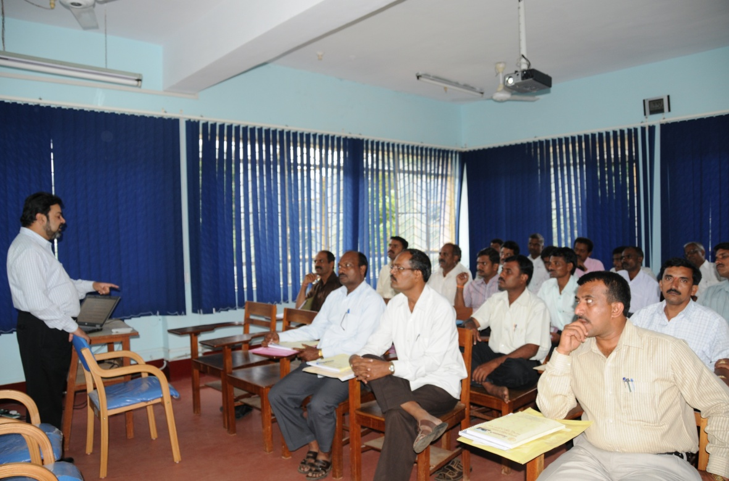

**Pic1.** Dr. S.venkatesan addressing the participants of AIISH-SSA Program

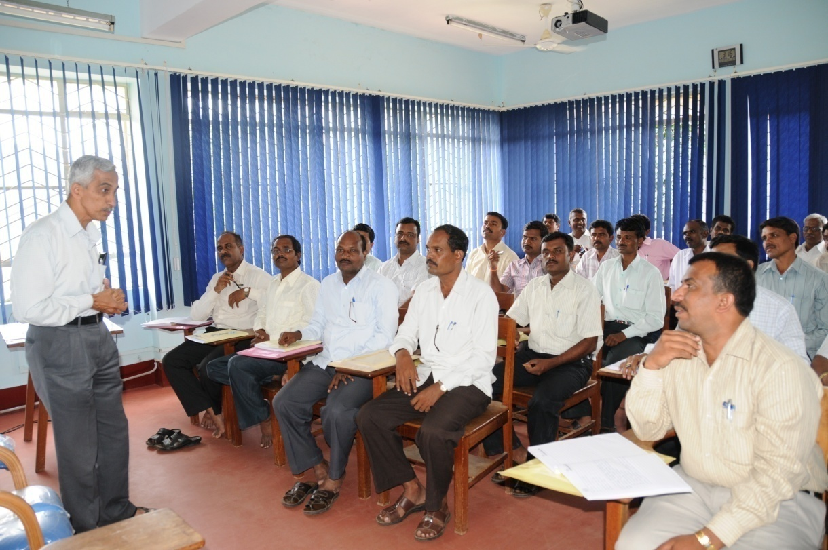

**Pic2.** Dr. G.Jayarama addressing the participants of AIISH-SSA Program

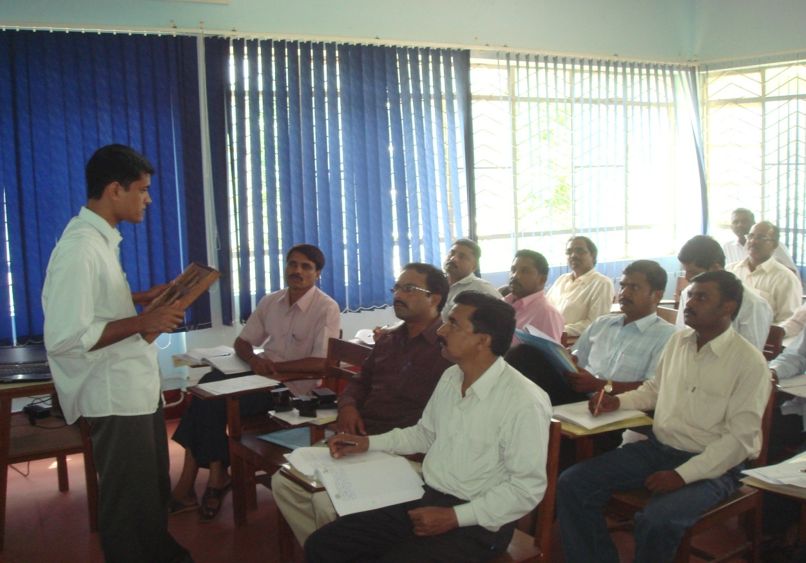

**Pic3.** Mr. Freddy Antony addressing the participants of AIISH-SSA Program

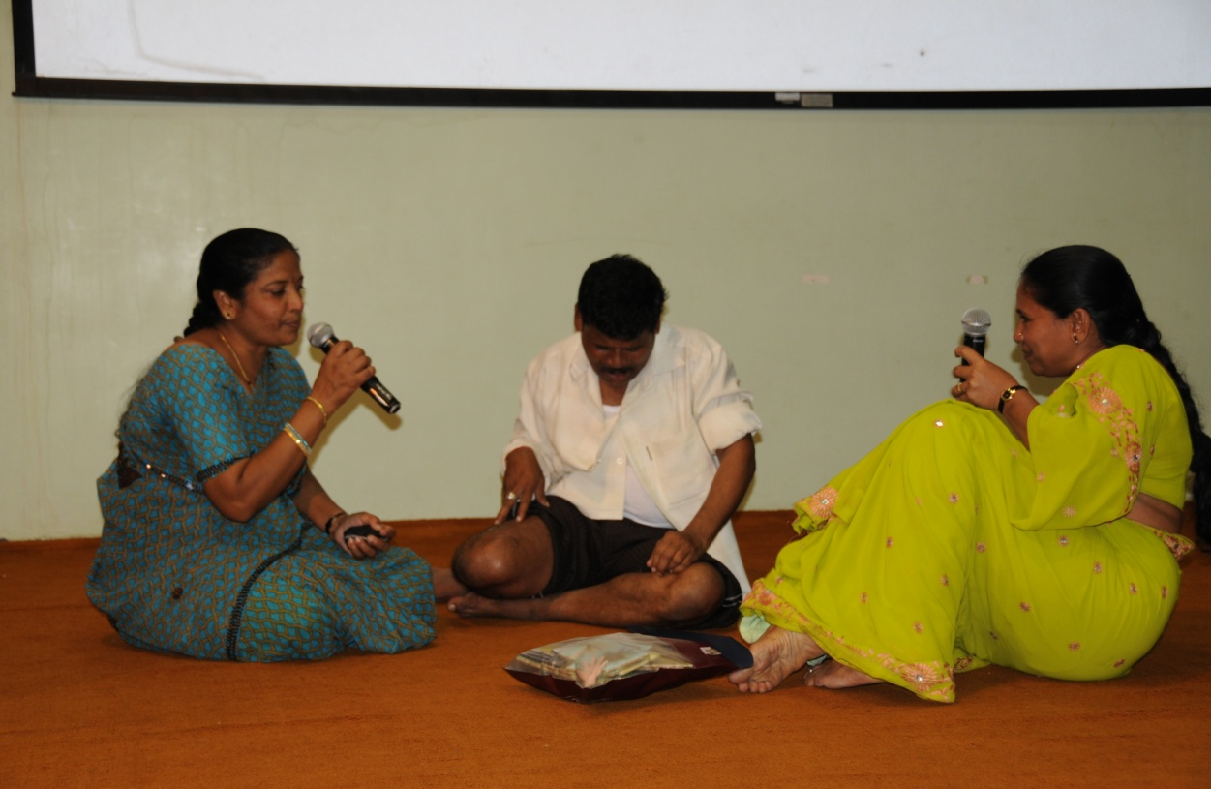

**Pic 4.** Participants of AIISH-SSA program exhibiting their talent and their understanding of the knowledge gained during Program.

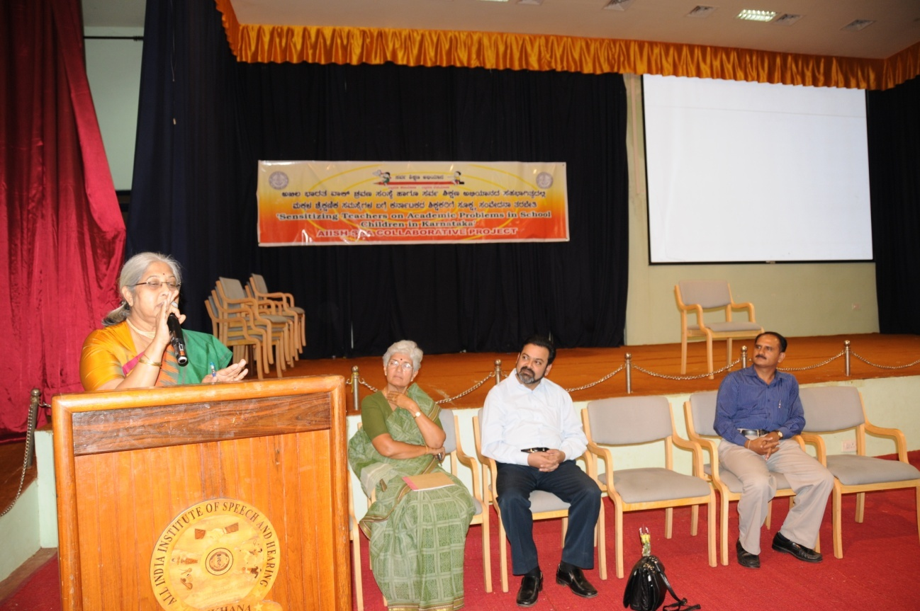

**Pic 5.** Our late Director Dr. Vijayalakshmi Basavaraj addressing the participants of AIISH-SSA Program during closing session of one of the batches.

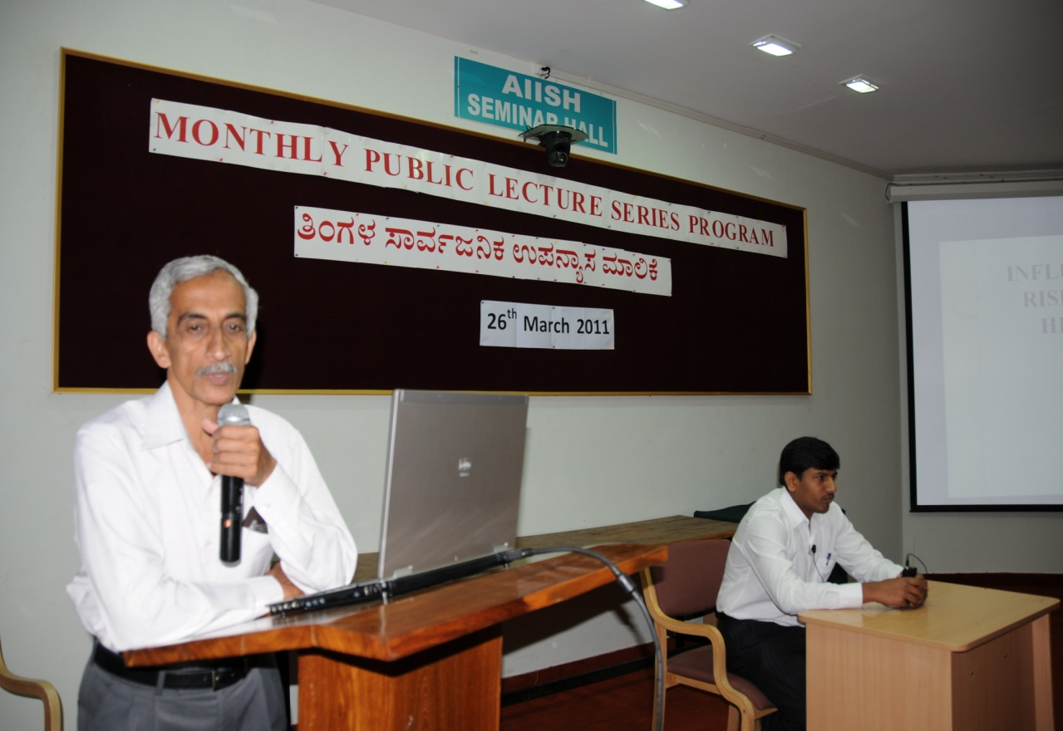

**Pic 6**: Dr. G. Jayaram addressing the participants at monthly public lecture series program