**7**

**the year in photos**

**1. MAJOR EVENTS OF THE YEAR**

1-2 JULY 2010

ANNUAL DHLS CO-ORDINATORS’ MEET

|  |
| --- |
| E:\Photo of July - 2010\DHLS MEET ON JULY 1 & 2, 2010 IN MYSORE\2 july 2010\DSC_0510.jpg |

Dignitaries: Dr.Deepankar Das, ADGS,Ministry of H&FW,Govt.of India & Prof.K.S.V.K.Subba Rao, Director, JIPMER, Pondicherry

17 SEPTEMBER 2010

INAUGURATION OF ‘BODHI’, GENTS HOSTEL

|  |
| --- |
| E:\DMD Photos of September 2010\Boys Hostal & Hindi vilidrity\DSC_2685.jpg |

Dignitaries: Dr.E.V.Ramana Reddy I.A.S, Secretary, Dept.of H&FW, Govt.of Karnataka, Dr.N.Rathna, Former Director, AIISH.

8 OCTOBER 2010

INAUGURATION OF ‘ASOKA’,INTERNATIONAL GUEST HOUSE

|  |
| --- |
| E:\8th Oct.2010 Guest house inagural & libo toy in preschool\CM\DSC_3724.jpg |

Sri.B.S.Yedddiyurappa, Chief Minister, Karnataka Unveiling the stone

8 OCTOBER 2010

Inauguration OF LIBRARY of Books and Toys (LIBOTOY)

|  |
| --- |
|  |

Dignitary: Mr. Keshav Desiraju, Addl. Secretary, Ministry of H&FW,Govt.of India

22 OCTOBER 2010

INAUGURATION OF VERTIGO CLINIC

|  |
| --- |
| E:\ENT workshop on 22.10.10\DSC_4178.jpg |

Dignitaries: Dr. Anirban Biswas, Neurotologist & President, AOI, Dr. Geetha Avadhani, Medical Superintendent, K.R. Hospital, Mysore.

22 November 2010

International Stuttering Awareness Day

|  |
| --- |
|  |

Dignitary on the dias: Brahma Kumari Vani, Brahma Kumari Vishwa Vidyalaya, Srirampura, Mysore.

16 December 2010

INAUGURATION OF AUDIOLOGY PRACTICAL LAB

|  |
| --- |
| E:\DMD photos of Decmber 2010\Audiology workshop on-16-17.12.2010\DSC_6608.jpg |

Dignitaries:Dr.M.D.Ravi,Prof.Paediatrics, JSS Medical College,Mysore & Dr.T.K.Parthasarathy,Prof.,Southern Illinois University,USA.

28 February 2011

RELEASE OF THE JOURNAL OF ALL INDIA INSTITUTE OF SPEECH AND HEARING

|  |
| --- |
| G:\Official\Annual Report\draft-depts\PHOTOS\JAIISH.jpg |

Dignitary: Prof.Mewa Singh,Professor in Psychology and Dean ,University of Mysore

8 MARCH 2011

International women’s day

|  |
| --- |
| E:\8 th March 2011 WWD\DSC_8868.jpg |

Dignitary on the dias: Dr.M.Indira,Prof.& Hon.Director,Centre for Women’s Studies Uni.sity of Mysore

11-13 MARCH 2011

AIISH AAWAZ: CULTURAL EVENT

|  |
| --- |
| E:\Awaaz 2011\DSC_0178.jpg |

Artistic Performance by Students

**2. EDUCATIONAL & RESEARCH ACTIVITIES**

24 APRIL 2010

MONTHLY PUBLIC LECTURE SERIES

|  |
| --- |
| E:\DMD Photos of April 2010\MPL April\DSC01422.JPG |

Resource Person:Dr.Sandip M,Lecturer,Department of Audiology.

4-8 October 2010

SHORT TERM TRAINING PROGRAM ON ‘Learning Disability’

|  |
| --- |
| E:\Clinical Severics on 4-8th Oct. 10\DSC_3302.jpg |

Resource person: Mrs.Prathibha, Clinical Psychologist.

9-10 DECEMBER 2010

NATIONAL WORKSHOP ON ‘PROFESSIONAL VOICE’

|  |
| --- |
| E:\DMD photos of Decmber 2010\SLS workshop on 9-10,12. 2010\DSC_6430.jpg |

Dignitary:Pandit Rajeev Taranath,Sarod Maestro.

11 DECEMBER 2010

Workshop on ‘Clinical RESEARCH METHODS in Communication disorders’

|  |
| --- |
| DSC_6288 |

Resource Person: Dr. Giri Hegde, Professor, California State University,USA.

27 JANUARY 2011

GUEST LECTURE on ‘Student AssessmEnt Procedure’

|  |
| --- |
| E:\Guest Lecture on 15 March 11\DSC_0274.jpg |

Resource person: Dr.G.N.Rangamani,Professor&Full-bright Scholar, St.Cloud State University,USA.

**3. CLINICAL ACTIVITIES**

AUDIOLOGICAL EVALUATION-I

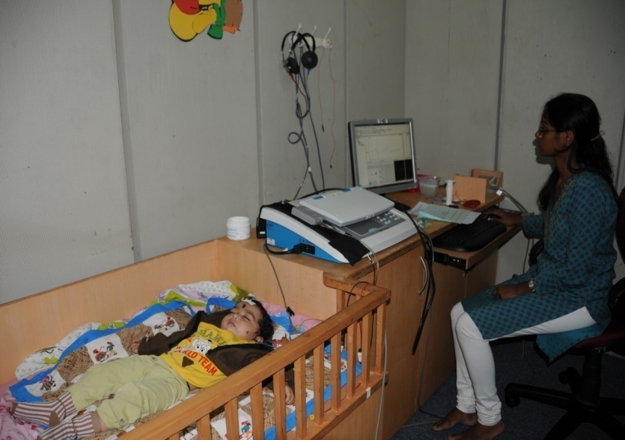

Paediatric screening

AUDIOLOGICAL EVALUATION-II

|  |
| --- |
| E:\DMD Photos of May 2010\Audiology\DSC02019.JPG |

Testing hearing sensitivity

SPEECH EVALUATION-I

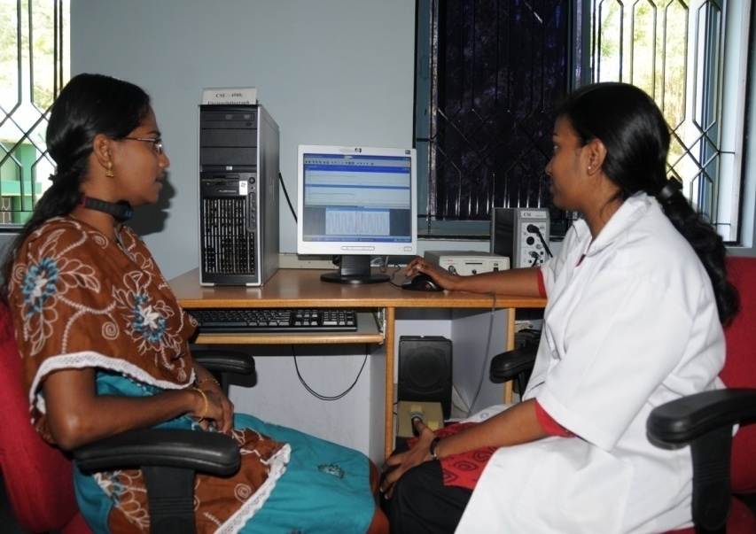

Voice evaluation using ElectroGlottograph

SPEECH EVALUATION-II

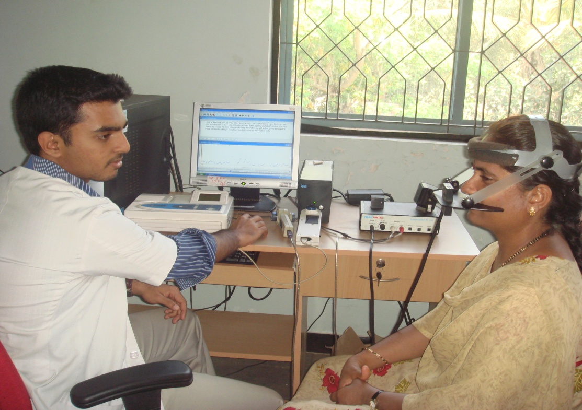

Instrumental Evaluation using Nasometer

OTORHINOLARYGOLOGICAL EVALUATION

|  |
| --- |
| E:\DMD Photos of May 2010\ENT Photos\DSC01889.JPG |

Microscopic Examination of the Ear

TELE-INTERVENTION

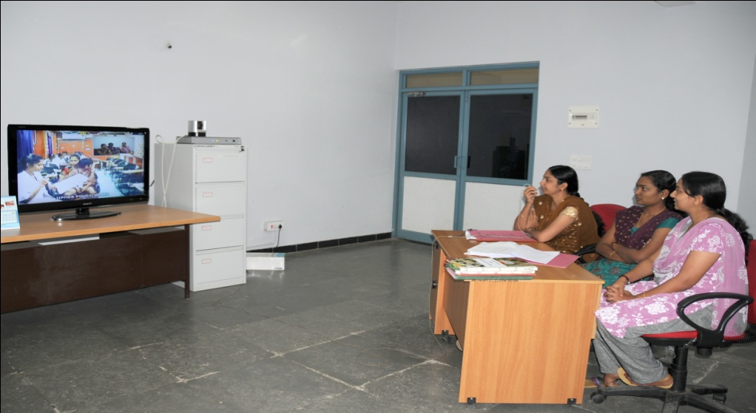

e-Assessment of Speech

Outreach clinical service

|  |
| --- |
| Rehabilitation_1 |

Speech language therapy at Outreach Service Centre, Hullahalli.

**4. CULTURAL ACTIVITIES**

2 OCTOBER 2010

GANDHI JAYANTHI

|  |
| --- |
| E:\Gandi jayanthi on 2.10.10\DSC_3165.jpg |

Vedanta Hemmige, Freedom Fighter, lighting the lamp.

5 NOVEMBER 2010

DEEPAVALI CELEBTATION

|  |
| --- |
| E:\DMD photos of Novmber 2010\Deepavali celebration Preschool  4.11.10\DSC_4861 copy.jpg |

Artistic performance by pre-school students

12 november 2010

KANNADA RAJYOTSAVA

|  |
| --- |
| **E:\DMD photos of Novmber 2010\Kannada rajyosva 12.11.10\DSC_5256.jpg** |

Dignitary: H.K.Ramanath, Dramatist and Literateur,Regional Institute of Education,Mysore.

13 FEBRUARY 2011

STREET PLAY ON TRAFFIC AWARENESS

|  |
| --- |
| E:\DMD Photos of February 2011\Street pay 13.2.2011\DSC_8496.jpg |

Students performing in street play