**ALL INDIA INSTITUTE OF SPEECH AND HEARING: MYSORE-6**

**DEPARTMENT OF SPEECH-LANGUAGE SCIENCES**

No.SH/SLP/AR/2012-13 10.4.2013

**Submitted to the Director:**

Sub: Material for Annual Report for the year 2012-13 - reg

Ref: Circular No. SH/LIC/AR/2012-13 dated 19.03.2013

With reference to the above, please find enclosed the Material for Annual Report for the year 2012-13 in the prescribed format. The soft copy is sent to [lio@aiishmysore.in](mailto:lio@aiishmysore.in)

**HOD, Speech-Language sciences**

**ANNUAL REPORT (APRIL – MARCH 2012-13)**

1. **ACADEMIC ACTIVITIES**
2. **Short-term Training Programs**

|  |  |  |
| --- | --- | --- |
| **1.** | **Theme/Topic** | Methods in Forensic Speaker Verification |
|  | **Coordinators** | Dr. K. Yeshoda, Dr. T. Jayakumar |
|  | **Objectives** | To impart training and hand-on experience in the said area |
|  | **Targeted Audience** | Scientific Officers from Directorate of Forensic Science Laboratories, Mumbai |
|  | **Number of Participants** | 2 |
|  | **Date** | 25th – 1st mar 2013 |

1. **Orientation Programs**

|  |  |  |
| --- | --- | --- |
| **1.** | **Theme/Topic** | Orientation Program on “Conservation of Voice”. |
|  | **Coordinator** | Dr. K. Yeshoda, Mr. Rajasudhakar, Dr. T. Jayakumar |
|  | **Objectives** | To enlighten the lawyers on voice production, causes of voice disorders and conservation of voice |
|  | **Targeted Audience** | Lawyers, Mysore Bar association, Mysore |
|  | **Number of Participants** | 40 |
|  | **Date** | 16th April 2012 |

|  |  |  |
| --- | --- | --- |
| **2.** | **Theme/Topic** | Orientation Program on “Conservation of Voice”. |
|  | **Coordinator** | Mr. Rajasudhakar & Dr. T. Jayakumar, |
|  | **Objectives** | To orient B.Ed about the activities of the department |
|  | **Targeted Audience** | B.Ed. students from Sharada Vilas College of Education |
|  | **Number of Participants** | 64 |
|  | **Date** | 25th September 2012 |

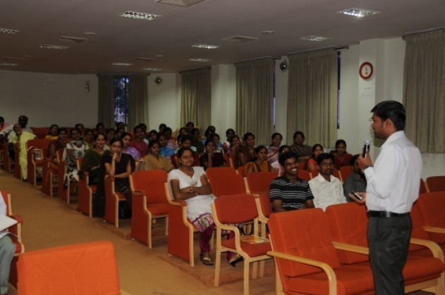

|  |  |  |
| --- | --- | --- |
| **3.** | **Theme/Topic** | Parent Enrichment Program on “Methods for development of speech in children with special needs” |
|  | **Speaker** | Ms. Sahana V, Clinical Assistant in Department of Speech-Language Sciences |
|  | **Objectives** | To educate parents about the methods for development of speech in children with special needs |
|  | **Targeted Audience** | Parents of children with special needs |
|  | **Number of Participants** | 200 |
|  | **Date** | 27th September 2012 |

1. **Clinical Observation Posting of Students from Other Institutes:**

|  |  |  |  |
| --- | --- | --- | --- |
| **Number of Students** | **Course** | **Institute** | **Date** |
| 1 | MD (ENT) | KIMS, Hubli | 22nd August 2012 |
| 3 | MDS, Pedodontics & preventive dentistry | Coorg institute of dental sciences (Virajpet) | 14th September 2012 |
| 1 | MD (ENT) | KIMS, Hubli | 18th October 2012 |
| 3 | MD (ENT) | KIMS, Hubli & SDUMC, Kolar | 5th November 2012 |
| 3 | MD (ENT) | SDUMC, Kolar and MMC Mysore | 4th December 2012 |
| 1 | MD (ENT) | MMC, Mysore | 20th December 2012 |
| 2 | MDS, Pedodontics & preventive dentistry | Coorg institute of dental sciences (Virajpet) | 21st December 2012 |
| 1 | MD (ENT) | Mysore medical college | 18th February 2013 |

1. **Seminars/Conferences/Workshops**

|  |  |  |
| --- | --- | --- |
| **1.** | **Theme/Topic** | Forensic Speaker Identification |
|  | **Coordinator** | Mr. R. Rajasudhakar |
|  | **Objectives** | To train on the methods used in speaker identification |
|  | **Target Audience** | Forensic scientists, SLPs |
|  | **Number of Participants** | 12 |
|  | **Date** | 12th-13th July 2012 |

|  |  |  |
| --- | --- | --- |
| **2.** | **Theme/Topic** | Symposium on ‘Language and Neurobiology’ |
|  | **Coordinator** | Dr. K.S. Prema with resource persons from University of Montreal, Canada (Dr. Yves Joanette and Dr. Ana Ines Ansaldo) |
|  | **Objectives** | To understand the impact of behavior therapy on the neural plasticity of brain in individuals with aphasia and project research work done on the topic related to language and neurobiology |
|  | **Target Audience** | SLPs, PG students |
|  | **Number of Participants** | 50 |
|  | **Date** | 14th December 2012 |

|  |  |  |
| --- | --- | --- |
| **3.** | **Theme/Topic** | National workshop on speech synthesis |
|  | **Coordinator** | Dr. M.Santosh & Dr. T. Jayakumar |
|  | **Objectives** | To train young scientists on speech synthesis |
|  | **Target Audience** | SLPs, PG students, Biomedical engineers |
|  | **Number of Participants** | 60 |
|  | **Date** | 14-15 March 2013 |

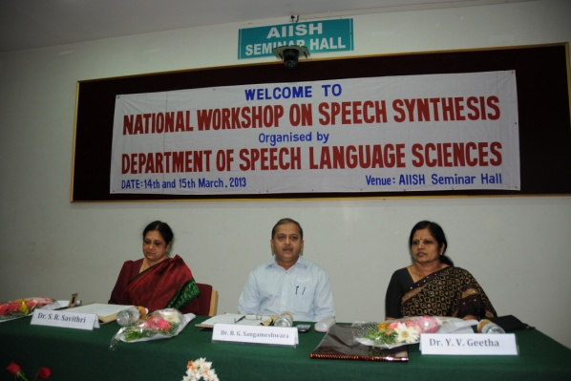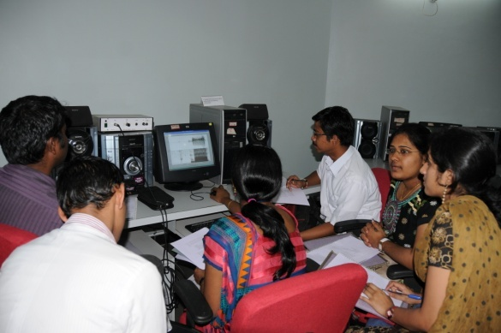

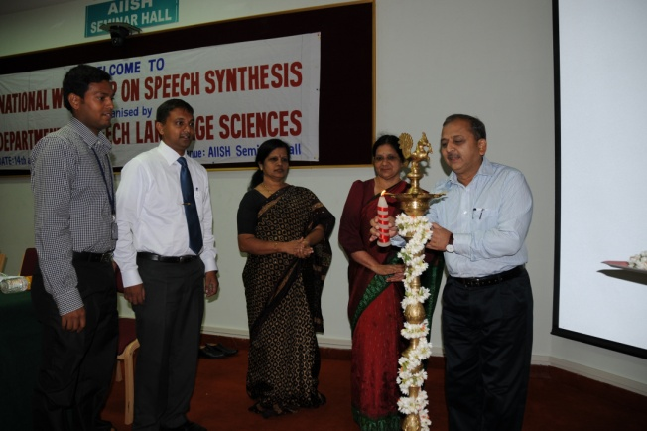 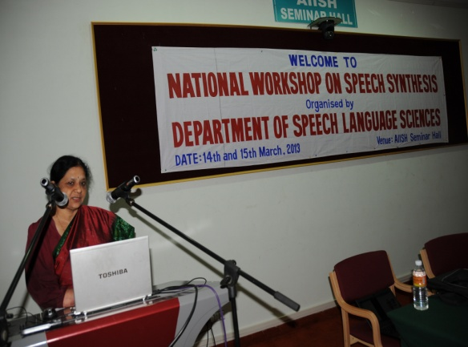

1. **Guest Lectures**

|  |  |  |
| --- | --- | --- |
| **1.** | **Name, Designation and Institutional affiliation of Lecturer** | Dr. N. Vishwanath, Stephen F. Austin State University, Communication Sciences and Disorders, USA, |
|  | **Topic of Lecture** | Insight on Subtypes of stuttering |
|  | **Date** | 8th January 2013 |

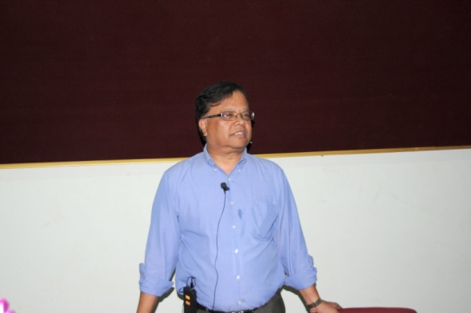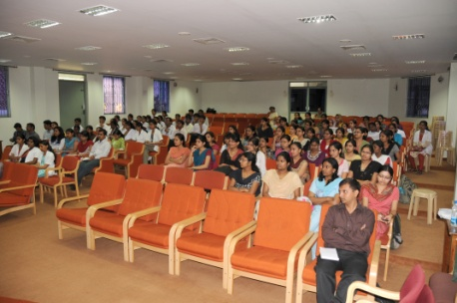

1. **Additional Academic Services by the Faculty and Staff**
2. **Invited Talks:**

**Dr. K.S. Prema**

* Participated and presented a concept paper on ‘*Significance of storytelling and story retelling for development of language and literacy*’ in the National Conference on Children’s Literature held at CIIL, Mysore in collaboration with EMESCO, Hyderabad on 14-16, June, 2012.
* Delivered invited talk on ‘*Emerging Trends in Inclusive Education for children with multiple disabilities: an Update’ at the Annual Educational Seminar on ‘Developmental Disabilities: an Update*’ organized by the Spastics Society of Karnataka, Bangalore and Shradha Trust on 30-06-2012
* Invited talk titled ‘*Aging and communicative decline: Identifying the gaps for decision making in diagnosis*” in the AIISH-ICMR funded National seminar on Non-Aphasic cognitive communicative disorders: Cutting edge clinical applications’ on 29.1.2013
* Participated and presented invited talk at RCI-CRE program on ‘C*urriculum planning and remedial teaching for children with hearing impairment and school drop outs’* held at Dr. SRC Institute of Speech and Hearing, Bangalore on 26-02-2013

**Dr. K. Yeshoda**

* Delivered a talk on “*Management of Voice and Speech Problems in patients with Parkinson Disease and other neurological conditions*” in Basal Ganglia Support (BGS) Group-Mysore, in association with BGS Global Hospitals, Bangalore  on 8th July 2012
* K. Yeshoda. *Pattern Matching Techniques in FSI*. National Workshop on Forensic Speaker Identification held on 12th & 13th July 2012.
* Delivered a talk on *“Recent advances in Spectrographic analysis of voice disorders”* and *“Recent advances in Forensic speech and voice analysis”* in the Workshop on “Analysis of Voice and Speech in relation to Perceptual, Acoustic and Aerodynamic measures”, organized by Helen Keller’s Institute of Speech & Hearing, Secunderabad on 8th Dec. 2012
* Delivered a talk on *“Forensic Speaker Recognition (Identification/Verification)” and “Issues related to speaker identification”*, to the Masters program students organized by Helen Keller’s Institute of Speech & Hearing, Secunderabad on 9th Dec. 2012.

1. **Curriculum Development : Nil**
2. **Development of Materials to Support Learning:**
3. **Service in Academic bodies of other organizations**

**Dr. K. S. Prema**

* Served as paper setter for post graduate course
* Nominated as Coordinator, M.Ed SE (HI), IGNOU through distance mode
* Member of Editorial Committee, Journal of Research in Innovative Teaching, National University Journal, USA
* Served as Reviewer for WJSA (Wudpecker Journal of Sociology and Anthropology)
* Chairperson of Board of Studies (Education) Composite Board
* Member of Board of Examiners (Education)

**Dr. Y. V. Geetha**

* Member of BOE Mangalore University
* Member of BOE Mysore University

**Dr. N. Sreedevi**

* Member of BOS Mysore University
* Member of BOS Mangalore University
* Member of BOS Manipal University
* Member of BOS Kerala University
* Member of BOS Calicut University
* Panel of examiners for PhD Program in Manipal University
* Coordinator for NPPCD program at Coorg
* Member, Board of Examiners for MSc (SLP/Aud), MASLP courses of Bangalore University for the year 2012-13

**Dr. K. Yeshoda**

* Coordinator for NPPCD program at Bangalore Rural
* Member, Board of Examiners for MSc (SLP/Aud), MASLP courses of Bangalore University for the year 2012-13
* Assistant Editor – JAIISH Vol. 31, 2012

1. **Membership in professional organizations**

**Dr. K.S. Prema**

* Member of International Reading Association, USA
* Life member of Dravidian Linguistic Association
* Life member of Indian Speech and Hearing Association
* Member of ‘Fulbright State Alumni Association’
* Member of ‘Women in Science’.
* Member of All India Association for Educational Research
* Member of Rehabilitation Council of India

**Dr. Y. V. Geetha**

* Life member of Dravidian Linguistic Association
* Life member of Indian Speech and Hearing Association
* Member of Rehabilitation Council of India

**Dr. N Sreedevi**

* Life member of Indian Speech and Hearing Association
* Member of Rehabilitation Council of India
* Member of Laryngology and Voice Association

**Dr. K.Yeshoda**

* Member of Indian Speech and Hearing Association

**Dr. T. Jayakumar**

* Life member of Indian Speech and Hearing Association
* Member of Rehabilitation Council of India
* Member of Indian Laryngology

**Dr. Santosh M.**

* Life member of Indian Speech and Hearing Association
* Member of Rehabilitation Council of India
* Member of Indian National science congress

1. **Participation in Committees/ Taskforces and Panels set up by other organizations/agencies**.

**Dr. K.S. Prema**

* Member of Editorial Committee for publication of the proceedings of the NSCS held in June 2011.
* selection committee member, Avinashalingam University, Coimbatore
* Expert to scrutinize applications for Student Welfare Scholarship submitted to the Directorate of Student Welfare Unit, UOM
* Representative to task force of Public Health Foundation of India from AIISH
* Member of Rehabilitation Council of India

1. **Any Other**

**Dr. K.S. Prema**

* HOD-Special Education
* Class Mentor for I B.Sc, ‘A’ section 2012-13
* Coordinator M.Sc., B.S.Ed Examination
* Preparation of B.S.Ed (HI) course syllabus
* Preparation of B.S.Ed (MR) course syllabus in progress
* Chairperson-Complaints Committee for redressal of the complaints of sexual harassment at the institute.
* Chairperson, Hostel Committee
* Chairperson, ISO Committee
* Chairperson, Committee for review of ARF projects
* Course coordinator for DTYDHH course
* Chairperson, BOE (SPl.Ed) Composite Board
* Member of doctoral committee, DOS, Psychology, UOM
* Member of Core Committee for ISO 9001-2008
* Chairperson for maintenance and preparation of APAR (Annual Performance Appraisal Report), GOI.
* Member of doctoral committee
* Member of core committee to plan quasi distance mode PG Program in speech language and hearing
* Chairperson, BOE (Spl.Ed) Composite Board
* Member, BOE (Ed) Composite Board,
* Member, BOE (Speech & Hearing) Composite Board,
* Member of Specialty Clinics at AIISH-ASD Unit and LD Unit
* Member of committee for establishment of digital speech language and hearing encyclopedia since
* Member of Committee for Internal Quality Assurance Mechanism, Feedback and Publications of AIISH.
* Member of Steering Committee for Self Study report for NAAC at AIISH
* Appellate Authority under RTI ACT

**Dr. Y. V. Geetha**

* HOD, Department of Speech Language Sciences
* Overall Coordinator of DHLS Program
* DHLS coordinator for Mysore Center
* Mentor for III B.Sc A section
* Chairperson of committee for admissions to 3 Diploma programs
* Chairperson of the committee to scrutinize applications for group A posts
* Member of the ARF review committee
* Member of Fluency Unit
* Member of Professional Voice Care unit
* Member of Doctoral committee for 5 Ph D fellows

**Dr. N. Sreedevi**

* + - Mentor for I M.Sc SLP A section
    - Chairperson of Voice clinic at the dept of Clinical services
    - Chairperson of Human Genetics Unit at the Dept of Speech Language Sciences
    - Chairperson of the committee to scrutinize applications for group C posts

**Dr. K. Yeshoda**

* Coordinator & Asst Editor JAIISH
* Internship Coordinator and Placement Cell Incharge
* Chairperson Professional Voice Care Unit
* Mentor for Internship
* Member of the Department Promotion Committee for consideration of successful completion of probationary period

**Mr. Rajasudhakar**

* Member secretary, PVC

**Dr. T. Jayakumar**

* Assistant warden in Men’s hostel.
* Instrument – incharge in Dept. of SLS
* Member, Professional Voice Care (PVC) center
* Mentor for I Msc (B) class
* Member of the committee to scrutinize applications for group A posts
* Incharge for NPPCD Dharwad
* Member of the Human Genetic unit

**Ms. Sahana.V.**

Member of Kuhoo Kuhoo compilation committee

**Mr. Santosh M.**

* Mentor – II M Sc. (SLP)
* Member of the Human Genetic unit
* Member of the fluency unit

**Ms. Anjana B Ram**

* Member of the Fluency Unit

**II. Research Activities**

1. **Research Projects**
2. **Submitted Research Projects**

|  |  |  |
| --- | --- | --- |
| **1.** | **Title** | Development of speech Rhythm in Kannada speaking children |
|  | **Objectives** | To investigate the development of speech rhythm in Kannada speaking children |
|  | **Investigator** | Dr. S.R.Savithri (PI) & Dr. N. Sreedevi (CI) |
|  | **Funding Source** | Dept. of Science and Technology, Ministry of Science and Technology, New Delhi |
|  | **Grant Amount** | Rs. 19 lakhs |

|  |  |  |
| --- | --- | --- |
| **2.** | **Title** | Development of Test for Assessment of Bilingual Proficiency through Lexical Priming Task |
|  | **Objectives** | To develop a test for assessment of Bilingual proficiency using Lexical priming task |
|  | **Investigator** | Dr. K.S. Prema |
|  | **Funding Source** | ARF |
|  | **Grant Amount** | Rs. 2, 58, 000/- |

|  |  |  |
| --- | --- | --- |
| **3.** | **Title** | Development and evaluation of center-based service delivery model for children with learning disability |
|  | **Objectives** | Development/compilation of text/audio/ video/digital resources:  To create public awareness on LD amongst different groups in the society including parents, teachers, medical practitioners, school administrations, NGOs, etc.  Training policy makers, heads of schools, special educators and regular teachers on the significance of imparting specialized training in classroom set-up for children at-risk/or those identified as having learning disability  Compilation of Tests and tools for early identification through screening and diagnostic procedures (including identification of subtypes of children with LD)  To finalize the resources for center-based service delivery on the principles of RTI for children with LD |
|  | **Investigators** | Dr. K.S.Prema , Dr. Jayashree Shanbal |
|  | **Funding Source** | ARF |
|  | **Grant Amount** | Rs. 4.99 lakhs |

|  |  |  |
| --- | --- | --- |
| **4.** | **Title** | Language proficiency in Hindi-English bilinguals: Cross language study |
|  | **Objectives** | To develop digitized test to assess language proficiency in Hindi-English bilingual adult speakers |
|  | **Investigators** | Dr. K.S Prema |
|  | **Funding Source** | ARF |
|  | **Grant Amount** | Rs. 4.94 lakhs |

|  |  |  |
| --- | --- | --- |
| **5.** | **Title** | Efficiency of multidisciplinary preparatory services of AIISH in mainstreaming children with communication disorder |
|  | **Objectives** | To survey the impact of multidisciplinary early intervention services offered at AIISH on the current school performance of children with different kinds of communication disorders. |
|  | **Investigators** | Dr. N. Sreedevi, (CI) |
|  | **Funding Source** | ARF |
|  | **Grant Amount** | Rs. 3.32 lakhs |

|  |  |  |
| --- | --- | --- |
| **6.** | **Title** | Phonetic Characteristics of Babbling in Kannada |
|  | **Objectives** | To trace the phonetic development of babbling longitudinally in infants from Kannada speaking homes from the age of 3 months to 12 months |
|  | **Investigators** | Dr. N. Sreedevi (PI) |
|  | **Funding Source** | ARF |
|  | **Grant Amount** | Rs. 4.60 lakhs |
| **7.** | **Title** | Frequency of occurrence of phonemes in Kannada |
|  | **Objectives** | To obtain a database with the occurrence of various phonemes in Kannada and from this to calculate the frequency of occurrence of each phoneme |
|  | **Investigators** | Dr. N.Sreedevi (PI), Smitha Nair |
|  | **Funding Source** | ARF |
|  | **Grant Amount** | Rs. 3,20,000/- |

|  |  |  |
| --- | --- | --- |
| **8.** | **Title** | An articulographic and ultrasound study of lingual consonants |
|  | **Objectives** | Investigate tongue dynamics of Kannada retroflex sounds using ultrasound and articulograph |
|  | **Investigators** | Dr. N. Sreedevi |
|  | **Funding Source** | ARF |
|  | **Grant Amount** | Rs. 3.15 lakhs |

|  |  |  |
| --- | --- | --- |
| **9.** | **Title** | Measurements of vocal doses using ambulatory phonation monitor (APM) in primary school teachers |
|  | **Objectives** | The aim of the project is to measure and document the three vocal doses. The objectives of the project are to measure (a) time dose, (b) cycle dose and (c) distance dose for daily and weekly vocalization of primary school teachers |
|  | **Investigators** | Mr. R. Rajasudhakar (PI) Mr. L. C. Sachin (CI) |
|  | **Funding Source** | ARF |
|  | **Grant Amount** | Rs. 3.23 lakhs |

|  |  |  |
| --- | --- | --- |
| **10.** | **Title** | Voice Characteristics of Partial Laryngectomy |
|  | **Objectives** | To find the acoustic characteristics, perceptual ratings and differences in EGG of Partial Laryngectomy Patients |
|  | **Investigators** | Mr. Sachin. L. C (PI) & Mr. Rajasudhakar. R (CI) |
|  | **Funding Source** | ARF |
|  | **Grant Amount** | Rs. 3.18 lakhs. |

|  |  |  |
| --- | --- | --- |
| **11.** | **Title** | Behavioral correlates of P300 response to voice onset time (VOT) and place of articulation continuum in Kannada and Hindi speaking individuals. |
|  | **Objectives** | To investigate the behavioral response for VOT and place of articulation continuum in Kannada & Hindi speakers and their relation with P300 response |
|  | **Investigators** | Dr. T. Jayakumar (PI) & Mr. Vijay Kumar Narne (Co-PI) |
|  | **Funding Source** | ARF |
|  | **Grant Amount** | Rs. 2.94 lakhs |

1. **New Research Projects (Initiated during 2012-13)**

|  |  |  |
| --- | --- | --- |
| **1.** | **Title** | Development of screening tool for LD |
|  | **Objectives** | To develop screening tool for children with learning disability |
|  | **Investigators** | Dr. Prema K.S.Rao (from South India and three other P.I’s from other states) & project coordinator Dr. Nandini Singh |
|  | **Funding Source** | DST-CSI-Educational Neuroscience |
|  | **Grant Amount** | Rs.14 lakhs for individual P.I. |

|  |  |  |
| --- | --- | --- |
| **2.** | **Title** | Computerized Analysis of Phonological Processes in Kannada (CAPP-K) |
|  | **Objectives** | To develop a software tool for evaluation of phonological processes in native Kannada speaking children in the age range of 2 – 3.6 years |
|  | **Investigators** | Dr. N. Sreedevi |
|  | **Funding Source** | ARF |
|  | **Grant Amount** | Rs. 4.75 lakhs |

|  |  |  |
| --- | --- | --- |
| **3.** | **Title** | Frequency of occurrence of phonemes in Malayalam |
|  | **Objectives** | To obtain a database with the occurrence of various phonemes in conversational samples of Malayalam and to calculate the frequency of occurrence of each phoneme |
|  | **Investigators** | Dr. N. Sreedevi (PI) |
|  | **Funding Source** | ARF |
|  | **Grant Amount** | Rs. 3,31,000/- |

|  |  |  |
| --- | --- | --- |
| **3.** | **Title** | Prevalence of voice disorders in Teachers: A Survey |
|  | **Objectives** | 1. To check for presence of voice problems in teachers with a minimum of 5 years of experience using questionnaire 2. To check for gender differences in the prevalence of voice problems |
|  | **Investigators** | Dr. K. Yeshoda (PI), Dr. Jayakumar T. (Co-PI) |
|  | **Funding Source** | ARF |
|  | **Grant Amount** | Rs. 3.8 lakhs |

|  |  |  |
| --- | --- | --- |
| **4.** | **Title** | Voice Characteristics in Teachers |
|  | **Objectives** | 1. To include primary and secondary school teachers with 5 years of experience 2. Carry out acoustic, aerodynamic and perceptual analyses to investigate the voice characteristics and check for specificity and trends, if any in the extracted measures. 3. To carry out similar analyses in non professional voice users 4. Compare the results in both sets of subjects |
|  | **Investigators** | Dr. K. Yeshoda (PI), Mr. Rajasudhakar (Co-PI) |
|  | **Funding Source** | ARF |
|  | **Grant Amount** | Rs. 3.6 lakhs |

|  |  |  |
| --- | --- | --- |
| **5.** | **Title** | Development of Prototypes for Electronic Publishing of Institute Journals |
|  | **Objectives** | To digitize the publications (JAIISH) |
|  | **Investigators** | Dr. C. Shijith Kumar, (PI), Dr. K. Yeshoda & Mr. M. Nanjunda Swamy, (Co-I**)** |
|  | **Funding Source** | ARF |
|  | **Grant Amount** | Rs. 2.0 lakhs |

|  |  |  |
| --- | --- | --- |
| **6.** | **Title** | Investigation of stuttering in bilingual individuals: Understanding its nature, assessment & treatment efficacy |
|  | **Objectives** | To examine relationship between stuttering and bilingualism |
|  | **Investigators** | Dr. Santosh M (PI), Geetha M. P. (CI) |
|  | **Funding Source** | ARF |
|  | **Grant Amount** | Rs. 2.94 lakhs. |

|  |  |  |
| --- | --- | --- |
| **7.** | **Title** | Prevalence of voice problems in primary school teachers of one district of Karnataka |
|  | **Objectives** | Estimation of prevalence of voice problems in primary school teachers of Mysore district |
|  | **Investigators** | Dr. Usha Devdas (PI), Dr. M Santosh (CO-PI) & Dr.B. Rajashekhar (Co-PI) |
|  | **Funding Source** | ARF |
|  | **Grant Amount** | Rs. 3. 16 lakhs |

iii) **Ongoing Research Projects**

|  |  |  |
| --- | --- | --- |
| **1.** | **Title** | Feedback controls in Persons with Stuttering |
|  | **Objectives** | To see the pattern of feedback control mechanisms in PWS compared to normal controls |
|  | **Investigators** | Dr. Y.V. Geetha, Ms. Sangeetha M, Ms. Sahana V, Dr. Sunderaraju |
|  | **Funding Source** | Dept. of Science & Technology |
|  | **Grant Amount** | 11,68,000 |

|  |  |  |
| --- | --- | --- |
| **2.** | **Title** | Cortical auditory evoked potentials as a measure of central auditory development in children with hearing impairment. |
|  | **Objectives** | * **To record P1 CAEP in normal hearing children and children with hearing impairment.** * **To find the relation between auditory development and language development using P1 maturation in normal and children with hearing impairment.** * To investigate the effect of age of intervention on P1 maturation in children with hearing impairment. * To compare the difference in P1 maturation in normal children, children using hearing aids and Cochlear implants. |
|  | **Investigators** | Vijay Kumar Narne (PI) & Dr. Jayakumar (Co-PI), Dr. N. Swapna (Co-PI) |
|  | **Funding Source** | Dept. of Science and Technology, Ministry of Science and Technology, New Delhi |
|  | **Grant Amount** | 28,37,200/- |

|  |  |  |
| --- | --- | --- |
| **3.** | **Title** | Development & Evaluation of curriculum for speech-language transcription |
|  | **Objectives** | **Objective:**   * 1. Develop a curriculum for speech and language transcription.   2. To develop a curricular framework to train manpower for Speech Language transcription.   3. To conduct a pilot study on small group of participants to evaluate the proposed curriculum   Method:   1. Develop modules for theory courses 2. Develop modules for practical training 3. To conduct a pilot study 4. Process evaluation 5. Modify if necessary   Implication: Development of curriculum for speech language transcription would facilitate launching of training program for capacity building in Speech Language transcription. |
|  | **Investigators** | Dr. K.S. Prema (PI), Dr. Peribhaskar Rao (CI), University of Tokyo, Japan |
|  | **Funding Source** | ARF |
|  | **Grant Amount** | Rs. 3, 94, 000/- |

|  |  |  |
| --- | --- | --- |
| **4.** | **Title** | Effects of semantic and syntactic treatments in bilingual stroke survivors |
|  | **Objectives** | To Study the influence and effectiveness of cognitive linguistic model – based syntactic and semantic treatments in Kannada-English bilinguals and to establish normative data on some linguistic parameters in the realm of semantics and syntax |
|  | **Investigators** | Dr. G.N.Rangamani and Dr. K.S. Prema |
|  | **Funding Source** | ARF |
|  | **Grant Amount** | Rs. 4.94 lakhs |

|  |  |  |
| --- | --- | --- |
| **5.** | **Title** | Digital tutorial for prereading skills (a Supplement to the intervention module for preschool children with communication disorders) |
|  | **Objectives** | * To develop a video tutorial as a supplement to the manual to enhance pre-reading skills * To evaluate the efficacy of the digital tutorial in training the special educators, SLP‘s and Parents/Caregivers in pre reading skills for children with special needs. |
|  | **Investigators** | Dr. Swapna N. & Dr. Prema K.S. (P.I’s), Dr. Y.V.Geetha (Co-P.I) |
|  | **Funding Source** | ARF |
|  | **Grant Amount** | Rs. 5.41 lakhs |

|  |  |  |
| --- | --- | --- |
| **6.** | **Title** | Effect of palatal obturator on speech |
|  | **Objectives** | To study the effect of using a palatal obturator with and without speech therapy on the speech characteristics of a case with submucous cleft palate |
|  | **Investigators** | Dr. N. Sreedevi (CI) |
|  | **Funding Source** | ARF |
|  | **Grant Amount** | Rs. 4.98 lakhs |

|  |  |  |
| --- | --- | --- |
| **7.** | **Title** | Neuro - physiology correlates of voice onset time in Kannada and Tamil speaking individual using N1 evoked potential |
|  | **Objectives** | (a) the behavioral response for VOT continuum in native Kannada and Tamil speakers, (b) The neuro-physiological changes for VOT continuum in native Kannada and Tamil speakers, (c) the existence and the reliability of double peak (morphological change in N1) with the change in stimulus property, (d) the behavioral and neuro-physiological response differences in two Dravidian languages (Kannada* and Tamil$), and (e) the neuro-physiological changes for non-speech stimuli that mimic the speech stimuli. |
|  | **Investigators** | Dr. Jayakumar T (PI) & Vijaya Kumar Narne (CI) |
|  | **Funding Source** | ARF |
|  | **Grant Amount** | Rs. 3.23 lakhs. |

|  |  |  |
| --- | --- | --- |
| **8.** | **Title** | Auditory processing in stutters: using non-linguistic and linguistic stimulus |
|  | **Objectives** | To investigate the degree of auditory processing ability in AWS with complex non-linguistic speech like stimulus and simple speech stimulus |
|  | **Investigators** | Dr. Jayakumar T., Dr. Y.V.Geetha & Mr. Vijay Kumar Narne |
|  | **Funding Source** | ARF |
|  | **Grant Amount** | Rs. 2.94 lakhs |

|  |  |  |
| --- | --- | --- |
| **9.** | **Title** | Investigations of speech rhythm in stuttering individuals: Understanding its nature, fluency inducing conditions and effect of treatment |
|  | **Objectives** | 1. To investigate whether stutterers differ from non stutterers on the measures of speech rhythm 2. To investigate whether different fluency inducing conditions have any effect on the speech rhythm of stutterers 3. To investigate whether prolongation therapy brings changes in speech rhythm of stutterers |
|  | **Investigators** | Dr. Santosh M (PI), Sahana V (CI) |
|  | **Funding Source** | ARF |
|  | **Grant Amount** | Rs. 2.94 lakhs |

1. **Doctoral and Post Doctoral Programs**
2. **Degree Awarded: 2**

|  |  |  |
| --- | --- | --- |
| **Name of the Student** | **Title** | **Guide** |
| Mr. Jayakumar T | Voice characteristics in monozygotic twins | Dr. S.R. Savithri |
| Ms. K. Yeshoda | Importance of Some Spectral and Temporal Parameters in Speaker Identification | Dr. M. Jayaram |

1. **Thesis Submitted:**

|  |  |  |
| --- | --- | --- |
| **Name of the Student** | **Title** | **Guide** |
| Ms. Sarika Khurana | Development of Emergent literacy in Kannada speaking English Language learners | Dr. K.S. Prema |
| Ms. Anjana. B. Ram | Disfluencies in 2.1-6 year old Kannada speaking children | Dr. S.R. Savithri |

|  |  |  |
| --- | --- | --- |
| **Name of the postdoctoral fellow** | **Title** | **Guide** |
| Mahalakshmi Prasad | Development of spoken language lexical corpora in Kannada | Dr. Prema K S |

1. **Post-Doctoral program**
2. **Under Progress**

|  |  |  |
| --- | --- | --- |
| **Name of the Candidate** | **Title** | **Guide** |
| Mr. Abhishek | Lexical-Semantic Processing in Persons with Bilingual Aphasia | Dr. K.S.Prema |
| Mr. Kuppuraj | Relationship between Procedural Memory Deficits and Specific Language Impairment: An Exploratory Study | Dr. K.S. Prema |
| Ms. Prarthana | Mental lexicon of nouns and verbs in adult speakers of Kannada | Dr. K.S. Prema |
| Ms. Pravesh Arya | Relapse management in adult PWS | Dr. Y.V. Geetha |
| Mr. Rajasudhakar R. | Voicing periods in daily and weekly speech in primary school teachers: Occupational voice measurements (time dose) | Dr. S.R. Savithri |
| Ms. Sangeetha M | Linguistic analysis of bilingual CWS | Dr. Y.V. Geetha |
| Ms. Reeny Roy | Emerging Phonetic Behavior in Hindi and Malayalam speaking children in the age range of 4-12months: A cross linguistic study | Dr. N. Sreedevi |
| Mr. Perumal (SRMC, Chennai) | Speech sound acquisition and phonological process in typically developing tamil speaking children – cross sectional study. | Dr. N. Sreedevi (co-guide) |
| Ms. Savitha (SRMC, Chennai) | Early speech & language development in children with cleft lip & palate: a longitudinal study | Dr. N. Sreedevi (co-guide) |

1. **Research Papers Presented at National/International Conferences /Seminars (**in APA format)

**Dr. K.S.Prema**

* **Prema, K.S.** (2012, June). *Significance of storybooks for development of language and literacy.* Presented at National Conference on children’s literature in Indian languages, CIIL, Mysore.
* Nayana L.R., Kumar P. & **Prema K.S.** (2012, July**).** *Acoustic characteristics of children with hearing impairment*. Presented at 3-day National Seminar on speech synthesis and its applications by Dept. of Linguistics, Univ. of Kerala & LDC-IL , Mysore and Kerala State IT Mission.
* Ceana M.P. & **Prema K.S. (**2013, February)**.** *Morphological development in ESL learners.* Scientific poster presented at ISHA 45, Chennai.

**Dr. Y.V. Geetha**

* Pravesh A. & **Y.V. Geetha.** (2012, July). *Relationship between stuttering management and predictors of treatment outcome In persons with stuttering*. Presented at 7th World Congress on Fluency Disorders, Vinci International Convention Center, France.
* Pravesh A. **& Y.V. Geetha.** (2012, July). *Differentiating recovered and very mild stutterers from non stutterers on speech naturalness*.Presented at 7th World Congress on Fluency Disorders, Vinci International Convention Center, France.
* Pravesh A. & **Y.V. Geetha.** (2012, July). *Non-speech behaviors in adult stutterers following treatment: A self rating measure.* Presented at 7th World Congress on Fluency Disorders, Vinci International Convention Center, France.
* Pravesh A. & **Y.V. Geetha**.( 2012, July). *Speech naturalness in bilingual adults with stuttering following treatment.* Presented at 7th World Congress on Fluency Disorders, Vinci International Convention Center, France.
* Reubin, T. V. & **Geetha Y.V.** (2012, November). *Mobile phone phobia in persons with stuttering – Indian scenario.* Presented in the ASHA Convention, USA

**Dr. N. Sreedevi**

* **Sreedevi, N.,** Smitha K Nair, Irfana, M., & Nimisha Raj (2012, July). *F2 Locus Equation: As an index for measuring coarticulation in cochlear implantees and hearing aid users*. Presented in the National seminar on Speech synthesis and its applications. Dept of Linguistics, University of Kerala, LDC-Il, CIIL, Mysore and Kerala State IT Mission, Govt. of Kerala, Thiruvananthapuram.
* **Sreedevi, N.,** Vikas, M. D., & Smitha K Nair (2012, December). *Frequency of occurrence of phonemes in Kannada: A comparative study between two dialects.* Presented in National Symposium on Acoustics (NSA – 2012). KSR Institute for Engineering and Technology & Acoustical Society of India, Erode.
* Shilpa N., Shruthi R.V. & **Sreedevi N.**( 2013, February)*. Emergence of phonological Awareness in bilingual children*. Poster presented at 45th ISHACON, Chennai.

**Mr. R. Rajasudhakar**

* **Rajasudhakar R. & L. C. Sachin**. (2012, December). *Time dose in daily and weekly speech of primary school teachers: An ambulatory phonation monitor study.* Presented at theNational Symposium on Acoustics (NSA-2012), Tiruchengode, Tamilnadu.
* Rekha H. S., Shwetha, & **Rajasudhakar. R.** (2012, December). *Voice range profile characteristics in mothers of children with hearing impairment and mothers children with normal hearing.* Presented at the National Symposium on Acoustics (NSA-2012), Tiruchengode**.** Tamilnadu.
* Jim Saroj Winston, Varun Singh. & **R. Rajasudhakar**. (2013, February) *An auditory perceptual analysis of emotions from dog barks.* Presented at 45th (ISHA CON), Chennai.
* Darshan H S, Deepak P. & **R. Rajasudhakar**. (2013, February). *A pre-post comparison of articulatory behaviours in accent training: preliminary investigation.* Presented at 45th Annual conference of Indian Speech & Hearing Association (ISHA CON) Chennai.

**Dr. T. Jayakumar**

* **T. Jayakumar**. Vijay Kumar Narne, & Pragati Rao.( 2012, July). *Categorical perception of voice onset (VOT) and F2 continuum by kannada and Malayalam speaking Individuals*. Presented at National seminar on Speech Synthesis and its applications at Dept of Linguistics, Uni of Kerala, Thiruvananthapuram.
* K. Sowmya & **Jayakumar T** (2013, February). *Benchmark of Euclidian Distances for Mel-Frequency Cepstral Coefficients and Cepstral Coefficients In Text Dependent Semi - Automatic Speaker Identification.* Presented at 45th ISHA CON, Chennai.

**Dr. M. Santosh**

* + - **Santosh, M.,** Priyanka Parakh, & **Sahana, V.** (December 2012). *Speech Rhythm in Individuals with Stuttering*. Paper presented at the National Symposium on Acoustics (NSA-2012), Tiruchengode,
    - Rashika Sharma, Pooja, K.& **Santosh, M.** (February 2013). *Speech Rhythm in Individuals with right hemisphere damage.* Paper presented at the 45th Indian Speech and Hearing Association Conference, Chennai.
    - Mamtha, H. R., Madalambika, K, & **Santosh, M.** (February 2013). *Relationship between grammatical class (content and function word) and stuttering frequency in persons with stuttering*. Paper presented at the 45th Indian Speech and Hearing Association Conference, Chennai.

1. **Research Papers Published (** in APA format)
2. **Papers Published in National /International Journals**

**Dr. K.S. Prema**

* Kuppuraj, S., Abhishek, B. P., & **Prema, K. S**. (2012). Relationship between morphology and reading in Kannada. *Language in India*, *12* (7), 397-421
* Prarthana, S. & **Prema K.S.** (2012).Role of semantics in the organization of Mental lexicon. *Language in India*, *12*(10), 259-277
* Kuppuraj S., & **Prema K.S.** (2013). Grammar learning as motor sequence learning. *Indian Linguistics,*  (ISSN 0378-0759), 73 (1-4), 2012, 147-164
* Kuppuraj S. & **Prema K.S Rao.** (2012). Is non-word repetition a true clinical marker of SLI?. *JAIISH*, *31*, 120-129

**Dr. Y.V.Geetha**

* Pravesh, A & Geetha Y.V. (2012). Speech Naturalness of Recovered and Relapsed Persons with Stuttering Following Treatment. ***Language in India,*** 12, *12* , 1-23

**Dr. N. Sreedevi**

* **Sreedevi, N** ., Smitha, K.N & Vikas, M D. (2012). Frequency of occurrence of phonemes in Kannada: A preliminary study, *JAIISH*, 31, 40-46.
* **Sreedevi, N.,** Jyothi, S & Smitha, K.N (2012). Phonetic characteristics of vowels in babbling, *JAIISH*, 31, 64-67.
* Alexei, K., **N Sreedevi** & Midula, K. (2012). Analysis of tongue shapes during the production of Kannada consonants, *Canadian Acoustics*, (ISSN 0711-6659), *40*(3), 30-31.
* Alexei, K., **N Sreedevi**, Midula Kasim & R. Manjula. (2012). A pilot ultrasound study of Kannada lingual articulations. *Journal of Indian Speech and Hearing Association, 26*(2), 38-49.
* Priyanka Jaysinghani., Akshay, M & **N Sreedevi**. (2012) Phonological Mean Length of Utterance (PMLU) Assessment of Native Hindi Speaking Children: 2 To 3 Years. *Journal of Indian Speech and Hearing Association*, *26*(2), 69-75.

**Ms. Anjana B.Ram**

* Anjana., B Ram & Savithri S.R (2012). Clustering of Disfluencies in 2.1 to 3 Year Old Kannada Speaking Children. *Language In India, 12,*136-148.

1. **Papers published in Conference/Seminar Proceedings**

**Dr. K.S. Prema**

* Nayana L.R., Kumar P. & Prema K.S. (2012). ‘Acoustic characteristics of children with hearing impairment.’ In the *Proceedings of the “National seminar on Speech synthesis and its applications,* Thiruvananthapuram

**Dr. N.Sreedevi**

* **Sreedevi, N.,** Smitha K Nair, Irfana, M., & Nimisha Raj (2012).*F2 Locus Equation: As an index for measuring coarticulation in cochlear implantees and hearing aid users*. In Proceedings of the National seminar on Speech synthesis and its applications. Dept of Linguistics, University of Kerala, LDC-Il, CIIL, Mysore and Kerala State IT Mission, Govt. of Kerala, Thiruvananthapuram.
* **Sreedevi, N.,** Vikas, M. D., & Smitha K Nair (2012).*Frequency of occurrence of phonemes in Kannada: A comparative study between two dialects.*  In Proceedings of National Symposium on Acoustics (NSA – 2012). KSR Institute for Engineering and Technology & Acoustical Society of India, Erode.

**Mr. R. Rajasudhakar**

* Rekha H. S., Shwetha, & **Rajasudhakar. R**. (2012). *Voice range profile characteristics in mothers of children with hearing impairment and mothers children with normal hearing.* Proceedings of National Symposium on Acoustics (NSA-2012), Tiruchengode, 181-187

**Dr. Jayakumar. T**

* **Jayakumar.T.,** Vijay Kumar Narne & Pragati Rao. (2012). *Categorical perception of voice onset (VOT) and F2 continuum by kannada and Malayalam speaking Individuals. In Proceedings of the National seminar on Speech synthesis and its applications*. Dept of Linguistics, University of Kerala, LDC-Il, CIIL, Mysore and Kerala State IT Mission, Govt. of Kerala, Thiruvananthapuram.

**Dr. M. Santosh**

* **Santosh, M.,** Priyanka Parakh, & Sahana, V. (2012). *Speech Rhythm in Individuals with Stuttering.* Proceedings of National Symposium on Acoustics (NSA-2012), Tiruchengode, 68-173

**Ms. Anjana B Ram**

* Anjana., B Ram & Savithri S.R (2012). Clustering of Dysfluencies in 2.1 to 3 Year Old Kannada Speaking Children, *Language In India, 12,* 136-148.

1. **Research Papers in Press**

**Dr. Y.V. Geetha**

* Pravesh, A & **Geetha Y.V**. (in press). *Factors related to recovery and relapse in persons with stuttering following treatment: a preliminary study.* Paper accepted for publication in DCID journal.
* Geetha, Y.V. Sangeetha, M, Sahana, V & Nisha, S (in press) *Pattern of relapse in children with stuttering*. Paper accepted for publication in DCID journal.

1. **Books Published (**in APA format**): Nil**
2. **Book Chapters Published (**in APA format**):**

**Dr. K.S. Prema**

* Shyamala K.C. & **Prema K.S.Rao** (2012). Language Processing in Bilinguals and Biliterates. In P.N.Tandon, R.C.Tripathi & N.Srinivasan (Eds.) *Expanding Horizons of the Mind Science, Nova Science* Publishers Inc., NY. pp. 205-238.

1. **Books in Press :Nil**
2. **Books/Manuals/Seminar Proceedings Edited :**
3. **Journal Editorship**
4. **Scholarly Reviewing Activities: Nil**
5. **Reviewer for Scholarly Journals**

**Dr. K.S.Prema**

* Reviewer of scientific **a**rticles submitted to JAIISH, 2012
* Served as reviewer for WJSA (Wudpecker Journal of Sociology and Anthropology). Reviewed article titled ‘ Effects of psychosocial developmental issues on children with learning disabilities in Ibadan North Local Govt. Area

**Dr. Y.V.Geetha**

* Reviewer of scientific **a**rticles submitted to JAIISH, 2012

**Dr. M.Santosh**

* Reviewer of scientific **a**rticles submitted to JAIISH, 2012

1. **Reviewer for Scholarly Conference Papers**

**Dr. Y.V.Geetha**

* Reviewer of 9 scientific papers for the ISHACON 2013

**Dr. N.Sreedevi**

* Reviewer of 9 scientific papers for the ISHACON 2013

**Dr. K. Yeshoda**

* Reviewer of 8 scientific papers for the ISHACON 2013

**Dr. T. Jayakumar**

* Reviewer of 10 scientific papers for the ISHACON 2013

**Dr. M. Santosh**

* Reviewer of 10 scientific papers for the ISHACON 2013

1. **Reviewer for Research Projects**

**Dr. K.S.Prema**

Reviewed 1 ARF project report

**Dr. N.Sreedevi**

Reviewed 2 ARF project reports and One thesis from Manipal University

**Dr. Santosh M**

Reviewed 3 ARF project reports

**III.Clinical Services**

1. **General Clinical Services**
2. **Speech and Language Assessment**

|  |  |
| --- | --- |
| **Unit** | **Diagnostics**  **(No of cases)** |
| Voice | 142 |
| Phonology | 111 |
| Fluency | 165 |
| Language | 1210 |
| PVC | 47 |

1. **Speech and Language Rehabilitation**

|  |  |
| --- | --- |
| **Unit** | **Therapy**  **(No. of cases)** |
| Voice | 80 |
| Phonology | 69 |
| Fluency | 304 |
| Language | 558 |
| PVC | 18 |

1. **Hearing Evaluation**
2. **Hearing Aid Trial**
3. **Hearing Aid Dispensing**
4. **Psychological Evaluation**
5. **Counseling and Guidance**
6. **Ear Moulds**
7. **Hearing Aid Issue and Electro-Acoustic Evaluation (ADIP Scheme, Ministry of Social justice)**
8. **AIISH Hearing Aid Dispensing Scheme**
9. **Specialized Clinical Services**
10. **Augmentative and Alternative Communication (AAC) Unit**
11. **Autism Spectrum Disorder Unit**
12. **Fluency Unit**
13. **Learning Disability Clinic**
14. **Listening Training Unit**
15. **Neuromotor Speech Disorder Unit**
16. **Pre-School Training and Special education**
17. **Professional Voice Care Unit**

|  |  |  |  |
| --- | --- | --- | --- |
| **Sl.No.** | **Course Level** | **No. of students**  **trained** | **No. of**  **Hours** |
| 1. | AIISH Interns | 56 | 346 |
| 2. | M.Sc (SLP) | 36 | 484 |

**U-SOFA**

1. **Vertigo Clinic**
2. **Voice Clinic**

* Stroboscopy was done for 35 cases with voice disorders in Feb 2013.
* Stroboscopy was done for 28 cases with voice disorders in March 2013

1. **Any other (Please Specify)**

**Neurophysiology Lab**

Inaugurated by Dr. Abdul Kalam, Ex President on 18.5.2012

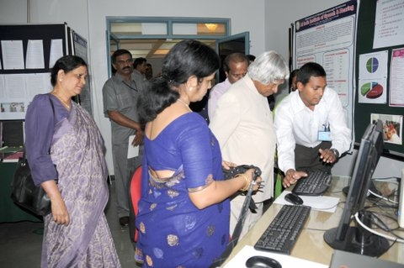

**Unit for Human Genetics**

**Dr. N. Sreedevi**

Officiating as Chairperson of Human Genetics Unit at the Dept of Speech Language Sciences for setting up genetics lab. Indents have been placed for procuring equipments

1. **Clinical Support Services to Patients and Family**

**i) Details of Certificates Issued**

**ii) Financial Aid**

**iii) Legal advice**

**iv) Any other (Please Specify)**

1. **Clinical Electronic Services**

**i) Electro-Acoustic Evaluation**

**ii) Hearing Aid Dispensing**

**iii) Repair of Hearing Aids**

**IV. Extension Activities**

1. **Rehabilitation and Education through Distance Mode**
2. **Prevention of Communication Disorders**
3. **Communication Disorders Screening Camps**
4. **Orientation Programs**
5. **Public Lecture Series**

|  |  |
| --- | --- |
| **Name, Designation and Institutional Affiliation of Lecturer** | Dr. M.Santosh, Reader in Department of Speech-Language Sciences |
| **Topic of Lecture** | Stuttering in children: prevention and its management |
| **Date** | 28th July 2012 |

|  |  |
| --- | --- |
| **Name, Designation and Institutional Affiliation of Lecturer** | Dr. N. Sreedevi, Reader in Department of Speech-Language Sciences |
| **Topic of Lecture** | Articulation problems - Causes and management |
| **Date** | 29th September 2012 |

**V.Technological Consultancy Services**

**Dr. N. Sreedevi**

* Evaluated one forensic case for speaker verification

**Dr. K.Yeshoda**

* Completed the report of Forensic Speaker Verification
* Testified the forensic speaker verification attended the Hon’ble court of the Senior Civil Judge & JMFC, Hospet

**VI. Central Facilities**

1. **Library and Information Services**
2. **Public Information Activities**
3. **Major Events of the Year with a brief account**

* A parade/walk on occasion of World Voice Day. Parade organized on 21st Saturday from City bus stand (Tathaiah park till Ramaswamy Circle).

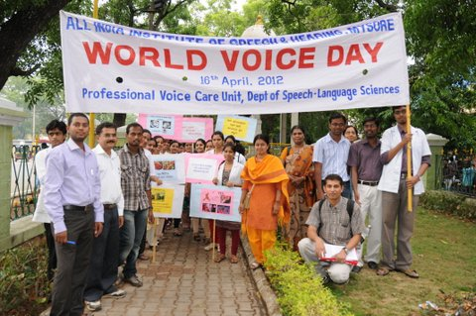 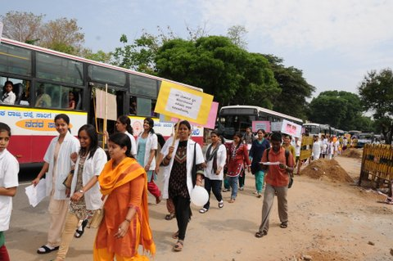

**Dr. K.S. Prema**

* Participated in live ‘Phone-in’ Women’s program organized by AIR, Mysore on ‘Role of parents on prevention of illiteracy’. Responded to parents and caregivers’ questions on 22-05-2012
* In view of International Day for Persons with Disability, participated in women’s program organized by AIR, Mysore titled ‘Haguragale mana’ that was broadcast from 4.4.30 p.m. Answered listeners’queries on ‘Challenges faced by parents/caregivers of special children’ on 04-12-2012.

1. **Press Releases and Media Coverage**
2. **Details of Institute Publications during the year**
3. **Material Development**

**Dr. K.S.Prema**

* Software development for CLiPS for use with clinical and typical population is complete with support from Dept. of Electronics.
* CD’s on practical module for speech language transcription as a product of ARF project
* DVD’s on Bilingual proficiency test for Hindi-English bilinguals as a product of ARF project

**Dr. N.Sreedevi**

* A CD on “ Orientation program for school teachers on the management of children with hearing impairment” was released on 25.7.2012 on the occasion of the inauguration of the workshop on “Structured methods of teaching for children with special needs” held at AIISH

**VII.Awards and Honors Received by Faculty and Staff**

**Dr. M.Santosh**

* Manohar award for Best Poster in Speech and Language pathology for the paper “*Speech Rhythm in Individuals with right hemisphere damage*”. Paper presented at the 45th Indian Speech and Hearing Association Conference, February 1-3, 2013, Chennai, India.

**VIII.Extra Curricular Activities**

1. **AIISH GYMKHANA**

**Dr. N. Sreedevi**

* Coordinated as chairperson of catering committee for Institute Day celebrations on 9.8.2012

**Dr. K. Yeshoda**

* Panelist for mock press held as part of AIISH Awaaz 2013 on 2nd mar 2013

1. **NSS**
2. **OTHERS**

**Dr. K.S.Prema**

* 20-05-2012: Participated in ‘Samvaada-Samvahana’ program organized by Srian Enterprises as an interaction program with persons with communication disorders due to neurological diseases at Namana Kala Mantapa alon with Dr. Suresh, Dr. Sangli (Neurologists) and three JRF’s working with me.

Ix.**MAJOR EVENTS OF THE** **YEAR**

x. **Eminent Visitors**

* Dr. Abdul Kalam, Ex President on 18.5.2012

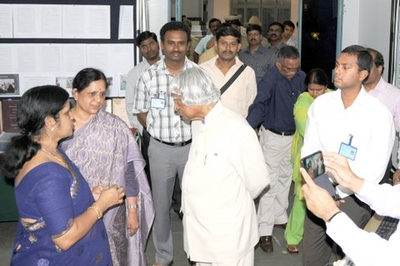

* Ms. Sujaya J.S. from ministry and 2 doctors on 3.7.2012
* State minister for health, Mr. Sudip Bandopadyay on 5.7.2012

XI.**Any Other**

**Dr. K.S. Prema**

* Prepared and sent success stories of persons with disability(9 Nos)for forwardal to NFC, Min of Soc Justice and Empowerment
* Participated as a representative from AIISH in ‘Call to Action: Child Survival and Development’ Global Summit organized by the Ministry of Health and Family Welfare in collaboration with WHO, UNICEF and USAID held at Mammalapuram, Chennai on 7-9 February, 2013.
* Submitted draft on Occupational Standards for Allied Health Professional (Speech and Hearing and Special Educators) as per the E mail request from PHFI, New Delhi.

**Dr. Y.V. Geetha**

* Prepared report on Fluency seminar and sent and settlement of ICMR grants
* Valuation of UG answer scripts at Crawford Hall, UOM from 5-7 June 2012
* Participated in one day workshop on Affiliation, Accreditation of Universities organized by the Univ. of Mysore in Centenary hall on 3.11.12
* Meeting with Prof. Padma and two of her students from Dayanand College of Engineering regarding research on stuttering on 16.1.2013
* Attended BOE (speech & Hearing) meeting in JSSISH on 19.5.12
* Organized DHLS AIISH coordinators’ meeting on 13.5.12
* DHLS correspondence and other work – sent special report to send to ministry
* Arrangements for the visit of Dr. Abdul Kalam and launching of Neurophysiology lab and dept activities in room 10 on 18.5.12
* DHLS correspondence and other work
* Valuation of UG answer scripts at Crawford Hall, UOM from 5-7 June 2012
* Purchase committee meeting with director on 12.6.12
* DHLS examinations for 2011-12, selection list for all centers
* Counseling for DTYHI, DHAET and DHLS on 25.7.2012 for 2012-13 as Chairperson of the committee
* Arrangements for the visit of state minister for health, Mr. Sudip Bandopadyay on 5.7.2012 and attended meeting with HODs
* Sent RE BE for the dept
* Attended BOE meeting in JSS ISH on 16.10.2012
* Arranged for Dasara exhibition of dept activities for 3 months
* Followed up purchase of furniture and equipments
* Participated in one day workshop on Affiliation, Accreditation of Universities organized by the Univ. of Mysore in Centenary hall on 3.11.12
* Participated in the demo/orientation on Turnitin software in the library by Mr. Arjun on 30.11.12
* Was the judge for vigilance awareness competition
* Sent BOS agenda & panel of examiners on 16.11.12
* Meeting with Prof. Padma and two of her students from Dayanand College of Engineering regarding research on stuttering on 16.1.2013
* Organized meeting on PGDFSST online program with Dr. TVA on 17.1.2013
* Attended as member of ARF review committee on 17.1.2013
* Chief Superintendent for DHLS mid term exams and for DHAET and DTYHI from 1.1.2013 to 8.1.2013
* Participated in the 2 days “National Seminar on Tele assessment and and Intervention for persons with communication Disorders held by CREDM, AIISH, Mysore” on 21-22, Feb 2013
* Sent information for Dept brochure
* Participated in two days workshop with Mr. Bhargava from Suprabha consultants regarding ISO-9001-2008 certification on 18-19, March 2013
* Arranged to conduct repeat midterm exam in 3 DHLS centers from 20-25.3.2013
* Discussed with Dr. Keshavan from Swift solutions and Director regarding PGDFSST online course on 7.3.2013
* Attended meeting with HODs, Director and ISO Core committee members with Mr. Bhargava from Suprabha consultants regarding ISO-9001-2008 certification on 11.3.2013

**Dr. N.Sreedevi**

* Served as External examiner for viva voce for I Msc Sc students at Bharathi Vidyapeeth, PUNE
* Valuation of UG course at UOM
* Performed stock verification of the Library Equipments for the year 2012 and submitted.
* Attended short term training program on stroboscopy for one week (17th -22nd Dec 2012) at Pune
* Served as external examiner for vive voce for II M Sc students at AWH, Calicut, Kerala
* Attended the workshop on “ Digital Accelerometry on Swallowing Imaging ( DASI) ” from 9th to 11th Jan 2013.
* Attended the workshop on “Techniques in Audiological Management of Auditory Processing Disorders” on 6th Feb 2013.
* Attended and served as a resource person for the “National work shop on speech synthesis” on 14th and 15th March 2013

**Dr. K. Yeshoda**

* Organized the programs to commemorate World Voice Day 2012
* Performed stock verification of Department of Speech Language Pathology
* Attended the National Seminar on Non-Aphasic Cognitive Communication Disorders: Cutting Edge Clinical Applications on 29th Jan 2013
* Attended the National Seminar on Tele Assessment and Intervention in Communication Disorders on 21st & 22nd Jan 2013
* Attended central valuation of PG Jan 2013 examinations at Bangalore university on 23rd Feb 2013

**Mr. R. Rajasudhakar**

* Performed stock verification of different gadgets provided by WHO, VRA, Danish and Camp unit and submitted a detailed report of the same.
* Attended a 1-day workshop on “Pamphlet Designing” on 12.9.2012 held at Department of Material Development, AIISH, Mysore.
* Participated in in-housing workshop on development and translation of public education materials for POCD on 30.10.12.
* Attended one day workshop on ‘Art of technical writing for public education’ conducted by Dept. of Material Development, AIISH, on 22.01.13.

**Dr. T. Jayakumar**

* Performed stock verification of technical equipments in audiology and submitted the report for the same
* Attended short term training program on stroboscopy for one week (17th -22nd Dec 2012) at Pune
* MASLP paper valuation at Trissur.

**Mr. Sachin L.C.**

* Prepared a report on the “Symposium on Language and Neurobiology” and submitted to Dr. Prema. K. S.

**Ms. Sahana.V**

* Performed stock verification of Department of Special Education as stock verification officer for furniture and submitted the report for the same
* Attended Hindi classes on Tuesdays & Fridays and trained for Praveen Exam and completed the exam.
* Assisted Mr. Sujith in stock verification of equipments in the Department of SLS.
* Attended a 1-day workshop on “Pamphlet Designing” on 12.9.2012 held at Department of Material Development, AIISH, Mysore.
* Convener for Hindi slogans competitions held on occasion of “Hindi Week”.
* Assisted Dr. K. Yeshoda in stock verification of instruments in Department of Speech Language Pathology
* Member of decoration committee for 47th Annual Day
* Attended the National Seminar on Non-Aphasic Cognitive Communication Disorders: Cutting Edge Clinical Applications on 29th Jan 2013
* Attended the Third Two day Internal Hindi Workshop from 10.01.2013 to 11.01.2013 at AIISH
* Assisted Mr Rajsudhakar in Forensic voice analysis of a voice sample received from Gundlupet police station in Feb 2013
* Assisted in Forensic voice analysis of a voice sample received from from Koppal to Dr. N. Sreedevi

**Dr. M. Santosh**

* Chairperson (registration committee) – Open day 2012
* Research proposal presentation at Delhi. In front of task force for cognitive science research intiative (CSI) DST on 7.02.2013

**Ms. Anjana B Ram**

* Assisted Mr Rajsudhakar in Forensic voice analysis of a voice sample received from Gundlupet police station in Feb 2013

**Ms. Smitha K. Nair**

* Transcribed the language samples elicited by Picture Description Task
* Training with Reading Success Lab for LD children and discussed with their speech therapists
* Establishment of speech and language database (Prema K.S. & Smitha N.)
* Development of multilingual lexical corpora ((Prema K.S. & Smitha N.)
* Establishment of norms on Cognispeed software (Prema K.S. & Smitha N.)
* Survey on ‘SLP’s sensitivity towards language sciences’(Prema K.S., Smitha N. & Sunitha S.)
* Development of standard procedures for language sampling (Prema K.S., Sridevi N. & Smitha N.)
* Establishment of measures for language analyses ((Prema K.S., Sridevi N. & Smitha N.)

**HOD-Speech-Language Pathology**