**ALL INDIA INSTITUTE OF SPEECH AND HEARING: MYSORE – 570006**

No. SH/ACA/AR/2013-14 8.4.2013

Submitted to the Director:

Sub: Preparation and submission of draft material for Annual Report for

the year 2012-13.

Ref: AIISH Circular SH/Lib/AR/2011-12, dated 2.4.2012.

Please find enclosed the material for Annual Report for the period 1.4.2012 to 31.3.2013 pertaining to Academic Section.

Registrar

**ALL INDIA INSTITUTE OF SPEECH & HEARING: MYSORE-6**

**ACADEMIC SECTION**

**A) EDUCATIONAL ACTIVITIES**

**I. Academic Programs offered during 2012-13**

The institute offered 3 Diploma, 2 undergraduate, 2 postgraduate and 2 doctoral programs. Thus, during the year, the institute offered 9 different programmes. Of these programs the Diploma in Hearing Language and Speech was conducted through video conferencing mode. The institute undertook the challenge of offering this programme to 12 study centers and having classes through video conferencing mode. All the degree programs had the approval of the University of Mysore and/or the Rehabilitation Council of India. In all 216 diploma, 241 undergraduate, and 128 post graduate students were admitted during the year. In addition, 44 researchers are doing their Ph.D.

**II. New Academic Programs offered during 2012-13**

NIL

**New admission**

B.Sc. (Sp. & Hg.) continued to be the well sought after professional program in the country with 536 students appearing for the B.Sc. (Sp. & Hg.) entrance examination conducted at Delhi, Kolkata, Guwahati, Mumbai, Chennai and Mysore. The entrance examinations for M.Sc. were conducted at Mysore and 135 and 149 students appeared for M.Sc. (Speech Language Pathology) and M.Sc. (Audiology) entrance examination, respectively.

**Students currently studying for each programme:**

The details regarding the various programmes, Gender-wise distribution of seats, Statewise distribution of the admissions during the year 2012-13 is given below:

|  |  |  |
| --- | --- | --- |
| Name of the programme | No. of seats available | No. of intake |
| Diploma (HA & ET) | 25 | 7 |
| DTY(DHH) | 20 | 6 |
| DHLS (AIISH, Mysore) | 25 | 18 |
| DHLS (Puducherry Center) | 25 | 20 |
| DHLS (Imphal, Center) | 25 | 21 |
| DHLS (Mumbai Center) | 25 | 12 |
| DHLS (Delhi Center) | 25 | 12 |
| DHLS (Shimla Centre) | 25 | 12 |
| DHLS (Ajmer Centre) | 25 | 4 |
| DHLS (Jabalpur, Centre) | 25 | 21 |
| DHLS (Jharkhand Centrer) | 25 | 25 |
| DHLS (CuttackCentre) | 25 | 13 |
| DHLS (Lucknow Centre) | 25 | 22 |
| DHLS (Bhagalpur Centre) | 25 | 25 |
| B.Sc. (Sp. & Hg.) | 62 | 54 |
| B.S.Ed. (Hearing Impairment) | 20 | 4 |
| PGDCLSLP | 10 | - |
| M.Sc. (Speech-Language Pathology) | 36 | 30 |
| M.Sc. (Audiology) | 36 | 33 |
| Ph.D. (Audiology) | 4 | - |
| Ph.D. (Speech-Language Pathology) | 4 | - |
| **Total:** | **520** | **339** |

Table 1: Details of admissions in 2012-13

**III. Total student strength**

**Genderwise distribution of seats of the admission during the year 2012-13**

|  |  |  |  |  |
| --- | --- | --- | --- | --- |
| **Name of the course** | | **Male** | **Female** | **Total** |
| DHA&ET | | 4 | 3 | 7 |
|  | |  |  |  |
| DTY(DHH) | | 2 | 4 | 6 |
| DHLS | | 97 | 108 | 205 |
| B.Sc. (Sp. & Hg.) |  | 15 | 39 | 54 |
| B. S. Ed. (HI) |  | 1 | 3 | 4 |
| M.Sc. (Audiology) |  | 13 | 20 | 33 |
| M.Sc. (SLP) |  | 3 | 27 | 30 |
| **Total:** |  | **134** | **203** | **339** |

**State-wise distribution of seats of the admission during the year 2012-13**

|  |  |
| --- | --- |
| **State** | **No. of seats** |
| [Andaman and Nicobar Islands](http://en.wikipedia.org/wiki/Andaman_and_Nicobar_Islands) | - |
| [Andhra Pradesh](http://en.wikipedia.org/wiki/Andhra_Pradesh) | 8 |
| [Arunachal Pradesh](http://en.wikipedia.org/wiki/Arunachal_Pradesh) | - |
| [Assam](http://en.wikipedia.org/wiki/Assam) | 1 |
| [Bihar](http://en.wikipedia.org/wiki/Bihar_(India)) | 36 |
| [Chandigarh](http://en.wikipedia.org/wiki/Chandigarh) | - |
| [Chhattisgarh](http://en.wikipedia.org/wiki/Chhattisgarh) | 1 |
| [Dadra and Nagar Haveli](http://en.wikipedia.org/wiki/Dadra_and_Nagar_Haveli) | - |
| [Daman and Diu](http://en.wikipedia.org/wiki/Daman_and_Diu) | - |
| [Delhi](http://en.wikipedia.org/wiki/Delhi) | 5 |
| [Goa](http://en.wikipedia.org/wiki/Goa) | 1 |
| [Gujarat](http://en.wikipedia.org/wiki/Gujarat) | - |
| [Haryana](http://en.wikipedia.org/wiki/Haryana) | 2 |
| [Himachal Pradesh](http://en.wikipedia.org/wiki/Himachal_Pradesh) | 12 |
| [Jammu and Kashmir](http://en.wikipedia.org/wiki/Jammu_and_Kashmir) | - |
| [Jharkhand](http://en.wikipedia.org/wiki/Jharkhand) | 21 |
| [Karnataka](http://en.wikipedia.org/wiki/Karnataka) | 55 |
| [Kerala](http://en.wikipedia.org/wiki/Kerala) | 33 |
| [Lakshadweep](http://en.wikipedia.org/wiki/Lakshadweep) | - |
| [Madhya Pradesh](http://en.wikipedia.org/wiki/Madhya_Pradesh) | 15 |
| [Maharashtra](http://en.wikipedia.org/wiki/Maharashtra) | 14 |
| Manipur | 23 |
| [Meghalaya](http://en.wikipedia.org/wiki/Meghalaya) | - |
| [Mizoram](http://en.wikipedia.org/wiki/Mizoram) | 1 |
| [Nagaland](http://en.wikipedia.org/wiki/Nagaland) | - |
| [Orissa](http://en.wikipedia.org/wiki/Orissa) | 15 |
| [Pondicherry](http://en.wikipedia.org/wiki/Pondicherry) | 19 |
| [Punjab](http://en.wikipedia.org/wiki/Punjab,_India) | 1 |
| [Rajasthan](http://en.wikipedia.org/wiki/Rajasthan) | 5 |
| [Sikkim](http://en.wikipedia.org/wiki/Sikkim) | - |
| [Tamil Nadu](http://en.wikipedia.org/wiki/Tamil_Nadu) | 17 |
| [Tripura](http://en.wikipedia.org/wiki/Tripura) | 1 |
| [Uttar Pradesh](http://en.wikipedia.org/wiki/Uttar_Pradesh) | 44 |
| [Uttarakhand](http://en.wikipedia.org/wiki/Uttarakhand) | 2 |
| Uttaranchal | - |
| [West Bengal](http://en.wikipedia.org/wiki/West_Bengal) | 2 |
| Overseas | 5 |
| **Total:** | **339** |

**IV. Ph.D. Program**

1. **No. of Part-time scholars (Ph.D.) currently working:**

Audiology: 9 SLP: 11

1. **No. of Full-time scholars (Ph.D.) currently working:**

Audiology: 5 SLP: 14

1. **Degree awarded:**

Speech & Hearing: 1 SLP: 2

1. **Thesis submitted:**

Audiology: 2 SLP: 4 Post-Doctoral Fellowship: 1

**JRF’s (Audiology)**

|  |  |  |  |
| --- | --- | --- | --- |
| Sl.  No. | Name & Designation of the Guide | Name of the candidate | Title of the thesis |
| 1. | Dr. Asha Yathiraj  Professor of Audiology | Ms. Roshni Pillai | Auditory, Visual and Auditory-Visual Perception in Children with Learning Disability |
| 2. | Ms. Ramya V. | Effect of Temporal Resolution Training in Older Adults with Temporal Processing Deficits |
| 3. | Dr. P. Manjula  Professor of Audiology | Mr. Reuben Jebaraj P. | The Influence of Hearing Aid Fitting Strategies on Speech Recognition in Individuals with Sloping Hearing Loss |
| 4. | Dr. K. Rajalakshmi  Professor of Audiology | Ms. Priyanka V. | Temporal Processing, Speech Perception in Noise and Auditory Working Memory in Vocalists, Violinists and Non-Musicians |

|  |  |  |  |
| --- | --- | --- | --- |
| 5. | Dr. Ajith Kumar U.  Reader in Audiology | Ms. Usha Shastri | Auditory Perceptual Training of Non-native Speakers: Role of Auditory and Cognitive Factors |

**JRF’s (SLP)**

|  |  |  |  |
| --- | --- | --- | --- |
| Sl.  No. | Name & Designation of the Guide | Name of the candidate | Title of the thesis |
| 1. | Dr. K.C. Shyamala  Professor of Language Pathology | Mr. Sunil Kumar Ravi | An Event Related Brain Potentials Study of Language Processing in Kannada-English Bilingual Aphasics |
| 2. | Dr. R. Manjula  Professor of Speech Pathology | Mr. Mahesh BVM | Influence of Second Language (English) Proficiency on Speech Motor Variables in Bilinguals who Stutters |
| 3. | Ms. Yashaswini R. | Presymbolic Dyadic Communication Behaviours in Typically Developing Children and Children with Intellectual Impairments (0.6 – 1.6 years): A Comparative Study |
| 4. | Ms. Yashomathi | Comparison of Syntax in Indian Sign Language between Two Dialects |
| 5. | Ms. Shylaja K. | Test Battery for Symbolic Communications Skills in 2-4 year Typically Developing Children |
| 6. | Dr. K.S. Prema  Professor of Language Pathology | Ms. Prarthana S. | Mental Lexicon of Nouns and Verbs in Adult Speakers of Kannada |
| 7. | Mr. Kuppuraj S. | Relationship Between Procedural Memory Deficits and Specific Language Impairment: An Exploratory Study |
| 8. | Mr. Abhishek B.P. | Lexical Semantic Processing in Persons with Bilingual Aphasia |
| 9. | Dr. Y.V. Geetha  Professor of Speech Sciences | Ms. Pravesh Arya | Speech and Non-Speech Characteristics of Recovered and Relapsed Persons with Stuttering Following Treatment |
| 10. | Dr. M. Pushpavathi  Professor of Speech Pathology | Ms. Navya A. | Construction of Nasality Severity Index |
| 11. | Mr. Gnanavel K. | Effect of Surgery on Speech Characteristics in Individuals with Velapharyngeal Dysfunction: Pre-Post Operative Comparison |

|  |  |  |  |
| --- | --- | --- | --- |
| 12. |  | Ms. Sahana M. | Development of deep test of articulation for pressure consonants in Kannada for Persons with Cleft Lip and Palate |
| 13. | Dr. S.P. Goswami  Professor of Speech Pathology | Mr. Sampath Kumar Lagishetti | Semantic Judgement in Monolingual and Bililngual Persons with Broca’s Aphasia: An ERP Study |
| 14. | Dr. N. Sreedevi  Reader in Speech Sciences | Ms. Reeny Roy | Emerging Phonetic Behaviour in Hindi and Malayalam Speaking Children in the age range 4 to 12 months: A Cross Linguistic Study |

**Part-time Doctoral students (Audiology)**

|  |  |  |  |
| --- | --- | --- | --- |
| Sl.  No. | Name & Designation of the Guide | Name of the candidate | Title of the thesis |
| 1. | Dr. Asha Yathiraj  Professor of Audiology | Mr. P.M. Jijo | The Effect of Intensity and Temporal Enhancement on Speech Perception in Individuals with Auditory Neuropathy Spectrum Disorder (ANSD) |
| 2. | Dr. P. Manjula  Professor of Audiology | Ms. C. Geetha | Optimization of Compression Parameters in Hearing Aids Using Aided Audibility Index |
| 3. | Mr. Sharath Kumar K.S. | Effect of Noise Reduction Algorithm (NRA) in Hearing Aids on Acoustic and Perceptual Measures |
| 4. | Mr. Sreeraj K. | Comprehensive Audiological Characterization of Tinnitus in Individuals with Normal Hearing |
| 5. | Mr. Hemanth N. | The Representation of Amplified Speech at Different Levels of Auditory Pathway in Individuals with Sensorineural Hearing Loss |
| 6. | Mr. Ganapathy M.K. | The Effect of Age and Noise on Acoustic Change Complex |
| 7. | Dr. Animesh Barman  Reader in Audiology | Mr. Niraj Kumar Singh | Frequency Tuning of Ocular Vestibular Evoked Myogenic Potentials in Healthy Individuals and Individuals with Some Vestibular Pathologies” |
| 8. | Dr. Ajith Kumar U. Reader in Audiology | Ms. Chandni Jain | Relationship Among Psychophysical Abilities, Speech Perception in Noise and Working Memory in Individuals with Normal Hearing Sensitivity Across Different Age Groups |

|  |  |  |  |
| --- | --- | --- | --- |
| 9. |  | Ms. Devi N. | Auditory Evoked Potential Correlates of Speech and Music in Individuals with and without Musical Abilities |
| 10. | Dr. M. Sandeep  Lecturer in Audiology | Ms. Megha | Auditory, Neurophysiological and Cognitive Factors of Hearing Aid, Acclimatization in Individuals with Cochlear Hearing Loss |
| 11. | Mr. Jithin Raj B. | Audiovisual Perception of Acoustically Enhanced Speech in Individuals with Auditory Neuropathy Spectrum Disorder (ANSD) |

**Part-time Doctoral students (SLP)**

|  |  |  |  |
| --- | --- | --- | --- |
| **Sl.**  **No.** | **Name & Designation of the Guide** | **Name of the candidate** | **Title of the thesis** |
| 1. | Dr. S.R. Savithri  Director | Mr. R. Rajasudhakar | Voicing Periods in Daily and Weekly Speech of Primary School Teachers: Occupational Voice Measurements (Time Dose) |
| 2. | Dr. K.C. Shyamala  Professor of Language Pathology | Ms. Maria Grace Treasa | Emergence of Expressive Grammatical Morphology in Malayalam Speaking Children with and without Language Impairment |
| 3. | Dr. R. Manjula  Professor of Speech Pathology | Ms. Mili Mary Mathew | Development of Gesture and Speech in Typically Developing Infants |
| 4. | Ms. Priya M.B. | Test Battery for Phonological Representations in Kannada Speaking Children |
| 5. | Dr. Y.V. Geetha  Professor of Speech Sciences | Ms. Sangeetha Mahesh | Linguistic Variability in Mono and Bilingual Children with Stuttering |
| 6. | Dr. M. Pushpavathi  Professor of Speech Pathology | Mr. Gopi Sankar | Some Acoustic and Perceptual Parameters of Cleft Palate Speech: A Pre-Post Operative Condition |
| 7. | Mr. Pebbili Gopi Kishore | Efficacy of Eclectic Voice Therapy Program in the Treatment of Hyperfunctional Voice Disorders |
| 8. | Dr. S.P. Goswami  Professor of Speech Pathology | Ms. Preethi T. Thomas | A Comparative Study on Content and Processes of Semantic Memory in Malayalam Speaking Persons with Dementia and Aphasia |

|  |  |  |  |
| --- | --- | --- | --- |
| 9. |  | Ms. Archana G. | Effect of Speech Language Therapy on Activity and Participation in Persons with Aphasia Due to Cerebro Vascular Accidents |
| 10. | Ms. Mithila Poonacha | Comparison of Cognitive Linguistic Demand Using Discourse in Persons with Traumatic Brain Injury and Cerebreo-Vascular Accident |

**Doctoral Thesis Submitted (Audiology)**

|  |  |  |  |
| --- | --- | --- | --- |
| **Sl.**  **No.** | **Name & Designation of the Guide** | **Name of the candidate** | **Title of the thesis** |
| 1. | Dr. Asha Yathiraj  Professor of Audiology | Mr. Prawin Kumar | Efficacy of Computer-assisted Listening Training on Individuals with Hearing Impairment |
| 2. | Animesh Barman  Reader in Audiology | Mr. Sujeet Kumar Sinha | Effect of Age on Brainstem Processing of Speech Sounds: An Electrophysiological Study |

**Doctoral Thesis Submitted (SLP)**

|  |  |  |  |
| --- | --- | --- | --- |
| **Sl.**  **No.** | **Name & Designation of the Guide** | **Name of the candidate** | **Title of the thesis** |
| 1**.** | Dr. S.R. Savithri  Director | Ms. Anjana B. Ram | Disfluencies in 2.1 to 6 year old Kannada Speaking Children |
| 2. | Dr. K.C. Shyamala  Professor of Language Pathology | Ms. Hema N. | Discourse Analysis in Kannada-English Bilingual Individuals with Traumatic Brain Injury |
| 3. | Dr. K.S. Prema  Professor of Language Pathology | Ms. Sarika Khurana | Development of Emergent Literacy in Kannada-Speaking English Language Learners |
| 4. | Dr. S.P. Goswami  Professor of Speech Pathology | Mr. Santosh Kumar | Development and Standardization of Comprehension Test in Hindi Language for Persons with Aphasia |

**Doctoral Degree Awarded (SLP)**

|  |  |  |  |  |
| --- | --- | --- | --- | --- |
| Sl.  No. | Name & Designation of the Guide | Name of the candidate | Title of the thesis | Doctoral Degree Awarded on |
| 1. | Dr. S.R. Savithri, Director | Dr. T.Jayakumar | Voice Characteristics in Monozygotic Twins | 15.11.2012 |
| 2. | Dr. K.C. Shyamala  Professor of Language Pathology | Dr. M.S. Deepa | Discourse in Bilingual Persons with Dementia | 26.11.2012 |

**Doctoral Degree Awarded (Speech & Hearing)**

|  |  |  |  |  |
| --- | --- | --- | --- | --- |
| Sl.  No. | Name & Designation of the Guide | Name of the candidate | Title of the thesis | Doctoral Degree Awarded on |
| 1. | Dr. M. Jayaram, Professor of Audiology & Speech-Language Pathology, NIMHANS, Bangalore | Dr. K.Yeshoda | Importance of Some Spectral and Temporal Parameters for Speaker Identification | 8.1.2013 |

**V. Post Doctoral Program**

Dr. Mahalakshmi Prasad, PDF submitted her thesis titled “Establishment of Spoken Language Lexical Corpora in Children (Kannada).

**VI. Educations Stipend / Fellowship provided:**

**VII. Other Financial Assistance**

Details of the stipend given to diploma, undergraduate, post graduate students and fellowships given to doctoral students are shown in table below. Apart from this, students were also given financial assistance to attend and present papers at various National and International Seminars.

* Ms. Pravesh Arya, Doctoral student received fellowship from ICMR to attend the International Conference.
* CSIR Foreign Travel Grant was received by Ms. Navya, Junior Research Fellow to attend 7th Biennial World Cleft Lip & Palate Congress, Republic of Seychelles and Mr. Sunil Kumar Ravi, Junior Research Fellow to attend International Conference on Bilingualism and Comparative Linguistics, China.

|  |  |
| --- | --- |
| **Name of the Programme** | **Stipend per month**  **(in Rs.)** |
| Diploma programmes | 250.00 |
| B.Sc. (Sp. & Hg.) | 400.00 |
| B.Sc. (Internship) | 1500.00 |
| B. S. Ed. (HI) | 400.00 |
| M.Sc. (Audiology) | 650.00 |
| M.Sc. (SLP) | 650.00 |
|  |  |
| PG Diploma programmes (PGDCL-SLP) | 500.00 |
|  |  |
| Ph. D. (1st and 2nd year) | 14000.00 + HRA |
| Ph. D. (3rd year) | 15000.00 + HRA |
| Post Doctoral Fellowship | 18750.00 + HRA |

**VIII. Internship details:**

Seventh batch of internship students successfully completed their internship training for a period of ten months. This training enabled the students to transfer their theoretical knowledge to clinical practice. Their posting in centers/institutions outside AIISH provided them with greater exposure to clinical population and settings different from that of AIISH. Internship students were actively involved in the outreach programs of the institute. They participated in a door to door survey of individuals with speech and hearing problems which was conducted as a part of the National Program on Control and Prevention of Deafness.

**IX. Academic Degrees Awarded**

**No. of students awarded Degree programme-wise:**

A total of 59 B.Sc. (Sp.&Hg.), 6 B.S.Ed. (Hearing Impairment), 35 M.Sc. (Audiology), 33 M.Sc. (Speech-Language Pathology) and 6 P.G. Diploma in Clinical Linguistics for SLP students successfully completed their training program in the academic year 2011-12. A brief summary of the results are given below:

|  |  |  |  |
| --- | --- | --- | --- |
| **Programme** | **No of students appeared** | **Overall pass** | **Percentage** |
| B.Sc. (Sp. & Hg.) | 60 | 59 | 98.33 |
| B.S.Ed. (HI) | 6 | 6 | 100% |
| M.Sc. (Audiology) | 36 | 35 | 97.22 |
| M.Sc. (SLP) | 35 | 33 | 94.28 |
| PGDCL | 6 | 6 | 100% |
|  |  |  |  |

**B. Awards and Honors received by students**

**Best Journal Club**

An article titled ***Vocal pitch discrimination in motor system*** presented by Ms. Amulya Rao, Ms. Aparajita Tanu, Ms. Preethi R. and Ms. Sethulakshmi, II M.Sc. (SLP) students, under the guidance of Dr. R. Manjula, Professor of Speech Pathology, has been rated as the ***Best Journal Club Presentation*** for the Academic Year 2011-12.

**Best Clinical Conference**

A case presentation titled ***Vestibular paroxysmia*** presented by Ms. Preeta Singh, Ms. Usha & Mr. Akshay M. III B.Sc. (Sp. & Hg.) students under the guidance of Mr. Neeraj Kumar Singh, Lecturer in Audiology has been rated as the ***Best Clinical Conference*** for the Academic Year 2011-12.

The following awards were presented to the students at the convocation held at the University of Mysore:

* Ms. Sara Paul was awarded *P.D. Manohar Gold Medal* for securing highest marks in M.Sc. (Speech-Language Pathology) in June 2012 examinations.
* Ms. Seby Maria Manuel was awarded *Arathi Venkataraman Gold Medal* for securing highest marks in M.Sc. (Audiology) in June 2012 examinations.

**Institute Awards:**

* Ms. Priyanka Jaisinghani was awarded *Sri. D.K. Venkatesh Murthy Medal* for securing I rank in B.Sc. (Speech & Hearing) in May 2012 examinations.
* Ms. Sara Paul was awarded *Smt. Jayalakshamma Medal* and *Friends United* *Organization Endowment Scholarship* for securing highest marks in M.Sc. (SLP) in June 2012 examinations.
* Mr. Reuben Thomas Varghese and Mr. Saravanan P. were awarded *Abhilash Award* for best student clinicians in Final M.Sc. for the year 2011-12.

**Any other:**

**A) Short-term Training Programs**

22 PG ENT students / PG Dental students from various medical colleges attended the Short term training program at this institute.

**B) Details of Guest Lecture /Orientation program:**

Mr. S. Ramkumar, Registrar attended the training programme on ***Quality Management System (QMS) Auditor/Lead Auditor Course*** organized by Indian Institute of Quality Management (IIQM), from 30th July to 3rd August 2012 at Indian Institute of Quality Management (IIQM), (ETDC Campus), STQC Dte, GOI, Ministry of Communications & Information Technology, Malviya Industrial Area, Jaipur.

Dr. M. Pushpavathi, Professor of Speech Pathology and Academic Coordinator, arranged a Seminar on Single Subject Design and Discussion on Report Writing and Presentation of Research Proposals by Prof. M.N. Hegde, Professor of Speech-Language Pathology, Dept. of Communicative Disorders, California State University, Fresno on 29th August 2012 between 10.00 to 5.00 p.m.

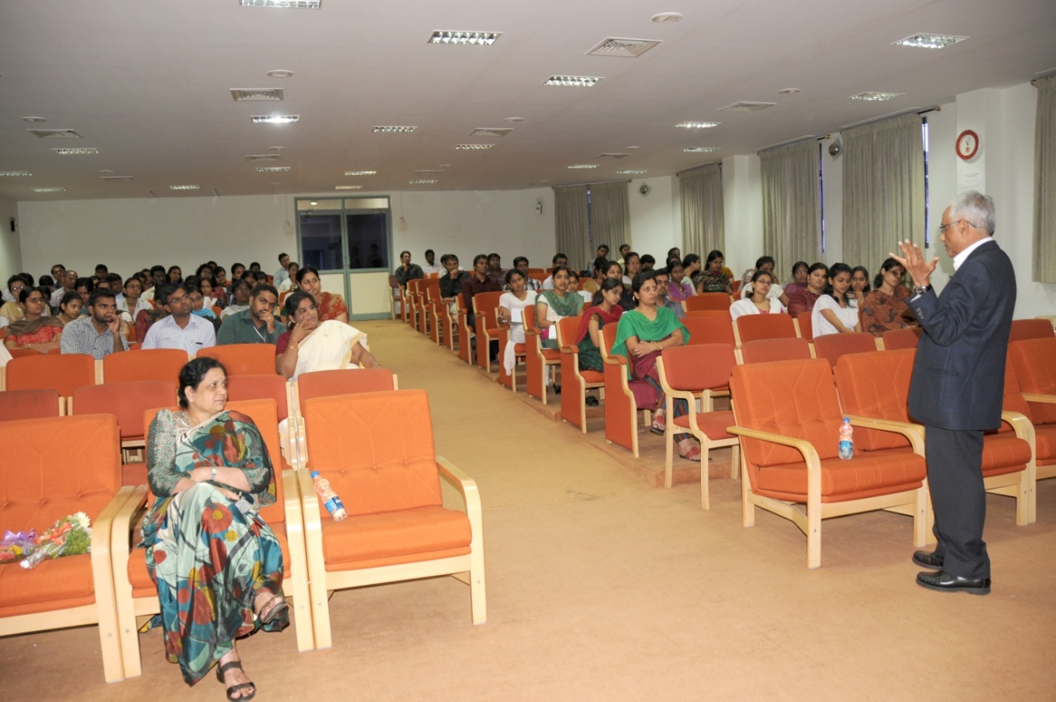

Dr. M. Pushpavathi, Academic Coordinator attended the meeting related to Yuva Sambhrama and the Examination related issues at the Centenary hall, UOM on 12.9.2012.

On 04.12.2012 – Parent-teacher meeting was arranged in the Seminar Hall, where 30-40 parents of AIISH students participated.

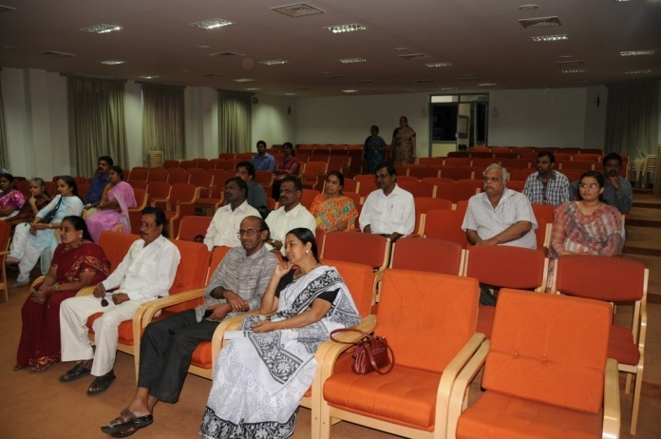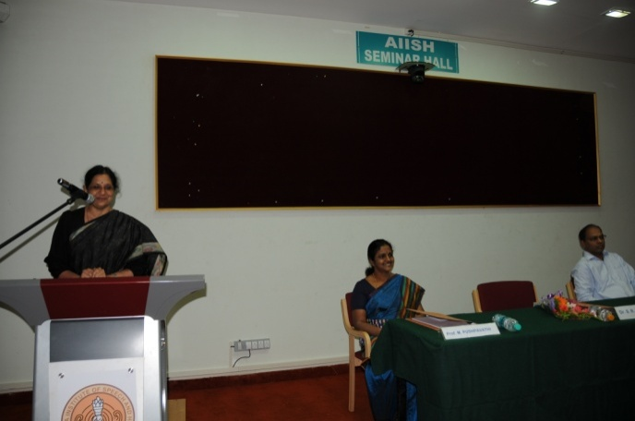

**Parents of Students of AIISH Director addressing the Parents of students of AIISH**

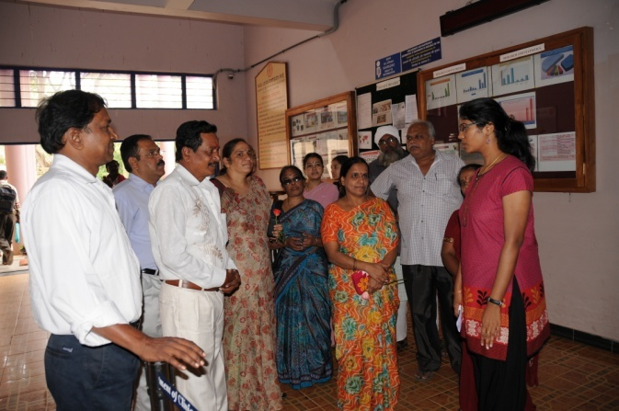 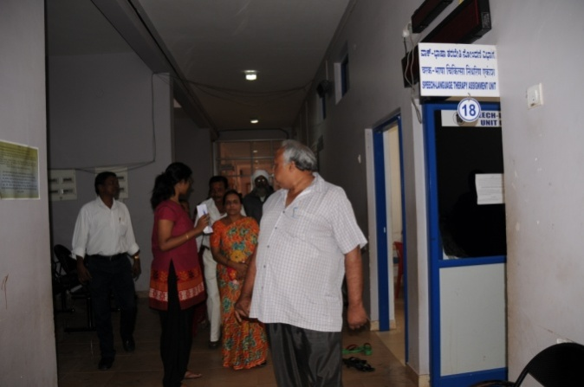

**Parents visiting the different department of AIISH**

AIISH participated in Margadarshi – Educational Vocational & Career Fair at Vijaya Vittala Vidyashala Premises, Kamakshi Hospital Road, Mysore from 10.00 am to 4.00 pm on 23rd December, 2012 and oriented around 400 students about the institute and the courses conducted at AIISH.

ARF staff members distributed the AIISH pamphlets to 45 education institutions (schools and colleges) to create awareness about the program offered at AIISH. 12 ARF staff members visited 45 schools and colleges.

**Guest faculty**

Expertise in allied area in speech and hearing such as Paediatrics, Pathology, Neurology and Genetics were augmented by inviting visiting faculty from other premier institutions such as K. R. Hospital, Mysore; JSS Medical College, Mysore; BGS Apollo Hospital, Mysore; who imbibed the students with their expert knowledge. This has enabled the institute to fulfill the commitment made to the student fraternity in imparting higher education. The names and area of expertise of the visiting faculty is given in the table below:

|  |  |
| --- | --- |
| **Name of the subject** | **Name of the visiting faculty** |
| Neurology | Dr. Somanath Vasudev |
| Pediatrics | Dr. Rajendra Kumar |
| Genetics | Dr. Shyamsundar |
| Pathology | Dr. A. L. Hemalatha |
| Epidemiology | Dr. S.N. Manjunath |

Registrar