Major Events

Many important academic, research, clinical and other events took place in the institute during the reporting year. This chapter outlines some of them.

**Launching of Unit for Structural Orofacial Anomalies (U-SOFA):** U-SOFA, a specialized clinic which facilitates services to children and adults with cleft lip palate and other craniofacial anomalies, was launched by Mr. K. Chandramouli, IAS, Secretary, Ministry of Health & Family Welfare, Govt. of India, New Delhi on 9 August 2011. Dr. K. S. Sriprakash, Vice-chancellor, Rajiv Gandhi University of Health Sciences, Bangalore and Dr. K. S. Rangappa, Vice-Chancellor, Karnataka State Open University, Mysore were the guests of honor during the event. The objective of U-SOFA is to provide multi-disciplinary assessment and rehabilitation of clients with structural orofacial anomalies and develop specialized speech assessment and evidence-based rehabilitation techniques.

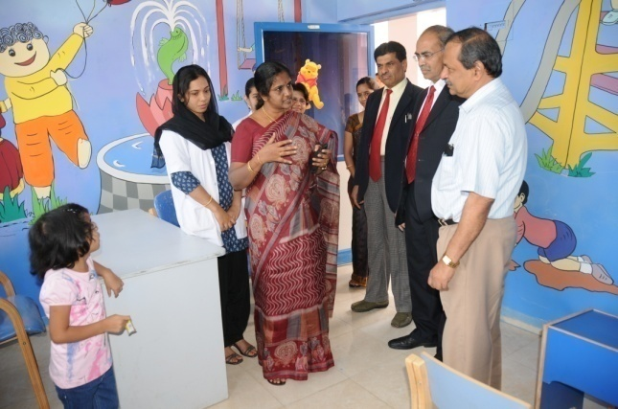

Launching of U-SOFA

**Opening of Learning Disability Clinic (LDC):** The institute opened a clinic for the early identification of students with learning disability and to suggest appropriate remedial measures. The clinic will also serve as a nodal centre for issue of certificates for educational concessions and developing related literature. Dr. K. S. Rangappa, Vice-Chancellor, Karnataka State Open University, Mysore inaugurated the clinic on 9 August 2011. Mr. K. Chandramouli, IAS, Secretary, Ministry of Health & Family Welfare, Govt. of India, New Delhi and Dr. K. S. Sriprakash, Vice-Chancellor, Rajiv Gandhi University of Health Sciences, Bangalore were present.

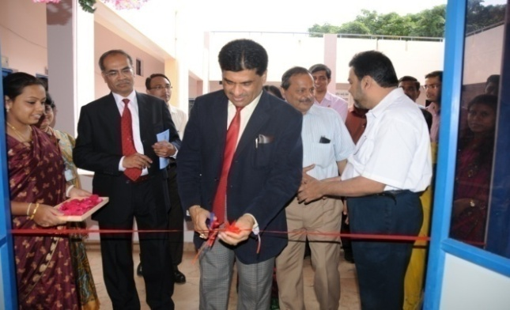

Opening of Learning Disability Clinic

**Inauguration of Motor Speech Disorders Clinic (MSDC):** This is a special clinic for persons with motor speech disorders which will provide systematic assessment and rehabilitation services by adopting state-of-the-art technology and bring awareness among the public. The clinic was inaugurated by Mr.K. Chandramouli, IAS, Secretary, Ministry of Health & Family Welfare, Govt. of India, New Delhi on 9 August 2011.

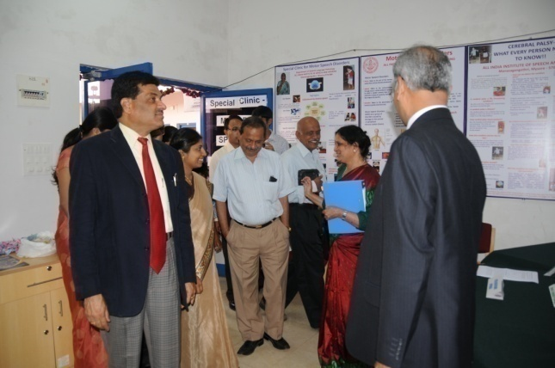

Inauguration of Motor Speech Disability Clinic

**All India DHLS Coordinators Meet:** The annual meeting of the coordinators of 12 Diploma in Hearing Language and Science (DHLS) centers of the institute spread across the country, was held on 22-23 September 2011. Prof. K.C Shyamala, Overall Coordinator of the DHLS centers welcomed the coordinators. Dr. S.R.Savithri, Director, addressed the meet and placed on record the excellent service of the coordinators. She briefed the objectives of the meet and each of the coordinator presented on the progress of the center, feedback of the previous year, admission to the DHLS program for the current year, requirements and other matters for the year 2011-12. Various issues such as RCI recognition and job prospects of the diploma students were discussed during the meet.

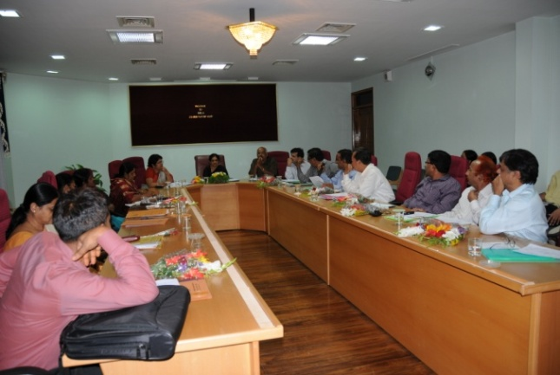

DHLS Coordinators’ Meet

**Dementia Week:** National Dementia Awareness Week was observed on 18-24 September 2011 with special emphasis on World Alzheimer’s Day on 21st September. The objective of the program was to create awareness among the general public and the students about dementia and Alzheimer’s disease.

**International Deafness day:** The International Deafness Day was held on 26 September 2011 under the aegis of the Department of Clinical Services. Various activities such as painting and drawing were conducted during the event for children with hearing impairment. Posters on various aspects of deafness were also displayed to create awareness about hearing impairment among the parents of children with deafness and the general public.

**Caregivers Literacy Training Unit (CLTU) :** This unit was launched in theDepartment of Special Education of the institute with the aim of empowering parents of special children on aspects like literacy skills, computer skills and preparation of teaching-learning material so that they can function as better partners with special educators. Literacy skills in parents play a very important role for the academic achievement of children with special needs. The unit was inaugurated by Dr. Shankaregowda, District Mass Education officer, District Adult Education Department, Govt. of Karnataka, Mysore on 29 September 2011.

**Foundation Stone for Knowledge Park*:*** Mr.Keshav Desiraju, Additional Secretary, Ministry of Health and Family Welfare, Govt. of India, New Delhi laid the foundation stone for the Knowledge Park, a modern academic building complex on 12 October 2011. Dr. S. Y. Kothari, Additional Director General of Health Services, Govt. of India, New Delhi was present. The three-storey Knowledge Park will spread over 34,254 sq.ft. and will have a seminar hall with 400 seats, 10 classrooms with state-of the art teaching learning equipments and a mini library.

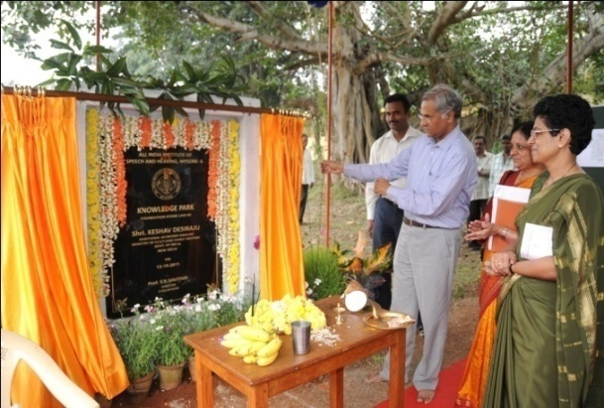

Foundation stone laying of Knowledge Park

**International Stuttering Awareness Day:** TheInternational Stuttering Awareness Day (ISAD) was observed on 24 October 2011 by Department of Clinical Services. The objective of the program was to orient the public and persons with stuttering on various aspects of stuttering such as characteristic features, causes, myths and facts, role of teachers in the identification of stuttering, and promoting and protecting the rights of persons with stuttering. Students from B.Ed. and D.Ed. colleges participated in the event.

**Tree Planting Program**: With its continued commitment to preserve and protect environment the institute under its Horticulture Section conducted a Tree Planting Program on 22 November 2011. Dr. S.R Savithri, Director inaugurated the activity by planting a coconut tree. During the program, the students and staffs planted more than 100 tree saplings of various varieties at the main campus.

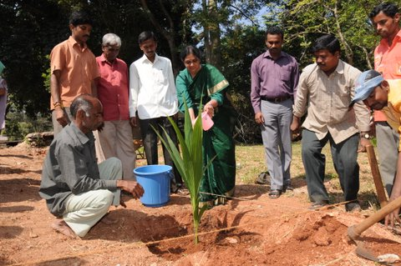

Inauguration of Tree Planting Program

**International Day of Persons with Disabilities:** The International Day of Persons with Disabilities was observed in the institute on 5 December 2011 and in this connection, the Department of clinical services organized a seminar on Rights and Acts for Persons with Disability. The objective of the seminar was to craft a better world including persons with disabilities in global development. Mr. K. V. Rajanna, Commissioner for Disabilities, Govt. of Karnataka, Bangalore inaugurated the seminar. Dr. Ishwar Bhat, Chairman, Department of studies in Law, University of Mysore, Mysore was the guest of honor. Around 200 persons from various parts of the country were honored at the seminar.

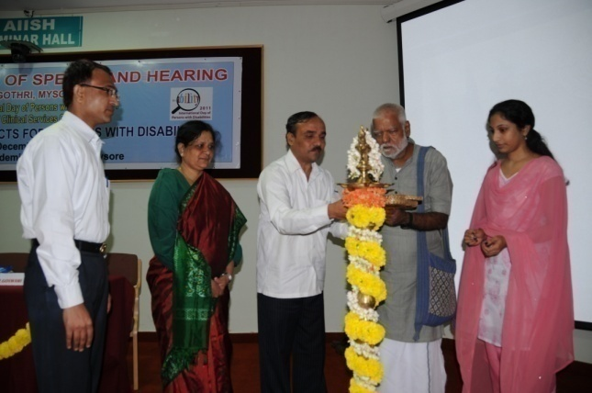

Inauguration of International Day of Persons

with Disabilities

**Launching of Network Link:** A network connection was established between the institute main campus at Mysore and its ten DHLS centers spread across the country on 3 February 2012. Sri Keshav Desiraju, IAS, Additional Secretary, Ministry of Health & Family Welfare, Govt.of India, New Delhi inaugurated the facility. Dr. B. D. Athani, Additional DGHS & Medical Superintendent, Safdarjung Hospital, New Delhi, was the Guest of Honor. The system which

is based on Virtual Private Network technology, enables the DHLS centres to access digital resources of the institute such as e-books, e-journals and facilities such as e-mail.

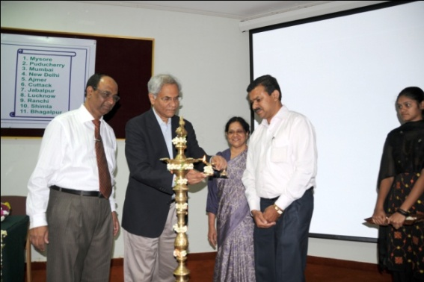

Launching of Network Link

Academic Activities

All India Institute of Speech and Hearing, the leading and trend-setting institution in the field of communication disorders, delivers a variety of practitioner-oriented academic programs to meet the manpower requirements in the field. This chapter details the courses offered, students admitted, workshops and conferences organized, and the guest lectures delivered during the reporting year.

**Academic Programs Offered**

The institute offered 14 academic programs ranging from certificate to post-doctorates during the reporting year. Of these, Diploma in Hearing, Language and Speech (DHLS) was offered at 12 centers across the country and classes were delivered from the institute through video conferencing. Graduate, PG Diploma, Post-graduate and Doctoral programs had the approval of the University of Mysore/Rehabilitation Council of India. Table 1 shows the details of the programs offered in 2011-12.

Table: 1: Academic Programs Offered

|  |  |  |  |
| --- | --- | --- | --- |
| **Sl.No** | **Program** | **Dura-tion** | **No. of seats** |
|  | Certificate Course for Care givers of Children’s with Developmental Disabilities(C4D2) | 2 wks | ** |
|  | Diploma in Hearing Aid & Earmould Technology (D.H.A. & E.T.) | 1 yr | 25 |
|  | Diploma in Teaching Young Deaf & Hard of Hearing (D.T.Y.D.H.H.) | 1 yr | 20 |
|  | Diploma in Hearing, Language and Speech (D.H.L.S.) | 1 yr | 300* |
|  | B.Sc. (Speech & Hearing) | 4 yrs | 62 |
|  | B.S.Ed. (Hearing Impairment) | 1 yr | 20 |
|  | PG Diploma in Forensic Speech Sciences & Technology (P.G.D.F.S.S.T.) | 1 yr | 10 |
|  | PG Diploma in Clinical Linguistics (Speech-Language Pathology) (P.G.D.C.L-SLP) | 1 yr | 10 |
|  | M.Sc. (Speech-Language Pathology) | 2 yrs | 36 |
|  | M.Sc. (Audiology) | 2 yrs | 36 |
|  | M.S.Ed. (Hearing Impairment) | 1 yr | 20 |
|  | Ph.D. (Audiology) | 3 yrs | 4 |
|  | Ph.D. (Speech-Language Pathology) | 3 yrs | 4  (backlog-3) |
|  | Post Doctoral Degree | 2 yrs | 2 |
| **Total** | | | **552** |

*Total seats in 12 centres

** Vary from year to year

**II. Admission and Enrolment**

National level entrance examinations were conducted to admit students to B.Sc. (Speech & Hearing), M.Sc. (Audiology) and M.Sc. (Speech-Language Pathology). Totally, 505 candidates appeared for the B.Sc. entrance examination held in different parts of the country. Entrance examinations to M.Sc. (Audiology) and M.Sc. (Speech-Language Pathology) held at the institute campus in Mysore were attended by 172 and 133 candidates, respectively. Admissions to all the diploma, post-graduate diploma and bachelor of Special Education courses were done based on the merit obtained in the respective qualifying examinations. Ph.D. admission was based on personal interview and merit in the qualifying examination.

The total number of students admitted to various programs during the reporting year was 344, and 188 among them were girls. The number of students admitted to each course is given in table 2 and the state-wise admission is given in figure 1.

Table 2: Student Intake 2011-12

|  |  |  |
| --- | --- | --- |
| **Sl .**  **No** | **Program** | **No. of intake** |
|  | C4D2 | 25* |
|  | D.H.A. & E.T. | 3 |
|  | D.T.Y.D.H.H. | 2 |
|  | D.H.L.S. AIISH, Mysore | 13 |
| JIPMER, Puducherry | 21 |
| RIMS, Imphal | 22 |
| AIIPMR, Mumbai | 7 |
| RML, New Delhi | 14 |
| RIMS, Ranchi | 13 |
| IGMC, Shimla | 10 |
| SRBMC, Cuttack | 11 |
| JLNMC, Ajmer | 10 |
| CSMMC, Lucknow | 23 |
| NSBC, Jabalpur | 21 |
| JNMC, Bhagalpur | 25 |
|  | B.Sc.(Speech&Hearing) | 62 |
|  | B.S.Ed. (Hearing Impairment) | 6 |
|  | P.G.D.F.S.S.T. | - |
|  | P.G.D.C.L-S.L.P. | 6 |
|  | M.Sc.(Speech-Language Pathology) | 32 |
|  | M.Sc. (Audiology) | 33 |
|  | M.S.Ed.(Hearing Impairment) | - |
|  | Ph.D. (Audiology) | 3 |
|  | Ph.D.(Speech-Language Pathology) | 7 |
|  | Post Doctoral Degree | - |
|  | **Total** | **369** |

* Vary from year to year

Figure 1: State-wise distribution of Enrolled Students

**Student Strength:** During the reporting year, 589 students were studying for various programs in the institute, as detailed in table 3.

Table 3: Student Strength

|  |  |  |
| --- | --- | --- |
| **Sl.No** | **Program** | **No. of Students** |
|  | C4D2 | 25 |
|  | D.H.L.S. | 190🟋 |
|  | D.H.A. & E.T. | 3 |
|  | D.T.Y.D.H.H. | 2 |
|  | B.Sc. (Sp. & Hg.) – 1st Yr. | 62 |
|  | B.Sc. (Sp. & Hg.) – 2nd Yr. | 62 |
|  | B.Sc. (Sp. & Hg.) – 3rd Yr. | 60 |
|  | Interns | 44 |
|  | M.Sc. (Audiology) – 1st Yr. | 33 |
|  | M.Sc. (Audiology) – 2nd Yr. | 36 |
|  | M.Sc. (SLP)- 1st Yr. | 32 |
|  | M.Sc. (SLP)- 2nd Yr. | 36 |
|  | B.S.Ed | 6 |
|  | P.G.D.C.L-S.L.P. | 6 |
|  | P.h.D | 17 |
|  | **Total** | **614** |

🟋Total number of students in 12 study centers.

**III. Academic Performance**

The students performed well in the final examinations conducted last year with 100 percentage pass in D.H.L.S, P.G.D.C.L. and M.S.Ed. and more than 90 percentage in B.Sc.(Sp.& Hg.) and M.Sc. (Audiology) examinations. For all other examinations, the pass percentage was 70 or more. The details of academic degrees awarded last year are given in table 4.

Table 4: Academic Awards: 2011-12.

|  |  |  |  |  |
| --- | --- | --- | --- | --- |
| **Sl.**  **No** | **Program** | **No of students appeared** | **Overall pass** | **Percentage** |
| 1 | D.H.A. & E.T. | 4 | 3 | 75 |
| 2 | D.T.Y.H.I. | 7 | 5 | 71 |
| 3 | D.H.L.S. | 6 | 6 | 100 |
| 4 | B.Sc.  (Sp. & Hg.) | 45 | 42 | 95 |
| 5 | B.S.Ed. (H.I.) | 3 | 2 | 70 |
| 6 | P.G.D.C.L. (S.L.P.) | 2 | 2 | 100 |
| 7 | M.Sc. (Audiology) | 36 | 33 | 92 |
| 8 | M.Sc. (S.L.P.) | 35 | 28 | 80 |
| 9 | M.S.Ed. (H.I.) | 5 | 5 | 100 |

**IV. Internship**

Forty six students underwent internship training during the reporting year. They were posted at (i) various clinical units of the institute main campus, (ii) centres of National Program on Prevention and Control of Deafness (NPPCD) and (iii) centres of Diploma in Hearing, Language and Speech. The interns were actively involved in providing assessment and rehabilitation of persons with communication disorders as well as public education on prevention and early identification of communication disorders, during the training period. The details of organizations other than AIISH, where the students underwent internship training are given in table 5.

Table: 5Internship Centers

|  |  |  |
| --- | --- | --- |
| **Sl.**  **No.** | **Institute** | **State** |
| 1 | District Hospital, Chamarajanagara | Karnataka |
| 2 | District Hospital, Chickmangalure | Karnataka |
| 3 | District Hospital, Dharwad | Karnataka |
| 4 | District Hospital, Gulbarga | Karnataka |
| 5 | District Hospital, Mandya | Karnataka |
| 6 | District Hospital, Udupi | Karnataka |
| 7 | Jawaharlal Nehru Medical College Hospital, Ajmer | Rajasthan |
| 8 | JIPMER, Dhanavanthri Nagar, Puducherry | Puducherry |
| 9 | Karnataka Institute of Med. Sciences, Hubli | Karnataka |
| 10 | Chhatrapati Shahuji Maharaj Medical University, Lucknow | Utter Pradesh |
| 11 | M.M.C. Hospital, Kamrup, Guwahati | Assam |
| 12 | N. S.C.B. Medical College, Jabalpur | Madhya Pradesh |
| 13 | R.l.M.S., Imphal | Manipur |
| 14 | Rajendra Institute of Medical Sciences, Ranchi | Jharkhand |
| 15 | Sri Ramachandra Bhanj Medical College, Cuttack | Odisha |

**V. Educational Stipend**

The institute provided educational stipend to all the eligible students pursuing various academic programs and distributed a total amount of `…………’ towards stipend during the reporting year. Program-wise amounts of stipend issued last year are given in table 6.

Table 6: Stipend Issued

|  |  |  |
| --- | --- | --- |
| **Sl.No** | **Program** | **Stipend/month(`)** |
| 1 | Diploma programs | 250.00 |
| 2 | B.Sc. (Sp. & Hg.) | 400.00 |
| 3 | B.Sc. (Internship)* | 3500.00 |
| 4 | B. S. Ed. (HI) | 400.00 |
| 5 | M.Sc. (Audiology) | 650.00 |
| 6 | M.Sc. (SLP) | 650.00 |
| 7 | PGDCL-SLP | 500.00 |
| 8 | Ph. D. (1st & 2nd yr.) | 14000.00+HRA |
| 9 | Ph. D. (3rd yr.) | 15000.00+HRA |

* `1500/- only for internship training at the institute

**VI. Other Financial Assistance**

Apart from the educational stipend, financial assistance to attend and present papers at various national and international seminars, were also made available to the students and staff. Ms. Pravesh Arya, doctoral student received a grant of ` 72,600/- from Indian Council of Medical Research, Dr.Y.V.Geetha, Professor in Speech Sciences and Mrs.Sangeetha M., Clinical Lecturer received a grant of ` 80,000 each from the institute, to attend 9th Oxford Dysfluency Conference, St. Catherine's College, Oxford University, Oxford, UK, 1-4 September 2011. Mrs.Sangeetha M., Clinical Lecturer also received a financial support of ` 20,000 from the Centre for International Cooperation in Science (CICS), Chennai in view of expenses of the Oxford Dysfluency Conference.

**VII. Faculty**

The experienced and well qualified teachers of the institute were engaged in teaching and mentoring the students and were available for supporting learners in every possible manner. The institute had a faculty strength of 50 during the reporting year which includes 43 regular and 7 contract staff. Category-wise, there were 31 lecturers, 8 readers and 11 professors. One permanent and seven contract teaching staff were appointed newly during the period. Expertise in allied area such as paediatrics, pathology, neurology and genetics were augmented by inviting experts from other premier healthcare institutions in Mysore such as Govt. Medical College, JSS Medical College, and BGS Apollo Hospital.

**Invited Talks Delivered by the Faculty and Staff:** The eminent faculty members and staff of the institute delivered many invited talks on the areas of their expertise on various occasions both inside and outside the institute. Totally 121 such invited talks were delivered during the reporting year, the details of which are given below.

**Dr. Savithri S.R, Professor in Speech Sciences and Director**

* Aural Perceptual Speaker Identification. Lecture delivered at the National workshop on Forensic Speaker Identification, organized by the Department of Speech Language Sciences, AIISH on 11-14 April 2011.
* About AIISH: Research and Labs at AIISH; Automatic Speaker Identification and Speech Processing Strategies to Enhance Depth Modulation; Cross Language Perception; Development of Text to Speech Software in Indian Languages; Low Cost Open Platform Digital Hearing Aids; Speech Oriented Learning Systems for Hearing Impaired. Lectures delivered at the conference organized as a part of ‘India 2011’, by the Department of Electronics and Telecommunication, Norwegian University of Science and Technology (NTNU), Trondheim, Norway on 5-10 October 2011.
* Fluency and Disfluency, Lecture delivered at the International Stuttering Awareness Day, organized by the Department of Clinical Services, AIISH on 24 October 2011.
* Speech Rhythm in Kannada Speaking Children. Prof. Rais Ahmed Memorial lecture delivered at the National Symposium on Acoustics (NSA 2011), organized by Bundelkhand University, Jhansi on 17 November 2011.
* Perception of Prosody in Brain Damaged. Invited lecture delivered at International Symposium on Frontiers of Research on Speech Music and Allied Signal Processing (FRSM 2012), organized by KIIT College of Engineering, Gurgaon, Hariana on 18-19 January 2012.
* Acoustic Analysis of Voice and Speech. Key note address delivered at the National Workshop on Voice and Speech, organized by JSS Institute of Speech and Hearing, Mysore on 19 February 2012.
* Introduction to Fluency and its Disorders. Lecture delivered at the National Seminar on Fluency Disorders, organized by the Department of Speech-Language Sciences, AIISH on 16 March 2012.

**Mr.Ajish K. Abraham, Reader in** **Electronics**

* Digital Signal Processing in Hearing Aids and Cochlear Implants. Lecture delivered at the Orientation Program for M.Tech in Biomedical Engineering students, organized by Sri Jai Chamarajendra Engineering College, Mysore on 7 April 2011.
* Cepstral Co-efficients and Mel Frequency Cepstral Co-efficients. Lecture delivered at the National Workshop on Forensic Speaker Identification, organized by the Department of Speech-Language Sciences, AIISH, Mysore on 11-14, April 2011.
* Museum Accessibility Options for Children with Hearing Impairment. Lecture delivered at the Special Nature Camp for the children with hearing impairment, organized by the Regional Museum of Natural History, Mysore, at Bannerghatta National Park, Bangalore on 4-6 June 2011.
* Audiometer. Lecture delivered at the Orientation Program for final year students, Diploma in Electronic Instrumentation and Control Engineering students, organized by the J.S.S. Polytechnic College for Women, Mysore on 14 September 2011.
* Protocol for Noise Measurement. Lecture delivered at the National Workshop on Noise Measurement and Conservation of Hearing in Industrial Workers, organized by the Dr. S. R. Chandrasekhar Institute of Speech and Hearing (Dr. SRCISH), Bangalore on 1-3 December 2011.

**Dr. Ajith Kumar U., Reader in** **Audiology**

* Speech and Auditory Processing in the Cortex: Evidence from Functional Neuroimaging. Lecture delivered at the National Symposium on Assessment and Management of (Central) Auditory Processing Disorders, organized by the Department of Audiology, AIISH on 19-20 August 2011.
* Neurophysiological Model of Tinnitus and Hyperacusis. Lecture delivered at the National Seminar on Evaluation and Management of Tinnitus, organized by the Department of Audiology, AIISH on 30 September 2011.

**Dr.Animesh Barman, Reader in Audiology**

* Neuromaturation, Neurodegeneration and Neuroplasticity of the Auditory Information Processing. Lecture delivered at the National Symposium on Assessment and Management of (Central) Auditory Processing Disorders, organized by the Department of Audiology, AIISH on 19-20 August 2011.

**Mr. Arunraj K., Clinical Assistant**

* Electrophysologial Assessment of (C)APD. Lecture delivered at the National Symposium on Assessment and Management of (Central) Auditory Processing Disorders, organized by the Department of Audiology, AIISH on 19-20 August 2011.

**Dr. Asha Yathiraj, Professor in Audiology**

* Central Auditory Processing and Cognition. Lecture delivered at the National Symposium on Exploring Areas of Research in Cognitive Sciences, organized by the Department of Audiology, AIISH on 30 June-1 July 2011.
* Overview of CBCS. Lecture delivered at the Faculty Enrichment Program on CBCS, organized by the Academic Section, AIISH on 1 August 2011.
* Management of (C) APD: Deficit Based Management of (C)APD. Lecture delivered at the National Symposium on Assessment and Management of (Central) Auditory Processing Disorders, organized by the Department of Audiology, AIISH on 19-20 August 2011.
* Direct Remediation of (C)APD. Lecture delivered at the National Symposium on Assessment and Management of (Central) Auditory Processing Disorders, organized by the Department of Audiology, AIISH on 19-20 August 2011.
* Speech Perception through Cochlear Implants. Lecture delivered at the National Seminar on Advances in Cochlear Implant Technology, organized by the Department of Audiology, AIISH on 18-19 November 2011.

**Mr. D. Baba Fakruddin, Audiologist**

* Recent Hearing Aid Devices. Lecture delivered at the Workshop on Fine Tuning of Digital Hearing Aids for individuals with hearing impairment, organized by the Department of Audiology, AIISH on 10 October 2011.

**Mr. Chethan C., Ear Mould Technician**

* Different Techniques of Impression Taking for Hard and Soft Mould. Lecture delivered at the the Workshop on Ear Mold Technology, organized by the Department of Audiology, AIISH on 6-7 September 2011.

**Ms. Chandni Jain, Lecturer in Audiology**

* Behavioural Assessment of (C)APD: Development of Tests. Lecture delivered at the National Symposium on Assessment and Management of (Central) Auditory Processing Disorders, organized by the Department of Audiology, AIISH on 19-20 August 2011.

**Ms. Devi N., Lecturer in Audiology**

* Management of (C)APD: Environmental Modification including Classroom Management for APD. Lecture delivered at the National Symposium on Assessment and Management of (Central) Auditory Processing Disorders, organized by the Department of Audiology, AIISH on 19-20 August 2011.
* Auditory Verbal Therapy for Children and Adults. Lecture delivered at the Workshop on Cochlear Implant and Baha Updates 2012 for Dummies, organized by Basaveswara Medical College and Hospital, Chitradurga on 11 March 2012.

**Ms. Geetha C., Lecturer in Audiology**

* Introduction of Ear Moulds, Materials in Ear Mould Making, Different Styles of Ear Moulds. Lecture delivered at the Workshop on Ear Mold Technology, organized by the Department of Audiology, AIISH on 6-7 September 2011.

**Dr.Y.V.Geetha, Professor in Speech Sciences**

* Role of Teachers in the Management of Stuttering in Classroom. Orientation lecture delivered to B.Ed trainees on International Stuttering Awareness Day, organized by the Department of Clinical Services, AIISH on 24 October 2011.
* Recent Theoretical Perspectives on Stuttering. Lecture delivered at the National Seminar on Fluency Disorders, organized by the Department of Speech Language Sciences, AIISH on 16 March 2012.

**Mr. Gopi K., Lecturer in Speech Pathology**

* Management of Hypofunctional Voice Disorders: Vocal Fold Paralysis. Lecture delivered at the National Seminar on Evidence Based Practice in the Management of Voice Disorders and Fluency Disorders, organized by the Department of Speech Language Sciences, AIISH on 15 March 2012.

**Dr. S.P. Goswami, Reader in** **Speech Pathology**

* Speech and Language Management for Persons with Stroke. Lecture delivered at the National Seminar on Stroke, organized by the Department of Clinical Services, AIISH on 10-11 November 2011.
* Revised Right Days Act. Lecture delivered at the Seminar on Rights and Acts for Persons with Disability, organized by the Department of Clinical Services, AIISH on 5 December 2011.
* Disability Act and Dementia: Socio-legal Issues. Lecture delivered at the 44th Indian Speech and Hearing Association Conference (ISHACON), University of Hyderabad, Hyderabad, 19 January 2012.

**Mr. Jawahar Antony P., Audiologist**

* Direct Remediation of (C)APD. Lecture delivered at the National Symposium on Assessment and Management of (Central) Auditory Processing Disorders, organized by the Department of Audiology, AIISH on 19-20 August 2011.
* Electrophysologial Assessment of (C)APD. Lecture delivered at the National Symposium on Assessment and Management of (Central) Auditory Processing Disorders, organized by the Department of Audiology, AIISH on 19-20 August 2011.
* Fine Tuning of Digital Hearing Aids. Lecture delivered at the Workshop on Fine Tuning of Digital Hearing Aids for Individuals with Hearing Impairment, organized by the Department of Audiology, AIISH on 10 October 2011.

**Dr.G. Jayarama, Reader in** **Clini. Psychology**

* Importance of Psychological Assessment in Patients with Communication Disorders. Lecture delivered at the Workshop on Early Identification of Communication Disorders, organized by the Department of ENT, AIISH on 21 September 2011.
* Maneyolagina Samvahana. Phone-in Program in Kannada on Communication in Family, organized and broadcasted by All India Radio, Mysore on 21 March 2012.

**Dr. Jayshree Shanbal, Lecturer in Language Pathology**

* Assessment of Language Disorders in School Going Children. Lecture delivered at the Staff Enrichment Program, organized by the Atomic Energy School, Mysore on 11 May 2011.
* Identification of Language Problems in School Going Children. Lecture delivered at the Sarva Siksha Abhiyan Program for Inclusive Education Resource Teachers, organized by the Department of Clinical Psychology, AIISH on 9 June 2011.
* Assessment of Communication Disorders. Lecture delivered at the Orientation Program for NGO workers, Aashiyana, Mysore , organized by the Department of Clinical Psychology, AIISH on 21 June 2011.

**Mr. Jithin Raj B., Audiologist**

* Electrophysologial Assessment of (C)APD. Lecture delivered at the National Symposium on Assessment and Management of (Central) Auditory Processing Disorders, organized by the Department of Audiology, AIISH on 19-20 August 2011.

**Dr.G. Malar, Reader in** **Special Education**

* Identification of Special Needs in School Children and Management of Special Needs in Mainstream Classrooms. Lecture delivered at the Program for Sensitisation of Caregivers of Children with ASD, organized by the Department of Clinical Psychology, AIISH on 13 May 2011.
* Vocational Assessment and Community Living Skills. Lecture delivered at the Program for Sensitisation of Caregivers of Children with ASD, organized by the Department of Clinical Psychology, AIISH on 22 September 2011.
* Educational Opportunities and Facilities for Children with Special Needs. Lecture delivered at the Parent Enrichment Programme, organized by the Department of Special Education, AIISH on 23 September 2011.
* Identification of Special Needs in School Children and Management of Special Needs in Mainstream Classrooms. Lecture delivered at Sarva Siksha Abhiyan Program for Inclusive Education Resource Teachers, organized by the Department of Clinical Psychology, AIISH on 29 September 2011.
* Educational Guidance and Services. Lecture delivered at the Monthly Video-Conferencing Program, organized by the Center for Rehabilitation and Education through Distance Mode, AIISH on 24 October 2011.
* Educational Technology for Children with Special Needs: An Overview. Lecture delivered at the Workshop on Application of Educational Technology in Teaching Children with Special Needs, organized by the Department of Special Education, AIISH on 7 December 2011.
* Identification and Management of Special Learning Needs in Mainstream Classrooms. Lecture delivered at the Regional In-Service Course for Primary School Educators, organized by the Kendriya Vidyalaya, Southern Region, Mysore on 28 December 2011.
* Pre-academic Training. Lecture delivered at the Workshop on Early Intervention in Natural Environment for Children with Hearing Impairment, organized by the Department of Special Education, AIISH on 28 February 2012.

**Dr. R. Manjula, Professor in Speech Pathology**

* Manjula R.. Neurogenic Communication Disorders and Cognition. Lecture delivered at the National Symposium on Exploring Areas of Research in Cognitive Sciences, organized by the Department of Audiology, AIISH on 30 June-1 July 2011.
* Prevention and Early Identification of Speech and Language Disorders. Lecture delivered at the Workshop on Early Identification of Communication Disorders, organized by the Department of ENT, AIISH on 21 September 2011.
* Prevention of Noise Induced Hearing Loss. Lecture delivered at the Training Program for Medical Officers in Karnataka on Occupational Health Risks, organized by Southern Regional Occupational Health Centre and ICMR, Bangalore on 23 September 2011.
* Profiling and Management of Articulation Disorders in Motor Speech Disorders. Lecture delivered at the National Workshop on Phonological Disorders: Clinical Perspectives, organized by the Department of Clinical Services, AIISH on 6 January 2012.
* Screening Newborns for Hearing, Speech and Language in Community Set Up. Lecture delivered at the National Multi-disciplinary Consultative Meet on Developing Operational Guidelines for Developmental Screening and Early Intervention Services (0-3 years) for at risk Newborns Discharged from the Health Facility, organized by UNICEF and Department of Neonatology, IPGMER & S.S.K.M. Hospital, Kolkata on 24-26 January 2012.

**Ms. Megha, Clinical Assistant**

* Direct Remediation of (C)APD. Lecture delivered at the National Symposium on Assessment and Management of (Central) Auditory Processing Disorders, organized by the Department of Audiology, AIISH on 19-20 August 2011.
* Fine Tuning of Digital Hearing Aids. Lecture delivered at the Workshop on Fine Tuning of Digital Hearing Aids for Individuals with Hearing Impairment, organized by the Department of Audiology, AIISH on 10 October 2011.

**Mr. Niraj K. Singh, Lecturer in Audiology**

* Mechanisms of Selected Auditory and Related Processes: Overview of (C)APD. Lecture delivered at the National Symposium on Assessment and Management of (Central) Auditory Processing Disorders, organized by the Department of Audiology, AIISH on 19-20 August 2011.
* Anatomy of the Non-classical Auditory Pathway. Lecture delivered at the National Seminar on Evaluation and Management of Tinnitus, organized by the Department of Audiology, AIISH on 30 September 2011.

**Mr. Prashanth Prabhu P., Clinical Assistant**

* Behavioural Assessment of (C)APD. Lecture delivered at the National Symposium on Assessment and Management of (Central) Auditory Processing Disorders, organized by the Department of Audiology, AIISH on 19-20 August 2011.

**U. Pratibha, Clinical Psychologist**

* Suicide Prevention. Lecture delivered as a part of Lecture Series Program, organized by Indian Association of Clinical Psychologists, Mysore Chapter, University of Mysore on 12 September 2011.
* Adaptive Behaviors and Behavioral Management in Children with ASD. Lecture delivered at the Seminar on Educational Management of Children with ASD, organized by the Department of Special Education, AIISH on 29 February 2012.

**Mr.Prawin Kumar, Lecturer in Audiology**

* Screening for (C)APD. Lecture delivered at the National Symposium on Assessment and Management of (Central) Auditory Processing Disorders, organized by the Department of Audiology, AIISH on 19-20 August 2011.
* Baseline Evaluation and Grouping of Children for Training. Lecture delivered at the Workshop on Facilitating Early Intervention in Natural Environment for Children with Hearing Impairment, organized by the Department of Special Education, AIISH on 28 February 2012.

**Dr. K.S.Prema, Professor in Language Pathology**

* Communication Disorders. Answered questions on communication disorders at Namma Arogya Program, organized and broadcasted by AIR, Mysore on 27 April 2011.
* Language and Cognitive Skill Development in Children through Play Behavior: Parents’ Role. Talk delivered at Paraspara Live Phone-in Program, organized and broadcasted by AIR, Mysore on 28 April 2011.
* Prevention and Early Identification of Learning Disability. Lecture delivered at the Staff Enrichment Program, organized by the Atomic Energy School, Mysore on 12 May 2011.
* Management of Children with Disabilities. Participated and coordinated interview with parents and professionals at the Bandhani Program, organized and broadcasted by AIR, Mysore on 9 June 2011
* Cognition and Literacy: Issues for Rsearch in the Indian Context. Plenary talk delivered at the National Symposium on Cognitive Sciences, organized by the Department of Speech Language Sciences,AIISH on 30 June- 1 July 2011.
* Academic Problems in Primary School Children. Lecture delivered at Sarva Siksha Abhiyan Program for Inclusive Education Resource Teachers, organized by the Department of Clinical Psychology, AIISH on 29 September 2011.
* Academic Problems in Primary School Children. Lecture delivered at Sarva Siksha Abhiyan Program for Inclusive Education Resource Teachers, organized by the Department of Clinical Psychology, AIISH on 2 February 2012

**Dr. G. Rajeshwari, Professor in ENT**

* Medical Aspects of Tinnitus and Hyperacusis and its Medical Management. Lecture delivered at the National Seminar on Evaluation and Management of Tinnitus and Hyperacusis, organized by the Department of Audiology, AIISH on 30 September 2011.

**Dr.Ramadevi K.J., Audiologist**

* Care, Use and Troubleshooting of Hearing Aids. Lecture delivered at the Workshop on Body Level Hearing Aid Users, organized by the Department of Audiology, AIISH on 22 June 2011.
* Digital Hearing Aids: Care, Use and Troubleshooting. Lecture delivered at the Workshop on Fine Tuning of Digital Hearing Aids for Individuals with Hearing Impairment, organized by the Department of Audiology, AIISH on 10 October 2011.

**Dr. Sandeep M., Lecturer in Audiology**

* Audiological Assessment of Tinnitus and Hyperacusis. Lecture delivered at the National Seminar on Evaluation and Management of Tinnitus, organized by the Department of Audiology, AIISH on 30 September 2011.

**Ms. Sangeetha M., Clinical Lecturer**

* An Overview and Identification of Speech Disorders in School Going Children. Lecture delivered at Sarva Siksha Abhiyan Program for Inclusive Education Resource Teachers of Lakshadweep, organized by the Department of Clinical Psychology, AIISH on 20 September 2011.
* Stuttering. Lecture delivered at the Seminar on Stuttering, organized by the Department of Clinical Services, AIISH on 29 October 2011.
* Govt. Schemes, Benefits and Concessions for Persons with Differentially Abled. Lecture delivered at the Orientation Program for NGO workers, Aashiyana, Mysore , organized by the Department of Clinical Psychology, AIISH on 21 June 2011.

**Mr. Sanjeev K. Gupta, Clinical Psychologist**

* Etiology of Suicide. Lecture delivered as a part of Lecture Series Program organized by Indian Association of Clinical Psychologists, Mysore chapter, University of Mysore on 12 September 2011.

**Dr. Santosh M.,** **Reader in** **Speech Sciences**

* Challenges in Management of Stuttering. Lecture delivered at the National Seminar on Fluency Disorders, organized by the Department of Speech Language Sciences, AIISH on 16 March 2012.

**Dr. K.C. Shyamala, Professor in Language Pathology.**

* Bilingual Issues and Cognition. Lecture delivered at the National Symposium on Exploring Areas of Research in Cognitive Sciences, organized by the Department of Speech Language Sciences, AIISH, on 30 June-1 July 2011.
* Assessment of Aphasia in Indian Context: Illiteracy & Multilingualism. Lecture delivered at the 2nd Teaching Course, organized by World Federation of Neurology, Kolkata on 6 January 2012.
* Dementia: Characteristics, Differential Diagnosis & Assessment. Lecture delivered at 44th Indian Speech and Hearing Association Conference (ISHACON), University of Hyderabad, Hyderabad on 19 January 2012.
* Multilingualism and Issues in Speech Language Pathology. Dr. N. Ratna Oration lecture delivered at 44th Indian Speech and Hearing Association Conference (ISHACON), University of Hyderabad, Hyderabad on 21 January.2012.

**Dr. N.Sreedevi, Lecturer in Speech Sciences**

* Assessment of Phonological Disorders. Lecture delivered at the National Workshop on Phonological Disorders: Clinical perspectives, organized by the Department of Speech Language Sciences, AIISH on 6 January 2012.
* Remedial Measures for Mis-articulation in Children with Special Needs. Lecture delivered at the Parents Enrichment Program, organized by the Department of Special Education, AIISH on 8 March 2012.

**Mr. Sreeraj K., Lecturer in Audiology**

* Overview, Etiologies, Types of Tinnitus and Epidemiology of Tinnitus and hyperacusis. Lecture delivered at the National Seminar on Evaluation and Management of Tinnitus, organized by the Department of Audiology, AIISH on 30 September 2011.

**Mr .Subramanya, M.N., Laboratory Assistant**

* Ear Mould Making with Hard Material. Lecture delivered at the Workshop on Ear Mold Technology, organized by the Department of Audiology, AIISH on 6-7 September 2011.
* Adaptation in Outreach Programs: Steps to Preserve Impressions. Lecture delivered at the Workshop on Ear Mold Technology, organized by the Department of Audiology, AIISH on 6-7 September 2011.

**Mr.Sujeet K. Sinha, Lecturer in Audiology**

* Neuroanatomy and Neurophysiology of Auditory Information Processing. Lecture delivered at the National Symposium on Assessment and Management of (Central) Auditory Processing Disorders, organized by the Department of Audiology, AIISH on 19-20 August 2011.
* Peripheral and Central Process Involved in Tinnitus and Hyperacusis. Lecture delivered at the National Seminar on Evaluation and Management of Tinnitus, organized by the Department of Audiology, AIISH on 30 September 2011.

**Dr.Swapna, N. Lecturer in Speech Pathology**

* Intervention Strategies in Classroom Settings. Lecture delivered at the Staff Enrichment Program, organized by the Atomic Energy School, Mysore on 11 May 2011.
* Communication, Speech and Language Aspects. Lecture delivered for C4D2 course, organized by the Dept. of Clinical Psychology, AIISH on 21 June 2011.
* Intervention Strategies in Classroom Settings. Lecture delivered at Sarva Siksha Abhiyan Program for Inclusive Education Resource Teachers, organized by the Department of Clinical Psychology, AIISH on 21 September 2011.

**Dr.Vijayakumar N., Lecturer in Audiology**

* Cognitive Involvement in (C)APD. Lecture delivered at the National Symposium on Assessment and Management of (Central) Auditory Processing Disorders, organized by the Department of Audiology, AIISH on 19-20 August 2011.
* Speech Processing and Auditory Evoked Potentials. Lecture delivered at the Seminar on Cognition and Brain Computer Interface, organized by the M S Ramaiah Institute of Technology in collaboration with the Ramaiah Institute of Neurosciences, Bangalore on 26-30 March 2012.

**Dr.S. Venkatesan, Professor in Cli. Psych.**

* Learning Disability: An Introduction. Orientation Lecture delivered to the B.Ed students, Government B.Ed. College, Karaikal, Puducherry, organized by the Department of Clinical Psychology, AIISH, Mysore on 1 April 2012.
* Laws, Rights and Privileges of Persons with Disabilities. Lecture delivered to PG Students of Child Mental Health, Manasa Education Foundation, Kuvempu University, Shimoga at Gangotri School, Mysore on 11 June 2011.
* Cognitive Sciences: Psychological Avenues and Prospects. Lecture delivered at the National Symposium on Exploring areas of Research in Cognitive Sciences, organized by the Department of Speech Language Sciences, AIISH on 30 June- 1 July 2011.
* Psychology in India: Then and Now. Key note address delivered at the Inauguration of the Psychology Association, Christ University, Bangalore on 12 July 2011.
* Disability, Impairments and Handicaps. Lecture delivered for the International Diploma in Guidance and Counseling Program at Regional Institute of Education, Mysore on 16 August 2011.
* Problem Behavior Management in Children. Lecture delivered for the International Diploma in Guidance and Counseling Program at Regional Institute of Education, Mysore on 17 August 2011.
* Learning Disabilities in School Children. Lecture delivered for the International Diploma in Guidance and Counseling Program at Regional Institute of Education, Mysore on 18 August 2011.
* Interventions for Individuals with Central Auditory Processing Disorders: Psychological Perspective. Lecture delivered at the National Symposium on Assessment and Management of (Central) Auditory Processing Disorders, organized by the Department of Audiology, AIISH on 19-20 August 2011.
* Mind Assessment and Management in Persons with Stroke. Lecture delivered at the National Seminar on Stroke, organized by the Department of Clinical Services, AIISH on 10-11 November 2011.
* Psychological Aspects of Stroke. Lecture delivered at the National Seminar on Stroke, organized by the Department of Clinical Services, AIISH on 10-11 November 2011.
* Neuropsychological Functional Assessment Battery for Adult with Mental Retardation (N-FAB)Test. Lecture delivered during the release function of N-FAB Test, organized by M/s Psychotronics, Bangalore on 12 November 2011.
* Academic Problems in School children. Lecture delivered for functionaries under Sarva Siksha Abhiyan, organized by the Faculty of Disability Management and Special Education, Ramakrishna Mission Vivekananda University, Kovai, Tamil Nadu on 3-4 December 2011.
* Disability Rights and Laws: Need for Relook. Lecture delivered at the Seminar on Rights and Acts for Persons with Disability, organized by the Department of Clinical Services, AIISH on 5 December 2011.
* Introduction to Disabilities and Home Based Training Programs. Lecture delivered at Sarva Siksha Abhiyan Program for Home Based Training Workers, organized by the Department of Clinical Psychology, AIISH on 12 January 2012.
* Learning Disability. Workshop lectures delivered at the Workshop on Learning Disability organized by SDM College, Ujire, Dakshina Kannada, sponsored by UGC on 27 January 2012.
* Current Perspectives and Psychological Tools for Evaluation of the Effects of Music Therapy. Lecture delivered at the Workshop on Music Therapy,organized by AYUSH and Ganapati Satchitananda Datta Peetam , Bangalore on 8 February 2012.

**Mr. Vivek A, Prosthodontic Technician**

* Ear Examination and Ear Impression Technique. Lecture delivered at the Workshop on Ear Mold Technology, organized by the Department of Audiology, AIISH on 6-7 September 2011.
* Different Techniques of Impression Taking for Hard and Soft Mould. Lecture delivered at the Workshop on Ear Mold Technology, organized by the Department of Audiology, AIISH on 6-7 September 2011.

**Ms.K.Yeshoda, Lecturer in Speech Sciences**

* Forensic Speaker Identification: Methods and Pattern Matching Techniques and Recording Procedures. Lecture delivered at the Bureau of Police Research and Development, New Delhi on 2, 25 and 26 November 2011.
* Introduction to Speech and Language Methods of Forensic Speaker Identification and Recording Procedures. Lecture delivered at the Bureau of Police Research and Development, New Delhi on 20 January 2012.
* Nonorganic Voice Disorders. Lecture delivered at the National Seminar on Evidence Based Practice in Voice Disorders, organized by the Department of Speech - Language Sciences, AIISH on 15 March 2012.

**Honorary Works done & Academic / Administrative Responsibilities Held:** The faculty and staff of the institute carried out significant honorary works like editorial and referee jobs for journals, reviewing of projects sponsored by national agencies, evaluation of theses and dissertations. Also, they held various academic and administrative positions at the institute and served other organizations, establishments and government bodies under various capacities during the reporting year. The details are given below.

**Dr.S.R. Savithri, Professor in Speech Sciences**

* Director.
* Member, Peer Team, National Assessment and Accreditation Council, Bangalore.
* Member, Selection Committee, Ali Yavar Jung National Institute for the Hearing Handicapped, Mumbai.
* Member, Advisory Committee on Audiological Testing and Dispensing of Hearing Aids and Devices, Rehabilitation Council of India, New Delhi.
* Resource person for Health Care Management (Mental Health) for the Training Programs of Administrative Training Institute, Mysore.
* Member, Governing Council, JSS Institute of Speech and Hearing, Mysore.
* Member, Academic Council, Ali Yavar Jung National Institute of Hearing Handicapped, Mumbai.
* Member, Standing Advisory Committee on Indian Sign Language Research and Training Center, IGNOU, New Delhi.
* Member, Project Review and Steering Group (PRSG) on Speech Technology Consortia Projects, Department of Information Technology, Ministry of Communications and Information Technology, New Delhi.
* Member, Affiliation Committee, College Development Council, University of Mysore, Mysore.
* Member, Expert Committee for the Selection of Associate Professor (Speech and Hearing) in National Institute for Empowerment of Persons with Multiple Disabilities, Chennai.
* Member, CESE, Indian Speech and Hearing Association (ISHA).
* Member, Science Faculty, University of Mysore.

**Mr. Ajish K. Abraham, Reader in Electronics**

* Head, Department of Electronics.
* Member, Acoustics Standards Committee, Bureau of Indian Standards, New Delhi.
* Technical Coordinator , DHLS program.
* Warden , Bodhi Gent’s Hostel.
* Officer In-charge, Institute Vehicles.
* Officer In-charge, Institute Website.
* Member, Board of Examinations, University of Mysore, Mysore.
* Executive Committee Member, AIISH Gymkhana.

**Dr. Ajith Kumar U, Reader in Audiology**

* Chairperson, Application Srutinization Committee for Group ‘A’ posts.
* Member, Board of Examinations, University of Calicut, Calicut.
* Member, Board of Examinations, University of Mysore, Mysore.
* Member, Board of Examinations, Bangalore University, Bangalore.
* Coordinator, NPPCD.
* District Coordinator, NPPCD, Uttara Kannada.
* Officer In charge, AIISH Guest House.
* Liaison Officer.
* Associate Editor, Journal of Indian Speech and Hearing Association.
* Associate Editor, International Journal of Otolaryngology.
* Reviewer, Journal of Audiological Society of America.
* Reviewer, Journal of Indian Speech and Hearing Association.
* Reviewer, Medical hypothesis.
* Reviewer , Journal of All India Institute of Speech and Hearing.
* Reviewer, 44th ISHA Conference Papers.
* Developed material for auditory disclosure.

**Dr. Animesh Barman, Reader in Audiology**

* Head, Department t.of Audiology.
* Member, Board of Examinations, University of Mysore, Mysore.
* Member, Board of Examinations, Bangalore University, Bangalore.
* Coordinator, DHLS Centre, Cuttack.
* Member, Committee for Computerization of Institute Activities.
* Member, Building and Works Committee.
* Member, Patient Welfare Fund Committee.
* Member, Steering Committee, Self-study Report for NAAC.
* Chairperson, Application Scrutinization Committee, Group ‘C’ posts.
* Reviewer, 44th ISHA Conference Papers.

**Dr. Asha Yathiraj, Professor in Audiology**

* Head, Department of Material Development.
* Chairperson, Listening Training Unit.
* Chairperson, Dr. Vijayalakshmi Charitable Society.
* Chairperson, Board of Examinations University of Mysore, Mysore.
* Member, Core Committee, Quasi Distance Mode PG Program in SLHS.
* Member, Inspection Committee, Rehabilitation Council of India, N.Delhi.
* Reviewer, Journal of RCI.
* Reviewer, Journal of Indian Speech and Hearing Association.
* Reviewer, ARF Projects.

**Mr. Brajesh P., Lecturer in Linguistics**

* Coordinator, DHLS Centre, Bhagalpur.
* Joint Secretary, AIISH Gymkhana.

**Ms. Chandni Jain, Lecturer in Audiology**

* Member, Committee on Issues of Clinical Services.
* Member, Listening Training Unit.
* Member, Learning Disability Unit.
* District Coordinator, NPPCD, Mandya.

**Ms. Devi N, Lecturer in Audiology**

* Member, Neonatal Screening Committee, DHLS centre, Cuttack.
* District Coordinator, NPPCD, Chamarajanagar.
* Reviewer, 44th ISHA Conference Papers.

**Ms. Geetha C, Lecturer in Audiology**

* District Coordinator, NPPCD, Hassan.
* Reviewer, 44th ISHA conference papers.
* Warden, Ladies Hostel.

**Dr. Y.V. Geetha, Professor in Sp. Sciences**

* Head, Department of Speech Language Sciences.
* Member, Sexual Harassment Committee.
* Member, Fluency Unit.
* Chairperson, Newsletter Committee.
* Member Secretary, ARF Project Review Committee.
* Member, Board of Examinations, Mangalore University, Mangalore.
* Member, Board of Examinations, University of Mysore, Mysore.

**Mr. Gopikishore, Lecturer in Sp. Pathology**

* Member, U-SOFA.
* District Coordinator, NPPCD, Kolar.
* Representative, Group ‘A’ Staff, AIISH Gymkhana.

**Dr.S.P Goswami, Reader in Speech Pathology**

* Head, Department of Clinical Services.
* Member, Fluency Unit.
* Member, Augmentation and Alternative Communication Unit.
* Member, Autism Spectrum Disorder Unit.
* Member, Unit of Structural and Orofacial Anomalies.
* Member, Learning Disability Clinic.
* Member, Motor Speech Disorder Unit.
* Member, Anti-ragging Squad.
* Member, Committee on 12th Five year plan for Empowerment of Persons with disability, Ministry of Social Justice & Empowerment, Govt.of India.
* Member, Selection Committees for various posts.
* Reviewer, Journal of Indian Speech and Hearing Association.
* Reviewer, 44th ISHA Conference Papers.

**Mr. Gopi Sankar R, Research Officer**

* Member Secretary, U-Sofa.
* District Coordinator, NPPCD, Tumkur.
* Reviewer, Cleft Palate Cranio-facial Journal.

**Dr. Jayasree Shanbal, Lecturer in Language Pathology**

* Member Secretary, Autism Spectrum Disorders Unit.
* Member Secretary, Learning Disability Unit.
* Member Secretary, AIISH Gymkhana.
* Member, Public Grievances and Redressal Committee.

**Dr. G. Malar, Reader in Special Education**

* Member, Board of Examinations, University of Mysore, Mysore.

**Ms. Mamatha N.M., Lecturer in Audiology**

* Reviewer, 44th ISHA Conference Papers.
* District Coordinator, NPPCD, Chickmagalore.

**Dr. Manjula P., Professor in Audiology**

* Head, Department .of Prevention of Communication Disorders.
* Overall coordinator, NPPCD.
* Chairperson, Hearing Aid Dispensing Unit.
* Member, Board of Examinations, University of Mysore, Mysore.
* Member, Board of Examinations, Bangalore University, Bangalore.
* Vice-President, AIISH Gymkhana.
* Reviewer, Journal of Indian Speech and Hearing Association.
* Reviewer, 44th ISHA Conference Papers.
* Reviewer, ARF Projects.

**Dr. R. Manjula, Professor in Sp. Pathology**

* Head, Centre for Rehabilitation and Education through Distance Mode.
* Coordinator, AAC Unit.
* Coordinator, DHLS Centre, New Delhi.
* Member, Review of ARF Projects Committee.
* Member, Anti Ragging Committee.
* Member, Selection Committee,Group B & C Staff.
* Vice President, ISAAC- India Chapter.

**Mr. N. Manohar, Lecturer in Electronics**

* Member, Library Committee.
* Member, Committee for AAC Speciality Clinic.
* Officer In-charge, Digital Library Portal.
* Nodal Officer, Youth Red Cross Unit.

**Mr. Niraj K.Singh, Lecturer in Audiology**

* Member, Vertigo Clinic.
* District Coordinator, NPPCD activities, Udupi.
* Reviewer, 44th ISHA Conference Papers.

**Mr. Prawin Kumar, Lecturer in Audiology**

* Officer Incharge, Ashoka International Guest House.
* District Coordinator, NPPCD, Chikkaballapur.
* Reviewer, 44th ISHA Conference Papers.

**Dr.K.S.Prema, Professor in Language Pathology**

* Head, Department of Special Education.
* Member, Board of Studies, University of Mysore, Mysore.
* Member, Autism Spectrum Disorders Unit.
* Member, Learning Disability Unit.
* Member, Core Committee on Quasi Distance Mode PG Program in Speech Language and Hearing.
* Member, Board of Examinations, University of Mysore, Mysore.
* Member, Committee for Internal Quality Assurance Mechanism.
* Course Coordinator, DTYDHH.
* Member, ARF Project Review Committee.
* Member, Steering Committee for Self Study report for NAAC.
* Member, Dravidian Linguistic Association.
* Member, Indian Speech and Hearing Association.
* Member, Fulbright State Alumni Association.
* Member, Women in Science.
* Member, Internal Research Committee for Evaluation.

**Ms. Priya M.B, Speech-Language Pathologist**

* Member, Internship Coordination Committee.

**Dr. M. Pushpavathi, Reader in Sp. Pathology**

* Academic Coordinator.
* Chairperson, U-SOFA.
* Coordinator, DHLS Center, Mumbai.
* Member, Anti Ragging Committee.
* Treasurer, AIISH Alumni Association.

**Mr. R. Rajasudhakar, Lecturer in Sp.Sciences**

* Member, Professional Voice Care Center.
* Asst. Hostel Warden, Gents Hostel.

**Dr. Rajalakshmi K, Reader in Audiology**

* Member, Board of Examinations, University of Mysore, Mysore.
* Member, Board of Examinations, Bangalore University, Bangalore.
* Member, Board of Examinations, MAHE.
* Member, Inspection Committee, Rehabilitation Council of India.
* Coordinator, DHL Centre, Jabalpur..
* Reviewer, Noise and health online journal.
* Reviewer, Journal of Psychology.
* Reviewer, 44th ISHA Conference Papers.

**Dr. R. Rajeswari, Reader in ENT**

* Head, Department of ENT.
* Chairperson, Hostel Committee.
* Chairperson, Public Grievances Committee.

**Ms. Revathi K.R, Clinical Supervisor**

* Member, Neonatal Screening Committee, DHLS centre, Ajmer.
* Member, Committee on Issues of Clinical Services.
* Member Secretary, Listening Training Unit.

**Dr. Sandeep M, Lecturer in Audiology**

* Coordinator, DHLS Centre, Lucknow.
* Member, Library Committee.
* Member, CP unit.
* Sports Secretary, AIISH Gymkhana.
* Reviewer, Journal of Indian Speech and Hearing Association.
* Reviewer, 44th ISHA Conference Papers.

**Dr. Santosh. M., Reader in Speech Sciences**

* Member, Fluency Unit.

**Mr. Sharath Kumar K.S., Research Assistant**

* District Coordinator, NPPCD, Chitradurga.

**Dr. Shyamala.K.C., Professor in Language Pathology**

* Head, Department of Speech Language Pathology.
* Overall Coordinator, DHLS Program.
* Member, Board of Studies, Osmania University, Hyderabad.
* Member, Board of Studies, Calicut University, Calicut.
* Member, Board of Studies, Kerala University, Trivandrum.
* Member, Board of Studies, Banaras Hindu University, Varanasi.
* Member, Board of Examinations, Kerala University, Trivandrum.
* Member, Board of Examinations Bangalore University, Bangalore.
* Member, Board of Studies, University of Mysore, Mysore.
* Coordinator & Chairperson, ASD Unit.
* Chairperson, Library Committee.
* Chief Vigilance Officer.
* Coordinator, PGDCL-SLP Program.
* Chairperson, Service Betterment Committee.
* Member, Postdoctoral Committee.
* Member, Quarters Allotment Committee.
* Member, Committee for Review of ARF Projects.
* Chairperson, Sexual Harassment Committee.
* Chairperson, DPC Committee.
* EC member, AIISH Alumni Association.
* Reviewer, Journal of Indian Speech and Hearing Association.

**Dr. N. Sreedevi, Lecturer in Speech Sciences**

* Warden, Ladies Hostel.
* Member, Board of Examinations, Mysore University, Mysore.
* Member Board of Examinations, Bangalore University, Bangalore.
* Member, Board of Examinations, Kannur University, Kannur.
* Member, Board of Examinations, Kerala University, Trivandrum.
* Member, Board of Examinations, SRMC, Chennai.
* Member, Indian Speech and Hearing Association.
* Member, Selection Committee for Various Posts.

**Mr. Sreeraj K., Lecturer in Audiology**

* District Coordinator, NPPCD, Bagalkote.
* NSS Program Officer.

**Mr. Sujeet K. Sinha, Lecturer in Audiology**

* Member Secretary, Vertigo Clinic.
* Member, Public Grievance Cell.
* Reviewer, Journal of Indian Speech and Hearing Association.
* Reviewer, 44th ISHA Conference Papers.

**Ms. Suma Chatni, Project Assistant**

* Assistant NSS Program Officer, NSS Special Camp at Mandya in March 2012.

**Dr. H. Sundara Raju, Professor in ENT**

* Member, Board of Examinations, University of Mysore, Mysore.
* Chief Public Information Officer
* Estate Officer.

**Dr. N. Swapna, Lecturer in Speech Pathology**

* Coordinator, DHLS Centre, Puducherry.
* Member, Listening Training Unit.
* Member, Infant Screening Committee DHLS Center, Ajmer.
* Chairperson, Motor Speech Disorders Unit.
* Coordinator, CBCS I MSc (SLP) and PGDCL-SLP.
* Member, Board of Examinations, University of Mysore, Mysore.

**Dr. Vasanthalakshmi, Lecturer in Statistics**

* Member, Board of Examinations, University of Mysore, Mysore.
* Member, Board of Examinations, Bangalore University, Bangalore.
* Member, Board of Examinations, Kerala University, Trivandrum.

**Dr.Venkatesan, Professor in Psychology**

* Reviewer, Psychological Studies, Springer, New York.
* Reviewer, Journal of Disability Management and Special Education.
* Reviewer, Indian Journal of Clinical Psychology.
* Reviewer, Journal of Indian Speech and Hearing Association.

**Dr. Vijayakumar N., Lecturer in Audiology**

* District Coordinator, NPPCD, Gadag.
* Reviewer, 44th ISHA Conference Papers.

**Ms. K.Yeshoda, Lecturer in Speech Sciences**

* Coordinator, Journal of All India Institute of Speech and Hearing Committee.
* Member, Professional Voice Care Center.
* Chairperson, Professional Voice Care Center.
* Member, Selection Committee for Administrative Assistants.
* Internship Coordinator.
* Officer In charge, Placement Cell.

**VIII. Guest Lectures**

The institute hosted lectures by distinguished persons both by special invitation and if they visit the institute as a part of other engagement. Faculty and students were encouraged to meet the visitors and engage in interactions. Some of the important lectures delivered by the eminent personalities, who visited the Institute during the reporting year, are given in table 7.

Table 7: Guest Lectures

|  |  |  |  |
| --- | --- | --- | --- |
| **Sl.**  **No** | **Name** | **Topic** | **Date** |
|  | Dr. G.N.Rangamani, Professor, St. Cloud State University, USA. | Cognitive linguistic assessment in individuals with aphasia | 30.4.11 |
|  | Dr. Teresa Estrem, Professor, St. Cloud State University, USA. | Communication skills in preschool groups. | 12.05.11 |
|  | Dr. Ananthanarayan K., Professor in Hearing Science and Audiology, Purdue University, USA. | Language experience on pitch representation in the human brain stem | 04.07.11 |
|  | Dr. Morag Clark, International Consultant, **AG Bell Academy for Listening & Spoken Language, USA.** | Natural auditory oral education on parent guidance. | 18.11.11 |
|  | Dr. Alexie Kochetov, Assistant Professor, University of Toranto, USA. | Articulatory analysis | 08.12.11 |
|  | Dr. Jerry Northern, Professor Emeritus, Audiology Clinical Services, University of Colorado, USA. | Frontiers in paediatric audiology research | 27.01.12 |
|  | Dr. Hans Oswald, Director, Path Medical Audiological Equipment, Germany. | Demonstration of latest hearing assessment equipment. | 01.02.12 |
|  | Mr. Ajimsha, Clinical Manager, Advanced Bionics Pvt. Ltd., Bangalore. | Cochlear implant technology | 15.02.12 |

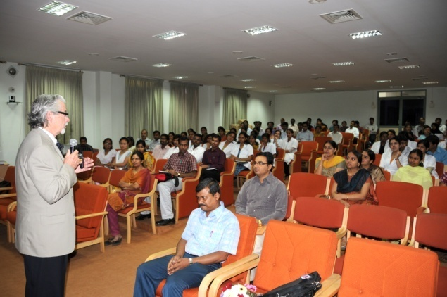

Dr. Jerry Northern, Professor, University of Colorado, USA, delivering guest lecture.

**IX. Orientation and Short-term Training Programs**

The institute conducted 102 orientation and short-term training programs on various aspects of communication disorders and special education services. More than 1700 persons including speech and hearing and allied professionals, ENT residents, school and college teachers, education trainees, members of voluntary organizations, family members and care givers of persons with communication disorders from across the main land, Lakshadweep and Andaman Nicobar Islands and countries like Bangladesh and The Netherlands attended the programs. The major themes of orientation programs are the following:

* Acoustic measurements and calibration of audiological equipment
* Assessment of voice
* Communication disorders in children and school screening program
* Conservation of voice
* Ear mould technology
* Effect of diet on behavior of children
* Forensic speaker identification
* Hearing evaluation and hearing aid trial
* Instrumentation in evaluation of voice & speech disorders
* Introduction to communication disorders
* Issues in professional voice
* Learning disability and related issues
* Normal voice production
* Preschool training for children with communication disorders
* Prevention, identification and management of communication disorders
* Speech language analysis Software.
* Speech and language pathologies

**X. Workshops/Seminars/Conferences**

The institute conducted 28 professional workshops, seminars and conferences pertaining to communication disorders and related topics during the reporting year in which 2260 students, researchers, teachers and practitioners in the field, care givers of persons with communication disorders and hearing aid users across the country attended. The details are given below.

1. National Workshop on Forensic Speaker Identification, organized by the Department of Speech - Language Sciences under the coordination of Dr.Y.V.Geetha on 11-14 April 2011 in which 10 speech - language pathologists and scientists from forensic labs across the country participated.
2. Workshop on Intervention in Autism Spectrum Disorders, organized by the Department of Speech - Language Pathology under the coordination of Dr.Shyamala K.C, on May 5 2011 in which 105 staff, students and parents of children with ASD participated.
3. Workshop on Care, Use and Troubleshooting of Body Level Hearing Aids, organized by the Department of Audiology under the coordination of Dr. K.J. Ramadevi and Mr. Darga Baba Fakruddin on 22 June 2011 in which 17 hearing aid users participated.
4. National Symposium on Exploring Areas of Research in Cognitive Sciences, organized by AIISH under the coordination of Dr. Manjula P. on 30 June- 1 July 2011 in which 55 professionals in the fields of linguistics,psychology, neurosciences, audiology, speech language pathology, anthropology, and special education participated.

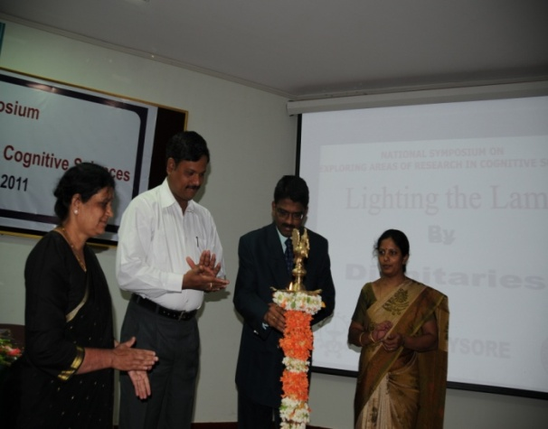

Inauguration of the National Symposium on Areas of Research in Cognitive Sciences.

1. Seminar on Acquired Brain Injury in Children and Adolescents, organized by the Department of Speech Language Pathology under the coordination of Dr.Shyamala K.C on 21 July 2011 in which 88 institute students, research scholars and staff participated.

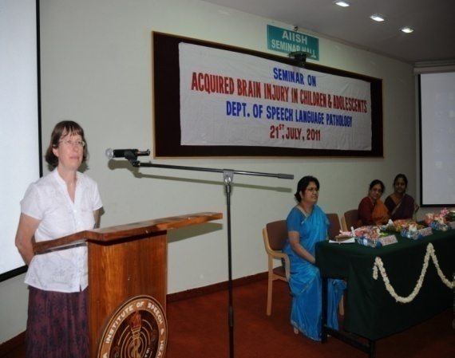

Dr. Sian A. Rees, Director, SHIPS Project, UK, speaks at the Seminar on Acq. Brain Injury.

1. Workshop on Introduction to Computers and Information Technology, organized by the Department of Electronics under the coordination of Mr.Ajish Abraham on 23 July 2011 in which 65 institute staffs and students participated.
2. Seminar on Dietary Intakes and Concerns in Typically Developing Children and Persons with Communication Disorders, organized by the Department of Clinical Services under the coordination of Ms. Prathima on 25 July 2011 in which 85 caregivers participated.
3. Seminar on Therapy for Anomia: Recent Trends, organized by the Department of Speech - Language Pathology under the coordination of Dr.M.Pushpavathi on 28 July 2011 in which 80 institute students, research scholars and staff participated.
4. National Symposium on Assessment and Management of (Central) Auditory Processing Disorders, organized by the Department of Audiology under the coordination of Mr. Niraj Kumar Singh and Mr. Prawin Kumar on 19-20 August 2011 in which 170 speech and hearing students and professionals participated.
5. Workshop on Ear Impression Technique, organized by the Department of Audiology under the coordination of Ms. Devi N and Mr. Vivek A on 6-7 September 2011 in which 17 special school teachers from Andhra Pradesh participated.
6. Seminar on Speech and Language Therapy, Behavioral Management, Physical and Motor Management and Curriculum Support, organized by the Department of Clinical Services under the coordination of Ms. Geetha M.P on 15 September 2011 in which 15 teachers participated.
7. Workshop on Early Identification of Communication Disorders, organized by the Department of ENT under the coordination of Dr. H. Sundara Raju on 21 September 2011in which 91 school teachers participated.
8. Seminar on Sensitizing Parents of Special Children about Child Development, organized by the Department of Clinical Services under the coordination of Ms. Geetha M.P on 28 September 2011 in which 50 parents participated.
9. National Seminar on Evaluation and Management of Tinnitus and Hyper-acusis, organized by the Department of Audiology under the coordination of Mr. Sujeet Kumar Sinha and Ms. Mamatha M.N on 30 September 2011 in which 67 audiologists and post-graduate students participated.
10. Workshop for Digital Hearing Aid Users, organized by the Department of Audiology under the coordination of Dr. K.J.Ramadevi, Mr. Darga Baba Fakruddin, Ms. Megha and Mr. Jawahar Antony P on 20 October 2011 in which 8 digital hearing aid users participated.
11. Seminar on Stuttering, organized by the Department of Clinical Services under the coordination of Ms. Sangeetha Mahesh on 24 October 2011 in which 200 teacher trainees participated.
12. National Seminar on Stroke, organized by the Department of Clinical Services under the coordination of Ms. Preethi T. Thomas on 10-11 November 2011 in which 130 speech-language pathologists, audiologists, psychologists, medical professionals, occupational therapists, physiotherapists and medical social workers participated.
13. National Seminar on Advances in Cochlear Implant Technology, organized by the Department of Audiology under the coordination of Dr. Manjula P and Ms. Geetha C on 18-19 November 2011 in which 48 speech and hearing students, professionals and ENT doctors participated.

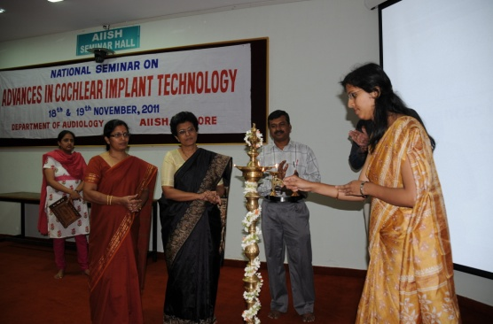

Inauguration of the National Seminar on

Advances in Cochlear Implant Technology

1. Seminar on Rights and Acts for Persons with Disability, organized by the Department of Clinical Services under the coordination of Mr. Prashanth R. on 5 December 2011 in which 285 speech and hearing and law college students, professionals and the general public participated.
2. Workshop on Application of Educational Technology in Teaching Children with Special Needs, organized by the Department of Special Education under the coordination of Prof. K.S.Prema, Ms.Prithi Nair, Ms.O.Shobha & Ms.P.Vijetha on 7 December 2011 in which 41 special educators, teacher trainees and students participated.
3. National Workshop on Phonological Disorders: Clinical Perspective, organized by the Department of Speech Language Sciences and the Department of Clinical Services under the coordination of Dr. N. Sreedevi and Ms. Priya M.B on 6 January 2012 in which 200 speech language pathologists and linguists participated.

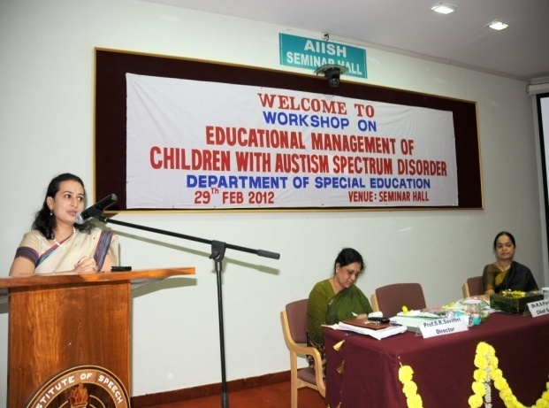

Dr.K.S.Pavitra, Neuro Psychiatrist, speaks at the Workshop on Educational Management of Children

with Autism Spectrum Disorders

1. Workshop on Developing of Material for Auditory Closure, organized by the Department of Material Development under the coordination of Dr.Asha Yathiraj on 9 February 2012 in which four audiologist and two educators participated.
2. Workshop on Cochlear Implant Technology, organized by the Department of Audiology under the coordination of Dr. Animesh Barman and Mr. Prashanth Prabhu P on 15 February 2012 in which 66 institute staff and students participated.
3. Workshop on Facilitating Early Intervention in Natural Environment for Children with Hearing Impairment, organized by the Department of Special Education under the coordination of Prof. K.S.Prema and Ms.Prithi Nair on 28 February 2012 in which 70 special educators, teacher trainees and school administrators participated.
4. Seminar on Educational Management of Children with ASD, organized by the Department of Special Education under the coordination of Prof. K.S.Prema, Ms. Ramanakumari P.D. and Ms. Shobha B.N. on 29 Febraury 2012 in which 95 special educators and caregivers participated
5. National Seminar on Evidence Based Practice in the Management of Voice Disorders, organized by the Department of Speech - Language Sciences under the coordination of Ms. K. Yeshoda on 15 March 2012 in which 150 speech - language pathologists and postgraduate students participated.

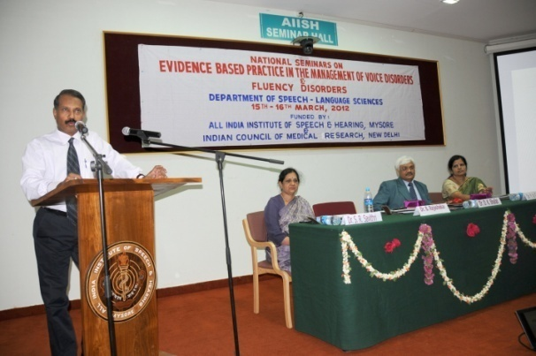

Dr. B. Rajashekar, Dean, Manipal College of Allied Health Sciences, speaks at the National Seminar on EBP in Voice Disorders.

1. National Seminar on Fluency Disorders, organized by the Department of Speech - Language Sciences under the coordination of Dr.Y.V. Geetha on 16 March 2012 in which 150 speech - language pathologists and speech and hearing and postgraduate students participated.

Research Highlights

The institute promotes research related to speech, language, hearing and related fields. Special emphasis is given to clinically relevant applied research on causes, control and prevention of communication disorders, assessment and treatment issues as well as the testing and refinement of new technologies for the speech and hearing impairment. This chapter gives an account of research activities carried out at the institute and the details scientific papers published/presented at various platforms by the faculty, staff and students during the reporting year.

Different levels of research works were conducted at the institute during the reporting year namely, (i) funded research by faculty and staff, and (ii) student research at postgraduate, doctoral and post doctoral levels carried out under the supervision of faculty.

**I. Funded Research Projects**

The research projects include extramural and those sponsored by the institute from the AIISH Research Fund (ARF). Extramural research projects were funded by the Department of Science and Technology and Indian Council of Medical Research and international agencies like World Health Organization.

**Completed Research Projects:** Twenty tworesearch projects worth a total cost of ` 86.83 lakhs were successfully completed in different departments during the reporting year, the details of which are given in table 8.

Table 8: Completed Research Projects

|  |  |  |
| --- | --- | --- |
| **1** | **Investigator(s)** | Dr. Vandana V. P  Dr. Shyamala K.C |
|  | **Title** | Adaptation & standardization of cognitive linguistic quick test in Kannada. |
|  | **Funding Source** | ARF |
|  | **Fund ( in** ` **lakhs )** | 3.40 |
|  | **Objectives** | To adapt and standardize cognitive linguistic quick test in Kannada. |
|  | **Outcome** | The test battery for attention, memory, language, visuospatial skills and executive functions were administered on 180 healthy monolingual and bilingual participants. Age related reduction in scores of cognitive test battery was obtained for monolinguals and bilinguals. However, bilinguals in all age groups performed better than monolinguals in non linguistic tasks and monolinguals performed better than bilinguals in linguistic tasks suggesting a bilingual disadvantage in verbal tasks requiring lexical access and bilingual advantage in non verbal tasks requiring executive control. The project summarized the effect of education and socio economic status on cognitive skills of monolinguals and bilinguals. |
|  |  |  |
| **2** | **Investigator(s)** | Dr.Jayashree C.S.  Dr. S.P. Goswami |
|  | **Title** | Assessment battery for children with language based learning disability- Phase II. |
|  | **Funding Source** | ARF |
|  | **Fund ( in** ` **lakhs )** | 3.23 |
|  | **Objectives** | To develop an assessment battery for children with learning disability. |
|  | **Outcome** | Test material was developed with the help of SLPs. Schools were surveyed for data collection. The material was administered on a pilot data. The final test material was administered on participants from different schools in Mysore. The data was statistically analyzed and the findings revealed a developmental trend across age group. Predictors were extracted through statistical analyses which can be considered during diagnosis. Children at risk for Language learning disability (LLD) can be identified using the tool. The final report has been submitted for review process. |
|  |  |  |
| **3** | **Investigator(s)** | Ms. P Vijetha  Ms. Prithi Nair |
|  | **Title** | Attitudes of pre-service educators towards inclusive education. |
|  | **Funding Source** | ARF |
|  | **Fund ( in** ` **lakhs )** | 2.50 |
|  | **Objectives** | To find out the attitudes of pre-service educators and their teacher educators towards Inclusive education. |
|  | **Outcome** | The study found that the majority of pre-service educators and their teacher educators were favorable towards inclusive education. An orientation on inclusive education brought significant differences in their attitude towards inclusive education. Many of the B.Ed trainees expressed their apprehensions about handling children with special needs in inclusive classrooms. The study suggested some strategies for modification of attitudes of B.Ed trainees. |
|  |  |  |
| **4** | **Investigator(s)** | Dr. N. Sreedevi |
|  | **Title** | Computer based assessment of phonological processes in Malayalam. |
|  | **Funding Source** | ARF |
|  | **Fund ( in** ` **lakhs )** | 4.81 |
|  | **Objectives** | To develop a software for analyzing the phonological processes in native Malayalam-speaking children in the age range of 2-3.6 years. |
|  | **Outcome** | A user-friendly software was developed to analyse the phonological processes in native Malayalam speaking children in the age range of 2-3 years. The clinician has to listen to the child’s response and click on the options provided for each target word. At the end, the program automatically lists the number of processes in each category for the client-tested.It is a quick tool which can be regularly used in the clinical settings for routine evaluation and assessment of efficacy of speech therapy for children with communication disorders.The whole testing procedure takes about 8-10 minutes. |
|  |  |  |
| **5** | **Investigator(s)** | Mr. Ajish Abraham.  Dr. S.P Goswamy  Mr.Brijesh P |
|  | **Title** | Computerized screening test for acquisition of syntax in Hindi. |
|  | **Funding Source** | ARF |
|  | **Fund ( in** ` **lakhs )** | 5.80 |
|  | **Objectives** | To develop a module on computerized Screening Test for Acquisition of Syntax in Hindi (STASH). |
|  | **Outcome** | The project computerized STASH (STAS in Hindi) with web based technology so that it can be used across the globe irrespective of the type of operating system. It can be used for screening, therapeutic and research purposes in speech, language and hearing clinics. The test will be useful in assessing the syntactic abilities of the children both with respect to their comprehension and expression levels. |
|  |  |  |
| **6** | **Investigator(s)** | Dr. Vijayakumar N.  Dr. Animesh B.  Dr. Sujeet K. S. |
|  | **Title** | Cortical potential as measure of auditory temporal processes. |
|  | **Funding Source** | ARF |
|  | **Fund ( in** ` **lakhs )** | 3.24 |
|  | **Objectives** | To measure the auditory late latency responses as a mean of temporal processing in normal hearing individuals, individuals with SNHL and auditory neuropathy. |
|  | **Outcome** | CAEPs in quiet and in the presence of were recorded for normal hearing cochlear hearing and AN listeners. Along with CAEPs, speech perception scores, and gap detection measures were also obtained. N100 latency in AN in quiet was delayed and amplitude was reduced compared to the normal and cochlear hearing listeners; the extent of latency delay was  related to psychoacoustic measures of gap detection threshold and speech recognition scores, but not to audibility. Noise in normal and cochlear hearing listeners was accompanied by N100 latency delays and amplitude reductions paralleling those found in AN tested in quiet. Additional N100 latency delays and amplitude reductions occurred in AN with noise. N100 latency to tones and performance on auditory temporal tasks were related in AN subjects. Noise masking in normal hearing subjects affected N100 latency to resemble AN in quiet. This Signifies that N100 latency to tones may serve as an objective measure of the efficiency of auditory temporal processes. |
|  |  |  |
| **7** | **Investigator(s)** | Dr. S. Venkatesan |
|  | **Title** | Action plan for disability access audit under UNCRPD |
|  | **Funding Source** | ARF |
|  | **Fund ( in** ` **lakhs )** | 2.00 |
|  | **Objectives** | To understand the accessibility for persons with disabilities as per the provisions mandated by the UNCRPD in the public utility buildings. |
|  | **Outcome** | This investigation covered a sample of six representative public utility buildings located inside AIISH, Mysore. Results paint a rather grim picture on available accessibility for persons with disabilities at the studied institute. At the basic or beginning baseline level, it is seen that there is limited structural access score measuring no more than 29.2 % for all the target buildings included in this study. Even wherein few facilities like ramps, railings, furniture, lifts, corridors, lighting or flooring surfaces are available, their accessibility score drops markedly by almost a third to 9.1 % when adequacy criteria is adopted to demarcate ‘genuine accessibility’. |
|  |  |  |
| **8** | **Investigator(s)** | Dr. K.S. Prema  Dr. Peribhaskar R. |
|  | **Title** | Development & evaluation of curriculum for speech-language transcription. |
|  | **Funding Source** | ARF |
|  | **Fund ( in** ` **lakhs )** | 3. 94 |
|  | **Objectives** | To develop and evaluate curriculum for training man power on speech language transcription. |
|  | **Outcome** | Developed CD’s and manual for training in speech language transcription. Five course books were developed by identified course writers with experience in the field. Curriculum for training in speech language transcription has been evaluated for impact on a small group of participants and found to be effective w.r.t content, training module and duration of training program. |
|  |  |  |
| **9** | **Investigator(s)** | Dr. K.S. Prema |
|  | **Title** | Development of test for assessment of bilingual proficiency through lexical priming task. |
|  | **Funding Source** | ARF |
|  | **Fund ( in** ` **lakhs )** | 2. 58 |
|  | **Objectives** | To develop a language proficiency test for Hindi-English bilingual adults on the principle of primed LDT and to implement the test as a computer based test for online assessment of language proficiency in Kannada-English bilinguals. |
|  | **Outcome** | Computer based language proficiency assessment tool has been developed for Kannada-English bilinguals using DMDX software and has been administered on 30 bilinguals for their proficiency assessment and for validation of the developed tool with a paper based proficiency questionnaire. The digitized tool showed good correlation with paper-based questionnaire besides being objective, user-friendly and time saving for administration. |
|  |  |  |
| **10** | **Investigator(s)** | Dr. S.P. Goswami  Ms. Jayashree C.S |
|  | **Title** | Field testing of manual of adult non-fluent therapy in Kannada |
|  | **Funding Source** | ARF |
|  | **Fund ( in** ` **lakhs )** | 5.71 |
|  | **Objectives** | To field test the manual of adult non-fluent therapy in Kannada. |
|  | **Outcome** | The field tested results have shown that all the 10 persons with non-fluent aphasia did show improvement on various domains i.e. functional communication, repetition, comprehension, expression, naming, reading and writing. This reflects that the manual helps in improving various communication skills. The stimuli presented in the manual have been field tested and thus has proved to be effective in the management of persons with non-fluent aphasia. Furthermore, this manual is quite effective in eliciting responses even in persons with minimal/no verbal responses. Since the manual covers a wide range of activities covering different domains to improve linguistic skills, it provides scope for flexibility and the speech language pathologists can carry out the activities to elicit maximum responses from the person with non-fluent aphasia. Also, using this manual suitable feedback can be given to persons with non-fluent aphasia and also to their caregivers. In addition, it is emphasized to use this manual along with various traditional therapy techniques, appropriate cueing strategies as stated in the manual can bring about a difference in the communication skills in persons with non-fluent aphasia. |
|  |  |  |
| **11** | **Investigator(s)** | Dr. S. Venkatesan |
|  | **Title** | Impact evaluation of training courses in rehabilitation and special education. |
|  | **Funding Source** | ARF |
|  | **Fund ( in** ` **lakhs )** | 2.22 |
|  | **Objectives** | To evaluate the impact of training courses in rehabilitation and special education by developing appropriate tools, techniques or devices. |
|  | **Outcome** | Results indicated that it is feasible to develop objective, reliable and valid program impact assessment tools to evaluate academic programs which were indeed being organized effectively. It was also found that the eventual impact of the programs is being reflected in terms of their increasing demand, higher pass percentages, growing placement records, and positive student-staff feedback. All this calls for the continuation of these programs with persistent vigor. |
|  |  |  |
| **12** | **Investigator(s)** | Dr. Shyamala. K.C |
|  | **Title** | Language performance of Kannada–English bilingual individuals with dementia |
|  | **Funding Source** | ARF |
|  | **Fund ( in** ` **lakhs )** | 5.92 |
|  | **Objectives** | To develop & establish preliminary normative data for Dementia Assessment Battery in Kannada & English. |
|  | **Outcome** | The study was conducted on 90 Kannada-English bilingual healthy participants and 30 Kannada-English bilinguals with dementia and it revealed significant deficits in all DAB-K and MMSE subtests in individuals with dementia when compared to normal population. The study focused significant deficits in memory, linguistic expression and visuospatial construction of DAB-K test when all the 3 normal subgroups (20-40 years, 40-60 years and 60 years & above) were compared. Age related decline in scores were obtained in 40-60 year age group for tests of memory and visuo spatial construction sub tests of DAB-K. However, older age groups (60 years and above) had poorer scores in all subtests except memory, visuospatial constructions and linguistic comprehension sub tests. |
|  |  |  |
| **13** | **Investigator(s)** | Dr. Y.V. Geetha  Ms. Sangeetha M |
|  | **Title** | Patterns of recovery in CWS |
|  | **Funding Source** | ARF |
|  | **Fund ( in** ` **lakhs )** | 4.71 |
|  | **Objectives** | To determine with reasonable accuracy the proportion of children who persist in stuttering and those who recovery of their own accord (spontaneous recovery), to determine the treatment related factors contributing to recovery in CWS and isolating factors that govern or influence persistency and remission. |
|  | **Outcome** | The study revealed that majority of the children experienced relapse in stuttering. Among the 93 CWS who reported, recovery was found in 45% of CWS. While in the remaining 55% there was no recovery or the condition worsened in some. Majority of the children belonging to lower age group, age of onset within 5 years of age, female CWS, those with gradual nature of onset, chronicity less than 6 months, absence of associated problems recovered better compared to other groups although group differences were not significant. The only significant predicting factor towards recovery pattern was found to be the severity of stuttering and gender. |
|  |  |  |
| **14** | **Investigator(s)** | Dr. K.S. Prema |
|  | **Title** | Phonological sensitivity training kit in Kannada |
|  | **Funding Source** | ARF |
|  | **Fund ( in** ` **lakhs )** | 4.64 |
|  | **Objectives** | To develop phonological sensitivity training kit for children who are native speakers of Kannada language, to evaluate the efficacy of the training kit on typically developing children and children who are ‘at-risk’ for literacy failure and to evaluate the effect of phonological sensitivity training on school performance. |
|  | **Outcome** | Developed phonological sensitivity training material and user manual in Kannada as a part of the training kit. Prepared a presentation and a video-recorded sample to sensitize SSA participants regarding early literacy and phonological sensitivity training. Early literacy screening tool was validated. Re-designed an emergent early literacy brochure. |
|  |  |  |
| **15** | **Investigator(s)** | Ms. Shivani T.  Mr.Gopee K.  Dr. Rajashekar. B.V  Dr. Shyamala. K.C |
|  | **Title** | Reading acquisition in children learning two distinct orthographies, Malayalam and English |
|  | **Funding Source** | ARF |
|  | **Fund ( in** ` **lakhs )** | 3.16 |
|  | **Objectives** | To investigate the reading acquisition in children learning to read two distinct orthographies, Malayalam and English simultaneously. |
|  | **Outcome** | The phonological awareness skills developed more gradually in Malayalam compared to English language, except for rhyme recognition skills. Syllable awareness developed ahead of phoneme awareness. Word and non-word reading performances were superior in Malayalam compared to English language. Reading of regular and irregular English words did not differ. Orthographic recognition was superior to recall in both languages. Orthographic recognition matured by grade III with Malayalam orthographic recognition scores superior to that of English orthographic recognition scores. In English, the lower case recognition scores were better than upper case recognition. Orthographic recall on the other hand was found to be superior in Malayalam language and dependant on the complexity of Akshara |
|  |  |  |
| **16** | **Investigator(s)** | Dr. S.P. Goswami  Mr. Brajesh P |
|  | **Title** | Screening test for acquisition of syntax in Hindi |
|  | **Funding Source** | ARF |
|  | **Fund ( in** ` **lakhs )** | 4.57 |
|  | **Objectives** | To develop a module on computerized Screening Test for acquisition of Syntax in Hindi (STASH). |
|  | **Outcome** | The test will assist speech language pathologist to assess the syntactic age of a child and if the child is at risk of developing deficits in syntax. Also it can be used as a research tool to collect normative data on a larger scale and on different populations and as a guide to plan therapy and therapy materials for language delay and disordered clients. |
|  |  |  |
| **17** | **Investigator(s)** | Ms.Preethi T.  Dr.S.P.Goswami |
|  | **Title** | Screening test for acquisition of syntax in Malayalam. |
|  | **Funding Source** | ARF |
|  | **Fund ( in** ` **lakhs )** | 2.44 |
|  | **Objectives** | To develop a module on computerized Screening Test for acquisition of Syntax in Hindi (STASH). |
|  | **Outcome** | The findings of the study project that language acquisition follow a developmental pattern and children develop its major morphosynatctic aspects during the preschool periods. The test serves as a precursor for a detailed syntactic assessment. It assist speech language pathologist to assess the syntactic age of a child and if the child is at risk of developing deficits in syntax. |
|  |  |  |
| **18** | **Investigator(s)** | Dr. S. Venkatesan |
|  | **Title** | Sensitizing teachers on academic problems in school children in Karnataka |
|  | **Funding Source** | SSA |
|  | **Fund ( in** ` **lakhs )** | 14.00 |
|  | **Objectives** | To sensitizing teachers on academic problems in school children. |
|  | **Outcome** | A dedicated team of resource persons covered various topics related to academic problems, their assessment and remediation through lectures, case history taking, group discussion, individual case presentation etc. Each 12 day program covered 40 participants every month through 15 batches completed by 2010-11. The program included a course manual in English/Kannada along with in built schemes to evaluate them, the resource persons, participants and program implementation. |
|  |  |  |
| **19** | **Investigator(s)** | Dr. P. Manjula  Dr. Ramadevi K.J.  Ms. N. Devi  Ms. Kalai Selvi |
|  | **Title** | Servicing and repairing of hearing aids: A profile. |
|  | **Funding Source** | ARF |
|  | **Fund ( in** ` **lakhs )** | 3.13 |
|  | **Objectives** | To explore various problems encountered by the hearing aid users who have obtained the hearing aids through ADIP scheme and HADS scheme and to quantify/list the problems faced by them when their hearing aids are given for repair. |
|  | **Outcome** | The study identified that the problems were in terms  of various listening task such as awareness, identification, localization, understanding in favourable and adverse conditions. They also faced problems in social and emotional areas. The children faced problems while at school when their hearing aids were given for repair. Based on the results obtained, a feedback form was prepared for the hearing aid manufacturers in order to give feedback to the manufacturers about the complaints of their hearing aids and also to  prevent and rectify the problems faced by the clients when their hearing aids were given for repair. The information obtained from the feedback form revealed the provision provided for hearing aid repair, servicing, FM compatibility, loaner/exchange of hearing aids, ear mould making, warranty,  duration taken for repair, cost involved, hearing aid life span, schemes and insurance covered by the manufactures. These information may be utilized to improvise the HAD scheme and provide better service to the clients. |
|  |  |  |
| **20** | **Investigator(s)** | Ms. Prithi Nair  Dr. I.P. Gowramma |
|  | **Title** | Special educators knowledge, attitude and practice on early intervention |
|  | **Funding Source** | ARF |
|  | **Fund ( in** ` **lakhs )** |  |
|  | **Objectives** | To assess the knowledge of special educators about the early intervention strategies for children with hearing impairment and to assess the attitude of special educators towards early intervention programmes for children with hearing impairment. |
|  | **Outcome** | The study found that the professionally qualified teachers performed well in skill, where as non-professionally qualified teachers performed well in the knowledge and attitude. Teachers having less than 10 years of teaching experiece performed well in Knowledge and skill, whereas teachers having more than 10 years of experiece performed well in the area of attitude. |
|  |  |  |
| **21** | **Investigator(s)** | Ms. Sangeetha M  Dr. Y.V. Geetha |
|  | **Title** | Treatment efficacy with response cost for CWS. |
|  | **Funding Source** | ARF |
|  | **Fund ( in** ` **lakhs )** | 4.44 |
|  | **Objectives** | To determine the effectiveness of response cost method and its long term effects in subgroups of children with stuttering and determine the possible client related variables influencing stuttering therapy outcome. |
|  | **Outcome** | The study revealed that the withdrawal of the treatment resulted in increase in the number of the dysfluencies though not to pre therapy level. During the Reinstatement (RI) of Response cost, the findings suggested decreased stuttering which also suggested no effect of spontaneous recovery or maintenance with the withdrawal of treatment. This study suggests that effective treatment of stuttering will enable one’s ability to communicate whenever, wherever, about whatever, and to whomever they want, without worry about stuttering. |
|  |  |  |
| **22** | **Investigator(s)** | Dr. Y.V. Geetha  Ms. Sangeetha M  Mr. Sachin L.C. |
|  | **Title** | Relapses in individuals with stuttering |
|  | **Funding Source** | ARF |
|  | **Fund ( in** ` **lakhs )** | 4.71 |
|  | **Objectives** | To identify the proportion of children and adult PWS who exhibit relapses and to identify the nature of such relapses such as whether it is complete or partial, probable duration after which relapses occur. |
|  | **Outcome** | The results revealed that majority of the participants experienced a relapse in stuttering. This was true in case of both children and adults with stuttering. Out of 30 CWS, 23 children were found to have relapsed, with 8 children having partially and 15 children completely relapsed. Among the 30 AWS in the study, 22 had relapsed, with 12 adults experiencing partial and 10 adults, a complete relapse to pre therapy condition. pre-treatment severity and associated problems to be possible factors contributing to relapse in both children and adults with stuttering. |

|  |  |  |  |  |
| --- | --- | --- | --- | --- |
| **Sl.**  **No.** | **Topic** | **Investigators** | **Funding source** | **Fund**  **amount in**  **lakhs (`)** |
| 1 | Adaptation & standardization of cognitive linguistic quick test in Kannada. The objective of the project was to adapt and standardize CLQT into kannada. | Dr. Vandana V. P  Dr. Shyamala K.C | ARF | 3.40 |
| 2 | Assessment battery for children with language based learning disability- Phase II. The objective of the project was to develop an assessment battery for children with learning disability. | Dr.Jayashree C.S.  Dr. S.P. Goswami | ARF | 3.23 |
| 3 | Attitudes of pre-service educators towards inclusive education. The objective of the project was to develop an attitude scale for assessing the attitude of pre-service educators and teachers towards inclusive education. | Ms. P Vijetha  Ms. Prithi Nair | ARF | 2.50 |
| 4 | Computer based assessment of phonological processes in Malayalam. The objective of the project was to develop a computer-based software for analyzing the phonological processes in native Malayalam-speaking children in the age range of 2-3 years. | Dr. N. Sreedevi | ARF | 4.81 |
| 5 | Computerized screening test for acquisition of syntax in Hindi. . The objective of the project was to develop a module on Computerized Screening Test for acquisition of Syntax in Hindi (STASH). | Mr. Ajish Abraham.  Dr. S.P Goswamy Mr.Brijesh P | ARF | 5.80 |
| 6 | Cortical potential as measure of auditory temporal processes. . The objective of the project was to measure the auditory late latency responses as a mean of temporal processing in Normal hearing individuals, individuals with SNHL, and aud. Neuropathy. | Dr. Vijayakumar  Dr. Animesh B.  Dr. Sujeet K. S. | ARF | 3.24 |
| 7 | Action plan for disability access audit under UNCRPD. The objective of the project was to understand the accessibility for persons with disabilities as per the provisions mandated by the UNCRPD in the public utility buildings. | Dr. S. Venkatesan | ARF | 2.00 |
| 8 | Development & evaluation of curriculum for speech-language transcription.The objective of the project was to develop a Language Proficiency test for Kannada-English Bilingual adults on the principle of primed LDT. | Dr. K.S. Prema  Dr. Peribhaskar R. | ARF | 3. 94 |
| 9 | Development of test for assessment of bilingual proficiency through lexical priming task. The objective of the project was to to develop a Language Proficiency test for Hindi-English Bilingual adults on the principle of primed LDT. | Dr. K.S. Prema | ARF | 2. 58 |
| 10 | Field testing of manual of adult non-fluent therapy in Kannada. The objective of the project was to field test the manual of adult non-fluent therapy in Kannada. | Dr. S.P. Goswami  Ms. Jayashree C.S | ARF | 5.71 |
| 11 | Impact evaluation of training courses in rehabilitation and special education. | Dr. S. Venkatesan | ARF | 2.22 |
| 12 | Language performance of Kannada–English bilingual individuals with dementia. The objective of the project was to develop & establish preliminary normative data for Dementia Assessment Battery in Kannada & English. | Dr. Shyamala. K.C | ARF | 5.92 |
| 13 | Patterns of recovery in CWS. The objective of the project was to determine with reasonable accuracy the proportion of children who persist in stuttering and those who recovery of their own accord (spontaneous recovery), to determine the treatment related factors contributing to recovery in CWS and isolating factors that govern or influence persistency and remission. | Dr. Y.V. Geetha  Ms. Sangeetha M | ARF | 4.71 |
| 14 | Phonological sensitivity training kit in Kannada. The objective of the project is to develop a phonological sensitivity training kit in Kannada. | Dr. K.S. Prema | ARF | 4.64 |
| 15 | Prediction of speech identification scores using speech intelligibility index. . The objective of the project was to to evaluate the effectiveness of speech intelligibility index in perdiction of SRS in Hindi, Marathi and Tamil languages. | Dr. Asha Yathiraj  Dr. Manjula P  Dr. Vanaja CS  Mr. Heramba G | ARF | 2.25 |
| 16 | Reading acquisition in children learning two distinct orthographies, Malayalam and English. . The objective of the project was to Investigate the reading acquisition in children learning to read two distinct orthographies, Malayalam and English simultaneously. | Ms. Shivani T. Mr.Gopee K.  Dr. Rajashekar. B.V  Dr. Shyamala. K.C | ARF | 3.16 |
| 17 | Screening test for acquisition of syntax in Hindi. The objective of the project was to develop a module on Computerized Screening Test for acquisition of Syntax in Hindi (STASH). | Dr. S.P. Goswami  Mr. Brajesh P | ARF | 4.57 |
| 18 | Screening test for acquisition of syntax in Malayalam. . The objective of the project was to develop a module on computerized Screening Test for acquisition of Syntax in Hindi (STASH). | Ms.Preethi T. Dr.S.P.Goswami | ARF | 2.44 |
| 19 | Sensitizing teachers on academic problems in school children in Karnataka. | Dr. S. Venkatesan | SSA | 14.00 |
| 20 | Servicing and repairing of hearing aids: A profile. The objective of the project was to explore various problems encountered by the hearing aid users who have obtained the hearing aids through ADIP scheme and HADS scheme and to quantify/list the problems faced by them when their hearing aids are given for repair. | Dr. P. Manjula  Dr. Ramadevi K.J.  Ms. N. Devi  Ms. Kalai Selvi | ARF | 3.13 |
| 21 | Special educators knowledge, attitude and practice on early intervention. The objective of the project was to assess the knowledge of special educators about the early intervention strategies for children with hearing impairment and to assess the attitude of special educators towards early intervention programmes for children with hearing impairment. | Ms. Prithi Nair  Dr. I.P. Gowramma | ARF | 2.20 |
| 22 | Treatment efficacy with response cost for CWS. The objectives of the project were to determine the effectiveness of response cost method and its long term effects in subgroups of children with stuttering and determine the possible client related variables influencing stuttering therapy outcome. | Ms. Sangeetha M  Dr. Y.V. Geetha | ARF | 4.44 |
| 23 | Relapses in individuals with stuttering. The objectives of the project were to identify the proportion of children and adult PWS who exhibit relapses and to identify the nature of such relapses such as whether it is complete or partial, probable duration after which relapses occur. | Dr. Y.V. Geetha  Ms. Sangeetha M  Mr. Sachin L.C. | ARF | 4.71 |

**Ongoing Projects:** Forty three research projects worth `. 205.66 lakhs were ongoing in different departments during the reporting year, the details of which are given in table 9.

**Table 9: Ongoing Projects**

|  |  |  |  |  |  |
| --- | --- | --- | --- | --- | --- |
| **Sl.**  **No** | **Topic** | **Investigators** | **Funding source** | | **Fund**  **Amount in lakhs (`)** |
|  | Development of speech rhythm in Kannada speaking children. | Dr. S.R.Savithri  Dr. N. Sreedevi | DST | 19.00 | |
|  | Language and brain organization in normative multilingualism. | Dr. Shyamala. K.C | DST | 12. 27 | |
|  | The central alexias and agraphias in semi-syllabic orthography. | Mr. Gopee K.  Ms. Shivani T.  Dr. Rajashekar B  Dr. Shyamala. K.C. | DST | 28.00 | |
|  | An adaptation of early reading skill (ERS) in Hindi. | Mr. Brajesh P. | ARF | 3.11 | |
|  | Audiovisual resource manual on voice disorders. | Dr. M. Pushpavathi  Dr. Jayanthi R.  Dr. Sundarraj.H  Mr. Gopi S.  Dr. Girish K. | ARF | 4.98 | |
|  | Auditory processing in person with stuttering using non-linguistic and linguistic stimulus. | Mr.Jayakumar T Dr.Geetha Y V  Dr.Vijaya kumar N | ARF | 3.23 | |
|  | Comparison of muscle potentials of synergistic and antagonistic primary masticatory muscles as a function of age and task. | Dr. R. Manjula  Dr. N. Swapna | ARF | 2.57 | |
|  | Cross-language treatment generalization in Indian bilingual people with aphasia. | Dr. Gopee K.  Dr.Swathi K.  Ms. Shivani T.  Dr. Shyamala. K.C. | ARF | 3.60 | |
|  | Development and evaluation of center-based service delivery model for children with learning disability. | Dr. K.S.Prema  Ms. Jayashree C.S | ARF | 4.99 | |
|  | Development & field testing of low cost supportive and mobility aids appliances for persons with physical disability–Phase I. | Dr. R. Manjula,  Mr. Siddesh N.S.  Mr. Harish Pai K.  Mr. Jayakaran | ARF | 2.28 | |
|  | Development & standardization of autism behavior check list for disability estimation. | Dr. S. Venkatesan | ARF | 4.85 | |
|  | Development & standardization of noun verb picture battery in Kannada and Malayalam. | Mr. Gopee K.  Ms. Shivani T.  Dr. Rajashekar. B.  Dr. Shyamala. K.C. | ARF | 5.92 | |
|  | Development of a key word signing manual in English for Indian context. | Dr. H. Venkatagiri  Dr. R. Manjula | ARF | 3.70 | |
|  | Development of assessment batteries for bilingual Kannada-English and Malayalam-English children with specific language impairment. | Dr. Shyamala. K.C  Ms. Shivani Tiwari  Mr. Gopee Krishnan | ARF | 5.82 | |
|  | Development of audio-video database for communication disorders. | Mr. R. Gopi S. Dr.S.P.Goswami  Ms.Preethi T. | ARF | 3.23 | |
|  | Development of norms for assessment protocol for lexical semantic deficits using componential analysis. | Mr. Brajesh P.  Dr. Shyamala. K.C | ARF | 3.06 | |
|  | Developmental pattern of children with Down’s syndrome: An exploratory study- Phase I. | Dr.M.Pushpavathi  Ms. Preethi T.T.  Dr.Venkatesh.S Mr.Siddesh  Mr.Jayakaran | ARF | 5.00 | |
|  | Digital tutorial for pre-reading skill. | Dr. Swapna.N  Dr.K.S. Prema  Dr. Y.V Geetha | ARF | 5.41 | |
|  | Early intervention module for parents of children with cleft lip palate in Kannada & English Phase-I. | Dr.M.Pushpavathi  Mr. Gopi K.  Mr. R. Gopi S.  Dr.H.V.Sathish | ARF | 6.07 | |
|  | Effect of palatal obturator on speech. | Dr. M. Pushpavathi  Dr. N. Sreedevi  Dr. Dakshayini M | ARF | 4.98 | |
|  | Effects of semantic and syntactic treatments in bilingual stroke survivors. | Dr.Rangamani  Dr. K.S. Prema | ARF | 4.94 | |
|  | Efficacy of multidisciplinary preparatory services of AIISH in mainstreaming children with communication disorders. | Dr. G. Malar  Dr. N. Sreedevi  Mr. C.B. Suresh | ARF | 3.32 | |
|  | Genotyping and a genetic association study in autism. | Dr. Shyamala. K.C | ARF | 5.72 | |
|  | Impact evaluation of government benefits and concession provided to with mentally retarded persons in Mysore. | Dr. G. Jayarama  Dr. Kalyan K.  Mr. Raju HH  Dr. Purushotham.P | ARF | 3.20 | |
|  | Intervention module for the management of speech and language skills for individuals with cerebral palsy. | Dr. Swapna.N  Dr. R. Manjula  Dr. Y.V Geetha | ARF | 5.72 | |
|  | Language proficiency in Hindi-English bilinguals: Cross language study. | Dr. K.S Prema | ARF | 4.94 | |
|  | Lexical organization in Kannada-English & Malayalam-English bilinguals with and without aphasia. | Dr. Shyamala. K.C.  Ms. Shivani T.  Mr. Gopee K. | ARF | 5.82 | |
|  | Measurements of vocal doses using ambulatory phonation monitor in primary school teachers. | Mr. R. Rajasudhakar  Mr. L. C. Sachin | ARF | 3.23 | |
|  | Motor control in persons with stuttering under conditions of motor stress. | Dr. R. Manjula  Dr. H. Venkatagiri | ARF | 6.02 | |
|  | Neuro-physiology correlates of voice onset time in Kannada & Tamil speaking individual. | Mr.Jayakumar T  Dr.Vijaya Kumar N | ARF | 3.23 | |
|  | Pattern of recovery in children with stuttering. | Dr.Y.V.Geetha Ms.Sangeetha M. | ARF | 4.17 | |
|  | Phonetic characteristics of babbling in Kannada. | Dr. N. Sreedevi | ARF | 3.80 | |
|  | Prediction of speech identification scores using speech intelligibility index. | Dr. Asha Yathiraj  Dr. Manjula P  Dr. Vanaja CS  Mr. Heramba G | ARF | 2.25 | |
|  | Process evaluation and comparison of the modules of outreach service centre’s as a factor of type of volunteers engaged in the activity. | Dr.S.R. Savithri  Dr. R. Manjula  Dr. H. Sudharshan | ARF | 6.62 | |
|  | Process evaluation of DHLS program conducted through actual vis-à-vis virtual mode. | Dr. S.Venkatesan, Dr.Vasantha Lakshmi | ARF | 3.75 | |
|  | School readiness test in Mathematics. | Dr. Asha Yathiraj  Dr. I.P. Gowramma  Ms. Prithi Nair  Ms. P.Vijetha  Dr. G. Malar | ARF | 2.20 | |
|  | Screening test for acquisition of syntax in Telugu. | Mr. P. Gopi K.  Dr. S.P. Goswami | ARF | 3.01 | |
|  | Speech characteristics in children with oral clefts pre & post surgery: A longitudinal study. | Dr.M.Pushpavathi Dr.H.V.Sathish  Mr.R.Gopi S. | ARF | 4.98 | |
|  | Speech characteristics in children with oral cleft –Pre and post surgery: a longitudinal study in Malayalam. | Dr. M. Pushpavathi  Dr. Sherry P.  Dr. Subramni I. | ARF | 4.98 | |
|  | Speech characteristics in children with oral cleft – Pre and post surgery: A longitudinal study in Telugu. | Dr. M. Pushpavathi  Dr. Srinivas G. R.  Dr. Swati R. |  | 4.98 | |
|  | Standardization of western aphasia battery in Telugu monolinguals and Telugu–English (T-E) bilinguals. | Dr.Shyamala, K.C | ARF | 3.16 | |
|  | Treatment efficacy using response cost in children with stuttering. | Dr.Y.V.Geetha Ms.Sangeetha M | ARF | 3.02 | |
|  | Word & non-word repetition test for children in Kannada. | Dr. Swapna.N | ARF | 3.06 | |

**New Research Projects:** Thirty fourresearch projects worth ` 205.83 lakhs were initiated in different departments during the reporting year, the details of which are given in table 10.

Table 10: New Research Projects

|  |  |  |  |  |
| --- | --- | --- | --- | --- |
| **Sl.**  **No.** | **Topic** | **Investigators** | **Funding source** | **Fund**  **Amount in lakhs (`)** |
|  | Cortical auditory evoked potentials as a measure of central auditory development in children with hearing impairment. | Dr.Vijay Kumar .N Mr. Jayakumar  Dr. N. Swapna | DST | 28.37 |
|  | Development of cognitive and linguistic intervention manual: Malayalam speaking persons with dementia . | Dr. S.P. Goswami  Mrs. Preethi T.T. | ICMR | 12.27 |
|  | Development of manual for adult non-fluent and fluent aphasia therapy in- Hindi, English, Tamil, Malayalam, Telgu and Marathi. | Dr. S.P. Goswami  Mrs. Preethi T.T. | DST | 15.43 |
|  | Reading-related eye movements in semi-syllabic and alphabetic orthographies. | Mr. Gopee K.  Ms. Shivani T.  Dr. Rajashekar. B  Dr. Shyamala. K.C | DST | 46.17 |
|  | Altered frequency tuning of VEMP: Could it be a diagnostic tool to identify endolymphatic hydrop. | Mr. Niraj K. S.  Dr. G. Rajeshwari  Dr. Animesh B.  Mr. Sujeet K. S. | ARF | 3.21 |
|  | An adaptation of Early Reading Scale (ERS) in Hindi. | Dr. S.P. Goswami  Mr.Brajesh P | ARF | 3.21 |
|  | An articulatory study of Kannada consonants: Co-articulation and speech errors. | Dr. N. Sreedevi Mr.Alexie K.  Dr. R.Manjula | ARF | 3.15 |
|  | Assessment of vestibular function in individuals with auditory neuropathy. | Mr.Sujeet K. S.  Dr. Rajeshwari G  Dr. Animesh B.  Mr. Niraj K. S. | ARF | 3.06 |
|  | Behavioral correlates of P300 response to voice onset time (VOT) and place of articulation continuum in Kannada & Hindi speaking individuals. | Mr. Jayakumar  Mr. Vijay Kumar N | ARF | 2.94 |
|  | Clinical evaluation of language fundamentals- Preschool for Kannada-speaking English language learners. | Ms.Sarika K.  Ms.Priya M. B | ARF | 3.06 |
|  | Comparison of screening protocols for the differentiation of type of hearing loss in NICU infants. | Dr. Vijayakumar N  Dr. Navid S.  Dr. Rafideh M.  Mr. Sharath K. | ARF | 3.16 |
|  | Comparison of CROS & BAHA in individuals with unilateral hearing loss. | Ms. Devi N  Dr. Ramadevi K.J  Mr. D Baba F | ARF | 3.26 |
|  | Comparison of normal & pathological middle ears using multi-frequency tympanometry. | Dr. Sandeep M  Mr.Sharath K.S  Ms. Megha  Dr.Sundara Raju | ARF | 3.16 |
|  | Comparison of temporal resolution abilities & speech perception in noise in children born in families with & without musical background. | Dr. Rajalakshmi K | ARF | 3.16 |
|  | Critical band based frequency compression & speech perception in noise in individuals with cochlear hearing loss. | Dr. Ajith Kumar .U Mr. Arivudai. N | ARF | 3.26 |
|  | Design & development of  assistive device for museum access to persons with hearing impairment. | Mr. Ajish Abraham  Mr.N. Manohar | ARF | 5.68 |
|  | Development and standardization of a questionnaire for early identification of psycho-social issues in children with cleft lip/palate. | Ms. Amrita K.  Dr. S. Venkatesan Mr.Yashodhara K | ARF | 2.20 |
|  | Development of a screening test for (C)APD. | Dr. Asha Yathiraj | ARF | 3.21 |
|  | Development of phonemically balanced word lists in Kannada for adults. | Dr. Manjula P  Ms. Geetha C  Mr. Sharath K  Mr. Jawahar A.P | ARF | 3.16 |
|  | Development of sentence lists in Kannada for adults. | Ms. Geetha C  Mr. Sharath K. | ARF | 3.16 |
|  | Development of sentence test for speech recognition threshold in Hindi. | Ms. Chandni J.  Dr.Vijayakumar. V  Mr. Niraj K.S.  Mr. Prawin K. | ARF | 3.06 |
|  | Development of verbal test of attention in children-Phase 1. | Ms. Priya M. B  Ms.Sangeetha M  Dr. S. Venkatesan | ARF | 3.11 |
|  | Frequency of occurrence of phonemes in Kannada. | Dr. N.Sreedevi Ms.Smitha N. | ARF | 3.20 |
|  | Hearing conservation program attitudes of employers and employees and the need for intervention module. | Mr Arunraj K  Ms. Devi N | ARF | 3.26 |
|  | Intervention module for the management of speech and language skills for individuals with cerebral palsy. | Dr. N. Swapna  Dr. R. Manjula  Dr. Y.V. Geetha | ARF | 5.72 |
|  | Investigations of speech rhythm in stuttering individuals . | Dr. Santosh M  Ms.Sahana V | ARF | 2.94 |
|  | Neuro-physiological mechanisms of speech perception in noise. | Dr. Sandeep M  Dr. Ajith Kumar U | ARF | 3.26 |
|  | Noise reduction algorithms and speech perception in cochlear implant user. | Dr. Asha Yathiraj | ARF | 3.21 |
|  | Periodicity coding and perception of speech in noise in individuals with symmetrical and asymmetrical cochlear hearing loss. | Dr. Rajalakshmi K | ARF | 3.26 |
|  | Process evaluation and comparison of the modules of outreach service centers as a factor of type of volunteers engaged in the activity. | Dr. R Manjula  Ms. E.Pragathi  Mr Niranjan D. | ARF | 6.62 |
|  | Quantification of the effects of noise on speech recognition. | Dr. Manjula P  Ms. Megha | ARF | 2.96 |
|  | Screening and diagnostic test materials and intervention manuals for communication disorders. | Dr. S.P. Goswami  Ms. Priya M. B. | ARF | 2.00 |
|  | Sub typing dyslexia: application of ERP measures. | Dr. Jayashree C.S  Ms. Mamatha N.M  Mr. R. Gopi S. | ARF | 5.77 |
|  | Voice characteristics of partial laryngectomy. | Mr. Sachin. L. C  Mr. Rajasudhakar | ARF | 3.18 |

**II. Doctoral Research**

Totally seven students completed their doctoral research works during the reporting year and among them two were awarded the degree and the remaining were under evaluation. Also, one student completed her postdoctoral work. The details are given in table 11.

Table 11 : Completed Doctoral/Postdoctoral Research

|  |  |  |  |
| --- | --- | --- | --- |
| **Sl.No** | **Candidate** | **Topic** | **Guide** |
|  | Deepa M.S | Discourse in bilingual individuals with dementia & aphasia. | Dr. K.C. Shyamala |
|  | Jayakumar T | Voice characteristics in monozygotic twins. | Dr. S.R. Savithri |
|  | Jayashree S. | Acquisition of biliteracy in children. | Dr. K.S. Prema |
|  | K. Yeshoda | Spectral & temporal parameters in speaker identification. | Dr. M. Jayaram |
|  | Mahalakshmi P | Spoken language lexical corpora in Kannada.* | Dr. K.S. Prema |
|  | Prawin Kumar | Computer-assisted listening training program. | Dr. Asha Yathiraj |
|  | Sarika Khurana | Emergent literacy in Kannada speaking English learners. | Dr. K.S. Prema |
|  | Shilpashri H.N | Pragmatic skills in autism spectrum disorders. | Dr. K.C. Shyamala |

*Postdoctoral research

In addition, 43 students were pursuing their doctoral research in different departments of the institute during the reporting year. The details are given in table 12.

Table 12: Ongoing Doctoral Research

|  |  |  |  |
| --- | --- | --- | --- |
| **S.N** | **Candidate** | **Topic** | **Guide** |
| 1 | Abhishek | Lexical-semantic processing in persons with bilingual aphasia. | Dr. K.S.Prema |
| 2 | Anjana. B. R | Disfluencies in 1-6 year old Kannada speaking children. | Dr. S.R. Savithri |
| 3 | Archana G. | International classification of functioning, health and disability (ICF) core set: assessment of activity and participation of persons with aphasia. | Dr. S.P. Goswami |
| 4 | Chandni J | Factors affecting psychophysical abilities across different age group. | Dr. Ajith Kumar U |
| 5 | Devi N | Auditory evoked potential correlation of speech and music. | Dr. Ajith Kumar U |
| 6 | Ganapathy | Effect of age and noise on acoustic change complex. | Dr. Manjula P |
| 7 | Geetha C | Compression parameters in hearing aids . | Dr. Manjula P |
| 8 | Gnanavel.K. | Speech characteristics in velopharyngeal dysfunctions. | Dr. M.Pushpavathi |
| 9 | Gopi K.P. | Eclectic voice program in the hyperfunctional voice disorders. | Dr. M.Pushpavathi |
| 10 | Gopi Sankar | Acoustic & perceptual parameters in cleft palate speech. | Dr. M.Pushpavathi |
| 11 | Hema. N | Discourse analysis in bilingual aphasic & non aphasic TBI. | Dr. K.C. Shyamala |
| 12 | Hemanth N. | Amplification on objective measure at brainstem. | Dr. Manjula P |
| 13 | Jijo P.M. | Enhancement of amplitude & durational cues. | Dr. Asha Yathiraj |
| 14 | Jithin Raj B | Differentiation of auditory neuropathy spectrum disorder (ANSD) in to pre synaptic and post synaptic ANSD. | Dr. Sandeep M |
| 15 | Kuppuraj | Procedural memory deficits & specific language impairment. | Dr. K.S. Prema |
| 16 | Mahesh BVM | Speech Motor Indices in Bililnguals who Stutter. | Dr. R. Manjula |
| 17 | Maria G.T | Expressive morphology in Malayalam speaking children. | Dr. K.C. Shyamala |
| 18 | Megha | Perceptual, cognitive and neurophysiological bases of hearing aid acclimatization’. | Dr. Sandeep M |
| 19 | Mili M.M | Gesture and speech in typically developing infants. | Dr. R. Manjula |
| 20 | Mithila P | Effects of social cognitive demand on theory of mind in adults with traumatic brain injury. | Dr. S.P. Goswami |
| 21 | Namrata Pai | Language assessment in toddlers and late talkers/SLI. | Dr. K.C. Shyamala |
| 22 | Navya | Correlation of subjective and objective measures of speech in children with repaired cleft lip and palate. | Dr. M.Pushpavathi |
| 23 | Niraj K. S. | The frequency tuning of ocular vestibular evoked myogenic potentials in normals, meniere’s disease, benign paroxysmal positional vertigo and auditory neuropathy spectrum disorders . | Dr. Animesh B |
| 24 | Perumal | Speech sound acquisition & phonological process. | Dr. N. Sreedevi |
| 25 | Prarthana | Mental lexicon of nouns and verbs in adult speakers of Kannada. | Dr. K.S. Prema |
| 26 | Pravesh A. | Relapse management in adult PWS. | Dr. Y.V. Geetha |
| 27 | Preethi T | Content and processes of semantic memory. | Dr. S.P. Goswami |
| 28 | Priya M.B | Test battery for phonological representations in children. | Dr. R.Manjula |
| 29 | Priyanka V | Quality of life of children with cochlear implants. | Dr. Rajalakshmi K |
| 30 | Radhakrishnan | Computerized auditory visual integration training. | Dr. S.P. Goswami |
| 31 | Rajasudhakar R | Voicing periods in primary school teachers. | Dr. S.R. Savithri |
| 32 | Ramya V | Auditory Processing in older adults: Perceptual problems and management. | Dr. Asha Yathiraj |
| 33 | Reeny R. | Emergent complexity of early vocalization. | Dr. N. Sreedevi |
| 34 | Reuben Jebaraj | Effect of aging on brainstem processing of speech sounds: an electrophysiologic study. | Dr. P. Manjula |
| 35 | Reuben M.P. | Hearing aid fitting strategies on speech recognition. | Dr. Manjula P |
| 36 | Roshni P. | Auditory, visual and auditory-visual processing. | Dr. Asha Yathiraj |
| 37 | Sahana M. | Speech characteristics in preschool children with repaired cleft lip and palate (CLP): a study of outcome measures of veau-wardil-kilner platoplasty with muscle reconstruction. | Dr. M.Pushpavathi |
| 38 | Sampath K L | Semantic Judgment in Monolingual and Bilingual Persons with Broca’s Aphasia: An ERP Study. | Dr. S.P. Goswami |
| 39 | Sangeetha M | Linguistic variability in children with stuttering. | Dr. Y.V.Geetha |
| 40 | Santosh K. | Comprehension test in Hindi language for persons with aphasia. | Dr. S.P. Goswami |
| 41 | Savitha | Speech & language development in children with cleft lip & palate. | Dr. N. Sreedevi |
| 42 | Sharath K. | Noise reduction algorithms in hearing aids. | Dr. Manjula P |
| 43 | Shylaja K. | Symbolic communication in aided AAC users. | Dr. R. Manjula |
| 44 | Sreeraj K | Audiological management options for individuals with normal hearing having tinnitus - based on Audiological profile. | Dr. Manjula P |
| 45 | Sujeet K. S. | Brainstem encoding of speech sounds. | Dr. Animesh B. |
| 46 | Sunil K.R | Brain potentials study of language processing. | Dr. K.C. Shyamala |
| 47 | Sunitha S.N | Intervention in autism spectrum disorders. | Dr. K.C. Shyamala |
| 48 | Usha Shastri | Perceptual learning of non-native speech contrast. | Dr. Ajith K.U |
| 49 | Yashaswini R. | Dynamic assessment of non symbolic abilities in aided AAC users. | Dr. R. Manjula |
| 50 | Yashomathi | Sign Language. | Dr. R. Manjula |

**III. Postgraduate Research**

The postgraduate students of the institute carry out research works as a part of their program work. The details of completed postgraduate research works done as a part of M.Sc.Audiology, M.Sc. Speech - Language Pathology and P.G. Diploma in Neuroaudiolgy are given in table 13 and the ongoing postgraduate research works as a part of M.Sc. Audiology and M.Sc. Speech - Language Pathology are given in table 14.

Table 13: Completed Postgraduate Research

|  |  |  |  |
| --- | --- | --- | --- |
| **S.N** | **Candidate** | **Topic** | **Guide** |
|  | Abhishek K.S | Normative of tone burst ABR for site of lesion testing. | Dr. Sandeep M |
|  | Achaiah MA | Comparison between outcomes using preferred gain and prescribed gain formulae in experienced  adult hearing aid users. | Dr. Vijay Kumar Narne |
|  | Adithya, K.K | Quality of life of individuals with right hemisphere damage relevance to cognitive communication disorders. | Dr. Jayashree C.S |
|  | Akash Juneja | Acoustic change complex in children: 7-15 years of age. | Dr. Devi N |
|  | Akshay R M | Effect of temporal pattern training on specific central auditory processes. | Dr. Asha Yathiraj |
|  | Anisha A.B | Immittance findings in infants using different probe tone frequencies. | Dr. Mamatha N.M |
|  | Anjana B.J | Utility of nonlinear frequency comparession in children with severe to profound hearing loss. | Dr. Geetha C |
|  | Anoop B.J | Test-retest reliability of vestibular evoked myogenic potentials parameters. | Mr. Niraj Kumar Singh |
|  | Anoop, O.T | Effect of musical training on temporal resolution abilities and speech perception in noise. | Dr. Rajalakshmi K |
|  | Ashwini Rao, P.N | Electrically evoked stapedial reflex threshold levels: relationship with behavioural t and c levels in cochlear implants users. | Dr. Asha Yathiraj |
|  | Bhamini Sharma | Relationship between dpoae fine-structure and hearing sensitivity across different age groups and gender. | Mr. Sujeet Kumar Sinha |
|  | Bharath Bhushan, K.R | Physiological correlates of masking level difference. | Dr. Animesh Barman |
|  | Chaitra, V | Effect of filtering and compression on right ear advantage. | Mr Niraj Kumar Singh |
|  | Deepthi, M.K | Voice characteristics in male to female transsexual individuals. | Ms. Yeshoda K |
|  | Dhatri S. Devaraju | Developmental changes in co-modulation masking release for pure tones: a cross-sectional study. | Ms. Mamatha N.M |
|  | Divyashree, M.S | Central auditory maturation and language development in children with hearing loss: a preliminary study. | Ms. Mamatha N.M |
|  | Gargi Singh | A study of non-manual markers in indian sign language. | Dr. Manjula R |
|  | Ghazala Perween | Usefulness of auditory brainstem response to identify retrocochlear pathology - a tutorial. | Dr. Animesh Barman |
|  | Hanan, M.N.T | Effect of context on brainstem encoding of speech. | Dr. Sandeep M |
|  | Hema Latha, P | Development of articulation drill book for cleft palate population. | Dr. Pushpavathi M |
|  | Jyoti | Effect of number of channels of hearing aids on speech perception in different degrees of sloping hearing loss cases. | Mr. Niraj Kumar Singh |
|  | K. Suresh | Comparison of stacked tone ABR with chirp ABR in normal hearing listeners. | Dr. Vijayakumar Narne |
|  | Kavitha, J | Novel word learning in monolinguals versus simultaneous and sequential bilinguals. | Dr. Prema K.S |
|  | Keerthi Prasad, B.M | Development of articulation drill book for cleft palate population in kannada. | Dr. Pushpavathi M |
|  | Lakshmi Prasanna, P | Benchmark for nasal continuants in telugu for speaker identification. | Dr. Savithri S.R |
|  | Lydia Mary Issac | A resource manual for learning disability (LD) with central auditory processing disorder (CAPD). | Dr. Jayshree C.S |
|  | Madhu, K | Communication inventory for infants (CII) 6 – 12 months. | Dr. Prema K.S |
|  | Madhuban Sen | Language abilities in bilingual children with autism (CWA). | Dr. Geetha Y.V |
|  | Merlin Thankam Thomas | Adaptation of TROLL to identify children at risk for LD. | Dr. Jayshree C.S |
|  | Midula Kasim | Performance of typically developing children in the age range of 4-5 years for swallowing sound using cervical auscultation module in digital swallowing workstation. | Dr. Manjula R |
|  | Mohammed Ameen | Effect of music on neural plasticity of efferent auditory system. | Dr. Sandeep M |
|  | Mohammed Shamin | Comparison of tone ABR and ASSR - a meta analysis. | Dr. Vijayakumar Narne |
|  | Mukesh Kumar | Dichotic WORD (CVC) test for native hindi speaking. | Ms. Chandni Jain |
|  | Navdeep Kanwer | Development of hearing aid benefit questionnaire for adults. | Dr. Devi N |
|  | Nayana, L.R | Noun and verb processing in bilingual malayalam - english individuals with aphasia. | Dr. Shyamala K.C |
|  | Neelanjana, M.K | Comparison of dysphonia severity index (DSI) and consensus auditory perceptual evaluation of voice (CAPE-V) in individuals with voice disorders for indian population. | Jayakumar T |
|  | Neenu Sobhan | revalidation of malayalam diagnostic articulation test (3-4 Years). | Dr. Sreedevi N |
|  | Neha Lakshmish | A digital literacy coach to promote oral language and early literacy (for SLPs, teachers and caregivers). | Dr. Prema K.S |
|  | Nike Gnanateja, G | Relation between consonant perception and psychoacoustic measures in individuals with auditory dys-synchrony. | Dr. Animesh Barman |
|  | Nimisha, S | Temporal processing in listeners with unilateral deafness. | Dr. Vijay Kumar Narne |
|  | Nirmal Sugathan | Nasal consonant and vowel production in individuals with broca’s aphasia: an acoustic study. | Mr. Rajasudhakar R |
|  | Padma Tharani, K.S | Performance of typically developing children between 4-5 years on two-tongue array module using digital swallowing workstation. | Dr. Manjula R |
|  | Pallavi | Correlation of cochlear hydrops analysis masking procedure and electrocochleography in menieres disease. | Mr. Prawin Kumar |
|  | Pavan, M | Perception of spectral riples and amplitude compressed speech by individuals with cochlear hearing loss. | Dr. Rajalakshmi K |
|  | Prabhash Kumar | Effect of hearing aid processed speech on brainstem responses. | Dr. Sandeep M |
|  | Pragati Rao, M.V | Hearing aid usage: relationship between plasticity and audiological measures. | Dr. Manjula P |
|  | Prajna Nayak | Effect of number of channels and compression parameters in hearing aids on music perception. | Dr. Manjula P |
|  | Praveen, H.R | Optimization and evaluation of a hearing aid in the ear contralateral to that with cochlear implant. | Dr. Manjula P |
|  | Prerna, A.C | Development of normative for stacked auditory brainstem response using derived-band technique. | Dr. Sandeep M |
|  | Priyanjali Harit | Vocal emotion recognition in group of individuals with normal hearing, sensorineural hearing loss and auditory dys-synchrony. | Dr. Devi N |
|  | Priyanka Parakh | Autism spectrum disorders: some epidemiological issues. | Dr. Geetha Y.V |
|  | Priyanka Shailat | Linguistic processing in bilinguals with mental retardation (with and without down syndrome). | Dr. Shyamala K.C |
|  | Ramya, R | Effect of post vocalic consonants on vowel duration in malayalam. | Dr. Savithri S.R |
|  | Ranjeet Ranjan | Effect of stimulus rate on subcortical auditory processing in children. | Dr. Animesh Barman |
|  | Ranjini, G.C | Rapid automatized naming - kannada (RAN-K) in 6-8 years old typically developing children. | Dr. Rajasudhakar R |
|  | Sangeetha, G | Effect of consonants on vowel duration in tamil. | Dr. Savithri S.R |
|  | Sangeetha, G.S | Cognitive linguistic abilities in simultaneous vs. sequential bilingual children. | Dr. Swapna N |
|  | Sharanya, R | Effect of hearing impairment and noise on the processing of simultaneous sentences. | Dr. Rajalakshmi K |
|  | Sheela, S | Symbolic play and language: its relationship in children with mental retardation. | Dr. Swapna N |
|  | Shruti D. Gulvadi | Role of auditory working memory in prescribing hearing aid gain and type of compression in geriatrics. | Ms. Geetha C |
|  | Sindhu V | Satisfaction of parents of CWHI on services. | Dr. Geetha Y.V |
|  | Sindhushree, H.S | Emotion perception in cochlear implant users, hearing aid users and normal hearing children. | Dr. Asha Yathiraj |
|  | Sneha George | Narrative abilities of individuals with down syndrome. | Dr. Swapna N |
|  | Sonitha Kumar | Binaural interaction component of auditory brainstem responses in children using click and speech stimuli. | Mr. Sujeet Kumar Sinha |
|  | Sony G.M | Immittance evaluation in children : a review of literature. | Dr. Manjula P |
|  | Srikar, V | Cortical auditory evoked responses to complex speech stimuli in auditory neuropathy spectrum disorders. | Dr. Vijay Kumar Narne |
|  | Suchi Soni | Usefulness of immitance audiometry to identify retrocochlear pathology- a tutorial. | Dr. Animesh Barman |
|  | Suma Chatni | Acoustic change complex in native speakers of tonal and non-tonal languages. | Dr. Sandeep M |
|  | Swapnaja Mantesh | Perception and production of emotive intonation in children with learning disability with and without central auditory processing disorder. | Dr. Geetha Y.V |
|  | Swathi, V.M | Effect of dance training on vestibular evoked myogenic potentials. | Mr. Sujeet Kumar Sinha |
|  | Tanvi, G.N | Management of tinnitus: a comparitive study. | Ms. Geetha C |
|  | Varun Uthappa, A.G | Implicit linguistic processing in bilingual children with learning disability. | Dr. Shyamala K.C |
|  | Vipina, V.P | Revalidation of malayalam diagnostic articulation test (4-5 Years). | Dr. Sreedevi N |
|  | Vivek, S | Comparisons between outcomes using preferred gain and prescribed gain formulae in children using hearing aids. | Dr. Vijay Kumar Narne |
|  | Vrinda, R | Revalidation of malayalam diagnostic articulation test (5-6 Years). | Dr. Sreedevi N |
|  | Wishly Mammen Paloor | Development of articulation drill book for cleft palate population in malayalam. | Dr. Pushpavathi M |

Table 14: Ongoing Postgraduate Research

|  |  |  |  |
| --- | --- | --- | --- |
| **S.N** | **Candidate** | **Topic** | **Guide** |
|  | Akshay | Effects of logographic and phonological skills on reading in typically developing children. | Dr. K. C.Shyamala |
|  | Alphonsa | Phonetic repertoire and syllable shapes in typically developing Malayalam speaking children 1-1.6 years. | Dr. N. Sreedevi |
|  | Amoolya | Sentence comprehension and processing in children with learning disability. | Dr.Jayashree Shanbal |
|  | |  | | --- | | Anusha A. | | Cognitive control in bilingual and multilingual children. | Dr. K. C.Shyamala |
|  | Aparna T.H | Audio-visual interaction in P300. | Dr. Sandeep M |
|  | Apoorva H.M | Lexical neighborhood test (LNT). | Dr. Asha Yathiraj |
|  | Arpitha V | Effects of compression release time in hearing aid on acoustic and behavioral measures of speech. | Dr. P. Manjula |
|  | Arsha M.S. | Relation between syntactic awareness and reading ability in 10-12 year old Malayalam speaking children. | Dr.K.S.Prema |
|  | |  | | --- | | Arya Chand | | A comparative study of rhythm perception in Carnatic musicians and Bharatanatyam dancers. | Dr. K. Rajalakshmi |
|  | Arya G | A pre-post surgical comparison of acoustic, aerodynamic and perceptual analysis of voice in patient with Vocal Fold polyp. | Mr. Rajasudhakar |
|  | Barkha | Development of pressure consonant articulation drill material in Hindi language. | Dr. M.Pushpavathi |
|  | Chandan H.S | Comparison between preferred gain and prescribed gain at different input levels. | Dr. Vijayakumar Narne |
|  | Chandni Malik | Effect of age on spectral distribution of click and tone-burst evoked otoacoustic emissions in infants. | Ms. N.M.Mamatha |
|  | Deepashree S.R | Influence of auditory closure ad working memory on audio-visual perception of speech. | Dr. Sandeep M |
|  | Deepika Verma | Auditory plasticity in musicians: A comparative study. | Dr. K. Rajalakshmi |
|  | Deepthi D | Influence of Malayalam Language (L1) on English (L2) vowel production. | Dr.S.R.Savithri |
|  | Deepthi M | Companding to improve speech recognition in noise in individuals with cochlear hearing loss. | Dr. Vijayakumar Narne |
|  | Dhanalakshmi G | Effect of personal music systems on hearing in young adults. | Dr. Ajithkumar U |
|  | Divya Vishu | Action potential latency in electrocochleography could be a hallmark of endolymphatic hydrops. | Mr. Niraj Kumar Singh |
|  | Erfana | Phonetic repertoire and syllable shapes in typically developing Malayalam speaking children 1-1.6 years. | Dr. N. Sreedevi |
|  | Garvita | Stimulus rate and subcortical auditory processing of speech in middle aged individuals. | Mr. Sujeet Kumar Sinha |
|  | Giten Eliza G | Effect of hearing aid channels on acoustic change complex. | Mr. Sreeraj K |
|  | Greeshma R. | Cross-linguistic conceptual combination in Kannada-English bilingual children. | Dr.K.S.Prema |
|  | Hemaraja N S. | Vocal fatigue and recovery pattern in adults following an induced vocal loading. | Mr. Rajasudhakar |
|  | Jagannadam P | A comparison of voice characteristics in congenital visually impaired and normal sighted primary school teachers. | Ms.K. Yeshoda |
|  | Jaslin Thomas | Cognitive control in children with learning disability. | Dr. K. C.Shyamala |
|  | Jasmine Abdul Rehman | Development of tone-burst ABR in infants. | Ms. N. M. Mamatha |
|  | Jobish T.J | Aided acoustic change complex in cochlear hearing loss. | Mr. Sreeraj K |
|  | Jonathan L | Mizo high frequency-speech identification test (MHF-SIT). | Ms. Chandni Jain |
|  | Karem Prathibha | Prevalence of voice problems in 3-5 years pre-school children in Yammiganur (AP). | Ms.K. Yeshoda |
|  | Kruthika S | An evaluation of acoustic and perceptual effects of feedback management in hearing aids. | Dr. P. Manjula |
|  | Laxme J | Effect of reverberation on acceptable noise level in individuals with normal hearing and hearing impairment. | Ms. N. Devi |
|  | Louisa | Cognitive-Linguistic and executive functions in abstinent alcoholics. | Dr.Jayashree Shanbal |
|  | Mahima Gupta | Effect of music exposure on online subcortical plasticity. | Dr. Sandeep M |
|  | Margaret H | Development of high frequency speech identification test in Manipuri language. | Ms. Geetha C |
|  | Merry E R | Effect of spectrally and temporally modulated maskers on speech perception in listeners with normal hearing, cochlear hearing loss and auditory dys-synchrony. | Dr. Animesh Barman |
|  | Mythri H.M | Age related changes in auditory memory and sequence in younger and older adults. | Dr. Asha Yathiraj |
|  | Navnit Kumar | Cognitive Linguistic assessment protocol (CLAP) for adults in hindi: An adaptation of CLAP (Kannada). | Brajesh Priyadarshi |
|  | Nitha | Normative data of Nasalence in Hindi language. | Dr. M.Pushpavathi |
|  | Prasanna Hegde | Coding gestures: Complementary tool in linguistic assessment of persons with aphasia. | Dr.K.S.Prema |
|  | Preeti Sahu | Developmental changes of auditory visual integration: A cross-sectional study. | Ms. Geetha C |
|  | Priyanka | Disfluency Clusters in Adults with Stuttering-An exploratory Study. | Dr. Swapna.N |
|  | Raheela Qudsiya | Processing speed on metalinguistic and non-linguistic cognitive tasks in bilinguals and multilinguals. | Dr. Swapna.N |
|  | Ratul Dey | Efficacy of a hearing checklist and screening test in identifying hearing problems in primary school children. | Dr. Asha Yathiraj |
|  | Reuben T V | A Comparative study of laughter acoustics in college students with and without hearing impairment. | Dr. S.R. Savithri |
|  | Rhea Mariam K | Assessment protocol for oral motor, oral praxis and verbal praxis skills in Malayalam speaking children with childhood apraxia of speech and suspected apraxia of speech. | Dr. R. Manjula |
|  | Rishi Pal | Awareness and attitude of parent towards autism. | Dr.Y.V.Geetha |
|  | Rishitha U H | Relationship between auditory temporal processing and working memory. | Dr. Ajith Kumar U |
|  | Rohit Kumar G | LLR and Dichotic speech scores in children with learning disability. | Mr. Prawin Kumar |
|  | S. Santhi | Comparison of voice characteristics in children with congenital visual impairment and normal sighted children. | Ms. K. Yeshoda |
|  | Sahana P | The effect of digital noise reduction (DNR) in hearing aids on ALLR, speech recognition ability and quality. | Dr. Manjula P |
|  | Sara Paul | Adaptation of ‘Test of aided communication symbol performance” in Kannada language. | Dr. R. Manjula |
|  | Saranya.V | Test for Metasemantic Awareness in Kannada (TMA-K). | Dr. Swapna.N |
|  | Saravanan P | Assessment of different vestibular pathways in individuals with dizziness. | Mr. Sujeet Kumar Sinha |
|  | Satbir Singh | Electrophysiological and behavioral assessment of temporal processing abilities in children with dyslexia. | Mr. Prawin Kumar |
|  | Seby M M | Effect of spectral bandwidth and spectral integration on speech perception in listeners with normal hearing cochlear hearing loss and auditory dys-synchrony. | Dr. Animesh Barman |
|  | Shabnam Rafi | Prevalence and Risk factors of Voice disorders in Mothers of Children with Hearing Impairment and Mothers of Typically developing children. | Dr. M. Santosh |
|  | Shachi | Perception of spectrally enhanced speech through companding process in individual with auditory neuropathy. | Dr. Animesh Barman |
|  | Shailaja Shukla | Comparison of “Swallow sound” as a factor of different recording sites using cervical auscultation procedure. | Dr. R. Manjula |
|  | Sindhusha | Phonemic verbal fluency in children with dyslexia. | Dr.Jayashree Shanbal |
|  | Sneha | Acquisition of clusters in typically developing Telugu speaking children – 4-6 years. | Dr. N. Sreedevi |
|  | Sneha Bansal | Subcortical encoding of tonal pitch counters in native speaker and musically trained non-native speakers. | Dr. Vijayakumar Narne |
|  | Spoorthi T | Acoustic change complex: Objective measure of speech in noise perception. | Ms. Devi N |
|  | Sushma | Effects of inter-stimulus-interval and prime modality on a semantic priming task in normal Telugu adults. | Mr. Rajasudhakar |
|  | Swathi E | Communicative spontaneity: A comparison between children with developmental and post seizure regressive autism. | Dr. Y.V. Geetha |
|  | Sweta U | Investigating Reaction Time and speech errors in the production of nonwords and tongue twisters in Bilingual Adults with stuttering. | Dr. Y.V. Geetha |
|  | Vinsha K | Comparison of performance with BAHA and binaural hearing aids. | Ms. Devi N |
|  | Vipin G.P.G | Vestibular evoked myogenic potential. | Mr. Sujeet Kumar Sinha |
|  | Zubin V | Speech perception in noise musicians vs non-musicians. | Dr. K Rajalakshmi |

**IV. Research Paper Presentations/Publications**

**Papers Presented at International Conferences**

1. Arya, P. & Geetha, Y.V. (2011). *Factors contributing to recovery and relapse in persons with stuttering following treatment*. Paper presented at the 9th Oxford Dysfluency Conference, St. Catherine's College, Oxford University, Oxford, UK, 1-4 September 2011.
2. Arya, P. & Geetha, Y.V. (2011). *Speech characteristics of recovered and relapsed persons with stuttering following treatment*. Paper presented at the 9th Oxford Dysfluency Conference, St. Catherine's College, Oxford University, Oxford, UK, 1-4 September 2011.
3. Geetha, Y.V., Sangeetha, M., Aishwarya, A. & Priyanka, B. (2011). *Recovery in children with stuttering.* Paper presented at the 9th Oxford Dysfluency Conference, St. Catherine's College, Oxford University,  Oxford, UK, 1-4 September 2011.
4. Geetha, Y.V., Jayaram, M. & Sangeetha, M. (2011). *Variables related to efficacy in the management of stuttering*. Paper presented at the 9th Oxford Dysfluency Conference, St. Catherine's College, Oxford University, Oxford, UK, 1-4 September 2011.
5. Geetha, Y.V., Sangeetha, M. & Nisha, S. (2011). *Relapse following therapy in adult PWS*. Paper presented at the 9th Oxford Dysfluency Conference, St. Catherine's College, Oxford University, Oxford, UK, 1-4 September 2011.
6. Geetha,Y.V., Sangeetha, M. & Aishwarya, A. (2011). *Recovery in children with stuttering*. Paper presented at the 9th Oxford Dysfluency Conference, St. Catherine's College, Oxford University, Oxford, UK, 1-4 September 2011.
7. Majumdar, M. & Santosh, M. (2011). *Efficacy of prolonged speech therapy in bilingual individuals who stutter: Is there a generalization to untreated to language*. Poster paper presented at the 9th Oxford Dysfluency Conference, St. Catherine's College, Oxford University, Oxford, UK, 1-4 September 2011.
8. Priyashri, S., Jasmine, M. & Geetha, Y.V.(2011). *Review of neuro-imaging studies and their clinical implications on stuttering*. Paper presented at the 9th Oxford Dysfluency Conference, St. Catherine's College, Oxford University, Oxford, UK, 1-4 September 2011.
9. Sangeetha, M., Geetha, Y.V., Bhuvaneshwari, N & Arya, P. (2011). *Evidence based practice using response cost in children with stuttering.* Paper presented at the 9th Oxford Dysfluency Conference, St. Catherine's College, Oxford University, Oxford, UK, 1-4 September 2011.
10. Sangeetha, M., Geetha, Y.V., Bhuvaneswari, N. & Arya, P. (2011). *Evidence based treatment in children with stuttering using response cost*. Paper presented at the 9th Oxford Dysfluency Conference, St. Catherine's College, Oxford University, Oxford, UK, 1-4 September 2011.
11. Sapna N., Shyamala, K.C. & Demuth, K*.* (2011).  *Novel word learning in Bi/Trilinguals: A cross linguistic study.* Paper presented at the 1st Annual Centre for Cognition and its Disorders Workshop, Macquarie University, Sydney,Australia on 23-24 November, 2011.
12. Greeshma, R., & Prema, K.S. (2011). *Conceptual combinations–Interpretation by Kannada-English bilingual children.* Paper presented at the Language, Literacy and Cognition: An International Symposium on Current Issues for a Science in Education, The Promise Foundation, Bangalore, 15-17 December 2011.
13. Kavitha, J. & Prema, K.S. (2011). *Novel word learning in monolinguals versus simultaneous and sequential bilinguals*. Paper presented at the Language, Literacy and Cognition: An International Symposium on Current Issues for a Science in Education, The Promise Foundation, Bangalore, 15-17 December 2011.
14. Prema, K.S. (2011). *Are the precursors to literacy governed by the script structure?* Paper presented at the Language, Literacy and Cognition: An International Symposium on Current Issues for a Science in Education, The Promise Foundation, Bangalore, 15-17 December 2011.
15. Arya, G., Rajasudhakar, R. & SundaraRaju, H. (2012). *A comparison of acoustic and aerodynamic parameters in patients with unilateral versus bilateral vocal fold polyp*. In the Proceedings of the International Symposium on Frontiers of Research on Speech and Music (FRSM), KIIT College of Engineering, Gurgaon, Hariana, 18-19 January 2012.
16. Deepika, V., Zubin V., Pravesh, A. & Rajalakshmi, K.(2012). *Brainstem correlates of speech in noise perception in musicians and non-musicians.* Paper presented at the International Symposium on Frontiers of Research on Speech and Music (FRSM), KIIT College of Engineering, Gurgaon, Hariana, 18- 19 January 2012.
17. Girish, K. S., & Rajasudhakar, R. (2012). *Voice range profile in different levels of carnatic singers*. In the Proceedings of the International Symposium on Frontiers of Research on Speech and Music (FRSM), KIIT College of Engineering, Gurgaon, Hariana, 18-19 January 2012.
18. Gnanavel, K., Sahana, M., Gopi S.R. & Pushpavathi, M. (2012). *Influence of vowels on consonants in nasalance values of individuals with submucous cleft palate.* Paper presented at the International Symposium on Frontiers of Research on Speech and Music (FRSM), KIIT College of Engineering, Gurgaon, Hariana, 18- 19 January 2012.
19. Gopi, K., P., Wishly, M., Jithin, J., & Pushpavathi, M. (2012).*Laryngeal aerodynamic analysis in Adult Indian population.* Paper presented at the International Symposium on Frontiers of Research on Speech and Music (FRSM), KIIT College of Engineering, Gurgaon, Hariana, 18- 19 January 2012.
20. Gopi, S.R. & Pushpavathi, M. (2012). *An acoustic study of sibilant /s/ in individual with cleft lip and palate*. Paper presented at the International Symposium on Frontiers of Research on Speech and Music (FRSM), KIIT College of Engineering, Gurgaon, Hariana, 18- 19 January 2012.
21. Hemaraja, N.S. & Rajasudhakar, R. (2012). *Effects of prolonged loud reading and vocal recovery on selected measures of acoustic and aerodynamic parameters.* In the Proceedings of the International Symposium on Frontiers of Research on Speech and Music (FRSM), KIIT College of Engineering, Gurgaon, Hariana, 18-19 January 2012.
22. Jayakumar, T., Geetha, Y.V., Vijayakumar, N. & Lincy, M.V. (2012). *Auditory processing in stuttering: Using complex non-linguistic stimulus*. In the Proceedings of the International Symposium on Frontiers of Research on Speech and Music (FRSM), KIIT College of Engineering, Gurgaon, Hariana, 18- 19 January 2012.
23. Merlin, T., Pankaja, K.R. & Jayakumar, T. (2012). *Effect of fundamental and formant frequency on listener’s judgment of speaker size, masculinity and attractiveness in Indian context.* In the Proceedings of the International Symposium on Frontiers of Research on Speech and Music (FRSM), KIIT College of Engineering, Gurgaon, Hariana, 18- 19 January 2012.
24. Rajasudhakar, R., Sachin, L.C., & Pramoda, K. (2012*). Comparison of vocal dose parameters in different professional voice user on a workday*. In the Proceedings of the International Symposium on Frontiers of Research on Speech and Music (FRSM), KIIT College of Engineering, Gurgaon, Hariana, 18-19 January 2012.
25. Reuben, T.V. & Savithri, S. R. (2012). *Formant frequencies of laughter in children with and without hearing impairment.* In the Proceedings of the International Symposium on Frontiers of Research on Speech and Music (FRSM), KIIT College of Engineering, Gurgaon, Hariana, 18-19 January 2012.
26. Sahana, M., Gnanavel, K., Gopi S.R. &Pushpavathi, M. (2012). *Nasalence measures in individuals with submucous cleft palate: pre & post operative Comparison.* Paper presented at the International Symposium on Frontiers of Research on Speech and Music (FRSM), KIIT College of Engineering, Gurgaon, Hariana, 18- 19 January 2012.
27. Sangeetha, G. & Savithri, S. R. (2012). *Acoustic correlates of emphasis in Tamil.* In the Proceedings of the International Symposium on Frontiers of Research on Speech and Music (FRSM), KIIT College of Engineering, Gurgaon, Hariana, 18-19 January 2012.
28. Sangeetha, G. & Savithri, S.R. (2012). *Intonation patterns in Manipuri-Kannada bilinguals*. In the Proceedings of the International Symposium on Frontiers of Research on Speech and Music (FRSM), KIIT College of Engineering, Gurgaon, Hariana, 18-19 January 2012.
29. Savithri, S.R., Sreedevi, N., Deepa, A., Aparna, V.S. & Shylaja, K. (2012). *Speech rhythm in Kannada speaking children 4-5 years*. In the Proceedings of the International Symposium on Frontiers of Research on Speech and Music (FRSM), KIIT College of Engineering, Gurgaon, Hariana, 18-19 January 2012.
30. Shylaja, K., Amulya, P. R., & Swapna, N**.** (2012). *Nonword repetition in children with specific learning disability.* Paper presented at the International Symposium on Frontiers of Research on Speech and Music (FRSM), KIIT College of Engineering, Gurgaon, Hariana, 18- 19 January 2012.
31. Supritha, A., Swathi, S. & Rajasudhakar, R. (2011). *Effect of different levels of training on singing power ratio and singer’s formant in classical carnatic singers.* In the Proceedings of the International Symposium on Frontiers of Research on Speech and Music (FRSM), KIIT College of Engineering, Gurgaon, Hariana, 18-19 January 2012.
32. Usha, R.K., Swathi, R. & Pushpavathi, M. (2011). *Nasalance measures across* *speech tasks in Telugu*. In the Proceedings of the International Symposium on Frontiers of Research on Speech and Music (FRSM), KIIT College of Engineering, Gurgaon, Hariana, 18- 19 January 2012.

**Papers Presented at National Conferences**

1. Pushpavathi, M., Navya, A., Sreedevi, N.& Dakshayani.(2011). *Influence of palatal obturation on acoustic measures of speech: A case study*. Paper presented at the 4th National Women’s Science Congress, M.S.Ramaih Institute of Technology, Bangalore on 7-9 November, 2011.
2. Anjali, V. B., Madhuri, S. & Ajith, K.U. (2012) *Test-retest-reliability of contralateral suppression of TEOAEs.* Paper presented at the 44th Indian Speech and Hearing Association Conference (ISHACON), University of Hyderabad, Hyderabad, 20-22 January 2012.
3. Dhatri, S.D.& Mamatha, N. M. (2012). *Developmental changes in co-modulation masking release for puretone: A cross-sectional study.* Paper presented at the 44th Indian Speech and Hearing Association Conference (ISHACON), University of Hyderabad Hyderabad, 20-22 January 2012.
4. Gnanateja, G.N., Ranjeet, R. & Sandeep, M. (2012). *Physiological bases of the encoding of speech evoked frequency following responses.* Paper presented at the 44th Indian Speech and Hearing Association Conference (ISHACON), University of Hyderabad, Hyderabad, 20-22 January 2012.
5. Garvita & Niraj, K.S. (2012*). Stimulus rate and subcortical auditory processing in children with learning disability*. Paper presented at the 44th Indian Speech and Hearing Association Conference (ISHACON), University of Hyderabad, Hyderabad, 20-22 January 2012.
6. Goswami, S.P. (2012). *Regression as a sign of linguistic progress in typically developing children.* Poster paper presented at the 44th Indian Speech and Hearing Association Conference (ISHACON), University of Hyderabad, Hyderabad, 20-22 January 2012.
7. Himanshu, K.S., Vaishnavi, B., & Sujeet, K.S. (2012). *A comparative study of cVEMP and oVEMP beween dancer and non-dancer*. Paper presented at the 44th Indian Speech and Hearing Association Conference (ISHACON), University of Hyderabad, Hyderabad, 20-22 January 2012.
8. Husna, F.G., Nike, D., Sandeep, M., & Sujeet, K.S.(2012). *Context dependent encoding of speech evoked brainstem responses.* Paper presented at the 44th Indian Speech and Hearing Association Conference (ISHACON), University of Hyderabad, Hyderabad, 20-22 January 2012.
9. Jithin, P.J, Swathi, C.S. & Sandeep, M. (2012). *Training related changes in the efferent auditory system*. Paper presented at the 44th Indian Speech and Hearing Association Conference (ISHACON), University of Hyderabad, Hyderabad, 20-22 January 2012.
10. Niraj K.S. & Kumari, A. (2012). *Effect of rise/fall time on vestibular evoked myogenic potential elicited by short tone bursts of 500 Hz.* Paper presented at the 44th Indian Speech and Hearing Association Conference (ISHACON), University of Hyderabad, Hyderabad, 20-22 January 2012.
11. Preeta S., Akshay M., Usha, M. & Niraj K.S. (2012). *Audio-vestibular profile of cases with vestibular paroxysmia.* Paper presented at the 44th Indian Speech and Hearing Association Conference (ISHACON), University of Hyderabad, Hyderabad, 20-22 January 2012.
12. Priyanjali, H., & Devi, N. (2012). *Effect of mode of stimulation on vocal emotion perception by individuals with auditory dys-synchrony.* Paper presented at the 44th Indian Speech and Hearing Association Conference (ISHACON), University of Hyderabad, Hyderabad, 20-22 January 2012.
13. Priyanjali, H. & Niraj, K.S. (2012). *Effect of rate, step size and surfaces of fukuda stepping test in normal and vestibular dysfunction*. Paper presented at the 44th Indian Speech and Hearing Association Conference (ISHACON), University of Hyderabad, Hyderabad, 20-22 January 2012.
14. Reuben, T.V., & Shyamala, K. C. (2012). *Quality of life among parents of children with severe developmental disabilities.* Paper presented at the 44th Indian Speech and Hearing Association Conference (ISHACON), University of Hyderabad, Hyderabad, 20-22 January 2012.
15. Sabir, S., Rohit, K. & Prawin, K. (2012). *Vestibular evoked myogenic potentials in children with sensorineural hearing loss*. Paper presented at the 44th Indian Speech and Hearing Association Conference (ISHACON), Hyderabad, 20-22 January 2012.
16. Sharanya, R., Animesh, B., Niraj K.S. & Sujeet K.S. (2012). *Comprehensive assessment of vestibular functions in individuals with audiology neuropathy.* Paper presented at the 44th Indian Speech and Hearing Association Conference (ISHACON), University of Hyderabad, Hyderabad, 20-22 January 2012.
17. Suma, C., & Sandeep, M. (2012). *Acoustic change complex in native speakers of tonal and non-tonal languages*. Paper presented at the 44th Indian Speech and Hearing Association Conference (ISHACON), University of Hyderabad, Hyderabad, 20-22 January 2012.
18. Tithi, J., Sujitha, P. S., & Swapna, N. (2012). *An investigation into the relationship between anxiety and stuttering.* Paper presented at the 44th Indian Speech and Hearing Association Conference (ISHACON), University of Hyderabad, Hyderabad, 20-22 January 2012.
19. Varun, U.A.G., Priyanka, S. & Shyamala, K.C. (2012). *Implicit linguistic processing in learning disability & down’s syndrome: A comparison through semantic priming*. Paper presented at the 44th Indian Speech and Hearing Association Conference (ISHACON), University of Hyderabad, Hyderabad, 20-22 January 2012.
20. Gnanavel, K., Sahana, M., & Pushpavathi, M. (2012). *Effect of type of stimuli and type of cleft on speech intelligibility in individuals with cleft lip and palate.* Paper presented at the 11th Annual Conference of Indian Society of Cleft Lip, Plate and Craniofacial Anomalies (Indocleftcon), NIMHANS, Bangalore, 26-28 January 2012.
21. Gopi, K., Navya, A., & Pushpavathi, M. (2012). *Effect of velopharyngeal port dynamics on voice quality and vocal efficiency*. Paper presented at the 11th Annual Conference of Indian Society of Cleft Lip, Plate and Craniofacial Anomalies (Indocleftcon), NIMHANS, Bangalore, 26-28 January 2012.
22. Indu, T., & Pushpavathi, M. (2012). *Can parents play an active role in early intervention program for children with clp??? An evidence based practice*. Paper presented at the 11th Annual Conference of Indian Society of Cleft Lip, Plate and Craniofacial Anomalies (Indocleftcon), NIMHANS, Bangalore, 26-28 January 2012.
23. Navya, A., Sreedevi, N., Dakshayani, & Pushpavathi, M. (2012). *Effect of palatal lift prosthesis on duration of speech segments: A case study*. Paper presented at the 11th Annual Conference of Indian Society of Cleft Lip, Plate and Craniofacial Anomalies (Indocleftcon), NIMHANS, Bangalore, 26-28 January 2012
24. Pushpavathi, M. (2012). *Role of prosthodontist in management of cleft lip and palate.* Paper presented at the 11th Annual Conference of Indian Society of Cleft Lip, Plate and Craniofacial Anomalies (Indocleftcon), NIMHANS, Bangalore, 26-28 January 2012.
25. Saranya, V., Shailaja, S., & Pushpavathi, M. (2012). *Speech characteristics in rare craniofacial cleft.* Paper presented at the 11th Annual Conference of Indian Society of Cleft Lip, Plate and Craniofacial Anomalies (Indocleftcon), NIMHANS, Bangalore, 26-28 January 2012
26. Gopi, K.P., Varsha, J. & Shilpa, N. P.(2012). *Quantification of nasal air emissions in cleft and non-cleft individuals.* Paper presented at the 11th Annual Conference of Indian Society of Cleft Lip, Plate and Craniofacial Anomalies (Indocleftcon), NIMHANS, Bangalore, 26-28 January 2012.
27. Gopi, K. P., Navya, A. & Pushpavathi, M. (2012). *Effect of laryngeal aerodynamics on vocal quality and vocal efficiency.* Paper presented at the 11th Annual Conference of Indian Society of Cleft Lip, Plate and Craniofacial Anomalies (Indocleftcon), NIMHANS, Bangalore, 26-28 January 2012.

**Papers Published in Seminar/ Conference Proceedings**

1. Ridhima, B., Pallavi, M., & Shyamala, K. C. (2011). *Naming deficits in bilingual aphasia.* In the Proceedings of the Third Students' Conference of Linguistics in India (SCONLI-3), Jawaharlal Nehru University, New Delhi.
2. Sunil, K.R. & Shyamala, K. C. (2011). *Dementia assessment battery-Kannada*. In the Proceedings of the Third Students' Conference of Linguistics in India (SCONLI-3), Jawaharlal Nehru University, New Delhi.
3. Prema, K.S., Avinash, M.C. & Raksha, R.M. (2011). *Bilingual proficiency questionnaire* [Abstract]. In the proceedings of the 39th All India Conference of Dravidian Linguistics, Patiala, 14-15 July 2011.
4. Raksha, R.M., Avinash, M.C., Simha, V.S., Lydia, J. & Prema, K.S. (2011). *Validation of informant questionnaire on cognitive decline in the elderly in Kannada (IQCODE-K)* [Abstract]. In the Proceedings of the 39th All India Conference of Dravidian Linguistics, Patiala, 14-15 July 2011.
5. Rajasudhakar, R., Sachin, L. C., Pramoda, K. (2011). *A comparative study of primary school teachers’ vocal load with and without voice amplification.* In the Proceedings of National Symposium on Acoustics (NSA 2011), Bundelkhand University, JHANSI, 17-19 November 2011.
6. Kalaiselvi, V.T. & Lakshmi.(2011). *Concept set modeling: An approach for developing multilingual digital dictionary*. In the Proceedings of the National Seminar on New Perspectives in Applied Linguistics, Annamalai University, T.Nadu, 20-21 December 2011.
7. Goswami, S.P., Brajesh, P., Maiteryee, R. & Malik, P. (2012). *Regression as a sign of Linguistic progress in typically developing children.* In the souvenir of 44th Indian Speech and Hearing Association Conference (ISHACON), University of Hyderabad, Hyderabad, 20-22 January 2012.
8. Ramana, K.P.V. (2012). *Significance of computer-assisted programs in training CWSN.* [Abstract]. In the Souvenir of Deaf @ Inclusive Education: A Search for Emerging and Sustainable Practices, National Convention of Educators of the Deaf (NCED-2012), Mahatma Jyotiba Phule Rohilkhand University, Bareilly, U.P, 5-7 February 2012.
9. Malar, G. & Subramanya, K. R. (2012). *Evolution of special schools in inclusive education scenario*. [Abstract]. In the Souvenir of Deaf @ Inclusive Education: A Search for Emerging and Sustainable Practices, National Convention of Educators of the Deaf, (NCED-2012), Mahatma Jyotiba Phule Rohilkhand University, Bareilly, U.P, 5-7 February 2012.
10. Malar, G., Sreedevi, N.& Suresh, C.B. (2012). *Impact of early identification and comprehensive preparation in mainstreaming children with hearing impairment*. [Abstract]. In the Souvenir of Deaf @ Inclusive Education: A Search for Emerging and Sustainable Practices, National Convention of Educators of the Deaf (NCED-2012), Mahatma Jyotiba Phule Rohilkhand University, Bareilly, U.P, 5-7 February 2012.
11. Malar, G., Umesha, D., Subramanya, K.R. & Santosha, B.R. (2012). *Reinvention of evaluation and assessment procedures in mainstream learning environment*. [Abstract]. In the Souvenir of Deaf @ Inclusive Education: A Search for Emerging and Sustainable Practices, National Convention of Educators of the Deaf (NCED-2012), Mahatma Jyotiba Phule Rohilkhand University, Bareilly, U.P, 5-7 February 2012.
12. Manjula, P.V.(2012). *Preschool training program for CWSN: A preliminary study of the importance of Library of Books and Toys (LiBoToy).* [Abstract]. In the Souvenir of Deaf @ Inclusive Education: A Search for Emerging and Sustainable Practices, National Convention of Educators of the Deaf (NCED-2012), Mahatma Jyotiba Phule Rohilkhand University, Bareilly, U.P, 5-7 February 2012.
13. Nandeesha, B. (2012). *FRBR in libraries: An overview.* In the Proceedings of 57th All India Library Conference, ST. Agnes Centre for Post Graduate Studies and Research, Mangalore, 23-25 February 2012.

**Papers Published in International Journals**

1. Deepa, M. S. & Shyamala, K. C. (2011). Cognitive linguistic performance in bilingual persons with Dementia. International journal of Mind, Brain and Cognition, 1 (2), 31-54.
2. Kumar,   K. ., Sinha, S.K., Bharti, A.K., & Barman, A. (2011). Comparison of vestibular evoked myogenic potentials elicited by click and short duration tone bust stimuli. *The Journal of Laryngology and Otology, 125*(4), 343-347.
3. Prashanth, P.P., Vijay, K.Y.A. & Barman, A. (2011). Effect of filtering on perception monosyllables (CV) and words. *Asia Pacific Journal of Speech, Language and Hearing, 14*(2), 111-118.
4. Prashanth, P.P., Vijay, K.Y.A. & Barman, A. (2011). Speech perception abilities for spectrally modified single in individuals with auditory dys-synchrony. *International Journal of Audiology, 50* (5), 349-352.
5. Jayakumar, T. & Savithri, S. R. (2012). Effect of geographical and ethical variation in dysphonia severity index: A normative study in Indian population. *Journal of Voice, 26*(1), 11-16.
6. Prashanth, P.P.,Vijay, K.Y.A. & P. Manjula (2012). Predisposing factors in individuals with late-onset auditory dys-synchrony. *Asia Pacific Journal of Speech, Language and Hearing, 15* (1), 41-50.
7. Rana, B. & Barman, A. (2011). Correlation between speech-evoked auditory brainstem responses and transient evoked otoacoustic emissions. *The Journal of Laryngology & Otology, 125* (9), 911-916.
8. Thakur, J.S., Mohindroo, N.K., Vasanthalakshmi, M.S., Sharma, D.R., Azad, R.K., Kashyap, N. (2012). Auditory brainstem evoked responses in hyperlipidaemia: Effect of various lipid fractions on auditory function. *The Journal of Laryngology and Otology, 126*(3), 249-256.
9. Vijay, K.Y.A, Dhanya, M. & Barman, A. (2012). Spontaneous otoacoustic emissions in Individuals with auditory neuropathy spectrum disorder. *Audiological Medicine, 10* (1), 50-54.

**Papers Published in National Journals**

1. Arya, P., Goswami, S.P., Gupta, A., & Batra, R. (2011). Correct information unit (CIU) as a measure of communicative informativeness and efficiency in persons with aphasia. *Journal of All India Institute of Speech and Hearing, 30*, 130-137.
2. Deepa, M. S. & Shyamala, K. C. (2011). Complex discourse production in persons with mild dementia: Measures of richness of vocabulary. *Journal of All India Institute of Speech and Hearing, 29* (1), 12-22.
3. Hema, N. & Shyamala, K. C. (2011). Discourse in traumatic brain injury. *Journal of All India Institute of Speech and Hearing, 29*(2), 181-197.
4. Hema, N. & Shyamala, K. C. (2011). A comparative study in narrative discourse of Kannada-English bilingual normal adults. *Journal of All India Institute of Speech and Hearing 30*, 101-107.
5. Impu, C., Shwetha, C. & Shyamala, K. C. (2011). Double deficit hypothesis: The relationship between phonological awareness and rapid automatized naming in adolescents with and without dyslexia. *Journal of All India Institute of Speech and Hearing, 30*, 138-145.
6. Kanchan, A., Khan, N.A. & Raman, R. (2011). Marital life of parents with disabled child. [Special Issue] *Indian Journal of Private Psychiatry*, 92-101.
7. Kanchan, A., Khan, N.A. & Rao, T.S.S. (2011). Marital issues in elderly sexuality. [Special Issue] *Indian Journal of Geriatric Mental Health*, 259-276.
8. Khan, N.A., Kanchan, A. & Manickam, L.S.S (2011). Psychosocial issues in elderly sexuality. [Special Issue] *Indian Journal of Geriatric Mental Health*, 213-227.
9. Khan, N.A., Kanchan, A. & Rao T.S.S (2011). Marital status and subjective well being across cultures. [Special Issue] *Indian Journal of Private Psychiatry*, 66-75.
10. Madhuban, S. & Geetha, Y.V. (2011). Language abilities in bilingual children with autism (CWA). *Journal of All India Institute of Speech and Hearing, 30*, 146-159.
11. Mahalakshmi, P.B.A. & Prema, K.S. (2011). Code switching in the lexical corpora of children. *Theory and Practice in Language Studies, 1*(5), 471-477.
12. Malar, G. (2011). Hamaara paatshaala, hamaara pyaraa dosth: vishesh bacche. *Saksham Mithra, 1*(1), 8.
13. Merin J., Sreedevi, N., & Nisha, S.(2011). Sensitivity evaluation of CAPP-M in children with hearing impairment. *Journal of All India Institute of Speech and Hearing, 30*, 185-188.
14. Nair, S. K. (2011). A comparative study of language development of normal and linguistically deviant retarded children. *Indian Journal of Applied Linguistics, 37*, 137-142.
15. Navya, A., Pushpavathi, M., Sreedevi, N. & Dakshayani, M. (2011). Effect of palatal prosthesis on few spectral parameters of speech in cleft lip and palate: A case study. *Journal of All India Institute of Speech and Hearing, 30*, 33-41.
16. Navya, A., Sreedevi, N., Dakshayani, M. & Pushpavathi, M. (2011). Effect of palatal prosthesis on few spectral parameters of speech in cleft lip and palate: A case study. *Journal of All India Institute of Speech and Hearing, 30*, 33-41.
17. Niraj, K.S., Sharada, S., Sachidanan, S. & Tamesekar, S.S. (2011). Test retest reliability of ocular evoked myogenic potentials. *Journal of All India Institute of Speech and Hearing, 30*, 207-210.
18. Odunavar, S. N. (2011). Shravan haani ek chipi hui samasyaa. *Saksham Mithra, 1*(1), 19.
19. Prawin, K. & Pallavi. (2011). Comparison of click and tone burst induced electro-cochleography in individuals with normal hearing. *Journal of All India Institute of Speech and Hearing, 30*, 195-200.
20. Rajasudhakar, R., Pramoda, K., Yeshoda, K., & Geetha, Y. V. (2011). An evaluative study of vocal hygiene awareness program in professional voice users (prospective teachers). *Journal of All India Institute of Speech and Hearing, 30*, 9-14.
21. Savithri, S. R. (2011). Speech rhythm in Kannada speaking children. *Acoustic Waves*, 1-14.
22. Savithri, S. R., Sreedevi, N., Aparna, V. S., & Deepa, A. (2011). Speech rhythm in Kannada speaking children. *Journal of All India Institute of Speech and Hearing, 30*, 80-84.
23. Shylaja, K., Ansu A., Grace L.T. & Swapna, N. (2011). Nonword repetition in simultaneous and sequential bilinguals. *Journal of All India Institute of Speech and Hearing, 30*,176-184.
24. Srividya, M.S. & Savithri, S. R. (2011). Speaker identification using cepstrum in Kannada language. Forensic Science Journal, 10 (1), 1-10.
25. Sudarshan, H.M., & Venkatesan, S. (2011). Knowledge and opinion preferences on HIV/AIDS in affected rural women undergoing anti retro viral drug therapy. *Journal of Indian Academy of Applied Psychology, 37* (2), 306-316.
26. Tiffy G.R. & Yeshoda, K. (2011). Vocal variations in speech following cognitive cueing. *Journal of All India Institute of Speech and Hearing, 30*, 85-93.
27. Venkatesan, S. (2011). Scope of practice for clinical social work in the field of speech, language and hearing. *Social Work Journal, 2*(1), 192-208.
28. Venkatesan, S. (2011). Blame game triangulation between parents, teachers and children with academic problems. *Psychological Studies, 56*(2), 206-215.
29. Venkatesan, S. (2011). Redefining psychological assessment for contemporary PG clinical training programs in psychiatry across India. *Indian Journal of Psychiatry.* [Supplementary Issue]. *Psychiatry in India: Training and Training Centers*, 432-340
30. Venkatesan, S., & Ravindran, N. (2011). Attitudes in non-disabled siblings of children with developmental disabilities. *Journal of Disability Management and Special Education, 1*(2), 1-23.
31. Vijay, K.Y.A, Dhanya, M. & Ramadevi, S.K.J. (2011). Effect of different compression procedures on aided speech identification scores in individuals with varying degree of hearing loss. *Journal of All India Institute of Speech and Hearing, 30*, 201-206.
32. Vishnu, N., Ranjini, R., Sapna, B. & Shyamala, K. C. (2011). Lexical learning of novel words in bi-multilingual children. *Journal of All India Institute of Speech and Hearing, 30*, 169-175.
33. Amulya, P. R., Sushma, M., Priyashri, S. & Manjula, R. (2012). Intonation in the WH and Y-N questions of mothers of hearing impaired: Influence of type of partner in communication. *Journal of All India Institute of Speech and Hearing, 29* (2), 269-282.
34. Indu, T., Jasmine, L. & Pushpavathi, M. (2011). Awareness of parents on the nature of cleft lip and palate: An exploratory study*. Journal of All India Institute of Speech and Hearing, 30*, 15-22.
35. Patel, G. S., & Manjula, R. (2012). Intonation contours in the speech of individuals with Broca’s aphasia. *Journal of All India Institute of Speech and Hearing, 30*, 67-74.
36. Rasha, S. J., Vinni, C., Gayathri, K. & Manjula, R. (2012). Feeding difficulties in children with Failure To Thrive (FTT): Awareness of characteristics of FTT in urban and rural mothers/female caregivers. *Journal of All India Institute of Speech and Hearing, 30*, 52-66.
37. Rhea, M. R., Sara, P., Merry, E. R., Seby, M. M., Gayathri, K. & Manjula, R. (2012). Effect of neighborhood density on speech sound acquisition in typically developing Malayalam speaking children aged 1-2 years. *Journal of All India Institute of Speech and Hearing, 30*, 23-32.
38. Shailaja, S., Manjula, R. & Praveen, H. R. (2012). Phonotactic patterns in conversational speech of typically developing children and children with phonological impairment: A comparison. *Journal of All India Institute of Speech and Hearing, 30*, 75-79.
39. Shailaja, S., Manjula, R., & Praveen, H. R. (2012). Comparison of time, space and whole word patterns in phonological processes of 2 to 7 year old typically developing Kannada speaking children. *Journal of All India Institute of Speech and Hearing, 30*, 117-124.
40. Venkatesan, S., & Ravindran, N. (2012). Play behaviors and activities in siblings of children with developmental disabilities. *Journal of Indian Academy of Applied Psychology, 38*(1), 74-83.

**Papers Published in Online Journals**

1. Supritha, A., Manjunath, Y.N. & Shyamala, K. C. (2011). Rett syndrome-a case study of Malayalam speaking child with an autism spectrum disorder. Language in India, 11(4), 304-321.Retrieved from http://www.language in india .com/april2011/rettsyndromesuprithafinal.pdf
2. Kumar, S. & Goswami, S.P. (2012). Phonology comprehension deficits in persons with aphasia. Language in India, 12(2), 643–658. Retrieved from http://www.languageinindia.com/feb2012/santoshaphasiaphonologyfinal.pdf.

**VI. Others**

**Book/Book Chapters Published**

1. Ajith, U.K. & M., Jayaram. (2011). Auditory Neuropathy/Dys-Synchrony, In Jason P. Dupont (Ed.), *Hearing Loss: Classification, causes and treatment* Chapter XIX, (pp. 379-388). New York: Otolaryngology Research Advances, Nova Science Publishers.
2. Goswami, S.P.(2011). Language assessment in children with hearing impairment. In Yathiraj, A (Ed.), *Aural Rehabilitation of children with Hearing Impairment*,( pp32-45). New Delhi: Indira Gandhi Open University.
3. Karimi, A. & Venkatesan, S. (2011). Mathematics Anxiety Scale-Indian Version. Bangalore: Psychotronics.
4. Venkatesan, S. (2011). Functional assessment battery: Idiometric analysis of neuropschological functions in adults with mental retardation. Bangalore: Psychotronics.
5. Venkatesan, S. (2011). Knowledge & opinion questionnaire on rights, immunities & privileges for persons with mental retardation: Test manual. Bangalore: Psychotronics.

**Resource Books/Pamphlets Published**

Many resource books in different languages such as Hindi, Kannada and English were developed by the faculty, staff and students of the institute for caregivers of children with communication disorders, based on the research works carried out. The details of the materials developed during the reporting year are given below.

1. Maguvige Tarabeti koduvudu Hanta,Ondu. (2011). Manual prepared by Savithri S.R., Rajalakshmi, K. & Revathi K.R. in Kannada.
2. Manual for Adult Aphasia Therapy in Kannada (MAAT-K). (2011). Manual prepared by Goswami, S.P., Jayashree C. S., Samasthitha, S., Navitha, U., Chaitra, S. & Ranjini, M.
3. Mata, Pita aur Bachcha. (2011). Manual prepared by Savithri, S. R., Malar, G., Seema, M., Sinthiya, K., Aswathy, A. K., Badariya, M., Darshan, S., Anusree, D. & Sivaprasad, M. in Hindi.
4. Train Your Child Level-II. (2011). Manual prepared by Savithri S.R., Ananthi, T., Anjana, S., Preethi, T. T., Somy, E. S., Seema, M., Sinthiya, K., Sruthy, H., Aswathy, A. K., Badariya, M., & Darshan, S. in English.

Clinical Services

The institute offers a broad range of evidence-based diagnostic evaluation and treatment services for clients with communication disorders of all ages, from infants to the elderly.

This chapter details the clinical activities carried out during the reporting year under the following headings: (i) general clinical services, (ii) specialized clinical services, (iii) special educational-cum clinical services**,** (iv) medical specialty services, (v) clinical electronic services, and (vi) clinical support services. The department of clinical services coordinated the clinical activities provided by the institute.

**I. General Clinical Services**

Highly skilled clinical practitioners of the departments of audiology, speech-language pathology, speech-language sciences along with allied practitioners at the departments of otorhinolaryngology and clinical psychology delivered general clinical services pertaining to communication disorders during the reporting year. The institute also offered a range of specialized speech, language and hearing, and medical specialty services to the needy clients.

Totally 47,756 persons were registered for availing clinical services at the institute during the reporting year. This includes 19,382 new and 28,374 review cases. There were new clients from all the Indian states (except Arunachal Pradesh, Punjab, Sikkim and Thripura), union territories and countries like Nepal, Bangladesh and Maldives. The geographical details of clients are given in table 15. Majority of the clients (18059) were from Karnataka, the state in which the institute is located followed by the neighboring states of Kerala (735), Tamil Nadu(251) and Andra Pradesh (152). There were 21 clients from north-east region of the country. The age-wise and gender-wise details are given in figure 2. Males (12075) outnumbered females (7307) in availing clinical services and the major age group of clients was 20-40 followed by 0-5 with 5067 and 3476 numbers, respectively.

Table 15: Geographical Details of Clients

|  |  |
| --- | --- |
| **Locality** | **Number** |
| **States/Union Territories** | |
| Andhra Pradesh | 152 |
| Assam | 17 |
| Bihar | 12 |
| Chattisgarh | 3 |
| Delhi | 7 |
| Goa | 3 |
| Gujarat | 4 |
| Hariyana | 3 |
| Himachal Pradesh | 1 |
| Jarkhand | 13 |
| Karnataka | 18059 |
| Kashmir | 1 |
| Kerala | 735 |
| Madhya Pradesh | 7 |
| Maharastra | 21 |
| Manipur | 3 |
| Meghalaya | 1 |
| Orissa | 17 |
| Rajasthan | 13 |
| Tamil Nadu | 251 |
| Uttar Pradesh | 14 |
| Uttaranchal | 2 |
| West Bengal | 18 |
| Union Territories | 5 |
| **Other Countries** | |
| Bangaladesh | 5 |
| Maldives | 6 |
| Nepal | 9 |
| **Total** | **19382** |

Figure 2: Age-Wise Statistics of Clients

**Speech and Language Assessment and Rehabilitation:** The speech and language outpatient unit evaluated 7370 clients during the reporting year. Of them, 6931 were identified with various kinds of speech and language disorders and 439were found to have normal speech. 4988 persons had language disorders. 608 persons had voice disorders, 688 had fluency disorders, 505 had articulation disorders and 142 had multiple disorders. The details of clients with speech and language disorders along with the category of disorders are given in table 16.

Table 16: Clients with Speech and Language Disorders

|  |  |  |  |  |  |  |  |  |  |  |  |  |  |  |  |  |  |  |
| --- | --- | --- | --- | --- | --- | --- | --- | --- | --- | --- | --- | --- | --- | --- | --- | --- | --- | --- |
| **Disorders** | **Language** | | | **Voice** | | | **Fluency** | | | **Articulation** | | | **Multiple** | | **Normal** | | | **Total** |
| **Months** | **C** | **A** | **G** | **C** | **A** | **G** | **C** | **A** | **G** | **C** | **A** | **G** | **C** | **A** | **C** | **A** | **G** |  |
| April | 504 | 46 | 7 | 9 | 10 | 8 | 51 | 18 | 0 | 59 | 8 | 0 | 0 | 0 | 21 | 4 | 0 | 745 |
| May | 526 | 60 | 7 | 15 | 24 | 8 | 89 | 21 | 0 | 70 | 9 | 0 | 1 | 0 | 37 | 10 | 2 | 879 |
| June | 513 | 51 | 4 | 14 | 37 | 12 | 37 | 23 | 0 | 22 | 4 | 1 | 8 | 1 | 28 | 15 | 0 | 770 |
| July | 366 | 52 | 4 | 17 | 26 | 6 | 27 | 25 | 0 | 18 | 11 | 3 | 53 | 4 | 20 | 27 | 4 | 663 |
| Aug | 264 | 35 | 7 | 9 | 17 | 15 | 23 | 23 | 0 | 16 | 7 | 2 | 0 | 0 | 12 | 16 | 1 | 447 |
| Sep | 297 | 38 | 4 | 14 | 25 | 6 | 22 | 32 | 0 | 25 | 6 | 1 | 6 | 0 | 13 | 12 | 5 | 506 |
| Oct | 398 | 26 | 7 | 22 | 28 | 9 | 71 | 17 | 0 | 55 | 7 | 2 | 24 | 0 | 30 | 19 | 4 | 719 |
| Nov | 276 | 52 | 6 | 22 | 27 | 12 | 26 | 19 | 2 | 21 | 4 | 5 | 11 | 0 | 7 | 12 | 0 | 502 |
| Dec | 358 | 46 | 10 | 19 | 26 | 14 | 22 | 13 | 0 | 46 | 2 | 1 | 5 | 0 | 41 | 9 | 0 | 612 |
| Jan | 326 | 43 | 4 | 23 | 33 | 11 | 21 | 20 | 0 | 28 | 7 | 1 | 10 | 1 | 19 | 9 | 0 | 556 |
| Feb | 266 | 36 | 4 | 6 | 19 | 7 | 25 | 16 | 0 | 24 | 4 | 1 | 0 | 0 | 22 | 9 | 7 | 446 |
| Mar | 303 | 35 | 7 | 16 | 34 | 8 | 31 | 13 | 1 | 25 | 7 | 3 | 18 | 0 | 24 | 0 | 0 | 525 |
| **Total** | **4397** | **520** | **71** | **186** | **306** | **116** | **445** | **240** | **3** | **409** | **76** | **20** | **136** | **6** | **274** | **142** | **23** | **7370** |
| **4988** | | | **608** | | | **688** | | | **505** | | | **142** | | **439** | | |

C: Child, A: Adult, G: Geriatric

Clients requiring further management were given various speech/language therapies depending upon the type and severity of disorder, for a number of daily sessions of 45 minutes duration. A total of 32,275 such therapy sessions were conducted for 5565 persons with speech/ language disorders during the reporting year. The details of disorder-wise distribution of therapy are given in table 17. ……………………………… …,,,,,,,……………………………

Table 17: Therapeutic Details of Speech and Language Disorders.

|  |  |  |  |  |  |  |  |  |  |  |  |  |  |  |  |
| --- | --- | --- | --- | --- | --- | --- | --- | --- | --- | --- | --- | --- | --- | --- | --- |
| **Disorders** | **Language** | | | **Voice** | | | **Fluency** | | | **Articulation** | | | **Multiple** | |  |
| **Months** | **C** | **A** | **G** | **C** | **A** | **G** | **C** | **A** | **G** | **C** | **A** | **G** | **C** | **A** | **Total** |
| April | 312 | 9 | 7 | 0 | 8 | 1 | 36 | 19 | 0 | 30 | 4 | 0 | 60 | 2 | 488 |
| May | 419 | 11 | 3 | 0 | 6 | 0 | 55 | 22 | 0 | 30 | 3 | 0 | 49 | 1 | 599 |
| June | 293 | 6 | 1 | 1 | 4 | 0 | 14 | 19 | 0 | 10 | 2 | 0 | 54 | 1 | 405 |
| July | 363 | 10 | 4 | 0 | 5 | 1 | 15 | 26 | 0 | 9 | 2 | 0 | 68 | 0 | 503 |
| Aug | 346 | 15 | 3 | 0 | 2 | 2 | 9 | 27 | 0 | 10 | 2 | 0 | 60 | 0 | 476 |
| Sep | 324 | 18 | 6 | 0 | 1 | 0 | 13 | 28 | 0 | 7 | 2 | 0 | 53 | 1 | 453 |
| Oct | 344 | 17 | 2 | 3 | 6 | 0 | 33 | 15 | 1 | 12 | 4 | 0 | 67 | 2 | 506 |
| Nov | 295 | 13 | 6 | 0 | 4 | 3 | 8 | 11 | 1 | 8 | 10 | 0 | 50 | 0 | 409 |
| Dec | 193 | 7 | 7 | 1 | 3 | 1 | 8 | 11 | 0 | 12 | 2 | 0 | 34 | 1 | 280 |
| Jan | 367 | 16 | 5 | 2 | 8 | 1 | 6 | 13 | 0 | 18 | 0 | 0 | 69 | 0 | 505 |
| Feb | 355 | 16 | 5 | 1 | 8 | 0 | 3 | 8 | 0 | 9 | 1 | 0 | 64 | 0 | 470 |
| Mar | 359 | 11 | 6 | 0 | 8 | 0 | 6 | 11 | 0 | 9 | 0 | 0 | 60 | 1 | 471 |
| **Total** | 3970 | 149 | 55 | 8 | 63 | 9 | 206 | 210 | 2 | 164 | 32 | 0 | 688 | 9 | **5565** |
| **4174** | | | **80** | | | **418** | | | **196** | | | **697** | |
| **5565** | | | | | | | | | | | | | |

C: Child, A: Adult, G: Geriatric

**Audiological Assessment and Rehabilitation:** Hearing evaluation of 11375 clients was carried out at the audiology department unit during the reporting year by administering various audiological tests such as pure tone audiometry, speech audiometry and otoacoustic emission and threshold-equalizing noise test. Totally 21890 ears were diagnosed with different degrees of hearing loss including severe (3995) and profound (3531) cases. Further, different types of hearing loss such as sensori-neural loss, mixed, conductive, auditory processing disorders and auditory dys-synchrony were identified during the evaluation. The details of hearing evaluation and diagnosis are given in table 18.

Table 18: Hearing Evaluation and Diagnosis

|  |  |
| --- | --- |
| **Particulars** | **No.** |
| Clients underwent hearing evaluation | 11365 |
| Clients from Hindi region | 442 |
| Clients for whom case history taken | 13389 |
| **Types of Evaluation** | |
| Auditory brainstem response audiometry | 2768 |
| Auditory steady state response test | 6 |
| Behavioral observation audiometry | 906 |
| Immittance evaluation | 10862 |
| otoacoustic emission test | 1272 |
| Pure tone audiometry | 10323 |
| Speech audiometry | 10473 |
| Threshold-equalizing noise test | 11 |
| Tinnitus evaluation | 118 |
| Vestibular evoked myogenic potentials test | 34 |
| Visual reinforcement audiometry | 55 |
| **Degrees of Hearing Loss Diagnosed** |  |
| Ears with normal hearing | 4187 |
| Ears with different degrees of hearing loss | 21890 |
| * Minimal | 2333 |
| * Mild | 2632 |
| * Moderate | 2943 |
| * Moderately severe | 3125 |
| * Severe | 3995 |
| * Profound | 3531 |
| **Types of Hearing Loss Diagnosed** | 13918 |
| Ears with conductive hearing  loss | 2742 |
| Ears with sensori-neural hearing loss | 7840 |
| Ears with mixed hearing loss | 3336 |
| **Other Hearing Disorders Diagnosed** |  |
| Clients with unilateral hearing loss | 1312 |
| Clients with bilateral hearing loss | 6346 |
| Clients with auditory processing disorders | 26 |
| Clients with functional hearing loss | 39 |
| Ears with auditory dys-synchrony | 72 |

Hearing aid trail was done for 8927 clients to determine the appropriate hearing aids and assistive learning devices. The candidacy for cochlear implants was also determined. The detailed statistics on hearing aid trial and hearing aids prescribed during the report year are given in table 19.

Table 19: Details of Hearing Aid Trials and Aids

|  |  |  |
| --- | --- | --- |
| **Particulars** | **No.** | |
| **Clients evaluated for hearing devices** | **8927** | |
| * + - * At the Institute | 8572 | |
| * + - * At the camps | 355 | |
| **Clients counseled** | **2423** | |
| * + - * At the Institute | 2028 | |
| * + - * At the camps | 395 | |
| **Hearing aid prescribed** | **5031** | |
| * + - * At the Institute | 4736 | |
| * + - * At the camps | 295 | |
| **Types of hearing aids distributed** |  | |
| * + - * Body level hearing aid | 3044 | |
| * Freely under ADIP scheme | 2781 | |
| * Cost sharing | 263 | |
| * Analogue BTE | 20 | |
| * Digital BTE | 1470 | |
| * Trimmer Digital BTE | 134 | |
| * Digital ITE | 5 | |
| * Digital ITC | 47 | |
| * Digital CIC | 9 | |
| Hearing aids distributed on exchange | 132 | |
| Clients recommended for auditory training | 1827 | |
| Clients recommended for Speech reading | | 805 |
| No. of audiograms taken | 739 | |
| **Cochlear Implantation** |  | |
| * Unaided/aided audiograms for CI | 59 | |
| * Candidacy for Cochlear Implant | 36 | |
| * Mapping for Cochlear Implant | 81 | |
| Aided VRA | 90 | |
| Programming of digital hearing aids | 1061 | |
| No. of IGO done | 100 | |
| No. of EAC of hearing aids done | 333 | |
| Retrial with custom EM | 503 | |
| No. of clients for whom ALDs tried | 5 | |
| No. of clients for whom BAHA tried | 3 | |

The ear mould laboratory made custom ear moulds for the clients who were prescribed hearing aids. Totally 4424 ear impressions of 2628 clients were taken during the reporting year. One thousand nine hundred and thirty eight ear moulds were made free of cost. The detailed ear mould statistics are given in table 20.

Table 20: Ear Mould Statistics

|  |  |
| --- | --- |
| **Particulars** | **No.** |
| Clients for whom ear impression taken | 2628 |
| * New clients | 2068 |
| * Old clients | 560 |
| Ear impressions taken | 4424 |
| * Ear moulds made free-of-cost | 1938 |
| * Ear moulds made on payment | 2486 |
| Ear moulds completed | 4119 |
| Ear moulds issued | 3475 |
| Hard regular moulds made | 1854 |
| Hard shell moulds made | 148 |
| Soft moulds made | 2298 |
| ITC impression made | 47 |
| Swimmer plug (soft) made | 71 |
| Swimmer plug (hard) made | 6 |
| Molds with acoustic modifications | 1 |
| Clients seen at camp | 72 |
| Ear moulds impression taken at camp | 116 |
| CPL impressions received | 95 |
| CPL moulds completed | 95 |
| CPL moulds defective ear impressions received | 3 |

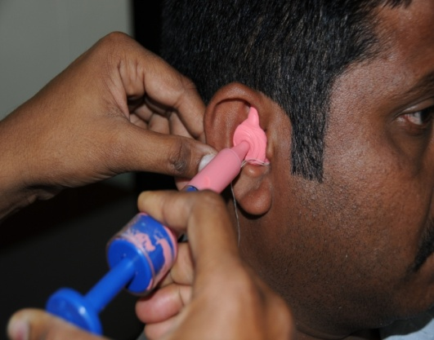

Ear mold making

Age-wise statistics of clients seen in Hearing Evaluation (HE), Hearing Aid Trial (HAT) & Counseling and Ear Mold (EM) laboratory are given in table 21.

Table 21**:** Age-wise Audiological Assessment**.**

|  |  |  |  |  |  |  |  |  |
| --- | --- | --- | --- | --- | --- | --- | --- | --- |
| **Age**  **group** | **H.E** | | **H.A.T** | | **HAT**  **C** | | **E.M** | |
| **M** | **F** | **M** | **F** | **M** | **F** | **M** | **F** |
| 00-01 | 207 | 133 | 163 | 123 | 38 | 22 | 43 | 39 |
| 02-05 | 766 | 619 | 1006 | 704 | 114 | 83 | 297 | 277 |
| 06-10 | 506 | 425 | 521 | 430 | 92 | 51 | 136 | 131 |
| 11-15 | 419 | 315 | 285 | 209 | 60 | 32 | 101 | 70 |
| 16-20 | 392 | 320 | 260 | 175 | 43 | 32 | 79 | 50 |
| 21-25 | 409 | 300 | 179 | 111 | 36 | 33 | 49 | 43 |
| 26-30 | 399 | 279 | 139 | 87 | 34 | 17 | 43 | 20 |
| 31-35 | 365 | 244 | 118 | 83 | 20 | 16 | 31 | 23 |
| 36-40 | 327 | 280 | 172 | 98 | 46 | 31 | 51 | 32 |
| 41-45 | 345 | 256 | 164 | 128 | 51 | 28 | 34 | 37 |
| 46-50 | 326 | 242 | 174 | 106 | 43 | 36 | 56 | 47 |
| 51-55 | 338 | 229 | 203 | 127 | 53 | 35 | 66 | 43 |
| 56-60 | 393 | 246 | 307 | 178 | 101 | 51 | 96 | 51 |
| 61-65 | 373 | 234 | 348 | 184 | 128 | 45 | 112 | 59 |
| 66-70 | 354 | 206 | 361 | 202 | 135 | 65 | 108 | 48 |
| 71-75 | 336 | 155 | 385 | 140 | 136 | 51 | 110 | 47 |
| 76-80 | 235 | 110 | 296 | 105 | 130 | 33 | 87 | 32 |
| 81-85 | 119 | 60 | 146 | 64 | 55 | 13 | 38 | 19 |
| 86-90 | 58 | 29 | 49 | 21 | 17 | 14 | 12 | 5 |
| 91+ | 11 | 5 | 15 | 6 | 6 | 2 | 4 | 1 |
| **Total** | **6678** | **4687** | **5291** | **3281** | **1338** | **690** | **1553** | **1074** |
| **11365** | | **8572** | | **2028** | | **2628** | |
| **Grand Total 24593** | | | | | | | | |

M : Male, F: Female ,HE: Hearing Evaluation, HAT: Hearing Aid Trial,

HAT C: HAT Counseling & EM: Ear moulds.

**Psychological Assessment and Rehabilitation:** The patients registered for availing clinical services at the institute underwent routine psychometric assessment at the psycho-diagnostic clinic of the Department of Clinical Psychology. The assessments carried out at the clinic include (i) pre-vocational assessment for persons with communication disorders, (ii) neuro-psychological evaluations for individuals with neuro-linguistic/communication problems, (iii) psycho-educational achievement testing and grade level assessment for children with scholastic backwardness and academic under achievement, (iv) behavior assessment for children with problem behaviors/skill deficits and (v) family assessment on specific cases requiring family intervention programs.

Psychometric assessment of 5587 new and 922 review cases was done at the clinic during the reporting year. The new cases include patients with mental retardation (1767), expressive language disorders (1067), hearing loss (468), learning disability (588), stuttering (469), misarticulation (126), aphasia (58), cerebral palsy (30), autism (18), functional voice disorders (3), voice problem (7) and others (986). Appropriate therapeutic services were provided, the details of which are given in table 22.

Table 22:Psychological Assessment and Rehabilitation.

|  |  |  |
| --- | --- | --- |
| **Particulars** | **No. of cases** | **No. of sessions** |
| Behavior therapy | 346 | 1025 |
| Home based training instruction for MR/SLD | 206 | 452 |
| Remedial training for SLD cases | 84 | 139 |
| Parent counseling program | 5082 | 5082 |
| Neuropsychological Assessment | 29 | 74 |
| Neuropsychological rehabilitation | 47 | 271 |
| **Total** | **5794** | **7043** |

**Otorhinolaryngological Assessment and Rehabilitation:** The Otorhinolaryngological assessment and rehabilitation for persons with communication disorders were carried out by the ENT department. The department assessed 16,383 new and 17,512 review cases during the reporting year and carried out 18,914 microscopic examinations, 306 endoscopic examinations and 264 vertigo evaluations. The ENT department staff also rendered services at the Government Medical College Hospital, Mysore where 6602 new and 6120 review cases were examined and 305 major and 151 minor surgeries were successfully carried out during the reporting year.

**II. Specialized Clinical Services**

The institute provided a variety of specialized clinical services and evaluations for individuals with communication disorders during the reporting year. The services were performed by qualified and trained professionals in their area of expertise at the following clinical units.

**Augmentative and Alternative Communication (AAC) Unit**: The AAC unit supported, enhanced and provided alternative methods of communication for individuals who are non-verbal and evaluated 25 new and 269 therapy cases, during the reporting year. The number of therapy sessions conducted was 1458. In addition, one home training and two demonstration therapy (DT) cases were attended.

**Autism Spectrum Disorders (ASD) Unit**: Assessment and treatment were provided for 253 clients with autism spectrum disorders at the ASD unit during the reporting year. The unit also attended 700 therapy and eight demonstration therapy cases. The total number of therapy sessions conducted was 3163. The details are given in table 23.

Table 23: Activities of ASD Unit

|  |  |
| --- | --- |
| **Particulars** | **Number** |
| Cases evaluated | 253 |
| Assessment sessions | 199 |
| Therapy cases | 700 |
| Therapy sessions | 3163 |
| Demonstration therapy cases | 8 |
| Cases discharged | 2 |
| Hindi cases | 33 |
| **Occupational Therapy** | |
| Cases evaluated | 166 |
| Assessment sessions | 213 |
| Therapy cases | 1248 |
| Therapy sessions | 3782 |
| Demonstration therapy cases | 583 |
| Cases discharged | 13 |
| Cases discontinued | 17 |
| Cases re-evaluated | 125 |

**Fluency Unit:** This unit catered to the needs of persons with stuttering and other fluency disorders and provided clinical services to 554persons with fluency disorders in 2922sessions during the reporting year. The unit also enabled the professionals to conduct research on neuroanatomical, neurophysiological and genetic aspects of fluency disorders.

**Learning Disability Clinic:** In view of the growing importance being accorded to identification and remediation of academic problems in school children, a Learning Disability Clinic’ was established. The objectives of the clinic include early identify students with learning disability, undertake their detailed evaluation by a multi-disciplinary team of experts, plan individualized remediation programs for the identified students, serve as nodal center for issue of certificates for certain educational concessions, conduct action research to facilitate advocacy, policy change and public education and develop related literature/ materials for or about students with learning disabilities. The details of the activities carried out at the clinic during the reporting year are given in table 24.

Table 24: Activities of Learning Disability Clinic

|  |  |
| --- | --- |
| **Activity** | **Number** |
| Children screened | 588 |
| Detailed testing & assessment | 331 |
| Individualized parent counseling | 331 |
| Issue of certificates for educational concessions |  |
| 1. Indian | 139 |
| 1. Foreign students | 15 |
| Center based remedial instruction | 84 |
| Home based remedial instruction | 247 |
| School liaison and consultancy services | 5 |
| Interns undergoing observation training |  |
| 1. AIISH Interns | 108 |
| 1. Outside | 97 |

**Listening Training (LT) Unit:** Clients who use hearing devices were provided with listening training. Training was also imparted to clients having tinnitus, hyperacusis as well as cochlear implantees. Totally, 2684 persons underwent listening training comprising of 16050 sessions during the reporting year. The detailed statistics on listening training activities are given in table 25.

Table 25: Activities of LT Unit.

|  |  |
| --- | --- |
| **Particulars** | **Numbers** |
| Clients evaluated | 2684 |
| Sessions taken | 16505 |
| Clients underwent demonstration therapy (DT) | 202 |
| New clients | 373 |
| Repeat clients | 2214 |
| Clients discharged | 49 |
| Pre-school sessions attended | 557 |
| Clients given training in Hindi | 185 |
| Clients with CI trained | 202 |
| Sessions for clients with CI taken | 1565 |
| Clients with tinnitus attended therapy | 8 |
| Sessions for clients with tinnitus | 51 |
| Clients with CAPD | 14 |
| Sessions for clients with CAPD | 75 |
| Clients for observation for session hearing aid fitting | 12 |
| Total no. of students trained | 1238 |

**Motor Speech Disorders (MSD) Unit:** This specialized unit caters to the needs of persons with Motor Speech Disorders. It enables them to realize their potential and become contributing members of the society. The clinic was inaugurated in Aug 2011 and the services have been initiated from October 2011 in a phased manner. During the reporting year, the clinic has catered to the needs of children with cerebral palsy below three years of age. They were assessed for their strengths and weaknesses and appropriate intervention strategies initiated. The detailed statistics are given in table 26.

Table 26: MSD Statistics

|  |  |
| --- | --- |
| **Particulars** | **Numbers** |
| Assessment | 14 |
| Intervention | 13 |
| Follow up for intervention | 18 |
| Counseling | 15 |

**Professional Voice Care (PVC) Unit**: The unit provided specialized assessment and management services to professional voice users during the reporting year. It organized various programs to orient and sensitize professional voice users on care, maintenance and conservation of voice. Specialized training in the assessment and counseling of professional voice users was imparted to 36 final year M.Sc. (SLP) and 40 Internship students for 188 hours and 104 hours respectively. The unit also provided detailed diagnostic and counseling services to 18 clients and management services to 31 clients.

**Structural Orofacial Anomalies (U-SOFA)Unit:** Clients with deformalities in the growth of head and facial bones were given multi-disciplinary diagnostic and rehabilitative services in the clinic. Totally 249 clients were evaluated at the clinic by the experts in speech pathology, orthodontics, prosthodontics and plastic surgery and clinical psychology. Among them, 103 were recommended for speech therapy, 41 for orthodontic treatment, 37 for surgery, and 26 for prosthesis. The detailed clinical statistics of the unit are given in table 27.

Table 27: U-SOFA Statistics.

|  |  |  |
| --- | --- | --- |
| **Particulars** | **Numbers** | |
| **Diagnostics** |  |  |
|  | **P** | **A** |
| Plastic surgeon | 136 | 34 |
| Prosthodontist | 14 | 11 |
| Orthodontist | 40 | 14 |
| **Rehabilitation Recommended** | | |
|  | **P** | **A** |
| Orthodontic treatment | 33 | 8 |
| Surgery | 30 | 7 |
| Speech therapy | 80 | 23 |
| Prosthesis | 20 | 6 |
| **Details of Rehabilitation** | | |
|  | **P** | **A** |
| Prosthesis preparation Session | 28 | 14 |
| No. of speech prosthesis prepared | 9 | 2 |
| Speech & Language therapy | 137 | 34 |
| Demonstration therapy(DT) | 45 | 6 |
| DT sessions | 437 | 97 |
| Speech & Language therapy sessions | 944 | 208 |

P: Pediatric, A: Adult

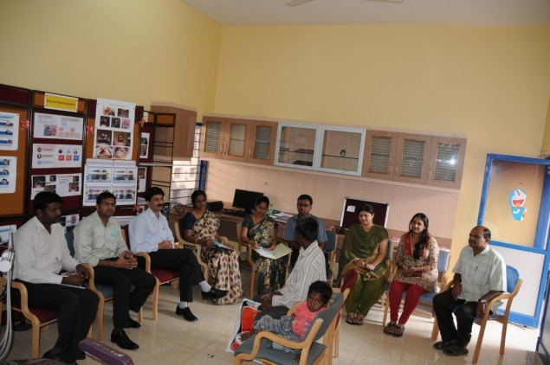

Experts evaluating cleft lip/palate case

**Vertigo Unit:**  The clinic offered comprehensive care in evaluation and management of patients with vertigo. A multidisciplinary team comprising of ENT surgeon, neurologist and audiologist evaluated 264 patients in the clinic for both peripheral and central vertigo during the reporting year and diagnostic tests like microscopic examination of ear, electronystagmography, vestibulo spinal tests, neurological evaluation, audiological tests and vestibular evoked myogenic potential (VEMP) test were carried out for the needy ones.

**III. Medical Specialty Services**

The institute facilitated the services of various medical specialists such as pediatrician, neurologist, plastic surgeon, prosthodontist, orthodontist, phonosurgeon, physiotherapist and occupational therapist, to the needy clients. Totally 1650 patients underwent occupational therapy in 11261 sessions and 811 underwent physiotherapy in 5984 sessions, during the reporting year. In addition, 499, 347, 166, 45, 27 and 22 clients consulted neurologist, pediatrician, plastic surgeon, orthodontist, prosthodontist and phonosurgeon respectively. Thus altogether 2489 clients availed the medical specialty services at the institute. The details are given in table 28.

Table 28: Medical Specialty Services.

|  |  |  |
| --- | --- | --- |
| **Category** | | **No.** |
| PT | Cases | 811 |
|  | Session | 5984 |
| OT | Cases | 1650 |
| Session | 11261 |
| Neurologist | | 499 |
| Pediatrician | | 347 |
| Plastic Surgeon | | 166 |
| Orthodontist | | 45 |
| Prosthodontist | | 27 |
| Phonosurgeon | | 22 |

PT: Physiotherapy, OT: Occupational Therapy

**IV. Special Educational-cum Clinical Services**

The institute provided educational-cum-clinical services to children with communication disorders belonging to different age groups under the aegis of the Department of Special Education. The major services given during the reporting year are the following.

**Parent infant program:** This catersto very young children with communication disorders in their infancy and toddlerhood. During the reporting year, 12 such children were provided early stimulation services through 310 sessions.

**Pre-school parent empowerment program:** Parents of 165 children of two years and above age, awaiting pre-school admission were empowered to prepare their children for pre-school. Language wise, 49 Kannada, 20 Malayalam, 17 English, 10 Hindi and 7 Telugu parents benefitted the service in 1076 sessions.

**Pre-school training:** Totally198 children with communication disorders underwent preschool training in 116403 sessions during the reporting year. This includes children with autism (40), mental retardation (85) and hearing loss (73). In addition, children with multiple disorders such as hearing loss with autism (27), hearing loss with cerebral palsy (55), hearing loss with mental retardation (48), mental retardation with autism (184), mental retardation with cerebral palsy (225), mental retardation with visual impairment(9), hearing loss with cerebral palsy with mental retardation (1) were also given training by grouping them according to disorders.

In coordination with the department of clinical services all the 198 children were given speech language training in 5473 sessions and listening training for 73 children in 810 sessions. Apart from these, all the enrolled children were given co-curricular training in 269 sessions.

**Curricular support services:** One hundred and three children with communication disorders studying in normal schools were provided with curricular support services in 2542 sessions during the reporting year. Individualized educational services were also provided to children out of school and those pursuing non-formal education.

**Placement guidance evaluation**: Educational assessments were carried out for 51 children with communication disorders in 102 sessions and follow-up guidance was provided for appropriate school placement and instructional services.

**Counseling and guidance**: This service was provided to 358 caregivers and educators in the field through 823 sessions for helping them support the education of children.

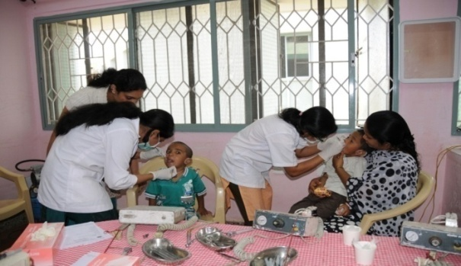

Oral hygiene and dental camp

**Organization of camps:** The department of special education also organized camps for children with disability such as one day oral hygiene and dental camp and 28 days summer camp for the overall development of children with special needs.

A summary of special educational-cum clinical services provided during the reporting year are given in table 29.

Table 29: Special Educational-cum Clinical Services

|  |  |  |
| --- | --- | --- |
| **Service** | **C** | **S** |
| Parent infant program | 12 | 310 |
| Pre-school parents empowerment program | 165 | 1076 |
| Pre-school training for children with comm. disorders | 198 | 116403 |
| * Speech language therapy | 198 | 5473 |
| * Listening therapy | 73 | 810 |
| Co-curricular training | 198 | 269 |
| Curriculum Support Service | 103 | 2542 |
| Placement guidance evaluation | 51 | 100 |
| Counseling and Guidance | 358 | 823 |

* C: clients, S: Sessions

**V. Clinical Electronic Services**

The clinical electronic services provided under the Department of Electronics include electro- acoustic evaluation and, management and issue of hearing aids. Hearing aids were distributed under ADIP Scheme of Ministry of Social Justice and Empowerment, Government of India and AIISH Hearing Aid Dispensing Scheme. Totally 1702 hearing aids with solar battery chargers were distributed at the main campus (1625), camps (21), and clinical outreach centers (56), after electro-acoustic evaluation and testing under ADIP scheme. Under AIISH Hearing Aid Dispensing Scheme, 1300 hearing aids were issued at concessional rate. The department also repaired 453 body level and 120 BTE hearing aids and freely serviced 404 BTE hearing aids.

**VI. Clinical Support Services**

The institute extended a diverse range of support services to patients and their family. These include: (i) counseling and guidance on various aspects of the disorders such as treatment procedures, usage and care of tools like hearing aids, and (ii) issue of certificates like financial aid, tax exemption, educational scholarship, railway concession, and school admission. The clinical support services provided to the eligible candidates, during the reporting year are given in table 30.

Table 30: Clinical Support Services.

|  |  |
| --- | --- |
| **Particulars** | **Numbers** |
| **Dept. of Clinical Services** |  |
| Transfer certificate | 39 |
| Case reports | 737 |
| Attendance certificates | 85 |
| School admission certificate/Language exemption certificate | 167 |
| Correspondence by e-mail/letter | 289 |
| Financial assistance to the needy patients (Total Amount Rs. 8813/-) | 4 |
| **Department of Audiology** | |
| Financial aid certificates | 553 |
| Certificates for school admission (deaf) | 75 |
| Physically handicapped certificates | 195 |
| Tax exemption certificates | 48 |
| Education scholarship certificates | 53 |
| Audiogram reports issued | 6690 |
| Counseling & Guidance on EPDs |  |
| Others | 94 |
| **Department of Clinical Psychology** | |
| Mental retardation certificates | 669 |
| Railway concession certificates | 90 |
| Learning disability certificates | 139 |
| Psychological report for special school admissions | 146 |
| Income tax exemption certificate | 34 |
| Medico-legal cases | 3 |

**VII. Others**

The department of Audiology and Clinical Services introduced biometrics for students posted.

Outreach and Public Education Services

In addition to diagnostic and therapy services provided within its walls, the institute delivers outreach clinical services and employs a variety of channels to enhance the public’s awareness and knowledge of the communication disorders. The outreach services of the institute are carried out mainly by the Department of Prevention of Communication Disorders (POCD) and Centre for Rehabilitation and Education through Distance Mode (CREDM).

This chapter lists out major outreach and public education services that the institute delivered during the reporting year.

**A. Outreach Services**

**I. Communication Disorder Screening Programs**

The Department of Prevention of Communication Disorders (POCD) conducted screening programs for communication disorders in different settings in various localities. The individuals participating in the program were checked for hearing, speech and language abilities and provided with diagnostic and therapeutic services. The screening programs conducted during the reporting year are mentioned below.

**Infant Screening:** Under this program, neonates and infants were screened using various tools such as High Risk Register for communication disorders, Behavioral Observation Audiometry, Oto Acoustic Emission Screening and Screening Checklists to identify the risk factors that could lead to communication disorders. Screening program was carried out throughout the year in 12 hospitals/immunization centres in Mysore and totally 13031 babies which include 6696 male and 6335 female were screened and 1629 among them were referred to the institute for follow-up. The distributions of pre-natal, natal and post-natal high risk factors in infants screened are given in figure 3.

The infant screening was also initiated at SCB Medical College & Hospital, Cuttack and Regional Institute of Medical Science & Hospital, Imphal, the two DHLS centres of the institute during the reporting year.

Figure 3: High risk factors in infants

**Industrial Screening**: As a part of hearing evaluation program for industrial workers, the institute conducted hearing screening of 132 employees working in the Karnataka Silk Industries Company (KSIC) factory located in Mysore and 32 employees were tested for hearing abilities. Most of them had high frequency sloping sensorineural hearing loss due to exposure to high noise level. The employees were counseled regarding the need to use devices to protect their hearing and on the attenuation of noise level at the source and transmission path. They were also referred for detailed evaluation at the institute. The details of the hearing evaluation of the employees are represented in figure 4.

Figure 4: Industrial Screening

**School Screening:** Children studying in the nearby schools of the outreach centres of the institute at Hullahalli and Akkihebbalu, were screened for communication disorders and learning disabilities. Of the 401 students screened, 136 were identified with language disorders and 107 with otolaryngological problems. The details of communication disorders identified among the school children are given in figure 5. Further evaluations of the needed cases were done at the outreach centres.

Figure 5: Communication disorders among school children

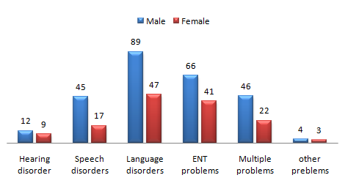

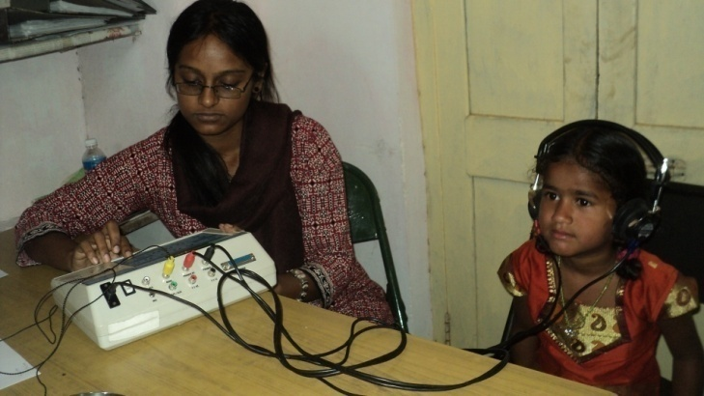

School Screening

**Communication Disorders Screening Camps:** Six camps were conducted in various localities in Karnataka with the objective of detecting communication disorders and creating awareness among the general public about the disorders, during the reporting year. These camps were mainly sponsored by NGOs, SSA, and other state and district level agencies. The expert speech and hearing and allied health practitioners of the institute evaluated a total number of 889citizens at the camps and 242cases were referred to the institute for further check-up. Further, 123 hearing aids, one audiological and 39 psychological certificates were also issued at the camps. The details of screening camps conducted are given in table 31 and the communication disorders identified in figure 6.

Table 31: Communication Disorders Screening Camps

|  |  |  |  |  |
| --- | --- | --- | --- | --- |
| **Location** | **Date** | **Sponsor** | **Cases**  **evaluated** | **Cases**  **referred** |
| Hosanagar, Shimoga | 28 April 11 | JCI, Kodachadri | 245 | 13 |
| Belaku Ashradhama | 13 May 11 | Belaku Ashradhama | 4 | 4 |
| Rotary club, Mandya | 24 Febr 12 | Rotary Inner Wheel, Mandya | 76 | 70 |
| Govt.Higher Primary School, Mathrumandali,  Mysore | 3 March12 | District Health Committee | 35 | 20 |
| Keelara, Mandya | 9-10 March12 | AIISH | 529 | 135 |
| **Total** | | | **889** | **242** |
| Figure 6: Communication disorders identified at camps | | | | |

**II. Diagnostic and therapeutic services at outreach service centres**

The outreach service centres of the institute located at (i) Hullahalli, Nanjangud, Mysore, (ii)Akkihebbalu, K.R. Pete, Mandya, (iii) Gumballi, Chamarajanagar, and (iv) Santhemaralli, Chamarajanagar, provided communication disorders related diagnostic and therapeutic services to the villagers in the locality during the reporting year. Totally 2872 clients ranging from infants to adults underwent speech and hearing evaluation. Among them, 2285 individuals were diagnosed to be having audiological (484), speech and language (239) and otolaryngological (1562) related disorders. In addition to the evaluation provided 72 hearing aids were issued among the clients and 52 ear mould impressions were taken at the outreach centres.

**III. Tele intervention and tele-assessment**

The institute through its Centre for Rehabilitation and Education through Distance Mode (CREDM) offered an innovative tele-intervention and assessment outreach service through videoconferencing to persons with communication disorders and their caregivers at 10 DHLS centers of the institute located in different parts of the country, from Monday to Friday throughout the year. Totally 215 clients with child language (123), fluency (45), voice (24), adult language (4) and articulation (19.) disorders were provided with needed diagnostic and therapeutic services. Tele-intervention was also done at the outreach service centres of the institute at Akkihebbalu and Hullahalli for three months and 14 persons with communication disorders benefitted the service.

**IV. Web-based Service**

TheCentre for Rehabilitation and Education through Distance Mode addressed queries related to communication disorders, their assessment and management by providing resource materials over its website. Totally, 2917 persons visited the site for availing the service during the reporting year.

**V. Educational Guidance and Counselling through Distance Mode**

Educational guidance and counselling were given to 15 caregivers of children with communication disorders at the DHLS study centres through videoconferencing in 25 sessions. The purpose was to help them understand how their child’s special need might affect his education; how to prepare him for schooling; help in deciding appropriate schools to educate the child and provide them information on various benefits and concessions that are offered by the central and state governments towards the education of children with special needs.

**B. Public Education**

The institute took various steps to make the common man aware of communication disorders, educate them on prevention of disorders and provide guidance and counseling to persons suffering from such disorders, during the reporting year. These include the following.

**I. Monthly Public Lectures**

In order to create public awareness on various communication disorders such as stuttering, articulation disorders, aphasia, mental retardation, hearing and voice problems, the institute organized monthly public lectures tailored for common man, throughout the year, during which expert practitioners in the field delivered one-hour lecture followed by question and answer session with the audience. The details of the lectures delivered during the reporting year are given in table 32.

Table 32: Public Lecture Series

|  |  |  |  |
| --- | --- | --- | --- |
| **Sl.**  **No.** | **Topic** | **Resource person** | **Date** |
|  | E.N.T. problems in school  children. | Dr. T .K. Prakash,  Lecturer in E.N.T. | 30.04.11 |
|  | Hearing screening in infants and children. | Dr. Ajith Kumar, U.,  Reader in Audiology. | 28.05.11 |
|  | Individualized educational plan for children with special needs. | Ms. P. Vijetha,  Lecturer in Special Education. | 25.06.11 |
|  | Communication disorders in children. | Ms. Priya, MB,  Speech Language Pathologist. | 31.07.11 |
|  | Physiotherapeutic aspects in communication disorders. | Mr. Siddesh N.S.  Physiotherapist. | 27.08.11 |
|  | Ear and balance. | Mr. Sujeet Kumar Sinha, Lecturer in Audiology. | 24.09.11 |
|  | Stuttering. | Mrs. Sangeetha Mahesh,Clinical lecturer. | 29.10.11 |
|  | Articulation problems in children. | Mr. Sachin L.C.,  Lecturer in Speech Sciences. | 26.11.11 |
|  | Middle ear infection: Consequences and solutions. | Ms. Mamatha N. M., Lecturer in Audiology. | 31.12.11 |
|  | Behavioral management of children with communication disorders. | Dr. G., Jayarama  Reader in Psychology. | 28.01.12 |
|  | Common problems of nose and solutions: Communication perspective. | Dr. Bhagyashri, K.,  E N T Surgeon | 25.02.12 |
|  | Benefits and concessions for the individuals with disability. | Mr.Prashanth Prabhu, P  Clinical Assistant. | 31.03.12 |

**II. Preparation and Dissemination of Information Resources**

Various public education materials related to the prevention and control of communication disorders were prepared in print and electronic formats and were disseminated among the general public. The major ones are given in table 33. In addition, translation of materials prepared in one language to others were also carried out and disseminated.

Table 33: Public education materials prepared

|  |  |  |  |  |  |
| --- | --- | --- | --- | --- | --- |
| **Sl.No** | **Title** | **Type** | **Format** | **Language** | **Department** |
| 1 | Adjusting to amplification | Manual | Print | English | Audiology |
| 2 | Assistive listening devices | Brochure | Print | English | Audiology |
| 3 | Beware of noise | Manual | Print | English | Audiology |
| 4 | Body level hearing aid care | Manual | Print | English | Audiology |
| 5 | Caring for your hearing aids: dos and donts | Manual | Print | English | Audiology |
| 6 | Child with hearing impairment in the class | Manual | Print | English | Audiology |
| 7 | Cleft lip and palate | Brochure | Print | Kannada&English | SLP |
| 8 | Correcting problem of BTE hearing aid | Manual | Print | English | Audiology |
| 9 | Correcting problems of body level hearing aid | Manual | Print | English | Audiology |
| 10 | Eight guidelines to keep you talking/ singing | Pamphlet | Print | English | SLS |
| 11 | Facts about hearing loss and hearing aids | Manual | Print | English | Audiology |
| 12 | Feeding issues in cleft lip and palate children | Manual | Print | English | SLP |
| 13 | For the person using hearing aid | Manual | Print | English | Audiology |
| 14 | Frequently asked questions on voice care | Pamphlet | Print | English | SLS |
| 15 | Getting to know digital hearing aid | Manual | Print | English | Audiology |
| 16 | Getting to know your hearing aid | Manual | Print | English | Audiology |
| 17 | Maguvige tharabeti koduvudu-Hanta ondu | Manual | Electronic | Kannada | CREDM |
| 18 | Manual for parents on cleft lip and palate | Manual | Print | English | SLP |
| 19 | Normal Development of Articulation | Movie | Electronic | English | CREDM |
| 20 | Normal Speech and Language Development | Movie | Electronic | English | CREDM |
| 21 | Prevention of hearing impairment | Brochure | Print | English | POCD |
| 22 | School screening checklist for teachers | checklist | Print | Kannada&English | POCD |
| 23 | Signs and symptoms of stroke | Brochure | Print | English | Clinical Services |
| 24 | Tinnitus: Ringing in the ears | Manual | Print | English | Audiology |
| 25 | Tips for better communication | Manual | Print | English | SLP |
| 26 | Tips for families with person using hearing aid | Manual | Print | English | Audiology |
| 27 | Train your child Level I | Manual | Electronic | English | CREDM |
| 28 | Use and care of BTE hearing aid | Manual | Print | English | Audiology |
| 29 | Vocal hygiene tips for professional voice users | Pamphlet | Print | English | SLS |

Activities of the Central Facilities

Central facilities are being developed in the Institute to serve the entire institute community. Some of these facilities are open to outsiders as well.

This chapter explains the activities carried out by the Department of Electronics, Department of Material Development, Library and Information Centre and Public Information Office, the major central facilities of the institute.

**A. Electronic Services**

The department of Electronics developed a faculty evaluation software.

**B. Library and Information Services**

The Library and Information Centre (LIC) continued to play a vital role in the academic, research and clinical activities of the institute by expeditiously providing the required information to the professional community.

**I. In-house Activities**

The section-wise in-house activities of the LIC during the reporting year are outlined below:

**Acquisition Section:** During the reporting year acquisition section added 843 books to the collection which is the highest number since the inception of the institute by spending more than `26 lakhs.

**Information Processing Section:** The latest edition of the world’s most heavily used book classification scheme, Dewey Decimal Classification, was introduced during the reporting year and all the existing books in the collection were re-classified using the new scheme.

**Periodical Section:** One hundred and six peer-reviewed journals pertaining to communication disorders and allied fields were subscribed which include 17 print only, 24 print plus electronic, and 65 electronic only journals.An online archive of electronic journals was also built up by purchasing electronic back issues of 27 most important Speech and Hearing journals, during the reporting year. LIC continued getting access to more than 2700 biomedical E-journals as a part of ERMED consortium, Ministry of Health and Family Welfare, Govt. of India.

**Information Technology Section:** This is a new section started during the reporting year to manage the electronic information sources and services. The major activities carried out by the section include (i) digitization of in-house research reports and other relevant study materials like previous question papers and uploading them on to the web portal, (ii) setting up of access to the subscribed electronic resources on the LIC web portal and continuous monitoring for the uninterrupted access to these resources by the user community, (iii) maintenance and modifications of the web portal, (iv) monitoring the functioning of Integrated Library Management System software and making suggestions for modifications.

**II. Major Services Provided**

The LIC provided both traditional and electronic information services such as book lending service, reference service, current awareness services, Internet service, online public access catalogue service and online database service. Further, all the electronic information sources and services were extended to the 11 DHLS centres of the institute across the country with the launch of Virtual Private Network in February 2012.

**III. User Education**

Comprehensive orientation program on the usage of various information sources with special reference to electronic resources were given to the newly admitted students.

**IV. Visitors**

A total number of 73 persons including students, research scholars, practitioners and teachers in the field of communication disorders from academic, research and clinical settings across the country visited the institute during the reporting year.

**C. Material Development Activities**

Department of Material Development created materials for the public on prevention, identification and management of various communication disorders, during the reporting year. In addition, it also generated materials regarding the various rights and welfare measures available for individuals with communication disorders. They were developed in such a way that dissemination of information can be done through various media such as word of mouth, orientation, street plays, print, video, radio and theatre.

The details of various materials developed during the reporting year by the Department are given in table 34.

Table 34: Material Development Activities

|  |  |
| --- | --- |
| **Material** | **Total**  **Number** |
| 1. **Designing** 2. Posters 3. Cover page 4. Brochures/ folders 5. Invitation cards 6. Certificates 7. Page layout 8. Photo editing 9. Identity/ Enrolment card 10. Others | 45  13  37  10  96  552  582  105  08 |
| 1. **Photo coverage** 2. No. of photos taken 3. Video coverage | 2581  2.45 hrs |
| **c) Printing**   1. A3 size 2. A4 size 3. Scanning & photocopy | 2445  12670  810 |
| **d) Others**  Preparation of documentary film | 20 Mts |

**D. Public Information Activities**

Public information office of the institute is responsible for taking care of institute publications and maintenance of media relations. The major activities of the Public Information Office during the reporting year are given below.

i). The office coordinated the publication of articles and news in leading dailies and magazines and broadcasting of programs on audiovisual media on prevention and control of communication disorders, and on the academic, research and clinical activities of the institute based on the interviews with the professionals in the institute. A few of them are given below.

* An article on PG Diploma in Forensic Speech Science & Technology, conducted by the institute was published in Education, a special supplement of Prajavani, the Kannada daily in May 2011.
* An article on institute’s academic programs was published in Education, a special supplement of Prajavani, the Kannada daily on 19 August 2011.
* An article on institute’s academic programs under the headline, Demand for Speech and Hearing Professionals, in Lava Lavike, special supplement of the Vijaya Karnataka, the Kannada daily, on 29 August 2011.
* A news item on Know How to Get AIISH Disability Certificate was published in all local and national dailies and also broadcasted over radio and television channels in July 2011.
* An article on Prevention of Suicide, based on an interview with Dr. S. Venkatesan, Professor of Clinical Psychology, published in Vijaya Karnataka, the Kannada daily in connection with the World Suicide Prevention Day on 11 September 2011.
* An article on Diploma in Hearing Aid and Earmould Technology conducted by the institute under the headline Lend An Ear To Them, in The Times of India, the English daily on 19 September 2011.
* A program on Academic Programs and Clinical Services for the Communication Disorders was broadcasted by Kannada Kasturi, the Kannada television channel as a part of Dasara special programs in October 2011.
* A program featuring creating awareness among the public on the effects of noise pollution and crackers under the headline Noise Pollution and Crackers: Care to be Taken was broadcasted over Citi Cable, UMN and MCN television channels in October 2011.
* An article by Dr.S.R.Savithri, Director on care to be taken during Deepavali festival, was published in the Deepavali’s special supplement of the Times of India, the English daily on 24 October 2011.
* An article on Cerebral Palsy, based on the interview with Dr.S.R.Savithri, Director was published in Just Kannada, an online Kannada News Journal on 21 February 2012.
* An article on singer’s nodule (Vocal nodule) and voice problem based on the interview with Ms.Yasodha, Lecturer in Speech Sciences was published in the health supplement of The WEEK, English magazine on September 2, 2011 issue under the headline Danger At The Workplace.

In addition to the above, print and electronic media gave excellent coverage of various activities and events taken place in the institute such as monthly public Lecture Series, orientation programs, workshops, seminars and the also the visit of dignitaries to the institute.

ii) The Public information office also coordinated the publication of the following institute publication during the reporting year.

* Journal of All India Institute of Speech and Hearing, Vol.30.
* Brochures and posters related to the activities of various departments

iii) The office also coordinated the organization of five communication disorders screening camps at various localities by the institute.

Administrative & Maintenance Activities

The institute is an autonomous establishment under government of India, fully financed by the Ministry of Health and Family Welfare. The affairs of the institute are managed by an executive council with the Union Minister of Health and Family Welfare as the chairman and the director of the institute as the member secretary. Academic committee and finance committee are the other two administrative bodies of the institute which advice the director on academic and financial matters, respectively. The members of executive council, academic and finance committees during the reporting year are given in Appendix I.

This chapter describes the personnel, financial and other activities related to the general administration of the institute. It also lists out the infrastructure development and maintenance activities carried out by the engineering and horticulture sections of the institute.

**A. Administrative Matters**

The administrative office provided assistance and support to the Director in general administration and management of the institute. The major activities of the office during the reporting year are given below.

**I. Personnel Management**

**New Recruitment:** Nine regular staff were recruited during the period and with this the regular staff strength of the institute became 178 which includes 46 group ‘A’, 61 group ‘B’ and 41 group ‘C’ staff. In addition, 162 contract staff were also recruited during the period. Thus the total staff strength of the institute by the end of the reporting year is 340.

**Promotions:** There were four promotions under Assessment Promotion Scheme and three regular promotions during the reporting period. Under Assessment Promotion Scheme, Dr. S. Venkatesan and Dr. R. Manjula were promoted to the post of Professor in the scale of pay ` 37400-67100+GP-8700 and Dr. M. Pushpavathi and Dr. G. Rajeshwari were promoted to the post of Professor in the scale of pay `15600-39100 + GP `7600/-. Under the regular promotion, Mrs. B. R. Chudamani, Mr. G. H. Anandaram and Mr. D. S. Ramesh were promoted to the posts of Electronics Engineer, Assistant Administrative Officer and Office Superintendent, respectively.

**Completion of 25 Years in Service:** Eight staff working in different departments/sections completed 25 years of service in the institute during the reporting year. They were felicitated by Mr. G. Gourisankar, General Manager, BSNL, Mysore Telecome District and Dr. S. M. H. Qadri, Director, Central Sericulture Research and Training Institute, Mysore with a shawl and a plaque of honour with inscription, during the annual day celebrations on 9 August 2011.

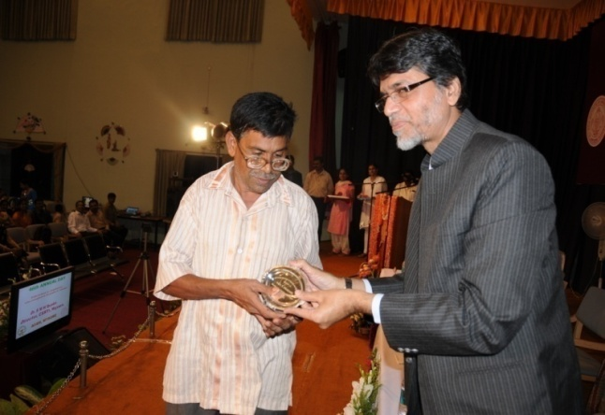

Dr. S. M. H. Qadri presenting the plaque of honour to Mr S.V Prakash

**Retirement/Repatriation/Resignation:** During the reporting year, 4 staff members superannuated, 1 repatriated and 2 resigned from the regular service of the institute. In addition, 91 contract staff working under various capacities, were relieved/resigned from the service during the period.

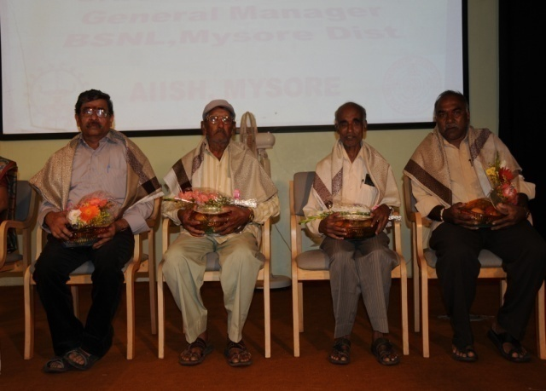

Felicitation of Superannuated Staff

**II. Financial Management**

The matters related to the financial status of the institute during the last fiscal year are given in Appendix – III.

**III. Official Language Implementation**

Hindi implementation program continued at the institute as per the guidelines of Government of India. The activities carried out towards the implementation of the official language policy, during the reporting year are detailed below.

**Hindi Training:** The faculty members and staff who do not possess working knowledge in Hindi were nominated for undergoing training in Prabodh and Praveen courses. Seven staff members were nominated for the July 2011– Nov 2011 session of the Prabodh course and five of them passed in the examination. For the Jan- May 2011 training session, one was enrolled for Prabodh and five for Praveen.

**Material Development:** Various materials including 15 training materials, 3 Invitation cards, 3 certificates, 7 formats of office memoranda, 2 press releases and 1 advertisement were prepared in Hindi. In addition, translation of the annual report 2010-11, and rendering of many public education materials, course materials and work books were also carried out.

**Word a Day in Hindi:** A list of most frequently used words in official settings was prepared and each day one word was displayed in bilingual form for the benefit of the staff in various locations such as administrative block, academic block, library, therapy clinic and pre-school.

**Correspondence:** During the reporting year, 24 general orders, memos and circulars were prepared and letters to outside organizations, office notes etc., were signed in Hindi in addition to sending replies to the letters received in Hindi.

**Hindi Week**: Hindi week was celebrated in the Institute on 14-20 September 2011 to commemorate the adoption of Hindi as the National Language of the Union of India on 14 September, 1949. Dr.S.R.Savithri, Director of the institute inaugurated the week long celebrations on 14 September. Mr.Vaidyanathan, the Controller-Administration, Central Food Technological Research Institute, Mysore was the chief guest at the valedictory function held on 20 September. To encourage and motivate the employees for doing official work in Hindi, various competitions were organized during the event.

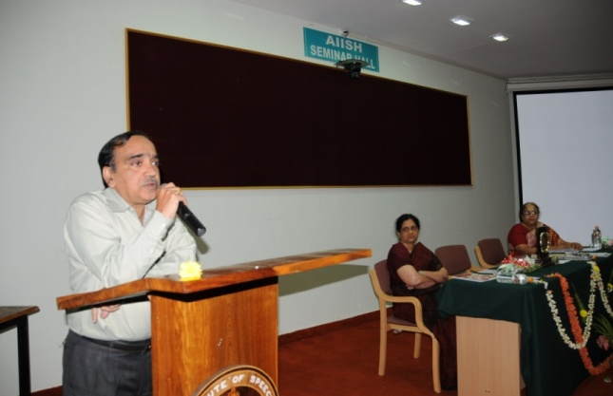

Mr.Vaidyanathan speaks during the valedictory function of the Hindi week.

**Workshop Organized**: A two day Hindi workshop was organized on 21-22 December 2011 and eminent faculty from outside organizations delivered lectures during the event.

**Workshops Attended:** (i)Dr. HP Uma Saraswathi, Hindi Translator and Ms. R.Shanthi, Upper Division Clerk attended the 17th Seminar and Workshop on Official Language Hindi, organized by Rajbhasha Sanstan, New Delhi, at Solan, Himachal Pradesh on 27-29 April 2011. (ii) Dr. HP Uma Saraswathi, Hindi Translator and Ms. N Parimala, Stenographer & Personal Assistant to the Director attended the Special Hindi Symposium and Workshop, organized by Rajbhasha Sanstan, New Delhi, at Dalhousie, Himachal Pradesh on 9-11 November 2011. (iii) Mr.N.Chandrashekar, the Lower Division Clerk attended the Workshop on the Use of Hindi IT Tools on Computers, organized by the Central Institute of Indian Languages, Mysore on 13-17 February 2012.

**B. Maintenance Activities**

The infrastructure development and maintenance activities of the institute are being carried out by the engineering and horticulture sections.

**I. Engineering Works**

The engineering section completed 15 construction works worth ` 626.74 lakhs during the reporting year, which include the construction of Psychoacoustic Lab, new men’s hostel and guest faculty suites. Also, the construction of Knowledge Park, Audiometric Block and 48 Type II & III Staff Quarters which totally cost `2601.87 lakhs were going on smoothly. In addition to the construction of new buildings the section also carried out extensive

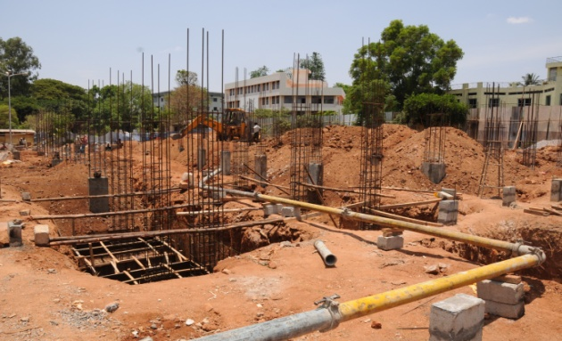Construction of Knowledge Park

**II. Horticulture Activities**

The Horticulture section is responsible for maintaining an aesthetically pleasing natural environment for the institute. The section continued developing garden and lawn and preserved the natural environment of the surroundings. The major activities carried out by the section during the reporting year are given below.

**Development of Nursery:** Around 2,000 ornamental potted plants, annual and bi-annual flowering plants for decorating departments and sections were developed.

**Participation in Dasara Horticultural Flower Show:** The Horticulture section participated in the Dasara Horticultural Flower Show 2011, organized by the State Horticulture Department on 28 September – 9 October 2011 at Curzon Prk, Mysore. The institute won 8 first prizes, 3 second prizes and 3 third prizes for arranging various types of flower groups. Apart from this, the institute won 5 First prizes and 1 Second prize for well garden maintenance and growing various flowers in pots and beds at the institute.

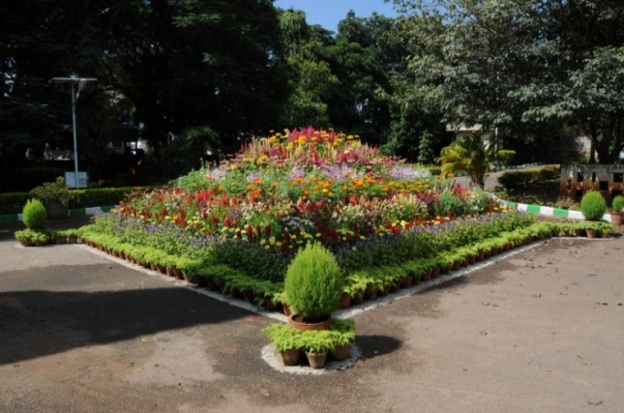

Garden

**Tree Planting Program**: The Horticulture Section was conducted a Tree Planting Program on 22 November 2011 at the institute main campus. More than hundred varieties of fruit plants were planted during the event.

**Other Activities:** Around 5850 Sq.ft. area of Mexican lawn was developed around rose garden adjacent to Department of Clinical Service and Old Engineering section and the pop-up sprinkler system installed near rose garden. Also, the development of kitchen garden was initiated at the backside of ladies hostel.

**III. Purchase of Equipments**

The institute also strengthened its infrastructure by procuring a number of new sophisticated tools and instruments and by the upgrading the existing scientific equipments and spent a total amount of ` 1, 53,34,861/- towards the purchase 63 items of equipments, during the reporting year.

Extra-Curricular Events

The institute organized a wide range of extra-curricular activities spread across the year under the aegis of AIISH Gymkhana, the cultural organization of staff and students of the institute and the National Service Scheme unit.

This chapter details the activities carried out by the Gymkhana and the NSS unit during the reporting year.

**A. AIISH GYMKHANA**

AIISH Gymkhana acted as a platform for various recreational, sports, social and cultural activities of students and staff of the institute. The major programs organized by Gymkhana during the report year are the following.

**Annual Day:** The 46th institute annual day was celebrated on 9August 2011. Mr. Chandramouli, IAS, Secretary, Ministry of Health & Family Welfare, Government of India*,* was the chief guest, Dr. K. S. Sriprakash. Vice-Chancellor of Rajiv Gandhi University of Health Sciences and Dr. K. S. Rangappa, Vice-Chancellor, Karnataka State Open University were the guests of honor during the event. A cultural program was also organized in the evening to mark the occasion and Dr. S. M. H. Qadri, Director, Central Sericulture Research and Training Institute, Mysore and Mr. G. Gourisankar, General Manager, BSNL, Mysore Telecome District were the chief guests. Retired employees of the institute and employees completing 25 years of institute service were honored and staff, students and preschool children presented various cultural performances during the occasion.

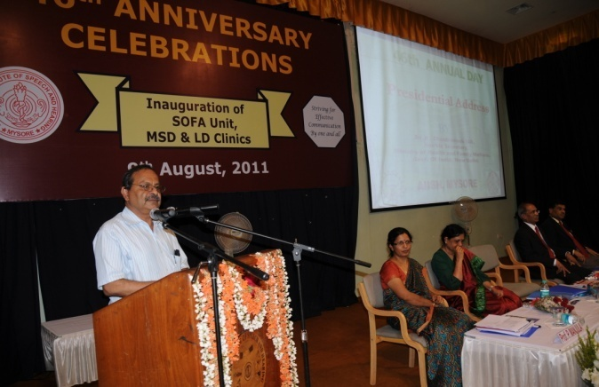

Mr. Chandramouli, IAS, delivering presidential address at the Annual Day Celebrations

**Pratibha Puraskar:** Gymkhana honored the children of staff members who secured highest marks in X standard, II PUC and degree courses with Prathibha Puraskar which contains a cash prize and merit certificate, on26 August 2011. Eight children received the honor. Dance, music, recitation, sketching, painting, and other cultural activities were also organized during the event.

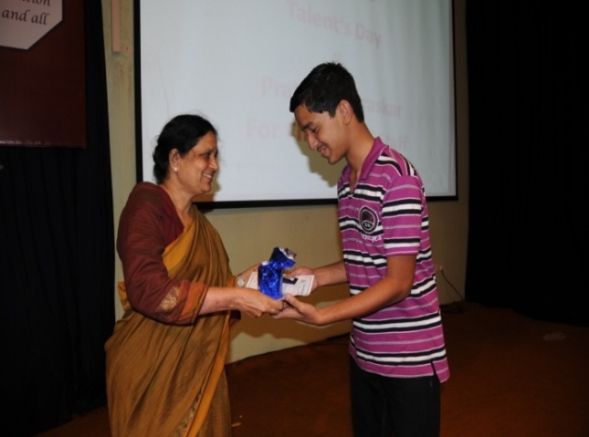

Master Thejas receiving prize

**Talent Day**: A talent day was organized on 7 September 2011 for showcasing the skills and talents of the institute students. Around fifty students participated in the dance, music, poetry, sketching, painting competitions held during the event.

**Open Day:** The instituteOpen Daywas held on 4 November 2011 during which the public were given opportunity to visit the institute and understand various facilities and services it provided. As a part of the Open Day celebrations, the public and school children were educated on various aspects of communication disorders through an exhibition. Various competitions were also conducted for both normal developing children and children with disabilities. More than 1700 people including school children, teachers and the general public visited the institute during the occasion.

**Kannada Rajyotsava Day:** The state festival of Karnataka which is observed on November 1st every year as the Karnataka Formation Day was celebrated at the with great joy and vigor. Professor Aravind Malagatti, Kuvempu Institute of Kannada Studies, University of Mysore was the chief guest. Several public education pamphlets on hearing impairment and haring devices prepared by the institute in Kannada language were released during the occasion. A variety of competitions including Pick and Speak (for Kannadigas and non-Kanadigas), Quiz and Essay Writing (topic ಬ್ರಷ್ಟಾಚಾರ ನಿರ್ಮೂಲನೆಯಲ್ಲಿ ಯುವಕರ ಪಾತ್ರ OR ಇಂದಿನ ಪ್ರಪಂಚದಲ್ಲಿ ಗಾಂಧಿ ಜಿಯವರ ಮೌಲ್ಯಗಳು) were also conducted to mark the event.

**Cultural Competitions:** Gymkhanaorganized intra-institute cultural competitions for its staff and student members on 1-10 February 2012.The members displayed their talents and creativity by enthusiastically participating in events such as Light Music, Salad Making, Chaat Making, Spot photography, Mehendi, Rangoli, Ikebana and Dance.

**National Science Day:** The national science daywas celebrated at the institute on 28 February 2012, to commemorate the day on which Sir C.V.Raman discovered the Raman Effect. Dr. P. Nagabhushan, Professor in Computer Sciences, University of Mysore was the chief guest who delivered a lecture on Research Bent of Mind. Prizes were distributed to the winners of Elocution and Treasure Hunt competitions, on the occasion.

**AIISH Aawaaz:** Gymkhana organized AIISH Aawaaz, the inter-collegiate cultural festival on 16-18 March 2012. The program was inaugurated by Dr. B.V. Rajaram, Director, Rangayana, Mysore on 16 March. Popular singer Ms. Divya was the guest of honor. Hundreds of students from different colleges participated in the event and exhibited their cultural talents. The events and competitions included group dance, skit, pencil sketch, quiz; face painting, mock press, antakshari, dumb charades, verbattle, mehendi, spot photography and many others. Sri. Ravi Belagere, noted Kannada journalist, writer and actor, was the chief guest at the valedictory ceremony held on 18 March 2012. The AIISH students won the rolling trophy for best overall performance and variety entertainment and the JSS Institute of Speech and Hearing won the rolling trophy for the best fashion show.

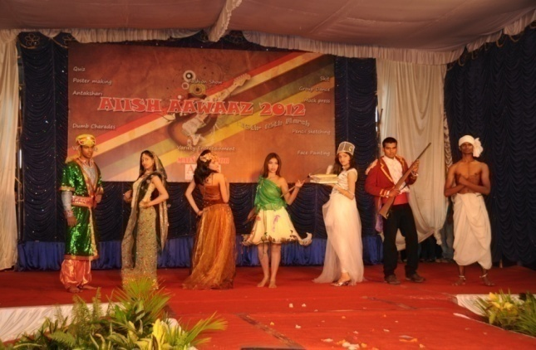

Students’ performance at AIISH AWAAZ

**Science Exhibition**: The institute participated in the Science Exhibition organized by the University of Mysore on 30-31 March 2012.The theme of the exhibition was ‘Save the Earth’. The Departments of Audiology, Speech Language Pathology, Speech Language Sciences, Special Education, POCD, CREDEM and Clinical Services participated in the science exhibition. Models, charts, brochures, public education materials, videos, and equipment were displayed for public education during the event.

**B. National Service Scheme**

The National Service Scheme (NSS) unit of the institute with 164 enrolled volunteers, rendered a variety of community services during the reporting year. The notable among them include the following:

**Shramadan:** With the objective of creating a plastic free environment, shramadan programs were conducted throughout the reporting year in different localities in Mysore. No plastic walks were organized and the volunteers made many areas in these localities plastic free. The public were also educated on the harm of plastic usage. In addition, the volunteers prepared paper bags out of waste newspapers and were sold to students, staff and other individuals interested.

**Blood Donation Camp:** A blood donation camp was organized on 26 August 2011. The camp was inaugurated by Dr.S.R.Savithri, Director of the institute. Fifty NSS volunteers donated their blood to the Blood Bank, Government Medical College Hospital, Mysore.

**Nature Camp**: Fifty NSS volunteers participated in a nature camp conducted in Shimoga district on 17-18 September 2011. The volunteers studied flora and fauna of the area.

**Sports Competition:** Inter-group sports competition was conducted among the four groups of NSS unit. Cricket, Lagori, Kabbadi and Tug of War were the main items of competition and they were held on 8 October 2011 and 3-4 March 2012.

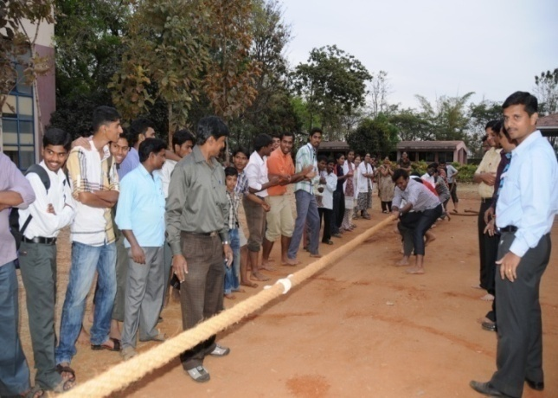

Tug of war competition

**Augmentative and Alternative Communication and Noise Awareness Campaign**: The public were made aware of Augmentative and Alternative Communication (AAC) and noise pollution in October 2011 on the eve of Diwali celebrations and as October is observed as the International AAC awareness month. The volunteers visited various schools in the locality and educated the students and staffs about noise pollution and do’s and don’ts. The teachers were also informed about the communication disorders and AAC techniques available. They were encouraged to refer children with communication disorders to the institute.

**Orphanage Visit:** The NSS unit volunteers visited Ashadayaka Seva Trust Orphanage on 5 February 2012 and donation collected from the institute staff and students along with clothes and confectionaries were handed over to the trust officials.

**Special Camp:** A special camp was conducted at Muthurayaswamy Samudaya Bhavana, Mudumgere, Keelara, Mandya District on 4-11 March 2012. Dr. S. R. Savithri, Director inaugurated the camp on 4 March. Mr. Shambhu, Manager, Muthurayaswamy Samuday Bhavana, Mudumgere and Dr. H. P. Manjula, Asst. Director, National Service and Sports Department, Mandya were the chief guests on the occasion. The volunteers carried out a door-to-door survey among the villagers on Speech and Hearing disorders. Families, schools and anganwadis in the locality were made aware of the communication disorders and the intervention facilities available. Totally 6184 villagers were surveyed by covering 1412 residences and 33 schools in the localities. The survey identified 121 persons with communication disorders who were referred to the institute for further evaluation and treatment. Adventure sports and trekking were also organized as part of the camp. The valedictory function was held on 14 March. Mr. M. Srinivas, MLA, Mandya presided over the function and Mr. Puttegowda, President of Grama Panchayat, Keelara and Mrs. A.R.Sudha, Vice-President, GramaPanchayat, Keelara were the chief guests.

**Trekking:** The unit organized a trekking to the mountain range of Kudremukh National Park, Chikkamagaluru district, Karnataka on 17-19 February 2012. Totally 37 volunteers participated in the expedition.

Other Activities and Events

The other major activities carried out, services rendered and events taken place during the reporting year are discussed in this chapter.

**I. Clinical Observation Posting**

The institute facilitated clinical observation posting for students in the area of communication disorders and allied fields from other institutes in the country and abroad. One thousand one hundred and thirty students from 46 institutions across the country and abroad were posted for clinical observation in different clinical units and departments of the institute during the reporting year. The details are given in table 35.

Table 35: Clinical observation posting

|  |  |  |
| --- | --- | --- |
| **Sl.**  **No.** | **Institution** | **No. of**  **Students** |
| 1 | A.S.College of Engineering, Trivandrum, Kerala | 03 |
| 2 | Ashokrao Mane M.Ed College, Kolapur, Maharashtra | 27 |
| 3 | B.M Hospital, Mysore | 64 |
| 4 | College of Rural Home Sciences, Dharward | 55 |
| 5 | Cote dI Vone, Ivorian Coast | 01 |
| 6 | Dept. of Education, Mysore university, Mysore | 03 |
| 7 | Dept. of Physically Challenged & Sr. Citizens, Govt.of Karnataka. | 14 |
| 8 | Dept. of Psychology, Christ University, Bangalore | 03 |
| 9 | Dept. of Psychology, Mysore University | 02 |
| 10 | Dept. of Sociology, Mysore University | 04 |
| 1 | Dept. of Studies in Psychology, University of Mysore | 10 |
| 12 | Devaraj URS Medical College, Davangere | 04 |
| 13 | DHLS Centres | 46 |
| 14 | Dr. A.V. Baliga Institute Brahmavar, Udupi | 21 |
| 15 | Education Block ,Mysore Rural | 30 |
| 15 | Indian Red Cross Society, Mysore | 01 |
| 16 | Information and Resource Centre, Bangalore | 01 |
| 17 | J.S.S College of Nursing, Mysore | 38 |
| 18 | JSS Medical College, Mysore | 09 |
| 19 | K.R.Hospital, Mysore | 41 |
| 20 | Kamakya School for Nursing, Mysore | 16 |
| 21 | Karnataka Institute of Medical Sciences, Hubli | 06 |
| 22 | Karnataka State Women’s University, Bijapur | 96 |
| 23 | Kautilya Vidyalaya, Mysore | 02 |
| 24 | Kuvempu University,Shimoga | 02 |
| 25 | KVG Medical College, Sulliya | 02 |
| 26 | Little Flower Convent Higher Secondary School, Chennai | 47 |
| 27 | M.L.M.N College of Teacher Education, Chikmanagalore | 107 |
| 28 | Monfort Centre for Education Tura, Meghalaya | 32 |
| 29 | Mother Teresa Nursing College, Mysore | 16 |
| 30 | Nalairaja School of Nursing, Mysore | 41 |
| 31 | Navis College of Education, Andhra Pradesh | 21 |
| 32 | Padmavathi Mahka Viswa Vidyalaya, Tirupathi, Andhra Pradesh | 29 |
| 33 | Perunthalavan Kamarajan Govt. College, Pondicherry | 79 |
| 34 | Ramya Architect College, Bangalore | 02 |
| 35 | Regional Institute of Education, Mysore | 55 |
| 36 | S.R.S D.Ed College, Pillekeranahally, Chitradurga | 42 |
| 37 | Sarvodaya College of Education, Virajpet, S. Coorg | 32 |
| 38 | Shri Gangdhareshwara D.Ed College, Gundalpet | 30 |
| 39 | SIBER School of Social Work, Kolhapur, Maharashtra | 07 |
| 40 | St. Agnes College, Magalore | 11 |
| 41 | St. Agnes College, Mangalore | 01 |
| 42 | Stell Maries College, Chennai | 51 |
| 43 | Surana PG Centre,Bangalore | 03 |
| 44 | V.H.D Home Science College, Bangalore | 19 |
| 45 | Vidya Vikas First Grade College, Mysore | 04 |
| **Total** | | **1130** |

**II. Technological Consultancy Services**

The department of Electronics is equipped with state-of the art equipments and expertise in the area of acoustic noise measurements. During the reporting year, the following consultancy services were carried out by the department.

1. Ambient noise and reverberation time measurements for Sathya Sai Hospital, Bangalore.
2. Calibration of BERA unit for M/s. MNE Technologies, Bangalore.
3. Electro acoustic evaluation of 113 hearing aids and 8 SBC for the following agencies.

* District Project Office, Sarva Siksha Abhiyan, Malappuram, Kerala
* District Rehabilitation Center, Chengalpet, Tamil Nadu
* Sarva Siksha Abhiyan, Kasargod, Kerala
* State Commissioner for Differently Abled, **Chennai,** Tamil Nadu.

**III. Awards and Laurels**

The staff and students were honored with a variety of awards and prizes during the reporting year. In addition, the institute received awards for effective implementation of official language, the details of which are given below.

**Best Scientific Paper Presentation Awards**

* Dr.S.R.Savithri, Director received Prof. Rais Ahmed Memorial Lecture Award at the National Symposium on Acoustics (NSA-2011), organized by Bundelkhand University, Jhansi on 17 November 2011.
* Dr. K.C. Shyamala, Professor & Head, Department of Speech Language Pathology received Dr. N. Ratna Oration Award at the 44th Indian Speech and Hearing Association Conference (ISHACON), organized by the University of Hyderabad, Hyderabad on 19 January 2012.

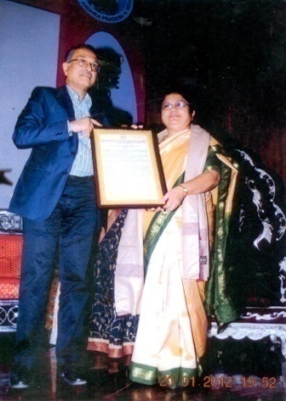

Dr. K.C Shyamala receiving Dr. N. Ratna Oration Award

* Dr.Pushpavathi, M., Navya, A., Sreedevi, N.& Dakshayani received Best Paper Award for their scientific paper, Influence of Palatal Obturation on Acoustic Measures of Speech: A Case Study, at the 4th National Women’s Science Congress, organized by the M.S.Ramaih Institute of Technology, Bangalore on 7-9 November, 2011.
* Dr Uma Sarawathi received Best Paper Award for her paper Aadhunik Bhasha Paripreshya Mem Soochana Proudyogiki (आधुनिक भाषा परिप्रेक्ष्य में सूचना प्रौद्योगिकी) at the Special Hindi Workshop and Symposium, organized by Rajbhasha Sanstan, NewDelhi at Dalhousie, Himachal Pradesh on 9-11 November 2011.
* Ms. Srividya, M. S. & Savithri, S. R. received Best Paper Award for their scientific paper, Formant Vectors of Long Vowels in Speaker Identification, at the Forensic Conference, organized by ………………. at Mumbai on …….. February, 2012
* Mr. Jithin P. Jacob & Swathi C.S., 3rd B.Sc. (Sp. & Hg.) students received Manohar Memorial Award for Best Paper in Audiology for the paper Training Related Changes in the Efferent Auditory System at the 44th Indian Speech and Hearing Association Conference (ISHACON), organized by the University of Hyderabad, Hyderabad on 20-22 January 2012.
* Mr. Jithin P. Jacob, 3rd B.Sc. (Sp. & Hg.) student received Best Paper Award for the paper Laryngeal Aerodynamic Parameters in Indian Adult Normally Speaking Population at the International Symposium on Frontiers of Research on Speech and Music (FRSM), KIIT College of Engineering, Gurgaon, Hariana, 18- 19 January 2012.
* Sharanya R., Animesh Barman, Niraj Kumar Singh, & Sujeet Kumar Sinha received muktesh Best Paper in Audiology for the paper Comprehensive Assessment of vestibular Functions in Individuals with Auditory Neuropathy at the 44th Indian Speech and Hearing Association Conference (ISHACON), organized by the University of Hyderabad, Hyderabad on 20-22 January 2012.

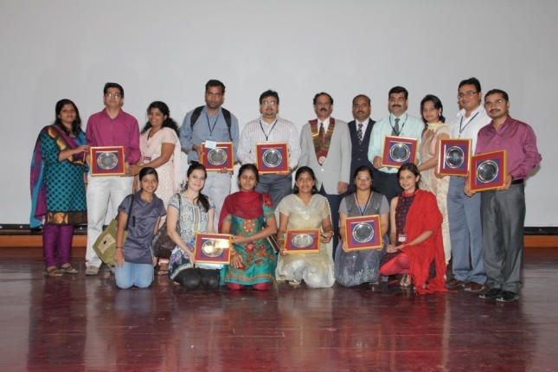

44th ISHA Conference best paper award winners

* Niraj Kumar Singh & Kumari Apeksha received Dr. M. Raghunathan Memorial Award for Best Paper in Audiology for the paper Effect of Rise/Fall Time on Vestibular Evoked Myogenic Potential Elicited by Short Tone Bursts of 500 Hz. at the 44th Indian Speech and Hearing Association Conference (ISHACON), organized by the University of Hyderabad, Hyderabad on 20-22 January 2012.
* Dhatri S Devaraju & Mamatha N.M. received Dr. N.R.Chaudhary Memorial Award for Best Poster in Audiology for the poster Development Changes in Co-Modulation Masking Release for Puretone: A Cross-sectional Study at the 44th Indian Speech and Hearing Association Conference (ISHACON), organized by the University of Hyderabad, Hyderabad on 20-22 January 2012.
* Jithin P Jacob, Swathi, C.S. & Sandeep M. received Manorama Young Scientist Award for Best Paper in Audiology for the paper Training Related Changes in the Efferent Auditory System at the 44th Indian Speech and Hearing Association Conference (ISHACON), organized by the University of Hyderabad, Hyderabad on 20-22 January 2012.

**Doctoral Degree Awards**

* Dr. Purusotham, P., Project Assistant, Department of Clinical Psychology was awarded the degree of Doctor of Philosophy in Psychology by the University of Mysore, for the thesis Development of Correctional Strategies for Number Remediation in Pre and Primary School Children, under the guidance of Dr.Venkatesan, Professor in Clinical Psychology, AIISH.
* Mrs. Vasantha Lakshmi M. S., Lecturer in Statistics was awarded the degree of Doctor of Philosophy in Statistics by the University of Mysore for the thesis, Limit Theorems for Sums, Extremes and related Stochastic Processes under the guidance of Dr.Vasudeva, Professor in Statistics, University of Mysore.

**Academic Ranks and Awards**

* Mr. Varun Uthappa received P.D. Manohar Gold Medal for securing I rank in M.Sc. (Speech-Language Pathology) examination held by the University of Mysore in June 2011.
* Ms.Pragathi Rao received Arathi Venkataraman Gold Medal for securing I rank in M.Sc. (Audiology) examination held by the University of Mysore in June 2011.
* Ms.Lakshmi M.S. received Sri. D.K. Venkatesh Murthy Medal for securing I rank in B.Sc. (Speech & Hearing) examination held by the University of Mysore in May 2011.

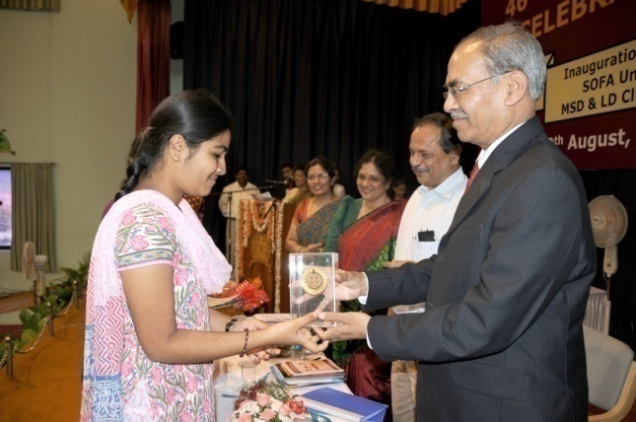

Ms.Lakshmi M.S.receiving award for securing I rank in B.Sc.

* Mr. Varun Uthappa received Smt. Jayalakshamma Medal and Friends United Organization Endowment Scholarship for securing I rank in M.Sc. (Speech-Language Pathology) in June 2011 examinations.

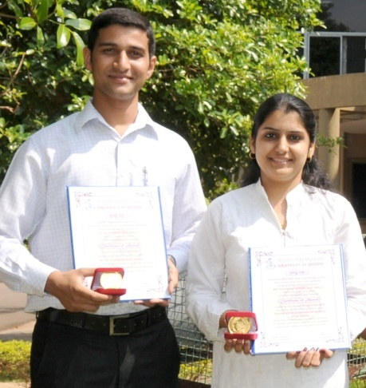

Mr.Varun Uthappa and Ms. Pragathi Rao, the M.Sc. rank holders

* Ms. Gargi Singh received Abhilasha Award for Best Student Clinician in final M.Sc. for the year 2010-11.

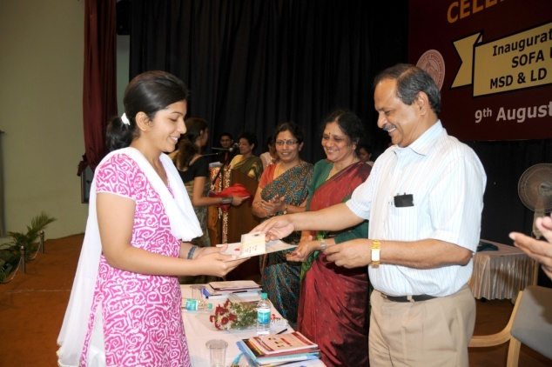

Ms. Gargi Singh receiving Abhilasha Award for best student clinician

**Official Language Implementation Awards**

The institute received two awards for its efforts towards the effective implementation of official languages, These are

* Rajbhasha Sanstan, New Delhi award for the best efforts in Southern region on Official Language Implementation.
* Karyalaya Deepa Smriti Chinh by Rajbhasha Sanstan, New Delhi in for better implementation of Official Language.

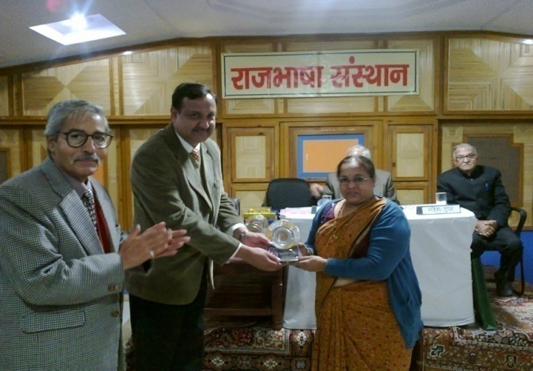

Dr.Uma Saraswathi, Hindi Translator receiving award for better implementation of Official Language Hindi

**IV. Visit Abroad**

1. Dr. S.R.Savithri, Director, attended India 2011, organized by Department of Electronics and Telecommunication, Norwegian University of Science and Technology (NTNU) at Trondheim, Norway on 5-10 October 2011.
2. Dr.Y.V.Geetha, Professor in Speech Sciences and Mrs. Sangeetha, M., Clinical Lecturer, attended 9th Oxford Dysfluency Conference, St. Catherine's College, Oxford University, Oxford, UK, on 1-4 September 2011.

**V. Distinguished Visitors**

A large number of distinguished scholars in the field of communication disorders and allied fields, and distinguished personalities in public life both from India and abroad visited the institute during the reporting year. A few among them are given in table 36.

Table 36: Distinguished Visitors

|  |  |  |
| --- | --- | --- |
| **Name** | **Designation** | **Date of Visit** |
|  |  |  |
| Dr. Theresea Estrem | Associate Prof. St.Cloud State University, MN, USA. | 12.05.11 |
| Ms. Pushpalatha Chikkanna | Corporation Mayor, Mysore. | 31.05.11 |
| Dr. Ananthanarayan Krishnan | Professor, Hearing Science & Audiology, , Purdue University, USA. | 04.07.11 |
| Dr. Vijayakumar | Deputy DGHS, Ministry of Health and Family Welfare, New Delhi. | 05.07.11 |
| Dr. Sian A. Rees | Director, Supporting Head Injured Pupils in School (SHIPS) Project, Bristol, UK. | 21.07.11 |
| Mrs. Shalini A | Professor of Audiology, Louisiana, USA. | 26.07.11 |
| Mr. K. Chandramouly IAS | Hon’ble Secretary, Ministry of Health and Family Welfare, Govt. of India, New Delhi. | 09.08.11 |
| Dr. K. S. Sriprakash | Vice Chancellor, RGUHS, Bangalore. | 09.08.11 |
| Dr. K.S. Rangappa | Vice-Chancellor, Karnataka State, Open University, Mysore. | 09.08.11 |
| Dr. G.Y. Nagaraja | Joint Director (HI), Karnataka Health System  Development & Reform Project, K.R. Circle  Bangalore. | 09.08.11 |
| Mr. G. Gourisankar, | General Manager, BSNL, Mysore | 09.08.11 |
| Mr.Mahendra Singh | Deputy Secretary, Ministry of Health & Family Welfare, Govt. of India. | 21.09.11 |
| Dr. Shankarappa | District Adult education Officer, Mysore | 29.09.11 |
| Mr. Pradhan P.K | Secretary (Health & Family Welfare)  Ministry of Health & Family Welfare, Government of India, New Delhi | 05.10.11 |
| Mr. Keshav Desiraju | Additional Secretary, Ministry of Health and Family  Welfare, Govt. of India, New Delhi. | 12.10.11 |
| Dr. S.Y Kothari | Additional Director General of Health Services,  Govt. of India, New Delhi. | 12.10.11 |
| Ms. Laura Hill | Educationist, Australia. | 25.10.11 |
| Dr. Morag Clark | International Consultant, **The AG Bell Academy for Listening and Spoken Language, USA.** | 18.11.11 |
| Dr. Alexie Kochetov | Assistant Professor, University of Toranto. | 08.12.11 |
| Mr. S Gandhiselvan | Hon’ble Minister of State for Health and Family Welfare, GOI, New Delhi .  ­ | 23.01.12 |
| Dr. Jerry Northern | Professor Emeritus, Audiology Clinical Services, School of Medicine, University of Colorado, USA. | 27.01.12 |
| Dr. Chandrasekhara Kambara | Kannada Writer and Gnanapeetha Awardee | 28.01.12 |
| Dr.-Ing. Hans Oswald | Director, Path Medical Audiological Equipment Company, Germany. | 01.02.12 |
| Dr. Vinod Nadig | Director, Advanced Bionics India (P) Ltd. Bangalore | 01.02.12 |
| Dr. B. D. Athani | Additional DGHS & Medical Superintendent, Safdarjung Hospital, New Delhi, | 03.02.12 |
| Mr. George, | Clinical Specialist, Advanced Bionics Pvt. Ltd., South-India, Bangalore. | 15.02.12 |
| Mr. Ajimsha, | Clinical Manager, Advanced Bionics Pvt. Ltd., South-East Asia. | 15.02.12 |
| Dr. B. Rajashekar | Dean, Manipal College of Allied Health Sciences, Manipal. | 15.03.12 |

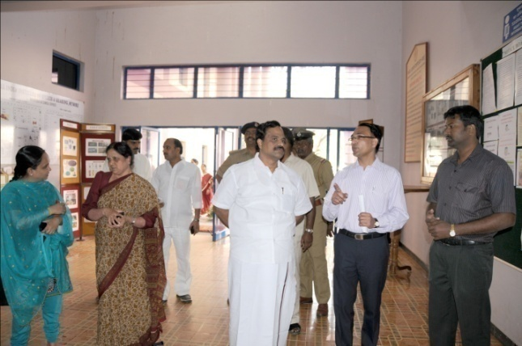

Mr. S. Gandhiselvan, Minister of State for H& FW,

visiting the Department of Clinical Services