Activities of the Institute 2007-08
(Supplement to the Annual Report 2007-08)

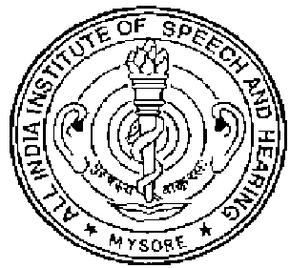
All India Institute of Speech & Hearing Manasagangothri, Mysore - 6

