**SPEECH RHYTHM IN KANNADA SPEAKING CHILDREN**

**AGED 7-8 YEARS**

# Introduction

Rhythm, a prosodic feature, refers to an event repeated regularly over a period of time. Languages are known to differ in characteristic rhythm (Pike, 1945), and are organized under stress-timed, syllable-timed, and mora-timed (Hoequist, 1983; Low, Grabbe & Nolan, 2000). If a language has simple syllabic structure, for e.g. VC or CCV, the durational difference between the simplest and most complicated syllable is not wide and it is possible to say that any syllable is less than 330 ms in duration. Under these circumstances, one can use a fast ***syllable-timed rhythm***. If the syllables are still simpler, for example VC or CV, then the durational difference between syllables is negligible and one can then use a ***mora-timed rhythm***. If a language has complex syllables, for e.g. V and CCCVCC, the difference between syllables can be very wide. For example, the duration of syllable V (a) can be 60 ms and that of CCCVCC (strength - strent) can be 600 ms. In this condition, one has to use a slow ***stress-timed rhythm***. According to the ***rhythm class hypothesis***, (Abercrombie, 1967) each language belongs to one of the prototypical rhythm.

The development of concept on rhythm measurement was started with the concept of isochrony – i.e. each syllable has equal duration. Various measures [syllable duration by Abercrombie (1967); inter-stress interval by Roach (1982); % V and SD of consonant intervals by Ramus, Nespor & Mehler (1999); Pair-wise Variability Index by Low (1998)] were used in the past to measure speech rhythm and classify it. The Pair-wise Variability Index (PVI) is a quantitative measure of acoustic correlates of speech rhythm and it calculates the patterning of successive vocalic and intervocalic intervals. Low, Grabe & Nolan (2000), using PVI indicated the possibility of classifying rhythm as in Table 1.

Table 1

Classification of rhythm based on PVIs.

|  |  |  |
| --- | --- | --- |
|  | Intervocalic Interval (IV) | Vocalic Interval (V) |
| Stress-timed | High | High |
| Syllable-timed | High | Low |
| Mora-timed | Low | Low |

In the Indian scenario, there have a number of attempts at examining rhythm manifestations in adults and in young children. Savithri, Jayaram, Kedarnath and Goswami (2006) investigated the rhythm of two etymologically unrelated languages – Hindi (Indo-Aryan) and Kannada (Dravidian) and reported Hindi to be a syllable-timed language (high rPVI and low nPVI) and Kannada to be a mora-timed language (low rPVI and nPVI). Savithri, Goswami, Maharani, and Deepa (2007) investigated speech rhythm in 12 Indian languages in the reading and speech sample of adults speaking these langauges, and reported Assamese, Punjabi, Telugu, Marathi and Oriya to be Mora-timed, and Bengali, Kodava, Malayalam, Tamil and Kashmiri to be Syllable-timed. Rajasthani and Gujarathi were unclassified. Savithri and Sreedevi (2012) investigated development of speech rhythm in Kannada speaking children in the age range of 3-12 years using PVIs of vocalic and intervocalic interval durations. The results indicated a developmental trend in speech rhythm. PVIs increased from 3-4 years to 11-12 years though not linearly.

Studies conducted hitherto in speech rhythm have exclusively used durational measures such as vocalic and intervocalic intervals to analyze rhythm. “Languages of the world differ in the way suprasegmental features operate. As a marker of stress, F0 and intensity are used in several languages. Hence, analyzing duration only as a measure of rhythm may not truly reflect rhythm of a language. Since prominence is a central concept in the definition of rhythm, and as F0 serves as a powerful cue in the production of prominent syllables, it needs to be investigated in order to advance our understanding of rhythm” (Kohler, 2009).

There have been a few preliminary attempts to decipher the role of F0 in rhythm analysis. Cumming (2011) aimed to investigate if a dynamic F0 increased with perceived durational increase. F0 was measured in three groups of participants who had Swiss German, Swiss French and French as their native language respectively. Variables such as type of stimuli, direction of F0 movement and timing, and duration of stimuli were included. Type of stimuli included linguistic versus non-linguistic stimuli, direction referred to simple falls and/or rises or complex contours such as fall-rises or rise-falls, timing of F0 movement included early and late falling falls and rises, and duration of stimuli included 3 different durations - 250ms, 375 ms and 500 ms. The non-linguistic stimulus in the experiment was a “buzz” while the linguistic material was a monosyllabic ‘si’. Binary forced choice decision task was carried out in 4 sets of trials. In type 1, the listener had to judge whether stimuli with dynamic f0 are longer than ones with level F0. In type 2, the listener had to judge if stimuli with higher f0 are longer as compared to ones having lower F0. Type 3 trials served as controls to check if listeners exhibited any preference in their judgment of the longer stimulus. Type 4 trials had stimuli that varied only in duration but had the same level F0. In all language groups and both types of sounds, the number of D > L responses were greater. The perceived lengthening effect was significantly greater in [si] stimuli irrespective of the language group. With respect to direction of F0 movement, for buzz stimuli, there were no differences in listeners’ responses between falls, rises and complex contours but in [si] stimuli, falls and complex contours were seen to be longer than rises. When direction and timing of F0 movement were both considered, it was seen that, in buzzes, late falls and early rises were compared to be longer than levels. However, in [si] stimuli, early falls and late rises were judged to be longer than levels. The results did not show any effect of listener’s native language on their perception.

Fuchs (2014) aimed to quantify the influence of differences in mean F0 on perceived duration (as against acoustic duration) and converted this influence into a quantitative measure, by modifying the original nPVI-V formula proposed by Low and Grabe (2003). He then applied the new nPVI-V formula (dur * F0) in British English (BrE) and Indian English (InE). Two experiments were conducted in the study. The first experiment was a binary forced choice listening experiment in which syllables of varying duration and F0 were presented. Participants had to decide if the second syllable presented was longer or shorter than the first. Results revealed that, when F0 of the second syllable was increased by 60 Hz, it was perceived 8 ms (4%) longer than the first syllable. Likewise, if second syllable had 60 Hz lower F0 than first; it was perceived as 8 ms or 4% shorter than the first. The second experiment dealt with integrating the influence of F0 on perceived duration into the PVI. The results confirmed that, in comparison with InE, BrE exhibited more variability in perceived duration (considering the influence of F0) than acoustic duration. The difference in variability of perceived duration was found to be 6.6% higher than the difference in acoustic duration.

Mori, Hori and Erickson (2014), taking a leaf out of observation of Kohler (2009), investigated the role of F0, intensity and vowel quality in differentiating the English Rhythm of Americans from that of Japanese. Maximum F0, maximum intensity and duration of all the vowels in target sentences spoken by the two groups of subjects were measured. In order to examine vowel quality, maximum F1 values for all vowels were noted. The acoustic measurements were normalised to remove inter-speaker variability. Two types of sentence stress were studied: Non-stress clash situation (where monosyllabic content and function words alternate) and stress clash situation (where stressed syllables occur successively). The results revealed that, in non-stress clash situation, for American speakers (AS), the vowels in content words were twice as long as those in function words, resulting in alternating long-short vowels. However, Japanese speakers (JS), did not show such duration-related changes. Instead, their rhythmic pattern was characterised by recursive high-low F0. In stress-clash situation, AS showed recursion of strong-weak syllables by means of F0, intensity and first formant, whereas JS showed inconsistent stress patterns. These results showed that AS and JS employed different strategies for implementing rhythmic alternation.

The above studies emphasize the role of various other phonetic constituents such as F0, intensity etc., apart from duration, in realisation of speech rhythm and hence necessitate their need to be investigated. In this context, the present paper examined the role of F0 and intensity (I0) in realizing speech rhythm in typically developing Kannada speaking children in the age range of 7-8 years.

# Method

# Participants: Thirty Kannada speaking normal children, 15 boys and 15girls, in the age range of 7-8 years participated in the study. It was ensured that the participants did not have any history of speech, hearing or cognitive impediments at the time of testing by an informal interview by a Speech-Language Pathologist.

* 1. Material and Recording: Picture stimuli depicting simple Panchatantra stories developed by Rajendra Swamy (1991) were used. The participants were tested individually and were visually presented with the pictures. They were instructed to see the picture carefully and describe the story depicted by the pictures. Prompting was used when the child did not respond. Five-minute speech sample of each child was elicited and audio-recorded. All speech samples were recorded on to a digital recorder Olympus LS-100 at a sampling frequency of 44,100 Hz.
  2. Analyses: The speech sample were transferred on to PRAAT (Boersma & Weenik, 2009) software and displayed as a waveform along with fundamental frequency (F0) and intensity (I0) displays. Using Praat, the peak F0 and I0 for each vocalic (V) and intervocalic intervals (IV) were extracted. Figure 1 illustrates extraction of peak F0 and I0 at each of the vocalic (V) and intervocalic (IV) intervals in the sentence [ondu:ralli ondu ka:ge ittu].

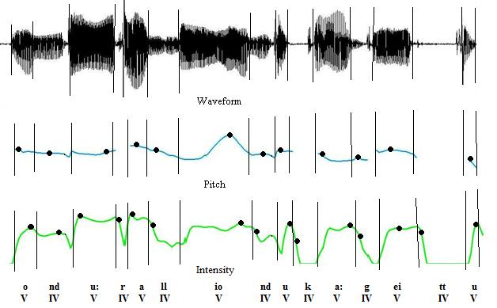

Figure 1, Illustration of extraction of peak F0 and I0 at each of the vocalic and intervocalic intervals.

The F0 and I0 difference between successive vocalic and intervocalic segments were calculated and averaged to get normalized PVI (NPVI). Pair wise Variability Index (NPVI) developed by Grabe and Low (2002) was used as a measure of rhythm. The NPVI for F0 and I0 were measured using the following formulae-

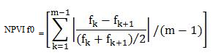and 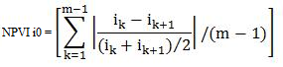

where ‘m’ is the number of vocalic/ intervocalic intervals and ‘f’ and ‘i’ are fundamental frequency and intensity, respectively at the kth interval.

# Results

The results indicated that the mean NPVIs for F0 at vocalic (V PVI) and intervocalic intervals (IV PVI) were 0.055 and 0.078, respectively in boys and 0.057 and 0.069 respectively, in girls. The mean NPVIs for I0 at vocalic and intervocalic intervals were 0.009 and 0.049, respectively in boys and 0.014 and 0.022, respectively in girls. The lowest VPVI in boys was 0.02 and the highest was 0.12.; that for IVPVI was 0.04 and the highest was 0.16. In girls, the lowest and highest VPVI was 0.037 and 0.077; also the lowest and the highest IVPVI were 0.04 and 0.09. The Standard Deviation for NPVI on F0 in girls was lower than that in boys.

VPVI for I0 in boys ranged from 0.0099 to 0.01; IVPVI ranged from 0.03 to 0.057. VPVI for I0 in girl ranged from 0.0088 to 0.0295; IVPVI ranged from 0.0131 to 0.0417. The Standard Deviation in girls was higher than that in boys. Tables 2 and 3 show the PVIs in 7-8 year old boys and girls for F0 and I0 respectively. Figures 2 and 3 represent the PVIs of F0 and I0.

Table 2

NPVI for F0 in boys and girls aged 7-8 years.

|  |  |  |  |  |
| --- | --- | --- | --- | --- |
| **Sl.**  **No.** | **VPVI** | | **IV PVI** | |
|  | **Boys** | **Girls** | **Boys** | **Girls** |
| 1. | 0.033 | 0.0451 | 0.059 | 0.0585 |
| 2. | 0.119 | 0.0476 | 0.161 | 0.0407 |
| 3. | 0.0418 | 0.0554 | 0.0675 | 0.0850 |
| 4. | 0.0408 | 0.0581 | 0.0631 | 0.0747 |
| 5. | 0.0429 | 0.0497 | 0.0729 | 0.0531 |
| 6. | 0.0592 | 0.088 | 0.0924 | 0.0984 |
| 7. | 0.0507 | 0.0373 | 0.0606 | 0.0547 |
| 8. | 0.0233 | 0.0575 | 0.0397 | 0.0460 |
| 9. | 0.0921 | 0.0516 | 0.1415 | 0.0717 |
| 10. | 0.039 | 0.050 | 0.052 | 0.0868 |
| 11. | 0.0333 | 0.0771 | 0.0502 | 0.0916 |
| 12. | 0.0421 | 0.0538 | 0.0769 | 0.0784 |
| 13. | 0.0751 | 0.0663 | 0.0805 | 0.0762 |
| 14. | 0.0553 | 0.0639 | 0.0609 | 0.0740 |
| 15. | 0.083 | 0.0610 | 0.0943 | 0.0567 |
| Avg. | 0.055 | 0.078 | 0.057 | 0.069 |
| SD | 0.026 | 0.013 | 0.033 | .017 |

Table 3

NPVI for I0 in boys and girls aged 7-8 years.

|  |  |  |  |  |
| --- | --- | --- | --- | --- |
| **Sl.**  **No.** | **VPVI** | | **IV PVI** | |
|  | **Boys** | **Girls** | **Boys** | **Girls** |
| 1. | 0.0078 | 0.0108 | 0.0545 | 0.0177 |
| 2. | 0.0099 | 0.0088 | 0.0488 | 0.0131 |
| 3. | 0.0107 | 0.0092 | 0.0567 | 0.0149 |
| 4. | 0.0124 | 0.0105 | 0.0557 | 0.0190 |
| 5. | 0.0094 | 0.0134 | 0.0427 | 0.0144 |
| 6. | 0.008 | 0.0081 | 0.0498 | 0.0145 |
| 7. | 0.0091 | 0.008 | 0.0327 | 0.0155 |
| 8. | 0.0062 | 0.0074 | 0.0525 | 0.0158 |
| 9. | 0.0089 | 0.0088 | 0.0437 | 0.0168 |
| 10. | 0.0059 | 0.0091 | 0.0481 | 0.0167 |
| 11. | 0.0099 | 0.0219 | 0.0571 | 0.0417 |
| 12. | 0.0088 | 0.0184 | 0.0449 | 0.0266 |
| 13. | 0.0091 | 0.0295 | 0.0393 | 0.0413 |
| 14. | 0.0111 | 0.0284 | 0.0483 | 0.0409 |
| 15. | 0.0208 | 0.0189 | 0.0681 | 0.0282 |
| Avg. | 0.009 | 0.014 | 0.049 | 0.022 |
| SD | 0.003 | 0.007 | 0.009 | 0.011 |

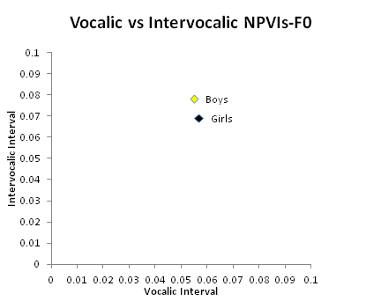

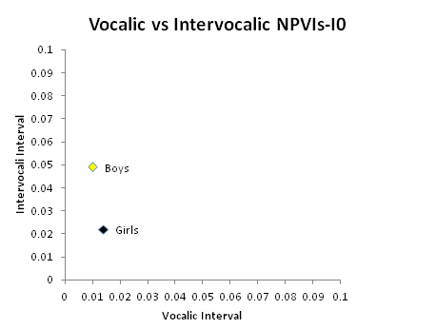Figure 2, NPVI for F0 in boys and girls.

Figure 3, NPVI for I0 in boys and girls.

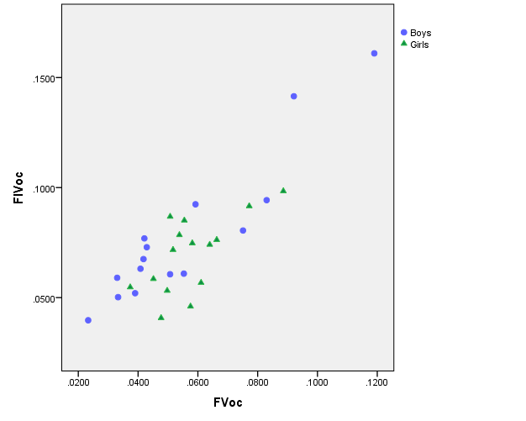The PVIs for F0 were scattered widely in boys compared to those in girls. PVIs for I0 were scattered widely in girls compared to those in boys. Figures 4 and 5 represent the scatter-plots of VPVI (vocalic PVI) and IVPVI (intervocalic PVI) for F0 and I0 respectively in 7-8 year old boys and girls.

Figure 4: Scatter plot for VPVI and IV PVI for F0 in boys and girls.

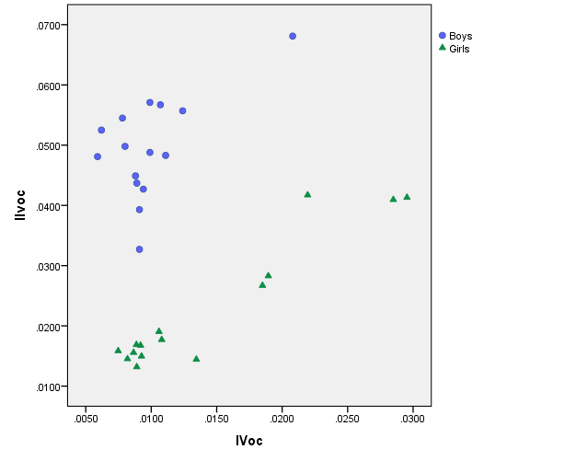

Figure 5: Scatter plot for VPVI and IV PVI for I0 in boys and girls.

* 1. **Comparison for NPVIs across F0, I0 and duration**

Results of Mann-Whitney test showed significant difference between genders on IVPVI for I0 [│Z│== -4.417, p<0.01]. Boys had significantly higher IVPVIs as compared to girls. Results of Wilcoxon Signed Ranks revealed that both boys and girls showed significantly higher NPVIs for F0 as compared to I0 in both genders (for VPVI, [│Z│=3.408; p<0.05; for IV PVI; [│Z│= 3.408, p<0.05]. The data on PVIs of duration from a previous study by Savithri et. al. (2012) was compared with PVIs of F0 and I0. Results of Mann-Whitney test revealed a significantly higher PVIs on F0 [for VPVI, [│Z│=4.542; p<0.05; for IV PVI; [│Z│=4.169, p<0.05] and I0 [for VPVI, │Z│=4.667; p<0.05; for IV PVI; [│Z│=4.667, p<0.05] in boys. Similar finding was observed for girls for both F0 [for VPVI, [│Z│=4.666; p<0.05; for IV PVI; [│Z│=4.666, p<0.05] and I0 [│Z│=4.666; p<0.05; for IV PVI; [│Z│=4.666, p<0.05].

# Discussion

First of all, the results indicated ***low vocalic and intervocalic NPVI for F0*** ***in boys and girls*** which suggest a mora-timed rhythm in Kannada speaking children in the age range of 7-8 years. The results are in consonance with those of Savithri et al (2012). Data of Savithri et al (2012) were re-calculated and it was observed that the mean vocalic and intervocalic NPVIs for boys were 0.16 each and that for girls were 0.22 and 0.23 respectively. According to rhythm class hypothesis (Abercrombie, 1967), a language with high PVIs can be classified to have stress-timed rhythm, low PVIs as mora-timed and high intervocalic PVI, low vocalic PVI as syllable-timed. None the less Standard Deviation of PVIs for F0 was higher in boys compared to girls. Higher PVIs indicate greater variations between PVIs of participants. This may reflect the fact that boys had greater variation in F0 within themselves. Combining the SD with average PVI (higher in boys compared to girls), it may be possible that some boys had better intonation pattern than others. SD of PVIs for I0 was significantly higher in girls compared to boys. Combining the SD with average PVI (higher in girls for VPVI and higher in boys for IVPVI), it may be postulated that some girls had better intensity variations than others. Also girls might have used different intervocalic interval compared to boys. Intervocalic interval dictates the intensity; for example intensity is higher for fricatives, and laterals compared to stop consonants. Figure 6 illustrates the VPVIs for F0 in boys. It can be observed that participants 2,6,9,13,14 and 15 have higher VPVIs and participants 1, 8, and 11 have lower VPVIs and others have in between VPVIs for F0.

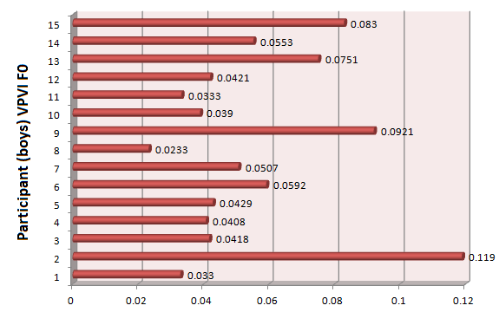

Figure 6: VPVIs for F0 in boys.

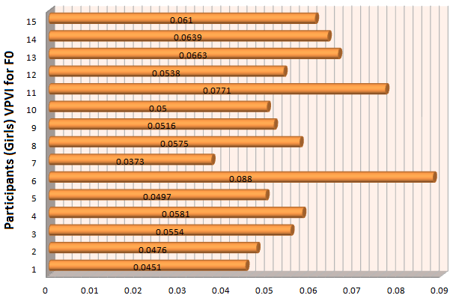On the other hand, in girls, it can be observed that, except participant 6 and 11, most of them have similar VPVIs. Figure 7 illustrates VPVIs in girls.

Figure 7: VPVIs for F0 in girls.

Second, scattering of PVIs on F0 was wider in boys compared to girls indicating high variations in the usage of F0 within boys. Results of the study by Willis and Kenny (2007) in boys and girls (average age in boys = 12.11, average age in girls = 13.0) indicated higher SD on F0 in boys (43.8) compared to girls (16.1) in a reading task and counting task (boys = 39.8; girls = 19.6). The finding also draws significant parallels with reports of Lee, Potamianos, and Narayanan (1999) who investigated changes in magnitude and variability of fundamental frequency along with various other acoustic parameters such as duration, formant frequencies etc. in the speech of 436 children, aged 5 to 17 years as a function of age and it was reported that among boys, significant pitch decrease/variations existed during two periods; from age 6- 8 years and from age 12-15 (i.e. during puberty). However, for girls, significant difference within-subject variability existed only between ages 10 – 14 years. Abrupt variations in the fundamental frequency of 8 and 10 year old boys have also been documented by Whiteside and Hodgson (1999). The accelerated F0 changes have been attributed to increased rate of laryngeal growth and use of intonation patterns that were different from girls.

Third, boys had significantly higher IVPVI on I0 compared to girls. This may reflect that variations in intensities of intervocalic intervals in boys were noticed more than those in girls. It is possible that boys used all intervocalic intervals that varied in intensities which the girls did not. Analyses of intervocalic intervals used by boys and girls indicate that boys used more percent trills and affricates compared to girls. Table 4 shows the percent use of various phonemes by boys and girls in the corpus. Further, results of t-test showed significant difference (P<0.05) between gender on laterals and affricates; girls used significantly higher percent of laterals and boys used significantly higher percent of affricates in the corpus. Also, Gelfer and Young (1997) examined the variability of their subjects’ comfortable speech intensity and reported that the mean SPL range associated with conversation level reading of young adult subjects to be from 61.5 dB (SD=3.1) to 80 dB (SD=3.6) for men and from 60.4 dB (SD=3.1) to 77.2 dB (SD=2.8) for women indicating higher intensities in men compared to women.

Table 4

Percent use of various phonemes by boys and girls.

|  |  |  |  |  |  |  |
| --- | --- | --- | --- | --- | --- | --- |
|  | Stops | Nasals | Trills | Laterals | Affricates | Fricatives |
| Girls | 52.7 | 24.5 | 7.5 | 10 | 0.37 | 5.1 |
| Boys | 53.0 | 25.0 | 8.7 | 8.0 | 0.47 | 4.3 |

Fourth, PVIs for F0 was significantly higher compared to those for I0. According to Fant (1960), contrastive to large changes in F0 in connected speech, an increase in voice level at a constant pitch will only cause an increase of 4 dB. Similar changes occur for the shift from a medium to a low voice effort.

The results of the present study were compared with those of the study by Savithri et al. (2012) on PVIs for duration. It was observed that PVIs on duration was significantly higher than those on F0 and I0. Results of study by Nataraja and Savithri (1990) indicate that the F0 range in speech was 304 Hz (adult females) and intensity range was 22 dB. Compared to duration, F0 and intensity do not change much. Pepiot (2014), reported an F0 range of 90 Hz and 41 Hz, respectively in adult female and male American English speakers and an F0 range of 74 Hz in females and 40 Hz in male French speakers. A longitudinal study by Bennet (1983) on children aged between 8-11 years old reported that the 8-, 9- 10- and 11- year olds exhibited an F0 range of 204-270 Hz, 198-264 Hz, 208-259 Hz and 195-259 Hz respectively. Also, while calculating NPVIs in duration, the successive difference between two intervals roughly equalled the average of two successive intervals, thereby yielding higher NPVIs, which was unlikely in case of F0 and I0. Results of Savithri et al. (2006) in adults speaking Kannada revealed higher vocalic PVI compared to intervocalic PVI. However, in the present study the vocalic PVI (for F0 and I0) was lower than that of intervocalic PVI. Figure 8 compares the results of the present study with that of Savithri et al. (2006).

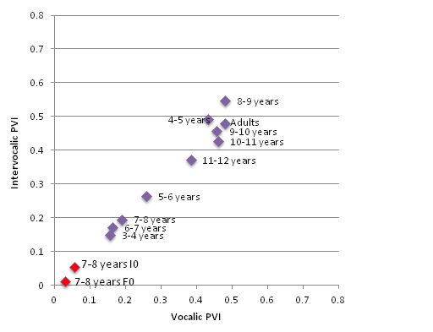

Figure 8: PVIs for duration in children (blue colour) and adults speaking Kannada and PVI for F0 and I0 (red colour).

Low and Grabe (2000) extracted vocalic and intervocalic PVIs of different languages of the world and reported stress-timed rhythm in British English, German, Dutch and Thai; syllable-timed rhythm in Tamil, Spanish, French, and Singapore English; mora-timed rhythm in Japanese and mixed rhythm in Polish and Catalan. The results of the present study were compared with those of Low and Grabe (2000) as shown in Figure 9.

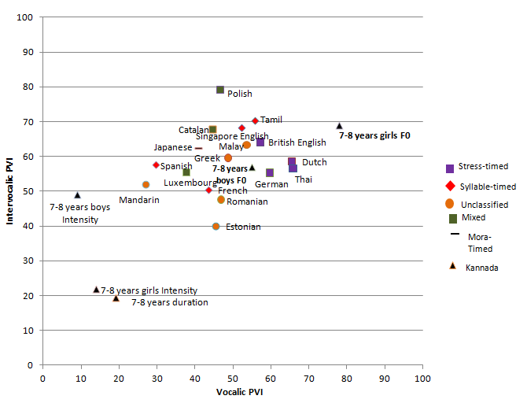

Figure 9: Vocalic and intervocalic PVIs in Kannada (F0, I0) and other languages (duration) of the world.

Comparing the data on F0 PVIs in Kannada with various languages of the world, one can observe that rhythm (F0) in 7-8 year old girls in the present study was closer to Dutch, Thai, British English and German which are all stress-timed languages. Further, rhythm (I0) in 7-8 year old boys in the present study was closer to Mandarin and the remaining had very low PVIs. It may be possible that the basis of the classification of speech rhythm in some of these languages is questionable.

# CONCLUSIONS

The present study investigated speech rhythm in typically developing Kannada speaking children in the age range of 7-8 years. Results revealed pronounced use of mora-timed rhythm especially in girls. The findings provide an insight into rhythm manifestations in young children and can be applied to assess persons with aprosody. These measures are also helpful in classifying the rhythm types in languages. Future studies using PVIs in children of other age groups are warranted.

**REFERENCES**

Abercrombie, D. (1967). *Elements of General Phonetics*. Chicago: Aldine Pub. Co.

Bennet, S. (1983). A 3-year longitudinal study of school-aged children’s fundamental frequencies. *Journal of Speech and Hearing Research, 26,* 137-142.

Boersma & Weenik. (2009). PRAAT 5.1.14 software. Retrieved from [http://www.goofull.com/au/programa/14235/speedyitunes.html on August 18](http://www.goofull.com/au/programa/14235/speedyitunes.html%20on%20August%2018), 2010.

Cumming, R. (2011). The effect of dynamic fundamental frequency on the perception of duration. *Journal of Phonetics,* 39, 375–38

Fant, G. (1960). *Acoustic theory of speech production: with calculations based on X-ray studies of Russian articulations*. Mouton & Company.

Fuchs, R. (2014). Towards a perceptual model of speech rhythm: Integrating the influence of f0 on perceived duration. *Proceedings from Interspeech 2014,* Singapore, 1949-1953.

Gelfer, M.P., & Young, S. R. (1997). Comparison of intensity measures and their stability in male and female speakers. *Journal of Voice, 11,* 178-186.

Grabe, E., & Low, E. L. (2002). *Durational variability in speech and the rhythm class hypothesis.* In Gussenhoven, C., & Warner, N. (2006) Eds, Laboratory Phonology, 7, 515-546. Berlin:Mouton de Gruyter.

Kohler, J.K. (2009). Rhythm in Speech and Language. A New Research Paradigm.*Phonetica,* 66, 29–45.

Lee, S., Potamianos, A., & Narayanan, S. (1999). [Acoustics of children’s speech: Developmental changes of temporal and spectral parameters](https://scholar.google.com/citations?view_op=view_citation&hl=en&user=pBQViyUAAAAJ&citation_for_view=pBQViyUAAAAJ:u5HHmVD_uO8C). *The Journal of the Acoustical Society of America, 105 (3),* 1455-1468.

Low, E. L., Grabe, E., & Nolan, F. (2000). Quantitative Characterizations of Speech Rhythm– ‘Syllable timing’ in Singapore English. *Language and Speech*, *43*, 377 – 401.

Hoequist, C. (1983). Syllable duration in stress-, syllable-, and mora-timed languages. *Phonetica,* 40, 203–237.

Mori, Y., Hori. T., & Erickson., D. (2014). Acoustic Correlates of English Rhythmic Patterns for American versus Japanese Speakers. *Phonetica*, 71, 83-108.

Nataraja, N. P., & Savithri, S. R. (1990). Voice evaluation: Clinical aspects. *Indian Speech, Language and Hearing Tests - The ISHA Battery,* 176-195.

Pepiot, E. (2014). Male and female speech: a study of mean f0, f0 range, phonation type and speech rate in Parisian French and American English speakers. *Speech Prosody, 7,* 305-330.

Pike, K. L. (1945). *The intonation of American English*. Ann Arbor: The University of Michigan Press.

Rajendra Swamy. (1991). *Some aspects of fluency in children: 6-7 years*. Unpublished master’s dissertation submitted in part-fulfillment for the master’s degree in Speech and Hearing. University of Mysore, Mysore.

Ramus, F., Nespor, M., & Mehler, J. (1999). Correlates of Linguistic Rhythm in the Speech Signal. *Cognition*, *72*, 1 – 28.

Roach, P. (1982). *On the distinction between ‘Stress-timed’ and ‘Syllable-timed’ languages*. In D. Crystal (1986) Eds., Linguistic Controversies (pp. 73-79). London: Arnold.

Savithri, S. R., Jayaram, M., Kedarnath, D., & Goswami, S. (2006). Speech rhythm in Indo Aryan and Dravidian languages. *Proceedings of the International Symposium on Frontiers of Research on speech and music*, 31-35.

Savithri, S.R., Goswami, S., Maharani, S., & Deepa, D. (2007) Speech rhythm in Indian languages . *Proceedings of the Frontiers of Research on Speech and Music, 272-275.*

Savithri, S.R., & Sreedevi, N. (2012). Development of speech Rhythm in Kannada Speaking Children*.* DST funded Project.

Willis, E. C., & Kenny, D. T. (2007). Variability in speaking fundamental frequency in the adolescent voice. The Inaugural International Conference on Music Communication Science 5-7. Retrieved from <http://www.academia.edu/3485951/Variability_in_speaking_fundamental_frequency_in_the_adolescent_voice>.

Whiteside, P. S., & Hodgson, C. (1999). Acoustic characteristics in 6-10-year-old children's voices: some preliminary findings. *Logopedics Phoniatrics Vocology,* 24 (1), 6-13.

**FIGURE LEGENDS**



Figure 1: Illustration of extraction of peak F0 and I0 at each of the vocalic and intervocalic intervals.



Figure 2: PVI for F0 in boys and girls.



Figure 3: PVI for I0 in boys and girls.



Figure 4: Scatter plot for VPVI and IV PVI for F0 in boys and girls.



Figure 5: Scatter plot for VPVI and IV PVI for I0 in boys and girls.



Figure 6: PVIs in children and adults speaking Kannada.



Figure 7: VPVIs for F0 in boys.



Figure 8: VPVIs for F0 in girls.

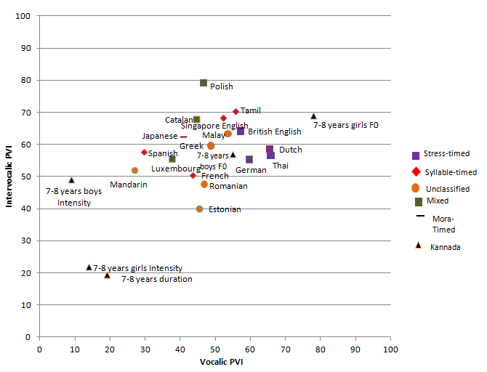

Figure 9: Vocalic and intervocalic PVIs in Kannada and other languages of the world

**LIST OF TABLES**

Table 1

Classification of rhythm based on PVIs.

|  |  |  |
| --- | --- | --- |
|  | **Intervocalic Interval (IV)** | **Vocalic Interval (V)** |
| Stress-timed | High | High |
| Syllable-timed | High | Low |
| Mora-timed | Low | Low |

Table 2

NPVI for F0 in boys and girls aged 7-8 years.

|  |  |  |  |  |
| --- | --- | --- | --- | --- |
| **Sl.**  **No.** | **VPVI** | | **IV PVI** | |
|  | **Boys** | **Girls** | **Boys** | **Girls** |
| 1. | 0.033 | 0.0451 | 0.059 | 0.0585 |
| 2. | 0.119 | 0.0476 | 0.161 | 0.0407 |
| 3. | 0.0418 | 0.0554 | 0.0675 | 0.0850 |
| 4. | 0.0408 | 0.0581 | 0.0631 | 0.0747 |
| 5. | 0.0429 | 0.0497 | 0.0729 | 0.0531 |
| 6. | 0.0592 | 0.088 | 0.0924 | 0.0984 |
| 7. | 0.0507 | 0.0373 | 0.0606 | 0.0547 |
| 8. | 0.0233 | 0.0575 | 0.0397 | 0.0460 |
| 9. | 0.0921 | 0.0516 | 0.1415 | 0.0717 |
| 10. | 0.039 | 0.050 | 0.052 | 0.0868 |
| 11. | 0.0333 | 0.0771 | 0.0502 | 0.0916 |
| 12. | 0.0421 | 0.0538 | 0.0769 | 0.0784 |
| 13. | 0.0751 | 0.0663 | 0.0805 | 0.0762 |
| 14. | 0.0553 | 0.0639 | 0.0609 | 0.0740 |
| 15. | 0.083 | 0.0610 | 0.0943 | 0.0567 |
| Avg. | 0.055 | 0.078 | 0.057 | 0.069 |
| SD | 0.026 | 0.033 | 0.012 | .017 |

Table 3

NPVI for I0 in boys and girls aged 7-8 years.

|  |  |  |  |  |
| --- | --- | --- | --- | --- |
| **Sl.**  **No.** | **VPVI** | | **IV PVI** | |
|  | **Boys** | **Girls** | **Boys** | **Girls** |
| 1. | 0.0078 | 0.0108 | 0.0545 | 0.0177 |
| 2. | 0.0099 | 0.0088 | 0.0488 | 0.0131 |
| 3. | 0.0107 | 0.0092 | 0.0567 | 0.0149 |
| 4. | 0.0124 | 0.0105 | 0.0557 | 0.0190 |
| 5. | 0.0094 | 0.0134 | 0.0427 | 0.0144 |
| 6. | 0.008 | 0.0081 | 0.0498 | 0.0145 |
| 7. | 0.0091 | 0.008 | 0.0327 | 0.0155 |
| 8. | 0.0062 | 0.0074 | 0.0525 | 0.0158 |
| 9. | 0.0089 | 0.0088 | 0.0437 | 0.0168 |
| 10. | 0.0059 | 0.0091 | 0.0481 | 0.0167 |
| 11. | 0.0099 | 0.0219 | 0.0571 | 0.0417 |
| 12. | 0.0088 | 0.0184 | 0.0449 | 0.0266 |
| 13. | 0.0091 | 0.0295 | 0.0393 | 0.0413 |
| 14. | 0.0111 | 0.0284 | 0.0483 | 0.0409 |
| 15. | 0.0208 | 0.0189 | 0.0681 | 0.0282 |
| Avg. | 0.009 | 0.014 | 0.049 | 0.022 |
| SD | 0.003 | 0.007 | 0.008 | 0.01 |

Table 4

Percent use of various phonemes by boys and girls.

|  |  |  |  |  |  |  |
| --- | --- | --- | --- | --- | --- | --- |
|  | Stops | Nasals | Trills | Laterals | Affricates | Fricatives |
| Girls | 52.7 | 24.5 | 7.5 | 10 | 0.37 | 5.1 |
| Boys | 53.0 | 25.0 | 8.7 | 8.0 | 0.47 | 4.3 |