**Treatment of underlying language impairment to overcome perseveration: A case study.**

**Abstract**

*Perseveration has always been a challenge for Speech Language Pathologists working with patients with adult language disorders. With the recent theories and approaches towards treating perseveration, treating the underlying language processing difficulty (Moses, Sheard & Nickels, 2004) has shown some evidence to help persons with aphasia (PWA) overcome verbal perseveration. Therefore, the task lies in understanding PWA language processing abilities and where the block in the processing is occurring. Based on this theoretical background, this paper presents a case of Broca’s Aphasia with sever perseveration. A detailed assessment of linguistic skills indicates a deficit in phonological processing of target words while having intact orthographic representation of the same. Treatment focussed on using an orthographic cueing hierarchy with intensive language therapy using Manual for Adult Fluent and Non-Fluent Aphasia Therapy in Kannada. The outcome of the study supports the approach of treating underlying language processing breakdown to overcome perseveration in PWA.*

***Key words:*** *Perseveration, Aphasia therapy, Therapy for recurrent perseveration, language processing, orthographic Cueing*

**Treatment of underlying language impairment to overcome perseveration: A case study.**

**Background**

Perseveration is a linguistic deficit mostly present in persons with brain damage and other neural disruptions (Albert & Sandson, 1986). Perseveration can be verbal, graphic or motor in nature. Verbal perseveration presents as repetition of whole word or part word of a previous response into subsequent responses, while graphic perseveration is exhibited in writing or drawing tasks where, the person continues to draw a pattern even after its completion. Example - continuing to add loops to letter ‘m’ or drawing circle (which was a previous response) instead of a triangle (target response); writing ‘doggg’ instead of ‘dog’ (Estabrooks, Ramage, Bayles & Cruz, 1998; Fischer-Baum & Rapp, 2012).

According to Sandson and Albert’s (1984) taxonomy, perseveration is of three types - continuous perseveration, stuck-in-set perseveration and recurrent perseveration. Continuous perseveration is the abnormal prolongation of the same response beyond the task. Usually present in persons with damage of frontal lobe and basal ganglia region. Studies have found evidence of continuous perseveration in individuals with right hemisphere damage (Chengappa & Ray, 2010) and patients with Alzheimers disease (Vliet, Miozzo, Marder & Stern, 2003). Stuck-in-set perseveration is the repetition of the same set of response, even when the nature of the task is changed; this error is more common in persons with frontal lobe damage. Recurrent perseveration is more common in persons with Left hemisphere damage and PWA. In PWA, recurrent verbal perseveration is presented as repetition of a previous response to subsequent stimuli. For example, if the target picture is of a car, and the previous picture was of a dog, PWA with perseveration would name car as ‘dar’ or ‘cog’ or even repeat ‘dog’. It is the frequently observed type of perseveration in PWA (Estra-brooks et.al, 1998).

Perseveration in Persons with Aphasia, when put into the International Classification of Functioning, Disability and Health (ICF; WHO, 2011) framework, indicates a definite pathology in the neural system and impairment in speech processing and production at the level of Body function and structure. At activity and participation level, it affects the quality of speech, conversation and in turn exacerbates the overall quality of communication limiting the activity and participation of the person in a social context. The focus of treatment of PWA has to be to improve the overall quality of life and social participation. Hence, there arises a need to look into aphasic perseveration which does not allow the PWA to go beyond it.

Literature offers numerous factors and causes underlying perseveration and several studies which indicate the occurrence of perseveration (Gotts, Rocchetta & Cipolotti, 2002), but, only a few studies address the treatment of perseveration in PWA. (Estabrooks, Emery & Albert, 1987; Moses, Nickels & Sheard, 2004; Stark, 2007 & 2011). Treatment of aphasic perseveration (TAP) Helm-Estabrooks (1987) is the only actual therapy program designed specifically for treatment of perseveration. The treatment is targeted for persons with moderate to severe perseveration. The procedure follows a series of cueing to elicit the target word without perseveration (Helm & Albert, 2004). The drawback of the treatment is that it focuses on treating perseveration in isolation, and PWA is expected to have some control over his verbal output. Research has shown that, the main issue is in what is assumed to be the cause of perseverative response (Moses, Sheard & Nickels, 2004). Therefore, than working on the impairment in isolation, the focus has to shift towards treating the underlying language impairment of which perseveration is symptomatic.

Among the many theoretical bases accounting for perseveration, disinhibition theory (Dell, Svec & Burger, 1997) and underlying language processing breakdown theory (Cohen & Dehaene, 1998; Moses, Sheard & Nickels, 2004) have shown to be of clinical importance. According to disinhibition theory, perseveration occurs due to failure of the new target to inhibit residual activation from the previous response which is still in the short term memory. With this principle, Fischer Baum and Rapp, 2012, studied letter perseveration in dysgraphic persons and found that failure-to-inhibit deficit led to perseveration errors in domains other than verbal communication. The latter theory is based on cognitive neuropsychological framework. According to this theory perseveration occurs due to breakdown in underlying linguistic processes of semantic and phonological component of language; which in turn leads to failure of activation of new verbal target. Moses, Sheard and Nickels (2007), conducted a case series of examination on five PWA. They examined the presence of recurrent perseveration in PWA on repetition, reading aloud and picture naming and found that the presence of recurrent perseveration in these individuals were directly related to the processing demand of the task, relative to their breakdown at various levels of language-processing. Based on the premise of this theory, therapy focussing on treatment of verbal perseveration in PWA should improve semantic and phonological component of language-processing. Hence, the present study was carried out following the approach of treating underlying language processing impairment in a PWA to overcome severe perseveration.

**Method:**

**Participant**

The participant was a 63 year right handed male (LM), with 10 years of formal education, retired as grama-panchayat secretary, and a monolingual, Kannada speaker. LM was a known case of type II diabetes and hypertension since 15 years and under medication for the same with a history of haemorrhagic stroke. CT scan result at the time of hospital admission revealed acute large infarct in the left parietal lobe corresponding to left MCA territory and subsequent MRI result revealed large infarct with early sub acute hemorrhage in the left temporo-parietal lobe (left MCA territory infarct). Two months post stroke, LM had an attack of scar epilepsy and MRI revealed chronic infarct in the left fronto- temporo parietal region involving basal ganglia.

LM started attending speech-language therapy at five months post onset stroke. With a profile of Global aphasia on the adapted version of WAB in Kannada (K-WAB) (Chengappa & Kumar, 2008) (Aphasia Quotient = 7.6), he underwent intensive speech-language therapy for three months. During this time, he was treated using Manual for Adult Aphasia Therapy in Kannada (MAAT-K) (Goswami, Shanbal, Samasthitha, Navitha, Chaitra & Rajini, 2011), with (MIT) Melodic Intonation Therapy (Albert, Sparks & Helm, 1973). In the course of therapy, it was observed that LM responded very well with phonemic cues and was maximally dependent on them. On re-evaluation after three months, LM’s language scores had improved and he had progressed to Brocas aphasia (AQ= 23.7). Despite this improvement, it was noticed that LM exhibited poor spontaneous speech and his perseveration affected his verbal communication skills. He had more of sound substitution errors, therefore, had sound perseveration (eg. /ka:pI/ and /kappu/for most of the words). Hence, the focus of therapy shifted toward treating his verbal perseverations.

It was found that LM had variable abilities in verbal language, oral reading and writing skill. His oral reading and writing skills were better than his verbal expression which was noted during the assessment session. He could correctly read the words which he could not produce verbally, as it was dominated by his recurrent perseveratory utterances. Therefore, in order to improve his verbal output, his underlying language processing difficulty had to be identified.

His performance on the adapted version of WAB in Kannada gave a clear picture of his language abilities and Boston Naming Test (BNT) in Kannada (Chengappa, Suni & Vijayetha, 2012) was assessed to unveil the underlying language processing difficulty. The pre-therapy scores on WAB are depicted in **Table 1**.

*Table 1: Pre-therapy scores of LM on the areas of WAB*

|  |  |
| --- | --- |
| **Sections** | **WAB scores prior to start of treatment phase** |
| **Spontaneous speech** | 2 |
| **Comprehension** | 7.95 |
| **Repetition** | 0.7 |
| **Naming** | 1.2 |
| **Reading and writing** | 3.75 |
| **Praxis** | 3.75 |
| **Construction** | 2 |
| **Aphasia quotient (AQ)** | 23.7 |
| **Cortical quotient (CQ)** | 31.9 |
| **Provisional diagnosis** | Broca’s aphasia |

The results on K-WAB demonstrated better cortical quotient than aphasia quotient. This indicated that his reading and writing skills were better than his oral language skills. Hence, his relatively preserved reading and writing skills were used to overcome the impediments in his verbal speech.

On Boston naming test, LM responded better with phonemic cues on the non perseverated words. There were no semantic errors seen (e.g. cat for dog). The outcome of his performance on BNT is illustrated in **Figure 1**. His reliance on the phonemic cues demonstrated that his difficulty was more with the processing of phonological form of words. As opposed to this, his ability to successfully read the written form of words (as observed on K-WAB) suggested that processing orthographic form of phonological representation of words was intact. Hence, it was concluded that the perseverations found in LM’s speech was a result of lack of access to the phonological representation of words.

*Figure 1:* *Pre-therapy naming scores on Boston Naming Test in Kannada.*

*\*Note: scores in the y-axis are raw scores based on the scoring pattern of BNT*

The severity of perseveration was assessed on confrontation naming task. For this the stimuli were selected from the naming sub-section of MAAT-K. Naming on 38 items from seven lexical categories (common objects, fruits, colors, numbers, clothes, vegetables & domestic animals) were assessed. The severity of perseveration was calculated by dividing the total number of words with one instance of perseveration by total number of words, multiplied by 100. LM named seven words without perseveration, yielding a perseveration score of 81.5% indicating severe perseveration, based on perseveration severity scale by Helm- Estabrooks (1987) [Moderate= 20%- 40%; Severe= +49%]

Based on the above test results, it was concluded that LM had severe perseveration which was a result of lack of access to the phonological representation of words, in the presence of intact orthographic processing of phonological form of words.

**Stimuli**

LM was treated with MAAT-K (Goswami et al., 2011), during the course of the therapy. MAAT-K is a compilation of the field tested manuals: Manual for Adult Non-Fluent Aphasia Therapy - Kannada (MANAT-K, Venugopal & Goswami, 2008) and Manual for Adult Fluent Aphasia Therapy - Kannada (MAFAT-K, Chaitra & Goswami, 2010). Based on the successful outcome on field testing of the manual, it was adapted, field tested and developed as MAAT-6 in six other Indian languages viz., Hindi, English, Tamil, Telugu, Malayalam and Marathi (Goswami, Thomas & Varghese, 2015). The stimuli in MAAT-K are presented under five domains of language namely: functional communication (FC), repetition (R), comprehension and expression (C & E), naming (N) and reading and writing (R & W). The stimuli in each domain are arranged in a hierarchical manner with increasing level of complexity from level I to level III. The manual also allows the flexibility of presenting stimuli through auditory, visual or orthographic modalities. The scoring pattern follows a three point rating scale of 1, 0.5 and 0 based on complete, partial and no response respectively. The manual can be used with any therapy technique.

**Treatment procedure**

The study adopted single subject multiple baseline design across sessions. LM was given language therapy with MAAT-K for two months. With weekly three sessions of one hour therapy, he received a total of 24 sessions of therapy. Each session was audio and video recorded with the consent of PWA and the care-giver, and the recording was analysed to note changes in verbal language, if any. The language scores on MAAT-K was assessed at three intervals, i.e., baseline (session 1), mid-therapy (session 12) and post therapy (session 24).

The study focussed on working on overall language skills while using strategies to improve access to phonological processing, which in-turn is hypothesised to reduce perseveration. Functional communication (FC) and semantic sub-section of Expression (E) domains at word and phrase level were treated using MAAT-K. Examples of sub-sections and stimuli used in the study, under domains of Functional communication and Expression from MAAT-K are provided in **Appendix 1**. For each stimulus, a hierarchy of cueing was used. The procedure was as follows:

Step 1: Presentation of picture (noun/verb); if a correct response was provided the clinician moved on to the next picture.

Step 2: If LM was not able to produce a correct response in step 1 or perseverated, he was asked to write the response i.e. Self orthographic cueing. If LM failed at this level,

Step 3: Orthographic cueing was provided by the clinician. If LM failed at this level,

Step 4: LM was asked to respond via repetition.

This hierarchy was adopted based on the premise that orthographic cueing improves access to phonological representation of words (Lorenz & Nickels, 2007). The same is illustrated in **Figure 2**.

One week after the termination of treatment phase, severity of perseveration was assessed on the same set of stimuli used for confrontation naming during the background assessment of perseveration. A re-evaluation on WAB-K and BNT was also carried out to see if therapy improved LM’s language skills.

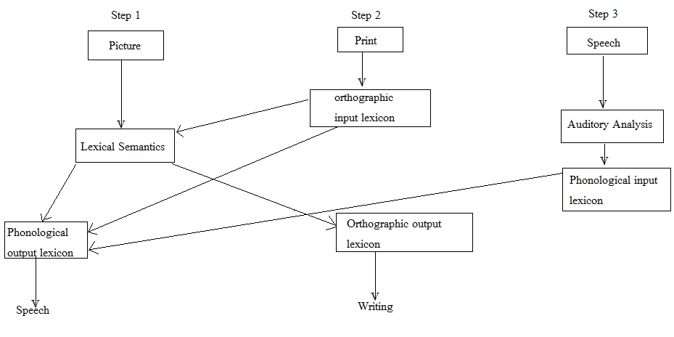

*Figure 2: An outline of the cognitive processes involved in the steps adopted in the cueing hierarchy during the therapy. The figure represents detail to interpret the performance of PWA.*

**Analyses**

Statistical analysis was carried out using statistical packages for social sciences (SPSS, version 17.0) for Friedman’s test and Wilcoxon-Signed Rank-Test. Mc Nemar’s Chi- Square Test was carried out using C.I calculator from the website www2.ccrb.cuhk.edu.hk. The scores on each sub section of FC and E domain were averaged and converted into percentage. Considering the subsections under FC and E as independent factors, the performance across session one, session 12 and session 24 were compared using Friedman’s test to analyse difference in overall score. If a significant difference was noted, Wilcoxon- signed Rank test was applied for pair-wise comparison within sessions. Mc Nemar’s Chi-Square test was applied to assess if there was any significant difference in perseveration before and after treatment.

**RESULTS**

It was observed that LM’s reliance on repetition as cue decreased mid-therapy to post-therapy and LM used more of self-orthographic cueing. **Table 2 and Table 3** presents the language scores across sessions for the functional communication and expression domain of MAAT-K, respectively. As the standard deviation was too high, median was considered for overall comparison.

*Table 2: Language scores (raw and percentage) on the functional communication domain of MAAT-K on session 1, session 12 and session 24.*

|  |  |  |  |  |  |  |
| --- | --- | --- | --- | --- | --- | --- |
| **Sub-sections of functional communication domain** | **Scores across sessions** | | | | | |
| **Session 1** | | **Session 12** | | **Session 24** | |
| Names of family members (/5) | 2.8 | 56% | 3.75 | 75% | 4.9 | 98% |
| Names of familiar objects (/15) | 6.45 | 43% | 10.5 | 70% | 14.4 | 96% |
| Saying verbs (/15) | 2.4 | 16% | 10.8 | 72% | 13.8 | 92% |
| Noun-verb combination(/10) | 0 | 0% | 5.7 | 57% | 7.5 | 75% |
| Small phrases (/10) | 0 | 0% | 4.5 | 45% | 6.5 | 65% |
| ***Total functional communication score (/55)*** | 11.65 | 21.18% | 35.25 | 64.09% | 47.1 | 85.63% |

*Table 3:**Language scores on the expression domain of MAAT-K on session 1, session 12 and session 24.*

|  |  |  |  |  |  |  |
| --- | --- | --- | --- | --- | --- | --- |
| **Semantics sub-sections of expression domain** | **Scores across sessions** | | | | | |
| **Session 1** | | **Session 12** | | **Session 24** | |
| GPL1 (/10) | 3.6 | 36% | 5.5 | 55% | 9.5 | 95% |
| GPL2 (/10) | 2.3 | 23% | 4.5 | 45% | 7.76 | 77.6% |
| FPL1 (/10) | 0 | 0% | 3.2 | 32% | 6.5 | 65% |
| FPL2 (/8) | 0 | 0% | 2.16 | 27% | 4.98 | 62.26% |
| Vocabulary (/30) | 4.8 | 16% | 13.5 | 45% | 21.6 | 72% |
| ***Total expression score (/68)*** | 10.7 | 15.7% | 28.86 | 42.44% | 50.34 | 74.02% |

*\*Note: GPL1= gross phonemic level 1, contains list of word pairs with widely variant phonemes; GPL2= gross phonemic level 2, contains list of word pairs with lesser variant phonemes in words; FPL1= fine phonemic level 1, contains bi-syllabic word pairs with Less variant phonemes which are visually or acoustically similar in a word; FPL2= fine phonemic level 2, contains word pairs with finer phonemic difference in tri-syllabic/polysyllabic words.*

The percentage scores showed around 43% improvement in FC from base-line to mid-therapy session i.e. 21% in session one to 64% in session 12, and another 20% improvement in FC skills from session 12 to session 24 (64% to 85%). Overall LM showed around 60% improvement in functional communication skills on MAAT-K in 24 sessions of intensive therapy. On expression domain, there was 26% improvement from session one to session 12 (16% to 42% rounding off) and around 32% improvement in expression from session 12 to session 24 (42% to 74%). Overall analyses with Friedman’s test showed a significant difference in the overall performance across sessions in both the domains {χ² (2) = 10.0, p < 0.05}. Further, testing with Wilcoxon signed rank test indicated a significant difference between all three sessions (session 1 to session 12 and session 12 to session 24) with (|z|= -2.02, p < 0.05). The results indicate that, therapy with MAAT-K did improve LM’s language skills from initial to post therapy session.

K-WAB was re-administered after one week post-therapy phase. PWA’s scores on all sub-tests increased by one to two points compared to pre-experimental scores. PWA’s AQ increased by 9.1 points from the pre-experimental AQ, making a total of 32.8, corresponding to Broca’s aphasia. A change of 5 or more points in AQ is considered clinically significant (Katz & Wertz, 1997).

*Table 4:**Comparison of pre and post experimental language scores on the adapted version of WAB in Kannada.*

|  |  |  |
| --- | --- | --- |
| **Domains of WAB** | **Pre- experimental scores** | **Post- experimental scores** |
| Spontaneous speech | 2 | 4 |
| Comprehension | 7.95 | 8.9 |
| Repetition | 0.7 | 2.1 |
| Naming | 1.2 | 2.4 |
| Reading and Writing | 3.75 | 9.4 |
| Praxis | 3.75 | 8.83 |
| Construction | 2 | 5 |
| *Aphasia quotient* | **23.7** | **32.8\*** |
| *Cortical quotient* | **31.9** | **48.53\*** |
| *Aphasia type* | **Broca’s** | **Broca’s** |
| *\*Indicates improvement of +9.1 AQ points following treatment. A change of five or more points is considered to be clinically significant (Katz & Wertz, 1997).* | | |

Post treatment results on WAB support the conclusion that therapy using orthographic cueing with MAAT-K significantly improved the overall language skills of LM. Also the comparative improvement in spontaneous speech, repetition and naming on WAB indicates improved phonological processing for verbal language.

The post-therapy results on BNT (**Figure 3**) showed improved naming scores indicating a decrease in perseveration post-therapy.

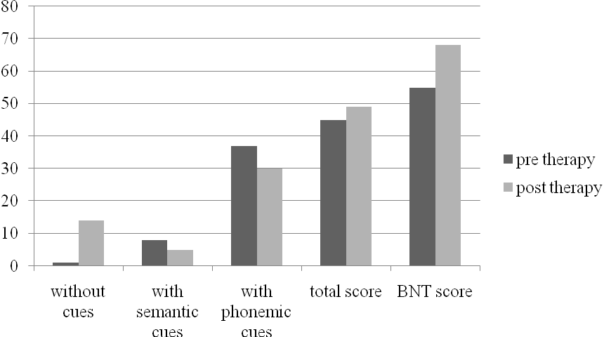

*Figure 3: Pre and post therapy scores on the adapted version of Boston Naming Test (BNT) in Kannada.*

His performance on BNT revealed improvement in naming without cues and a comparative decrease on reliance on phonemic cues. These outcomes indicate that phonologically based treatment indeed improved word retrieval skills which in-turn reduced LM’s perseveration.

In order to assess if improvement in language domains brought about any change in perseveration, percentage of perseveration was assessed one week post therapy. The results on perseveration are presented in **Table 5**. The assessment of severity of perseveration post therapy on the 38 item noun list yielded a score of 57% (severe perseveration). It can be seen that perseveration greatly reduced following the cueing hierarchy applied in the study with simultaneous improvement in language skills. Analysis with Mc Nemar’s Chi-Square test showed a chi score of = 4.26 with p= 0.01, at significance level of p < 0.02, indicating a significant improvement in naming at post-therapy, there-by indicating reduction in perseveration.



*Table 5: comparison of pre and post-therapy severity of perseveration on confrontation naming task*

|  |  |  |
| --- | --- | --- |
| **Confrontation naming (MAAT-K)** | **Pre/post therapy naming score** | **Pre/post therapy perseveration score in percentage** |
| Nouns (/38) | 7/16*  (p=0.01) | 81.5/57.5 |

*Note:*Indicates a statistical significant improvement in scores*

**DISCUSSION**

The purpose of the study was to find out if the approach of treating underlying language processing impairment (Moses, Sheard & Nickels, 2007) in a PWA worked to overcome perseveration in person (LM) with Broca’s aphasia with severe perseveration. During the course of assessment, LM’s ability to successfully read the words and repeat indicated that the phonological representation of words was preserved. But, his inability to access these representations for spontaneous or elicited speech which was further inhibited by his linguistic deficit of perseveration revealed that the access to the phonological forms of words was impaired. During verbal expression phonemic errors were seen with more of sound substitutions. Therefore, difficulty with encoding the phonological form of words was considered the cause for his perseveration. Hence, therapy was focussed towards utilising his intact reading and writing skill to enable access to the phonological form of words through orthographic route, using MAAT-K. The use of orthography to facilitate retrieval of phonological form is most beneficial when written naming is less impaired than spoken naming .

Therapy was carried out while using a cueing hierarchy to access the phonological form of words. Following ICF-WHO framework, the present study sought to work on overall language skills and indirectly tap the perseveration (impairment level).

The results on the outcome of therapy with MAAT-K indicated that phonologically based therapy did improve LM’s access to phonological representation of words for verbal production which further, reduced his sound perseverations and improved his spontaneous speech production. The positive outcomes of the therapy can be attributed to the use of letter identities which activated the orthographic form of words which in turn activated the phonological form of words (Best et al., 1997; Nickels, 2000). The same can be substantiated by a study by Nickels (1992), where his patient TRC showed a generalized improvement in oral language while using orthographic forms to access the phonological form of words. Since Kannada orthography is alphasyllabary and transparent, the orthographic form of words directly allowed access to the phonological form of words, increasing the activation of target and in turn reducing perseverations. Language therapy focussed towards treating phonological processing in PWAs in alphasyllabary languages should take advantage of this direct route of orthography to phonological conversion. The outcomes of the study support the literature that working on language as a whole reduces perseveration than focusing on perseveration in isolation. As LM improved in self cueing the orthographic form of words from mid-therapy session onwards, it led to a better generalization to non-treated items and reduction in perseveration error.

The use of repetition in the cueing hierarchy benefited by providing, a direct auditory model of phonological representation of the words. Also, the use of self-orthographic cueing, which LM started using frequently from mid-therapy session onwards led to independence in his communication. A significant increase in AQ on post-therapy assessment indicated that the methodology applied in the study improved verbal language skills while reducing perseveration. The results also support the fact that working on language as a whole reduces perseveration than focusing on perseveration alone.

**Conclusion and future implications**

Verbal perseveration and repetition of unintentional utterances have always hindered communication in PWAs. In the midst of several theories and hypothesis describing the cause of perseveration, there is no standalone procedure that works in remediating this linguistic error. Therefore, there is a need for evidence based practice in this area. This study was a result of one such attempt. Based on the outcome of the study, working on language as a whole while simultaneously improving underlying language processing difficulty is an ideal way to help PWA overcome perseveration. But a single case study cannot affirm this; Future research needs to address the limitations of the present study. First and foremost, this is a single case study and hence, generalised statement cannot be drawn for the population. There is a need to replicate the findings of the study on a heterogeneous aphasia population. Investigation should focus on finding if, the cueing hierarchy used in the present study holds good for irregular words, as it was not taken up for the study. Also, time taken for perseverated utterances and the change in response time with improvement in verbal language skills was not considered. Research in these directions in Indian languages will further strengthen the outcome and external validity of the treatment method. Despite the limitations of the study, the outcomes lead to new directions in treating perseveration in Aphasia population and pave way for further research in other languages.