1. **Scope: Digital Repository Uploading Procedure**
2. **Responsibility: In-charge of In-House Publication Section**
3. **Procedure for Uploading Materials:**
4. Go to Administrative Login Page and Login using Administrative User Id and Password.

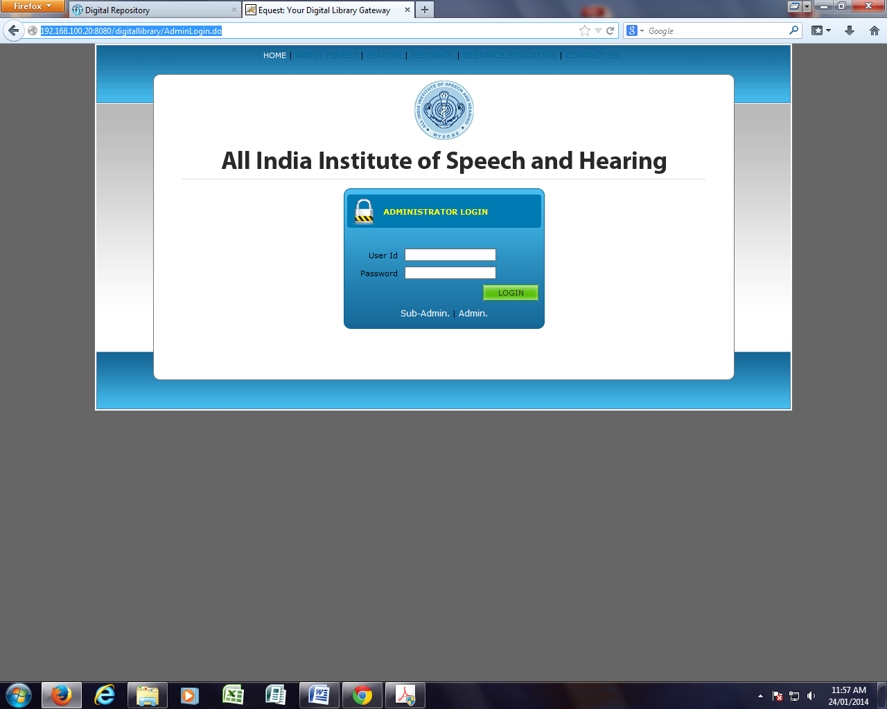

1. Select Resource Management link on the main page

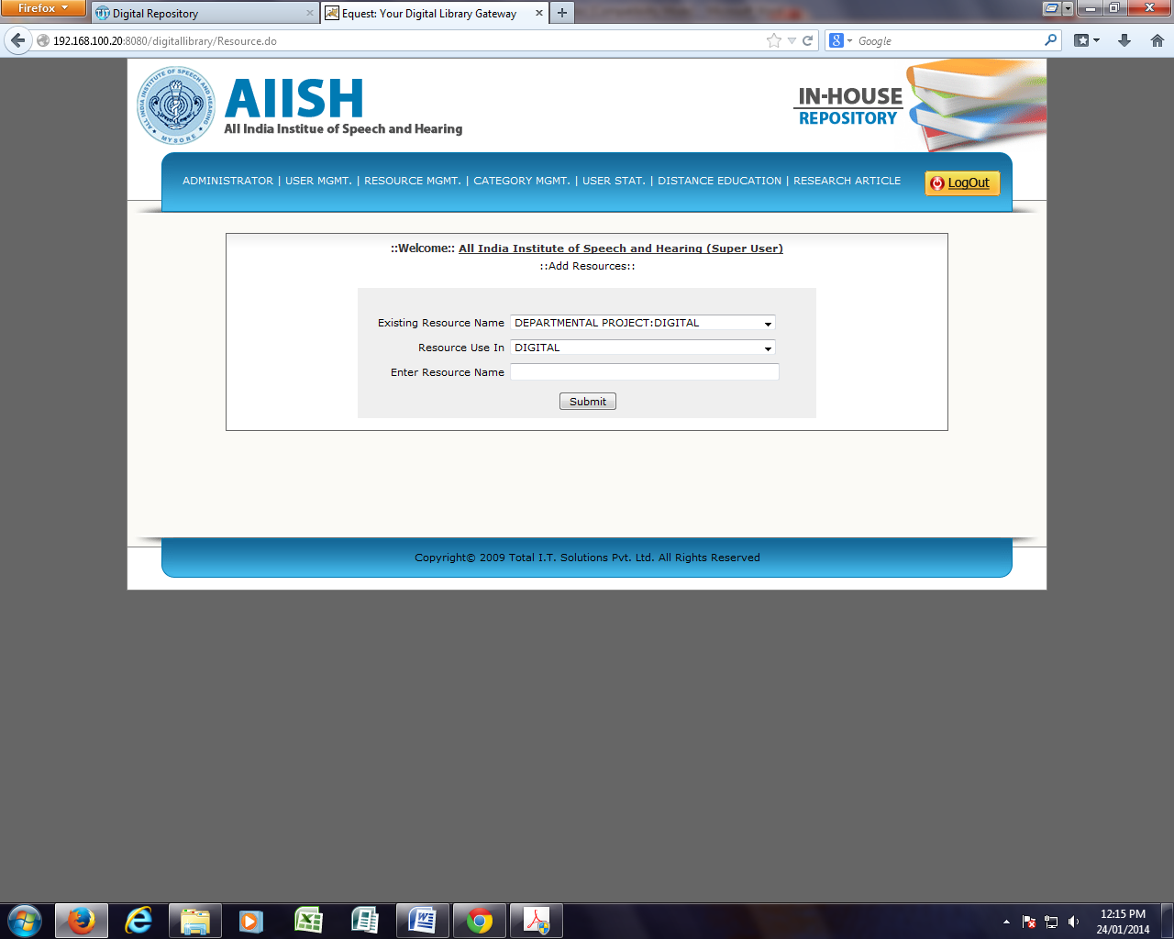

1. Select **Add Degree** option and enter the name of the course such as M.Sc. and click **Submit** button,

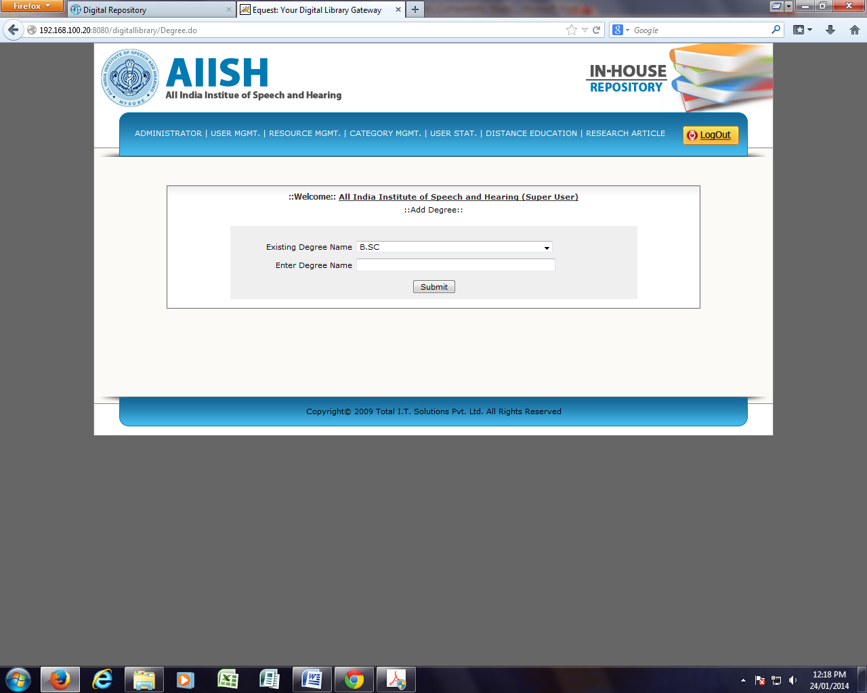

1. Fill-in the submission form by giving the details such as author, title, guide etc of the research and click **submit** button

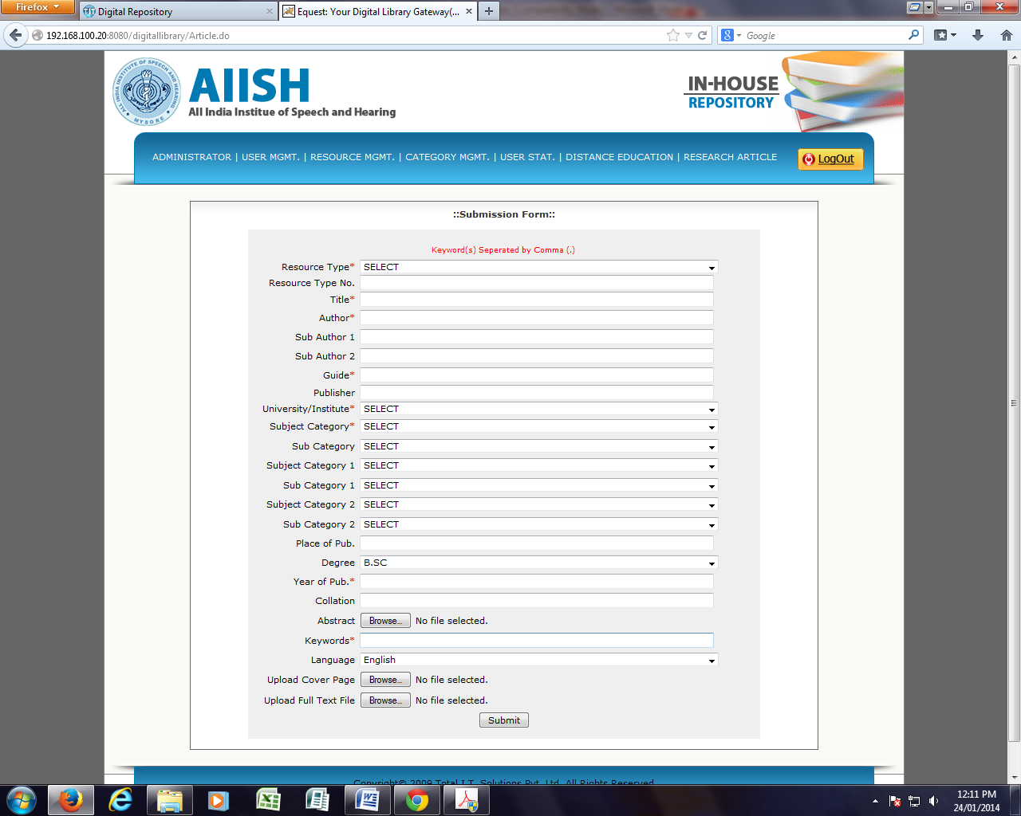

1. To edit or delete a record, select **Resource Management** and click **Edit/delete Record** button.

