# Effect of Temporal Pattern Training on Specific Central Auditory Processes

### 1Akshay Raj Maggu & 2Asha Yathiraj

**Abstract**

*Direct remedial training has been considered a feasible way to bring about improvement in the perception of acoustic signals in children with central auditory processing disorders [(C)APD]. The present study aimed to test the effect of temporal pattern training on different central auditory processes in children with (C)APD. Ten children, aged 8 to 13 years, who had poor temporal patterning skills, were recruited for the study. Five of the children, who formed the experimental group, underwent temporal pattern training with material that was developed. Five children, who did not receive training, served as the control group. Baseline responses, obtained on all the children for five processes (temporal patterning, temporal resolution, auditory separation, binaural integration and auditory memory and sequencing) were compared with the response obtained after 19 – 25 sessions of the training in the experimental group. In the control group it was obtained 3 – 4 weeks after the baseline evaluation. Following training, Wilcoxon signed rank test revealed a significant difference in scores in the experimental group on the tests that tapped temporal patterning and auditory memory and sequencing. No such difference was seen in the control group. In addition, Mann Whitney U test showed a significant difference in the scores on these two processes between the two groups in the second evaluation but not in the first evaluation. Thus, the study highlighted that temporal pattern training not only resulted in an improvement in process that was directly targeted (temporal patterning) but also in a process that was not directly targeted (auditory memory & sequencing).*

***Keywords****: (C)APD, temporal pattern training, auditory memory and sequencing*

**Introduction**

Bellis (2003) suggested that intervention for (C)APD should arise logically from the nature of an individual’s auditory deficit, besides dealing with functional difficulties. Such training has been termed as deficit- specific intervention. Several authors (English, Martonik & Moir, 2003; Maggu & Yathiraj, 2011; Priya & Yathiraj, 2007; Putter-Katz et al., 2002) have noted improvement in individuals with (C)APD with the use of deficit specific intervention. The improvement was confirmed using imaging (Temple et al., 2003), electrophysiological (Jirsa, 1992) and behavioural measures (Maggu & Yathiraj, 2011;

Musiek, 1999; Musiek & Schochat, 1998; Priya & Yathiraj, 2007; Yathiraj & Mascarenhas, 2003).1

According to Rupp and Stockdell (1978), between 15% to 20% of school-age children have some type of language/learning disorder, 70% of these had some form of auditory impairment. Further, Chermak and Musiek (1997) estimated that as many as 2% to 5% of the school-age population exhibit (C)APD. A temporal processing disorder has been observed to be one of the most frequently occurring subtype of (C)APD (Chermak & Musiek, 1997; Musiek, Geurkink, Kietel

& Hanover 1982; Musiek, Geurkink, Kietel & Hanover

1E-mail: [akshay_aiish@yahoo.co.in,](mailto:akshay_aiish@yahoo.co.in) 2Professor of Audiology, E-mail: [ashayathiraj@aiishmysore.in](mailto:ashayathiraj@aiishmysore.in)

1982; Muthuselvi & Yathiraj, 2009). Muthuselvi and Yathiraj (2009), who studied 3120 school-going children, observed that 6.9% of them were at-risk for (C)APD. They further found that in the 42 at-risk children evaluated on diagnostic tests, binaural integration was most affected (38%), followed by auditory memory (35%), temporal processing (14.2%-

16.2%), auditory closure (14-19%) and binaural

interaction (2.3%).

Musiek, et al. (1982) found that 72.7% of their clients with (C)APD had temporal processing deficit. According to Bellis (2003), children with temporal processing disorders have been shown to have deficits in acoustic contour recognition and thus difficulty recognizing and using prosodic aspects of speech.

Several training procedures have been carried out in the past to improve temporal processing abilities (Alexander & Frost, 1982; Bellis & Anzalone, 2008; Ferre, 1997; Merzenich et al., 1996; Tallal et al., 1996; Temple et al., 2003; Turner & Pearson, 1999; Vanaja

& Sandeep, 2004; Yathiraj & Mascarenhas, 2003). Some studies have used speech based training programmes (Ferre, 1997; Tallal et al., 1996; Temple et al., 2003; Turner & Pearson, 1999) while others have used a combination of speech and tone (Merzenich et al., 1996; Yathiraj & Mascarenhas, 2003). However, there are relatively few studies that have used only tone based material for training (Bellis & Anzalone, 2008; Vanaja & Sandeep, 2004).

Activities such as two-tone ordering and consonant- vowel sequencing have shown improvement in the temporal aspects (Merzenich et al., 1996). Vanaja and Sandeep (2004) studied the impact of discrimination training using pairs of tones differing in durations on long latency response and mismatch negativity responses. However, they did not study the impact of the training on other central auditory processes. Evidence of a speech based training activity improving other processes has been shown by Battin, Young and Burns (2000). They found that the Fast ForWord (FFW) (Scientific Learning Corporation, 1999) resulted in improvement in the temporal aspects as well as the other central auditory processes such as auditory figure ground and binaural separation. Likewise, there is a need to check the impact of a non-speech based temporal processing training programme on temporal processing as well as other auditory processes. Thus, the present study aimed at testing the efficacy of temporal pattern training directly on temporal processes in children with (C)APD. This study also aimed at testing its impact on other central auditory processes (temporal patterning, auditory separation, binaural integration, temporal resolution and auditory memory and sequencing).

## Method

The present study was carried out in three stages. In the *first stage*, participant selection and baseline evaluation (evaluation-I) were carried out. In the *second stage*, the participants in the experimental group were provided training while those in the control group were not given any training. In the *third stage*, tests were administered to evaluate the effect of training.

##### Participants

Two groups of participants, an experimental and a control group, were studied. Each group had five participants whose age ranged from 8 to 13 years. The participants were randomly assigned to the above two groups. The participants included those who did not pass the ‘Screening checklist for auditory processing’, (SCAP) developed by Yathiraj and Mascarenhas (2002, 2004) and had poor scores on the duration pattern test (DPT) developed by Gauri and Manjula (2003). All the participants studied in schools where the medium of instruction was English; had pure-tone air conduction and bone conduction thresholds within 15 dB HL from 250 Hz to 8000 Hz and 250 Hz to 4000 Hz, respectively; had Type A tympanograms and acoustic reflexes present between 90 and 100 dB HL; had speech identification scores above 90% on ‘Speech test material in English for Indians’, developed by

Chandrashekhar (1972); had no report of any speech and language problems; and had Intelligence Quotients between 90 and 110 on the Raven’s coloured progressive matrices (Raven, 1956).

The experimental group was provided with the temporal pattern training while the control group was not given any training. A written consent was taken from the caregivers prior to the evaluation.

##### Material

The training material included non-speech stimuli i.e. tones of 250 Hz, 1 kHz and 4 kHz, representing low, mid and high frequency signals. The tones were of different durations with a constant inter-tone interval of 250 ms. A hierarchy of training material developed, consisting of 2-tone, 3-tone and 4-tone activities. The tones were generated using Adobe audition version 3.0 software. The intensity of the signals was maintained at 60 dB SPL. The duration of the tones ranged from 250 ms to 500 ms. The lower limit of 250 ms was selected based on the duration used in the DPT (Gauri & Manjula, 2003). Details of the training material are provided in Appendix I.

To determine the minimum temporal difference required by a person for the perception of temporal order among tones, a pilot study was conducted. This was carried out on 5 normal hearing adults and 5 normal hearing children in the age range of 18 to 25 years and 8 to 13 years, respectively. The tones having frequencies of 250 Hz, 1 kHz and 4 kHz at 60 dB SPL were generated and presented through Adobe audition version 3.0 software. The participants had to identify the temporal order of the tones. It was found that both groups required at least 75 ms. difference between the two tones for perception of temporal order.

##### Instrumentation

A calibrated dual channel diagnostic audiometer, OB 922 (version 2) with air conduction (TDH-39) and bone conduction (B-71) transducers was used to carry out pure-tone audiometry, speech audiometry and the (C)APD tests. A calibrated immittance meter (GSI Tympstar) was used to ensure the presence of normal middle ear function. The CD version of the test material was played through a Dell Vostro laptop with Intel Celeron processor. Adobe audition 3.0 was used for the presentation of the training material monaurally using headphones. The output level from the headphones was measured using a ‘Larson Davis systems 824’ sound level meter equipped with a ½” free-field 2540 microphone. The volume control of the software and that of the computer were manipulated so

that output from the headphone was approximately 60 dB SPL.

##### Environment

All the evaluations were carried out in an acoustically treated two-room situation which met the specifications of ANSI S3.1 (1999). The training was given in a quiet, distraction free environment.

##### Procedure

###### Stage I

*Procedure for selection of participants*: Screening for the presence of (C) APD was carried out on school- going children aged 8 to 13 years. Teachers who had taught the children for at least one year were asked to identify those with a suspected (C)APD using the SCAP. The checklist was scored on a two point rating scale. Each answer marked ‘Yes’ was scored ‘1’ and each ‘No’ was scored ‘0’.

Those children who obtained less than 50% scores on the SCAP, the cut-off value that indicates the suspicion of (C)APD, were tested for their temporal patterning skills, using DPT. Their responses were compared with the norms developed by Gauri and Manjula (2003). Those who got scores lower than the normative were included in the study. Baseline evaluation (Evaluation-

I) was carried out on these children on 4 additional (C)APD tests to assess different central auditory processes. The tests included Speech perception in noise (SPIN) test developed by Yathiraj, Vanaja and Muthuselvi (2010) which evaluated auditory separation; Dichotic CV test developed by Yathiraj (1999) to determine auditory integration; Gap Detection Test (GDT) developed by Shivaprakash and Manjula (2003), to obtain the information on temporal processing abilities; and Revised Auditory Memory and Sequencing Test (R-AMST) developed by Yathiraj, Vanaja and Muthuselvi (2010) to determine auditory memory skills.

The SPIN, Dichotic CV, GDT and R-AMST tests were administered using the CD version of the tests which were played on a computer. The output from the computer was routed through the audiometer. The outputs of the all tests were presented through the headphones, except R-AMST which was presented through sound-field speakers.

The *SPIN* test was presented monaurally at 0 dB SNR at 40 dB SL (ref. Speech Recognition Threshold). Verbal responses of the participants were noted. A correct response was given a score of ‘1’ and an incorrect response a score of ‘0’. Similarly, in the

*GDT,* the signals were presented monaurally at 40 dB SL (ref. Pure tone average). The participants were required to indicate as to which set of noise bursts in a triad contained a gap. The minimum gap duration which the participants were able to detect was compared with norms given by Chermak and Lee (2005). For both these tests (SPIN & GDT), half the participants were initially tested in the right ear while the other half were tested in the left ear, to avoid any ear order effect.

For the *Dichotic CV test,* the stimuli were presented at 40 dB SL (ref. SRT) and the participants were asked to repeat the syllables which were heard through headphones. Their oral responses were noted by the experimenter. Their right ear, left ear and double correct responses were scored and compared with the norms given by Krishna and Yathiraj (2001).

Stimuli for the *R-AMST* were presented through a loudspeaker in a sound-field condition at 40 SL (ref. SRT). The loudspeaker was placed at a 450 azimuth at a distance of one meter from the head of each participant. The participants were asked to repeat the words heard by them. Their oral responses were later scored by the experimenter. A score of ‘1’ was given for each correctly repeated word to calculate the auditory memory score. Also, sequencing score was calculated by awarding an additional score of ‘1’ when an item was in the correct order. The responses were compared with age appropriate norms developed by Devi, Sujitha and Yathiraj (2008).

###### Stage II

The children in the experimental group were trained using the hierarchical material that was developed. The training started with easy tasks (level 1a) and gradually proceeded to more difficult tasks (level 3e) (Appendix I). The material was played through a computer loaded with Adobe audition (Version 3.0) software. The participants heard the stimuli through headphones, in a monaural condition at approximately 60 dB SPL. In half the participants, the training commenced in the right ear, while for the other half it was commenced in the left ear. This was done to avoid any ear order effect. Only after the completion of training in both the ears at a particular level of difficulty, was the next level of difficulty commenced.

The participants were trained initially using a discrimination task followed by an identification task. This was done at each level of difficulty. In the discrimination tasks, the children had to say whether the tones were same or different while in the identification task they were expected to repeat the pattern of the tones verbally (eg. long-short-long). In

order for a child to progress to a higher level of training activity, he/she had to obtain a correct score of at least 80% on both the discrimination and the identification tasks.

###### Stage III

Following the training, the experimental group was tested using the same five tests as used in evaluation-I. The control group was also evaluated 3 *–* 4 weeks after the initial evaluation. The order in which the tests were administered during evaluation II for each participant was the same as that of evaluation-I. This was adopted to avoid any test order effect.

###### Test retest reliability

Test-retest reliability was conducted on 40% of participants (2 from each group). All tests were administered on these participants after a period of 1 month subsequent to evaluation-II.

###### Statistical analysis

The scores on the five different processes (auditory separation, binaural integration, temporal resolution, temporal patterning and auditory memory and sequencing) obtained by the 10 children with (C)APD

were analysed using SPSS (version 19) software. Besides descriptive statistics, Mann Whitney U test was used to compare the performance of the two groups within the two evaluations. Further, in order to compare the scores for each group across the two evaluations, Wilcoxon test was used.

## Results and Discussion

The outcomes of the statistical analyses are reported and discussed in terms of the scores obtained across evaluation I and II; scores obtained across the experimental and control groups; and scores obtained across evaluation II and III.

##### Comparison across evaluation I and II

In order to check the impact of training, the scores obtained in evaluation I were compared with that obtained in evaluation II. This was done for each of the groups i.e. those who underwent training (experimental group) as well as those who did not undergo training (control group). It can be observed from Table 1 and Figure 1 that the mean values differed considerably across the two evaluations for the experimental group, but not so for the control group. To check whether these differences were statistically significant or not, Wilcoxon signed ranks test was carried out.

*Table 1*: *Mean and Standard deviation (SD) for each test for evaluation I and II across groups*

Tests Ear/

|  |  |  |  |  |  |  |
| --- | --- | --- | --- | --- | --- | --- |
| Score | | Mean score | S. D. | Mean score | S. D. | differ |
| Right | I | 5 (16.6%) | 1.87 | 5.6 (18.7%) | 3.04 | -2.1% |
|  | II | 12 (40%) | 2.91 | 5.6 (18.7%) | 3.04 | 31.3% |
| Left | I | 4.8 (16%) | 2.48 | 6.4 (21.3%) | 1.14 | -5.3% |
|  | II | 12.6 (42%) | 3.28 | 6.2 (20.6%) | 1.3 | 21.4% |
| Right | I | 10.2 (40.8%) | 6.18 | 12.2 (48.8%) | 5.8 | 8% |
|  | II | 15 (60%) | 4.79 | 12.2 (48.8%) | 5.8 | 11.2% |
| Left | I | 12.8 (51.2%) | 7.69 | 12.2 (48.8%) | 4.38 | 2.4% |
|  | II | 15 (60%) | 7.71 | 12.4 (49.6%) | 4.15 | 10.4% |
| Right | I | 11.4 (38%) | 6.22 | 10 (33.3%) | 5.24 | 4.7% |
|  | II | 11.4 (38%) | 6.22 | 10 (33.3%) | 5.24 | 4.7% |
| Left | I | 14.4 (48%) | 6.98 | 10 (33.3%) | 5.09 | 14.7% |
|  | II | 14 (46.6%) | 6.70 | 9.6 (32%) | 4.44 | 14.6% |
| DCS | I | 5 (16.6%) | 4.35 | 3.6 (12%) | 2.88 | 4.6% |
|  | II | 5.2 (17.3%) | 4.14 | 3.6 (12%) | 2.88 | 5.3% |
| Right | I | 7.6 ms | 1.67 | 8.8 ms | 0.89 | --NA-- |
|  | II | 6.8 ms | 2.28 | 8.6 ms | 0.89 | --NA-- |
| Left | I | 8.2 ms | 2.16 | 5.8 ms | 1.30 | --NA-- |
|  | II | 7 ms | 2.73 | 5.8 ms | 1.30 | --NA-- |
| MSα | I | 21 (17.7%) | 8.21 | 13.2 (11.2%) | 3.03 | 6.5% |
|  | II | 54.8 (46.4%) | 11.5 | 12.8 (10.8%) | 3.19 | 35.6% |
| SSα | I | 3.6 (3.0%) | 1.34 | 2.4 (2.03%) | 2.50 | 0.97% |
|  | II | 12.8 (10.8%) | 4.81 | 2.8 (2.4%) | 2.88 | 8.4% |

DPTƭ

Eval Experimental group (E) Control group (C) E-C

ence

SPIN¤

DCV ƭ

GDT

R-AMST

*Note:* Eval= Evaluation; Maximum possible score: ƭ *=30,* ¤ = 25, α = 118

In the *experimental group*, the Wilcoxon signed rank test revealed that there was a significant difference at the 0.05 level for the scores obtained on the DPT and the R-AMST while there was no significant difference on the other tests (Figure 1). In the *control group*, there was no significant difference between the scores obtained across the two evaluations on all the tests, as per the outcome of the Wilcoxon signed rank test (Figure 2).

##### Comparison across the experimental and control groups

To further ensure that the improvement in the scores

for the various processes was due to training, a comparison of both participant groups (experimental

& control) was carried out. The two groups were compared on the various tests, before the training (evaluation I) and after the experimental group underwent a training (evaluation II). It is evident from Table 1 and Figure 3 that there was no significant difference between the two groups at the initial stage of the study (evaluation I). However, after training was provided to the experimental group, there was considerable change in the scores of the two groups (Table 1 & Figure 4). Mann Whitney U test was carried out to check whether these differences were statistically significant.

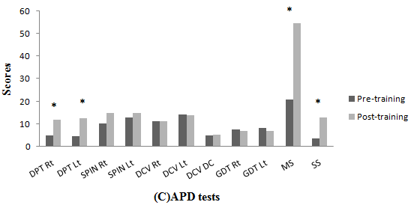

* = p < 0.05

*Figure 1: Comparison of evaluation-I and II within the experimental group.*

*Note:* DPT: Duration pattern test, SPIN: Speech-in-noise test, DCV: Dichotic CV test, GDT: Gap detection test, R-AMST: Auditory memory and sequencing test

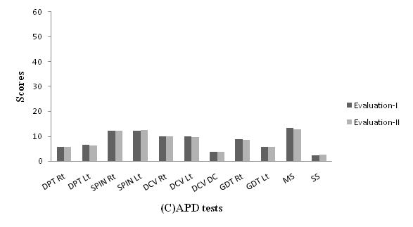

*Figure 2: Comparison of scores across evaluation-I and II within the control group.*

*Note*: DPT: Duration pattern test, SPIN: Speech-in-noise test, DCV: Dichotic CV test, GDT: Gap detection test, R-AMST: Auditory memory and sequencing test,

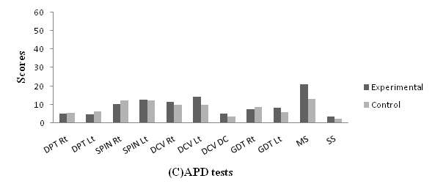

*Figure 3: Comparison of scores across experimental and control group for evaluation-I.*

*Note*: DPT: Duration pattern test, SPIN: Speech-in-noise test, DCV: Dichotic CV test , GDT: Gap detection test, R-AMST: Auditory memory and sequencing test,

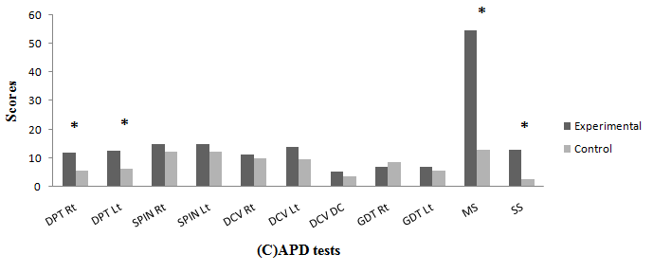

*Note*: DPT: Duration pattern test, SPIN: Speech-in-noise test, DCV: Dichotic CV test, GDT: Gap detection test, R-AMST: Auditory memory and sequencing test,

*Figure 4: Comparison of scores across the experimental and control group in the evaluation-II.*

The Mann Whitney U test revealed that there was no significant difference between the experimental and control group for any of the tests carried out during evaluation-I (baseline evaluation). In contrast, there was a significant difference obtained between the two groups after the training paradigm. The significance was noted at the 0.05 level for DPT and R-AMST. Although improvement occurred on other tests too, they were found to be insignificant.

The positive *impact of temporal pattern training on temporal processing* was evident from the fact that there was a significant improvement in the DPT scores following training. This improvement can be attributed to the implementation of a temporal based deficit specific intervention. This goes to confirm that direct remediation does have an influence on the process being targeted. The finding of the present

study is in agreement with that of Bellis and Anzalone 2008)who found considerable improvement in the scores of a participant on a frequency pattern test following temporal pattern training.

The *impact of temporal pattern training on other central auditory processes* was apparent from the significant improvement seen in the scores on the R- AMST following training. This improvement was seen for both the memory sub-test as well as the sequencing sub-test. It can be construed from this finding that temporal pattern training using non-verbal material, has a positive effect on auditory memory and sequencing. This could have occurred due to the relation between the temporal patterning and auditory memory which has been suggested by several authors (Pinheiro & Musiek, 1985; Benaish & Tallal, 1996). Pinheiro and Musiek (1985) proposed that temporal patterning and

auditory memory and sequencing may share the same neurophysiologic process. The relationship between temporal processing and memory was also perceptible from the findings of Benaisch and Tallal (1996). They reported that infants aged 6 to 10 months with a positive family history of language impairment, had poor temporal processing thresholds and recognition memory. These infants had been evaluated to determine their temporal processing threshold, habituation and recognition memory.

The influence of temporal processing on other domains has also been reported in literature. Tallal, et al., (1996) noted that temporal processing abilities could be improved through training and this in turn led to an improvement in language and literacy skills. They employed the use of acoustically modified speech and found that this resulted in an improvement in speech discrimination and language comprehension skills.

The findings of studies dealing with individuals with dyslexia also throw light on the association between temporal based training and other processes. Habib, et al. (2002) found temporally modified speech to result in improvement in phonological abilities which in turn correlated with temporal order judgment. Likewise, Overy (2003) observed that music training, administered on children having dyslexia with deficits in timing, brought about improvement in other processes. Rapid auditory processing was one of the processes that improved.

Thus, it can be concluded from the findings of the present study and from those discussed above that temporal based training could bring about an improvement in other processes, including auditory memory. The current study reveals that providing temporal based training can bring about improvement in both auditory memory and auditory sequencing. However, such training does not result in improvement in other processes such as auditory integration and auditory separation. It is speculated that these processes are more dependent on acoustic parameters other than temporal cues.

##### Comparison of scores across evaluations II and III

Four participants, two each from the experimental (participants A and B) and control group (participants C and D) were reevaluated to check the maintenance of training after a gap of 1 month following evaluation-II. It was noticed that the scores on the various tests remained almost constant for the participants from both the groups.

Figure 5 depicts the scores of two participants (evaluation-III) from the experimental group who were evaluated on the same set of tests as in evaluation-I and II, after a gap of one month following the training. It can be observed that the effect of training was maintained even after a month of termination of the training. The scores on the various tests remained almost constant.

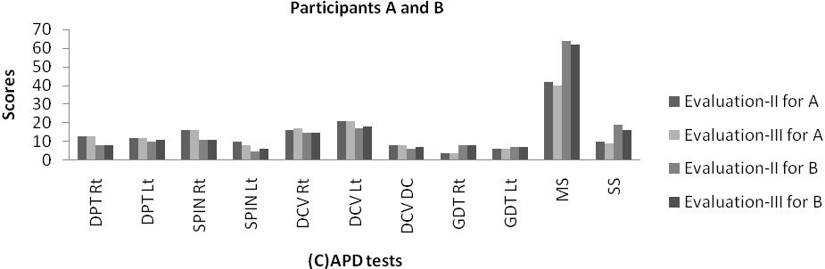

*Figure 5: Comparison of scores of participants A and B (experimental group) across evaluation II and III*

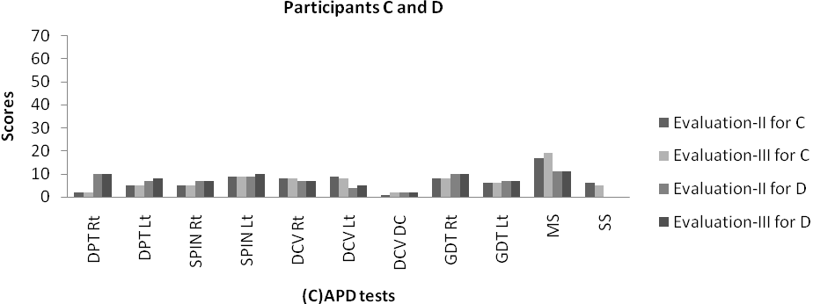

*Figure 6: Comparison of scores of participants C and D (control group) across evaluation II and III*

Similarly, Figure 6 shows the scores of two participants (evaluation-III) who were randomly selected from the control group. It was found that there was not much change in the scores obtained in evaluation III compared to that obtained in evaluation-II.

The above finding shows that the effect of training is maintained even after one month after the cessation of therapy. From the findings, it can also be noted that without training, scores obtained on different auditory process tests, do not improve. Further, the findings confirm the reliability of the scores obtained in evaluation II.

## Conclusions

Thus, from the findings of the present study it can be concluded that the temporal pattern training brings about an improvement in the individuals with deviant temporal processing. Along with the improvement in temporal pattern processing, the training also positively influenced the auditory memory and sequencing abilities of the participants who underwent temporal pattern training, affirming its effect on other central auditory processes. The study also brought to light that the positive effects of training are maintained even after a month following the cessation of the therapy. Hence, it can be construed that temporal pattern training is useful in improving not only temporal processing but also auditory memory and sequencing.

## References

Alexander, D. W., & Frost, B. P. (1982). Decelerated synthesized speech as a means of shaping speed of auditory processing of children with delayed language. *Perceptual and Motor skills, 55*, 783-792.

ANSI S3.1 (1999). American National Standards Institute (1999). *Maximum permissible ambient noise for audiometric test rooms. ANSI S3.1-1999.* New York: American National Institute.

Battin, R. R., Young, M., & Burns, M. (2000). Use of Fast ForWord in remediation of central auditory processing disorders. *Audiology Today, 12*(2), 13-15.

Bellis, T. J. (2003). *Central auditory processing in the educational setting: From science to practice* (2nd Ed.). Clifton Park, NY: Thomas–Delmar Learning.

Bellis, T. J., & Anzalone, A., M. (2008). Intervention approaches for individuals with (central) auditory processing disorder. *Contemporary issues in communication science and disorders*, *35*, 143-153.

Benaisch, A. A., & Tallal, P. (1996). Auditory temporal processing thresholds, habituation and recognition memory over the 1st year. *Infant behavior anddevelopment, 19*(3), 339-357.

Chandrashekhar, S. K. (1972). *Development and Standardization of speech test material in English for Indians.* Unpublished Master’s Dissertation. University of Mysore, Mysore.

Chermak, G. D., & Lee, J. (2005). Comparison of children’s performance on four tests of temporal resolution. *Journal of American Academy of Audiology, 16* (8), 554-563.

Chermak, G. D., & Musiek, F. E. (1997). *Central auditory processing: New perspective.* San Diego: Singular Publishing Group.

Devi, N., Sujitha, N., & Yathiraj, A. (2008). Auditory memory and sequencing in children aged 6 to 12 years, *Journal of All India Institute of Speech And Hearing,* 27, 95-100.

English, K., Martonik, J., & Moir, L. (2003). An auditory training technique to improve dichotic listening, *Hearing Journal, 56* (1)*,* 34-38.

Ferre, J. M., (1997). *Processing power: a guide to CAPD assessment and management.* San Antonio, TX: The psychological corporation.

Gauri, D. T., & Manjula, P. (2003). *Development of norms on duration pattern test.* Unpublished Master’s independent project submitted to the University of Mysore.

Habib, M., Rey, V., Daffaure, V., Camps, R., Espesser, R., Joly-Pottuz & Demonet, J. F. (2002). Phonological training in children with dyslexia using temporally modified speech: a three-step pilot investigation.

*International Journal of Language and Communication Disorders, 37*(3), 289-308.

Jirsa, R., E. (1992). The clinical utility of P3 AERP in children with auditory processing disorders. *Journal of Speech and Hearing Research*, *35*, 903-912.

Krishna, G. & Yathiraj, A. (2001). *Dichotic CV test – Revised normative data on children*. Unpublished Master independent Project submitted to the University of Mysore, Mysore.

Maggu, A. R., & Yathiraj, A. (2011). Effect of noise desensitization training on children with poor speech- in-noise scores. *Canadian Journal of Speech Language Pathology and Audiology, 35* (1)*,* 56-63.

Merzenich, M. M., Jenkins, W. M., Johnston, P., Schreiner, C., Miller, S. L., & Tallal, P. (1996). Temporal processing deficits of language-learning impaired children ameliorated by training. *Science*, 271, 77-80.

Musiek, F. E. (1999). Habilitation and management of auditory processing disorders: overview of selected procedures. *Journal of the American Academy of Audiology, 10*, 329-342.

Musiek, F. E., Geurkink, N. A., Kietel, S. A., & Hanover, N.

H. (1982). Test battery assessment of auditory perceptual dysfunction in children, *Laryngoscope, 92(3),*251-257.

Musiek, F. E., & Schochat, E. (1998). Auditory training and central auditory processing disorders: A case study. *Seminars in Hearing, 19,* 357-366.

Muthuselvi, T., & Yathiraj, A. (2009). *Utility of the screening checklist for auditory processing (SCAP) in detecting (C)APD in children.* Unpublished Master’s dissertation, University of Mysore, Mysore.

Overy, K. (2003). Dyslexia and music: From timing deficits to musical intervention. *Annals of New York Academy of Sciences, 999,* 497-505.

Pinheiro, M. L. & Musiek, F. E. (1985). Sequencing and temporal ordering in the auditory system. In: M . L. Pinheiro and F. E. Musiek (Eds). *Assessment of Central Auditory Dysfunction: Foundation and Clinical Correlates.* (pp. 219-228). Baltimore: Williams and Wilkins.

Priya, G., & Yathiraj, A. (2007). *Effect of dichotic offset training (DOT) in children with an auditory processing disorder*. Unpublished Master’s Dissertation. University of Mysore, Mysore.

Putter-Katz, H., Said, L. A., Feldman, I., Meran, D., Kushmit, D., Muchnik, C., & Hildesheimer, M. (2002). Treatment and evaluation indices of auditory processing disorders. *Seminars in Hearing, 23* (4), 357-363.

Raven, J. C. (1956). *Coloured progressive matrices*. Lewis and Co.: London.

Rupp, R. R., & Stockdell, K. G. (1978). *Speech protocols in Audiology.* New York: Grune & Stratton.

Scientific Learning Corporation. (1999). Fast ForWord: Assessment. Retrieved from [http://www.scientificlearning.com.](http://www.scientificlearning.com/)

Shivaprakash, S., & Manjula, P. (2003). *Gap Detection Test- development of norms.* Unpublished Master independent Project submitted to the University of Mysore, Mysore.

Tallal, P., Miller, S. L., Bedi, G., Byma, G., Wang, X., Nagarajan, S. S., Schreiner, C., Jenkins, W. M., & Merzenich, M. M. (1996). Language Comprehension in Language Learning Impaired Children Improved with Acoustically Modified, Speech, *Science, 271,* 81-84.

Temple, E., Deutsch, G., Poldrack, R., Miller, S., Tallal, P., Merzenich, M., & Gabrielli, J. (2003). Neural deficits in children with dyslexia ameliorated by behavioural remediation evidence from functional MRI. *Proceedings of the National Academy of Sciences of the United States of America, 100*, 2860-2865.

Turner, S., & Pearson, D. W. (1999). Fast ForWord language intervention programs: four case studies. *Texas Journal of Audiology and Speech Language Pathology.* Retrieved from<http://www.scilearn.com/results/science/articles/main>

=abstract10_1.

Vanaja, C. S., & Sandeep, M. (2004). Auditory long latency responses in children with learning disability. Departmental project, All India Institute of Speech and Hearing, Mysore.

Yathiraj, A. (1999). The Dichotic CV test. Unpublished material developed by department of Audiology, All India Institute of Speech and Hearing, Mysore.

Yathiraj, A., & Mascarenhas, K. (2002). Audiological profile of the children with suspected auditory processing disorder. Developed as a part of project titled ‘Effect of auditory stimulation of central auditory processes in children with CAPD’, at the department of audiology, All India Institute of Speech and Hearing, Mysore.

Yathiraj, A., & Mascarenhas, K. (2003). Effect of auditory stimulation in central auditory processing in children with (C)APD, project carried out at the department of Audiology, All India Institute of Speech and Hearing, Mysore.

Yathiraj, A., & Mascarenhas, K. (2004). Auditory profile of children with suspected auditory processing disorder. *Journal of Indian Speech and Hearing Association, 18*, 6-14.

Yathiraj, A., Vanaja, C. S., & Muthuselvi, T. (2010). Speech in noise test. Developed as a part of project titled ‘Maturation of auditory processes in children aged 6 to 11years’, at the department of audiology, All India Institute of Speech and Hearing, Mysore.