# Acoustic Change Complex in Children: 7-15 Years of Age

### 1Akash Juneja & 2N. Devi

**Abstract**

*The objective was to see the age related changes in the Acoustic Change Complex (ACC). A total of 45 participants in the age range of 7 to 15 years were taken. These participants were divided into three groups according to the age: 7 to 9; 11 years, 10 to 12; 11 years, and 13 to 15; 11 years. Fifteen participants were taken in each sub-group. Naturally spoken speech stimuli /sa/ and /si/ were recorded using Adobe Audition software (version 2) and were used to record the ACC by using Evoked Potential System (Bio-logic Navigator Pro).Different positive-negative components for ACC responses were marked as P1, N1, P2, N2 and P3. Latencies for these components were measured in ms while the peak to peak amplitude of N1P2 and N2P3 complexes were measured in µV. The latencies and amplitudes were calculated across the ages by different statistical analysis by using SPSS version (10, 17) software. The results revealed that there were effects of age on the latencies and amplitudes of different ACC component, evidencing maturational changes in ACC.*

***Key Words:*** *Acoustic change complex (ACC), amplitude, latency, maturation*

*.*

**Introduction**

Acoustic Change Complex (ACC) is a negative- positive complex that is elicited by a change that occurs during an ongoing acoustic stimulus (Martin & Boothroyd, 1999). In appearance and timing, the ACC is similar to the N1-P2 complex that occurs in response to stimulus onset (Onishi & Davis, 1968; Hillyard & Picton, 1978; Naatanen & Picton, 1987; Naatanen, 1992; Pantev, Euliz, Hampton, Ross, & Roberts, 1996). Both amplitude and frequency modulation during an ongoing sound can evoke an N1-P2 complex (Clynes, 1969; Spoor, Timmer & Odenthal, 1969; McCanless & Rose, 1970; Yingling & Nethercut, 1983), as can an acoustic change during a sustained speech sound (Kaukornata, Hari & Lonasma, 1987). In sustained speech sound (syllables), it occurs in response to transition from consonantal segment to vocalic segment (Hari, 1991; Imaizumi, Mori, & Kiritani et al, 1996; Ostroff, Martin & Boothroyd, 1998). In the multiple responses evoked by the speech stimuli /shee/, in normal hearing listeners, the first N1 response signals the change in acoustic energy (from silence to sound) coinciding with the onset of consonant. The second N1 reflect a change in acoustic energy corresponding to the onset of the vowel (Tremblay, Friesen, Martin & Wright, 2003).

The ACC has been used to study the neural detection of consonant vowel (CV) transitions (Kaukornata, Hari

& Lonasma, 1987; Ostroff, Martin & Boothroyd, 1999),

1E-mail: akijuneja@gmail.com; 2Lecturer in Audiology, E- m[ail: deviaiish@gmail.com](mailto:deviaiish@gmail.com)

periodicity changes (Martin & Boothroyd, 1998), amplitude envelope and speech spectral content variation (Martin & Boothroyd, 2000). It can be recorded reliably in individuals by two variants of stop consonants and fricatives, and results are consistent with the reliability of CAEP’s in response to tones (Pekkonen, Rinne & Naatanen, 1995; Vitanen, Ahveninen, Ilmoniemi, Naantanen & Pekkonen, 1998), and synthetic speech stimuli (Tremblay, Friesen & Martin et al., 2003). ACC can be used as an electrophysiological tool for the encoding of speech changes in adults and children if LLR is present (Karthik, 2005). ACC provides important insight into the brain’s capacity to discriminate the acoustic features of speech present in the signal. First, the ACC has been recorded in response to consonant-vowel syllables, in which the acoustic change include frequency, amplitude, and periodicity cues similar to those found in normal conversational speech (Kaukornata, Hari & Lonasma, 1987; Ostroff, Martin

& Boothroyd, 1998). The ACC has also been seen in response to isolated acoustic cues that often differentiate speech sounds as well as to combinations of these acoustic cues. For example, it had been recorded to a change from a harmonic tonal complex to a noise-band stimulus with the same spectral envelope (Martin & Boothroyd, 1999), and amplitude and formant frequency changes within a vowel (Martin & Boothroyd, 2000). Martin and Boothroyd (2000) demonstrated that the ACC was present in response to

+2 or -3 dB of intensity change, which dovetails nicely with the behavioral intensity discrimination literature.

According to Martin and Boothroyd (1999) N1-P2 complex in response to periodic and aperiodic stimuli has been studied. The response of the noise-only and

tone-only stimuli showed a clear N1-P2 complex to the onset of stimulation followed by sustained potential that continued until the offset of stimulation. The noise-tone and tone-noise stimuli elicited an additional N1-P2 acoustic change complex in response to the change in periodicity occurring in the middle. The acoustic change complex was larger for tone-noise than for noise-tone stimulus. Tremblay, Friesen, Martin and Wright (2003) reported that ACC has been recorded in normal hearing individuals and also checked for test- retest reliability within an eight-day period. Results showed that ACC by naturally produced speech sounds were reliably recorded in individuals. Also, naturally produced speech tokens, representing different acoustic cues, evoked distinct neural response pattern.

A thorough characterization of the AEP changes that continue into adolescence is a first step in establishing whether a relationship exists between physiological maturation and the prolonged development of some psychophysical abilities (Litovsky, 1997; Schneider & Trehub, 1992; Marshall, Brandt & Marston et al., 1979; Elliott, 1979; Palva & Jokinen, 1975). Maturation of the CAEPs is an extended process with profound effects on the appearance and disappearance of some components, and on the amplitude and latency of other components (Ponton, Eggermont, & Kwong et al., 2000). ACC could possibly help us to quantify the neuromaturation for complex speech signals. ACC are to hold promise as a clinical tool for assessing the neural detection of time varying cues contained in speech, as well as longitudinal changes in neural activity (Tremblay, Friesen & Martin et al., 2003).

A comprehensive description of age-related ACC changes in neurologically intact and normal-hearing children will provide a useful reference for assessing suspected neuromaturational deficits or central auditory processing disorders in children. These reference data may also be useful in evaluating children with hearing disorders (e.g. unilateral deafness) or profoundly deaf children fitted with cochlear implants (Ponton & Don, 1995). So the present study was carried out to get the reference in diagnosing normal from disordered population. ACC responses can provide a non behavioral means of investigating the processing of speech sound. These changing complexes can be used in individuals who neither comprehend nor participate in a behavioral task. Wunderlich and Cone-Wesson (2006) reports that examining childhood development of the CAEP has mostly included children aged from 4 years through to adolescence and early adulthood. The span of years examined varies from study to study but there is considerable overlap from the later years of childhood (7 years onwards) up to early adolescence (about 15 years) so that this period is relatively well

understood. By comparison, there is a dearth of literature on the developmental patterns of ACC in age range of 7 to 15 years. A study of the same might lead to a better understanding of the neuromaturation of the auditory system to complex signals in this age group.

Hence the objective of the current study was to study the variations of Acoustic Change Complex (ACC) in children between 7 to 15 years of age for /sa/ and /si/ stimuli.

## Method

Forty-five participants were taken who were further divided into three groups (fifteen participants in each group) based on their age. The three groups were Group A: 7 to 9; 11 years of age (26 ears), Group B: 10

to 12; 11 years of age (29 ears), and Group C: 13 to 15; 11 years of age (30 ears). All participants had normal hearing sensitivity as revealed by pure tone audiometry with air conduction (250-8000 Hz) and bone conduction (250-4000 Hz) thresholds within 15 dBHL. They had Speech Identification Scores of 90% and above, normal middle ear function as revealed on Tympanometry. They had ‘A’ type Tympanogram and reflexes present at 500, 1 kHz and 2 kHz both ipsi and contralaterally. All participants passed in Screening Checklist for Central Auditory Processing (SCAP), developed by Yathiraj and Mascarenhas (2003). They had no relevant Otological or neurological history and illness on the day of testing. They were native speakers of Kannada. For all participants, informed consent of parents/caregiver was obtained.

A calibrated diagnostic audiometer (OB-922) was used for pure tone and speech audiometry with signal matched headphones, TDH 39 and Radio ear B71 bone vibrator for measurement of the bone conduction thresholds. GSI Tympstar was used to carry out the tympanometry and acoustic reflexes. A unidirectional microphone connected to the computer, and Adobe Audition (version 3.0) software was used to record the speech stimuli. A Sound Level Meter SLM 824 LND was used to calibrate the stimulus output. An evoked potential system (Bio-logic Navigator Pro) was used to record cortical evoked auditory responses, ACC using

/sa/ and /si/ stimuli. All the audiological evaluation and recording was carried out in a sound treated room (ANSI 1991; S3.1). Written consent from the parents was taken for their children to participate in the study, and SCAP was administered with the help of teacher or parents. The health conditions of the children were asked from the teacher and parents. The behavioral thresholds in octave frequencies from 250 Hz to 8 kHz for air conduction and 250 Hz to 4 kHz for bone conduction were obtained. The thresholds were traced

using modified Hughson and Westlake method (Carhart & Jerger, 1959).Speech recognition thresholds were found using spondees and speech identification scores was obtained at MCL using test material developed by Mayadevi (1974). Tympanometry and acoustic reflexes were carried out to rule out any possibility of middle ear pathology using 226 Hz probe tone, and reflexes at 500, 1 kHz and 2 kHz both ipsi and contralaterally.

Speech stimuli /sa/ & /si/ were used to record ACC. These syllables were spoken by an adult male, Kannada speaker with normal vocal effort, and were recorded by a unidirectional microphone, kept at distance of approximately 10 cm from the speaker, connected to the computer. The recording was done using Adobe Audition software (version 2), with a sampling rate of 48000 Hz and 16 bit resolution. The stimuli duration was 248 ms for syllables /sa/ and /si/. The best recorded signals were given to ten listeners and asked to rank them for the clarity, stimuli marked as best in the clarity were taken as the test signals. Pitch and formant frequency of the signal taken were;

106.1 Hz, F1-573.6 Hz, F2-1479 Hz for stimulus /sa/; and 120.4 Hz, F1- 388.3 Hz, F2- 2647 Hz for stimulus

/si/ at vowel midpoint. When analyzed, speech stimulus

/sa/ found to have 133 ms portion of /s/ and 115 ms portion of vowel /a/, and stimulus /si/ found to have 147 ms portion of /s/ and 101 ms portion of vowel /i/.

Further the files were loaded in Biologic system for ACC recording. Intensity calibration was done with SLM 824 LND for the stimulus to be equivalent to 80 dBSPL. Value obtained was 75 dBnHL for /sa/ and /si/ stimulus for both the ears.

Electrode sites were cleaned by using abrasive gel. AgCl electrodes were used and placed on different sites by applying conduction gel. Different sites for electrode placements were; inverting electrode on the test ear, non-inverting on the vertex and common on the contra-lateral mastoid. Intra electrode impedance was maintained <5 kOhms, and <2 kOhms inter electrode impedance. Subjects were instructed to be awake and not to move while testing is carried out, as well as a mute cartoon video was played.

Both N1-P2 complexes were identified and analyzed with respect to latency and peak to peak amplitude. Latencies and amplitude were marked visually by two experienced audiologists. First positive peak as P1 latency, first negative peak as N1 latency, second positive peak as P2 latency, second negative peak as N2 latency, third positive peak as P3 latency. All the latencies were calculated in ms. Peak to peak amplitude of N1P2 and N2P3 complexes were calculated in µV. Latencies and amplitudes of P1, N1, P2*,* N2 , P3 and N1P2, N2P3 were analyzed for Group A (7-9; 11 years), group B (10-12; 11 years), and group C (13-15; 11 years).

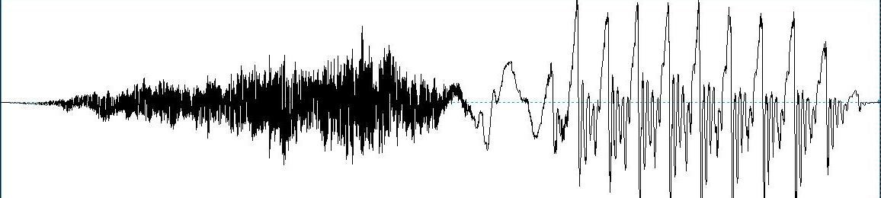

*Figure 1: waveform of stimulus /sa/ used for recording of ACC.*

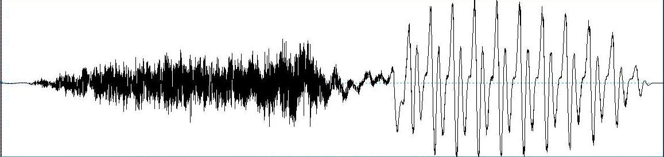

*Figure 2: waveform of stimulus /si/ used for the recording of ACC.*

*Table 1: Stimulus and acquisition parameters used for the recording of ACC*

Stimulus parameter

Stimulus /sa/

/si/

Duration 248 ms

for stimulus /sa/ and /si/

Number of sweeps 200

Stimulus rate 1.1/s

Intensity 75 dBnHL

Polarity Alternating

## Results and Discussion

The latencies P1, N1, P2, N2, P3 and amplitudes N1P2 and N2P3 of different ACC components were analyzed with SPSS version (10 and 17) software, within and across the age groups. Mean latencies in ms and standard deviation for P1, N1, P2, N2, and P3 were calculated; mean amplitude in µV and standard deviation for N1P2 and N2P3 complexes were calculated. Descriptive statistical analysis was used to calculate the mean latency and mean amplitude values along with the standard deviation for each ACC component. Mixed ANOVA was done for both the stimuli to see the interaction between stimuli, group and stimuli, and group for each ACC components. If interaction was seen in Mixed ANOVA; Duncan’s Post Hoc test was administered to see the significant difference among any two groups for each ACC component. Multiple Analyses of Variance was done to find out for which of the stimulus the groups were

Acquisition parameters Mode of stimulation Ipsi

Electrode montage Cz, M1, M2

Filter setting 1-30 Hz.

Transducer ER-3A

Analysis window 799.5 ms Notch filter On

No. of channels Single

Amplification 50,000

No. of repetitions 2

showing the difference. If difference was seen for the stimulus across age group, Duncan’s Post Hoc Analysis was done and significant difference among any two groups was checked for particular stimulus for each ACC component. Paired t-test was administered to see the significant difference between the stimuli /sa/ and /si/ with-in the group for each ACC component.

ACC recorded on fifteen subjects (26 ears) for stimuli

/sa/ and /si/ for Group A (7 to 9; 11 years) has been shown in Figure 3.

ACC recorded on fifteen subjects (29 ears) for both the stimuli /sa/ and /si/ for Group B (10 to 12; 11 years) has been shown in Figure 4.

ACC recorded on fifteen subjects (30 ears) for both the stimuli /sa/ and /si/ for Group C (13 to 15; 11 years) has been shown in Figure 5.

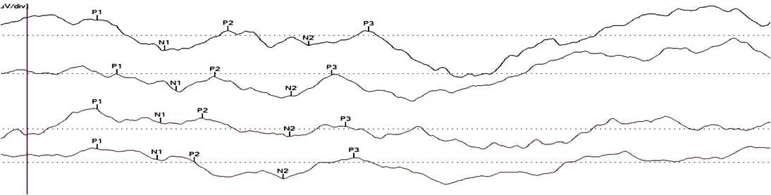

(si)

(sa)

(si)

(sa)

*Figure 3: ACC recording for Group A (7 to 9; 11 years) for /sa/ and /si/ stimuli.*

|  |  |  |  |  |
| --- | --- | --- | --- | --- |
| (si) | | |  | |
|  | | (sa) | | |
|  | (si) | | |  |

*Figure 4: ACC recording for Group B (10 to 12; 11 years) for /sa/ and /si/ stimuli.*

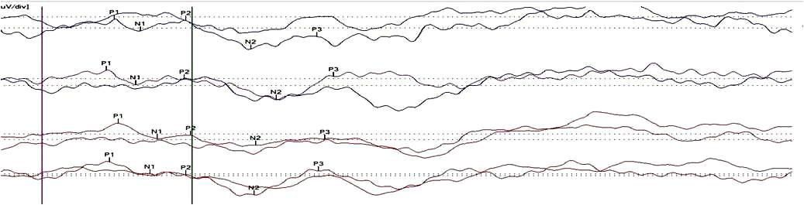

(sa)

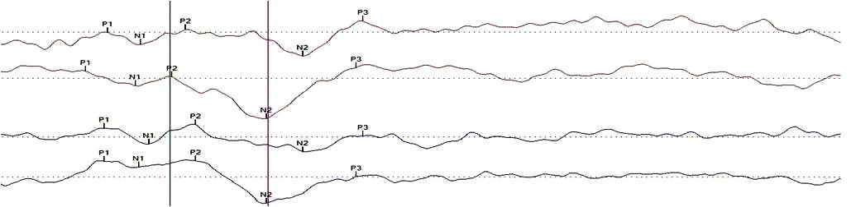

(sa)

(si)

(sa)

(si)

*Figure 5: ACC recording for Group C (13 to 15; 11 years) for /sa/ and /si/ stimuli.*

*Table 2: Mean and standard deviation of P1 latency observed at 75 dBnHL for both syllable /sa/ and /si/ across the groups*

Stimulus Group Mean latency (ms) Standard deviation 7-9;11 122.72 16.98

P1 (Sa)

P1 (Si)

10-12;11 105.55 9.67

13-15;11 94.35 12.16

7-9;11 126.05 18.74

10-12;11 109.71 9.15

13-15;11 95.41 10.94

The age related changes for ACC obtained for different stimuli /sa/ and /si/ are discussed under each component P1, N1, P2, N2, P3 in terms of latency and N1P2, N2P3 in terms of amplitude separately.

##### P1 component

The latency for P1 component of ACC was measured across age groups for both the stimuli. The mean and standard deviation were calculated by descriptive analysis.

Table 2 shows that as the age increases the latency of P1 reduces for both the stimuli. Group A (7-9; 11 years) has longer latency compared to group B (10-12; 11 years), and group C (13-15; 11 years) has shortest latencies across the three age groups.

Mixed ANOVA was done to see the interaction for the stimuli and the groups. Mixed ANOVA did not reveal any interaction for the stimulus [F(1, 83)=4.34, p>0.05]; stimuli and group [F(2, 83)=0.46, p>0.05]. Mixed ANOVA showed a significant interaction for the groups [F(2, 83)=45.32, p<0.05]. As the mixed ANOVA showed a significant interaction for the groups, Duncan’s Post Hoc analysis was done to see which of the groups had significant difference. Duncan’s post Hoc analysis revealed a significant difference between the Group A (7-9; 11 years) and Group B (10-12; 11 years) (p<0.05), Group A (7-9; 11 years) and Group C (13-15; 11 years) (p<0.05), group B (10-12; 11 years) and Group C (13-15; 11 years) (p<0.05). So, all the groups were significantly different from one another. In order to find out for

which of the stimulus, the groups were different, MANOVA was done.

MANOVA revealed a significant difference for the /sa/ stimulus [F(2, 83) =33.44, p<0.05] and /si/ stimulus [F(2, 83)=37.07, p<0.05]. So, the groups were different for both the stimuli. To understand, the significant difference for each of the stimulus across the groups Duncan’s post Hoc was done. Post Hoc analysis revealed a significant difference between group A (7-9;

* + - 1. years) and Group B (10-12; 11 years) (p<0.05), group A (7-9; 11 years) and group C (13-15; 11 years) (p<0.05), Group B (10-12; 11 years) and Group C (13- 15; 11 years) (p<0.05) for stimulus /sa/ and /si/. It could be due to maturational changes which makes one group significantly different from the other. Also similar results were seen for speech-evoked cortical potentials in children (Kraus, McGee, Carrell, Sharma, Micco & Nicol, 1993). Significant difference between

/sa/ and /si/ stimuli for P1 component was noticed only in the Group B (10-12; 11 years) [t(27)=2.82, p<0.05].

##### N1 component

The latency for N1 component of ACC was measured across age group and the mean and standard deviation were calculated by descriptive analysis.

Table 3 shows that as the age increases the latency of N1 reduces for both the stimuli for both the ears. Group A (7-9; 11 years) has longer latency, Group B (10-12; 11 years) has shorter latencies compared to Group A (7-9; 11 years), and Group C (13-15; 11 years) has the shortest latencies across the groups.

Mixed ANOVA was done to see the interaction for the stimuli and the groups. Mixed ANOVA did not reveal any interaction for the stimulus [F(1, 76)=11, p>0.05]; stimuli and group [F(2, 76)=1.13, p>0.05]. Mixed ANOVA showed a significant interaction for the groups [F(2, 76)=42.05, p<0.05]. As the mixed ANOVA showed a significant interaction for the groups, Duncan’s Post Hoc analysis was done to see which of the group had significant difference. Duncan’s post Hoc analysis revealed a significant difference between the Group A (7-9; 11 years) and Group B (10-12; 11 years) (p<0.05), Group A (7-9; 11 years) and Group C (13-15; 11 years) (p<0.05), Group B (10-12; 11 years) and group C (13-15; 11 years) (p<0.05). So, all the groups were significantly different from one another. In order to find out for which of the stimulus, the groups were different, Multiple Analysis of Variance (MANOVA) was done. MANOVA revealed a significant difference for the /sa/ stimulus [F (2, 76)=34.28, p<0.05 and /si/ stimulus [F(2, 76)=39.39, p<0.05]. So, the groups were different for both the stimuli. To understand, the significant difference for each of the stimulus across the groups Duncan’s post Hoc was done. Post Hoc analysis revealed a significant difference between Group A (7- 9;11 years) and Group B (10-12; 11 years) (p<0.05), Group A (7-9; 11 years) and Group C (13-15;11 years) (p<0.05) for stimulus /sa/ and /si/, perhaps for group B (10-12;11 years) and Group C (13-15; 11 years) there was a significant difference for stimulus /si/ (p<0.05) but no significant difference for stimulus /sa/ (p>0.05). There was no significant difference between /sa/ and

/si/ stimuli for N1 component for any of the age group.

##### P2 component

The latency for P2 component of ACC was measured across age group for both the stimuli and the mean and standard deviation were calculated by descriptive analysis.

Table 4 shows that as the age increases the latency of P2 reduces for both the stimuli in both the ears. Group A (7-9; 11 years) has longer latency compared to Group B (10-12; 11 years), and group C (13-15; 11 years) has shortest latencies across the three age groups.

Mixed ANOVA was done to see the interaction for the stimuli and the groups. Mixed ANOVA did not reveal any interaction for the stimulus [F(1, 75)=.43, p>0.05]; stimuli and group [F(2, 75)=1.45, p>0.05]. Mixed ANOVA showed a significant interaction for the groups [F(2, 75)=54.49, p<0.05]. As the mixed ANOVA showed a significant interaction for the groups, Duncan’s Post Hoc analysis was done to see which of the group had significant difference. Duncan’s post Hoc analysis revealed a significant difference between the Group A (7-9; 11 years) and Group B (10-12; 11 years) (p<0.05), Group A (7-9; 11 years) and group C (13-15; 11 years) (p<0.05), and for Group B (10-12; 11 years) and Group C (13-15; 11 years) (p<0.05). In order to find out for which of the stimulus, the Post Hoc analysis revealed a significant difference between Group A (7-9; 11 years) and Group B (10-12; 11 years) (p<0.05), Group A (7-9; 11 years) and group C (13-15; 11 years) (p<0.05) for stimulus

/sa/ and /si/, perhaps for group B (10-12;11 years) and

*Table 3: Mean and standard deviation of N1 latency observed at 75 dBnHL for both syllable /sa/ and /si/ across the groups*

Stimulus N1 (Sa)

|  |  |  |
| --- | --- | --- |
| Group | Mean latency (ms) | Standard deviation |
| 7-9;11 | 186.11 | 32.49 |
| 10-12;11 | 147.63 | 12.90 |
| 13-15;11 | 138.25 | 16.47 |
| 7-9;11 | 188.42 | 38.27 |
| 10-12;11 | 150.00 | 10.56 |

N1 (Si)

13-15;11 135.33 8.66

*Table 4: Mean and standard deviation of P2 latency observed at 75 dBnHL for both syllable /sa/ and /si/ across the groups*

Stimulus P2 (Sa)

|  |  |  |
| --- | --- | --- |
| Group | Mean latency (ms) | Standard deviation |
| 7-9;11 | 246.68 | 46.54 |
| 10-12;11 | 197.64 | 17.55 |
| 13-15;11 | 181.95 | 14.19 |
| 7-9;11 | 259.56 | 63.26 |
| 10-12;11 | 196.74 | 11.76 |

P2 (Si)

13-15;11 177.95 13.07

group C (13-15; 11 years) stimulus /sa/ showed a significant difference (p<.005) but no significant difference between /sa/ and /si/ stimuli for P2 component for any of the age group

##### N2 component

The latency for N2 component of ACC was measured across age group and the mean and standard deviation were calculated by descriptive analysis.

Table 5 shows that as the age increases the latency of peak N2 reduces for both the stimuli. Group A (7-9; 11 years) has longer latency, Group B (10-12; 11 years) has shorter latencies compared to Group A (7-9; 11 years), and Group C (13-15; 11 years) has shorter latencies even from Group B (10-12; 11 years).

Mixed ANOVA was done to see the interaction for the stimuli and groups. Mixed ANOVA showed interaction for the stimulus [F(1, 84)=4.83, p<0.05]; but no significant interaction between stimuli and group [F(2, 84)=2.04, p>0.05]. Mixed ANOVA showed significant interaction for the groups [F(2, 84)=9.58, p<0.05]. As the mixed ANOVA showed a significant interaction for the groups, Duncan’s Post Hoc analysis was done to see which of the group had significant difference. Duncan’s post Hoc analysis revealed a significant difference between the Group A (7-9; 11 years) and Group B (10-12; 11 years) (p<0.05), Group A (7-9; 11 years) and Group C (13-15; 11 years) (p<0.05), but no significant difference for Group B (10-12; 11 years) and Group C (13-15; 11 years) (p>0.05). In order to find out for which of the stimulus, the groups were different, Multiple Analysis of Variance (MANOVA) was done. MANOVA revealed significant difference for the /sa/ stimulus [F(2, 84)=5.45, p<0.05] and for /si/ stimulus [F(2, 84)=13.5, p<0.05]. To understand, the significant difference for each of the stimulus across the groups Duncan’s post Hoc was done. Post Hoc analysis revealed a significant difference between Group A (7-9; 11 years) and Group B (10-12;11 years) (p<0.05), Group A (7-9; 11 years) and Group C (13-15;

11 years) (p<0.05), but no significant difference between group B (10-12; 11 years) and Group C (13- 15; 11 years) (p>0.05) for stimuli /sa/ and /si/. The possible reason could be the onset response elicited by vowel portion matures by age of 10 years. So there might be no significant difference in the N2 responses beyond 10 years of age. Also supported by other studies in which it has been seen that significant negativity could be traced back to the youngest age group of 10 years (Kummer, Burger, Schuster, Rosanowoski, Eysholdt & Hoppe, 2007). Significant difference between /sa/ and /si/ stimuli was noticed only in the Group C (13-15; 11 years) [t (29)=3.03,

p<0.05]. It could be because of the maturational changes, seen in the group age of 10 years and above, as they can detect the different stimulus onset with different latencies as the duration of consonant and vowel changes for both the stimuli are different even though the overall duration is same for both the stimulus.

##### P3 component

The latency for P3 component of ACC was measured across age group and the mean and standard deviation were calculated by descriptive analysis. Table 6 shows that as the age increases the latency of P3 reduces for both the stimuli. Group A (7-9;11 years) has longer latency compared to Group B (10-12; 11 years), and Group C (13-15;11 years) has shortest latencies across the three age groups taken for stimulus /si/ but for the stimulus /sa/ Group B (10-12;11 years) and group C (13-15;11 years) showed similar latencies.

Mixed ANOVA was done to see the interaction for the stimuli and groups. Mixed ANOVA revealed interaction for the stimulus [F(1, 84)=14.95, p<0.05]; stimuli and group [F(2, 84)=7.00, p<0.05]. Mixed ANOVA showed significant interaction for the groups [F(2, 84)=8.07, p<0.05]. As the mixed ANOVA

showed a significant interaction for the groups, Duncan’s Post Hoc analysis was done to see which of the group had significant difference. Duncan’s post Hoc analysis revealed a significant difference between the Group A (7-9; 11 years) and Group B (10-12; 11 years) (p<0.05), Group A (7-9; 11 years) and Group C (13-15; 1 years) (p<0.05), but no significant difference for Group B (10-12; 11 years) and Group C (13-15; 11 years) (p>0.05). In order to find out for which of the stimulus, the groups were different, Multiple Analysis of Variance (MANOVA) was done. MANOVA revealed a significant difference for stimulus /sa/ [F (2, 84)=3.73, p<0.05] and /si/ [F(2, 84)=12.15, p<0.05)].

To understand, the significant difference for each of the stimulus across the groups Duncan’s post Hoc was done. Post Hoc analysis revealed a significant difference between Group A (7-9; 11 years) and Group B (10-12; 11 years) (p <0.05), Group A (7-9;11 years) and Group C (13-15;11 years) (p<0.05), but no significant difference between group B (10-12; 11 years) and Group C (13-15;11 years) (p>0.05) for stimulus /sa/ and /si/. The possible reason could be no more maturational changes for the onset responses to ongoing stimuli for more than 10 years of age. Significant difference between /sa/ and /si/ stimuli was noticed in the Group C (13-15; 11 years) [t (29)=4.03, p<0.05] and Group B (10-12; 11 years) [t (28)=2.47, p<0.05].

*Table 5: Mean and standard deviation of N2 latency observed at 75 dBnHL for both syllable /sa/ and /si/ across the groups*

|  |  |  |  |
| --- | --- | --- | --- |
| Stimulus | Group | Mean latency (ms) | Standard deviation |
|  | 7-9;11 | 306.37 | 61.10 |
| N2 (Sa) | 10-12;11 | 283.77 | 15.86 |
|  | 13-15;11 | 275.18 | 15.37 |
|  | 7-9;11 | 306.45 | 52.73 |
| N2 (Si) | 10-12;11 | 279.59 | 12.63 |

13-15;11 263.93 10.54

*Table 6: Mean and standard deviation of P3 latency observed at 75 dBnHL for both syllable /sa/ and /si/ across the groups*

|  |  |  |  |
| --- | --- | --- | --- |
| Stimulus | Group | Mean latency (ms) | Standard deviation |
|  | 7-9;11 | 372.87 | 51.32 |
| P3 (Sa) | 10-12;11 | 352.15 | 18.95 |
|  | 13-15;11 | 352.23 | 18.76 |
|  | 7-9;11 | 374.39 | 50.71 |
| P3 (Si) | 10-12;11 | 343.54 | 21.94 |
|  | 13-15;11 | 332.78 | 18.14 |

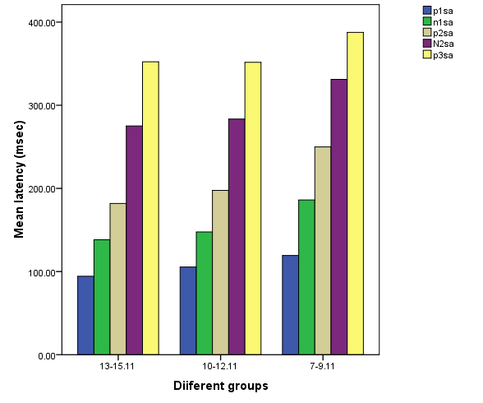 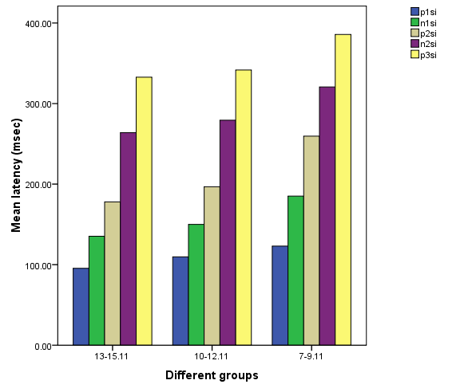

*Figure 6: Mean latencies of P1, N1, P2, N2, and P3 for stimulus /sa/.*

*Figure 7: Mean latencies of P1, N1, P2, N2, and P3 for stimulus /si/.*

*Table 7: Mean and standard deviation of N1P2 amplitude observed at 75 dBnHL for both syllable /sa/ and /si/ across the groups*

Stimulus Group Mean amplitude (µV) Standard deviation 7-9;11 1.44 0.78

N1P2 (Sa)

N1P2 (Si)

10-12;11 1.92 0.73

13-15;11 1.90 0.79

7-9;11 1.83 0.89

10-12;11 1.88 0.62

13-15;11 1.80 0.69

Figure 6 and Figure 7 show the mean latencies of ACC components across the age groups for stimuli /sa/ and

/si/ respectively.

##### N1P2 Amplitude

The amplitude of N1P2 component of ACC was measured peak to peak across age groups and the mean and standard deviation were calculated by descriptive analysis.

As shown in the Table 7, the amplitude of N1P2 peak increases with age for stimuli /sa/ and /si/. But for Group B (10-12; 11 years) and Group C (13-15; 11 years) amplitudes were similar.

Mixed ANOVA was done to see the interaction for the stimuli and groups. Mixed ANOVA did not reveal any interaction for the stimulus [F(1, 76)=0.63, p>0.05]; stimuli and group [F(2, 76) =1.93, p>0.05]. Mixed ANOVA also showed no significant interaction for the groups [F(2, 76)=1.34, p>0.05]. As N1P2 complex is the first complex to appear it might be possible that it gets mature by 7 or 8 years of age so no significant changes are taking place in terms of amplitude but it shall be further investigated with more number of subjects.

##### N2P3 Amplitude

The amplitude of N2P3 component of ACC was measured peak to peak across age group and the mean and standard deviation were calculated by descriptive analysis.

From Table 8, it can be seen that amplitude of N2P3 increases with age for both the stimuli /sa/ and /si/.

Mixed ANOVA was done to see the interaction for the stimuli and groups. Mixed ANOVA did not reveal any interaction for the stimulus [F(1, 84)=1.23, p>0.05]; stimuli and group [F (2, 84) =0.04, p>0.05]. Mixed ANOVA showed significant interaction for the groups [F(2, 84)=5.92, p<0.05].As the mixed ANOVA showed

a significant interaction for the groups, Duncan’s Post Hoc analysis was done to see which of the group had significant difference. Duncan’s post Hoc analysis revealed a significant difference between the Group A (7-9; 11 years) and group C (13-15; 11 years) (p<0.05), but no significant difference for Group B (10-12; 11 years) and Group C (13-15; 11 years) (p>0.05), and Group B (10-12; 11 years) and Group A (7-9; 11 years) (p>0.05). In order to find out for which of the stimulus, the groups were different, Multiple Analyses of Variance (MANOVA) was done. MANOVA revealed a significant difference for the /sa/ stimulus [F(2, 84)=4.24, p<0.05] and /si/ stimulus [F(2, 84)=4.26, p<0.05]. To understand, the significant difference for each of the stimulus across the groups Duncan’s post Hoc was done. Post Hoc analysis revealed a significant difference between Group A (7- 9; 11 years) & Group C (13-15; 11 years) (p<0.05), but no significant difference between group B (10-12; 11 years) & Group A (13-15;11 years) (p>0.05); and Group B (10-12; 11 years) & Group C (13-15; 11 years) (p>0.05) for stimulus /sa/ and /si/. It could be possible due to maturation changes which effects the amplitude of the second complex of ACC. The second complex keeps changing in amplitude till 15 years of age, and is significantly different from what is seen till 8-9 years of age. It shall be investigated further to see when it becomes adult like in amplitude. There was no significant difference between /sa/ and /si/ stimuli for N2P3 amplitude for any of the age group.

Figure 8 and Figure 9 show the mean amplitude of ACC components across the age groups for the stimuli

/sa/ and /si/ respectively. Similar results as noticed in the study are also seen in other studies, the younger group of children showed longer latencies than older group children and morphology was also better in older group. These findings are consistent with findings in CAEP that the latency decreased with increasing age (Kurtzberg, Hilpert, Kreuzer & Vaughan, 1984; Little, Thomas & Letterman, 1999; Sharma, Kraus, McGee & Nicol, 1997; Shucard, Shucard & Thomas, 1987); and the positive negative peak component of the CAEP

*Table 8: Mean and standard deviation of N2P3 amplitude observed at 75 dBnHL for both syllable /sa/ and /si/ across the groups*

|  |  |  |  |
| --- | --- | --- | --- |
| Stimulus | Group | Mean amplitude (µV) | Standard deviation |
| N2P3 (Sa) | 7-9;11 | 3.94 | 1.78 |
|  | 10-12;11 | 4.69 | 1.46 |
|  | 13-15;11 | 5.16 | 1.56 |
| N2P3 (Si) | 7-9;11 | 3.73 | 1.85 |
|  | 10-12;11 | 4.42 | 1.77 |

13-15;11 5.02 1.39

becomes more clearly defined with age (Ponton, Eggermont, & Kwong et al., 2000). The waveform for speech stimuli for 14 years of age showed adult-like complexes. With decreasing age, P1 and N1 latencies distinctly increased and their amplitudes appeared to decrease (Kummer, Burger, Schuster, Rosanowski et al., 2007).

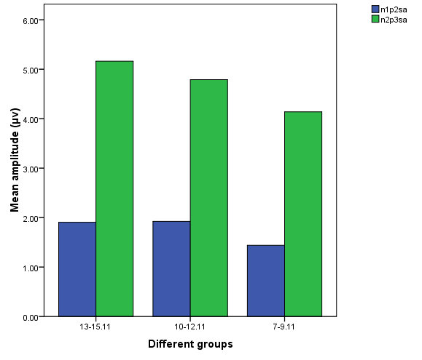

*Figure 8: Mean amplitudes of N1P2 and N2P3*

*complexes for stimulus /sa/.*

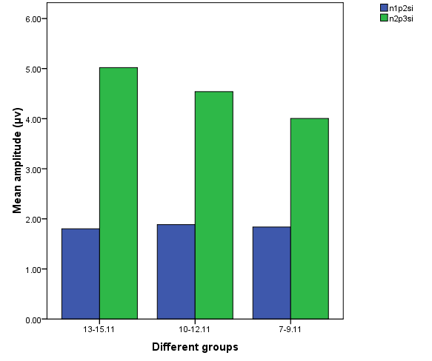

*Figure 9: Mean amplitudes of N1P2 and N2P3 complexes for stimulus /si/.*

## Conclusions

ACC could possibly help us to quantify the neuromaturation for complex speech signals. ACC can be promising as a clinical tool for assessing the neural detection of time varying cues contained in speech, as well as longitudinal changes in neural activity.

## References

American National Standards Institute (1991). *Maximum Ambient Noise Levels for Audiometric Test Rooms.* (ANSI S3. 1-1991). American National Standards Institute: New York.

Carhart, R., & Jerger, J. F. (1959). Preferred method for clinical determination of pure tone thresholds. *Journal of Speech and Hearing Disorder, 36,* 476- 483.

Clynes, M. (1969). Dyanamics of vertex evoked potentials. In

E. Donchins & D. B. Lindsley (Eds.), *Average evoked potentials: methods, results, and evaluations (NASA SP-191).*363-374. Washington, DC: U.S. Government Printing Office.

Hari, R. (1991). Activation of the human auditory cortex by speech sounds. *Acta Otolaryngologica Supplement, 491*, 132-138.

Hillyard, S. A., & Picton, T. W. (1978). ON and OFF components in the auditory evoked potential*. Perception and Psychophysics, 24*, 391-398.

Imaizumi, S., Mori, K., Kiritani, S., & Yumoto, M. (1996). Neural representation of concurrent sounds, *Amsterdam: Elsevier science,* 191-197.

Karthik, N. (2005). Acoustic change complex (ACC): An electrophysiological index for speech perception in children and adults. Unpublished masters Dissertation, University of Mysore, India.

Kaukornata, E., Hari, R., & Lonasma, O. V. (1987). “Responses of the human auditory cortex to vowel onset after fricative consonant.” *Experimental Brain Research, 69*, 19-23.

Kohn, M., Lifshitz, K., & Litchfield, D. (1980). “Average evoked potentials and frequency modulation.” *Electroencephalography and Clinical Neurophysiology, 50*, 134-140.

Kraus, N., McGee, T., Carrell, T., Sharma, A., Micco, A., & Nicol, T. (1993). Speech-Evoked cortical potential in children. *Journal of American Academy of Audiology, 4,* 238-248.

Kummer, P., Burger, M., Schuster, M., Rosanowski, F., Eysholdt U., & Hoppe, U. (2007). Cortical Auditory Evoked Potential to Acoustic Changes in Speech Stimuli in Children, *Folia Phoniatricaet Longopaedica, 59,* 273-280.

Kurtzberg, D., Hilpert, P. L., Kreuzer, J. A., & Vaughan, H.

1. (1984). Differential maturation of cortical auditory evoked potentials to speech sounds in normal fullterm and very low-birth weight infants. *Developmental Medicine and Child Neurology*, *26*, 466–475.

Litovsky, R. Y. (1997). Developmental changes in the precedence effect: estimates of minimum audible angle. *Journal Acoustical Society of America*, *102*, 1739-1745.

Little, V. M., Thomas, D. G., & Letterman, M. R. (1999).

Single-trial analyses of developmental trends in infant auditory event-related potentials. *Developmental Neuropsychology*, *16*, 455–478.

Marshall, l., Brandt, J. F., Marston, L. E., & Ruder K. (1979). Changes in number and types of errors on repetition of acoustically distorted sentence as a function of age

in normal children. *Journal of American Audiology Society, 4,* 218-225.

Martin, B. A., & Boothroyd, A. (1999). Cortical, auditory, event-related potentials in response to periodic and aperiodic stimuli with the same spectral envelope. *Ear and Hearing, 20,* 33-44.

Martin, B. A., & Boothroyd, A. (2000). Cortical, auditory, evoked potentials in response to changes of spectrum and amplitude. *Journal of the Acoustical Society of America, 107*, 2155–2161.

Mayadevi. (1974). Development and Standardization of common speech discrimination test for Indians. Unpublished Masters Dissertation, University of Mysore, Mysore.

McCandless, G. A., & Rose, D. E. (1970). “Evoked cortical responses to stimuli change.” *Journal of Speech and hearing Research, 13*, 624-634

Naatanen, R. (1992). *Attention and Brain function*. Hillsdale, New Jersey: Lawrence Erlbaum Associates, Inc.

Naatanen, R., & Picton, T. (1987). The N1 wave of the human electric and magnetic response to sound: a review and an analysis of the component structure. *Psychophysiology, 24,* 375-424.

Onishi, S., Davis, H. (1968). Effects of rise time on evoked potentials, *Journal of the Acoustical society of America, 44*, 582-591.

Ostroff, J. M., Martin, B. A., &Boothroyd, A. (1998). “Cortical evoked responses to acoustic change with a syllable.” *Ear & Hearing, 19*, 290-297.

Palva, A., & Jokinen, K. (1975). Undistorted and filtered speech audiometry in children with normal hearing. *Acta Otolaryngology, 80,* 383-388

Pantev, C., Euliz, C., Hampton, S., Ross, B., & Roberts, L.E. (1996). “The auditory evoked “off” response: Source and comparison with the “on” and “sustained” responses.” *Ear & Hearing, 17*, 255-265.

Pekkonen, E., Rinne, T., & Naatanen, R. (1995). Variability and replicability of the mismatch negativity. *Electroencephalography and Clinical Neurophysiology, 96,* 546–554.

Ponton, C,W., & Don, M. (1995). The mismatch negativity in cochlear implant users. *Ear & Hearing*, *16*, 131-146.

Ponton, C. W., Eggermont, J. J., Kwong, B., & Don, M. (2000) Maturation of human central auditory system activity: evidence from multi-channel evoked potentials. *Clinical Neurophysiology, 111,* 220-236.

Schneider, B. A., & Trehub, S .E. (1992). Sources of developmental changes in auditory sensitivity. In: L.

* 1. Werner, E. W. Rubel, (Ed), *Developmental psychoacoustics*, pp. 3-46. Washington, DC: American Psychological Association.

Sharma, A., Kraus, N., McGee, T. J., & Nicol, T. G. (1997). Developmental changes in P1 and N1 central auditory responses elicited by consonant-vowel syllables. *Electroencephalography and Clinical Neurophysiology*, *104*, 540-545.

Shucard, D. W., Shucard, J. L., & Thomas, D. G. (1987). Auditory event related potentials in waking infants and adults: a developmental perspective. *Electroencephalography and Clinical Neurophysiology*, *68*, 303–310.

Spoor, A., Timmer, F., & Odenthal, D. W. (1969). “The evoked auditory responses to intensity modulated and frequency modulated tone and tone bursts.” *International journal of Audiology, 8*, 410-

415.

Tremblay, K .L., Friesen, L., Martin, B. A., & Wright, R. (2003). Test-retest reliability of cortical evoked potentials using naturally produced speech sounds*. Ear and Hearing, 24,* 225–232.

Wunderlich, J. L.,& Cone-Wesson, B. K. (2006). Maturation of CAEP in infants and children: A review, *Hearing Research, 212,* 212-223.

Yathiraj, A., & Mascarenhas, K. (2003). Audiological profile of the children with suspected auditory processing disorder. Developed as a part of project titled 'Effect of auditory stimulation of central auditory processes in children with CAPD', at the Department of Audiology, All India Institute of Speech and Hearing, Mysore.

Yingling, C. D. & Nethercut, G. E. (1983). “Evoked resposes to frequency shifted tones”. *International Journal of Neuroscience, 22*, 107-118.