# Comparison Between Outcomes Using Preferred Gain and Prescribed Gain Formulae in Experienced Adult Hearing Aid Users

### 1Achaiah M.A. & 2Vijayakumar Narne

**Abstract**

*Prescriptive formulae prescribe gains based on different formulae that in turn are based on different rationales. But it has been noted by several authors that the gains prescribed by the prescriptive formulae may be different from the preferred gain settings. This study was done with the aim to compare the gain provided using the two most commonly used prescriptive formulae, NAL NL-1 and DSL[i/o] and compare this with the preferred gain settings. Ten subjects, in the age range of 30 to 75 years, who were regular users of hearing aids since more than twelve months were taken up for the study. The measures used for comparison were overall aided gain, gain at various input levels (45 dB, 65 dB & 89 dB), Real Ear Insertion Gain, and Speech Identification Scores for all the conditions. Results revealed that majority of the participants needed a gain of about 10 dB higher than NAL-NL1 and about 5 dB higher than DSL [i/o] and for Indian population, higher gain is required at mid to higher frequencies. Comparison of SIS revealed that the speech perception at the preferred condition was the best followed by NAL-NL1 and DSL [i/o]. From the results, it can be noted that there is a difference between the prescribed gain settings and preferred gain settings and this might have to be done on a larger population to arrive at a more concrete findings.*

***Keywords****: NAL NL-1, DSL[i/o], preferred gain, REIG, SIS*

**Introduction**

Cochlear hearing loss in adult subjects can vary in terms of degree and configuration which creates a necessity for tailor made fitting of the hearing aid for every client. Most common practice in the clinics is to use a prescriptive procedure that takes care of approximate target amplification required for every individual. That is in prescriptive approaches amplification characteristics required were calculated based on hearing characteristics of the hearing- impaired individuals. In general prescriptive procedures were deceived from hearing characteristics and properties speech spectrum. The prescriptive methods were changed over the years due to advancement in technology, better understanding of hearing characteristics and other factors affecting hearing aid performance.

Prescriptive procedures for nonlinear hearing aids are based upon different underlying rationales. The idea behind these procedures is either to normalize loudness so that loudness recruitment can be compensated or to maximize speech intelligibility at various input levels (Dillon, 2001). Some of these fitting procedures use threshold and some others use supra threshold measurements as input data (Dillon, 2001). Threshold based procedures are mainly NAL-NL1 (Dillon, 1999), FIG6 (Killion & Fikret-Pasa, 1993), and partly DSL

1E-mail:achaiah.audiologist@gmail.com; 2Lecturer in Audiology[, E-mail: vijaynarne@gmail.com](mailto:vijaynarne@gmail.com)

[i/o] (Cornelisse, Seewald & Jamieson, 1995). Supra threshold procedures are LGOB (Allen, Hall & Jeng, 1990), IHAFF (Cox, 1995) and partly DSL [i/o] (Cornelisse, Seewald & Jamieson, 1995). Among the procedures described above, most commonly used procedure for prescribing hearing aids is NAL-NL1 and DSL [i/o] (Dillon, 2001).

The prescriptive formulae, be it threshold based or supra threshold based, give the first approximation of gain required. Practical clinical experiences with prescriptive methods show that the methods cannot eliminate the need for individual allowances and adjustments i.e., fine tuning of hearing aid (Dillon, 2001). However, one should bear in that fine tuning of gain settings in the hearing aids is performed on prescribed gain. The prescribed gain should be a good approximation to preferred gain, which reduces the trial and error done by the clinician and also saves time (Dillon, 2001). Keisder et al., (Keidser & Grant, 2001; Keidser, Brew, Brewer, Dillon, Storey & Grant, 2005; Keidser & Dillon, 2006; Keidser, Dillon, Dyrlund, Carter & Hartley, 2007; Keidser, O’Brien, Carter, McLelland & Yeend, 2008) did a series of studies to compare the gain prescribed by NAL-NL1 prescriptive formula and that preferred by listeners with different degrees of hearing loss. They reported that, gain preferred by the adult experienced hearing aid users is lower by 6 dB on average in comparison to that prescribe by NAL-NL1. These studies suggest that prescriptive procedure has to be a good approximation to preferred gain on which fine tuning of the device

according to individual needs will be performed. Similar results were also reported by Ching, Scollie, Dillon and Seewald, (2010) in children and Zakis, McDermott and Dillon, (2007) in adult participants. All the above studies comparing preferred and prescribed gain were performed on western population. Little or no data is available on comparing preferred gain and prescriptive gain settings in experienced hearing impaired adults in Indian context. Although, long-term average speech spectrum (LTASS) may be similar across languages but frequency importance function (Studebaker & Sherbecoe, 1993) may be quite different for Indian languages which suggests different gain settings than that of western population. Further, general opinion among the clinicians in India is that, majority of the clients prefer different gain settings than that prescribed by NAL-NL1 and DSL [i/o]. Hence, it becomes all the more important to compare the prescribed and preferred gain settings in experienced hearing aid listeners.

## Method

##### Participants

Ten participants (10 ears), having sensory-neural hearing loss, who had been clinically diagnosed as having cochlear hearing loss at Department of Audiology, All India Institute of Speech and Hearing, Mysore participated in the present study. All the participants were regular hearing aid users; the minimum duration of hearing aid use being more than one year. The age of the participants ranged from 30 to 75 years with the mean age of 64 years. All listeners were native speakers of Kannada (A Dravidian

language spoken in a southern state of India). Pure tone average ranged from 30 to 91.6 dB HL. It was ascertained from a structured interview that none of these participants had any history of neurologic or otologic disorders. The demographic and audiological data of the participants, which includes degree of hearing loss, speech identification scores, hearing aid being used and the duration of hearing aid use, is provided in Table 1. The pure-tone thresholds at octave frequencies of each participant have been provided in Figure 1 from 30 to 75 years with the mean age of 64 years.

##### Procedure

###### Pre-testing procedure

On otoscopic examination, all participants had ear canals that were free from cerumen, debris or foreign body. This was followed by estimating audiometric thresholds for air conduction at 250 Hz, 500 Hz, 1000 Hz, 2000 Hz, 4000 Hz and 8000 Hz and Bone Conduction at 250 Hz, 500 Hz, 1000 Hz, 2000 Hz and 4000 Hz using Modified Hughson and Westlake procedure (Carhart & Jerger, 1959). The thresholds obtained were compared with pure-tone thresholds obtained during initial hearing aid fitting. None of the participants had a shift greater than 10 dB at any of the frequencies for both air and bone conduction. A calibrated (ISO, 389) Orbiter OB-922 diagnostic audiometer with TDH 39 supra aural head phones and Radio ear B-71 bone vibrator were the instruments used for pure tone and speech audiometry. All the subjects had normal middle ear functioning and the same was confirmed by testing with GSI-Tympstar Immittance meter.

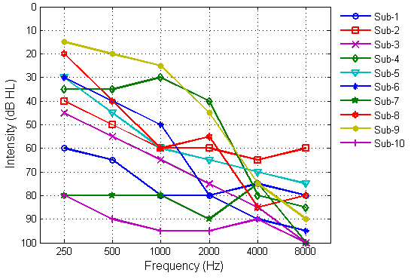

*Figure 1: Pure-tone thresholds of each participant at octave frequencies.*

*Table 1: Demographic and Audiological data of the participants with cochlear hearing loss Speech Identification Scores*

Sl.

No.

Age/

Gender Ear

Pure Tone Average

Speech Identification Score

Hearing aid Model

Duration of HA use

* + - 1. 59/M Right 75 72% Figaro 2P 24 months
      2. 59/M Left 56.6 92% Figaro 2P 22 months
      3. 69/M Left 65 76% Figaro 2P 19 months
      4. 71/M Left 35 84% Figaro 2P 14 months
      5. 63/M Left 56.6 76% Figaro 4P 16 months
      6. 71/M Right 56.6 68% Figaro 4P 19 months
      7. 73/M Right 83.3 60% Eclipse 2SP 21 months
      8. 71/M Right 51.6 72% Eclipse 2SP 17 months
      9. 75/M Right 30 88% Eclipse 2SP 21 months
      10. 32/M Right 91.6 Nil Eclipse 2SP 22 months

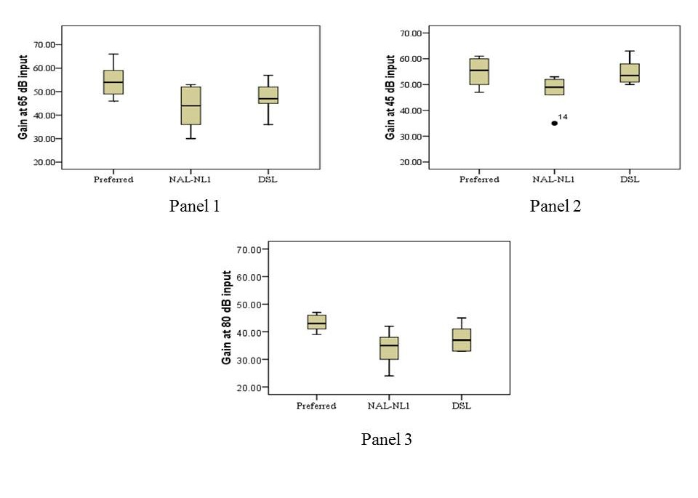

*Figure 2: Overall gain at three input levels 65 dB (Panel 1), 45 dB (Panel 2) and 80 dB (Panel 3).*

###### Speech Identification Scores

Speech Identification scores were assessed in Kannada language. This was assessed using live voice presentation. Stimuli used were Yathiraj and Vijayalakshmi (2005) word list and it was scored out of 25 words and by finding out the percentage for the correct responses. This test material consists of 4 word lists of 25 words each. This test material was used in 4 different conditions, which will be explained in detail in the next section and for each of these conditions, different word list was used. Stimuli were presented through the loud speakers placed at 0° azimuth at a distance of 1 meter.

###### Real Ear Measurements

*Real ear unaided response (REUR):* This was measured for the subjects without wearing the hearing aid using FONIX 7000 hearing aid analyzer by using Digispeech as the stimuli at 65 dBSPL as the input.

The loudspeaker was kept at a distance of 12 inches and at 45 degree to the pinna (as specified in the FONIX 7000 user manual). A probe microphone was placed inside the subject’s ear at a distance equal to the length of ear mould plus 5 mm. Before the stimulus was presented, leveling of the stimulus was done. The stimulus was presented and the output was represented in the form of a graph on screen and once the graph onscreen was stabilized for more than 10 seconds, the input was stopped. Then, the graph was converted to real ear unaided scores and the values were noted down.

*Real ear aided response (REAR):* The subject’s hearing aid was connected to the HIPRO using the programming cable and the HIPRO was connected to the computer. Once connected, the gain and program settings in the hearing aid, under all 3 conditions, i.e., subject’s preferred settings, NAL-NL 1, DSL [i/o] (version 4.1) were noted.

Real measures were performed for preferred, NAL-NL 1 and DSL[i/o] gain settings in all the subjects using the FONIX 7000 hearing aid analyzer by using digispeech as the stimuli at 65 dB SPL as the input. The loudspeaker was kept at a distance of 12 inches and at 45 degree to the pinna (as specified in the FONIX 7000 user manual). A probe microphone was placed inside the subject’s ear at a distance equal to the length of ear mould plus 5 mm. Before the stimulus was presented, leveling of the stimulus was done. The stimulus was presented and the output was represented in the form of a graph on screen and once the graph onscreen was stabilized for more than 10 seconds, the input was stopped. Then, the graph was converted to real ear aided scores and the values were noted down. The gain at three input levels (45 dB, 65 dB & 80 dB) was noted from the software program and REAG was obtained from real ear measures across all the aided conditions were tabulated and subjected to analysis and the results obtained have been discussed in the next section.

## Results and Discussion

##### Comparison of Gain at three input levels

Figure 2 shows the overall gain at three input levels i.e., 45 dB (soft sound input), 65 dB (overall gain), 80 dB (loud sound input) for three conditions. For 45 dB and 80 dB input levels data was available for only 6 subjects. As it can be noted from the Figure 2.1, the gain, overall is higher for preferred condition compared to NAL-NL1 and DSL[i/o] at all input levels. The difference is higher at 65 dB and 80 dB input level compared to 45 dB input level. In addition, DSL[i/o] provides slightly higher gain at all the input levels compared to NAL-NL1.

Friedman’s ANOVA was carried out to find out if the mean difference is significant in the three conditions at all the three input levels separately. For all the Friedman’s ANOVA analysis a Bonferroni correction was applied and so all the effects are reported at 0.016 level. At 65 dB input level, analysis revealed that mean difference is significant across three conditions for overall gain (χ2 (2)=12.1, p<0.001). This is followed by Wilcoxon signed rank test to compare across conditions. Results revealed that there was a significant difference between preferred and NAL-NL1 (Z=2.6, p< 0.01), DSL[i/o] and NAL-NL1 (Z=2.56, p<

0.01), whereas, there was no significant difference between preferred and DSL[i/o] (Z=1.5, p=0.144). Similar analysis was carried out for 45 dB input (χ2 =

(2)

please note that after applying the Bonferroni correction, p=0.017 was not significant as significant value was more than 0.016.

Results of present study clearly show that majority of the participants needed a gain of about 10 dB higher than NAL-NL1 and about 5 dB higher than DSL [i/o]. These results clearly demonstrates that gain needed in the Indian subjects is higher than that prescribed by NAL-NL1 and DSL[i/o] for 65 dB input level. These results are in agreement with clinical observation made by majority of the clinicians. The precise reason for needing a higher gain is not known. Probable reasons for higher gain requirement in the present study is as follows; first, for the western population, Keidser et al. reported that preferred gain is lesser by 6 dB than that prescribed by NAL-NL1 in 46% of subjects, gain prescribed and preferred was similar in 49% of subjects and a only 5% of subjects need more than NAL-NL1, this amounts to 3 to 8 dB. Probably, the subjects taken in the present study fall in the 5% range. Another reason could be that, as Studebaker and Sherbecoe (1993) reported that frequency importance functions vary widely across the languages and hearing aid prescriptive formulae were derived from the frequency importance function. Probably, the frequency importance functions for Indian languages are different which would have led to this difference.

##### Comparison of REIG

Using the REUR data and REAR data, the REIG (Real Ear Insertion Gain) data was calculated for each subject at each frequency for all the three conditions. This was calculated using the formula [Real Ear Insertion gain (REIG)=REAG–REUG; REAG=Real ear aided gain, REUG = Real ear unaided gain] described by Dillon (2001). REIG values were calculated only at octave and mid octave frequencies. The individual REUR, REAR scores for all the subjects at each frequency in all three conditions has been given in the appendix.

Figure 3 represents the mean values of the REIG scores across frequencies for all the three conditions at 65 dB SPL input signal. As it can be seen from the figure, there is a difference in the mean values across frequencies in the three conditions. At the low frequency region, till about 800 Hz, REIG values of DSL [i/o] condition are greater than preferred condition and NAL-NL1. In the same region, NAL-NL1 is slightly higher than preferred condition. At mid and high frequencies, REIG scores for the preferred

5.3, p=0.069) and 80 dB input condition (χ2

(2)

=8.2,

condition were greater than NAL-NL1 and DSL [i/o]

p=0.017*) and results revealed that there was no significant difference across conditions. Readers may

condition. At the high frequency region, DSL is also

higher than NAL-NL1 condition. At the extreme high

frequency region, the mean scores have dipped in all the three conditions because the frequency response of the hearing aid is limited up to 4000 Hz to 5000 Hz.

Repeated Measures ANOVA revealed a significant main effect of the condition (F(2,18)=5.8, p<0.05) and frequency (F(9,8)=4.5, p<0.01). No significant interaction was found (F(18,162)=1.5, p=0.1). Further, One-way ANOVA was carried out to find out if the mean difference of REIG scores was significant in the three conditions at different frequencies. The data of 8 kHz was not considered in the analysis. The analysis revealed that there was a significant difference between the conditions at 3000Hz (F(2,490) = 5.75, p<0.05), 4000 Hz (F(2,810)=12.20, p<0.05), 6000 Hz (F(2,862)=5.53,

p<0.05) input frequency. Post-hoc Bonferroni analysis showed that there was a significant difference between

preferred and NAL-NL1 at 3000 Hz, 4000 Hz, and 6000 Hz and significant difference between preferred and DSL at 3000 Hz, 4000 Hz and 6000 Hz input frequency.

Results of the REIG clearly demonstrate that for the Indian population, higher gain is required at mid to higher frequencies. Although, the mean data is different, it did not reach significance at mid frequencies (1 kHz & 2 kHz); this is may be due to more variation noted in the data. Studebaker and Sherbecoe (1993) reported that frequency importance functions vary widely across the languages and hearing aid gain prescriptions were derived from the frequency importance function. Probably, the band importance function was different for mid and high frequency, which is why they needed a higher gain at mid and high frequency and not at low frequency. One more reason could be that the differences may be because of the fine-tuning changes. As the subjects selected had undergone fine-tuning at regular intervals, it may be

possible that the changes were mostly required at high frequencies in these populations. Similar results have been reported by Aazh and Moore, 2007.

##### Comparison of Aided Speech Identification scores

Comparison of speech identification scores across the three different conditions was performed. The mean scores were 75.5% (6.46), 64% (11.31) and 61.33% (11.45) for preferred, NAL-NL1 and DSL respectively. By this analysis, we can infer that the speech perception at the preferred condition was the best followed by NAL-NL1 and DSL [i/o]. Repeated measures ANOVA was carried out to check if there was any significance across the three conditions. The results revealed that there was a statistically significant main effect of conditions (F(2,16)=23.7, p<0.05). Bonferroni pair wise analysis showed that the preferred condition was significantly different from both NAL and DSL. The difference between NAL and DSL was not statistically significant. Mean scores did not reach significance between NAL-NL1 and preferred due to large SD (i.e., 11.5) noticed in the NAL-NL1 scores. The speech perception scores further confirm that gain settings in the preferred gain condition are quite different from the gain settings prescribed by NAL- NL1 and DSL [i/o].

Overall, the results demonstrate that the subjects participated in the present study needed a higher gain than NAL-NL1 and DSL[i/o] by at least 10 dB at 65 dB input. In addition, more gain is required at higher frequencies than at lower frequencies. However, these results have to be interpreted with caution because, the present study did not control for gender, degree of hearing loss, age and the number of subjects taken up for the study were less. Hence, further studies are needed in this direction to cross-verify the results of the present study.

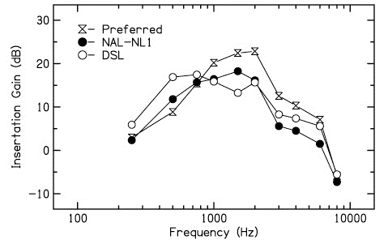

*Figure 3: REIG values across Frequency for all three conditions.*

## Conclusions

Finally, it can be inferred from the results of the present study that for the Indian population, higher gain is required at mid to higher frequencies, compared to western population. This study supports the notion that better speech perception scores are achieved in conditions which have favorable gain settings. This study also reflects on the importance of fine-tuning of hearing aids based on participant’s preference because the results of this present study was based on the fine tuning changes made based on subjective preference and it was mostly in the mid to high frequencies which was consistent across all the participants.

## References

Aazh, H., & Moore, B. C. J. (2007). The Value of Routine Real Ear Measurement of the Gain of Digital Hearing Aids. *Journal of the American Academy of Audiology, 18*, 653–664.

Allen, J. B., Hall. J. & Jeng, P. (1990). Loudness growth in

½-octave bands (LGOB) – a procedure for assessment of loudness. *Journal of the Acoustical Society of America, 88*(2), 745-753.

Carhart, R., & Jerger, J. F. (1959). Preferred method for clinical determination of pure-tone thresholds. *Journal of Speech and Hearing Disorders, 24*, 330- 345

Ching, T. Y. C., Scollie S. D., Dillon, H., & Seewald, R., (2010).A cross-over, double-blind comparison of the NAL-NL1 and the DSL v4.1 prescriptions for children with mild to moderately severe hearing loss. *International Journal of Audiology*, *49*, S01–S15.

Cornelisse, L., Seewald, R. & Jamieson, D. (1995). The input/output formula: a thoeretical approach to the fitting of personal amplification devices. *Journal of Acoustical Society of America, 97*(3), 1854-1864.

Cox, R. (1995). Using loudness data for hearing aid selection: The IHAFF approach. *Ear and Hearing, 48*(2), 39-44.

Dillon, H. (2001). Hearing aids. Turramurra: Boomerang press.Dillon, H.(1999). NAL-NL1: A new prescriptive fitting procedure for non-linear hearing aids. *The Hearing Journal. 52*(4), 10-16.

International Standards Organisation. (1998). Acoustics : Reference Zero for the Calibration of Audiometric Equipment. Part 2: Reference Equivalent Threshold Sound Pressure Level for Pure Tones and Supra-aural ear phones. ISO : 389-1.

Keidser, G., & Grant, F. (2001). Comparing loudness normalization (IHAFF) with speech intelligibility maximization (NAL NL-1) when implemented in a two-channel device. *Ear and Hearing. 22*(6), 501- 515.

Keidser, G., Brew, C., Brewer, S., Dillon, H., Storey, L., & Grant, F. (2005). The preferred response slopes and two-channel compression ratios in twenty listening conditions by hearing-impaired and normal-hearing listeners and their relationship to the acoustic input. *International Journal of Audiology*. *44*, 656-/670.

Keidser, G., & Dillon, H. (2006). What’s new in prescriptive fittings Down Under? In Palmer, C.V., & Seewald,

R. (Eds.), *Hearing Care for Adults.* pp. (133-142). Phonak AG, Stafa, Switzerland.

Keidser, G., Dillon, H., Dyrlund, O., Carter, L., & Hartley, D. (2007). Preferred low- and high-frequency compression ratios among hearing aid users with moderately severe to profound hearing loss. *Journal of the American Academy of Audiology. 18*(1), 17-33.

Keidser, G., O’Brien, A., Carter, L., McLelland, M., & Yeend, I. (2008). Variation in preferred gain with experience for hearing aid users. *International Journal of Audiology*. *47*(10), 621-635.

Killion, M. C., & Fikret-Pasa, S. (1993). The 3 types of sensorineural hearing loss: loudness and intelligibility considerations. *The Hearing Journal. 46*(11), 31-36

Studebaker, G. A., & Sherbecoe, R. L. (1993). Frequency- importance functions for speech recognition. In G. A. Studebaker & I. Hochberg (Eds.), *Acoustical factors affecting hearing aid performance* (2nd ed., pp. 185- 204). Boston: Allyn and Bacon.

Yathiraj, A., & Vijayalakshmi. (2005). Auditory memory test. Test developed at the Department of Audiology, All India Institute of Speech and Hearing, Mysore.

Zakis, J. A., McDermott, H. J., & Dillon, H. (2007).The design and evaluation of a hearing aid with trainable amplification parameters. *Ear and Hearing*, *28*(6), 812–830.