ComparisonBetweenOutcomesUsingPreferredGainandPrescribedGainFormulaeinExperiencedAdultHearingAidUsers

1AchaiahM.A. &2Vijayakumar Narne
Abstract
Prescriptiveformulaeprescribegainsbasedondifferentformulaethatinturnarebasedondifferentrationales.Butithasbeennotedbyseveralauthorsthatthegainsprescribedbytheprescriptiveformulaemaybedifferentfromthepreferredgainsettings.Thisstudywasdonewiththeaimtocomparethegainprovidedusingthetwomostcommonlyusedprescriptiveformulae,NALNL-1andDSL[i/o]andcomparethiswiththepreferredgainsettings.Tensubjects,intheagerangeof30to75years,whowereregularusersofhearingaidssincemorethantwelvemonthsweretakenupforthestudy.Themeasuresusedforcomparisonwereoverallaidedgain,gainatvariousinputlevels(45dB,65dB&89dB),RealEarInsertionGain,andSpeechIdentificationScoresforalltheconditions.Resultsrevealedthatmajorityoftheparticipantsneededagainofabout10dBhigherthanNAL-NL1andabout5dBhigherthanDSL[i/o]andforIndianpopulation,highergainisrequiredatmidtohigherfrequencies.ComparisonofSISrevealedthatthespeechperceptionatthepreferredconditionwasthebestfollowedbyNAL-NL1andDSL[i/o].Fromtheresults,itcanbenotedthatthereisadifferencebetweentheprescribedgainsettingsandpreferredgainsettingsandthismighthavetobedoneonalargerpopulationtoarriveatamoreconcretefindings.

Keywords:NALNL-1, DSL[i/o],preferred gain, REIG, SIS

Introduction
Cochlear hearinglossinadultsubjectscanvaryintermsofdegreeandconfigurationwhichcreatesanecessityfortailormadefittingofthehearingaidforeveryclient.Mostcommonpracticeintheclinicsistouseaprescriptiveprocedurethattakescareofapproximatetargetamplificationrequiredforeveryindividual.Thatisinprescriptiveapproachesamplificationcharacteristicsrequiredwerecalculatedbasedonhearingcharacteristicsofthehearing-impairedindividuals.Ingeneralprescriptiveproceduresweredeceivedfromhearingcharacteristicsandpropertiesspeechspectrum.Theprescriptivemethodswerechangedovertheyearsduetoadvancementintechnology,betterunderstandingofhearingcharacteristicsandotherfactorsaffectinghearing aid performance.

Prescriptiveproceduresfornonlinearhearingaidsarebasedupondifferentunderlyingrationales.Theideabehindtheseproceduresiseithertonormalizeloudnesssothatloudnessrecruitmentcanbecompensatedortomaximizespeechintelligibilityatvariousinputlevels(Dillon,2001).Someofthesefittingproceduresusethresholdandsomeothersusesuprathresholdmeasurementsasinputdata(Dillon,2001).ThresholdbasedproceduresaremainlyNAL-NL1(Dillon,1999),FIG6 (Killion &Fikret-Pasa,1993), and partly DSL

1E-mail:achaiah.audiologist@gmail.com; 2Lecturer inAudiology, E-mail: vijaynarne@gmail.com
[i/o](Cornelisse,Seewald&Jamieson,1995).SuprathresholdproceduresareLGOB(Allen,Hall&Jeng,1990),IHAFF(Cox,1995)andpartlyDSL[i/o](Cornelisse,Seewald&Jamieson,1995).Amongtheproceduresdescribedabove,mostcommonlyusedprocedureforprescribinghearingaidsisNAL-NL1and DSL[i/o] (Dillon, 2001).

The prescriptiveformulae,beitthresholdbasedorsuprathresholdbased,givethefirstapproximationofgainrequired.Practicalclinicalexperienceswithprescriptivemethodsshowthatthemethodscannoteliminatetheneedforindividualallowancesandadjustmentsi.e.,finetuningofhearingaid(Dillon,2001).However,oneshouldbearinthatfinetuningofgainsettingsinthehearingaidsisperformedonprescribedgain.Theprescribedgainshouldbeagoodapproximationtopreferredgain,whichreducesthetrialanderrordonebytheclinicianandalsosavestime(Dillon, 2001).Keisderetal.,(Keidser& Grant, 2001;Keidser,Brew,Brewer,Dillon,Storey&Grant,2005;Keidser&Dillon,2006;Keidser,Dillon,Dyrlund,Carter&Hartley,2007;Keidser,O’Brien,Carter,McLelland&Yeend,2008)didaseriesofstudiestocomparethegainprescribedbyNAL-NL1prescriptiveformulaandthatpreferredbylistenerswithdifferentdegreesofhearingloss.Theyreportedthat,gainpreferredbytheadultexperiencedhearingaidusersislowerby6dBonaverageincomparisontothatprescribebyNAL-NL1.Thesestudiessuggestthatprescriptiveprocedurehastobeagoodapproximationtopreferredgainonwhichfinetuningofthedevice

accordingtoindividualneedswillbeperformed.SimilarresultswerealsoreportedbyChing,Scollie,DillonandSeewald,(2010)inchildrenandZakis,McDermottandDillon,(2007)inadultparticipants.Alltheabovestudiescomparingpreferredandprescribedgainwereperformedonwesternpopulation.LittleornodataisavailableoncomparingpreferredgainandprescriptivegainsettingsinexperiencedhearingimpairedadultsinIndiancontext.Although,long-termaveragespeechspectrum(LTASS)maybesimilaracrosslanguagesbutfrequencyimportancefunction(Studebaker&Sherbecoe,1993)maybequitedifferentforIndianlanguageswhichsuggestsdifferentgainsettingsthanthatofwesternpopulation.Further,generalopinionamongthecliniciansinIndiaisthat,majorityoftheclientspreferdifferentgainsettingsthanthatprescribedbyNAL-NL1andDSL[i/o].Hence,itbecomesallthemoreimportanttocomparetheprescribedandpreferredgainsettingsinexperienced hearingaid listeners.

Method

Participants

Tenparticipants(10ears),havingsensory-neuralhearingloss,whohadbeenclinicallydiagnosedashavingcochlearhearinglossatDepartmentofAudiology,AllIndiaInstituteofSpeechandHearing,Mysoreparticipatedinthepresentstudy.Alltheparticipantswereregularhearingaidusers;theminimumdurationofhearingaidusebeingmorethanoneyear.Theageoftheparticipantsrangedfrom30to75yearswiththemeanageof64years.Alllistenerswerenativespeakersof Kannada(ADravidian
languagespokeninasouthernstateofIndia).Puretoneaveragerangedfrom30to91.6dBHL.Itwasascertainedfromastructuredinterviewthatnoneoftheseparticipantshadanyhistoryofneurologicorotologicdisorders.Thedemographicandaudiologicaldataoftheparticipants,whichincludesdegreeofhearingloss,speechidentificationscores,hearingaidbeingusedandthedurationofhearingaiduse,isprovidedinTable1.Thepure-tonethresholdsatoctavefrequenciesofeachparticipanthavebeenprovidedinFigure1from30to75yearswiththemeanageof64years.

Procedure

Pre-testing procedure
Onotoscopicexamination,allparticipantshadearcanalsthatwerefreefromcerumen,debrisorforeignbody.Thiswasfollowedbyestimatingaudiometricthresholdsforairconductionat250Hz,500Hz,1000Hz,2000Hz,4000Hzand8000HzandBoneConductionat250Hz,500Hz,1000Hz,2000Hzand4000HzusingModifiedHughsonandWestlakeprocedure(Carhart&Jerger,1959).Thethresholdsobtainedwerecomparedwithpure-tonethresholdsobtainedduringinitialhearingaidfitting.Noneoftheparticipantshadashiftgreaterthan10dBatanyofthefrequenciesforbothairandboneconduction.Acalibrated(ISO,389)OrbiterOB-922diagnosticaudiometerwithTDH39supraauralheadphonesandRadioearB-71bonevibratorweretheinstrumentsusedforpuretoneandspeechaudiometry.AllthesubjectshadnormalmiddleearfunctioningandthesamewasconfirmedbytestingwithGSI-TympstarImmittancemeter.

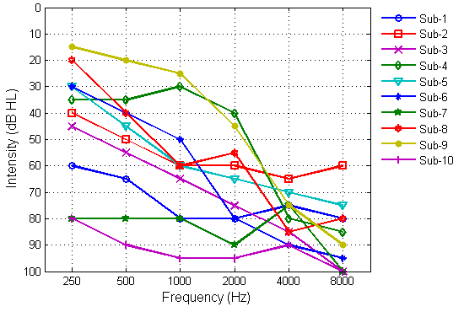
Figure 1:Pure-tonethresholds of each participant atoctavefrequencies.

Table1:Demographic and Audiological data ofthe participants with cochlearhearingloss SpeechIdentificationScores

Sl.
No.
Age/
Gender Ear
PureToneAverage
Speech IdentificationScore
Hearing aidModel
Duration of HAuse

      - 59/M Right 75 72% Figaro 2P 24 months
      - 59/M Left 56.6 92% Figaro 2P 22months
      - 69/M Left 65 76% Figaro 2P 19 months
      - 71/M Left 35 84% Figaro 2P 14 months
      - 63/M Left 56.6 76% Figaro 4P 16 months
      - 71/M Right 56.6 68% Figaro 4P 19 months
      - 73/M Right 83.3 60% Eclipse2SP 21 months
      - 71/M Right 51.6 72% Eclipse2SP 17 months
      - 75/M Right 30 88% Eclipse2SP 21 months
      - 32/M Right 91.6 Nil Eclipse2SP 22 months

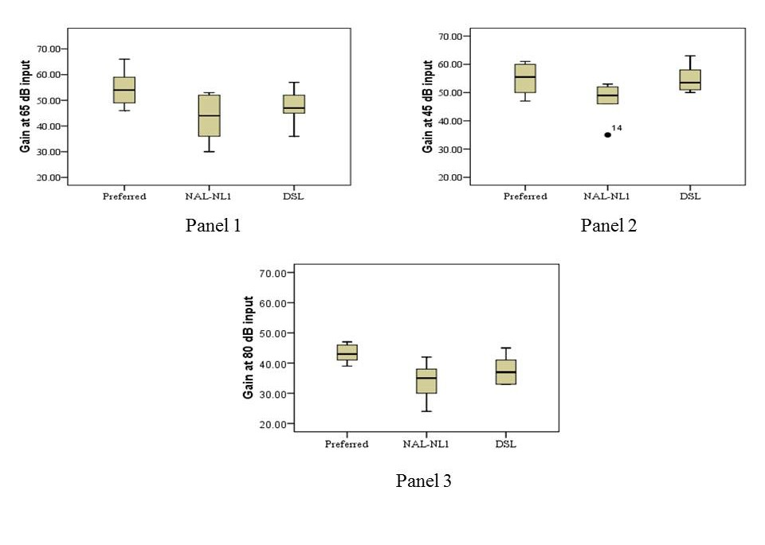
Figure 2: Overallgain atthree input levels65dB (Panel 1), 45dB (Panel 2)and80 dB(Panel 3).

SpeechIdentificationScores

SpeechIdentificationscoreswereassessedinKannadalanguage.Thiswasassessedusinglivevoicepresentation.StimuliusedwereYathirajandVijayalakshmi(2005)wordlist and it was scored outof25wordsandbyfindingoutthepercentageforthecorrectresponses.Thistestmaterialconsistsof4wordlistsof25wordseach.Thistestmaterialwasusedin4differentconditions,whichwillbeexplainedindetailinthenextsectionandforeachoftheseconditions,differentwordlistwasused.Stimuliwerepresentedthroughtheloudspeakersplacedat0°azimuthatadistance of 1 meter.

Real EarMeasurements

Realearunaidedresponse(REUR):ThiswasmeasuredforthesubjectswithoutwearingthehearingaidusingFONIX7000hearingaidanalyzerbyusingDigispeechasthestimuliat65dBSPLastheinput.

Theloudspeakerwaskeptatadistanceof12inchesandat45degreetothepinna(asspecifiedintheFONIX7000usermanual).Aprobemicrophonewasplacedinsidethesubject’searatadistanceequaltothelengthofearmouldplus5mm.Beforethestimuluswaspresented,levelingofthestimuluswasdone.Thestimuluswaspresentedandtheoutputwasrepresentedintheformofagraphonscreenandoncethegraphonscreenwasstabilizedformorethan10seconds,theinputwasstopped.Then,thegraphwasconvertedtorealearunaidedscoresandthevalueswerenoteddown.

Realearaidedresponse(REAR):Thesubject’shearingaidwasconnectedtotheHIPROusingtheprogrammingcableandtheHIPROwasconnectedtothecomputer.Onceconnected,thegainandprogramsettingsinthehearingaid,underall3conditions,i.e.,subject’spreferredsettings,NAL-NL1,DSL[i/o](version 4.1) were noted.

Realmeasureswereperformedforpreferred,NAL-NL1andDSL[i/o]gainsettingsinallthesubjectsusingtheFONIX7000hearingaidanalyzerbyusingdigispeechasthestimuliat65dBSPLastheinput.Theloudspeakerwaskeptatadistanceof12inchesandat45degreetothepinna(asspecifiedintheFONIX7000usermanual).Aprobemicrophonewasplacedinsidethesubject’searatadistanceequaltothelengthofearmouldplus5mm.Beforethestimuluswaspresented,levelingofthestimuluswasdone.Thestimuluswaspresentedandtheoutputwasrepresentedintheformofagraphonscreenandoncethegraphonscreenwasstabilizedformorethan10seconds,theinputwasstopped.Then,thegraphwasconvertedtorealearaidedscoresandthevalueswerenoteddown.Thegainatthreeinputlevels(45dB,65dB&80dB)wasnotedfromthesoftwareprogramandREAGwasobtainedfromrealearmeasuresacrossalltheaidedconditionsweretabulatedandsubjectedtoanalysisandtheresultsobtainedhavebeendiscussedinthenextsection.

Results and Discussion

Comparison of Gain at three input levels

Figure2showstheoverallgainatthreeinputlevelsi.e.,45dB(softsoundinput),65dB(overallgain),80dB(loudsoundinput)forthreeconditions.For45dBand80dBinputlevelsdatawasavailableforonly6subjects.AsitcanbenotedfromtheFigure2.1,thegain,overallishigherforpreferredconditioncomparedtoNAL-NL1andDSL[i/o]atallinputlevels.Thedifferenceishigherat65dBand80dBinputlevelcomparedto45dBinputlevel.Inaddition,DSL[i/o]providesslightlyhighergainatalltheinputlevelscomparedto NAL-NL1.

Friedman’sANOVAwascarriedouttofindoutifthemeandifferenceissignificantinthethreeconditionsatallthethreeinputlevelsseparately.ForalltheFriedman’sANOVAanalysisaBonferronicorrectionwasappliedandsoalltheeffectsarereportedat0.016level.At65dBinputlevel,analysisrevealedthatmeandifferenceissignificantacrossthreeconditionsforoverallgain(χ2(2)=12.1,p<0.001).ThisisfollowedbyWilcoxonsignedranktesttocompareacrossconditions.ResultsrevealedthattherewasasignificantdifferencebetweenpreferredandNAL-NL1(Z=2.6,p<0.01),DSL[i/o]andNAL-NL1(Z=2.56,p<
0.01),whereas,therewasnosignificantdifferencebetweenpreferredandDSL[i/o](Z=1.5,p=0.144).Similaranalysiswascarriedoutfor45dBinput(χ2 =
(2)
pleasenotethatafterapplyingtheBonferronicorrection,p=0.017wasnotsignificantassignificantvaluewas morethan 0.016.

Resultsofpresentstudyclearlyshowthatmajorityoftheparticipantsneededagainofabout10dBhigherthanNAL-NL1andabout5dBhigherthanDSL[i/o].TheseresultsclearlydemonstratesthatgainneededintheIndiansubjectsishigherthanthatprescribedbyNAL-NL1andDSL[i/o]for65dBinputlevel.Theseresultsareinagreementwithclinicalobservationmadebymajorityoftheclinicians.Theprecisereasonforneedingahighergainisnotknown.Probablereasonsforhighergainrequirementinthepresentstudyisasfollows;first,forthewesternpopulation,Keidseretal.reportedthatpreferredgainislesserby6dBthanthatprescribedbyNAL-NL1in46%ofsubjects,gainprescribedandpreferredwassimilarin 49%of subjectsandaonly5%ofsubjectsneedmorethanNAL-NL1,thisamountsto3to8dB.Probably,thesubjectstakeninthepresentstudyfallinthe5%range.Anotherreasoncouldbethat,asStudebakerandSherbecoe(1993)reportedthatfrequencyimportancefunctionsvarywidelyacrossthelanguagesandhearingaidprescriptiveformulaewerederivedfromthefrequencyimportancefunction.Probably,thefrequencyimportancefunctionsforIndianlanguagesaredifferentwhich would haveled tothis difference.

Comparison ofREIG

UsingtheREURdataandREARdata,theREIG(RealEarInsertionGain)datawascalculatedforeachsubjectateachfrequencyforallthethreeconditions.Thiswascalculatedusingtheformula[RealEarInsertiongain(REIG)=REAG–REUG;REAG=Realearaidedgain,REUG=Realearunaidedgain]describedbyDillon(2001).REIGvalueswerecalculatedonlyatoctaveandmidoctavefrequencies.The individualREUR,REARscoresforall thesubjectsateachfrequencyinallthreeconditionshasbeengiveninthe appendix.

Figure3 representsthemeanvalues oftheREIGscoresacrossfrequenciesforallthethreeconditionsat65dBSPLinputsignal.Asitcanbeseenfromthefigure,thereisadifferenceinthemeanvaluesacrossfrequenciesinthethreeconditions.Atthelowfrequencyregion,tillabout800Hz,REIGvaluesofDSL[i/o]conditionaregreaterthan preferredconditionandNAL-NL1.Inthesameregion,NAL-NL1isslightlyhigherthanpreferredcondition.Atmidandhighfrequencies,REIG scoresforthe preferred

5.3,p=0.069)and80dB inputcondition(χ2
(2)
=8.2,
conditionweregreaterthanNAL-NL1andDSL[i/o]

p=0.017*)andresultsrevealedthattherewasnosignificantdifferenceacrossconditions.Readersmay
condition.Atthehighfrequencyregion,DSLisalso
higherthanNAL-NL1condition.Attheextremehigh

frequencyregion,themeanscoreshavedippedinallthethreeconditionsbecausethefrequencyresponseofthehearingaidislimitedupto 4000 Hzto5000 Hz.

RepeatedMeasuresANOVArevealedasignificantmaineffectofthecondition(F(2,18)=5.8,p<0.05)andfrequency(F(9,8)=4.5,p<0.01).No significantinteractionwasfound(F(18,162)=1.5,p=0.1).Further,One-wayANOVAwascarriedouttofindoutifthemeandifferenceofREIGscoreswassignificantinthethreeconditionsatdifferentfrequencies.Thedataof8kHzwasnotconsideredintheanalysis.Theanalysisrevealedthattherewasasignificantdifferencebetweentheconditionsat3000Hz(F(2,490)=5.75,p<0.05),4000Hz (F(2,810)=12.20,p<0.05),6000Hz (F(2,862)=5.53,
p<0.05)inputfrequency.Post-hocBonferronianalysisshowedthattherewasasignificantdifferencebetween
preferredandNAL-NL1at3000Hz,4000Hz,and6000HzandsignificantdifferencebetweenpreferredandDSLat3000Hz,4000 Hz and6000 Hz inputfrequency.

ResultsoftheREIGclearlydemonstratethatfortheIndianpopulation,highergainisrequiredatmidtohigherfrequencies.Although,themeandataisdifferent,itdidnotreachsignificanceatmidfrequencies(1kHz&2kHz);thisismaybeduetomorevariationnotedinthedata.StudebakerandSherbecoe(1993)reportedthatfrequencyimportancefunctionsvarywidelyacrossthelanguagesandhearingaidgainprescriptionswerederivedfromthefrequencyimportancefunction.Probably,thebandimportancefunctionwasdifferentformidandhighfrequency,whichiswhytheyneededahighergainatmidandhighfrequencyandnotatlowfrequency.Onemorereasoncouldbethatthedifferencesmaybebecauseofthefine-tuningchanges.Asthesubjectsselectedhadundergonefine-tuningatregularintervals,itmaybe
possiblethatthechangesweremostlyrequiredathighfrequenciesinthesepopulations.Similarresultshavebeen reportedby Aazhand Moore,2007.

Comparison ofAidedSpeechIdentificationscores

Comparisonofspeechidentificationscoresacrossthethreedifferentconditionswasperformed.Themeanscoreswere75.5%(6.46),64%(11.31)and61.33%(11.45)forpreferred,NAL-NL1andDSLrespectively.Bythisanalysis,wecaninferthatthespeechperceptionatthepreferredconditionwasthebestfollowedbyNAL-NL1andDSL[i/o].RepeatedmeasuresANOVAwascarriedouttocheckiftherewasanysignificanceacrossthethreeconditions.Theresultsrevealedthattherewasastatisticallysignificantmaineffectofconditions(F(2,16)=23.7,p<0.05).BonferronipairwiseanalysisshowedthatthepreferredconditionwassignificantlydifferentfrombothNALandDSL.ThedifferencebetweenNALandDSLwasnotstatisticallysignificant.MeanscoresdidnotreachsignificancebetweenNAL-NL1andpreferredduetolargeSD(i.e.,11.5)noticedintheNAL-NL1scores.ThespeechperceptionscoresfurtherconfirmthatgainsettingsinthepreferredgainconditionarequitedifferentfromthegainsettingsprescribedbyNAL-NL1and DSL[i/o].

Overall,theresultsdemonstratethatthesubjectsparticipatedinthepresentstudyneededahighergainthanNAL-NL1andDSL[i/o]byatleast10dBat65dBinput.Inaddition,moregainisrequiredathigherfrequenciesthanatlowerfrequencies.However,theseresultshavetobeinterpretedwithcautionbecause,thepresentstudydidnotcontrolforgender,degreeofhearingloss,ageandthenumberofsubjectstakenupforthestudywereless.Hence,furtherstudiesareneededinthisdirectiontocross-verifytheresults of thepresent study.

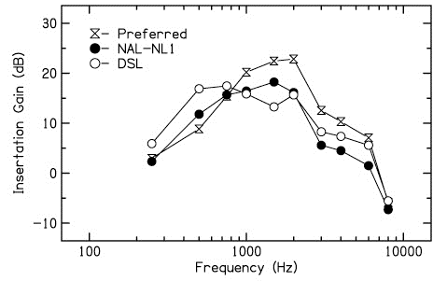
Figure 3:REIG values across Frequency for all three conditions.

Conclusions
Finally,itcanbeinferredfromtheresultsofthepresent study that forthe Indianpopulation, higher gainisrequiredatmidtohigherfrequencies,comparedtowesternpopulation.Thisstudysupportsthenotionthatbetterspeechperceptionscoresareachievedinconditionswhichhavefavorablegainsettings.Thisstudyalsoreflectsontheimportanceoffine-tuningofhearingaidsbasedonparticipant’spreferencebecausetheresultsofthispresentstudywasbasedonthefinetuningchangesmadebasedonsubjectivepreferenceanditwasmostlyinthemidtohighfrequencieswhichwasconsistentacrossalltheparticipants.

References
Aazh,H.,&Moore,B.C.J.(2007).TheValueofRoutineRealEarMeasurementoftheGainofDigitalHearingAids.Journalof theAmericanAcademyofAudiology,18, 653–664.
Allen,J.B.,Hall.J.&Jeng,P.(1990).Loudnessgrowthin
½-octave bands (LGOB) – a procedure for assessmentofloudness.JournaloftheAcousticalSocietyofAmerica, 88(2), 745-753.
Carhart,R.,&Jerger,J.F.(1959).Preferredmethodforclinicaldeterminationofpure-tonethresholds.JournalofSpeechandHearingDisorders,24,330-345
Ching,T.Y.C.,ScollieS.D.,Dillon,H.,&Seewald,R.,(2010).Across-over,double-blindcomparisonoftheNAL-NL1andtheDSLv4.1prescriptionsforchildrenwithmildtomoderatelyseverehearingloss.International Journal of Audiology,49,S01–S15.
Cornelisse,L.,Seewald,R.&Jamieson,D.(1995).Theinput/outputformula:athoereticalapproachtothefittingofpersonalamplificationdevices.JournalofAcousticalSocietyofAmerica,97(3),1854-1864.
Cox, R. (1995). Using loudness data for hearing aid selection:The IHAFFapproach. Ear and Hearing,48(2),39-44.
Dillon,H.(2001).Hearingaids.Turramurra:Boomerangpress.Dillon, H.(1999). NAL-NL1: A newprescriptivefittingprocedurefornon-linearhearingaids.TheHearingJournal.52(4), 10-16.
InternationalStandardsOrganisation.(1998).Acoustics:ReferenceZerofortheCalibrationofAudiometricEquipment.Part2:ReferenceEquivalentThresholdSoundPressureLevelforPureTonesandSupra-auralear phones. ISO : 389-1.
Keidser,G.,&Grant,F.(2001).Comparingloudnessnormalization(IHAFF)withspeechintelligibilitymaximization(NALNL-1)whenimplementedinatwo-channeldevice.EarandHearing.22(6),501-515.
Keidser,G.,Brew,C.,Brewer,S.,Dillon,H.,Storey,L.,&Grant,F.(2005).Thepreferredresponseslopesandtwo-channelcompressionratiosintwentylisteningconditionsbyhearing-impairedandnormal-hearinglistenersandtheirrelationshiptotheacousticinput.International Journal of Audiology.44, 656-/670.
Keidser,G.,&Dillon,H.(2006).What’snewinprescriptivefittingsDownUnder?In Palmer,C.V.,&Seewald,
R.(Eds.),HearingCareforAdults.pp.(133-142).Phonak AG, Stafa,Switzerland.
Keidser,G.,Dillon,H.,Dyrlund, O.,Carter,L.,& Hartley, D.(2007).Preferredlow-andhigh-frequencycompressionratiosamonghearingaiduserswith moderatelyseveretoprofoundhearingloss.Journalof theAmerican Academy of Audiology. 18(1),17-33.
Keidser,G.,O’Brien,A.,Carter,L.,McLelland,M.,&Yeend,I.(2008).Variationinpreferredgainwithexperienceforhearingaidusers.InternationalJournal of Audiology.47(10),621-635.
Killion,M.C.,&Fikret-Pasa,S.(1993).The3typesofsensorineuralhearingloss:loudnessandintelligibilityconsiderations. The Hearing Journal.46(11),31-36
Studebaker,G.A.,&Sherbecoe,R.L.(1993).Frequency-importancefunctionsforspeechrecognition.InG.A.Studebaker&I.Hochberg(Eds.),Acousticalfactorsaffectinghearingaidperformance(2nded.,pp.185-204).Boston:Allyn and Bacon.
Yathiraj,A.,&Vijayalakshmi.(2005).Auditorymemorytest.TestdevelopedattheDepartmentofAudiology,All IndiaInstitute of Speech andHearing, Mysore.
Zakis,J.A.,McDermott,H.J.,&Dillon,H.(2007).Thedesignandevaluationofahearingaidwithtrainableamplificationparameters.EarandHearing,28(6),812–830.

