TIMING IN SPEECH : A REVIEW OF LITERATURE

S. R. SAVITHRI*

The paper reviews the literature on durational models, role of duration in speech perception and factors affecting the duration of speech sounds. In the course of discussion, several areas warranting further research have been identified. Further, the paper briefly dwells on the notions of ancient Indian scholars on durational models.

Huma n speec h i s characterize d b y slopp y an d precis e articulator y move - ment s wit h th e acousti c speec h wav e a s result . I n orde r t o perceiv e an d com - prehen d thi s message , th e listene r no t onl y ha s t o notic e th e importan t events , bu t als o ha s t o neglec t unimportan t distortions . Duratio n i s a n importan t aspec t o f th e messag e comprehended . Severa l studie s o n th e durationa l struc - tur e o f speec h sound s hav e bee n conducte d whic h revea l marke d variation s a s well as smal l variation s in th e segmenta l duration s (STL, QPSR, 1975).

Variation s i n segmen t duratio n ar e importan t cue s o f acousti c variabilit y i n th e realizatio n o f linguisticall y identica l unit s (Nooteboom , 1973).

Stud y o f th e systemati c variation ? i n vowe l duratio n ma y possibl y revea l som e aspect s o f th e organizatio n o f th e menta l structure s o f language , parti - cularl y thos e tha t ar e no t studie d b y th e conventiona l method s o f linguistic s (Nooteboom , 1973).

Physica l measurement s o n th e articulator y an d acousti c aspect s o f speec h productio n indicat e th e regularitie s i n th e timin g o f speech . Thos e regularitie s ar e foun d t o b e languag e specific an d thu s reflect learne d aspect s o f verba l behaviour . A stud y o f suc h regularitie s ma y lea d t o th e formulatio n o f rule s whic h mode l par t o f th e knowledge , th e speake r ha s abou t hi s language . Th e physica l measurement s woul d b e th e bes t wa y t o gai n insigh t int o th e structure s o f languag e (Nooteboo m 1973).

Further, durational data could be used to understand the nature and orga- nization of speech production, speech perception and phonological theory (Khozhevnikov and Christovich, 1965). The duraticnal patterns reflect the speaker's mood, speaking rate and the locations of the emphasized material. The phonetic identity of different types of segment is cued by their duration (Klatt,

* Department of Speech Pathology, AIISH, Mysore-6.

S. R. SAVITHRI : TIMING IN SPEECH 7

1976). Perceptual studies of natural and synthethic speech that have been altered with regard to temporal aspects (Haggins 1972 ; Nooteboom, 1971) indicate tha t the listener can perceive very small changes in segmental duration as deviant. Duration plays another kind of role in speech perception. The speech sound heard is determined by the duration of gradually changing speech event such as a formant transition (Liberman el at, 1956: Suzuki, 1970).

It has been shown that duration can effectively disambiguate syntactically ambiguous sentences even in the absence: of cues provided by fundamental fre- quency and pauses (Lehiste, Olive and Streeter, 1976).

In addition, durational dats may of immense use in a appled research areas, viz., automatic generation of speech for a reading machine for the blind and the automatic recognition of speech from the acoustic waveform.

The present paper reviews the literacey on durational models factors affec- ting the segmental duration, role of duration in speech perception and contribu- tion of Sanskrit literature to the duraiton models.

Durational Models

Several models have been proposed to explain the way in which control over duration i s achieved. Currently 2 models are recognized, viz.. . "Com b model ", " Chain model ".

The " Comb model " holds that the units of speech are executed according to some underlying pre-programmed time schedule, i-e-, the duration of speech sounds to be uttered are determined before they are produced. For example, if the speech sound [a] is to be produced the duration for which it is to be produced is determined before its production.

According to the " Chain model',ther is no underlying time program or a given speech gesture is executed after the preceding gestures have- been completed successfully (Ohala, 1973), i.e., the duration of the speech sound to be produced is not pre-determined.

Ohala (1973) suggests the "Chain model" for long-term timing and the
"Com b model " for the short-term timing.

Khozhevnikov and Christovich (1965) presented evidence for the "Com b model ". They stated that the durational structure of a sentence is- pre-planned and that the open syllable is an important unit in this process. Pre-planned sequential commands change the articulatory processes, which results in compensa- tory effect in speech production This further gives rise to lengthening of the preceding segment when the following is shortened or vice versa.

8 JOURNAL OF A.I.I.S.H.. VOL. XV, 198 4
Ohala (1975) questions these findings and claims that a chain model is as relevant as a Comb model. If the Comb model is the most basic model, compensa- tory effects in speech perception to minimize the influence of local disturbances while decoding the message is needed. If Chain model is true, there is no imme- diate need for such a compensatory behaviour (STL, QPSR, 1975).

Some models describe the way in which timing information takes place in brain (Allen, 1972 ; Creelman, 1962 ; Triesman, 1963 ; Michon 1967). This timing information has been explained by Allen (1972) in two ways. Allen (1972), using the vowel duration, states that the commands to produce a vowel articula- tion could include the information : " Simultaneous with the start of the commands for the vowel, send out a neutral impulse along a nerveloop type, known to the Motor Control program, specific to vowels with this particular duration, continues to issue commands for this vowel production until impulses arrive back on the return branch of this loop "• According to him " the neutral loop would act like a delay line, with each class of articulatory durations having its own fixed delay between initiation and cessation of neuromotor command" (Allen, 1972).

The second model involves a " Clock and a Countdown number ". The vowel command would include the instruction " simultaneous with the start of the commands for this vowel, begin counting down cycles of the speech time clock ; when ' n' cycles are complete, the vowel is complete ". The number would be computed by the brain for each articulatory duration (Allen, 1972).

Other models involving time quarter have been developed by Creelman (1962), Triesman (1963) and Michon (1967), Creelman (1962) suggests a Poisson source and says that no constantly running " internal clock " will account for the data of his experiments. Triesman (1963) suggests a " Pacemaker " or " Clock like generator " whose rate may be subject to small errors. Michon (1967) assumes a " Pacemaker source " whose rate of pulsation is highly task dependent, to account for a variety of periodicities in his data.

" Another model called the " Condenser model " suggests that the duration may be stored in terms of the interval of time, a given condenser with a given charge needs to decharge to a certain threshold level. Therefore each unit which is to be assigned a duration is assigned a charge for a condenser. Thus duration rules would be opsrations on the charge of condensers " (STL, QPSR, 1975).

At present none of the models on timing information in speech behaviour could be accepted or rejected for lack of empirical evidence. It could be hypo- thesized that a model for the storage of timing information must have the possi- bility of storing in a duration with an accuracy of a few milliseconds and must have a higher absolute accuracy for shorter intervals than for longer intervals. However, the question of the accuracy of the descriptive model still remains.

S. R. SAVITHRI : TIMING IN SPEECH 9
Factors Influencing Duration in Speech Production

Durations of different segments vary widely depending upon several factors.
Klatt (1976) classified these factors as follows :—
(1) Extralinguistic factors, (2) Discourse level factors, (3) Semantic factors,
(4) Syntactic factors,
(5) Phonetic factors and
(6) Physiological factors.

1. Extralinguistic Factors

Under the extralinguistic factors Klatt (1976) includes speakers' mood, their physical Condition and speaking rate. Further age and sex are included in the present review.

Speaker's Mood and Physical Condition

Speaker's mood and his physical condition affects the durational patterns largely. Williams and Stevens (1972) have shown that actors, attempting to simulate various emotional states, speak differently in different emotional condi- tions. They speak very slowly when angry and slower than normal when express- ing fear or sorrow.

Speaking Rate

Change in speaking rate tends to change the durational patterns. For example it has been shown that a good fraction of the extra duration goes into pauses when speakers slow down (Goldman-Eislcr 1968). Huggins (1964) has shown that increase in speaking rate shortens vowels, and consonants. It is also accom- panied by phonological and phonetic simplifications.
Figure 1 depicts the effect of speaking rate on segment durations
(As the original spectrograms are not available spectrograms of a Kannada speaker, SA are used as examples. However, it should not be confused that the findings hold good for Kannada language unless It is specified.)

Gay et al. (1974) states that the consonantal gestures are strengthened when the speaking rate is increased because of the complex reorganization of the motor commands to the articulators. However i he motor commands for vowels are not enhanced.

Age

Sweetings (1980) found that the vowel duration increased with the age of the speaker.

10 JOURNAL OF A.I.I.S.H., VOL. XV, 198 4

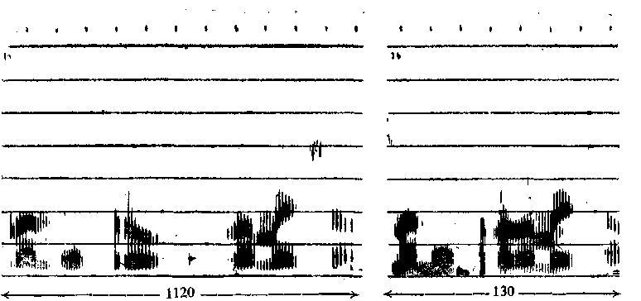
Ettralinguistic factor : speaking rate
1 (a.) Normal rate of speech 1 (b.) Fast rate of speech

Fig. 1. Broad-band spectrograms are shown to illustrate the change induration (in m.sec.) of speech sounds in normal (1«) and fast (16) rate of speech in the sentence/nan hesru ramesa/.

According to Dismoni (1974), the mean duration of vowels in the voiceless consonant environment remains constant, whereas that in the voiced consonant environment increases with the age of the speaker.

Sex
Zue and Lafferirre (1979) observed that longer durations characterized female speech. This phenomenon was also observed in earlier investigations by the present author on Sanskrit vowels (1983) and Kannada vowels (1985a, 1985b).

2. Discourse—Level Factors
The sentence of a read passage will be longer than the non-final sentence of the passage (Klatt 1976). Spectrograms in Fig. 2 show the difference in duration between the final sentence (2260 m.sec.) and the non-final sentence (1390 m.sec). It has been observed by Klatt (1976) that the vowel duration has primary importance only in phrase-final environments. The final syllable of the sentence is lengthened when compared to the non-final syllable. It is as if the speakers tend to slow down at the ends of the conceptual unit. An example of the difference between the final and non-final use of the syllable [a] is presented in Fig. 2a. The final syllable [a] is 120 m.sec. longer than the non-final syllable [a].

3. Semantic Factors
Emphasis and semantic novelty are listed as semantic factors affecting the speech sound duration.

S. R. SAVITHRI : TIMING IN SPEECH 11

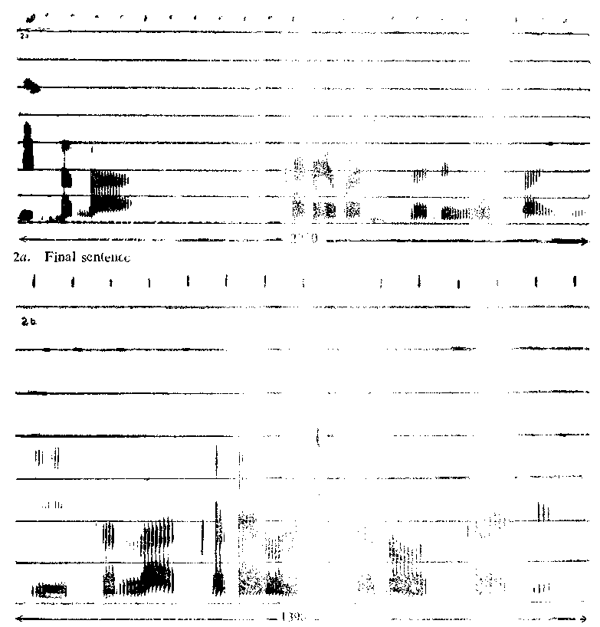 -i
Discourse level factor : Final sentence lengthening
Fig . 2. Broad-ban d spectrograms illustrate the lengthening of the final sentence.of a read passage, (a) Fina l sentence, (b)non- final (medial) sentence.(Isala
kad e varsadall i odt a idini.)
*Note : Figs, 2a and2 b are not in the same scale.

Emphasis
The first semantic factor to be considered is emphasis or contrastive stress. The acoustic correlate of emphasis is an increase in the duration of the word. The spectrograms in Fig. 3 indicate that there is as much as 30m.sec increment in the duration of the word emphasised when compared to the non-emphasised word.

12 JOURNAL OF A.I.I.S.H., Vol XV, 1984
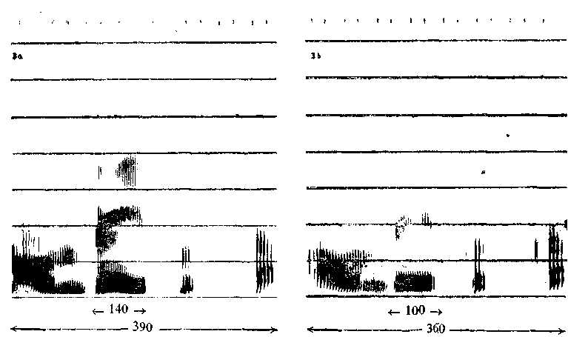
Semantic factor : Emphasis
3a. Stress in the word 3b. No stress.
Fig. 3. Broad-band and narrow-band spectrograms indicating the increase in the duration (in m. sec.) of the stressed syllable [e] In the word /Ava]ade/.
Semantic Novelty
An unusual word would be longest, the first time it appears in a connected discourse inferring that semantic novelty has an influence on segmcntal durations.

4. Syntactic Factors

Phrase-structure L engthening
Gaitenby (1965) found that the syllable or syllables at the end of a sentence are longer than they would be within an utterance. The same was observed by Klatt (1976).
An example is given in Fig. 2.

Prepausal Lengthening

The syllables before the pause are lengthened when compared to syllables in other positions. In Fig. 4 it Could be observed that the syllables [u] and [e] are 60 m.secs longer before pause.

Martin (1970) showed that segments tended to be lengthened in spontaneous speech just prior to major grammatical constituent boundaries. Lengthening was observed at the ends of noun phrases and conjoined or embedded clauses.

It may be a natural tendency to slow down at the end of all motor sequences or the speaker may learn to lengthen the prepausal syllables to enable the listener

S. R. SAVITHRl : TIMING IN SPEECH 13

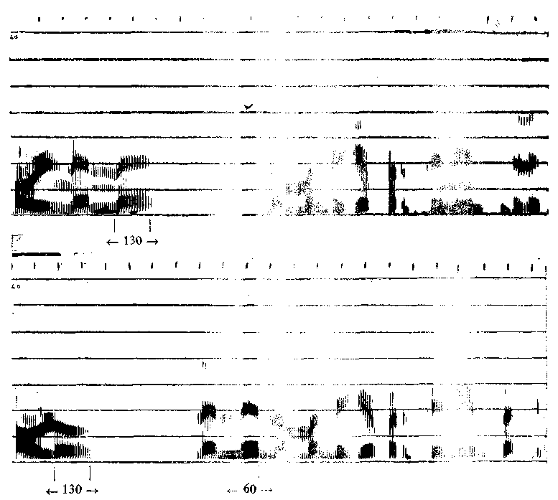
Syntactic factor : Prepausal lengthening

4a. Prepausal lengthening of the syllable [e]; word final lengthening of the syllable [e]

4b- prepausal lengthening of the syllab[u].

Fig. 4. Broad-band spectrogramsdepicting the lengthening of the [u]and [e] in the

sentences (a) Avalu nenne nammalige bandidlu/and (b) Avalu nenne nammalige (a)

and word-final syllable lengthening of [e] in /nenne/ (b). decode the message better or it is oroba'- Iv icu t1 to the genenn (kcelaration of motor activity at the ends of
sp ak;n; uols 'Ulatt, 1976).

Word -final Lengthening

The word-final syllables are somewhat longer in duration the non-final syllables (Oller, 1973; Klatt,

1975), The examples can be observed in the spectrograms of Fig. 4 and Fig. 5. In Fig 4a the duration of final [e] is 130 m.sec. whereas the duration of non-final [e] is 60 m.sec. In Fig. 5, the final syllable [a] is 160 m.sec. longer than the non -final syllable [a] which is 60 m.sec. long.

14 JOURNAL OF A.I.I.S.H . VOL. XV, 1984

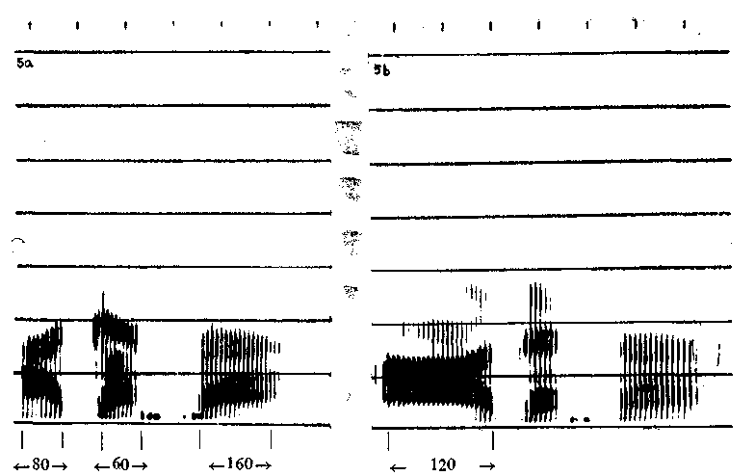
Syntactic factor : Word-final lengthening
5a. Word-final lengthening of the vowel [a] 56. Short/long contrasts.
Fig. 5. Broad-band spectrograms showing the lengthening of the word-final syllable [a] in the word /agasa/ and the durational contracts of the short (a) and long vowel (b) in
/agasa/ and /agasa/

5. Phonetic Factors

Inherent Phonological Duration

Each phonetic segment has its own intrinsic phonological duration. Some vowels are short and some vowels long and some are over-long. Figure 5 depicts the duration of short and long counterparts of the vowel [a] which are 80 and
220 m.sec. respectively.
The duration of the vowels appears to be related to tongue height. Other factors being equal a low vowel is longer than a high vowel. Experimental evidence for this emerges from studies on English, German, Danish, Swedish, Thai, Lappish, Spanish (Klatt, 1976) and Kannada (Savithri, 1985). An example
. is shown in Fgi. 6 in which the duration of the low vowel [a] is 10 m.sec. more than that of the high vowel [i].

The reason for this might be found in the physical processes. It is a known fact that velar height and the degree of closure of the velopharyngeal port varies systematically with vowel articulation. In general, the velum is characteristically lower and the port more open for low vowels than for high vowels. This takes more time thus explaining the longer duration for low vowels.

S. R. SAVITHRI : TIMING IN SPEECH 15

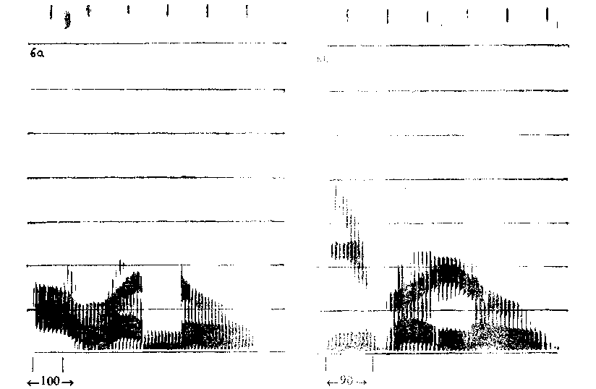
Phonetic factor : Tongue height
6a. Low vowel 6b. High vowel
Fig. 6. Broad-band spectrograms are shown to illustrate the duration of low-vowel [a] in
/avanu/ (a) and high vowel [ij /ivalu/(b).

Duration of consonants depend- on many factors. The aspirated consonants are longer (160 m.sec.) than the unaspirated consonants (110m.sec ) as shown in Fig. 7.
The duration of the voiceless consonant is more than that of the voiced (Klatt,
1976 ; Weismer and Sthathopoulous, 1979).
In the example given in Fig. 8 viz.atavi/ and /adavi/ the duration of the voiced consonant [d] is 70 m.se c whereas that .of the voiceless consonant [t] is
110 m.sec.
Word initial consonants are longer than non-initial consonants (Klatt, 1976),' In Kannada it was observed that the duration of consonants in the medial position was less than those in the initial position (Rajapurohit, 1982). Fintoft (1961) found that the unvoiced fricatives of Norwegian speech sounds were always longer than any other consonants in. Sanskrit it was observed that the retroflex consonants were the shoriest in duration when compared to consonants with other places of articulation (Savithri. 1983)

Effect of Linguistic Stress :
Stress pattern of an utterance modifies the segmental duration. Stressed vowels are generally longer than unstressed vowels (Parmenter and Trevino.
16 JOURNAL OF A.I.I.S.H.. Vol XV, 1984
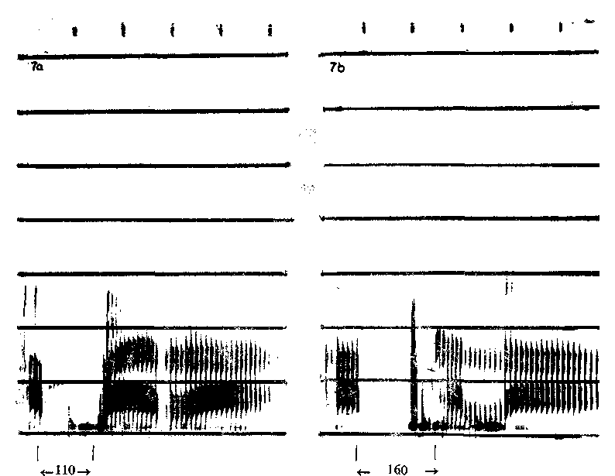
Ponetic factor : Aspiration
(7a) Unaspirated [p]. (7b) Aspirated [ph].
Fig. 7. Broad-band spectrograms are shown to illustrate the change in duration of [p] in aspirated (a) and unaspirated (6) conditions, in the words / apara / and / aphala /.

1936 ; Oiler, 1973; Lehiste 1975a). In Fig. 3a the stress is on the vowel
[e] which is 40 m.sec greater than the unstressed vowel [e] in Fig. 3b.
In Dutch, the duration of the stressed vowel decreases with increasing number of syllables that remain to be produced in the word. The effect is more pro- nounced in stressed long vowels than in stressed short vowels and stronger for isolated words than for embedded words. (Nooteboom, 1973).

Effect of Post-vocalic Consonants on the Vowel Duration and Effect of Preceding and Following Vowels on Consonants Duration :
Vowels ate longer if followed by voiced than if followed by voiceless consonants (Delattre 1962 ; Lyberg, 1981). An example is shown in Fig. 8 in which the vowel preceding voiced [d] is 30 m.sec. longer than that preceding the voiceless [t].
The reasons for this as hypothesized by Halle and Stevens (1967) is that the vocal cords are widely open for the voiceless consonants, whereas for the voiced sounds fine adjustments are required. These fine adjustments consume more time than the wide separation for the voiceless consonants because of

S. R. SAVITHRl . TIMING IN SPEECH 17
2
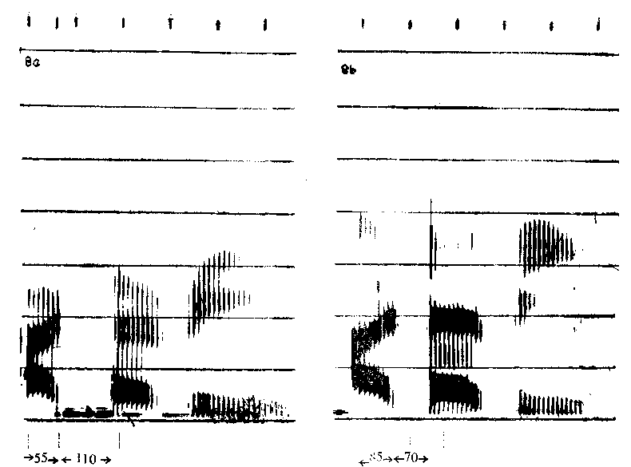
Phonetic factor : Voicing
(8a) Voiceless cansonant [t] (8b) Voiced consonant [d]
Fig. 8. Broad-band spectrograms are provided to illustrate the longer duration for the voiceless consonant [t] (a) in the word . /atavi/ when compared to the voiced consonant [d] (b) in the word ,/adavi/ and the effect of post -vocalic consonant on the vowel.
which vowels are lengthened preceding voiced consonants. Further, the velo- pharyngeal width will be longer for voiced stops, when compared.to the voiceless. This widening of the velopharynx for voiced stops requires more time which lengthens the vowels preceding voiced stops.
In German, it has been observed that the front vowels ate longer before labials and velars than before dentals and back vowels are longest before velars (Maack, 1953). House and Fairbanks (1953) found that English vowels are generally longer before labials or velars. Kenneth (1976) found that vowel duration in tricative environment is longer than in the plosive environment.
Nooteboom (1973) has shown that (1) the consonant duration is affected by the number of syllables following. Consonantal duration decreases as the number of syllables following increases , Further, the consonants preceding short vowels are more affected than consonants preceding long vowels ;
(2) Consonants occuring in the initial position of the word are about
15-30 m.sec. longer than those in the non-initial position, provided it is not
followed by a stressed vowel ;

18 JOURNAL OF A.I.I.S.H., VOL. XV, 198 4
(3) Consonants preceding stressed vowels having a pitch accent show an

INCREASES in duration of about 25 m.sec. ; and

(4) Consonants when preceding a pause are lengthened.

segmental Interactions :

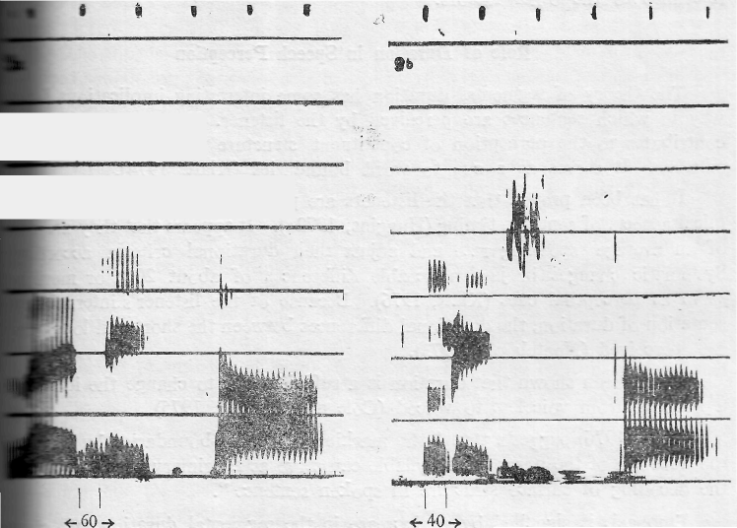
Consonants tend to become short in the environment of clusters. The duration of the consonant [1] is 20 m.sec shorter in the cluster [kl] when compared to its duration in non -cluster in Fig. 9.

Phon etic factor : Segmental interactions

(9a) Consonant [1] in the word /laiita/. (9b) Consonant [1] in the word /k'is a/. Note: 9a and 9b are coi in the same scale.
Fig. 9 Broad-band spectrograms are shown to illustrate the shortening of [1] in cluster.

According to Klatt (1976) "the durational recording in clusters may have its origin in physical constraints on the speed of various articulators, their ability to act independently so that consonantal gestures partially overlap in time and
on the articulatory distances to be traversed ". " Another possible cause of the shorting of consonants in clusters may be a desire on the part cf a talker to maintain a nearly constant duration for each word independent of its phonetic composition. It has been su ggested that the shortening of initial syllables in polysyllabic words is also a result of this factor. However, it is hard to believe that constant word duration i; a very important constraint in English since duration has already been implicated as functioning to differentiate inherently
long from short vowels, voiced from voiceless fricafives etc. " (Klatt, 1976).

S.R. SAVITHRI : TIMING IN SPEECH 19
6. Physiological Factors :

Finally the physiological efforts (to minimize the articulatory efforts) have been used to explain the difference in inherent phonological durations of vowels. For example the longer duration of low r vowels has been attributed to the extra effort to open the jaw in the context 0f a consonant (Lindblom, 1967). Some of the physiological efforts arc already mentioned in the above paragraphs with relevance to the other factors.

Role of Duration in Speech Perception

The theory of segmental duration has some interesting implications for the way in which sentences are perceived by the listener. The segmental duration contributes to the perception of constituent structure and phrasal and lexical patterns. It serves as a cue to word boundaries (Klatt, 1974).
It has been proved that the listener, are particularly sensitive to the rhyth- mical aspects of sentence timing (Huggins 1972a). It appears that they are aware of an average speaking rate and adjust their durational criteria accordingly. Systematic changes in just notic able inferences, of about 20 % or more may ssr\e as perceptual cues (Klatt, 1976), Because of the listener's internal repre- sentation of duration, the durational differences between the short and long vowels are perceived (Nocteboom, 1973)
It has been shown that duration is. a sufficient cue to change the identity of a fricative from voiceless to voiced (Cole and Cooper, 1975).
Klatt (1976) suggests that " the ma king of phrase-boundaries by increasing the duration of the phrase-final syllable can serve as a primary perceptical cue to the decoding of surface structure in spoken sentence ".
Emphasis is signalled by an increase in the segmental duration and change in the fundamental frequency (Klau, 1976).
Durational cues are capable of carrying considerable information in connected speech. The listeners may be aware of the durational rules. However, research is necessary on the type of ruler used be the listeners as cues in perception.

Contribution of Sanskrit Literature to the Durational Models

It is interesting to know that the ancient Sanskrit scholars had knowledge regarding the durational aspects and their importance. This is evident from the definition of phonetics as well as from ; he classification of speech sounds.

Tn the treatise Taittiriya UpaniSat, phonetics is defined as the study of speech sounds, their pitch, quantity, intensity, intonation and conjunction (T.U.II—29-32). Paniniya Siksa classified the speech sounds on the basis of various factors like the place cf articulation, etc., among which quantity is given the second place (P.S. 6-7).

20 JOURNAL OF A.1.I.S.H-, VOL. XV, 198 4
According to quantity, speech sounds were divided into hrasva, dlrgha and pluta (P.&-8) (Short, long and prolated, which are 1, 2 and 3 matra long ;—unit of quantity ; respectively). They had set the units of quantity. The lowest unit was termed a paramanu which is considered to be equivalent to two Anus (V.R.P.§. 23). Next was a matra, the more commonly used unit, equivalent to
2 paramanus. It was compared to the time taken for the snap of a finger, eye blink or a flash of lightening (V.S. 27-3 ; N.S. 2—2-3 ; Y.S. 8).

Vowels were classified as short, long and prolated (P.S. 8) and consonants are considered to be half a matra long (V.R.P.S. 22 ; T.P. 1-38; S.Y.P.Y.S. I. 57). The intrinsic duration of consonants was also observed in the sense that the voiced sounds were considered to be shorter than the voiceless sounds (P.S. 20). The duration of nasalised sound when articulated in different places was considered different (L.S. 17).
It was noticed that the final syllable was prolated in calling someone at a distance, in reply to a greeting and in case of a doubt (Astadhyayr 8—2-83,
84, 97).
In Natyasastra, one of the oldest treatise in dramatics, the duratioal differences in different intonation patterns and the duration of pause are mentioned. It states that there exists a direct relationship between the duration of a pause and the length of the syllable. When pause is of greater duration, the syllable produced will always be long. However, the duration of the pause should not exceed 6 Kalas (a measure of time) (N.S. Chap. 15). The treatise suggests that actors should use (1) grave intonation and slow rate of speech in conditions of sickness, fever, hunger, communicating confidentially etc., (2) High, excited into- nation and fast rate of speech in a rejoinder, confusion, harsh appoach, represen- ting sharpness and roughness, agitation, challenging one who is not present, threatening etc. (N.S., Chap. 15).
It has been advocated that slow rate of speech should be used while teaching, medium rate while speaking and fast rate while reciting (P.S). The importance of duration was observed in considering the normalcy of speech which could be noticed by the fact that the durational deviations are included under articulation disorders (Rg. Veda Pratisakhya, Chap. 15).
Finally, the physical processes underlying the speech behaviour was also explored. Kaiyyata connects the perception of different rates of speech to a psycho-physical process affecting the nervous system. The ratio of slow to normal to fast rate of speech was considered to be 9 : 12 : 16. According to him, the ratio implied that 9, 12 and 16 drops of nervous fluid flow from the susumna (? ) nerve of the listener, when he hears a sound in slow, normal and fast rate (Kaiyyata Pradipa 1—1-70).
Though the interpretation of the Sanskrit terms are difficult (ex. Susumna nerve), it would be useful to compile a detailed review of Sanskrit literature on duration of speech sounds, and to conduct research on the basis of this model.

S. R. SAVITHRI : TIMING IN SPEECH 21
Summary

It is known for a long time that duration is one of the important measurable aspects of ;peech. The study of duration is necessary to obtain knowledge about speech production and perception. Futher , the study of the factors affecting segmental durations and thedurational cues assisting the segmental perception are of importance to a speech language pathologist in order to understand the organization of the mental stuctures of language. The research is still in the
infant stage and not much h a s b e e n u n d e r s t o
speech production and perception. It might be expected thar further quantitative exploration on the segmental duration may lead to the formulation of the properties of the mechanism for the storage and timing in speech.

Acknowledgements

The author expresses her thanks to Dr. M. Jayaram, Lecture, Speech Pathology, All India Institute of Speech and Hearing, Mysore, for the help provided in writing this paper.

She think s Dr. M. Nithyasheelan, Director, All India Institute of Speech and Hearing, Mysore and Dr. Prathibha Karanth, Reader and Head, Department of Speech Pathology, All India Institute of Speech and Hearing , Mysore for permitting her to write this review.

Abbreviations used

L.Ś |  | Lomasa Ś iksa
N.Ś  P.Ś | . | Narada Ś iksa  Paniniya Ś iksa
Ś .Y.P. Suklayajus Pratisakliya
T.P. Taittiriya Pratisakhya
T.U. Taittiriya Upanisat
V.R.P.Ś Varnaratna Pradipika Śiksi
V.Ś Vyasa Siksa
Y.Ś Yajnavalkya Ś iksa
References

Allen, G. D. (1972), Cit. in Linguistic uses of segmental duration in English : Acoustic and perceptual evidence, by Klatt, D. H., /. Acoust. Soc. Amer., Vol. 59, 1208-1221.
Amaresa, "Varnaratna Pradipika Ś iksa". in Ś iksa Snmgrahah, Benares Printing Press, Benares, 1893.
Bharata Muni Ndtya Sastram, Granthalaya Pvt. Ltd,, Calcutta, 1967 (100 B.C.-200 A.D.). Carlson, R., et al (1973), Cit. in STL-QPSK 1/1975.
Carlson, R., Granstrom, Lindblom, B. and Rapp (1972.) Cit. in STL-QPSR, 1/1975. Cole, R. A. and Cooper, W. E. (1975), Cit in Linguistic uses of segmental duration in
English: Acoustic and perceptual evidence, by Klatt D.H., J. Acoust. Soc. Amer.,
Vol. 59, 1208-1221.

22 JOURNAL OF A.I.I.S.H. VOL. XV, 1984
Creelman, C. D., (1962), Cit. in Production and Perception of Vowel Duration : A Study of
Dumtional Properties of Vowels in Dutch by Nooteboom, S. G., 1973.
Delattre, P. C., "Som e factors of vowel duration and their cross-linguistic validity",
J. Acoust. Soc. Amer., 34, 1141-1143, 1962.
Disimoni, F. G., "Influence of consonant environment on the duration of vowels in the speech of 3, 6 and 9 years old children ", J. Acoust. Soc. Amer., Vol. 55, 362-363, 1974. Fintoft, K., "Th e duration of some Norweigan speech sounds" , Phonetica, Vol. 7, 19-39,
1961.
Gay, T., et at. (1974), Cit. in "Linguistic uses of segmental duration in English : Acoustic and perceptual evidence " by Klatt, D. H., /. Acoust. Soc Amer., Vol. 59, 1208-1221.
Gaitenby, J. (196.5), Cit. in Linguistic uses of segmental duration in English: Acoustic and perceptual evidence by Klatt, D. H., /. Acoust. Soc. Amer., Vol. 59, 1208-1221. Goldman-Eisler, F. (1968), Cit. in Linguistic uses of segmental duration in English :
Acoustic and perceptual evidence " by Klatt, D. H-, J. Acoust. Soc. Amer., Vol. 59,
1208-1221.
Halle, M. and Stevens, K. N. (1967), Cit. in Suprasegmentals, Edited by Lehiste, I., M.I.T. Press, Massachusetts, 1970.
House, A. S. and Fairbanks (1953), Cit. in Suprasegmentals, Edited by Lehiste, I., M.I.T.
Press, Meassachusetts, 1970.
Huggins, A. W. F. , (1964), Cit. in Linguistic uses of segmental (1972a) duration in English : Acoustic and perceptual evidence ; by Klatt, D. H-, /. Acoust. Soc. Amer., Vol. 59, 1208-1221.
Katyayana " Suklayajus Pratisakhya" in Ś iksa Somgrahah, Benares Printing Press, Benares,
1893.
Khozhevnikov and Christovich, H. A. (1965), Cit. in Production and Perception of Vowel
Duration: A Study of Durational Properties of Vowels in Dutch by Nooteboom, S. G.,
1973
Klatt, D. H., " The duration of /S/ in English words" , J. of Speech and Hearing
Research, 17, 51-63, 1974.
Klatt,D . H. (1975-76), "Linguistic uses of segmental duration in English : Acoustic and perceptual evidence", J. Acoust. Soc. Amer, Vol. 59, 1208-1221.
Lehiste, I. (1975a), Cit. in Linguistic uses of segmental duration in English : Acoustic and perceptual evidence ",J . Acoust. Soc. Amer., Vol. 59, 1208-1221.
Lehiste, I., Olive, J. P. and Streeter, L. A., " Role of duration in disambiguating syntacti-
cally ambiguous sentences", J. Acoust. Soc. Amer., Vol. 69, 1199-1202, 1976. Liberman, etal. (1956), Cit. in Linguistic uses of segmental duration in English : Acoustic
and perceptual evidence by Klatt, D. H., J. Acoust. Soc. Amer., Vol. 59, 1208-1221. Lindblom, B. (1967, 75), Cit. in Linguistic uses of segmental duration in English : Acoustic
and perceptual evidence",J/. Acoust. Soc. Amer., Vol. 59, 1208-1221.
Lomasa "Lomas a Siksa "in Siksa Samgrahah, Benares Printing Press, Benares, 1893. Lyberg, B., "Som e observations on the vowel duration and the fundamental contour in
/ Swedish utterances", J. of Phonetics, Vol. 9, 261-273, 1981.
Maack (1953), Cit. in Suprasegmentals, edited by Lehiste, I., M.I.T. Press, Massachusetts,
1971.
Martin, J. G. (1970), Cit. in Linguistic uses of segmental duration in English : Acoustic and perceptual evidence", J. Acoust. Soc. Amer., Vol.59, 1208-1221.
Michon, J. A. (1967), Cit. in Production and Perception of Vowel Duration : A Study of
Durational Properties of Vowels in Dutch by Nooteboom, S. G., 1973.
S. R. SAVITHRI : TIMING IN SPEECH 23
Nagesabhatta, Kaiyyata Pradipa, Kashinath Press, Kashi, 1935.
Narada (1150 A.D.), "Narada Siksa" in Siksa Ssmgrahah, Benares Printing Press, Benares, 1893.
Nooteboom, S. G. (1971, 73, 75), Cit .in Linguistic uses of segmental duration in English : Acoustic and perceptual evidence ", acoust. Sec. Amer., Vol. 59, P.08-1221. Nooteboom, S. G., "The phonetic feature of vowel length in Dutch''- language and
Speech, Vol.15, 301-316, 1972
Nooteboom, S. G., "Production and perception of vowel duration. A study of durational properties of vowel in Dutch", language and Speech, Vol. 15, 1973.
Ohala (1973), Cit. in Contemporary Issues on expermental Phonetics by Norman Lass,
Academic Press, New York, 1976
Ohala (1975) Cit. in STL, QPSR, 1/1975. Ohala (1975), Cit. in STL,, QPSR, 1/1975
Oller, D. K. (1973), Cit. in "Linguistic uses .of segmental duration in English: Acoustic and perceptual evidence" by Klatt,D.H .J. Acoust. Soc. Amer., Vol 59, 1208-1221.
Paniniya Siksa, Benares Printing Press, Benares., 1887.
Parmenter, C. E. and Trevino, S.N," The length of the sounds of the middle Westerner",
American Speech, Vol. 10, 129-133. 1936
Rajapurohit, B. B., Acoustic Characteristics of kannada, CHL occasional monograph
series 27, Mysore, 1982.
Savithri, S. R., "Primary effort and quantty an experimental verification", Thesis submitted to the University of Mysore 1983.
Savithri, S. R., "Relationship between the fundamental frequency and duration unpublished research conducted at AIISH, Mysore 1984a,.
Savithri, S. R.," Durational analysis of Kannada vowels unpublished research conducted at AIISH, Mysore, 19856.
Saunaka, Taittinya Pratisakhya, Oriental Research institute Mysore, 1978.
Rg Veda Pratisakhya, Vidyavilas press, Benares, 1903.
Speech Transmission Laboratory Quaterly progress and Status Report (STL, QPSR),
April 15, 1975,
Suzaki, H. (1970), Cit. in Linguistic use of segmental duration in English Acoustic and perceptual evidence", J. Acoust. Soc Amer., Vol 59.1208-1221.
Sweetings, P.M., " VOT and vowel duration in a normal aged population". Dissertation
Abstract International, Vol. 40,101,1980.,
Taittinya Upanisat, Ramakrishna Mutt Madras,1920.
Triesman, M. (1963), Cit. in Production and preception of Vowel Duration : A Study of
Durational Properties of Vowels in Dutch by Nooteboom, S G., 1973. Vyasacarya, Vyasa Siksa, Veda Mimansa Research Center , Varanasi, 1976
Weismer, G. and Stathopoulous, "Theduration of stop consonants", J Acoust. Soc.
Amer., Vol. 65, 5-33, 1979.
Williams, C. and Stevens, P. (1972) Cit in Linguistic uses of segmental duration in English: Acoustic and perceptual evidence by Katt,D H.,J . Acoust. Soc. Amer., Vol. 59, 12.08-1221.
Yajnavalkya, " Yajnavalkya Siksa' in S i k s a ' Samgrahah Benares Printing Press, Benares,
1893.
Zue, V. W. and Lafferriere, M., "Acoustic of t, d in American English", J. Acoust.
Soc. Amer., Vol. 66, 1039, 1979.
24 JOURNAL OF A.I.I.S.H., VOL. XV, 1984

