**Electronic Journal of All India Institute of Speech and Hearing (E-JAIISH)**

**User Manual**

**Assistant Editor**

(*E-mail:* [astjaiish2@gmail.com](mailto:astjaiish2@gmail.com) *; Password: aiish@123 // Ejaiish login name (Assistant Editor Speech & Language E-jaiish User Name saha; Password: 123456// Assistant Editor Hearing: User Name: shar; Password: 123456*)

1. When the **Managing Editor** assigns a manuscript to the **Assistant Editor** to take through the submission stage activities the concerned **Assistant** **Editor** will receive an e-mail notification (Hearing Section: [astjaiish1@gmail.com](mailto:astjaiish1@gmail.com) & *Speech & Language Section:* [*astjaiish2@gmail.com*](mailto:astjaiish2@gmail.com)) with a link to the assigned manuscript on the journal website (*Figure 1*) .

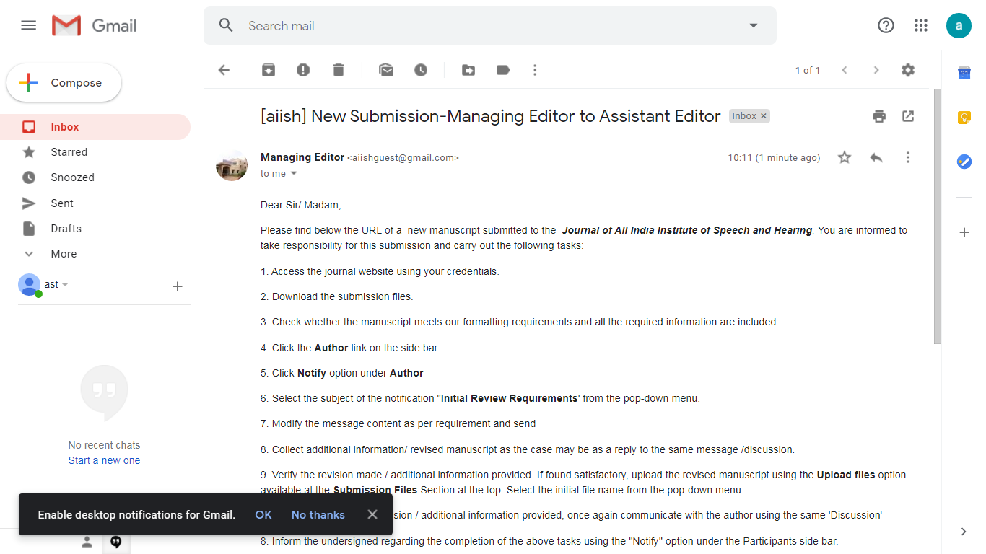 **Figure 1**

1. Click the link to land at the login page of the journal website. (*Figure 2*).

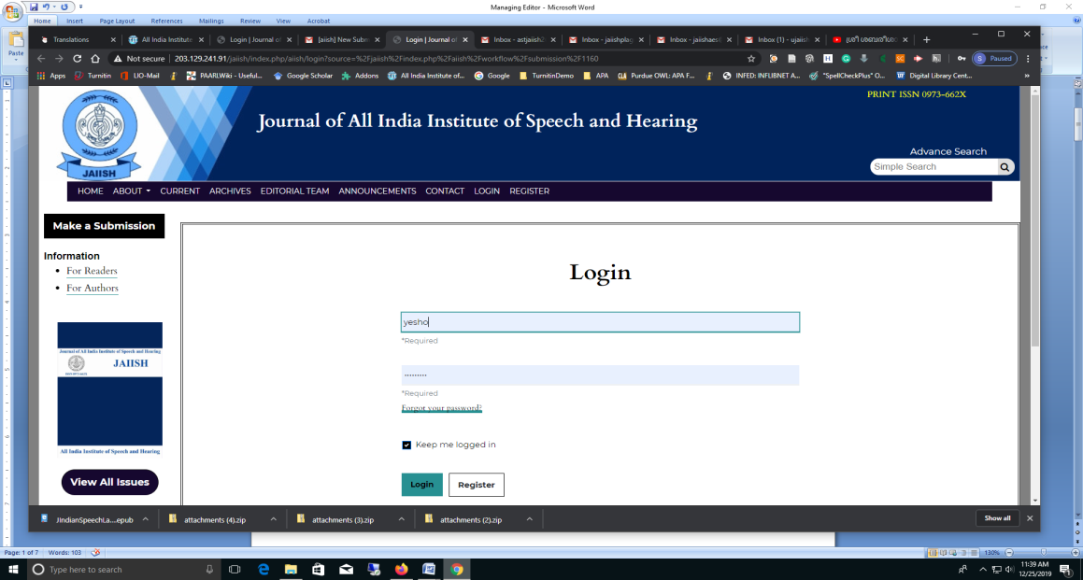

**Figure 2**

1. Enter the **Username** (saha/shar) and **Password** (123456) to reach the **dashboard** of the submitted manuscript on the journal website (*Figure 3*).

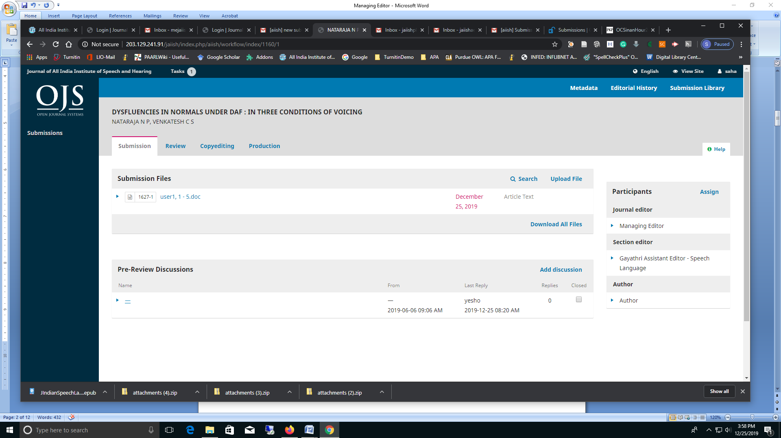

**Figure 3**

1. Alternatively, the **Assistant Editor** can access the JAIISH Website directly from [www.aiish.ac.in](http://www.aiish.ac.in) under the link ‘**Journal of AIISH**’ and then entering the Username (saha) and Password (123456) on the login page. This type of access will take the **Assistant Editor** to the **Submission** Section of her dashboard on the Journal Website with sub-sections **My Queue**, and **Archives**. In ‘**My Queue**’, there will be ‘**My Assigned**’ Section (*Figure 4*). The new submissions will be available under ‘**My Assigned**’ Section.

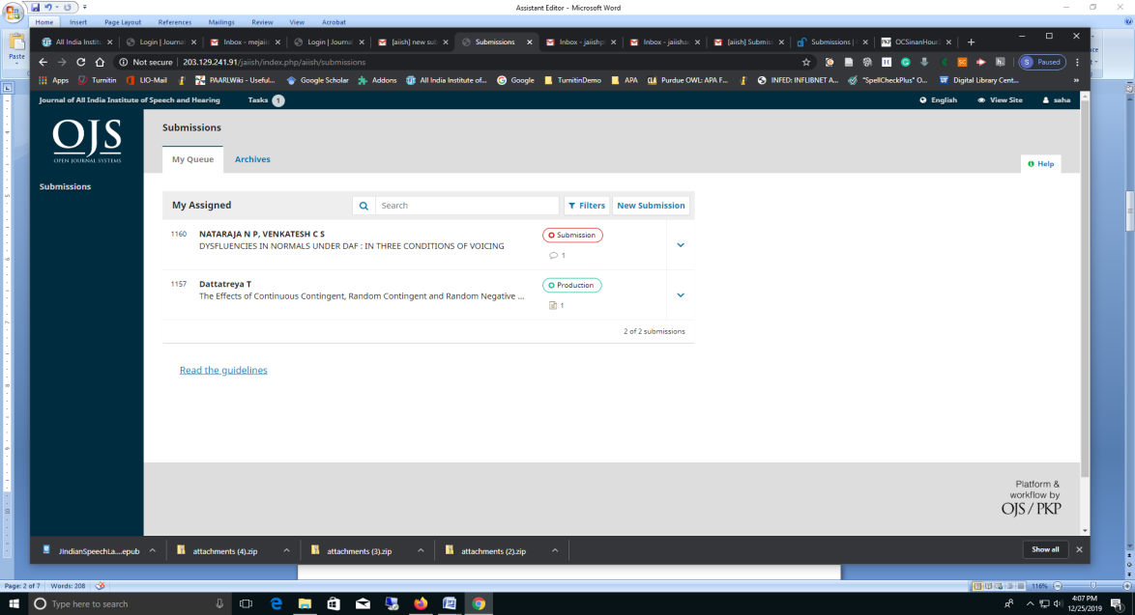

**Figure 4**

1. Click on the manuscript title to open the dashboard pertaining to it (*Figure 5*). You can see 4 main sections on the dashboard: **Submission**, **Review**, **Copy Editing** and **Production**. These are the four stages in the Editorial Work Flow of a manuscript. Now, the **Assistant Editor** is assigned to the Submission stage. It has two Sections: **Submission Files** and **Pre-Review Discussion**. The author submitted manuscript and other documents will be available under the Submission FilesSection. In the Pre-Review Discussion Section the Assistant Editor can read the message from the Managing Editor detailing the actions to be taken on the manuscript. Please note that the messages under the discussions will be a replica of the e-mail message that the Assistant Editor received from the Managing Editor.

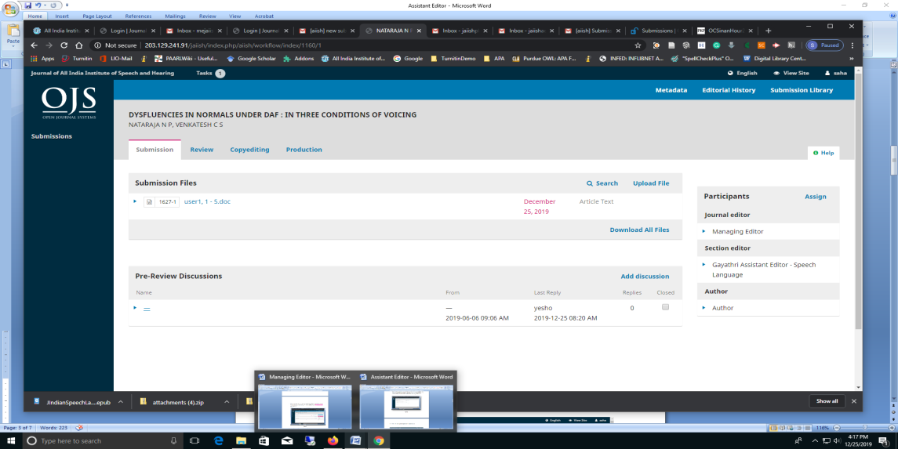

**Figure 5**

1. Download the submission files and verify the details. For clarification regarding the manuscript the Assistant Editor can contact the Author. For this, click the **blue right-pointing triangle symbol** against ‘Author’ on the right panel. From the resulting pop-down menu select **Notify** (Figure 6).

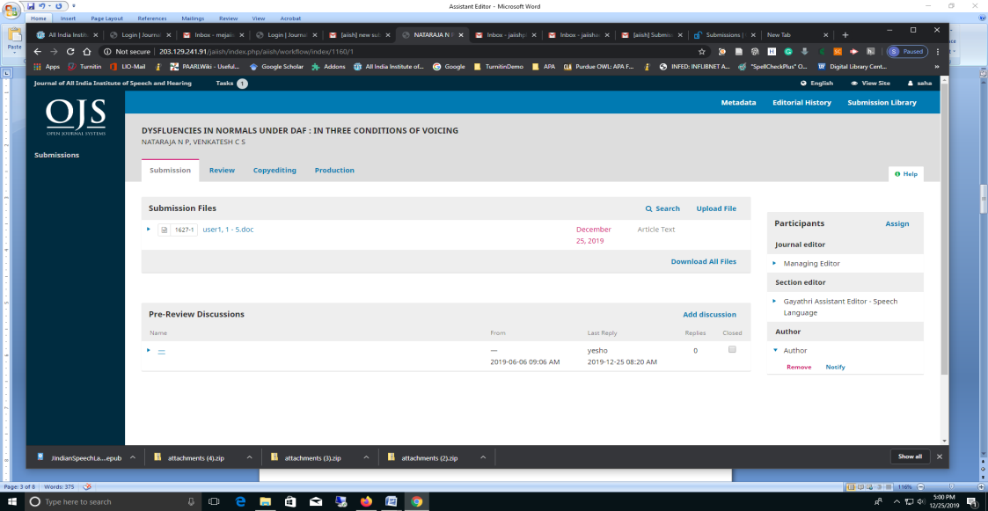

**Figure 6**

1. The **Notify** option will start a discussion with the **Author** by openinga new window titled **Notify**. From the **Choose a predefined message to use, or fill out the form below** select the message titled **Initial Review Requirement: Assistant Editor to the Author**. (Figure 7)

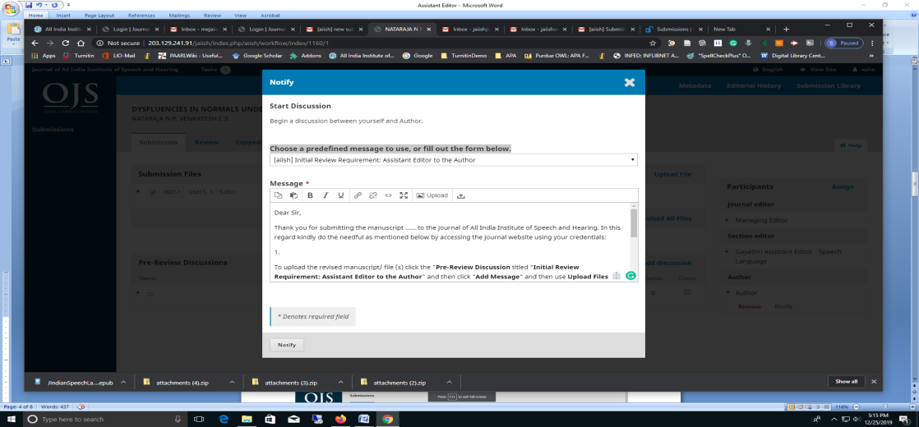**Figure 7**

1. Prepare the message content or copy paste the required modifications as per the template and click **Notify** button at the bottom.

**NB**: The author cannot replace his submission files by himself on his dashboard after making necessary modifications as per the instruction of the Assistant Editor. Also, he cannot add any new files onto his dashboard. The Assistant Editor has to receive the revised manuscript or the additional files, if any, as an attachment to the return communication from the author through the discussion. Hence, it must be clearly communicated to the author as follows: “*To upload the revised manuscript/ file (s) click the "****Pre-Review Discussion*** *titled "****Initial Review Requirement: Assistant Editor to the Author****" on your dashboard on the journal website, click "****Add Message****" and use* ***Upload Files*** *option*”.

1. When the Author submits the revised file/ additional file, the Assistant Editor will receive an email notification regarding this. It will also be available at the Pre-Review Discussion mentioned above.
2. Access the journal website and download the file(s) from the **Pre-Review Discussion** replyof the Author (*Figure 8*).

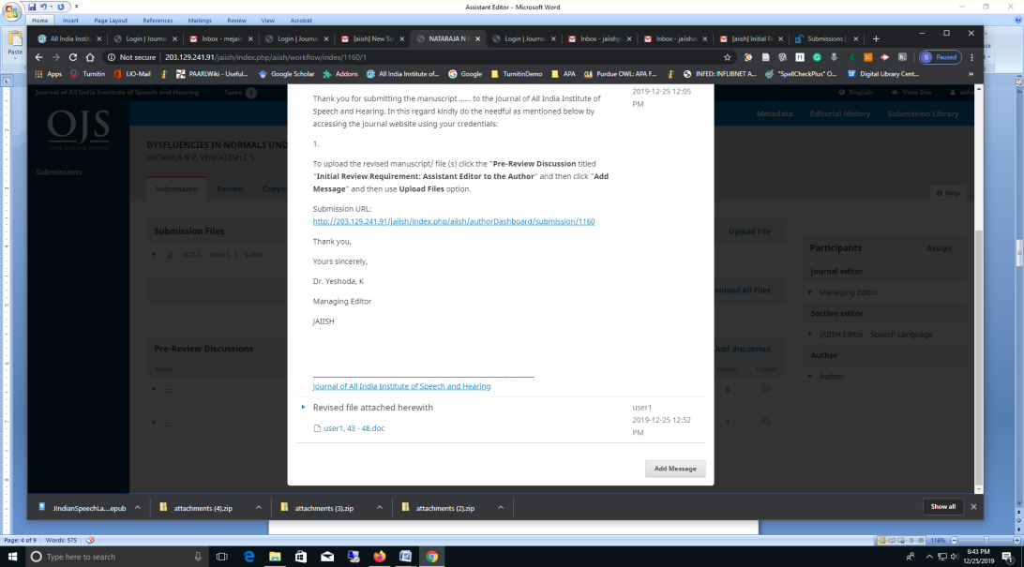

**Figure 8**

1. Verify the details. In case the manuscript meets the requirement **upload** the revised file(s) using the **Upload Files** option at the **Submission Files** section. The manuscript already submitted by the Author will be display under the pop-down menu titled **If you are uploading a revision of an existing file, please indicate which file.** Select it and replace the existing file with revised one (Figure 9).

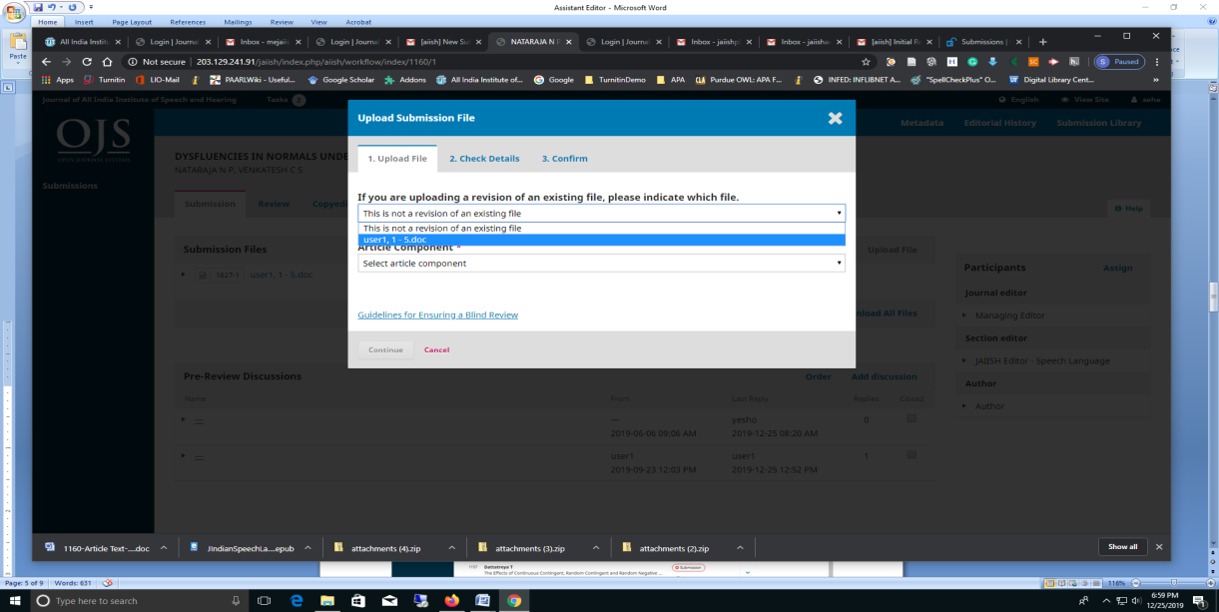

**Figure 9**

1. For further requirements, if any, the Assistant Editor may contact the Author using the same **Discussion** or by creating a new discussion using the **Notify** option on the right side panel.
2. Now, communicate the Managing Editor regarding the completion of the assigned activities of the submission stage. For this, click the **Managing Editor**  link on the right side bar and select **Notify** button under it. (Figure 10).

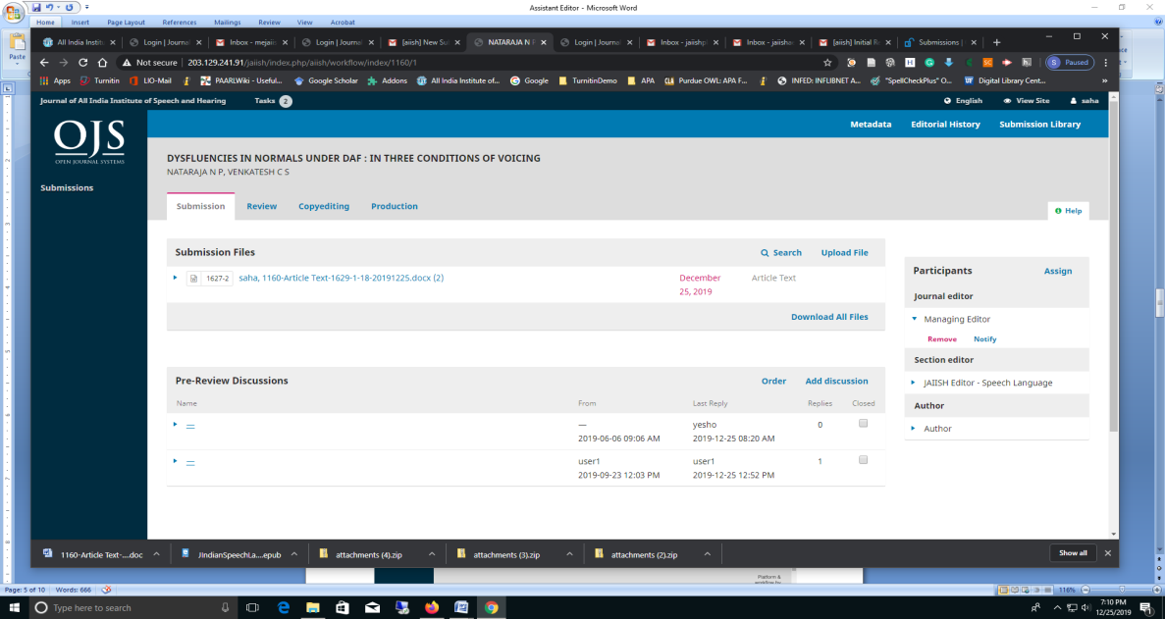

**Figure 10**

1. In the resulting **Notify** window,selectthe pre-defined e-mail template titled **Completion of** **Submission Stage Work: Assistant Editor to Managing Editor**.Makenecessary changes in the e-mail content and send by clicking **Notify** button at the bottom.(Figure 11).

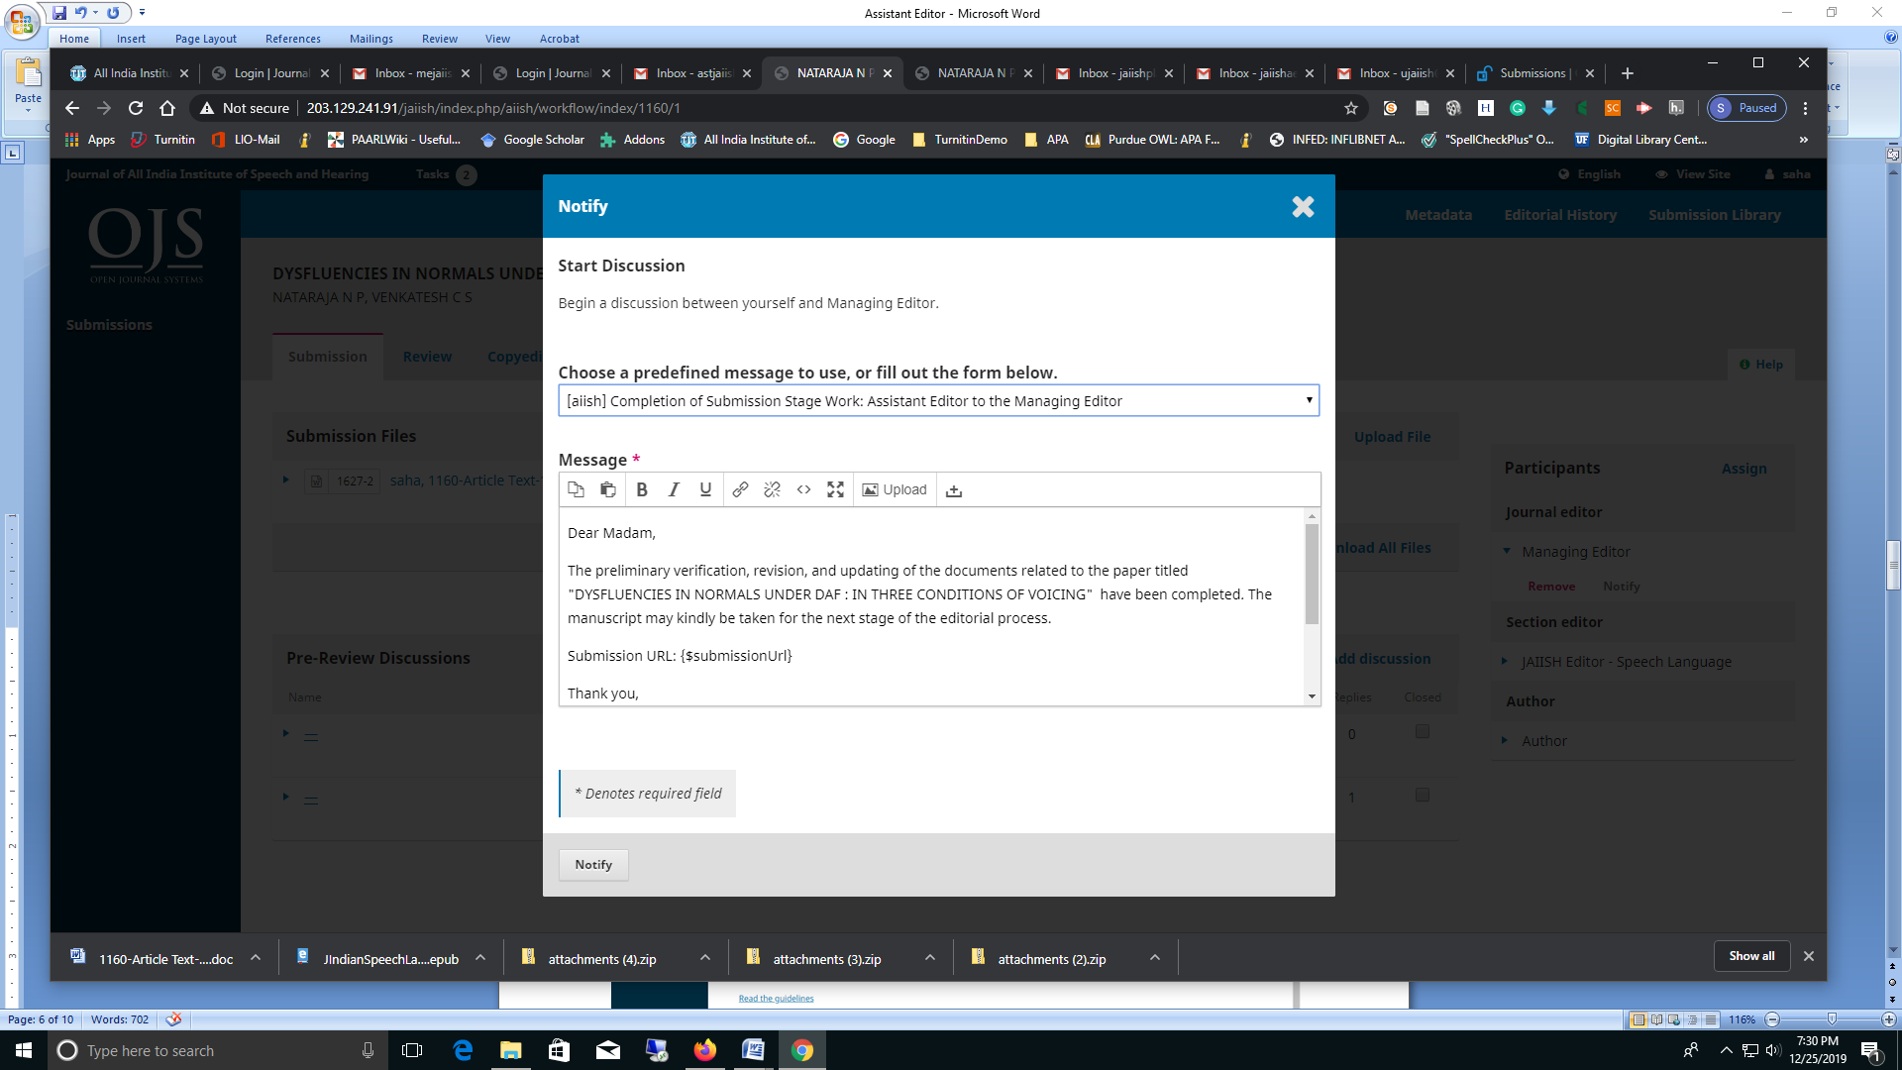

**Figure 11**

**Plagiarism Checking Stage**

1. During the Plagiarism Checking Stage of the manuscript, the Assistant Editor will receive an e-mail notification from the **Managing Editor** for cross-checking of the Author manuscript with the Plagiarism report.
2. Follow the e-mail message link and access the journal website.
3. Cross check the manuscript with the plagiarism report made available at the **Submission File** section
4. If any discrepancy is found, inform the Author using the **Notify** button on the **Author** panel right side. From the pre-defined message select **Request to revise manuscript as per similarity report: Assistant Editor to Author**
5. Receive back the revised manuscript and upload onto the **Submission File** section and inform the Managing Editor regarding the completion of the work using **Notify** on the **JAIISH Managing Editor** Panel. Select the pre-defined message titled **Completion of Cross Checking of Manuscript with Plagiarism Report** and send the message.

**Production**

1. During the **Production Stage** of the manuscript, the Assistant Editor will receive an e-mail notification from the **Managing Editor** for coordinating the **Production Stage** work.
2. Follow the e-mail message link and access the journal website.
3. Download the manuscript ready for production.
4. Prepare the galley using the layout editing link provided by Type Set at
5. Upload the final ready-to publish manuscript onto the Journal using the option **Add Galley**
6. **Notify** the Author using the **Author** panel right side. Select the Pre-defined message titled“**Production Complete: Assistant Editor to the Author**”
7. Receive comments/ suggestions, if any from the Author in the reply message and complete the production.
8. Notify the Managing Editor regarding the completion of the Production. To do this Click the JAIISH Managing Editor on the right panel and click **Notify** and choose In the resulting pre-defined message **Completion of Production : Assistant Editor to Managing Editor**