An understanding of the basic elements of research is essential for good research practices. Among the most important elements to be considered are variables, associations, sampling, random selection, random assignment, and blinding. For a more detailed explanation of other research concepts, please see the [list of references](https://ori.hhs.gov/content/basic-research-concepts-additional-sections-links-to-additional-resources) provided at the end of this curriculum.

**Section 1: Variables**

The purpose of all research is to describe and explain [variance](https://ori.hhs.gov/content/basic-research-concepts-additional-sections#var) in the world. Variance is simply the difference; that is, variation that occurs naturally in the world or change that we create as a result of a manipulation. Variables are names that are given to the variance we wish to explain.

A variable is either a result of some force or is itself the force that causes a change in another variable. In experiments, these are called [dependent](https://ori.hhs.gov/content/basic-research-concepts-additional-sections#depend) and [independent](https://ori.hhs.gov/content/basic-research-concepts-additional-sections#indep) variables respectively.

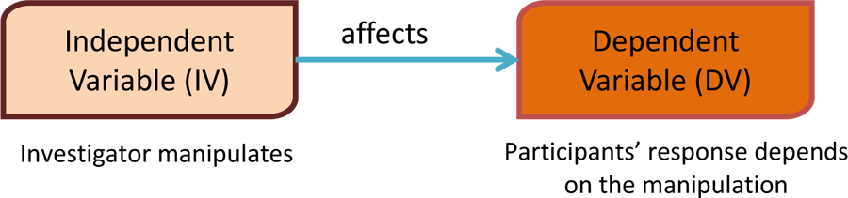

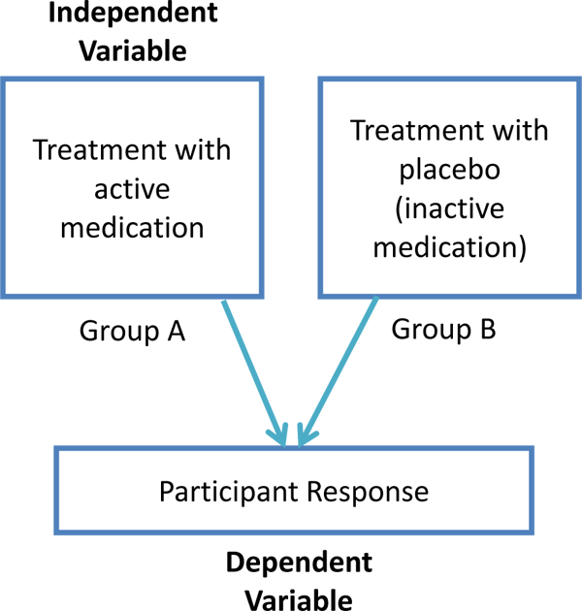When a researcher gives an active medication to one group of people and a placebo, or inactive medication, to another group of people, the independent variable is the medication treatment. Each person's response to the active medication or [placebo](https://ori.hhs.gov/content/basic-research-concepts-additional-sections#plac) is called the dependent variable.

This could be many things depending upon what the medication is for, such as high blood pressure or muscle pain. Therefore, in experiments, a researcher manipulates an independent variable to determine if it causes a change in the dependent variable.

As we learned earlier in a descriptive study, variables are not manipulated. They are observed as they naturally occur and then associations between variables are studied. In a way, all the variables in descriptive studies are dependent variables because they are studied in relation to all the other variables that exist in the setting where the research is taking place. However, in descriptive studies, variables are not discussed using the terms "independent" or "dependent." Instead, the names of the variables are used when discussing the study. For example, there is more diabetes in people of Native American heritage than people who come from Eastern Europe. In a descriptive study, the researcher would examine how diabetes (a variable) is related to a person's genetic heritage (another variable).

**Definition**: A variable is either a result of some force or it is the force that causes a change in another variable. In experiments, these are called dependent and independent variables respectively.

**Case Examples for Independent and Dependent Variables**

**Example 1:**

In an experimental study looking at classical music exposure and reading ability in children, the researcher divided the children into two groups (Groups A and B). In Group A, the children listened to Mozart for one hour every day for one month. In Group B, parents were instructed to refrain from playing classical music around the child for one month. At the end of the month, all children were given a reading comprehension test. Those who listened to Mozart daily (Group A) scored significantly higher on the reading test. In this case, the reading comprehension test score is the dependent variable and exposure to Mozart’s music is the independent variable. This is because the test score is *dependent* on whether or not the child listens to Mozart’s music. The independent variable, exposure to Mozart’s music, is *independent* because it is something that can be manipulated or changed by the researcher.

**Example 2:**

In a study with a similar design as the previous example, researchers looked at the effects of nutrition on reading ability. In Group A, children ate at least three ounces of dark green vegetables every day for one month. In Group B, children were fed their regular diet. At the end of the month, the children took a reading comprehension test. Those who ate the green vegetables every day for one month (Group A) did not vary in their test scores when compared to Group B.

## Section 2: Associations and Cause and Effect

**Definition**: The term association means that two or more things are related or connected to one another.

The term association means that two or more things are related or connected to one another like height and weight, cholesterol level and heart failure or exercise and weight loss. Associations can be positive or negative (the positive and negative associations do not necessarily mean that the association is ‘good’ or ‘bad’). Positive associations suggest that when one variable is increased, the value of another variable increases (e.g., as height increases, so does weight; as cholesterol level increases, so does the risk of heart failure). Negative associations mean that when a variable is increased, the value of another variable decreases (e.g., exercise is introduced (or increased) and weight decreases). Associations can be found in experimental or descriptive studies. Finding significant associations, either during descriptive or experimental studies, may lead to the development of programs or treatments to remedy a particular problem.

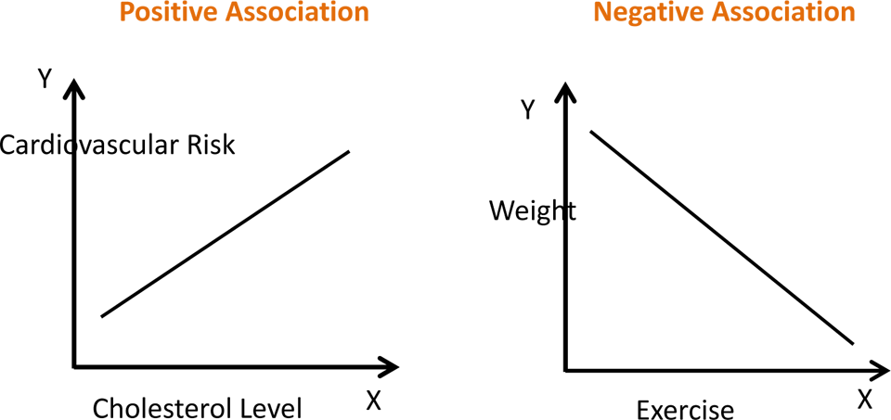

The variable X is the independent variable.

The variable Y is the dependent variable.

## Case example for Associations and Cause and Effect

One example of an association is seen with aspirin use and prevention of heart attacks. The more aspirin that a former heart-attack patient takes, the less likely it is that he/she will have another heart attack ([American Heart Association, "Aspirin and Heart Disease,"](http://www.heart.org/HEARTORG/Conditions/HeartAttack/PreventionTreatmentofHeartAttack/Aspirin-and-Heart-Disease_UCM_321714_Article.jsp), Accessed September 9, 2015).

### Examples of Positive and Negative Associations:

| **Variable 1** | **Variable 2** | **Direction of Association** | **Explanation** |
| --- | --- | --- | --- |
| Education level | Income level | Positive  Positive | As education level increases, so does income level. |
| Exercise | Weight | Negative  Negative | As exercise increases, weight decreases |
| Study time | Test score | Positive  Positive | As study time increases, test score increases |
| Sick days | Work productivity | Negative  Negative | As number of sick days increases, work productivity decreases |

## Section 3: Sampling

Sampling is the process of choosing participants for a research study. Sampling involves choosing a small group of participants that will represent a larger group. Sampling is used because it is difficult or impractical to include all members of a group (e.g., all Latina women in the United States; all male college athletes). However, research projects are designed to ensure that enough participants are recruited to generate useful information that can be generalized to the group represented.

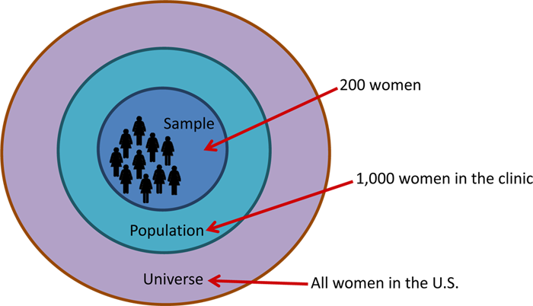

**Definition**: Sampling is defined as the method by which some members of a larger group are selected. The usual goal is sample those members so that they are representative of the group as a whole.

## Case Example for Sampling

An investigator will be studying nutrition among Latina women. To find participants to interview, she requested a list of names and contact information for all Latina women from a community clinic. These women had already provided consent and had agreed to be contacted about participating in future research studies. The list included 1,000 names of potential participants for the nutrition study. The investigator chose 200 of the women from this list to contact for possible inclusion in the study.

## Section 4: Random Selection

Random selection is a form of sampling where a representative group of research participants is selected from a larger group by chance. This can be done by identifying all of the possible candidates for study participation (e.g., people attending the County fair on a Tuesday) and randomly choosing a subset to participate (e.g., selecting every 10th person who comes through the gate). This allows for each person to have an equal chance of participating in the study.

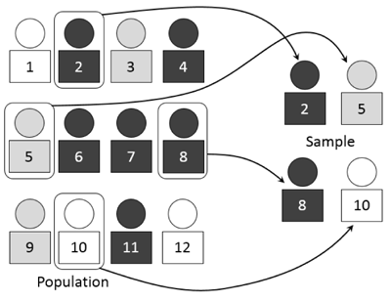Allowing each person in the group an equal chance to participate increases the chance that the smaller group possesses characteristics similar to the larger group. This produces findings that are more likely to be representative of and applicable to the larger group. Therefore, it is extremely important to adhere to this procedure if it is included in the research design. Ignoring or altering random selection procedures compromises the research design and subsequent results. For example, friends or relatives may be easier or more convenient to recruit into a research study, but selecting these individuals would not reflect a random selection of all of the possible participants. Similarly, it would be wrong to select only individuals who may potentially benefit from study participation rather than randomly selecting from the entire group of individuals being studied. Ignoring random selection procedures when they are called for in the research design reduces the quality of the information collected and decreases the usefulness of the study findings.

**Definition**: Random selection is the process of selecting a smaller group of individuals from a larger group to be participants in a study. Every person has an equal chance of being selected, which allows each of the individuals in the group the same chance of participating.

### Case Example for Random Selection

The investigator selects 200 names from a list of 50,000 Latina women by placing all of their names in a hat. Each name is put on a separate piece of paper and names are drawn until 200 names have been picked. This procedure to select names at random can also be done by using special computer programs. A computer program would probably be used for this process when there are hundreds of participants to randomly choose.

## Section 5: Random Assignment

Random assignment is a procedure used in experiments to create multiple study groups that include participants with similar characteristics so that the groups are equivalent at the beginning of the study. The procedure involves assigning individuals to an experimental treatment or program at random, or by chance (like the flip of a coin). This means that each individual has an equal chance of being assigned to either group. Usually in studies that involve random assignment, participants will receive a new treatment or program, will receive nothing at all or will receive an existing treatment. When using random assignment, neither the researcher nor the participant can choose the group to which the participant is assigned.

The benefit of using random assignment is that it "evens the playing field." This means that the groups will differ only in the program or treatment to which they are assigned. If both groups are equivalent except for the program or treatment that they receive, then any change that is observed after comparing information collected about individuals at the beginning of the study and again at the end of the study can be attributed to the program or treatment. This way, the researcher has more confidence that any changes that might have occurred are due to the treatment under study and not to the characteristics of the group.

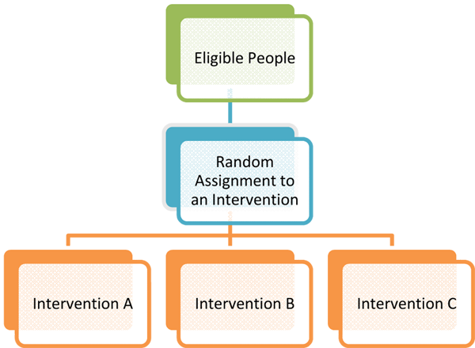A potential problem with random assignment is the temptation to ignore the random assignment procedures. For example, it may be tempting to assign an overweight participant to the treatment group that includes participation in a weight-loss program. Ignoring random assignment procedures in this study limits the ability to determine whether or not the weight loss program is effective because the groups will not be randomized. Research staff must follow random assignment protocol, if that is part of the study design, to maintain the integrity of the research. Failure to follow procedures used for random assignment prevents the study outcomes from being meaningful and applicable to the groups represented.

**Definition**: Random assignment is a procedure used in experiments to create study groups with similar characteristics so that the groups are equivalent at the beginning of the study.

## Case Example for Random Assignment

In a study to help individuals quit smoking, investigators randomly assigned participants to one of two groups. In Group A, participants took a class to quit smoking. The classes took place each week for 10-weeks and included information about the benefits of quitting smoking. In addition, participants in the class received strong social support from mentors or "buddies." In the Group B, participants read a 3-page pamphlet created by the American Cancer Association that explains the benefits of quitting smoking. The investigator randomly assigned participants to one of the two groups. It was found that those who participated in the class and received support from their buddies were more likely to quit smoking compared to those in the other group that received only the pamphlet.

## ection 6: Blinding

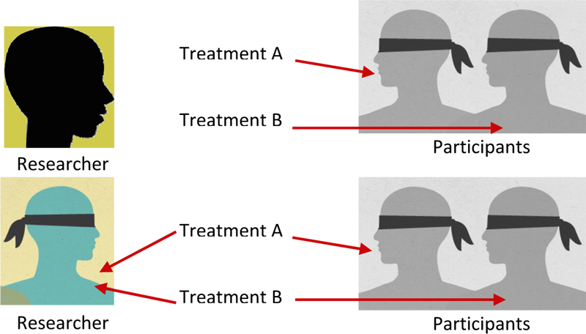Blinding is a technique used to decrease [bias](https://ori.hhs.gov/content/basic-research-concepts-additional-sections#bias) on the part of the researcher or the participant. In some studies, the participant is not told to which group they have been assigned. This is called single blinding. There is another level of blinding called double blinding where neither the researcher nor the participant know which group the participant is in until this information is revealed at the end of the study. Blinding can reduce the temptation to ignore random assignment procedures and can reduce any expectations about the potential effectiveness of the treatment or program since group assignment remains unknown by the participant, the researcher or both the participant and researcher. The results are more likely to provide information about the true effect of the treatment or program being tested when blinding is used.

**Definition**: Blinding is a technique used to decrease bias on the part of the researcher or the participant where the participant, or both the researcher and the participant are not told to which group they have been assigned.

## Case Example for Blinding

In a study investigating the effects of a new anti-itch cream, participants with minor skin rashes were randomly divided into one of three groups. In the first group, participants received a new anti-itch cream that contained 3% hydrocortisone. In the second group, the participants received the standard cream available over-the-counter which contains 1% hydrocortisone. The third and final group members received a cream that contained 0% hydrocortisone. The participants did not know to which group they were assigned. Participants used the cream for three days to relieve itching symptoms caused by the rash. After three days, each participant’s rash was examined to determine if itching symptoms subsided. If this was not the case, the participant was provided with the standard treatment, which is known to relieve itching.