Academic Integrity Online Tutorial – Practical skills

Practical skills module

Use this document as an alternative to the online interactive tutorial
Contents
Academic Integrity Online Tutorial – Practical skills 1
Practical skills module 1
Use this document as an alternative to the online interactive tutorial 1
Screen 1 Title – Practical skills 2
Screen 2 - Introduction 2
Screen 3 –Time management - understanding the assessment task process 3
Screen 4 –Time management - practical tips 5
Screen 5 –Finding information 6
Screen 6 – Effective reading 7
Screen 7 – Effective note taking 8
Screen 8 – Example summary 9
Screen 9 – Using your summaries 11
Screen 10 – Referencing 12
Screen 11 – Using Turnitin 13
Screen 12 – Conclusion 13
Screen 13 – Additional resources 14

Screen 1 Title – Practical skills

Title screen image showing a student holding a pen looking in a dictionary.

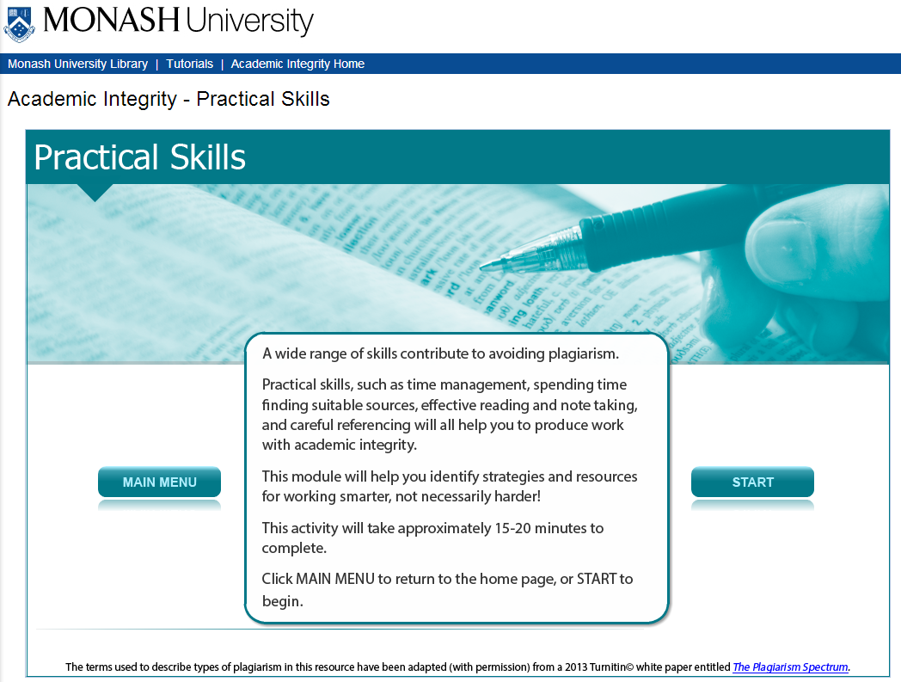

A wide range of skills contribute to avoiding plagiarism.

Practical skills, such as time management, spending time finding suitable sources, effective reading and note taking, and careful referencing will all help you to produce work with academic integrity.

This module will help you identify strategies and resources for working smarter, not necessarily harder!

This activity will take approximately 15-20 minutes to complete.

Screen 2 - Introduction

Image of a young woman holding a white card with information on it.

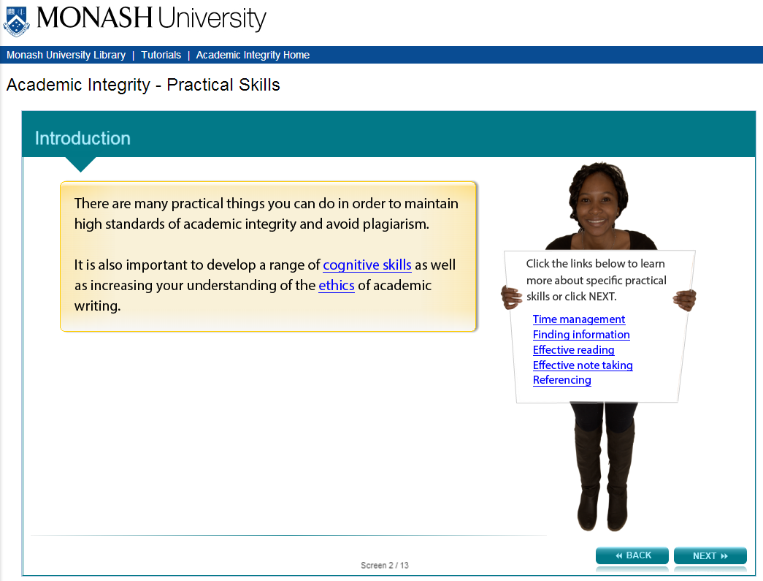

There are many practical things you can do in order to maintain high standards of academic integrity and avoid plagiarism.

It is also important to develop a range of cognitive skills as well as increasing your understanding of the ethics of academic writing.

Instruction to user: (Information on card says):
Click the links below to learn more about specific practical skills or click NEXT. Links take the learner to the screens listed below.

- Time management
- Finding information
- Effective reading
- Effective note taking
- Referencing

Screen 3 –Time management - understanding the assessment task process

Image of same young woman pointing to three text boxes on page.

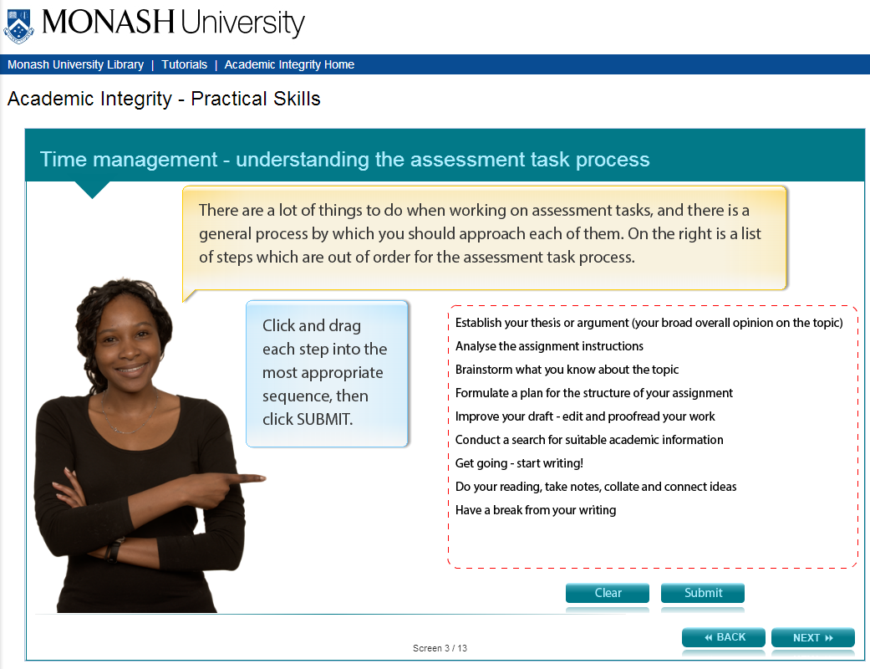

There are a lot of things to do when working on assessment tasks, and there is a general process by which you should approach each of them. There is a list of steps on the right which are out of order for the assessment task process. The user is expected to drag the steps into order.

List of steps

- Establish your thesis (your broad overall opinion on the topic)
- Analyse the assignment instructions
- Brainstorm what you know about the topic
- Formulate a plan for the structure of your assignment
- Improve your draft-edit and proofread your work
- Conduct a search for suitable academic information
- Get going - start writing!
- Do your reading, take notes, collate and connect ideas
- Have a break from your writing

Answers:
Actually, everyone may do these in a slightly different order. The important thing is to know that there are numerous steps. Below is a suggested order.

- Analyse the assignment instructions
- Brainstorm what you know about the topic
- Conduct a search for suitable academic information
- Do your reading, take notes, collate and connect ideas
- Establish your thesis (your broad overall opinion on the topic)
- Formulate a plan for the structure of your assignment
- Get going - start writing!
- Have a break from your writing
- Improve your draft - edit and proofread your work

Screen 4 –Time management - practical tips

Image of same young woman pointing to laptop.

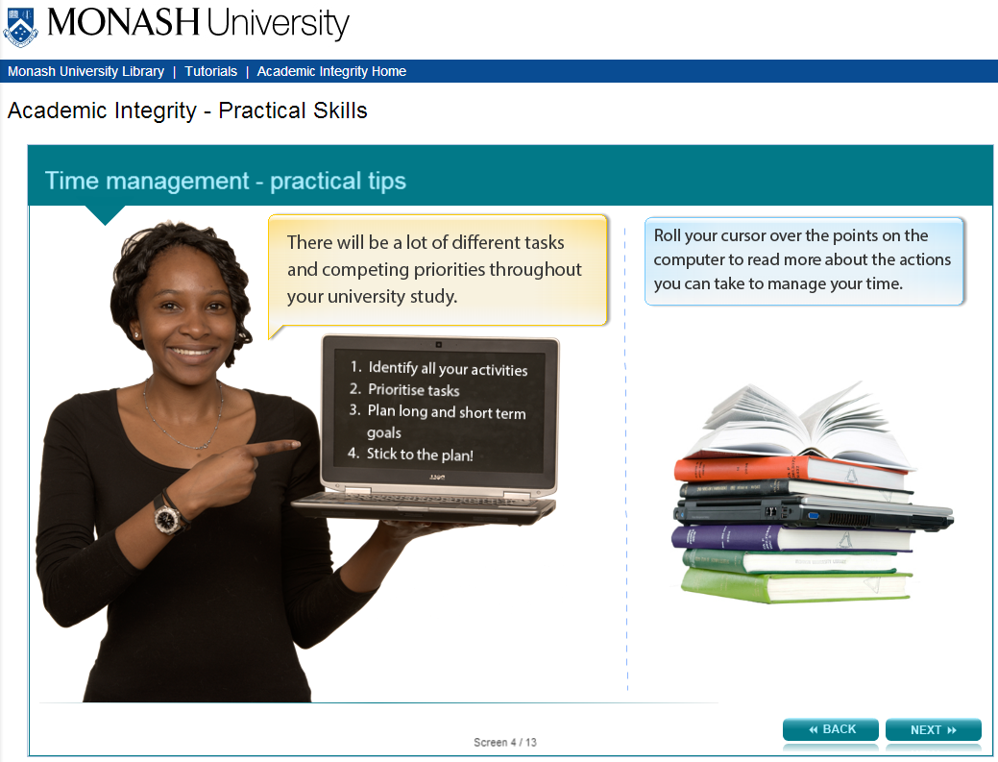

There will be a lot of different tasks and competing priorities throughout your university study.

The users is asked to roll their cursor over the points on the computer to read more about the actions one can take to manage their time.

Headings and information on computer:

- Identify all your activities

Have you thought about all the activities you do in one day?
Your really can’t afford to be wasting your time.

Ask yourself:
- Which activities do you NEED to do?
- Which activities do you spend more time on?
- Have you go time for everything you WANT to do?

- Prioritise tasks

- Prioritise tasks by IMPORTANCE and URGENCY. For example, meeting with friends for coffee is important but not as urgent as finishing and submitting an assignment due this afternoon.

- When several assignments are due in the same week it can be difficult to prioritise tasks, so divide big tasks into smaller pieces and work on these gradually leading up to due dates. This avoids clashes in priorities in the critical week.

- Plan long and short term goals

- Enter classes and assignment due dates in your calendar at the beginning of a semester of study. This overview will help you plan ahead.
- Set short term goals on a weekly basis to achieve your long term targets. For example, study prior to and after classes, or work on smaller parts of an assignment.

- Stick to the plan!

- Work out how long it takes you to do things, and schedule appropriate time to do them.
- Schedule tasks requiring deep critical thinking at times when you are usually most alert.
- Schedule more practical tasks (eg. tidying a reference list) when you’re not at your best.
- Leave gaps in your timetable to catch up on unfinished tasks the following week
- Don’t lose sight of the BIG PICTURE: your degree and your dream job! Remind yourself of these, to keep the motivation and the momentum going.

Screen 5 –Finding information

Image of same young woman holding card displaying links to other Library resources.

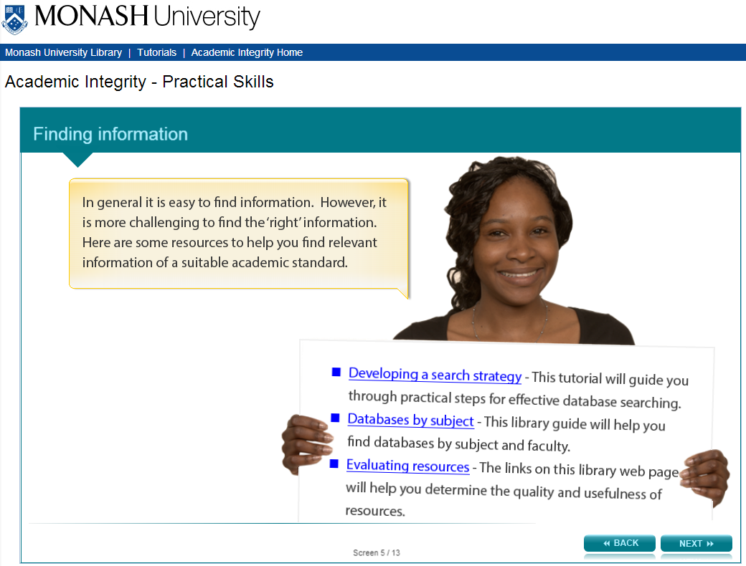

In general it is easy to find information. However, it is more challenging to find the ‘right’ information. Here are some resources to help you find relevant information of a suitable academic standard.

Information on card:

Developing a search strategy (http://www.monash.edu/library/skills/resources/tutorials/searching/) - This tutorial will guide you through practical steps for effective database searching.

Databases by subject (http://guides.lib.monash.edu/subject-databases) - This library guide will help you find databases by subject and faculty.

Evaluating resources (http://www.monash.edu/rlo/research-writing-assignments/finding-and-evaluating-information/evaluating-what-you-find) - The links on this library web page will help you determine the quality and usefulness of resources.

Screen 6 – Effective reading

Image of same woman holding up her hands.

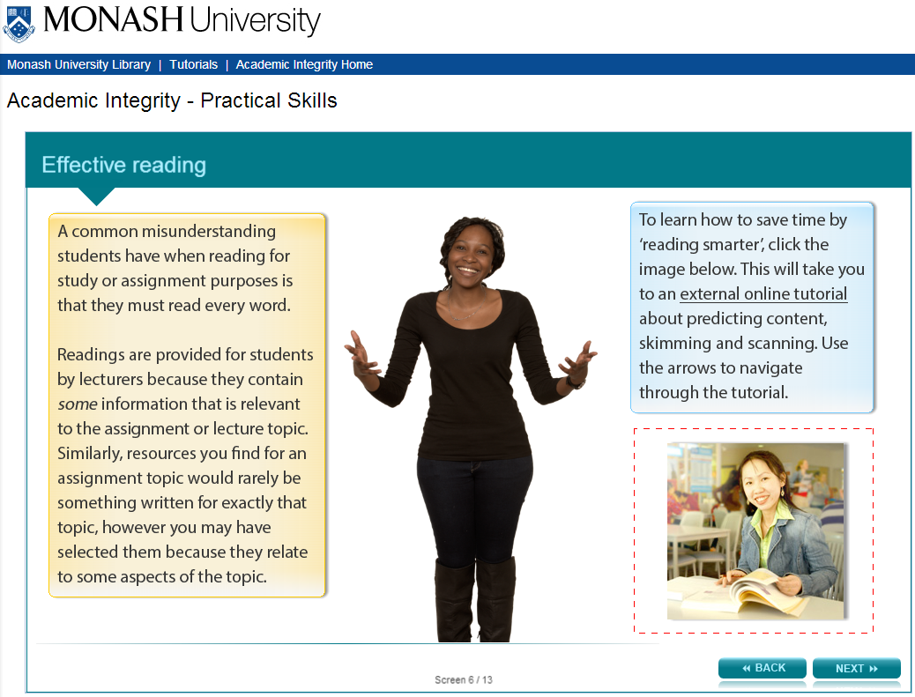

A common misunderstanding students have when reading for study or assignment purposes is that they must read every word.

Readings are provided for students by lecturers because they contain some information that is relevant to the assignment or lecture topic. Similarly, resources you find for an assignment topic would rarely be something written for exactly that topic, however you may have selected them because they relate to some aspects of the topic.

Instruction to user:
To learn how to save time by ‘reading smarter’, the user is asked to click an image. This will take you to an external online tutorial about predicting content, skimming and scanning. Use the arrows to navigate through the tutorial.

Image of a young woman reading a book. Links to http://www.monash.edu.au/lls/llonline/reading/index.xml

Screen 7 – Effective note taking

Image of same young woman holding up card with information on it.

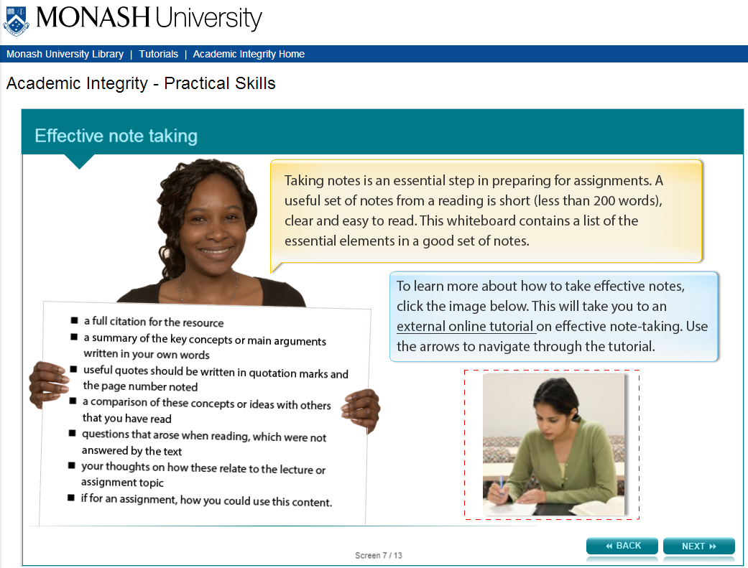

Taking notes is an essential step in preparing for assignments. A useful set of notes from a reading is short (less than 200 words), clear and easy to read. This whiteboard contains a list of the essential elements in a good set of notes.

Information on card:

- a full citation for the resource
- a summary of the key concepts or main arguments written in your own words
- useful quotes should be written in quotation marks and the page number noted
- a comparison of these concepts or ideas with others that you have read
- questions that arose when reading, which were not answered by the text
- your thoughts on how these relate to the lecture or assignment topic
- if for an assignment, how you could use this content.

Instruction to user:
To learn more about how to take effective notes, the user is asked to click an image. This will take you to an external online tutorial on effective note-taking. Use the arrows to navigate through the tutorial.

Image of a woman writing notes. Links to http://www.monash.edu.au/lls/llonline/reading/taking-notes/index.xml

Screen 8 – Example summary

Image of same young woman pointing to summary information.

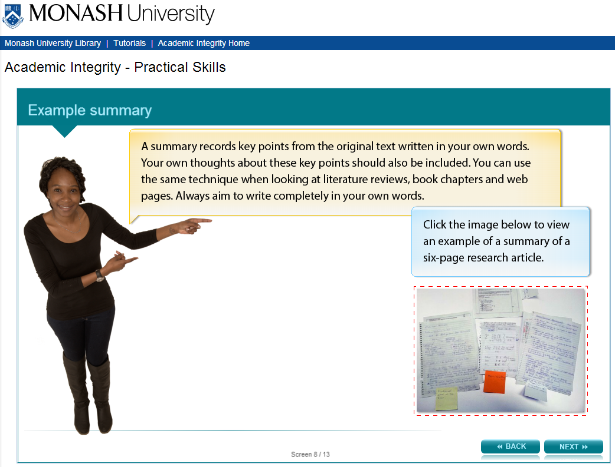

A summary records key points from the original text written in your own words. Your own thoughts about these key points should also be included. You can use the same technique when looking at literature reviews, book chapters and web pages. Always aim to write completely in your own words.

Instruction to user:
The user is asked to click an image to view an example of a summary of a six-page research article.

Image of student’s notes.
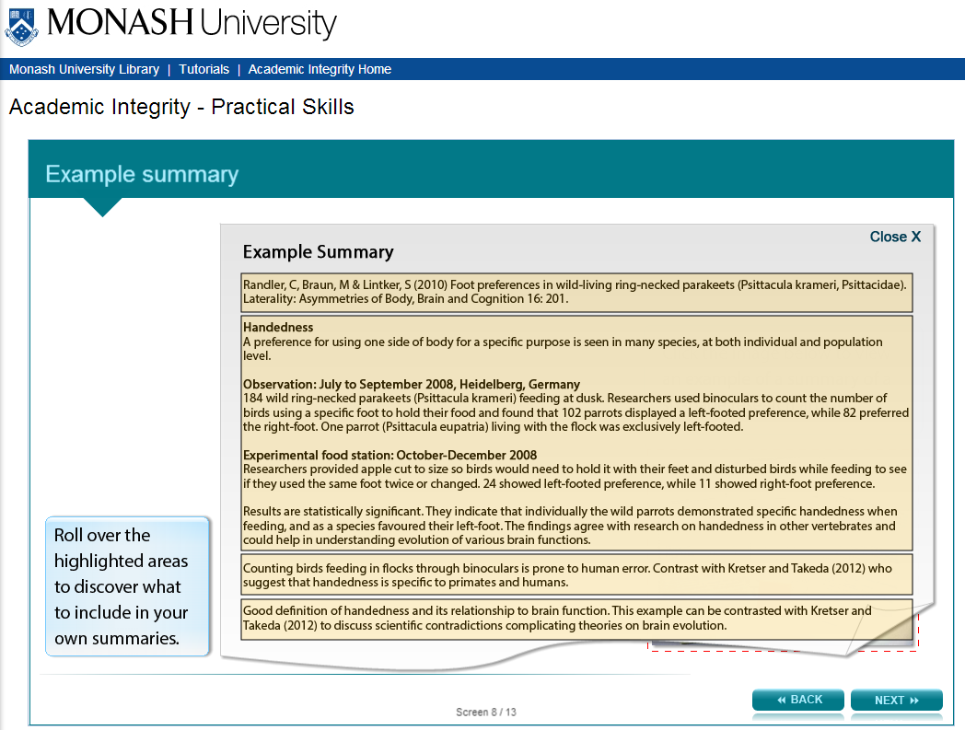

Instructional box:
User is asked to roll cursor over the highlighted areas to discover what to include in their own summaries.

Example Summary
Section 1:
Randler, C, Braun, M & Lintker, S (2010) Foot preferences in wild-living ring-necked parakeets (Psittacula krameri, Psittacidae). Laterality: Asymmetries of Body, Brain and Cognition 16: 201.

Roll over text: Full citation

Section 2:
Handedness
A preference for using one side of body for a specific purpose is seen in many species, at both individual and population level.

Observation: July to September 2008, Heidelberg, Germany 184 wild ring-necked parakeets (Psittacula krameri) feeding at dusk. Researchers used binoculars to count the number of birds using a specific foot to hold their food and found that 102 parrots displayed a left-footed preference, while 82 preferred the right-foot. One parrot (Psittacula eupatria) living with the flock was exclusively left-footed.

Experimental food station: October-December 2008]
Researchers provided apple cut to size so birds would need to hold it with their feet and disturbed birds while feeding to see if they used the same foot twice or changed. 24 showed left-footed preference, while 11 showed right-foot preference.

Results are statistically significant. They indicate that individually the wild parrots demonstrated specific handedness when feeding, and as a species favoured their left-foot. The findings agree with research on handedness in other vertebrates and could help in understanding evolution of various brain functions.

Roll over text: Summary of the original text

Section 3:
Counting birds feeding in flocks through binoculars is prone to human error. Contrast with Kretser and Takeda (2012) who suggest that handedness is specific to primates and humans.

Roll over text: Student’s thoughts on the text, and how it relates to other things he has read

Section 4:
Good definition of handedness and its relationship to brain function. This example can be contrasted with Kretser and Takeda (2012) to discuss scientific contradictions complicating theories on brain evolution.

Roll over text: Student’s thought s on how this can be used in his assignment

Screen 9 – Using your summaries

Image of same young woman thinking.

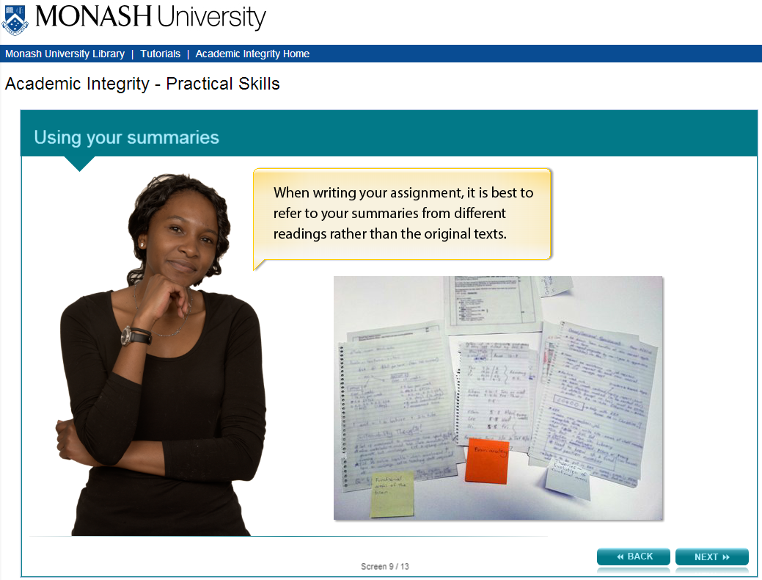

When writing your assignment, it is best to refer to your summaries from different readings rather than the original texts.

Image of student hand written summaries is shown.

Screen 10 – Referencing

Image of same young woman smiling and putting thumb up.

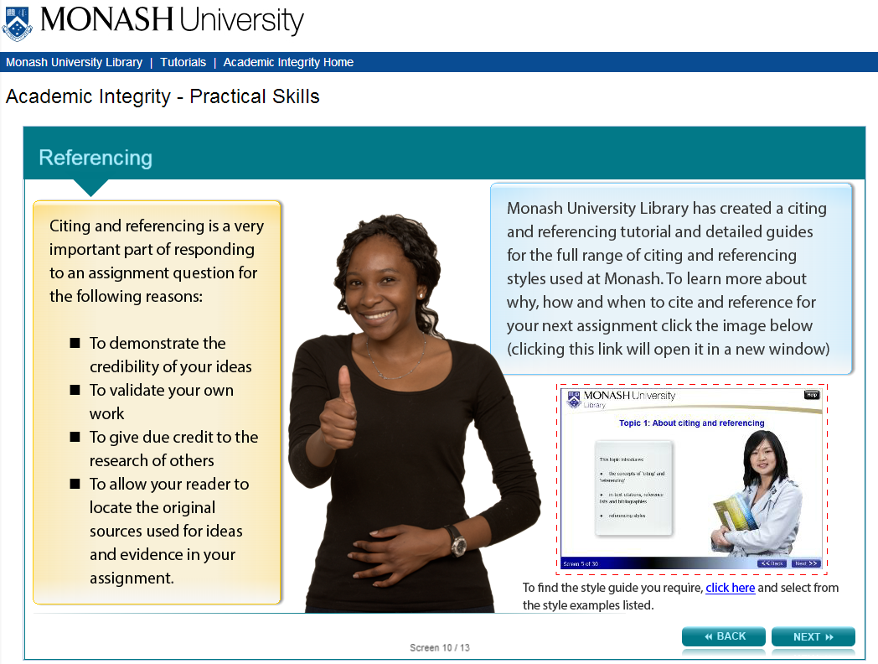

Citing and referencing is a very important part of responding to an assignment question for the following reasons:

- To demonstrate the credibility of your ideas
- To validate your own work
- To give due credit to the research of others
- To allow your reader to locate the original sources used for ideas and evidence in your assignment.

Instruction to user:
Monash University Library has created a citing and referencing tutorial and detailed guides for the full range of citing and referencing styles used at Monash. To learn more about why, how and when to cite and reference for your next assignment click the image below (clicking this link will open it in a new window)

Image of Citing and Referencing online tutorial. Links to http://www.monash.edu/rlo/research-writing-assignments/referencing-and-academic-integrity/citing-and-referencing

Summary below:
To find the style guide you require, click the following link: http://guides.lib.monash.edu/citing-referencing

Screen 11 – Using Turnitin

Image of same young woman holding up a laptop.

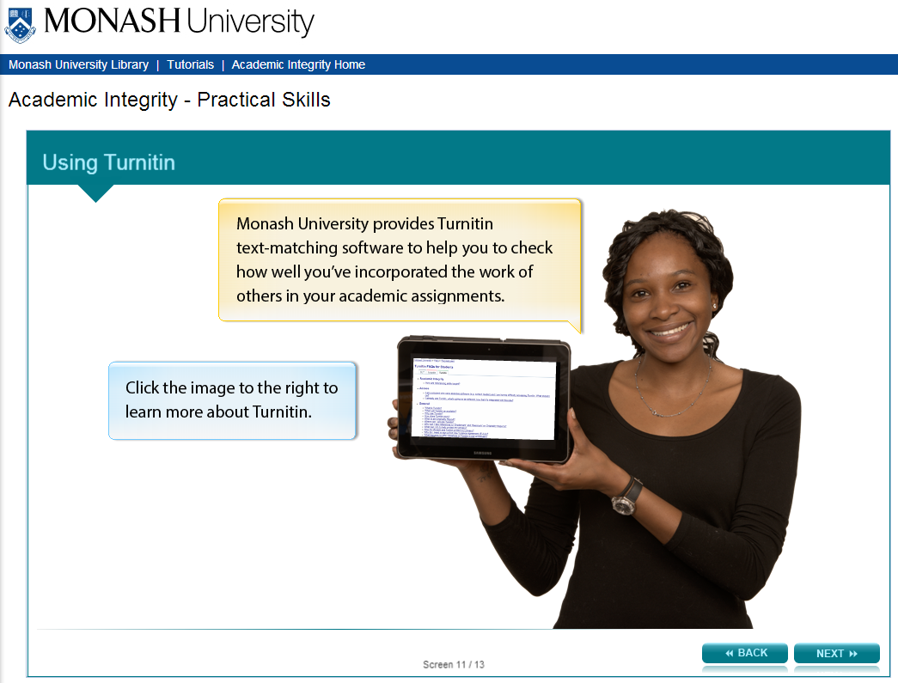

Monash University provides Turnitin text-matching software to help you to check how well you’ve incorporated the work of others in your academic assignments.

Instruction to user:
The user is asked to click the image to the right to learn more about Turnitin.

Links to Turnitin FAQs for students at http://guides.lib.monash.edu/turnitin

Screen 12 – Conclusion

Image of same young woman with hands on hips smiling.

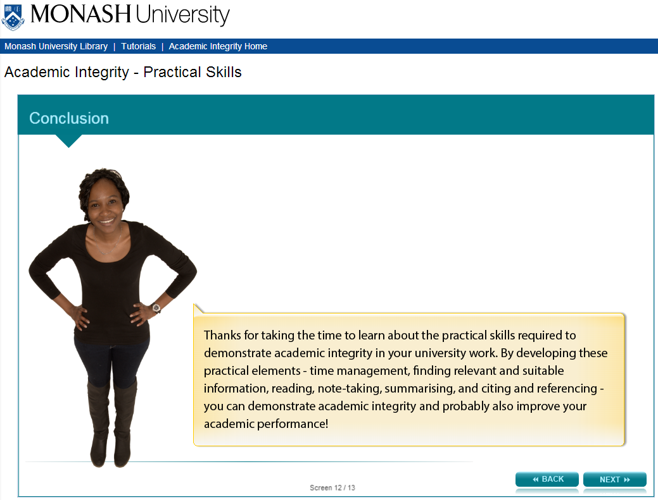

Thanks for taking the time to learn about the practical skills required to demonstrate academic integrity in your university work. By developing these practical elements - time management, finding relevant and suitable information, reading, note-taking, summarising, and citing and referencing - you can demonstrate academic integrity and probably also improve your academic performance!

Screen 13 – Additional resources

Image shows titles and icons of related resources.

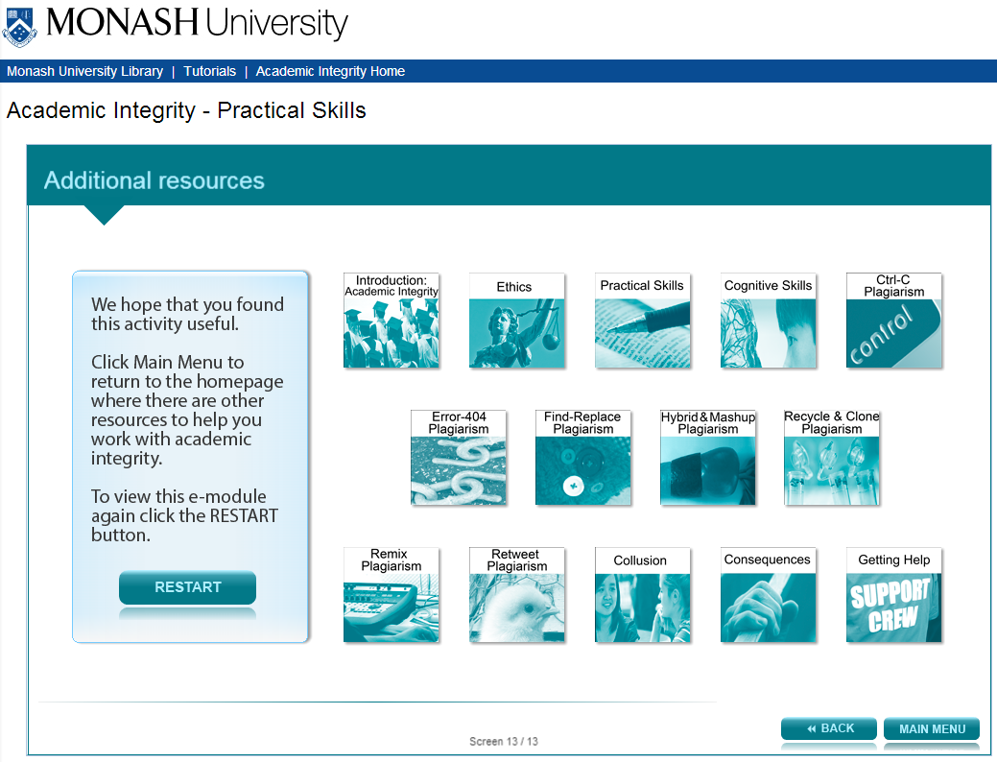

We hope that you found this activity useful.

Click the links below to view other modules in this academic integrity tutorial:

- Introduction: Academic integrity (http://www.monash.edu/rlo/research-writing-assignments/referencing-and-academic-integrity/academic-integrity/introduction)
- Ethics (http://www.monash.edu/rlo/research-writing-assignments/referencing-and-academic-integrity/academic-integrity/ethics)
- Practical skills (http://www.monash.edu/rlo/research-writing-assignments/referencing-and-academic-integrity/academic-integrity/practical-skills)
- Cognitive skills (http://www.monash.edu/rlo/research-writing-assignments/referencing-and-academic-integrity/academic-integrity/cognitive-skills)
- Ctrl-C plagiarism (http://www.monash.edu/rlo/research-writing-assignments/referencing-and-academic-integrity/academic-integrity/ctrl-c)
- Error-404 plagiarism (http://www.monash.edu/rlo/research-writing-assignments/referencing-and-academic-integrity/academic-integrity/error-404)
- Find-Replace plagiarism (http://www.monash.edu/rlo/research-writing-assignments/referencing-and-academic-integrity/academic-integrity/find-and-replace)
- Hybrid & Mashup plagiarism (http://www.monash.edu/rlo/research-writing-assignments/referencing-and-academic-integrity/academic-integrity/hybrid-mashup)
- Recycle & Clone plagiarism (http://www.monash.edu/rlo/research-writing-assignments/referencing-and-academic-integrity/academic-integrity/recycle-and-clone)
- Remix plagiarism (http://www.monash.edu/rlo/research-writing-assignments/referencing-and-academic-integrity/academic-integrity/remix)
- Retweet plagiarism (http://www.monash.edu/rlo/research-writing-assignments/referencing-and-academic-integrity/academic-integrity/retweet)
- Collusion (http://www.monash.edu/rlo/research-writing-assignments/referencing-and-academic-integrity/academic-integrity/collusion)
- Consequences (http://www.monash.edu/rlo/research-writing-assignments/referencing-and-academic-integrity/academic-integrity/consequences)
- Getting help (http://www.monash.edu/rlo/research-writing-assignments/referencing-and-academic-integrity/academic-integrity/getting-help)

