Academic Integrity Online Tutorial – Getting Help

Getting Help module

Use this document as an alternative to the online interactive tutorial
Contents
Academic Integrity Online Tutorial – Getting Help 1
Getting Help module 1
Use this document as an alternative to the online interactive tutorial 1
Screen 1 – Title – Getting help 2
Screen 2 – Introduction 2
Screen 3 – I want to behave with academic integrity 3
Screen 4 – I’m in trouble – what can I do? 4
Screen 5 – Conclusion 5
Screen 6 – Additional resources 6

Screen 1 – Title – Getting help

Title slide image shows a support crew.

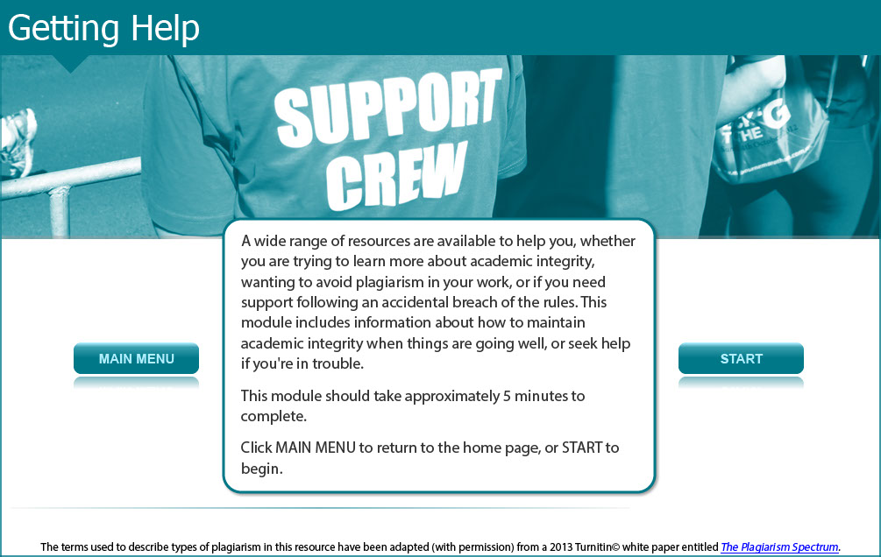

A wide range of resources are available to help you, whether you are trying to learn more about academic integrity, wanting to avoid plagiarism in your work, or if you need support following an accidental breach of the rules. This module includes information about how to maintain academic integrity when things are going well, or seek help if you're in trouble.

This module should take approximately 5 minutes to complete.

Screen 2 – Introduction

The image shows a female student asking for help.
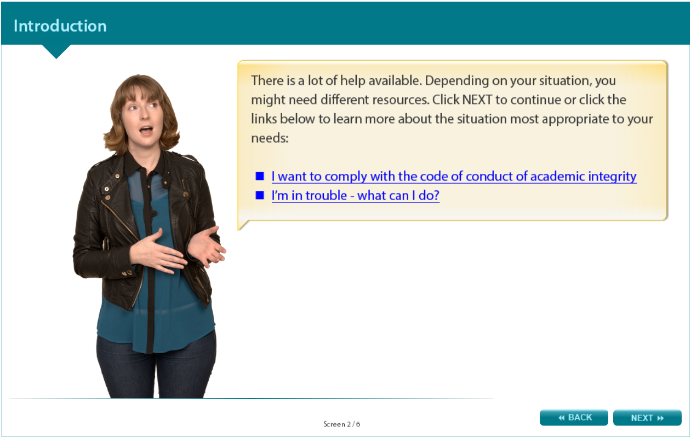

There is a lot of help available. Depending on your situation, you might need different resources. To learn more about the situation most appropriate to your needs read the following information titled “I want to comply with the code of conduct of academic integrity” or “I’m in trouble - what can I do?” in the screens that follow.

Screen 3 – I want to comply with the code of conduct of academic integrity

Image shows a female student pointing to a choice of resources.

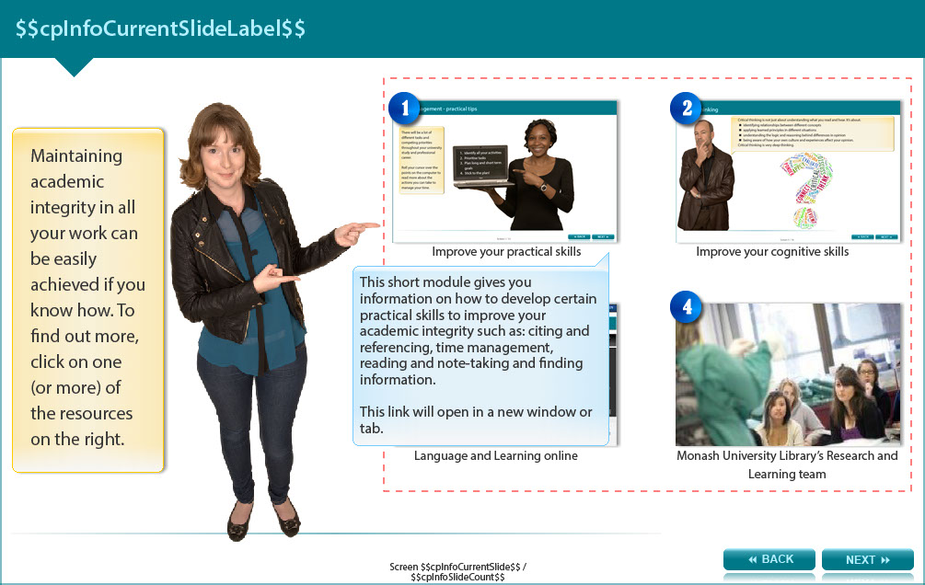

Maintaining academic integrity in all your work can be easily achieved if you know how. To find out more, use one (or more) of the resources described below. The screen shows four images which link to various online resources.

Improve your practical skills - This short module gives you information on how to develop certain practical skills to improve your academic integrity such as: citing and referencing, time management, reading and note-taking and finding information. To view this resource, go to: http://www.monash.edu/rlo/research-writing-assignments/referencing-and-academic-integrity/academic-integrity/practical-skills

Improve your cognitive skills - This short module gives you information on how to develop certain cognitive skills to improve your academic integrity such as: analysis, critical thinking, synthesis and evaluation. To view this resource, go to: http://www.monash.edu/rlo/research-writing-assignments/referencing-and-academic-integrity/academic-integrity/cognitive-skills

Monash University Library’s Research and Learning team - You can get help from a learning skills adviser or librarian to give tailored advice on your assessment tasks or study need. To view this resource, go to: http://monash.edu/library/skills/contacts/

Research and Learning Online - This very comprehensive resource provides help with a range of skills for reading, listening, speaking, writing and university studies. To view this resource, go to: http://www.monash.edu.au/rlo

Screen 4 – I’m in trouble – what can I do?

Image shows a female student indicating several options.

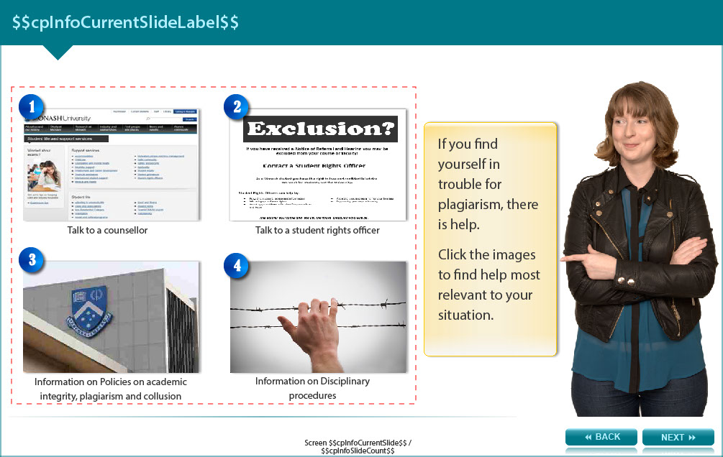

If you find yourself in trouble for plagiarism, there is help.

Choose whichever offers the help most relevant to your situation.

Talk to a counsellor - If you are concerned about your studies, or a mistake you may have made, consider seeing a counsellor to talk through the issues. This is a completely confidential conversation. To view this resource, go to: http://www.monash.edu.au/counselling/

Talk to a student rights officer - If you feel you might be in trouble, a student rights officer can advise you on various policies, processes and your rights and responsibilities in relation to these. Student rights officers are completely independent from the University. To view this resource, go to: http://www.monash.edu/students/support/grievances/student-rights

Access information on disciplinary procedures – information, advice and support are available on academic misconduct. To view this resource, go to: http://www.monash.edu/execserv/discipline

Access information on policies on academic integrity, plagiarism and collusion – detailed explanation of the University processes regarding unsatisfactory academic progress. To view this resource, go to: http://www.monash.edu/students/academic/policies/academic-integrity

Screen 5 – Conclusion

Image shows a female student making a thumbs-up gesture.

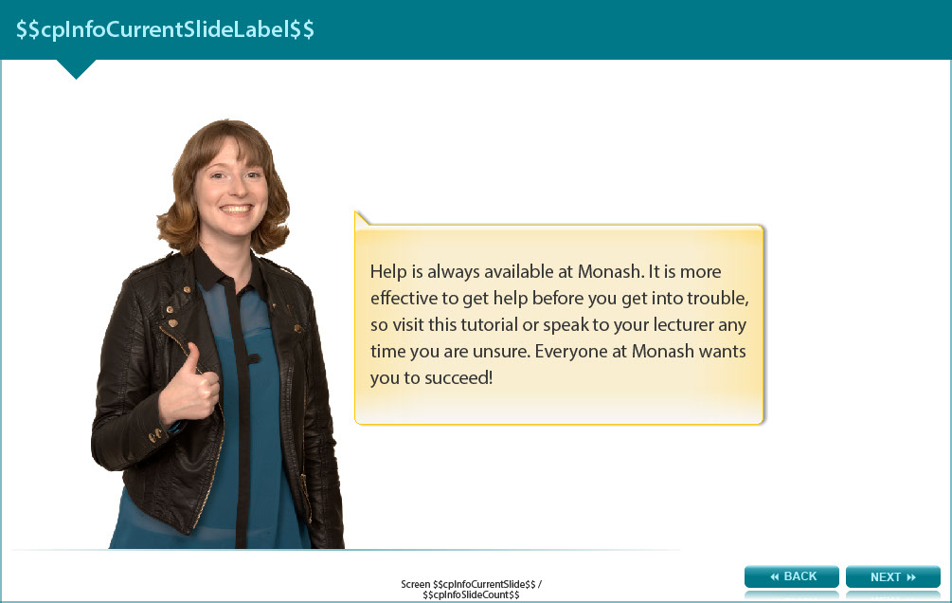

Help is always available at Monash. It is more effective to get help before you get into trouble, so revisit this resource or speak to your lecturer any time you are unsure. Everyone at Monash wants you to succeed!

Screen 6 – Additional resources

Image shows titles and icons of related resources.

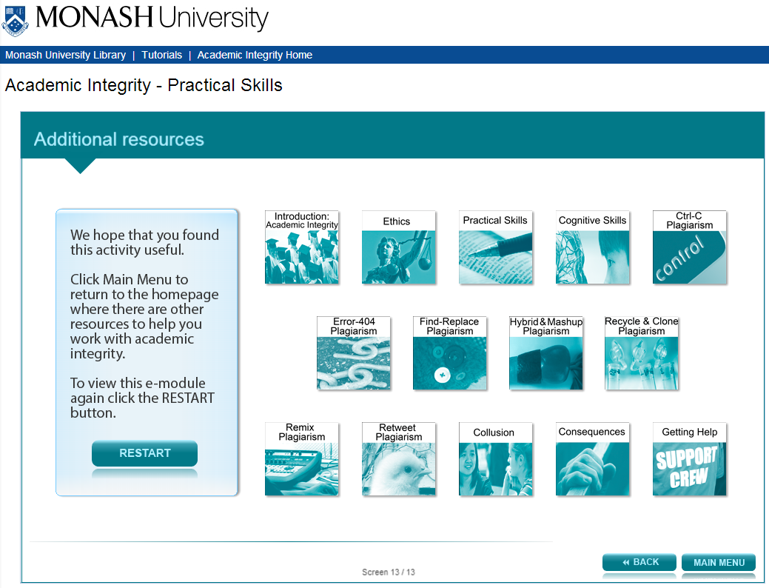

We hope that you found this activity useful.

Click the links below to view other modules in this academic integrity tutorial:

- Introduction: Academic integrity (http://www.monash.edu/rlo/research-writing-assignments/referencing-and-academic-integrity/academic-integrity/introduction)
- Ethics (http://www.monash.edu/rlo/research-writing-assignments/referencing-and-academic-integrity/academic-integrity/ethics)
- Practical skills (http://www.monash.edu/rlo/research-writing-assignments/referencing-and-academic-integrity/academic-integrity/practical-skills)
- Cognitive skills (http://www.monash.edu/rlo/research-writing-assignments/referencing-and-academic-integrity/academic-integrity/cognitive-skills)
- Ctrl-C plagiarism (http://www.monash.edu/rlo/research-writing-assignments/referencing-and-academic-integrity/academic-integrity/ctrl-c)
- Error-404 plagiarism (http://www.monash.edu/rlo/research-writing-assignments/referencing-and-academic-integrity/academic-integrity/error-404)
- Find-Replace plagiarism (http://www.monash.edu/rlo/research-writing-assignments/referencing-and-academic-integrity/academic-integrity/find-and-replace)
- Hybrid & Mashup plagiarism (http://www.monash.edu/rlo/research-writing-assignments/referencing-and-academic-integrity/academic-integrity/hybrid-mashup)
- Recycle & Clone plagiarism (http://www.monash.edu/rlo/research-writing-assignments/referencing-and-academic-integrity/academic-integrity/recycle-and-clone)
- Remix plagiarism (http://www.monash.edu/rlo/research-writing-assignments/referencing-and-academic-integrity/academic-integrity/remix)
- Retweet plagiarism (http://www.monash.edu/rlo/research-writing-assignments/referencing-and-academic-integrity/academic-integrity/retweet)
- Collusion (http://www.monash.edu/rlo/research-writing-assignments/referencing-and-academic-integrity/academic-integrity/collusion)
- Consequences (http://www.monash.edu/rlo/research-writing-assignments/referencing-and-academic-integrity/academic-integrity/consequences)
- Getting help (http://www.monash.edu/rlo/research-writing-assignments/referencing-and-academic-integrity/academic-integrity/getting-help)

