Academic Integrity Tutorial accessibility document

Find-Replace module

Use this document as an alternative to the online interactive tutorial

Contents
Academic Integrity Tutorial accessibility document 1
Find-Replace module 1
Use this document as an alternative to the online interactive tutorial 1
Screen 1- Title – Find-Replace 2
Screen 2 – Identifying Find-Replace Plagiarism 2
Screen 3 – What does Find-Replace look like? 4
Screen 4 – Student Example 5
Screen 5 – Find-Replace-What is the problem? 6
Screen 6 – Another example 7
Screen 7 – Concerns from Find-Replace Plagiarism 9
Screen 8 – Conclusion 9
Screen 9 – Additional Resources 10
Appendix 1-Further Statements for Screen Five 12

Screen 1- Title – Find-Replace

Title slide image showing woollen slipper with different coloured buttons sewn on.

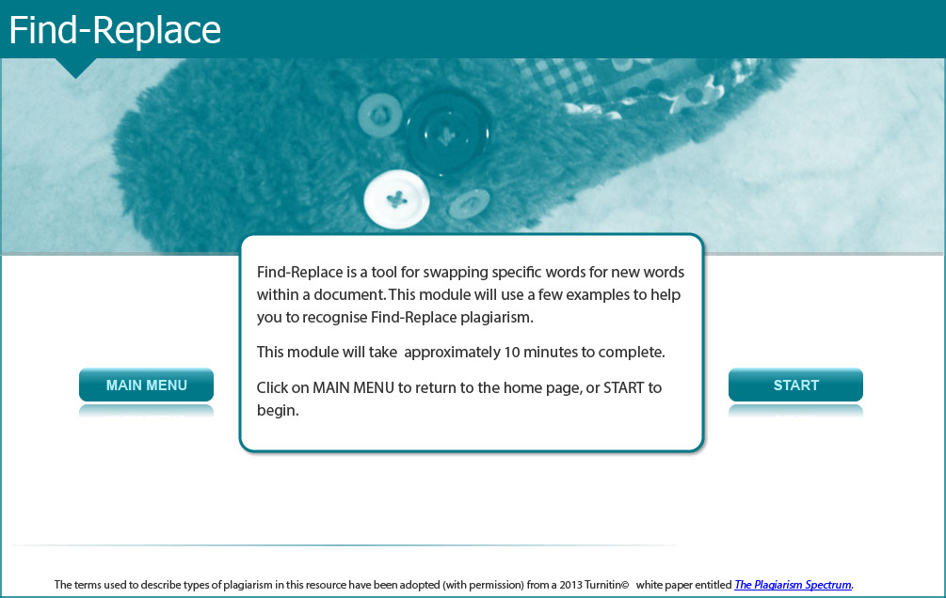

Find-Replace is a tool for swapping specific words for new words within a document. This module will use a few examples to help you to recognise Find-Replace plagiarism.

This module will take approximately 10 minutes to complete.

Screen 2 – Identifying Find-Replace Plagiarism

Image of a male student pointing to an example of find-replace plagiarism in computer code.

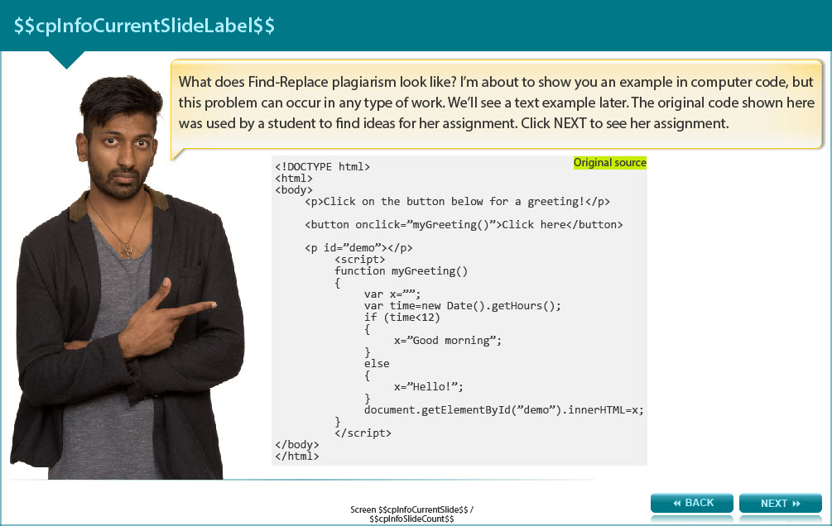

What does Find-Replace plagiarism look like? I’m about to show you an example in computer code, but this problem can occur in any type of work. We’ll see a text example later. The original code shown here was used by a student to find ideas for her assignment. The next screen shows her assignment.

<!DOCTYPE html>
<html>
<body>
<p>Click on the button below for a greeting!</p>

<button onclick=”myGreeting()”>Click here</button>

<p id=”demo”></p>
<script>
function myGreeting()
{
var x=””;
var time=new Date().getHours();
if (time<12)
{
x=”Good morning”;
}
else
{
X=”Hello”;
}
document.getElementByID(“demo”).innerHTML=x;
}
</script>
</body>
</html>

Screen 3 – What does Find-Replace look like?

Image of a male student holding a noticeboard with an example of find-replace plagiarism by a student in their assessment.

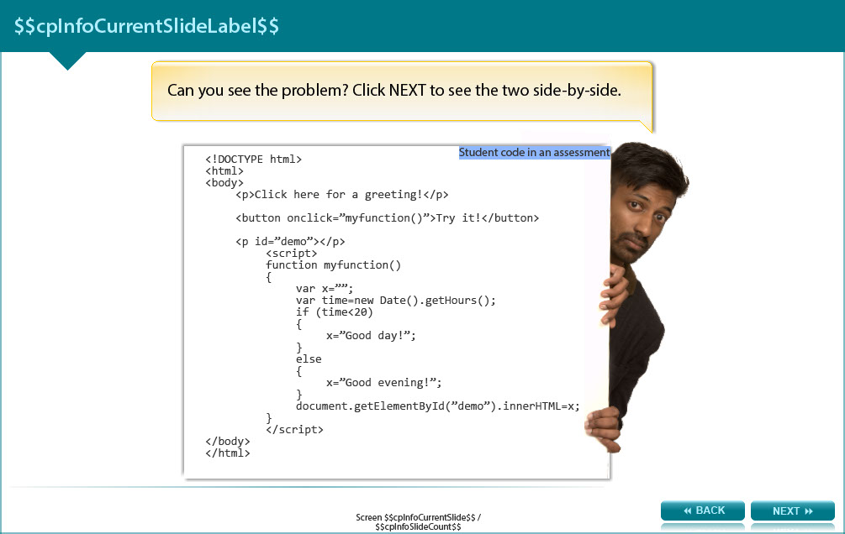

Can you see the problem? The next screen shows the two side-by-side.

<!DOCTYPE html>
<html>
<body>
<p>Click here for a greeting!</p>

<button onclick=”myfunction()”>Try it!</button>

<p id=”demo”></p>
<script>
function myfunction()
{
var x=””;
var time=new Date().getHours();
if (time<20)
{
x=”Good day!”;
}
else
{
X=”Good evening”;
}
document.getElementByID(“demo”).innerHTML=x;
}
</script>
</body>
</html>

Screen 4 – Student Example

Image of an original source computer code and student assessment in computer code side by side as an example of find-replace plagiarism.

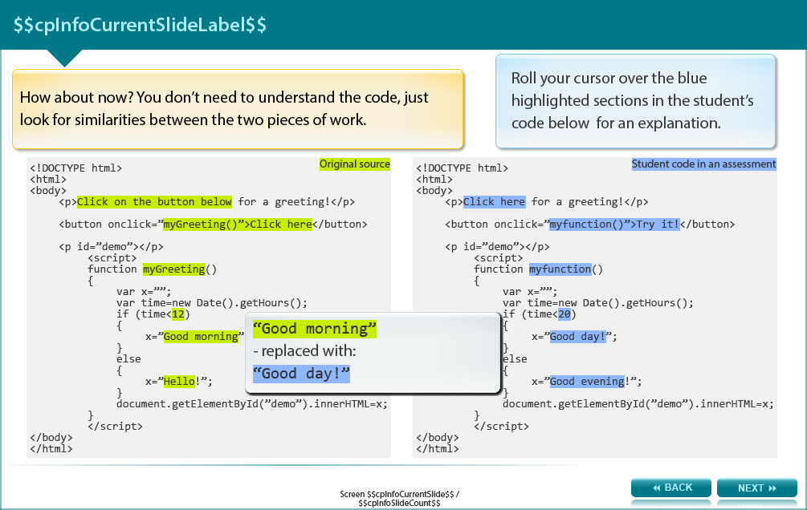

How about now? You don’t need to understand the code, just look for similarities between the two pieces of work.

Original code:

<!DOCTYPE html>
<html>
<body>
<p>Click on the button below for a greeting!</p>

<button onclick=”myGreeting()”>Click here</button>

<p id=”demo”></p>
<script>
function myGreeting()
{
var x=””;
var time=new Date().getHours();
if (time<12)
{
x=”Good morning”;
}
else
{
X=”Hello”;
}
document.getElementByID(“demo”).innerHTML=x;
}
</script>
</body>
</html>

Student code: Note the bold text in the student’s code and read below for an explanation.

<!DOCTYPE html>
<html>
<body>
<p>Click here for a greeting!</p>

<button onclick=”myfunction()”>Try it!</button>

<p id=”demo”></p>
<script>
function myfunction()
{
var x=””;
var time=new Date().getHours();
if (time<20)
{
x=”Good day!”;
}
else
{
X=”Good evening”;
}
document.getElementByID(“demo”).innerHTML=x;
}
</script>
</body>

Points of difference between the original code and the student’s code:

- Click here – replaced original “Click on the button below”
- myfunction()”>Try it! – replaced original “myGreeting()”>Click here”
- myfunction – replaced original “myGreeting()”
- 20 - replaced original “12”
- Good day! - replaced original “Good morning”
- Good evening - replaced original “Hello”

Screen 5 – Find-Replace-What is the problem?

Image of a male student considering the issue.

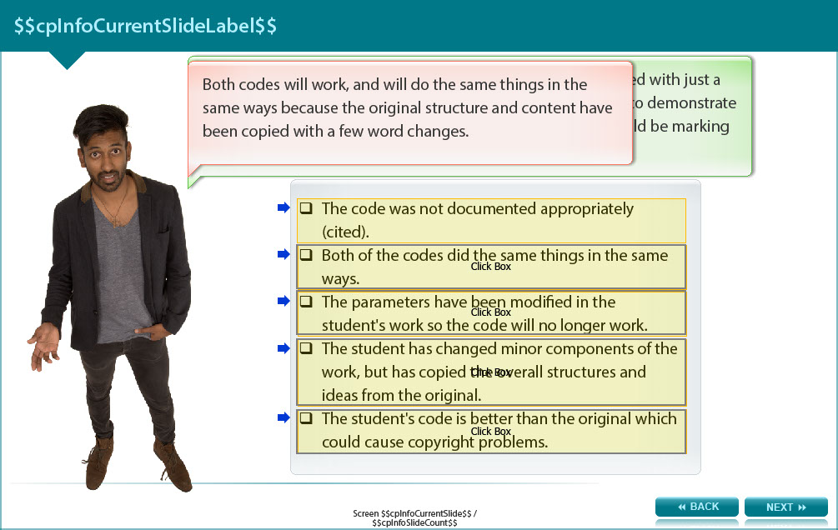

The original source and the student’s work are quite similar. What are the particular problems with this work? Click on the statements that you think apply.

Answers (see the appendix for the correct answer and feedback)

- The code was not documented appropriately (cited).

- Both of the codes did the same things in the same ways.

- The parameters have been modified in the student's work so the code will no longer work.

- The student has changed minor components of the work, but has copied the overall structures and ideas from the original.

- The student's code is better than the original which could cause copyright problems.

Screen 6 – Another example

Image of an original source and a student’s essay side by side as an example of find-replace plagiarism.

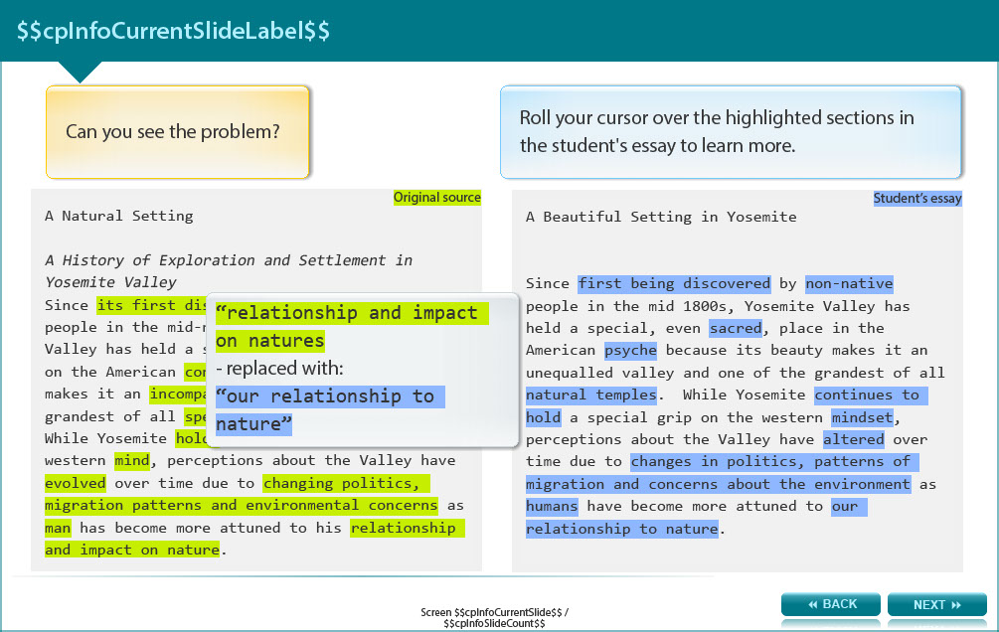

Can you see the problem?

Original source

A Natural Setting

A History of Exploration and Settlement in Yosemite Valley
Since its first discovery by non-indigenous people in the mid-nineteenth century, Yosemite Valley has held a special, even religious, hold on the American conscience because its beauty makes it an incomparable valley and one of the grandest of all special temples of Nature. While Yosemite holds a special grip on the western mind, perceptions about the Valley have evolved over time due to changing politics, migration patterns and environmental concerns as man has become more attuned to his relationship and impact on nature.

Student’s essay

A Beautiful Setting in Yosemite

Since first being discovered by non-native people in the mid 1800s, Yosemite Valley has held a special, even sacred, place in the American psyche because its beauty makes it an unequalled valley and one of the grandest of all natural temples. While Yosemite continues to hold a special grip on the western mindset, perceptions about the Valley have altered over time due to changes in politics, patterns of migration and concerns about the environment as humans have become more attuned to our relationship to nature.

The replaced sections of the student's essay are listed below.

- “its first discovery” replaced with “first being discovered”
- “non-indigenous” replaced with “non-native”
- “religious” replace with “sacred”
- “conscience” replaced with “psyche”
- “special temples of nature” replace with “natural temples”
- “holds” replaced with “continues to hold”
- “mind” replaced with “mindset”
- “evolved” replaced with “altered”
- “changing politics, migration patterns and environmental concerns” replaced with “ changes in politics, patterns of migrations and concerns about the environment”
- “man” replaced with “humans”
- “relationship and impact on nature” replaced with “our relationship to nature”

Screen 7 – Concerns from Find-Replace Plagiarism

Image of male student pointing to reasons and concerns from find-replace plagiarism on a white board.

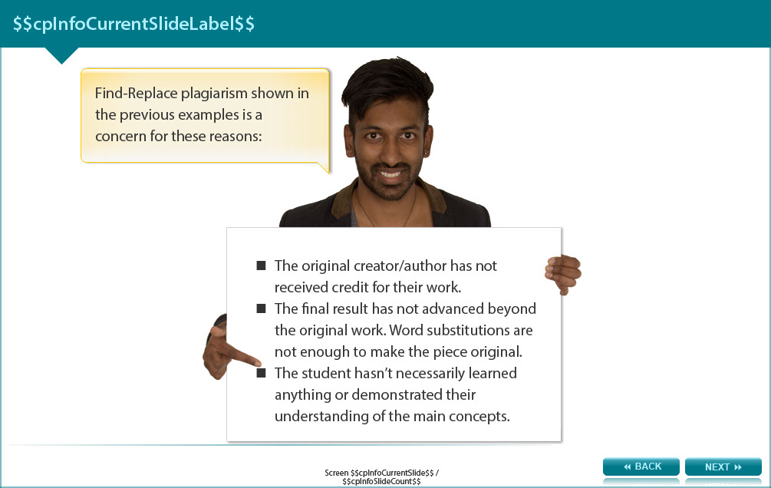

Find-Replace plagiarism shown in the previous examples is a concern for these reasons:

- The original creator/author has not received credit for their work.

- The final result has not advanced beyond the original work. Word substitutions are not enough to make the piece original.

- The student hasn’t necessarily learned anything or demonstrated their understanding of the main concepts.

Screen 8 – Conclusion

Image of a male student pointing to a list of what has been learnt on completion of the find-replace module.

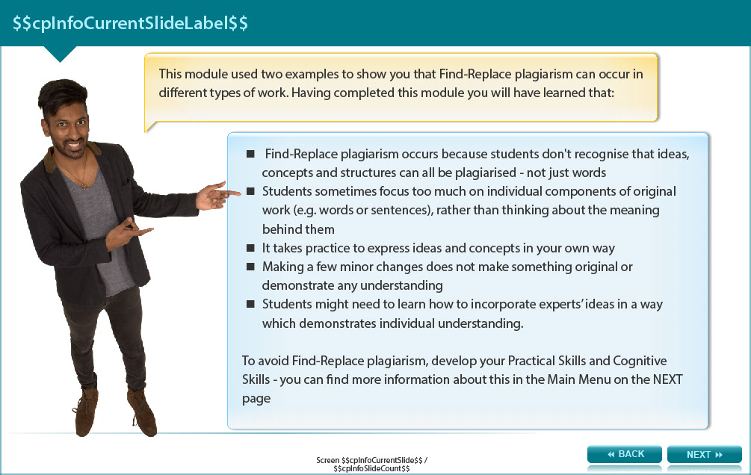

This module used two examples to show you that Find-Replace plagiarism can occur in different types of work. Having completed this module you will have learned that:

- Find-Replace plagiarism occurs because students don't recognise that ideas, concepts and structures can all be plagiarised - not just words

- Students sometimes focus too much on individual components of original work (e.g. words or sentences), rather than thinking about the meaning behind them

- It takes practice to express ideas and concepts in your own way

- Making a few minor changes does not make something original or demonstrate any understanding

- Students might need to learn how to incorporate experts’ ideas in a way which demonstrates individual understanding.

To avoid Find-Replace plagiarism, develop your Practical Skills and Cognitive Skills - you can find more information about this on the next screen.

Screen 9 – Additional Resources

Image shows titles and icons of related resources.

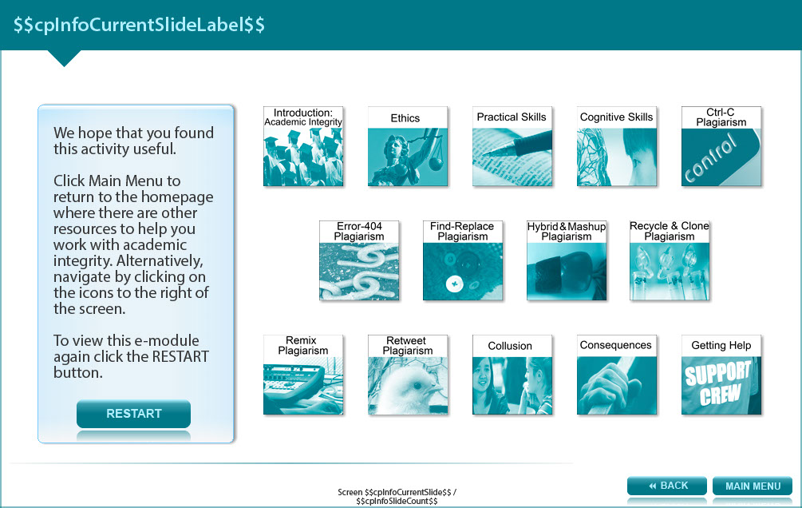

We hope that you found this activity useful.

Click the links below to view other modules in this academic integrity tutorial:

- Introduction: Academic integrity (http://www.monash.edu/rlo/research-writing-assignments/referencing-and-academic-integrity/academic-integrity/introduction)
- Ethics (http://www.monash.edu/rlo/research-writing-assignments/referencing-and-academic-integrity/academic-integrity/ethics)
- Practical skills (http://www.monash.edu/rlo/research-writing-assignments/referencing-and-academic-integrity/academic-integrity/practical-skills)
- Cognitive skills (http://www.monash.edu/rlo/research-writing-assignments/referencing-and-academic-integrity/academic-integrity/cognitive-skills)
- Ctrl-C plagiarism (http://www.monash.edu/rlo/research-writing-assignments/referencing-and-academic-integrity/academic-integrity/ctrl-c)
- Error-404 plagiarism (http://www.monash.edu/rlo/research-writing-assignments/referencing-and-academic-integrity/academic-integrity/error-404)
- Find-Replace plagiarism (http://www.monash.edu/rlo/research-writing-assignments/referencing-and-academic-integrity/academic-integrity/find-and-replace)
- Hybrid & Mashup plagiarism (http://www.monash.edu/rlo/research-writing-assignments/referencing-and-academic-integrity/academic-integrity/hybrid-mashup)
- Recycle & Clone plagiarism (http://www.monash.edu/rlo/research-writing-assignments/referencing-and-academic-integrity/academic-integrity/recycle-and-clone)
- Remix plagiarism (http://www.monash.edu/rlo/research-writing-assignments/referencing-and-academic-integrity/academic-integrity/remix)
- Retweet plagiarism (http://www.monash.edu/rlo/research-writing-assignments/referencing-and-academic-integrity/academic-integrity/retweet)
- Collusion (http://www.monash.edu/rlo/research-writing-assignments/referencing-and-academic-integrity/academic-integrity/collusion)
- Consequences (http://www.monash.edu/rlo/research-writing-assignments/referencing-and-academic-integrity/academic-integrity/consequences)
- Getting help (http://www.monash.edu/rlo/research-writing-assignments/referencing-and-academic-integrity/academic-integrity/getting-help)

Appendix 1-Further Statements for Screen Five

Screen 5 – Find-Replace – what is the problem?
- True, there was no citation of the original source. Just including a citation is not sufficient to avoid plagiarism; there are other problems.
- Well done. The original structure and content have been copied with just a few words altered, so both codes will do the same things in the same ways.
- Both codes will work, and will do the same things in the same ways because the original structure and content have been copied with a few word changes.
- Absolutely. The original structure and content have been copied with just a few words altered. There is nothing unique in this submission to demonstrate that she knows how the code works. Her assessor would be marking the original programmer’s creation, not the student’s work. Click NEXT to see an example in a student essay.
- One would not necessarily be better than the other; both codes will do the same things in the same ways because the original structure and content have been copied with very minor changes. Click NEXT to see an example in a student essay.

