Academic Integrity Online Tutorial - Ctrl-C

Ctrl-C module

Use this document as an alternative to the online interactive tutorial
Contents
Academic Integrity Online Tutorial - Ctrl-C 1
Ctrl-C module 1
Use this document as an alternative to the online interactive tutorial 1
Screen 1- Title – Ctrl-C 2
Screen 2 – What does academic integrity include? 3
Screen 3 – What is Ctrl C Plagiarism ? 5
Screen 4 – Ctrl-C Plagiarism 7
Screen 5 – Another example 8
Screen 6 – Something Missing 9
Screen 7 – Acknowledging Images 10
Screen 8 – Conclusion 10
Screen 9 – Additional Resources 11

Screen 1- Title – Ctrl-C

Title slide image showing part of a keyboard with the word “control”.

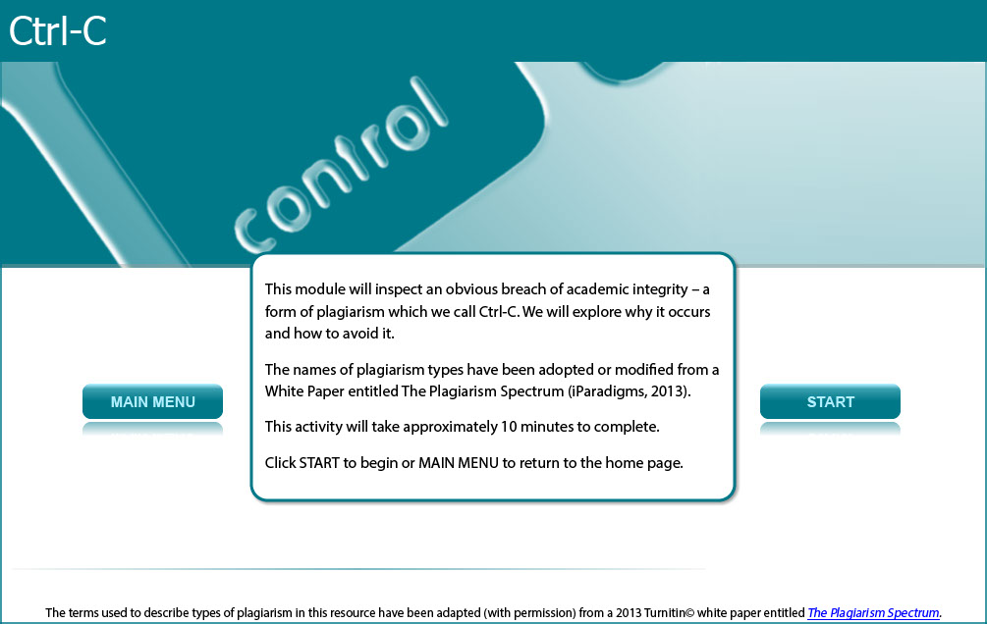

This module will inspect an obvious breach of academic integrity – a form of plagiarism which we call Ctrl-C. We will explore why it occurs and how to avoid it.

The names of plagiarism types have been adopted or modified from a White Paper entitled The Plagiarism Spectrum (iParadigms, 2013).

This activity will take approximately 10 minutes to complete.

Screen 2 – What does academic integrity include?

Image of a female student pointing to a link to as student’s essay.

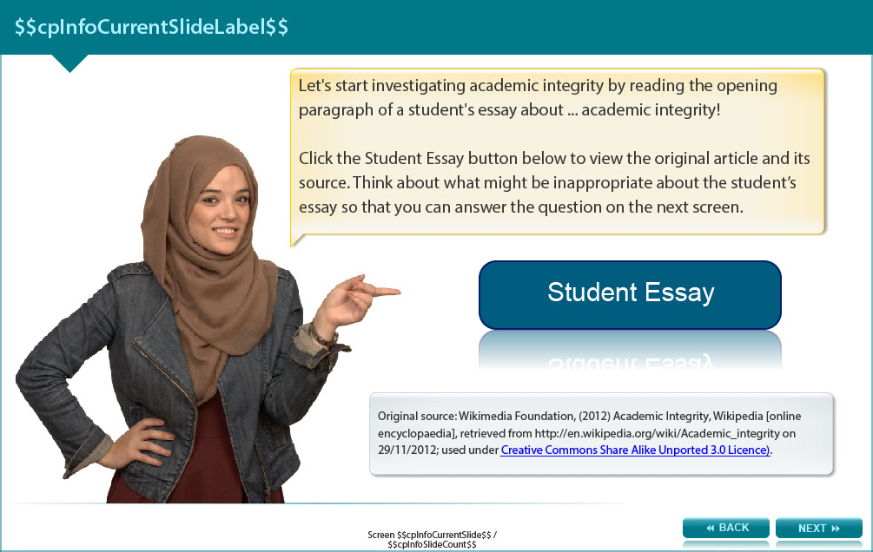

Let's start investigating academic integrity by reading the opening paragraph of a student's essay about ... academic integrity!

Read below to view the original article and its source. Think about what might be inappropriate about the student’s essay so that you can answer the question on the next screen.

Original source: Wikimedia Foundation, (2012) Academic Integrity, Wikipedia [online encyclopaedia], retrieved from http://en.wikipedia.org/wiki/Academic_integrity on 29/11/2012; used under Creative Commons Share Alike Unported 3.0 Licence).

Student Essay

It is important to be aware of issues relating to academic integrity when studying at university. There are quite a few problems surrounding academic integrity with regards to the modern world. The internet has provided a quick, relatively easy way to cheat -- a temptation that did not exist until quite recently. And the definition of what constitutes cheating or plagiarism has become blurred. Students have become less likely to cite their sources simply because of the sheer variety of sources that they may use. Prior to the internet, books and magazines were the primary sources. But now, information is being gathered at alarming rates from the web and is going un-cited because of an increasing ignorance of what needs to be cited. For example, because the information is found on the internet, a student may assume because it is “free” and “unpublished” that it need not be cited.

Original Source

Academic Integrity Issues

There are quite a few problems surrounding academic integrity with regards to the modern world. The internet has provided a quick, relatively easy way to cheat-a temptation that did not exist until quite recently. And, the definition of what constitutes cheating or plagiarism has become blurred. Students have become less likely to cite their sources simply because of the sheet variety of sources that they may use. Prior to the internet, books and magazines were the primary sources. But now, information being gathered at alarming rates from the web and is going un-cited because of an increasing ignorance of what needs to be cited. For example, because the information is found on the internet, a student may assume because it is “free” and “unpublished” that it need not be cited.

Screen 3 – What is Ctrl C Plagiarism?

Image of a female student considering the issue.

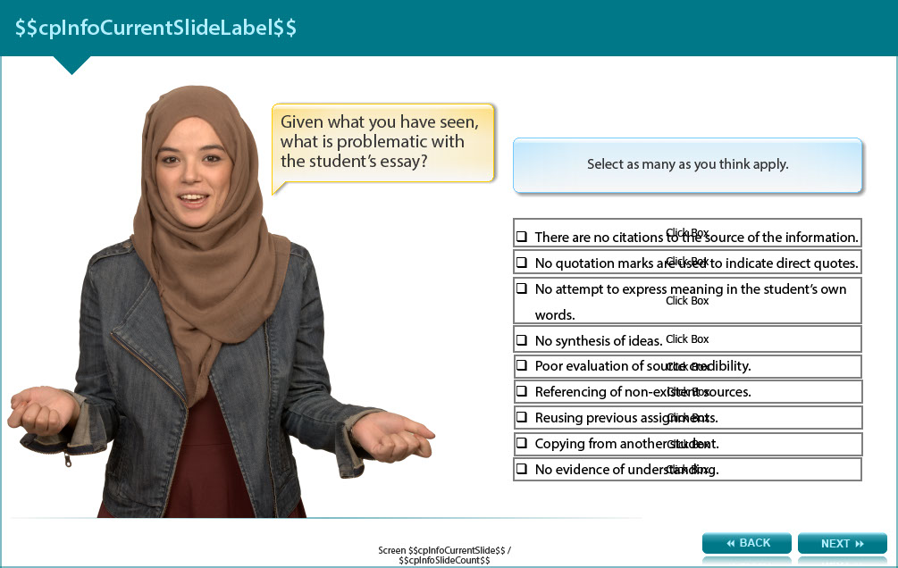

Given what you have seen, what is problematic with the student’s essay?

Select as many as you think apply.

- There are no citations to the source of the information. (feedback: True. Even the original source had a citation!)

- No quotation marks are used to indicate direct quotes. (feedback: I agree. The whole passage is directly quoted and there are no quotation marks.)

- No attempt to express meaning in the student’s own words. (feedback: True. In fact this has been directly copied and pasted.)

- No synthesis of ideas. (feedback: I agree. The student has not tried to include any information from other sources or comment on the information provided by this source.)

- Poor evaluation of source credibility. (feedback: I agree. The Wikipedia entry has not necessarily been produced or reviewed by experts in the field. It is important to evaluate the credibility of the source when searching for information.)

- Referencing of non-existent sources. (feedback: Hmm. I didn’t see any referencing at all.)

- Reusing previous assignments. (feedback: This wasn’t a previous assignment. It came from Wikipedia.)

- Copying from another student. (feedback: Hmm. This isn’t another student’s own work, it’s from Wikipedia.)

- No evidence of understanding. (feedback: I absolutely agree. Because the student has copied and pasted, there is no evidence of understanding.)

Screen 4 – Ctrl-C Plagiarism

Image of female student giving two thumbs up.

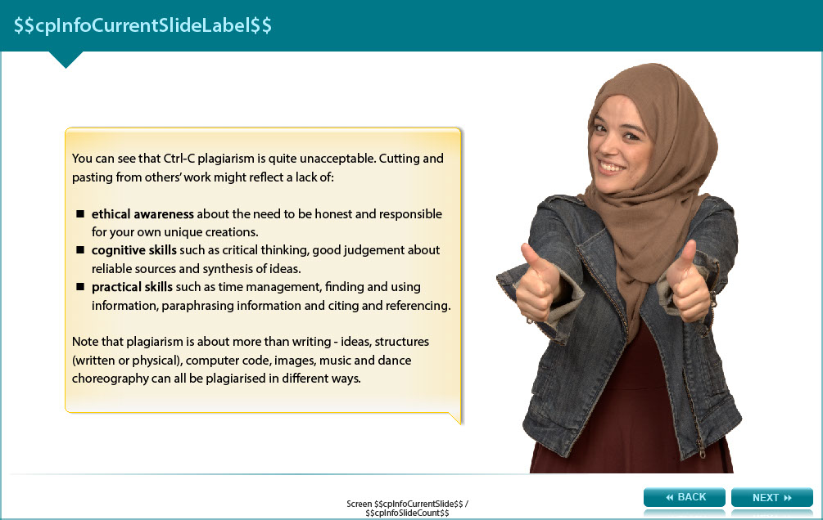

You can see that Ctrl-C plagiarism is quite unacceptable. Cutting and pasting from others’ work might reflect a lack of:

- ethical awareness about the need to be honest and responsible for your own unique creations.

- cognitive skills such as critical thinking, good judgement about reliable sources and synthesis of ideas.

- practical skills such as time management, finding and using information, paraphrasing information and citing and referencing.

Note that plagiarism is about more than writing - ideas, structures (written or physical), computer code, images, music and dance choreography can all be plagiarised in different ways.

Screen 5 – Another example

Image of a female student pointing to another case of Ctrl-C plagiarism.

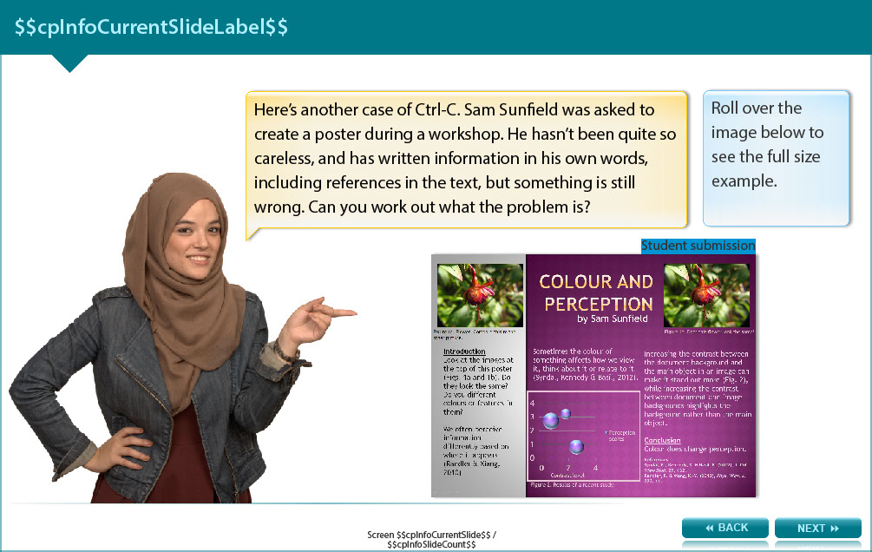

Here’s another case of Ctrl-C. Sam Sunfield was asked to create a poster during a workshop. He hasn’t been quite so careless, and has written information in his own words, including references in the text, but something is still wrong.

The screen shows an image of the poster where the photographer isn’t acknowledged, the text refers to the figures and there is no citation in the graph on the poster.

Can you work out what the problem is?

Screen 6 – Something Missing

Image of a female student considering the issue.

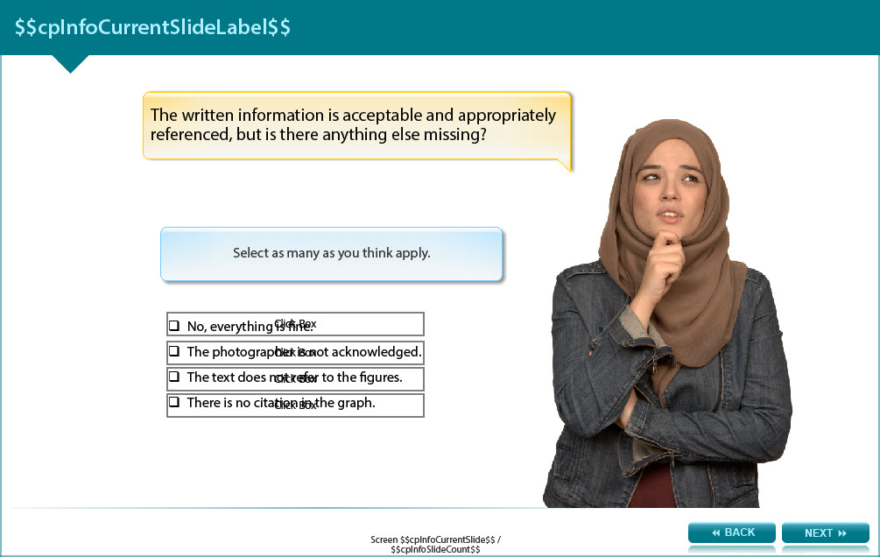

Answer the following question and check the answer in the appendix. Select as many as you think apply.

The written information is acceptable and appropriately referenced, but is there anything else missing?

- No, everything is fine.

- The photographer is not acknowledged.

- The text does not refer to the figures.

- There is no citation in the graph.

Screen 7 – Acknowledging Images

Image showing a female student pointing at an image of the poster.

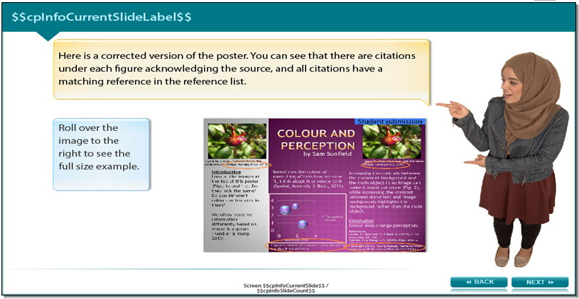

This screen shows a corrected version of the poster. The poster shows that there are citations under each figure acknowledging the source, and all citations have a matching reference in the reference list.

Screen 8 – Conclusion

Image of a female student pointing to links to other types of plagiarism.

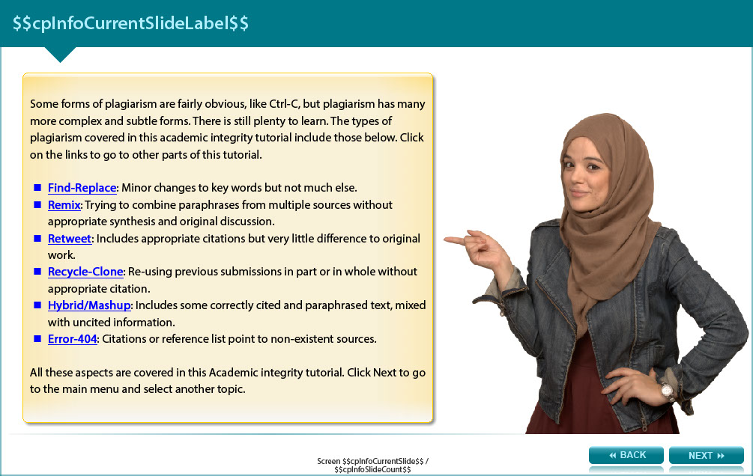

Some forms of plagiarism are fairly obvious, like Ctrl-C, but plagiarism has many more complex and subtle forms. There is still plenty to learn. The types of plagiarism covered in this academic integrity tutorial include those below.

Click on the links to go to other parts of this tutorial.

Find-Replace (http://www.monash.edu/rlo/research-writing-assignments/referencing-and-academic-integrity/academic-integrity/find-and-replace): Minor changes to key words but not much else.

Remix (http://www.monash.edu/rlo/research-writing-assignments/referencing-and-academic-integrity/academic-integrity/remix): Trying to combine paraphrases from multiple sources without appropriate synthesis and original discussion.

Retweet (http://www.monash.edu/rlo/research-writing-assignments/referencing-and-academic-integrity/academic-integrity/retweet): Includes appropriate citations but very little difference to original work.

Recycle-Clone (http://www.monash.edu/rlo/research-writing-assignments/referencing-and-academic-integrity/academic-integrity/recycle-and-clone): Re-using previous submissions in part or in whole without appropriate citation.

Hybrid/Mashup (http://www.monash.edu/rlo/research-writing-assignments/referencing-and-academic-integrity/academic-integrity/hybrid-mashup): Includes some correctly cited and paraphrased text, mixed with uncited information.

Error-404 (http://www.monash.edu/rlo/research-writing-assignments/referencing-and-academic-integrity/academic-integrity/error-404): Citations or reference list point to non-existent sources.

All these aspects are covered in this Academic integrity tutorial. See the next screen for links to the other topics in this tutorial.

Screen 9 – Additional Resources

Image shows titles and icons of related resources.

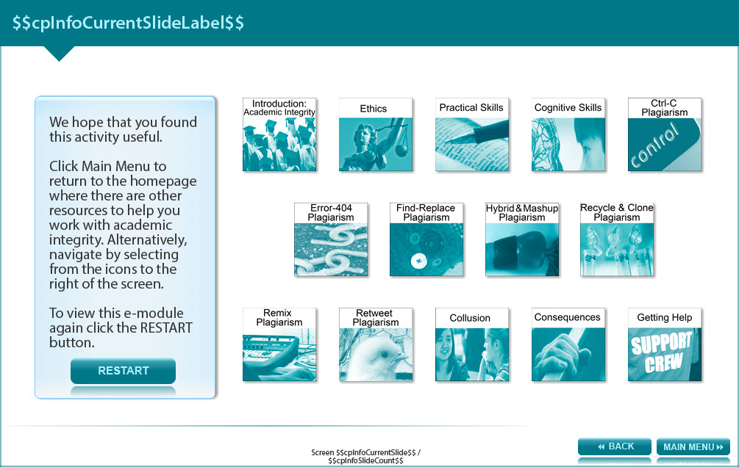

We hope that you found this activity useful.

Click the links below to view other modules in this academic integrity tutorial:

- Introduction: Academic integrity (http://www.monash.edu/rlo/research-writing-assignments/referencing-and-academic-integrity/academic-integrity/introduction)
- Ethics (http://www.monash.edu/rlo/research-writing-assignments/referencing-and-academic-integrity/academic-integrity/ethics)
- Practical skills (http://www.monash.edu/rlo/research-writing-assignments/referencing-and-academic-integrity/academic-integrity/practical-skills)
- Cognitive skills (http://www.monash.edu/rlo/research-writing-assignments/referencing-and-academic-integrity/academic-integrity/cognitive-skills)
- Ctrl-C plagiarism (http://www.monash.edu/rlo/research-writing-assignments/referencing-and-academic-integrity/academic-integrity/ctrl-c)
- Error-404 plagiarism (http://www.monash.edu/rlo/research-writing-assignments/referencing-and-academic-integrity/academic-integrity/error-404)
- Find-Replace plagiarism (http://www.monash.edu/rlo/research-writing-assignments/referencing-and-academic-integrity/academic-integrity/find-and-replace)
- Hybrid & Mashup plagiarism (http://www.monash.edu/rlo/research-writing-assignments/referencing-and-academic-integrity/academic-integrity/hybrid-mashup)
- Recycle & Clone plagiarism (http://www.monash.edu/rlo/research-writing-assignments/referencing-and-academic-integrity/academic-integrity/recycle-and-clone)
- Remix plagiarism (http://www.monash.edu/rlo/research-writing-assignments/referencing-and-academic-integrity/academic-integrity/remix)
- Retweet plagiarism (http://www.monash.edu/rlo/research-writing-assignments/referencing-and-academic-integrity/academic-integrity/retweet)
- Collusion (http://www.monash.edu/rlo/research-writing-assignments/referencing-and-academic-integrity/academic-integrity/collusion)
- Consequences (http://www.monash.edu/rlo/research-writing-assignments/referencing-and-academic-integrity/academic-integrity/consequences)
- Getting help (http://www.monash.edu/rlo/research-writing-assignments/referencing-and-academic-integrity/academic-integrity/getting-help)

Appendix

Screen 6 – Something missing

The written information is acceptable and appropriately referenced, but is there anything else missing?

- No, everything is fine. (feedback: Are you sure? Inspect the images and their captions carefully.)

- The photographer is not acknowledged. (feedback: This is part of the problem. Someone did the work of obtaining the image, so their contribution needs to be recognised. If you can’t find the image creator’s name, you shouldn’t use the image.)

- The text does not refer to the figures. (feedback: Look again - Sam has mentioned Fig. 1a and 1b, and Fig. 2 in the text to direct readers to look at the images.)

- There is no citation in the graph. (feedback: This is part of the problem. Instead of noting that it relates to ‘a recent study’ Sam should acknowledge the authors of the study - even if he created the graph himself from their data.)

