Academic Integrity Online Tutorial – Collusion

Collusion module

Use this document as an alternative to the online interactive tutorial
Contents
Academic Integrity Online Tutorial – Collusion 1
Collusion module 1
Use this document as an alternative to the online interactive tutorial 1
Screen 1 Title Screen – Collusion: Academic Integrity 2
Screen 2 – Sharing assignments 2
Screen 3 – Collusion = plagiarism? 4
Screen 4 – Collusion or not? Scenario 1 5
Screen 5 – Collusion or not? Scenario 2 6
Screen 6 – Collusion or not? Scenario 3 7
Screen 7 – Avoiding collusion 8
Screen 8 – Conclusion 10
Screen 9 – Additional resources 11
Appendix 12

Screen 1 Title Screen – Collusion: Academic Integrity

Title screen image showing three students talking.

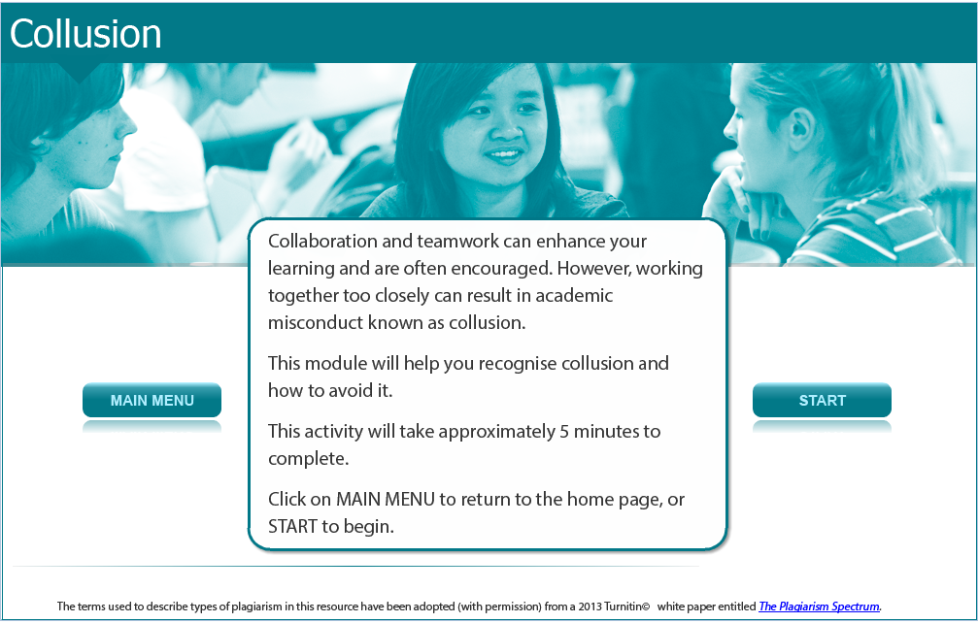

Collaboration and teamwork can enhance your learning and are often encouraged. However, working together too closely can result in academic misconduct known as collusion.

This module will help you recognize collusion and how to avoid it.

This activity will take approximately 5 minutes to complete.

Screen 2 – Sharing assignments

Image of two assignments side by side.

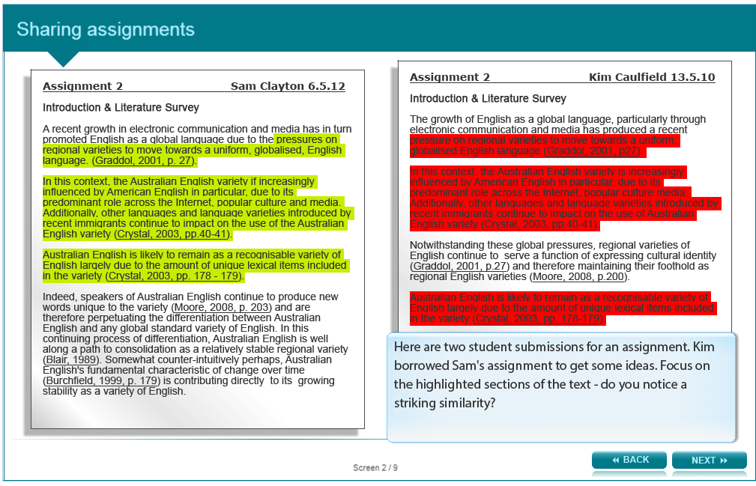

Here are two student submissions for an assignment. Kim borrowed Sam's assignment to get some ideas. Focus on the bold sections of the text - do you notice a striking similarity?

Assignment 2: Sam Clayton 6.5.12
Introduction & Literature Survey

A recent growth in electronic communication and media has in turn promoted English as a global language due to the pressures on regional varieties to move towards a uniform, globalised, English language. (Graddol, 2001, p. 27).

In this context, the Australian English variety if increasingly influenced by American English in particular, due to its predominant role across the Internet, popular culture and media. Additionally, other languages and language varieties introduced by recent immigrants continue to impact on the use of the Australian English variety (Crystal, 2003, pp.40-41).

Australian English is likely to remain as a recognisable variety of English largely due to the amount of unique lexical items included in the variety (Crystal, 2003, pp. 178 - 179).

Indeed, speakers of Australian English continue to produce new words unique to the variety (Moore, 2008, p. 203) and are therefore perpetuating the differentiation between Australian English and any global standard variety of English. In this continuing process of differentiation, Australian English is well along a path to consolidation as a relatively stable regional variety (Blair, 1989). Somewhat counter-intuitively perhaps, Australian English's fundamental characteristic of change over time (Burchfield, 1999, p. 179) is contributing directly to its growing stability as a variety of English.

Assignment 2: Kim Caulfield 13.5.10

Introduction & Literature Survey

The growth of English as a global language, particularly through electronic communication and media has produced a recent pressure on regional varieties to move towards a uniform, globalised English language (Graddol, 2001, p27).

In this context, the Australian English variety is increasingly influenced by American English in particular, due to its predominant role across the Internet, popular culture media. Additionally, other languages and language varieties introduced by recent immigrants continue to impact on the use of Australian English variety (Crystal, 2003, pp.40-41).

Notwithstanding these global pressures, regional varieties of English continue to serve a function of expressing cultural identity (Graddol, 2001, p.27) and therefore maintaining their foothold as regional English varieties (Moore, 2008, p.200).

Australian English is likely to remain as a recognisable variety of English largely due to the amount of unique lexical items included in the variety (Crystal, 2003, pp. 178-179).

Screen 3 – Collusion = plagiarism?

Image of a young man looking up as if thinking.
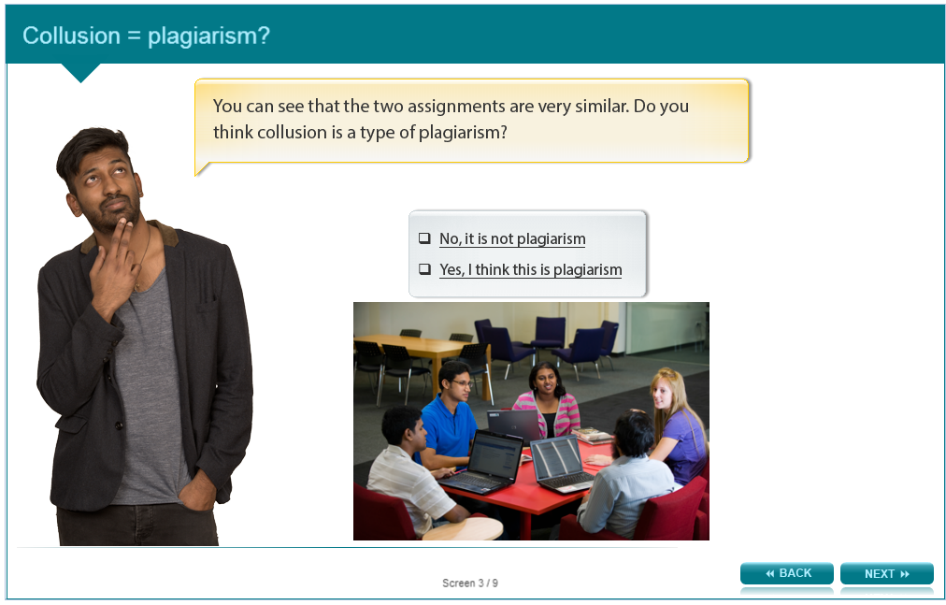

Answer the following question and check the answer in the appendix.

You can see that the two assignments are very similar. Do you think collusion is a type of plagiarism?

- No, it is not plagiarism
- Yes, I think this is plagiarism

Screen 4 – Collusion or not? Scenario 1

Image of the same young man looking up as if thinking.
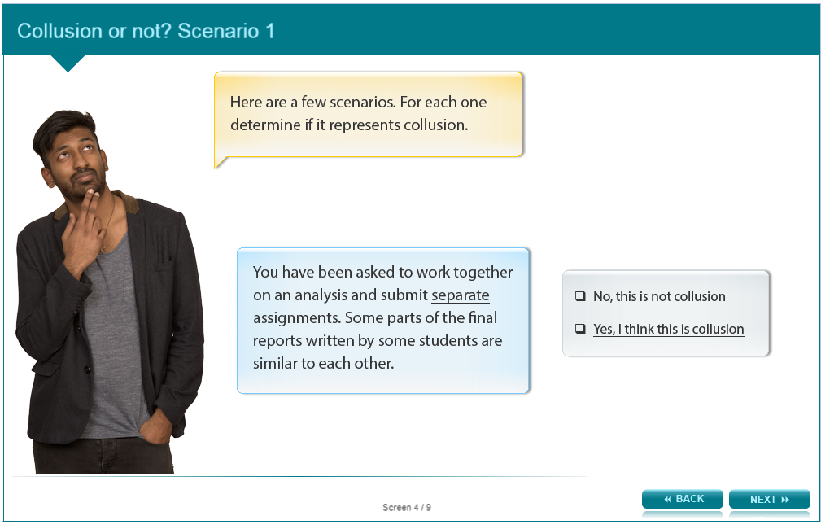

Answer the following question and check the answer in the appendix.

Here are a few scenarios. For each one determine if it represents collusion.

You have been asked to work together on an analysis and submit separate assignments. Some parts of the final reports written by some students are similar to each other.

- No, this is not collusion
- Yes, I think this is collusion

Screen 5 – Collusion or not? Scenario 2

Image of same young man smiling.
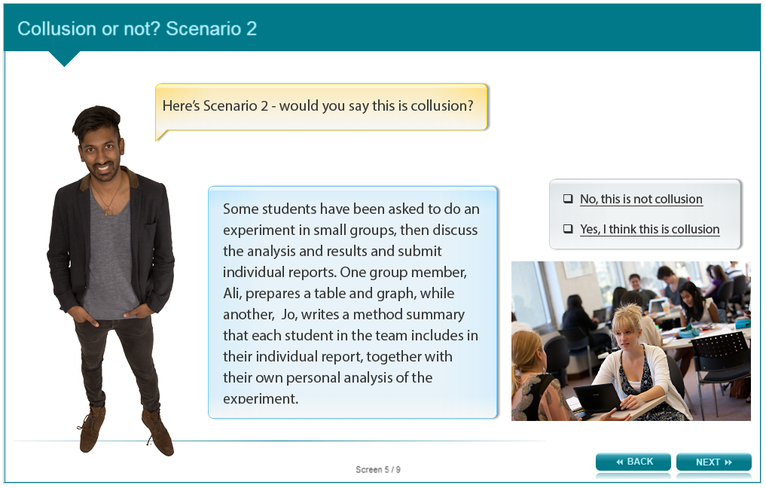

Answer the following question and check the answer in the appendix.

Here’s Scenario 2 - would you say this is collusion?

Some students have been asked to do an experiment in small groups, then discuss the analysis and results and submit individual reports. One group member, Ali, prepares a table and graph, while another, Jo, writes a method summary that each student in the team includes in their individual report, together with their own personal analysis of the experiment.

- No, this is not collusion
- Yes, I think this is collusion

Screen 6 – Collusion or not? Scenario 3

Image of same young man thinking.
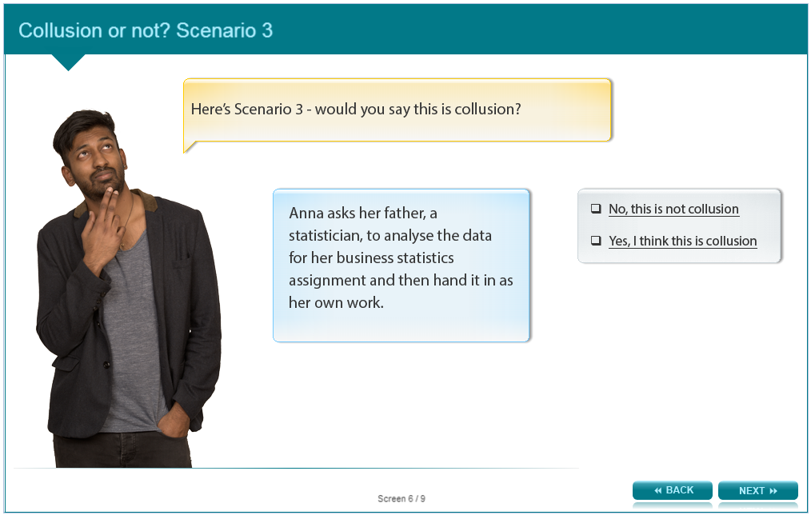

Answer the following question and check the answer in the appendix.

Here’s Scenario 3 - would you say this is collusion?

Anna asks her father, a statistician, to analyse the data for her business statistics assignment and then hand it in as her own work.

- No, this is not collusion
- Yes, I think this is collusion

Screen 7 – Avoiding collusion

Image of same young man pointing to links on a card.
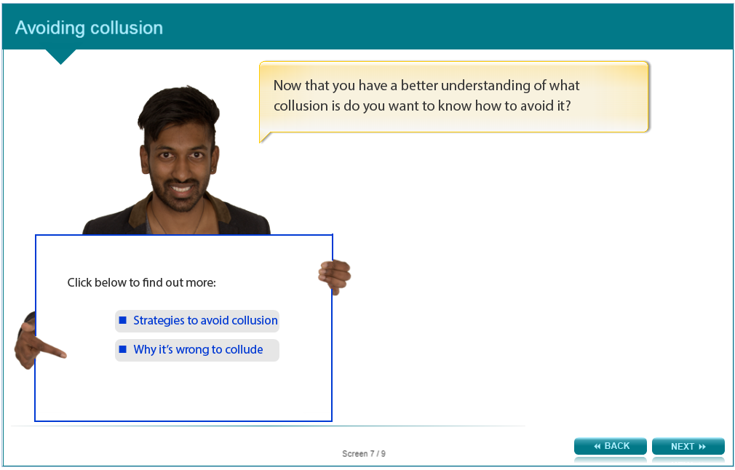

Now that you have a better understanding of what collusion is do you want to know how to avoid it?

Read below to learn more.

Strategies to avoid collusion
- Take your own notes when working with others
- Check with the unit lecturer to make sure it is okay to collaborate
- Don’t ask to look at someone else’s essay before it is due
- Plan how you will work with others and set some ground rules
- Check with the unit lecturer about the extent to which collaboration is acceptable

Why it’s wrong to collude
- You may miss an opportunity to learn and advance knowledge
- Collusion is fraudulent and unethical
- Collusion can involve taking advantage of relationships

Screen 8 – Conclusion

Image of same young man smiling and putting thumb up.

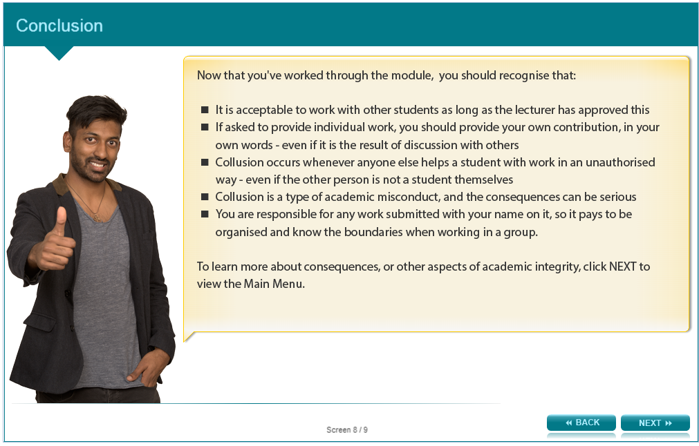

Now that you’ve worked through the module, you should recognise that:

- It is acceptable to work with students as long as the lecturer has approved this
- If asked to provide individual work, you should provide your own contribution, in your own words – even if it the result of discussion with others
- Collusion occurs whenever anyone else helps a student with work in an unauthorized way – even if the other person is not a student themselves
- Collusion is a type of academic misconduct, and the consequences can be serious
- You are responsible for any work submitted with your name on it, so it pays to be organised and know the boundaries when working in a group.

To learn more about consequences, or other aspects of academic integrity, click the links listed on the next screen.

Screen 9 – Additional resources

Image shows titles and icons of related resources.



We hope that you found this activity useful.

Click the links below to view other modules in this academic integrity tutorial:

- Introduction: Academic integrity (http://www.monash.edu/rlo/research-writing-assignments/referencing-and-academic-integrity/academic-integrity/introduction)
- Ethics (http://www.monash.edu/rlo/research-writing-assignments/referencing-and-academic-integrity/academic-integrity/ethics)
- Practical skills (http://www.monash.edu/rlo/research-writing-assignments/referencing-and-academic-integrity/academic-integrity/practical-skills)
- Cognitive skills (http://www.monash.edu/rlo/research-writing-assignments/referencing-and-academic-integrity/academic-integrity/cognitive-skills)
- Ctrl-C plagiarism (http://www.monash.edu/rlo/research-writing-assignments/referencing-and-academic-integrity/academic-integrity/ctrl-c)
- Error-404 plagiarism (http://www.monash.edu/rlo/research-writing-assignments/referencing-and-academic-integrity/academic-integrity/error-404)
- Find-Replace plagiarism (http://www.monash.edu/rlo/research-writing-assignments/referencing-and-academic-integrity/academic-integrity/find-and-replace)
- Hybrid & Mashup plagiarism (http://www.monash.edu/rlo/research-writing-assignments/referencing-and-academic-integrity/academic-integrity/hybrid-mashup)
- Recycle & Clone plagiarism (http://www.monash.edu/rlo/research-writing-assignments/referencing-and-academic-integrity/academic-integrity/recycle-and-clone)
- Remix plagiarism (http://www.monash.edu/rlo/research-writing-assignments/referencing-and-academic-integrity/academic-integrity/remix)
- Retweet plagiarism (http://www.monash.edu/rlo/research-writing-assignments/referencing-and-academic-integrity/academic-integrity/retweet)
- Collusion (http://www.monash.edu/rlo/research-writing-assignments/referencing-and-academic-integrity/academic-integrity/collusion)
- Consequences (http://www.monash.edu/rlo/research-writing-assignments/referencing-and-academic-integrity/academic-integrity/consequences)
- Getting help (http://www.monash.edu/rlo/research-writing-assignments/referencing-and-academic-integrity/academic-integrity/getting-help)

Appendix

Screen 3 – Collusion = plagiarism?

You can see that the two assignments are very similar. Do you think collusion is a type of plagiarism?

- No, it is not plagiarism (feedback: Technically, collusion isn’t the same as plagiarism. Collusion refers to the fact that Kim and Sam conspired, enabling Kim to cheat and create his essay without doing all the required research. Kim and Sam both displayed academic misconduct by colluding.)

- Yes, I think this is plagiarism (feedback: Collusion isn’t the same as plagiarism. Collusion refers to the fact that Kim and Sam conspired, enabling Kim to cheat and create his essay without doing all the required research. Kim and Sam both displayed academic misconduct by colluding.)

Screen 4 – Collusion or not? Scenario 1

You have been asked to work together on an analysis and submit separate assignments. Some parts of the final reports written by some students are similar to each other.

- No, this is not collution (feedback: Well done! This is not collusion. It's expected that the information presented will be similar as they were instructed to work together, but the reports should be in their own words.)

- Yes, I think this is collusion (feedback: Think a little more. If they have been asked to work on the analysis together, the information in their final reports would be similar. The important thing is they should express this information in their own words.)

Screen 5 – Collusion or not? Scenario 2

Here’s Scenario 2 - would you say this is collusion?

- No, this is not collusion (feedback: The situation is quite tricky. We might expect their work to be similar, but they should not be using exactly the same method summary and graphs in their individual work.)

- Yes, I think this is collusion (feedback: Well done! By asking for individual reports, the lecturer is expecting each student to prepare all aspects of their own report - graphs, tables and text, even if the students worked together to collect and discuss the data.)

Screen 6 – Collusion or not? Scenario 3

Here’s Scenario 3 - would you say this is collusion?

- No, this is not collusion (feedback: Anna’s father is not helping her to learn the content, he is conspiring to help her pass the assessment task. This is collusion.)

- Yes, I think this is collusion (feedback: Good work! Collusion can occur when two people work together, even if one of them is not a student.)

