Annual Report
2013-14

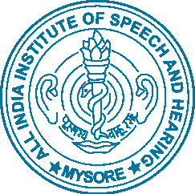

All India Institute of Speech and Hearing
Manasagangothri, Mysore – 570 006

© 2014 All India Institute of Speech and Hearing, Mysore
Edited and Published by S. R. Savithri, PhD
Compiled by C. Shijith Kumar, PhD
Assistance: K.Asha
Photos: Kavitha N.
Design & Printing: Tech Prints, Mysore

Contents

Greetings from the Director
 | About Us | 1
 | Major Events and New Initiatives | 2 – 7
 | Learning and Teaching | 8 –45
 | Research | 47-85
 | Clinical Care | 87-100
 | Outreach Clinical Care | 101-
 | Public Education | 102 – 105
 | Extracurricular Events | 106 – 109
 | Official Language Implementation | 110 – 114
 | Reservation Policy Implementation | 115 – 120
 | Awards and Laurels
 | Other Activities and Events | 121 – 123
 | Oversight | 124 – 125
Appendices
- Financial Statements and Audit Report
- Organizational Chart

