Public Education
The institute has been taking various steps to make the common man aware of communication disorders, educate them on prevention of the disorders and provide guidance and counseling to persons suffering from such disorders. The major public education activities carried out during the reporting year are the following.

Monthly Public Lectures
In order to create public awareness on various communication disorders such as stuttering, articulation disorders, aphasia, mental retardation, hearing and voice problems, the institute organized monthly public lectures tailored for common man, throughout the year, during which expert professionals working in the institute delivered one-hour lecture followed by question and answer session with the audience. The details of the lectures delivered during the reporting year are given in table 36.

Table 36: Public Lectures Delivered
Sl. No. |  | Date | Topic | Resource person
 |  | 27.04.13 | Classroom settings for children with hearing impairment | Mr. Jijo, Lecturer in Audiology, Dept. of Audiology
 |  | 25.05.13 | Listening training for individuals with hearing impairment | Ms. N Devi, Lecturer in Audiology, Dept. of Audiology
 |  | 29.06.13 | Facilitating language skills in children with communication disorders | Dr. Swapna, N, Lecturer in Speech Pathology, Dept. of Speech Langu8age Pathology
 |  | 27.07.13 | Hearing problems in children | Ms. Spoorthi,T, Research Officer, Dept. of Audiology
 |  | 31.08.13 | Stuttering | Dr. Santosh, M, Reader in Speech Sciences, Dept. of Speech Language Sciences
 |  | 28.09.13 | Learning disability | Dr. S. Venkatesan, Professor in Clinical Psychology, Dept. of Clinical Psychology
 |  | 26.10.13 | Cleft lip and palate – Causes and management | Ms. Deepthi K. J, Lecturer in Speech Pathology, Dept. of Speech Language Pathology
 | 30.11.13 |  | Effects of noise on hearing | Mr. Kishore Tanniru, Lecturer in Audiology, Dept. of Audiology
 | 28.12.13 |  | Hearing aids - Common quarries | Dr. Manjula P, Professor in Audiology Dept. of Audiology
 | 25.01.14 |  | Traumatic Brain Injury- causes, symptoms and management | Dr. Hema N, Lecturer in Speech Sciences, Dept. of Speech-Language Sciences
 | 22.02.14 |  | Stuttering | Dr. Anjana B Ram, Lecturer in Speech Pathology, Dept. of Speech Language Pathology
 | 29.03.14 |  | Screening of New Born Communication | Mr. Arun Raj, Clinical Assistant, Dept. of Audiology

Preparation and Dissemination of Information Resources
Various public education materials related to the prevention and control of communication disorders were prepared in print and electronic formats and disseminated among the general public. The major ones are given in table 37. In addition, the materials prepared in one language were translated to others and disseminated.

Table 37: Public Education Materials Prepared & Translated

S.No | Title | Type | Language
 | An overview to auditory training | Brochure | English / Hindi / Telugu / Kannada / Tamil / Malayalam / Marathi
 | Sudden hearing loss | Brochure | English
 | Can hearing loss be sudden?Yes, it can | Pamphlet | Hindi / Kannada / Malayalam
 | Considering cochlear implant | Pamphlet | Hindi / Kannada / Malayalam
 | Learning disability | Pamphlet | Hindi / Kannada / Malayalam
 | Dementia | Pamphlet | Hindi / Kannada / Malayalam
 | Train your child - Level 3 | Manual | Hindi
 | Parent & child | Manual | Manipuri / Oriya / Tamil
 | Train your child - Level 4 | Manual | English / Hindi
 | Train your child - Level 3 | Manual | Kannada
 | Train your child in pre-academic skills | Manual | Hindi
 | Role of teachers in the management of children with cerebral palsy | Brochure | Kannada / English
 | Attention Deficit Hyper Active Disorder | Pamphlet | Kannada/ Hindi,/ Malayalam/ Tamil, Manipuri/ Odiya
 | Protect your ears from noise | Pamphlet | English
 | Know before you burst | Pamphlet | English
 | Home training for motor speech disorders (language & feeding aspects) | Pamphlet | English
 | Home training programme for Aphasia | Pamphlet | English
Translation of Materials
24 pamphlets on the following topics were translated from English to Kannada, Hindi, Malayalam, Tamil, Manipuri and Oriya languages.
a) Aphasia, (b) Articulation, (c) Autism, (d) Cerebral Palsy, (e) Cleft Lip and Palate, (f) Communication Problems in Elderly, (g) Dementia, (h) Dysarthria, (i) Ear discharge, (j) FAQ on Noise Induced Hearing Loss, (k) FAQ on Newborn hearing screening, (l) Feeding, (m) Fluency disorders, (n) Hearing Loss, (o) Know This With Pictures and Text, (p) Laryngectomy, (q) Learning Disability, (r) Mental Retardation, (s) Prevention of Developmental Disability, (t) Specific Language Impairment, (u) Stuttering, (v) Voice, (w) Young Girls to be Married

Camp-based awareness activities
The institute organizes communication disorders screening camps in different localities in the state and other parts of the country. As a part of the camp extensive awareness programmes are being conducted to educate the public on the prevention and management of communication disorders. During the reporting year, nine such camps were conducted and thousands of general public were educated on communication disorder.

Open Day Celebrations
The institute celebrates open day with the objective of providing opportunity for the public to visit the institute and understand various facilities and services it offers with respect to the prevention and control of communication disorders. The open day was celebrated on 17th December 2013 during the reporting year and 3728 persons visited the institute. The public were given awareness classes on different aspects of communication disorders on the occasion.

Participation in Dasara Procession
The institute participated in the world famous Mysore Dasara procession, the Jamboo Savari which attracts a huge audience from all over the country and abroad, on 14th October, 2013 with a tableau on communication disorders. The tableau won first prize.

Participation in Science Exhibition
The institute participated in a Science Exhibition organized by Gopalaswamy Shishuvihara High School, Mysore, on 7-8 December, 2013 and exhibited charts, flashcards and models on prevention of communication disorders. A video on the topic was also displayed during the event.

Awareness rallies and street plays
A cycle rally was conducted to mark the international noise awareness day on 24th April, 2013. In addition, the institute organized a noise awareness rally in Mysore city to create awareness among the public on the hazardous effects of noise, especially from fire crackers in the run up to Deepavali on 27th October, 2013. The Director, staff and students of the institute and hundreds of general public participated in the rally.
The institute also organized a street play in Hariharapura village, K.R. Pete, Mysore, to create awareness among the public on prevention of communication disorders on 26th December, 2013.

Observation of Commemorative Days
The following commemorative days associated with speech and hearing and allied fields were observed at the institute to raise awareness, and hundreds of people from different walks of life attended them.
- Autism Awareness Day on 2nd April, 2013.
- World Voice Day on 16th April, 2013.
- International Noise Awareness Day on 24th April, 2013.
- World Music Day on 4th July, 2013.
- International Stuttering Awareness Day on 8th November, 2013.
- International Day of Persons with Disability on 3rd December, 2013.
- National Cerebral Palsy Day on 29th January, 2014

Public Orientation Programmes
In addition to the monthly public lecture series conducted at the institute campus, the institute organized 13 orientation lectures on prevention of communication disorders in various localities in Mysore and nearby districts under the aegis of the Department of Prevention of Communication Disorders of the Institute. Totally, 722 persons including senior citizens, ASHA workers, industry workers, doctors and teachers benefitted from these orientation programmes. The details are shown in the figure..
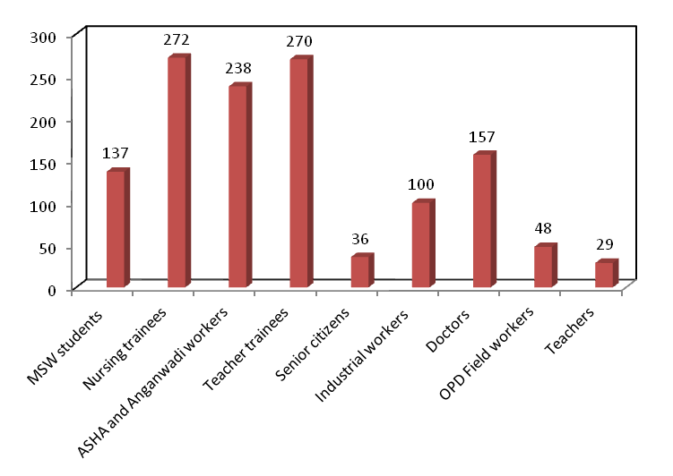
Fig. Public Orientation Programmes

Mass Media Based Public Education
Public Education for the prevention and control of communication disorders was also carried out through the print and electronic media. Some of the media based activities carried out during the reporting year are the following.

- An article titled Your Future is in your Voice based on an interview with Dr. K. Yeshoda, Lecturer in Speech Sciences was published in the District Plus, special supplement of The Hindu on 13th April, 2013.
- An article titled How to Save Your Voice based on an interview with Dr. K. Yeshoda, Lecturer in Speech Sciences was published in the District Plus, special supplement of The Hindu on 27th April, 2013.
- A Live Phone in Programme on Allergy and Deafness with Dr. Rajeswari, Professor in ENT was broadcasted by the Television Channel, Channel C, Mysore on 20th July, 2013.
- An article titled It is a Noisy World based on an interview with the professional staff of the Institute was published in the District Plus, special supplement of The Hindu on 29th September, 2013.
- A radio talk on Bursting Crackers and Its ill Effects on Hearing Mechanism was delivered by Dr. P. Manjula, Professor in Audiology at All India Radio, Mysore, which was broadcasted on 31 October, 2013.
- Twenty Slogans on Prevention of Hearing impairment were broadcasted by the All India Radio, Mysore as part of Diwali festival in the month of October, 2013.
- A 60 minute programme on Noise Pollution and Crackers: Care to be Taken was telecasted by the Siti Cable, UMN and MCN television channels during Deepavali Festival in October, 2013.
- A news item on Open Day activities of the institute was published in Vijaya Karnataka a leading Kannada news paper on 15th December, 2013.
- A radio talk on Prevention of Communication Disorders was delivered by Dr. jayashree Shanbal, Lecturer in Speech Pathology in Doctors Talk Programme at All India Radio, Mysore which was broadcasted on 28th March, 2014.
- A documentary film on Centre for Rehabilitation and Education through Distance Mode of the Institute was relayed in Just Kannada online news portal.
In addition to the above, the print and electronic media gave excellent coverage of various other activities and events of the institute such as workshops, conferences, guest lectures and monthly public lectures during the reporting year.

