Outreach Services
In addition to the diagnostic and therapeutic services provided within its walls, the institute provides various outreach activities pertaining to communication and its disorders in different parts of the country. The following outreach services were carried out during the reporting year.

Communication Disorder Screening Programmes
The Department of Prevention of Communication Disorders of the Institute conducted screening programmes for communication disorders in different settings in various localities. The individuals participating in the programmes were checked for speech, language and hearing abilities and provided with diagnostic and therapeutic services. The screening programmes conducted during the reporting year in different settings are mentioned below.

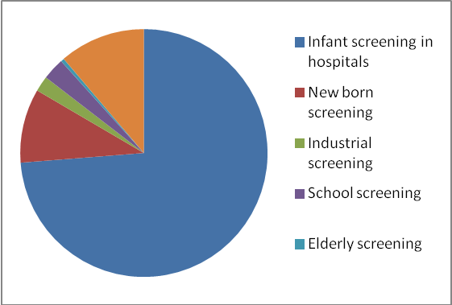
Figure 1 : Screening done in different settings

- Infant Screening
Under this programme, neonates and infants were screened using various tools such as High Risk Register for communication disorders, Behavioral Observation Audiometry, Oto Acoustic Emission Screening and Screening Checklists to identify the risk factors that could lead to communication disorders.

Screening programme was carried out at the hospitals/immunization centres in and around Mysore, outreach clinical centres and hospitals attached to the DHLS centres of the institute, and the parents / caregivers were counseled regarding the identification of any delay or deviancies in normal developmental milestones of speech, language, hearing, motor and other related domains that affect the development of communication skills in children.
Screening at the hospitals in Mysore: Screening was carried out at 15 hospitals and 3 immunization centres in and around Mysore throughout the year and totally 13398 babies were screened and 243 (1.81%) among them were referred to the institute for follow-up. The details are given in table 1.
Table 1: Infant screening in hospitals in Mysore city
S. No. | Hospitals/ Immunization centres | Cases  screened | Cases  referred
 | Apollo hospital | 410 | 10
 | B.M. hospital | 225 | 0
 | Combined hospital | 160 | 1
 | E.S.I. hospital | 104 | 2
 | Harsha hospital | 85 | 0
 | Kamakshi hospital | 574 | 2
 | K.R. hospital | 9519 | 178
 | Immun. centre, K.R. hospital | 25 | 2
 | Makkalakoota Immun. centre | 279 | 12
 | Mission hospital | 601 | 26
 | Mission immun. centre | 101 | 1
 | N.P.C . maternity hospital | 151 | 1
 | S.M.T.D. hospital | 553 | 1
 | Railway hospital | 40 | 0
 | Ashwini nursing home | 120 | 2
 | Sridevi nursing home | 109 | 0
 | Gopala gowda shantaveri memorial hospital | 29 | 2
 | Family planning association of India clinic | 278 | 3
 | Total | 13363 | 243

Screening at Outreach Service Centres and Other Hospitals: The infant screening was also carried out at the outreach centres of the institute located in Akkihebbalu and Hullahalli, and the three government hospitals at K.R.Nagar, Santhemaralli and T.Narsipura. A total of 1756 infants were screened, of which 22 (1.25%) were referred for detailed assessment, the details of which are given in table 2.
Table 2: Infant Screening at Outreach Service Centres and other hospitals
S. No | Hospitals / Outreach centres | Cases Screened |  |  | Cases referred
 | Hospitals / Outreach centres | M | F | T | Cases referred
1 | OSC, Akkihebbalu | 9 | 8 | 17 | 0
2 | GH, K R Nagar | 368 | 358 | 726 | 6
3 | OSC, Hullahalli | 117 | 100 | 217 | 5
4 | GH, Santhemarahalli | 148 | 150 | 298 | 1
5 | GH, T Narsipura | 257 | 240 | 498 | 10
 | Total | 899 | 856 | 1756 | 22
OSC=Outreach Service Centre; GH=Government Hospital; M=Male; F=Female; T=Total

Newborn Screening at Hospitals of DHLS Centres: The newborn screening was also carried out at the hospitals attached to the three DHLS centers, namely Sri Ramachandra Bhanj Medical College and Hospital, Cuttack (2905), Regional Institute of Medical Sciences Imphal (3848), Janana Hospital & JLNMCH, Ajmer (6309). Totally 13062 babies were screened and 643 (4.92%) of them were referred for follow-up. A complete test battery was administered for those who came for follow up.

- Industrial Screening
Hearing evaluation of industrial workers, were carried out for the employees working in the AMW-MGM Forgings Pvt. Ltd., Mysore, KSIC, Mysore and M/s. TATA Global Beverages Limited, Banglore. Of the 215 persons screened, 71 (33.02%) were referred to the institute for further check-up.
In addition, 152 employees of Karnataka Silk Industries Co., Mysore, were evaluated for hearing at the institute and 144 (94.73%) of them were identified with hearing impairment ranging from minimal to severe hearing loss. The employees were counseled on the need to use hearing protective devices.
- School Screening
Nursery and primary school students of the St. Joseph’s School, Mysore, were screened for communication disorder as a part of the school screening programme during the reporting year. Totally 520 students were screened and 27 (5.19%) of them were recommended for follow-up at the Institute.

d. Elderly screening
Speech, language and hearing evaluation were carried out for elderly citizens residing in different old age homes in Mysore. Eighty persons underwent the evaluation and 25 (31.25%) among them who had hearing problem were provided with hearing aids. The details are given in table in table 3.

d. Camp-based screening
The Institute organized nine camps in various localities in Karnataka, Katpadi, Tamil Nadu and Guna, Mandhya Pradesh and the expert speech and hearing and allied health professionals from the institute screened 2033 persons for communication disorders in the camps. The details are given in table 4.

Table 3: Elderly Screening
Old Age Homes | Speech- Language evaluation |  |  | Hearing evaluation |  |  | Hearing aid Distribution
Old Age Homes | M | F | T | M | F | T | M | F | T
Sri Vasavi Shanthidham, Mysore | 2 | 0 | 2 | 12 | 15 | 27 | 7 | 6 | 13
Belaku Vathsalya Dhama, Mysore | 0 | 0 | 0 | 0 | 11 | 11 | 0 | 4 | 4
JSS old age home, Mysore | 0 | 0 | 0 | 8 | 13 | 21 | 1 | 5 | 6
Sri Bharathi Vruddhashram, Mysore | 1 | 0 | 1 | 8 | 10 | 18 | 0 | 2 | 2
TOTAL | 3 | 0 | 3 | 28 | 49 | 77 | 8 | 17 | 25
M= Male; F= Female

Table 4: Communication Disorders Screening Camps
S. No. | Locality | Date | Speech- language evaluation | Audiological evaluation | ENT  Evalua-tion | Total
1 | Vyasarajanapura, Mysore | 18.05.13 | 3 | 25 | 0 | 28
2 | H D Kote, Mysore | 25.06.13 | 0 | 32 | 0 | 32
3 | Talakadu, Mysore | 02.07.13 | 27 | 33 | 0 | 60
4 | B R hills, Mysore | 06.07.13 | 22 | 111 | 22 | 155
5 | Sri Sai Ranga special school, Mysore | 14.07.13 | 9 | 94 | 0 | 103
6 | Worth trust school, Katpadi, Tamil Nadu | 23.08.13  to  24.08.13 | 0 | 141 | 0 | 141
7 | Koppa, Periyapatna, Mysore | 19.11.13 | 26 | 4 | 0 | 30
8 | Government Hospital, Periyanpatna, Mysore | 22.11.13 | 12 | 5 | 0 | 17
9 | Ragoghar, Guna district, Madhya Pradesh | 21.02.14 to 27.02.14 | 239 | 806 | 422 | 1467
 | Total |  | 338 | 1251 | 444 | 2033

Diagnostic and Therapeutic Services at Outreach Service Centres
Communication disorders related diagnostic and therapeutic services were provided at the three outreach centres of the institute located in Gumballi, Chamarajanagar, Akkihebbalu, Mandya, and Hullahalli, Nanjangud. Totally 4447 persons availed the services. The details of the evaluation are given in figure 2. In addition to the evaluation provided, 441 hearing aids were issued to the needy ones.

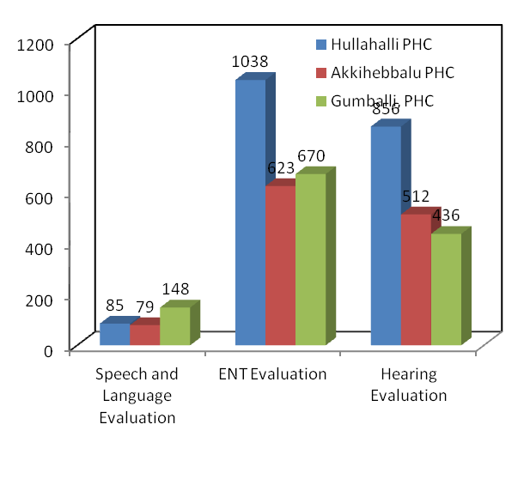
Figure 2 : Clinical Services at Outreach Service Centres
Tele – intervention and Tele - assessment
The Centre for Rehabilitation and Education through Distance Mode offered tele-intervention and assessment service to the persons with communication disorders and their caregivers at 11 DHLS centers of the institute located throughout the country through the AIISH video conferencing system, the details of which are given in table 5.

Table 5: Tele intervention and Tele Assessment Services
Service | Types of Disorders
Service | Phonological / Articulation |  | Fluency |  | Voice |  | Language |  | Multiple |  | Total
Service | Clients | Session | Clients | Session | Clients | Session | Clients | Session | Clients | Session | Total
Tele Assessment | 19 |  | 27 |  | 18 |  | 54 |  | 12 |  | 130
Tele intervention | 30 | 32 | 43 | 47 | 19 | 21 | 84 | 98 | 12 | 14 | 212

Figure 3: Tele-assessment and Tele-intervention
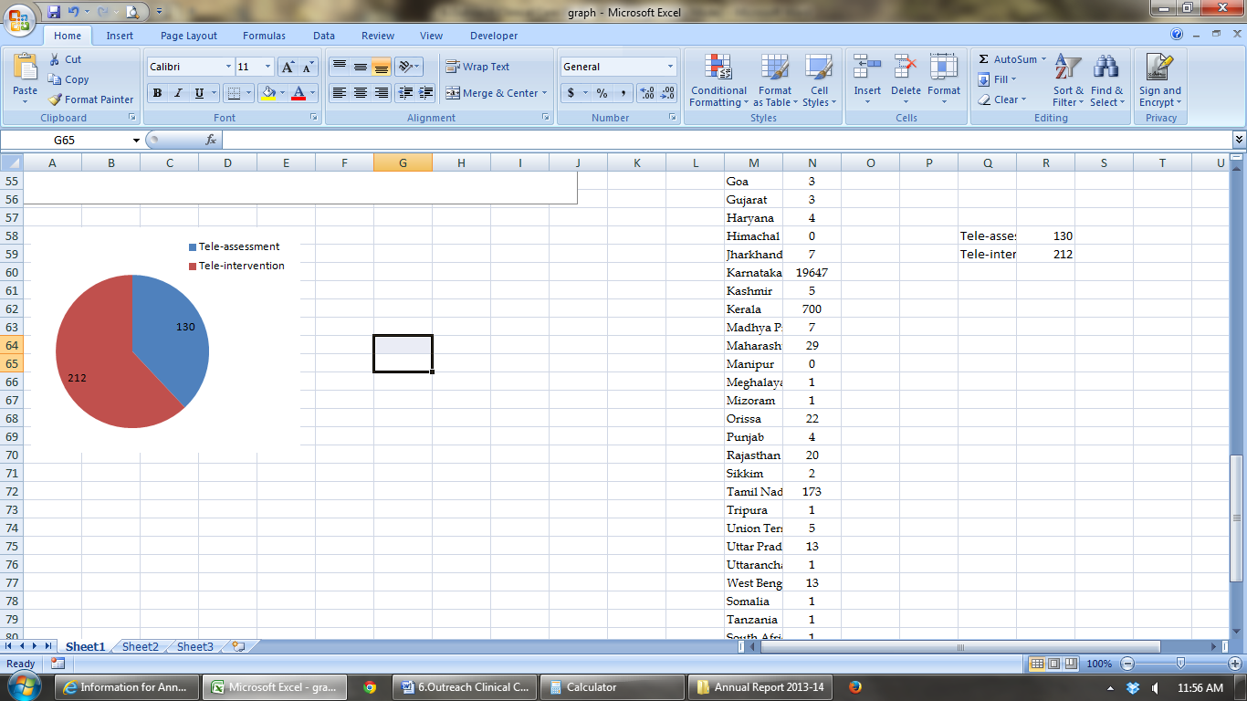

In addition, tele intervention was also provided to 11 clients in 128 sessions through SKYPE, the web-based audio-video communication system.

Website-based Service
The Centre for Rehabilitation and Edu-cation through Distance Mode adderssed queries related to communication disorders, their assessment and mana-gement by providing various resource materials over its website. Totally, 4458 persons visited the site for availing the service during the reporting year. In addition, the website provided a helpline service for persons with Parkinson’s disease.

Educational Guidance and Counseling through Distance Mode
Educational guidance and counseling were given to 14 parents of children with communication disorders at the DHLS study centres through videoconferencing and the SKYPE to make them understand how the child's special need might affect his education, how to prepare him for schooling, help in deciding appropriate schools for the child and inform them of various benefits and concessions offered by the central and state governments for the children with special needs.
Mainstream School Adoption
In order to ensure proper care for the children with communication disorders, studying in normal schools, a mainstream

school adoption programme was initiated
and 11 schools were adopted and 130 teachers in these schools were oriented through 19 programmes on identification of special needs in children, curricular adaptation and management of their special educational needs in the inclusive learning environments.

