AIISH at a Glance

An autonomous institute established in the year 1965 under the Ministry of Health and Family Welfare, Govt. of India to advance the cause of quality training, research , patient care and public education on communication and its disorders.
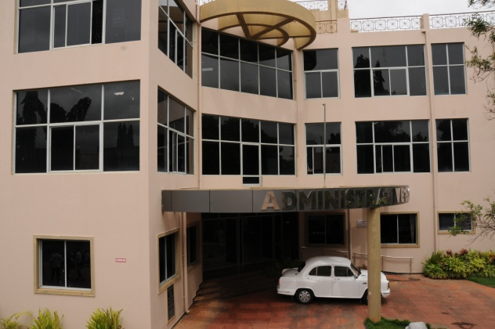  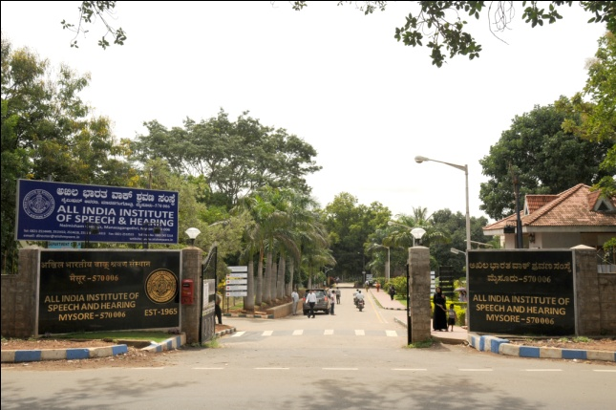 | Vision  To be a world-class institute for human resource development, conducting need-based research, striving for excellence in clinical services, creating awareness and public education in the field of communication disorders
Mission
To be a world-class institute for human resource development, conducting need-based research, striving for excellence in clinical services, creating awareness and public education in the field of communication disorders.
Accomplishments
- ISO 9001-2008 Certification
- ‘A’ Grade accreditation by the National Assessment and Accreditation Council, University Grants Commission
- Centre of Excellence in the area of Communication and its Disorders by the by Ministry of Health & Family Welfare, Govt. of India.
- Centre of Excellence in the area of deafness by World Health Organization
- Centre of Advanced Research by University Grants Commission
- Science & Technology Institute by the Department of Science and Technology,
- Nodal Centre for Implementation of Prevention and Control of Deafness by Ministry of Health & Family Welfare, Government of India.

