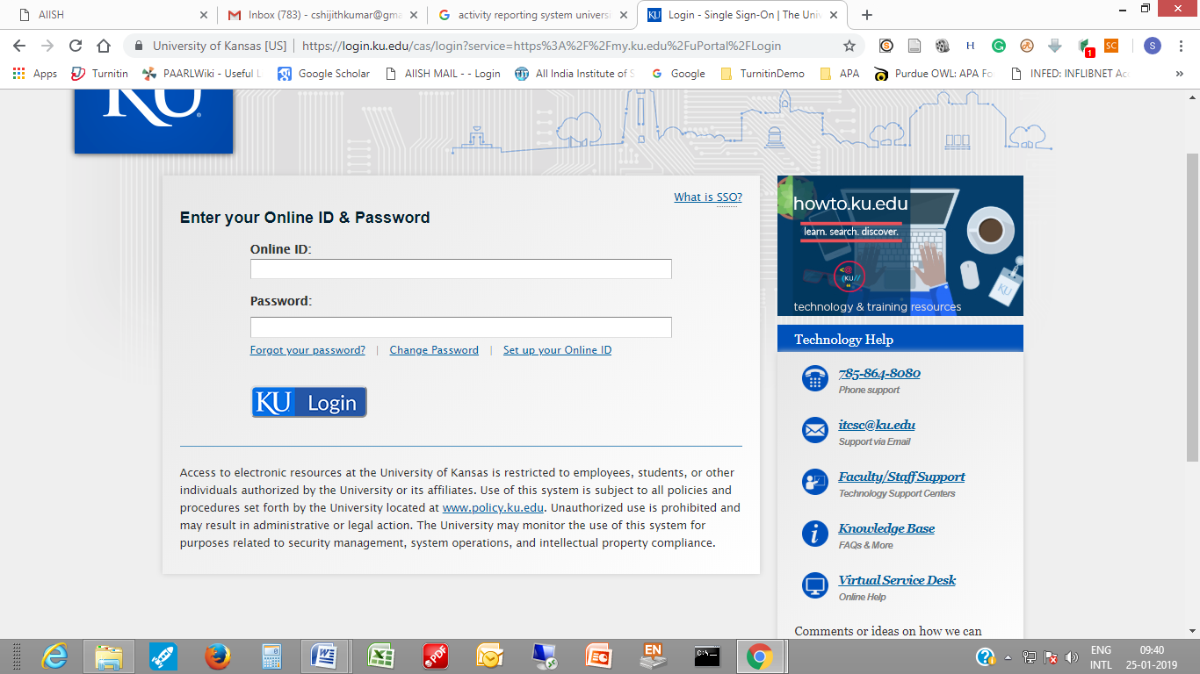

(Access to electronic resources at the University of Kansas is restricted to employees, students, or other individuals authorized by the University or its affiliates. Use of this system is subject to all policies and procedures set forth by the University located at [www.policy.ku.edu](http://www.policy.ku.edu/). Unauthorized use is prohibited and may result in administrative or legal action. The University may monitor the use of this system for purposes related to security management, system operations, and intellectual property compliance.)