PROJECT PROPOSAL
PART-A
1.0 | Title of the Project: | Indian Literature Database on Communication Disorders: A Proposal
 | Area of Research: | Others
1.1 | Principal Investigator | Dr.Shijith Kumar C
1.2 | Principal Co-investigators | Mr. Nanjunda Swamy, M.,  Mr. Nandeesha, B,  Mr. Raghavendra G.N.
1.3 | Collaborating Institution | Nil
1.4 | Total Grants required | Rs. 3 lakhs
1.5 | Duration of the Project | 12 months

- Project Summary
India has been contributing dynamically to the global scholarly literature on communication disorders in the form of articles in scientific journals, test and therapy materials, books and conference papers. However, there is a lack of a common platform providing access to the entire spectrum of studies carried out in the country in the field of communication disorders. This project addresses the design and development of a web based database on Indian scholarly literature on communication disorders using open source tools. A survey of the Indian studies in the field will be conducted and maximum number of literature will be collected and uploaded to the database under different categories. Efficient searching and retrieval system will be designed on the database. The database is supposed to help in preserving the vast amount of Indian literature on communication disorders.
- Introduction
The scientific world has been witnessing explosive growth in the number and types of information resources since the publication of the first scientific journal, The Philosophical Transactions of the Royal Society in the year 1665. The exponential growth in the scientific journal publications was reported way back in 1975 by De Solla Price¹ and a later study ² estimated that the amount of new information stored on paper, film, magnetic tape and optical media are getting doubled in three years. The growth in scientific literature coupled with the developments in computer storage and communication technologies resulted in the emergence of bibliographic and full text databases. These databases help the scientists in searching and locating the relevant information very easily from a vast pool of scientific knowledge generated from across the world.
3.1 Definition of the Problem
The field of communication disorders deals with the disorders related to speech and hearing and considerable amount of research is taking place in countries across the world on various aspects of communication disorders. In India also many studies are being conducted in the field and the country has been contributing dynamically to the global scholarly literature on communication disorders. However, there is a lack of a common platform where the researchers can access all the studies carried out in the country in the field of communication disorders. This project addresses the design and development of a web based database on Indian scholarly literature on communication disorders using open source tools
3.2 Objectives of the Project
The objectives of the project are the following.
- To collect, preserve and archive Indian scholarly literature on communication disorders
- To design and develop an open source software based platform for the Indian literature on communication disorders.
- To serve as an single entry point to access the Indian literature on communication disorders
- To provide organized access and facilitate easy retrieval of resources
- To facilitate an online gateway of Indian literature on communication disorders
- To create and develop metadata contents and facilitate searching and browsing of the multimedia contents
- To facilitates information sharing among users through notification, file sharing and co-operative document preparation
- To facilitate quantitative analysis of Indian literature on communication disorders
- To act as a resource discovery tool on communication disorders in India
3.3 Current international and national status of literature databases
Corresponding to the growth in the published literature in different branches of knowledge, thousands of literature databases have been developed across the world. Majority of these databases are international in nature covering the scholarly works reported in international journals. These include general databases covering all the fields of knowledge such as Web of Science and Scopus, and the specialised databases such as Medline, Embase, Cancelit and PsycInfo. Only a few databases are operating at the national level in India such as Indmed, a database covering the scientific literature of 100 medical journals published from the country. There is only one database pertaining exclusively on the scientific literature on communication disorders, namely Comdisdome. This database developed by Proquest is also international in coverage but with meagre representation of Indian studies.
3.4 Importance and Implications of the Present Project
The present project is significant in the context of the lack of a database on Indian studies on communication disorders. The development of a database based on Indian studies in the field of communication disorders is expected to have the following implications:
- Help in preservation of the Indian literature on communication disorders, especially those which are available only in print format at present.
- Help the researchers in identifying the gap in research and avoiding duplication in research in the area of communication disorders in the India
- Assist the decision makers in investing funds for the research in the area.
- Promote education and research on communication disorders in India
- Enable the researchers in the field to keep abreast of the developments in the field
- Facilitate wider accessibility, visibility and distribution of Indian literature
4.0 Work Plan
4.1 Materials and Methods
The following step by step methodology will be adopted for the study.
- Surveying of the literature on communication disorders and identification and collection of the relevant publications.
- Metadata creation of the identified sources
- Surveying of open source software applications in the field of Information management and shortlisting of the suitable ones for the design and development of the proposed database.
- Evaluation of the features and capabilities of the shortlisted software applications and selection of the most suitable one.
- Development of system architecture
- Customization of the selected software as per the requirements including interface design, database integration & coding, development of search system
- Database creation and uploading of the materials to the database
- Trial running and finalization
4.2 Hardware and Software system requirement
- Computer with Intel Core-i 3 or later processor, 4 GB RAM and 2 TB storage capacity
- Open source software for Information Management
- Apache
- MySQL
- Ubuntu-Linux Operating System
- PHP
4.2 Time Schedule
Sl.  No. | Activity | Required Time
Sl.  No. | Activity | In Weeks | In Months
 | Overall duration of the Project | 52 | 12
 | Identification, collection and categorization of the resources | 26 | 6
 | Metadata creation and uploading | 8 | 2
 | Software selection and evaluation | 8 | 2
 | Software installation and integration | 2 | 1/2
 | Software customization, interface design, programming/coding | 34 | 8
 | System trial running | 8 | 2

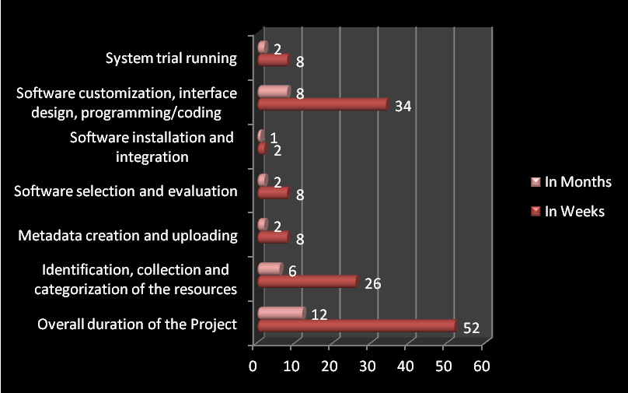

- Budget Summary
SNo. | Item | Expenditure  (Rs.)
1 | Salary (Rs.25000 p.m. x 12 months)  Designation: Research Officer (One Post)  Qualifications: 1. MCA/ B.E. (Computer Science) /M.Sc. (Computer Science)/ Diploma in Computer Science 2. Experience in PHP programming  Justification for the Post: Research officer with computer science background and experience in PHP programming is required for customizing the open source software for building literature database. | 3.00 lakhs  (Rs.25000 p.m. x 12 months)
2. | Consumables | Nil
3 | Travel | Nil
4. | Other Costs | Nil
 | Total | 3.00 lakhs

6.0 Implications of the Study (already mentioned)
- Utilization of the Study
The database developed will be hosted and made available for the Indian Speech and Hearing Community after getting the necessary approval.
8.0 Roles and Responsibilities
SNo. | Investigator | Roles and Responsibilities | Signature
1 | Dr. Shijith Kumar C | Overall supervision and coordination, report writing, presentation, system design, developing workflow, interacting with open source community
2. | Mr. Nanjunda Swamy, N | Software identification and evaluation, System development, error detection, trial running
3 | Mr. Nandeesha, B | Identification, collection and categorization of the resources, creation of metadata contents, uploading of the resources to the database, trial running
4. | Mr. Raghavendra G.N | Evaluation of open source software code, Rectification errors in codes/programs, Programming and coding
5. | Research Officer | Customization of the software applications, programming and coding

References
- Price, D. J. S., & Price, D. J. S. (1986). Little science, big science-- and beyond. New York: Columbia University Press.
- Varian, Hal. (2003). How much information? 2003. Retrieved from UC Berkeley's School of Information Management and Systems website: http://www.ischool.berkeley.edu/research/projects/howmuchinfo2003

